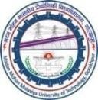Madan Mohan Malaviya University of Technology Gorakhpur – 273010 (U.P.) India

**(*Formerly: Madan Mohan Malaviya Engineering College, Gorakhpur*)**

**[NIRF Ranked - 227]**

|  |  |
| --- | --- |
| Prof. V.K. Dwivedi Professor  Training & Placement Cell | **Telephone No.:** 9953001761/8765783675  **Website:** [www.mmmut.ac.in](http://www.mmmut.ac.in/)  **E-mail:** [tnp@mmmut.ac.in](mailto:tnp@mmmut.ac.in) |

# To,

**{{Name}}**

**{{Post}}**

# {{Company}}

**Sub: Request for the Campus Recruitment Drive for final year students of 2024 Batch.** **Dear {{Gender}},**

I feel immense pleasure in introducing **Madan Mohan Malaviya University of Technology, Gorakhpur** with the humble request to invite you on behalf of this University for our ***‘Campus Recruitment Programme'.*** The Govt. of Uttar Pradesh established **Madan Mohan Malaviya Engineering College in the year 1962** to impart professional education in the fields of Civil Engineering, Electrical Engineering, Mechanical Engineering, Electronics & Communication Engineering, and Computer Science & Engineering leading to a bachelor’s degree B.Tech. and subsequently reconstituted it as non-affiliating technological University of U.P. State Govt. through its act number 22 of 2013 with effect from 1st December 2013. The institution is presently functioning **as Madan Mohan Malaviya University of Technology since December 1, 2013.**

Presently **Departments of Computer Science, Electronics and Communication Engineering, Civil Engineering, Mechanical Engineering, and Electrical Engineering have been accredited by NBA.** This University has **been ranked 15th** among the top Engineering institutes/Universities (2019) **by India Today, 6th in** Engineering Institute/University **in India in Times Engineering Institute 2018, 44th by HackerRank Community, and 16th** in PG & Research (2018) **by India Today Magazine.**

**This University has signed many MOUs with National and International Universities for collaborative research and development. The International Universities are** The Clouds Laboratory, University of Melbourne, Australia, Central Michigan University Board of Trustees, Michigan, USA, North Dakota State University, USA, University of Wisconsin, Green Bay, USA, Warsaw Management University, Poland, Universidad Carlos III DE Madrid, Spain, Faculty of Engineering, University of Ryukyus, Japan and ENEA, Italy.

MMMUT is also part of the Technical Education Quality Improvement Program (**TEQIP**) of the Government of India assisted by the World Bank and also a **center for the Ph.D. degree under the Quality Improvement Program (QIP) of the Government of India.**

## The intakes of students in different programs as available for campus recruitment programs are detailed ahead:

|  |  |  |  |  |  |
| --- | --- | --- | --- | --- | --- |
| **S. No.** | **UG Course** | **Intake** | **S. No.** | **PG Courses with specialization** | **Intake** |
| **1.** | **B.Tech.** | **174** | **1.** | **M.Tech. in** |  |
| (Civil Engg.) | (i) Environment Engg. | **18** |
|  | (ii) Hill Area Development | **18** |
|  | Engineering |  |
|  | (iii) Structural Engg. | **18** |
|  | (iv) Earthquake Engg. & Seismic | **18** |
|  | Design |  |
| **2.** | **B.Tech.** | **189** | **2.** | **M.Tech. in** |  |
| (Computer Sci. & Engg.) | (i) Computer Science & Engg. | **18** |
|  | (ii) Information Technology | **18** |
| **3.** | **B.Tech.** | **178** | **3.** | **M.Tech. in** |  |
| (Electrical Engg.) | (i) Power Electronics and Drive | **18** |
|  | (ii) Control & Instrumentation | **18** |
| **4.** | **B.Tech.** | **177** | **4.** | **M.Tech. in** |  |
| (Electronics & | (i) Digital Systems | **18** |
| Communication Engg.) | (ii) Communication Engg. | **18** |
| **5.** | **B.Tech**. | **174** | **5.** | **M.Tech. in** |  |
| (Mechanical Engg.) | (i) Computer Integrated | **18** |
|  | Manufacturing |  |
|  | (ii) Energy Technology & | **18** |
|  | Management |  |
| **6.** | **B.Tech**.  (Chemical Engg.) | **84** | **6.** | **M. Sc.** Physics  (Specialisation in Electronics) | **30** |
| **7.** | **B.Tech**.  (Information Technology) | **94** | **7.** | **M.C.A.** | **75** |
| **8.** | **B.B.A.** | **60** | **8.** | **M.B.A.** | **75** |
|  |  |  | **9.** | **Ph.D.** (All Discipline) |  |
|  | **Total** | **1130** |  | **Total** | **396** |

I feel great pleasure in informing that during previous years the companies like **M/s *Tata Consultancy Services (TCS), Wipro Technologies, HCL, Cognizant, Idea Cellular (P) Ltd., Vodafone, Indian Army, Adobe, Coforge Technologies, Amazon, Mahindra Comviva, Software AG, Snapdeal, DLT Labs, Jaro Group, Future Generali, Lava International Ltd, Ericsson Global, Nagarro, Juspay, HummingWave Technologies, Prism Jhonson, Escorts, MG Motors, Aditya Birla Group, JK cement, Berger Paint*** have visited this University and recruited students from our campus. The details of placement for the **last five years** have been given below:

|  |  |  |  |
| --- | --- | --- | --- |
| **Academic Year** | **No. of placements** | **Max. package per-annum (in Lac)** | **Average Salary per annum (in Lac)** |
| **2022-23** | **975\*** | **52 (Google)** | **7.02** |
| **2021-22** | **1023** | **50 (Microsoft)** | **6.32** |
| **2020-21** | **404** | **37 (D.E. Shaw)** | **4.91** |
| **2019-20** | **287** | **39 (Microsoft)** | **4.70** |
| **2018-19** | **135** | **8 (Juspay)** | **3.60** |

It is also a matter of pride that our students have been consistently securing high scores in *GATE/CAT/GRE/GMAT* for admission to various Master’s Programs in reputed institutes in India and abroad and also in other national-level competitive examinations.

## It is worthwhile to mention here that from 1966 till date more than 15,000+ engineers who had been excelling in various industries and acquired leadership and top executive positions in Fortune 500 organizations.

I shall be extremely thankful if you kindly accede to our request for interaction with our students for their *placement/internship* and developing a long-term relationship with this University. You can contact the undersigned for any of the information in this regard. University will feel immense pleasure in hosting you on the lush green campus of ***Madan Mohan Malaviya University of Technology, Gorakhpur***.

In case of any queries, feel free to contact the undersigned at (**9953001761/8765783675**) or Dr. Rajan Mishra, *Vice Chairman (Internship) and Coordinator*, (***Mobile No:*** 09235500560). Looking forward to your kind response.

With best regards,

# (Prof. V.K. Dwivedi)

***Attachments Area:*** Preview YouTube video Campus Tour of Madan Mohan Malaviya University of Technology[-Gorakhpur](https://www.youtube.com/watch?v=SpMVPPIl8x0&authuser=0)

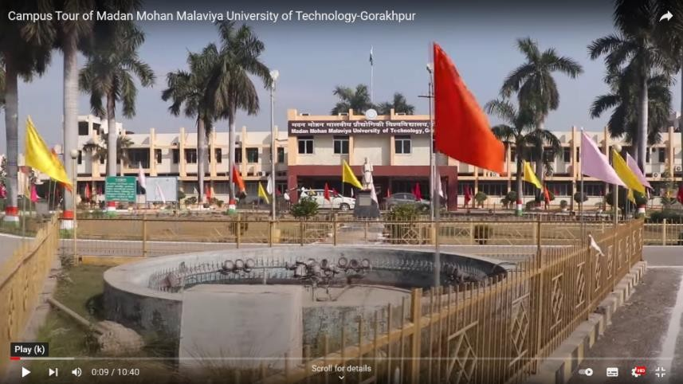 [**Campus Tour of MMMUT, Gorakhpur**](https://youtu.be/SpMVPPIl8x0)