**Table of Contents**

​ Introduction 2

​ CSS Syntax 2

​ CSS Selector 3

​ 1) CSS Element Selector 3

​ 2) CSS Id Selector 3

​ 3) CSS Class Selector 3

​ CSS Class Selector for specific element 4

​ 4) CSS Universal Selector 4

​ 5) CSS Group Selector 4

​ How to add CSS 5

​ 1. Inline CSS 5

​ 2. Internal CSS 5

​ 3. External CSS 5

​ CSS Stylings 5

​ Website Layout 7

​ Self study & practise 9

### Introduction

* CSS is the language we use to style an HTML document.
* CSS describes how HTML elements should be displayed.
* CSS stands for Cascading Style Sheet.
* CSS is used to design HTML tags.
* CSS is a widely used language on the web.

HTML, CSS and JavaScript are used for web designing. It helps the web designers to apply style on HTML tags.

It can also be used with any kind of XML documents including plain XML, SVG and XUL.

CSS is used along with HTML and JavaScript in most websites to create user interfaces for web applications and user interfaces for many mobile applications.

### CSS Syntax

A CSS rule set contains a selector and a declaration block.

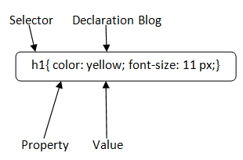

**Selector:**

Selector indicates the HTML element you want to style. It could be any tag like <h1>, <title> etc.

**Declaration Block:**

The declaration block can contain one or more declarations separated by a semicolon. For the above example, there are two declarations:

1. color: yellow;
2. font-size: 11 px;

Each declaration contains a property name and value, separated by a colon.

**Property:**A Property is a type of attribute of HTML element. It could be color, border etc.

**Value:**Values are assigned to CSS properties. In the above example, value "yellow" is assigned to color property.

Selector{Property1: value1; Property2: value2; ..........;}

### CSS Selector

**CSS selectors** are used to select the content you want to style. Selectors are the part of CSS rule set. CSS selectors select HTML elements according to its id, class, type, attribute etc.

There are several different types of selectors in CSS.

#### 1) CSS Element Selector

The element selector selects the HTML element by name.

P{

text-align: center;

color: blue;

}

**<p>**This style will be applied on every paragraph.**</p>**

#### 2) CSS Id Selector

The id selector selects the id attribute of an HTML element to select a specific element. An id is always unique within the page so it is chosen to select a single, unique element.

It is written with the hash character (#), followed by the id of the element.

#para1 {

1. text-align: center;
2. color: blue;
3. }

<p id="para1">Hello Javatpoint.com</p>

#### 3) CSS Class Selector

The class selector selects HTML elements with a specific class attribute. It is used with a period character . (full stop symbol) followed by the class name.

Note: A class name should not be started with a number.

.center {

1. text-align: center;
2. color: blue;
3. }

**<h1** class="center"**>**This heading is blue and center-aligned.**</h1>**

1. **<p** class="center"**>**This paragraph is blue and center-aligned.**</p>**

#### CSS Class Selector for specific element

If you want to specify that only one specific HTML element should be affected then you should use the element name with class selector.

p.center {

1. text-align: center;
2. color: blue;
3. }

**<h1** class="center"**>**This heading is not affected**</h1>**

1. **<p** class="center"**>**This paragraph is blue and center-aligned.**</p>**

#### 4) CSS Universal Selector

* {

1. color: green;
2. font-size: 20px;
3. }

#### 5) CSS Group Selector

th, td {  
 border-style: solid;  
 border-color: #96D4D4;  
}

<table>  
 <tr>  
 <th>Company</th>  
 <th>Contact</th>  
 <th>Country</th>  
 </tr>  
 <tr>  
 <td>Alfreds Futterkiste</td>  
 <td>Maria Anders</td>  
 <td>Germany</td>  
 </tr>

### How to add CSS

CSS is added to HTML pages to format the document according to information in the style sheet. There are three ways to insert CSS in HTML documents.

#### 1. Inline CSS

<div style="background-color:powderblue; text-align:center; border: black">

#### 2. Internal CSS

<style>  
 .class1{  
 background-color:tomato;  
 color:white;

}  
</style>

#### 3. External CSS

<link rel="stylesheet" type="text/css" href="css/h1Format.css">

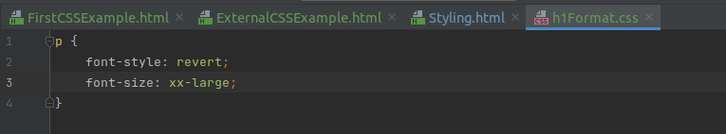**Comments** are single or multiple lines statement and written within

/*............*/ .

### CSS Stylings

The **CSS background** properties are used to add background effects for elements.

* background-color
* background-image
* background-repeat (x, y)
* background-attachment
* background-position (center, bottom, top, left, right)

The **CSS border** properties are use to specify the style, color and size of the border of an element. The CSS border properties are given below:

* border-style
* border-color
* border-width
* border-radius

The **CSS margin** properties are used to create space around elements, outside of any defined borders.

With CSS, you have full control over the margins. There are properties for setting the margin for each side of an element (top, right, bottom, and left).

margin-top

margin-right

margin-bottom

margin-left

**CSS Padding** is used to create space around an element's content, inside of any defined borders.

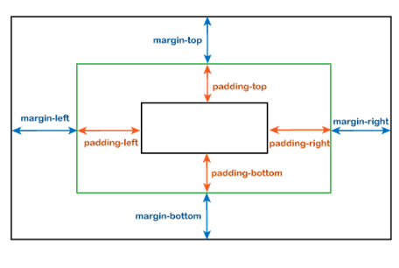

CSS margin property defines the space around the elements. It is completely transparent and doesn't have any background color. It clears an area around the element.

We can independently change the top, bottom, left, and right margin by using separate properties that are margin-top, margin-bottom, margin-left, and margin-right. We can also change all properties at once by using the shorthand margin property.

Unlike the margin property, the CSS padding property defines the space between the element content and the element border. CSS padding is affected by background colors. It clears an area around the content.

|  |  |
| --- | --- |
| Margin | Padding |
| Margin is said to be the outer space of an element, i.e., the margin is the space outside of the element's border. | Padding is said to be the inner space of an element, i.e., the padding is the space inside of the element's border. |
| We can set the **margin** to **auto**. | We cannot set the **padding** to **auto**. |
| It can be negative or any float number. | It does not allow negative values. |
| Styling of an element such as background color does not affect the margin. | Padding is affected by the styling of an element, such as background color. |

==========End of day 2========================

### Website Layout

A website is often divided into headers, menus, content and a footer:

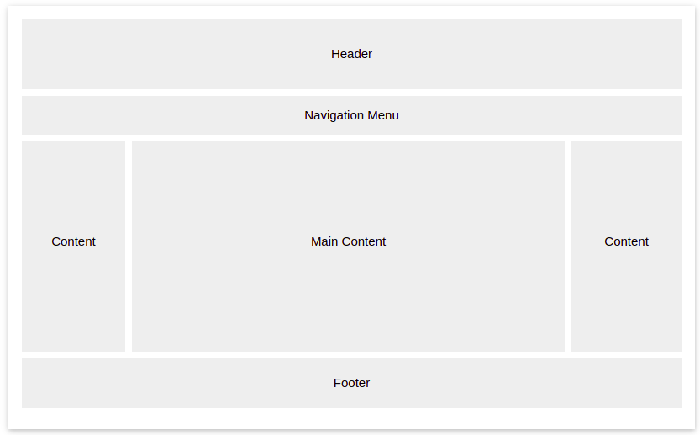

There are tons of different layout designs to choose from. However, the structure above, is one of the most common.

**Header**

A header is usually located at the top of the website (or right below a top navigation menu). It often contains a logo or the website name.

**Navigation Bar**

A navigation bar contains a list of links to help visitors navigating through your website.

**Content**

The layout in this section, often depends on the target users. The most common layout is one (or combining them) of the following:

1-column (often used for mobile browsers)

2-column (often used for tablets and laptops)

3-column layout (only used for desktops)

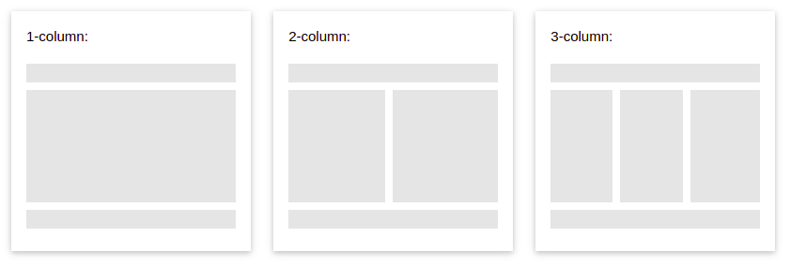**Footer**

The footer is placed at the bottom of your page. It often contains information like copyright and contact info.

### **References**

* w3Schools
* javatpoint

### Self study & practise

* Responsive layout (@media, other options & features)
* Desktop-Laptop view ( <meta name="viewport" content="width=device-width, initial-scale=1">)