Exampe

Variable

Function

var vs let vs const

**Scope of var**

Scope essentially means where these variables are available for use. var declarations are globally scoped or function/locally scoped.

The scope is global when a var variable is declared outside a function. This means that any variable that is declared with var outside a function block is available for use in the whole window.

var is function scoped when it is declared within a function. This means that it is available and can be accessed only within that function.

**var variables can be re-declared and updated**

var greeter = "hey hi";

var greeter = "say Hello instead";

**Hoisting of var**

Hoisting is a JavaScript mechanism where variables and function declarations are moved to the top of their scope before code execution. This means that if we do this:

console.log (greeter);

var greeter = "say hello"

it is interpreted as this:

var greeter;

console.log(greeter); // greeter is undefined

greeter = "say hello"

So var variables are hoisted to the top of their scope and **initialized with a value of undefined.**

**Problem with var**

There's a weakness that comes with var. I'll use the example below to explain:

var greeter = "hey hi";

var times = 4;

if (times > 3) {

var greeter = "say Hello instead";

}

console.log(greeter) // "say Hello instead"

So, since times > 3 returns true, greeter is redefined to "say Hello instead". While this is not a problem if you knowingly want greeter to be redefined, it becomes a problem when you do not realize that a variable greeter has already been defined before.

If you have used greeter in other parts of your code, you might be surprised at the output you might get. This will likely cause a lot of bugs in your code. This is why let and const are necessary

**let is block scoped**

A block is a chunk of code bounded by {}. A block lives in curly braces. Anything within curly braces is a block.

So a variable declared in a block with let is only available for use within that block. Let me explain this with an example:

let greeting = "say Hi";

let times = 4;

if (times > 3) {

let hello = "say Hello instead";

console.log(hello);// "say Hello instead"

}

console.log(hello) // hello is not defined

We see that using hello outside its block (the curly braces where it was defined) returns an error. This is because let variables are block scoped .

**let can be updated but not re-declared.**

Just like var, a variable declared with let can be updated within its scope. Unlike var, a let variable cannot be re-declared within its scope. So while this will work:

let greeting = "say Hi";

greeting = "say Hello instead";

this will return an error:

let greeting = "say Hi";

let greeting = "say Hello instead"; // error: Identifier 'greeting' has already been declared

However, if the same variable is defined in different scopes, there will be no error:

let greeting = "say Hi";

if (true) {

let greeting = "say Hello instead";

console.log(greeting); // "say Hello instead"

}

console.log(greeting); // "say Hi"

Why is there no error? This is because both instances are treated as different variables since they have different scopes.

This fact makes let a better choice than var. When using let, you don't have to bother if you have used a name for a variable before as a variable exists only within its scope.

Also, since a variable cannot be declared more than once within a scope, then the problem discussed earlier that occurs with var does not happen.

**Hoisting of let**

Just like var, let declarations are hoisted to the top. Unlike var which is initialized as undefined, the let keyword is not initialized. So if you try to use a let variable before declaration, you'll get a Reference Error.

**Const**

Variables declared with the const maintain constant values. const declarations share some similarities with let declarations.

**const declarations are block scoped**

Like let declarations, const declarations can only be accessed within the block they were declared.

**const cannot be updated or re-declared**

This means that the value of a variable declared with const remains the same within its scope. It cannot be updated or re-declared. So if we declare a variable with const, we can neither do this:

const greeting = "say Hi";

greeting = "say Hello instead";// error: Assignment to constant variable.

nor this:

const greeting = "say Hi";

const greeting = "say Hello instead";// error: Identifier 'greeting' has already been declared

Every const declaration, therefore, must be initialized at the time of declaration.

This behavior is somehow different when it comes to objects declared with const. While a const object cannot be updated, the properties of this objects can be updated. Therefore, if we declare a const object as this:

const greeting = {

message: "say Hi",

times: 4

}

while we cannot do this:

greeting = {

words: "Hello",

number: "five"

} // error: Assignment to constant variable.

we can do this:

greeting.message = "say Hello instead";

This will update the value of greeting.message without returning errors.

**Hoisting of const**

Just like let, const declarations are hoisted to the top but are not initialized.

So just in case you missed the differences, here they are:

var declarations are globally scoped or function scoped while let and const are block scoped.

var variables can be updated and re-declared within its scope; let variables can be updated but not re-declared; const variables can neither be updated nor re-declared.

They are all hoisted to the top of their scope. But while var variables are initialized with undefined, let and const variables are not initialized.

While var and let can be declared without being initialized, const must be initialized during declaration.

**Window Object**

The window object represents a window in browser. An object of window is created automatically by the browser.

Window is the object of browser, it is not the object of javascript. The javascript objects are string, array, date etc.

Method Description

=================================================

alert() displays the alert box containing message with ok button.

confirm() displays the confirm dialog box containing message with ok and cancel button.

prompt() displays a dialog box to get input from the user.

open() opens the new window.

close() closes the current window.

setTimeout() performs action after specified time like calling function, evaluating expressions etc.

**Document Object Model**

The document object represents the whole html document.

When html document is loaded in the browser, it becomes a document object. It is the root element that represents the html document. It has properties and methods. By the help of document object, we can add dynamic content to our web page.

As mentioned earlier, it is the object of window. So

window.document Is same as document

Properties of document object

Let's see the properties of document object that can be accessed and modified by the document object. javascript document object

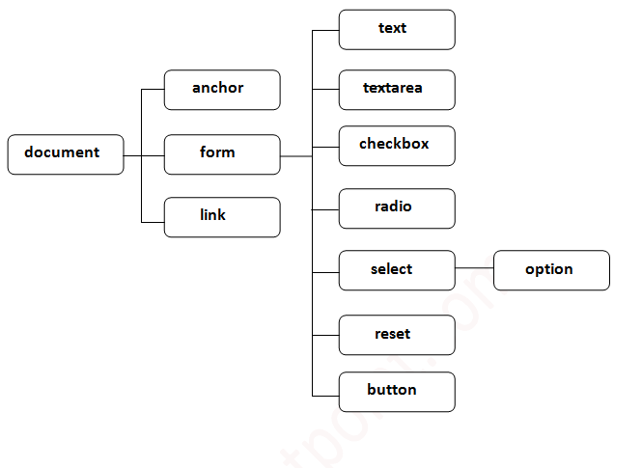

Methods of document object

We can access and change the contents of document by its methods.

The important methods of document object are as follows:

Method Description

write("string") writes the given string on the doucment.

writeln("string") writes the given string on the doucment with newline character at the end.

getElementById() returns the element having the given id value.

getElementsByName() returns all the elements having the given name value.

getElementsByTagName() returns all the elements having the given tag name.

getElementsByClassName() returns all the elements having the given class name.