Table of Contents

### Introduction

* CSS is the language we use to style an HTML document.
* CSS describes how HTML elements should be displayed.
* CSS stands for Cascading Style Sheet.
* CSS is used to design HTML tags.
* CSS is a widely used language on the web.

HTML, CSS and JavaScript are used for web designing. It helps the web designers to apply style on HTML tags.

It can also be used with any kind of XML documents including plain XML, SVG and XUL.

CSS is used along with HTML and JavaScript in most websites to create user interfaces for web applications and user interfaces for many mobile applications.

### CSS Syntax

A CSS rule set contains a selector and a declaration block.

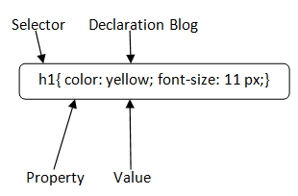

**Selector:**

Selector indicates the HTML element you want to style. It could be any tag like <h1>, <title> etc.

**Declaration Block:**

The declaration block can contain one or more declarations separated by a semicolon. For the above example, there are two declarations:

1. color: yellow;
2. font-size: 11 px;

Each declaration contains a property name and value, separated by a colon.

**Property:**A Property is a type of attribute of HTML element. It could be color, border etc.

**Value:**Values are assigned to CSS properties. In the above example, value "yellow" is assigned to color property.

Selector{Property1: value1; Property2: value2; ..........;}

### CSS Selector

**CSS selectors** are used to select the content you want to style. Selectors are the part of CSS rule set. CSS selectors select HTML elements according to its id, class, type, attribute etc.

There are several different types of selectors in CSS.

#### 1) CSS Element Selector

The element selector selects the HTML element by name.

P{

text-align: center;

color: blue;

}

**<p>**This style will be applied on every paragraph.**</p>**

#### 2) CSS Id Selector

The id selector selects the id attribute of an HTML element to select a specific element. An id is always unique within the page so it is chosen to select a single, unique element.

It is written with the hash character (#), followed by the id of the element.

#para1 {

1. text-align: center;
2. color: blue;
3. }

<p id="para1">Hello Javatpoint.com</p>

#### 3) CSS Class Selector

The class selector selects HTML elements with a specific class attribute. It is used with a period character . (full stop symbol) followed by the class name.

Note: A class name should not be started with a number.

.center {

1. text-align: center;
2. color: blue;
3. }

**<h1** class="center"**>**This heading is blue and center-aligned.**</h1>**

1. **<p** class="center"**>**This paragraph is blue and center-aligned.**</p>**

#### CSS Class Selector for specific element

If you want to specify that only one specific HTML element should be affected then you should use the element name with class selector.

p.center {

1. text-align: center;
2. color: blue;
3. }

**<h1** class="center"**>**This heading is not affected**</h1>**

1. **<p** class="center"**>**This paragraph is blue and center-aligned.**</p>**

#### 4) CSS Universal Selector

* {

1. color: green;
2. font-size: 20px;
3. }

#### 5) CSS Group Selector

th, td {  
 border-style: solid;  
 border-color: #96D4D4;  
}

<table>  
 <tr>  
 <th>Company</th>  
 <th>Contact</th>  
 <th>Country</th>  
 </tr>  
 <tr>  
 <td>Alfreds Futterkiste</td>  
 <td>Maria Anders</td>  
 <td>Germany</td>  
 </tr>

### How to add CSS

CSS is added to HTML pages to format the document according to information in the style sheet. There are three ways to insert CSS in HTML documents.

#### Inline CSS

<div style="background-color:powderblue; text-align:center; border: black">

#### 2. Internal CSS

<style>  
 .class1{  
 background-color:tomato;  
 color:white;

}  
</style>

#### 3. External CSS

<link rel="stylesheet" type="text/css" href="css/h1Format.css">

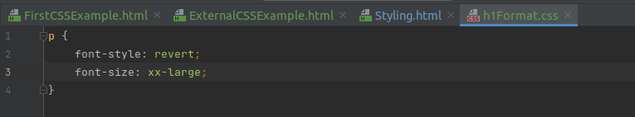**Comments** are single or multiple lines statement and written within

/*............*/ .

The **CSS background** properties are used to add background effects for elements.

* background-color
* background-image
* background-repeat (x, y)
* background-attachment
* background-position (center, bottom, top, left, right)

The **CSS border** properties are use to specify the style, color and size of the border of an element. The CSS border properties are given below:

* border-style
* border-color
* border-width
* border-radius