Cheat Sheet

02 April 2023

15:26

Git Cheat Sheet

1. Git configuration

* **Git config**Get and set configuration variables that control all facets of how Git looks and operates.  
  **Set the name:**$ git config --global user.name "User name"  
  **Set the email:**$ git config --global user.email "himanshudubey481@gmail.com"  
  **Set the default editor:**$ git config --global core.editor Vim  
  **Check the setting:**$ git config -list
* **Git alias  
  Set up an alias** for each command:  
  $ git config --global alias.co checkout  
  $ git config --global alias.br branch  
  $ git config --global alias.ci commit  
  $ git config --global alias.st status

2. Starting a project

* **Git init  
  Create a local repository:**$ git init
* **Git clone  
  Make a local copy** of the server repository.  
  $ git clone

AD

3. Local changes

* **Git add  
  Add a file** to staging (Index) area:  
  $ git add Filename  
  **Add all files** of a repo to staging (Index) area:  
  $ git add*
* **Git commit  
  Record** or snapshots the file permanently in the version history **with a message**.  
  $ git commit -m " Commit Message"

4. Track changes

* **Git diff**Track the changes that have not been staged: $ git diff  
  Track the changes that have staged but not committed:  
  $ git diff --staged  
  Track the changes after committing a file:  
  $ git diff HEAD  
  Track the changes between two commits:  
  $ git diff Git Diff Branches:  
  $ git diff < branch 2>
* **Git status**Display the state of the working directory and the staging area.  
  $ git status
* **Git show Shows objects:**$ git show

5. Commit History

* **Git log**Display the most recent commits and the status of the head:  
  $ git log  
  Display the output as one commit per line:  
  $ git log -oneline  
  Displays the files that have been modified:  
  $ git log -stat  
  Display the modified files with location:  
  $ git log -p
* **Git blame**Display the modification on each line of a file:  
  $ git blame <file name>

6. Ignoring files

* **.gitignore**Specify intentionally untracked files that Git should ignore. Create .gitignore:  
  $ touch .gitignore List the ignored files:  
  $ git ls-files -i --exclude-standard

7. Branching

* **Git branch Create branch:**$ git branch List Branch:  
  $ git branch --list Delete a Branch:  
  $ git branch -d Delete a remote Branch:  
  $ git push origin -delete Rename Branch:  
  $ git branch -m
* **Git checkout**Switch between branches in a repository.  
  Switch to a particular branch:  
  $ git checkout  
  Create a new branch and switch to it:  
  $ git checkout -b Checkout a Remote branch:  
  $ git checkout
* **Git stash**Switch branches without committing the current branch. Stash current work:  
  $ git stash  
  Saving stashes with a message:  
  $ git stash save ""  
  Check the stored stashes:  
  $ git stash list  
  Re-apply the changes that you just stashed:  
  $ git stash apply  
  Track the stashes and their changes:  
  $ git stash show  
  Re-apply the previous commits:  
  $ git stash pop  
  Delete a most recent stash from the queue:  
  $ git stash drop  
  Delete all the available stashes at once:  
  $ git stash clear  
  Stash work on a separate branch:  
  $ git stash branch
* **Git cherry pic**Apply the changes introduced by some existing commit:  
  $ git cherry-pick

8. Merging

* **Git merge**Merge the branches:  
  $ git merge  
  Merge the specified commit to currently active branch:  
  $ git merge
* **Git rebase**Apply a sequence of commits from distinct branches into a final commit.  
  $ git rebase  
  Continue the rebasing process:  
  $ git rebase -continue Abort the rebasing process:  
  $ git rebase --skip
* **Git interactive rebase**Allow various operations like edit, rewrite, reorder, and more on existing commits.  
  $ git rebase -i

9. Remote

* **Git remote**Check the configuration of the remote server:  
  $ git remote -v  
  Add a remote for the repository:  
  $ git remote add Fetch the data from the remote server:  
  $ git fetch  
  Remove a remote connection from the repository:  
  $ git remote rm  
  Rename remote server:  
  $ git remote rename  
  Show additional information about a particular remote:  
  $ git remote show  
  Change remote:  
  $ git remote set-url
* **Git origin master**Push data to the remote server:  
  $ git push origin master Pull data from remote server:  
  $ git pull origin master

10. Pushing Updates

* **Git push**Transfer the commits from your local repository to a remote server. Push data to the remote server:  
  $ git push origin master Force push data:  
  $ git push -f  
  Delete a remote branch by push command:  
  $ git push origin -delete edited

11. Pulling updates

* **Git pull**Pull the data from the server:  
  $ git pull origin master  
  Pull a remote branch:  
  $ git pull
* **Git fetch**Download branches and tags from one or more repositories. Fetch the remote repository:  
  $ git fetch< repository Url> Fetch a specific branch:  
  $ git fetch  
  Fetch all the branches simultaneously:  
  $ git fetch -all  
  Synchronize the local repository:  
  $ git fetch origin

12. Undo changes

* **Git revert**Undo the changes:  
  $ git revert  
  Revert a particular commit:  
  $ git revert
* **Git reset**Reset the changes:  
  $ git reset -hard  
  $ git reset -soft:  
  $ git reset --mixed

13. Removing files

* **Git rm**Remove the files from the working tree and from the index:  
  $ git rm <file Name>  
  Remove files from the Git But keep the files in your local repository:  
  $ git rm --cached

From <[*https://www.javatpoint.com/git-cheat-sheet*](https://www.javatpoint.com/git-cheat-sheet)>

To add existing project in local to github

1. Git init



1. 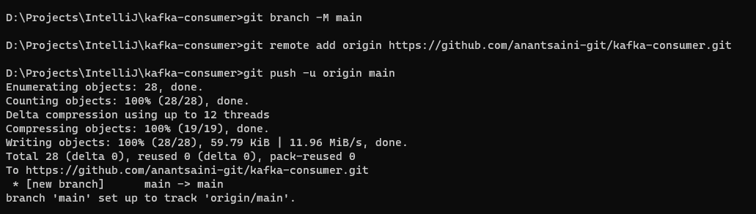
2. Check if git add -a is required