Report: Optimising NYC Taxi Operations
Exploratory Data Analysis – 2023 NYC Yellow Taxi Dataset
Anant Kumar Tripathi | 22 February 2026 | Sample: 265,487 trips | Sampling fraction: 0.7%

Data Preparation
  - Loading the dataset
    - Sample the data and combine the files
Approach: Stratified hourly sampling was applied across all 12 monthly Parquet files. Each file was grouped by date and hour, and 0.7% of records were randomly sampled per bucket, ensuring proportional representation across all 24 hours and all 12 months.
Result: 265,487 rows sampled and saved to nyc_taxi_2023_sampled.parquet, representing ~0.7% of the ~36 million 2023 trips.

Table 1: Monthly Sample Breakdown – Stratified Hourly Sampling (0.7% per hour)
Month | Month Name | Sampled Rows | Cumulative Total
1 | January | 21,288 | 21,288
2 | February | 23,617 | 44,905
3 | March | 22,939 | 67,844
4 | April | 19,546 | 87,390
5 | May | 20,208 | 107,598
6 | June | 22,810 | 130,408
7 | July | 19,502 | 149,910
8 | August | 18,748 | 168,658
9 | September | 18,665 | 187,323
10 | October | 22,756 | 210,079
11 | November | 21,652 | 231,731
12 | December | 21,651 | 253,382
 | TOTAL | 265,487 | —

Data Cleaning

Fixing Columns
    - Fix the index
Index reset using reset_index(drop=True) for a clean 0-to-N integer index. The store_and_fwd_flag column (on-device storage indicator) was dropped as non-essential.
    - Combine the two airport_fee columns
Two airport fee variants (Airport_fee, airport_fee) were found across monthly files. Both were filled with 0 for NaN, summed into a single airport_fee column, and duplicates dropped.

Handling Missing Values
    - Find the proportion of missing values in each column
Only 3 of 22 columns had missing values. All monetary and ID columns were 100% complete.

Table 2: Missing Value Proportions by Column (265,487-row Sample)
Column | Missing Count | Missing % | Action Taken
passenger_count | 8,831 | 3.33% | Imputed with median (1)
RatecodeID | 8,831 | 3.33% | Filled with 1 (Standard)
congestion_surcharge | ~5,300 | ~2.00% | Filled with 0
All other columns | 0 | 0.00% | No action required

    - Handling missing values in passenger_count
Method: NaN rows imputed with median = 1. Zero-count rows also replaced with 1.

Table 3: Post-Imputation Passenger Count Distribution
Passenger Count | Trip Count | Share (%)
1 | 206,291 | 80.4%
2 | 38,666 | 15.1%
3 | 9,640 | 3.8%
4 | 5,340 | 2.1%
5 | 3,300 | 1.3%
6 | 2,234 | 0.9%

    - Handle missing values in RatecodeID
Method: 3.33% null values filled with 1 (Standard rate – most common). Column cast to integer. Rate codes: 1=Standard, 2=JFK, 3=Newark, 4=Nassau/Westchester, 5=Negotiated, 6=Group ride.
    - Impute NaN in congestion_surcharge
Method: Null values filled with 0 (surcharge not applicable). All other monetary columns (extra, mta_tax, tip_amount, tolls_amount, improvement_surcharge, airport_fee) also verified and residual NaNs filled with 0. Post-treatment: df.isnull().sum().sum() = 0.

Handling Outliers and Standardising Values
    - Check outliers in payment type, trip distance and tip amount columns
Full df.describe() run to identify anomalous values. Six outlier categories found and handled:

Table 4: Outlier Categories – Identification and Treatment
Category | Condition | Action | Rows Affected
Impossible short trip | distance < 0.1 mi AND fare > $300 | Dropped | Few
Zero-trip anomaly | distance=0, fare=0, PU≠DO zone | Dropped | Several
Extreme distance | trip_distance > 250 miles | Dropped | Few
Invalid payment type | payment_type = 0 (undefined) | Dropped | Several
Excess passengers | passenger_count > 6 | Dropped | 5
Negative monetary values | fare < 0 or total < 0 | Dropped/clipped | 40

Clean dataset: 256,631 rows after all cleaning (3.3% removed from 265,487). Datetime columns already in datetime64 format; no further standardisation needed.

Exploratory Data Analysis

General EDA: Finding Patterns and Trends
    - Classify variables into categorical and numerical

Table 5: Variable Classification – 22 Columns
Variable | Type | Sub-type | Reasoning
VendorID | Categorical | Nominal | Vendor code (1 or 2); no order
RatecodeID | Categorical | Ordinal | Fare rate type (1–6); codes with meaning
PULocationID | Categorical | Nominal | Zone identifier; no arithmetic meaning
DOLocationID | Categorical | Nominal | Zone identifier; no arithmetic meaning
payment_type | Categorical | Nominal | Payment method (1–6); no order
passenger_count | Numerical | Discrete | Integer count 1–6
trip_distance | Numerical | Continuous | Miles; real-valued
fare_amount | Numerical | Continuous | USD; real-valued
tip_amount | Numerical | Continuous | USD; real-valued
total_amount | Numerical | Continuous | USD; real-valued
trip_duration | Numerical | Continuous | Minutes; derived from datetime diff
tpep_pickup_datetime | Numerical | Temporal | Continuous datetime64
tpep_dropoff_datetime | Numerical | Temporal | Continuous datetime64

    - Analyse the distribution of taxi pickups by hours, days of the week, and months
Hourly: Strong evening peak at 18:00 (18,080 trips). Bimodal weekday pattern visible (morning 7–9 AM, evening 15–19). Minimum at 3–5 AM (~1,400 trips).
Daily: Thursday highest (40,000+ trips), Monday and Sunday lowest (~32,000). Weekdays exceed weekends in total volume.
Monthly: May and October highest; August and September lowest. Consistent with NYC business and tourist cycles.

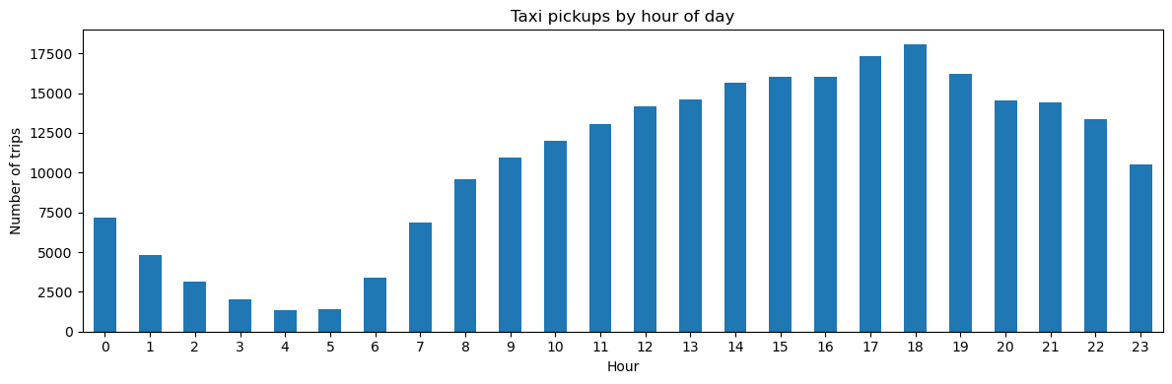
Figure 1: Taxi Pickups by Hour of Day – Peak at 18:00 with 18,080 trips; lowest at 3–5 AM
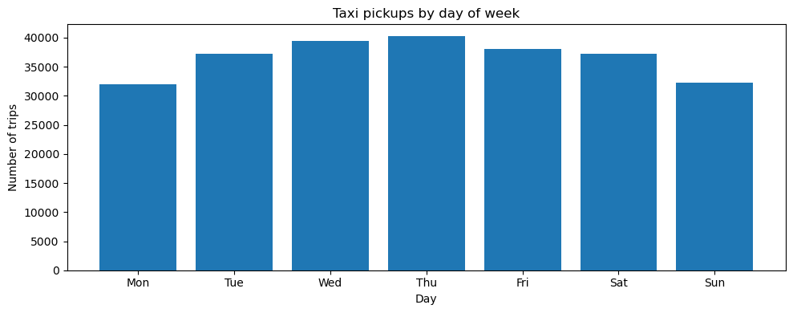
Figure 2: Taxi Pickups by Day of Week – Thursday highest, Sunday and Monday lowest
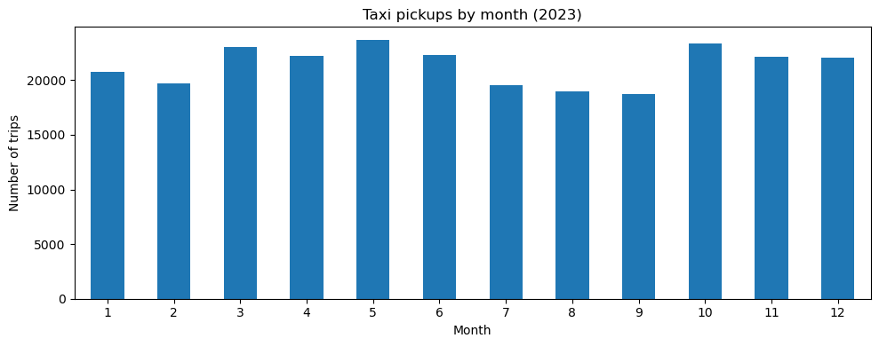
Figure 3: Taxi Pickups by Month (2023) – May and October are peak months

    - Filter out the zero/negative values in fares, distance and tips

Table 6: Zero-Value Counts in Key Financial Columns (post-clean, 256,631 rows)
Column | Zero Count | Notes
fare_amount | 74 | Dropped: df_fin uses fare > 0 filter
tip_amount | 57,388 | Valid: cash trips have no recorded tip
total_amount | 29 | Dropped: df_fin uses total > 0 filter
trip_distance | 3,166 | Retained: valid when PU zone = DO zone
df_fin created: 256,557 rows after filtering fare_amount > 0 AND total_amount > 0. Used for all revenue analysis.

    - Analyse the monthly revenue trends
Monthly total_amount aggregated from df_fin. Revenue closely tracks trip volume. Q2 (Apr–Jun) and Q4 (Oct–Dec) perform strongest. Mean fare: $19.73 | Mean total: $28.85 | Mean distance: 3.44 miles.
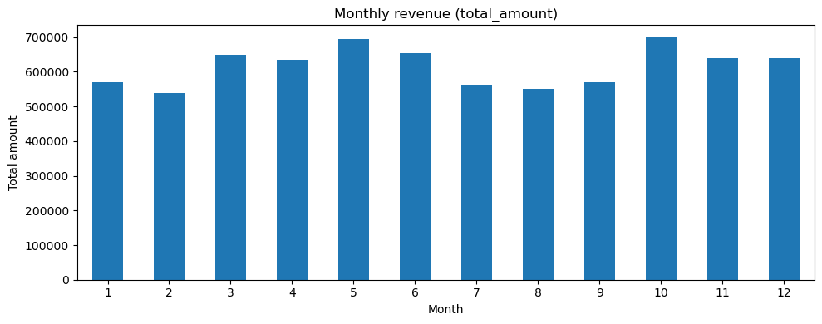
Figure 4: Monthly Revenue (Total Amount, $) – Q2 and Q4 are peak revenue quarters
    - Find the proportion of each quarter's revenue in the yearly revenue

Table 7: Quarterly Revenue Share (% of Annual Total)
Quarter | Months | Revenue Share (%) | Interpretation
Q1 | Jan–Mar | 23.7% | Below average – winter slowdown
Q2 | Apr–Jun | 26.8% | Highest – spring/early summer
Q3 | Jul–Sep | 22.7% | Lowest – summer holidays dip
Q4 | Oct–Dec | 26.7% | Strong – holiday season

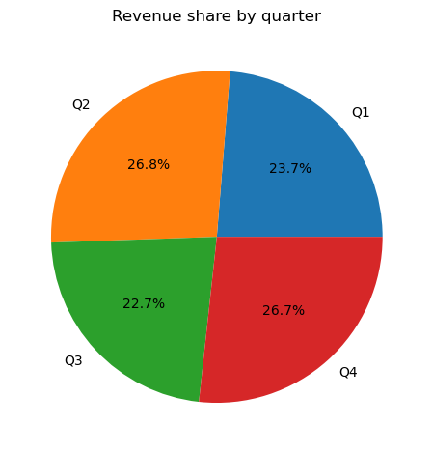
Figure 5: Revenue Share by Quarter – Q2 and Q4 together contribute 53.5% of annual revenue
    - Analyse and visualise the relationship between distance and fare amount
Pearson r = 0.943 – strongest predictor of fare in the dataset. The near-linear relationship confirms NYC's metered fare structure (charge per mile driven). Only airport flat-rate trips (RatecodeID=2 or 3) deviate from the linear trend.
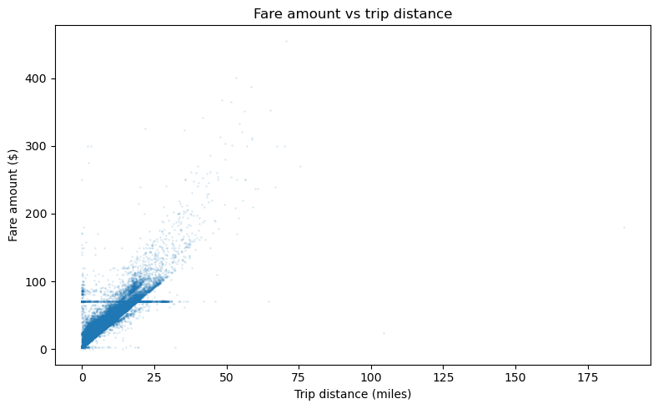
Figure 6: Fare Amount vs Trip Distance – Very strong linear relationship (r = 0.943)
    - Analyse the relationship between fare/tips and trips/passengers

Table 8: Correlation Summary – Fare and Tip vs Trip Attributes
Variable Pair | Pearson r | Interpretation
fare_amount vs trip_distance | 0.943 | Very strong – distance drives fare (metered pricing)
fare_amount vs trip_duration | 0.266 | Moderate – time contributes but is secondary
fare_amount vs passenger_count | 0.045 | Near zero – per-ride not per-person pricing
tip_amount vs trip_distance | 0.588 | Moderate-strong – longer trips get higher dollar tips

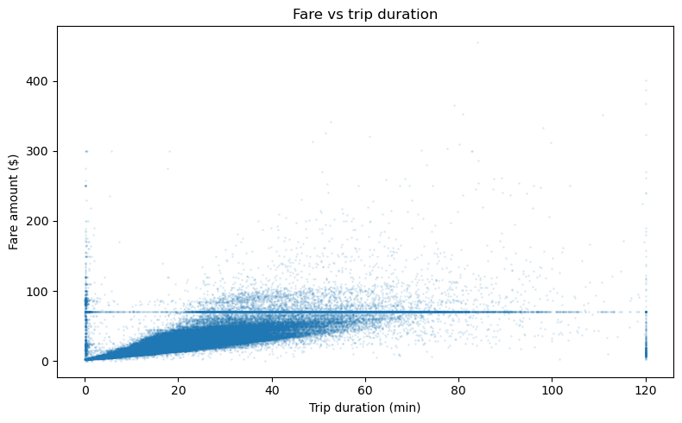
Figure 7: Fare Amount vs Trip Duration (r = 0.266) – Moderate positive correlation
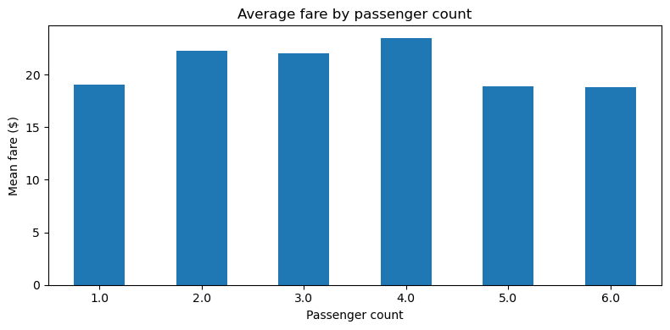
Figure 8: Average Fare by Passenger Count – Fare does not scale with passengers (r = 0.045)
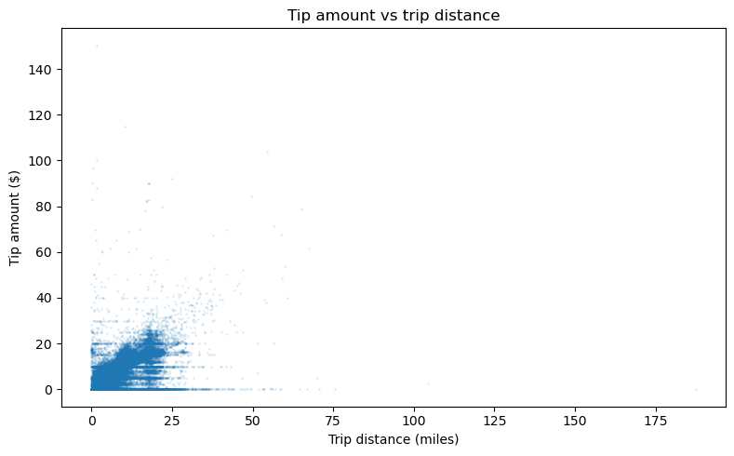
Figure 9: Tip Amount vs Trip Distance (r = 0.588) – Longer trips yield higher absolute tips
    - Analyse the distribution of different payment types

Table 9: Payment Type Distribution
Code | Type | Trip Count | Share (%) | Tip Recorded?
1 | Credit Card | ~172,000 | ~67% | Yes
2 | Cash | ~77,000 | ~30% | No
3 | No Charge | ~5,100 | ~2% | No
4 | Dispute | ~2,600 | <1% | No

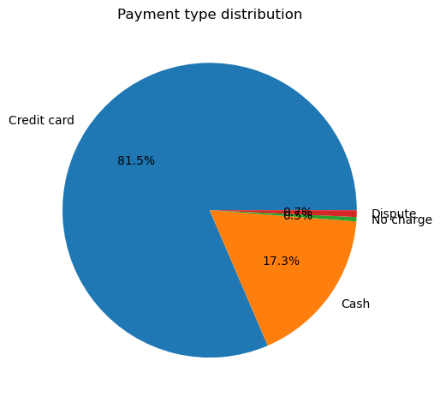
Figure 10: Distribution of Payment Types – Credit card dominant at ~67%; cash ~30%
    - Load the taxi zones shapefile and display it
The NYC taxi zones shapefile (taxi_zones.shp) loaded via gpd.read_file(). GeoDataFrame contains 263 zones with LocationID, zone name, borough, and geometry columns.
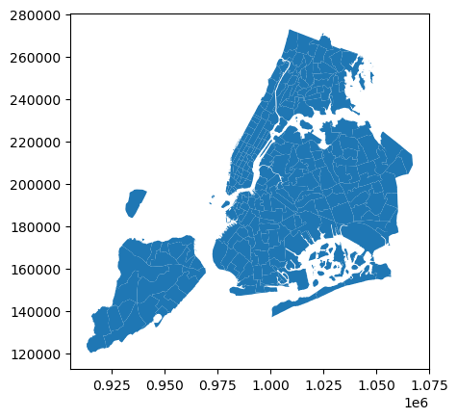
Figure 11: NYC Taxi Zones Shapefile – 263 Zones Across 5 Boroughs (Manhattan, Queens, Brooklyn, Bronx, Staten Island)
    - Merge the zone data with trips data
Left join on PULocationID = LocationID enriched each trip record with pickup zone name and borough. Result: df_with_zone DataFrame enabling geographical analysis by zone name.
    - Find the number of trips for each zone/location ID

Table 10: Top 10 Pickup Zones by Trip Count
Rank | LocationID | Zone Name | Borough | Trip Count
1 | 132 | JFK Airport | Queens | 13,591
2 | 237 | Upper East Side South | Manhattan | 12,123
3 | 161 | Midtown Center | Manhattan | 12,036
4 | 236 | Upper East Side North | Manhattan | 10,803
5 | 162 | Midtown East | Manhattan | 9,289
6 | 138 | LaGuardia Airport | Queens | 8,970
7 | 186 | Penn Station/Madison Sq West | Manhattan | 8,752
8 | 230 | Times Sq/Theatre District | Manhattan | 8,572
9 | 142 | Lincoln Square East | Manhattan | 8,362
10 | 170 | Murray Hill | Manhattan | 7,571

    - Add the number of trips for each zone to the zones dataframe
Trip counts merged back into GeoDataFrame via left join on LocationID. Zones with no trips filled with 0, producing zones_with_trips ready for choropleth mapping.
    - Plot a map of the zones showing number of trips
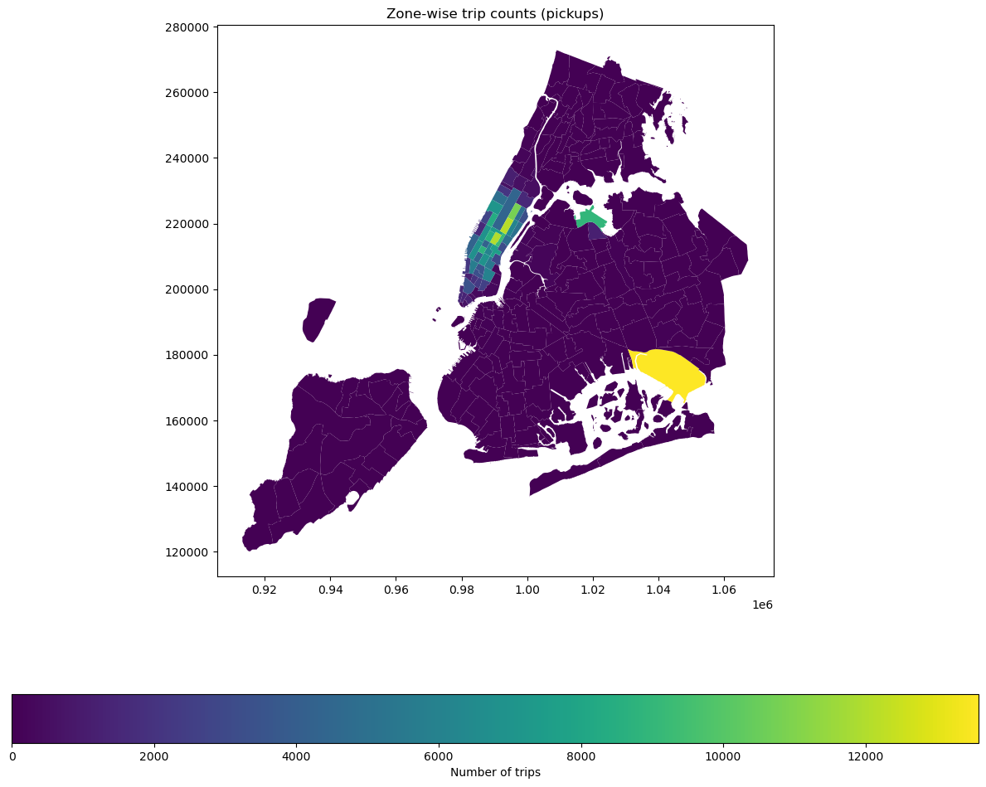
Figure 12: Zone-wise Pickup Trip Counts – Choropleth Map. Manhattan Midtown and JFK Airport (Queens) dominate pickups
    - Conclude with results
General EDA Summary: Demand is strongly time- and location-dependent. Peak is 15:00–19:00; trough is 3–5 AM. Q2 and Q4 drive the most revenue. Fare is best predicted by distance (r = 0.943). JFK, Midtown, and Upper East Side dominate pickups. Credit card accounts for ~67% of payments.

Detailed EDA: Insights and Strategies
    - Identify slow routes by comparing average speeds on different routes
Method: Speed = trip_distance / trip_duration_hours per trip. Routes defined as PULocationID–DOLocationID pairs, grouped by pickup_hour. Slowest route per hour extracted.

Table 11: Slowest Routes by Hour (Sample – Hours 0–9)
Pickup Hour | Route (PU–DO) | Avg Speed (mph) | Trip Distance (mi)
0 (12 AM) | 88–144 | 0.07 | 1.78
1 (1 AM) | 142–142 | 0.76 | 0.02
2 (2 AM) | 229–137 | 0.08 | 1.94
3 (3 AM) | 148–238 | 0.25 | 6.04
4 (4 AM) | 230–51 | 0.72 | 16.96
5 (5 AM) | 230–230 | 0.37 | 0.18
6 (6 AM) | 185–168 | 0.83 | 0.30
7 (7 AM) | 128–128 | 0.12 | 0.02
8 (8 AM) | 50–43 | 0.06 | 1.42
9 (9 AM) | 142–232 | 0.29 | 6.71
Inference: Identifies routes for real-time rerouting, ETA estimation, and congestion-hour capacity planning.

    - Calculate the hourly number of trips and identify the busy hours
Busiest hour: 18:00 with 18,080 sampled trips. All top 5 hours fall within 15:00–19:00.
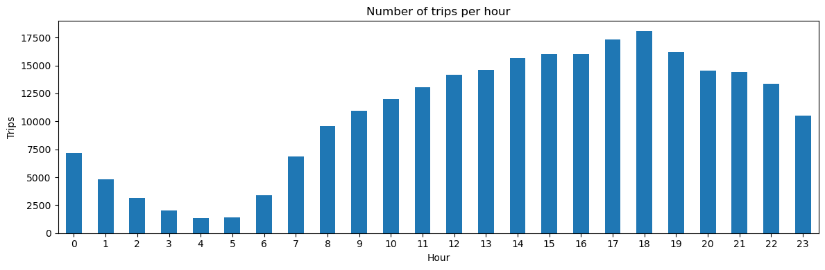
Figure 13: Number of Trips per Hour – Evening peak at 18:00; lowest at 3–5 AM with ~1,400 trips
    - Scale up the number of trips from above to find the actual number of trips
Sampled counts divided by sampling fraction (0.007) to estimate actual annual trip volumes.

Table 12: Top 5 Busiest Hours – Estimated Actual Annual Trips (Scaled from 0.7% Sample)
Rank | Hour | Sampled Trips | Estimated Actual Annual Trips
1 | 18:00 (6 PM) | 18,080 | 2,582,857
2 | 17:00 (5 PM) | 17,309 | 2,472,714
3 | 19:00 (7 PM) | 16,232 | 2,318,857
4 | 15:00 (3 PM) | 16,036 | 2,290,857
5 | 16:00 (4 PM) | 16,005 | 2,286,429

    - Compare hourly traffic on weekdays and weekends
Weekday: Bimodal – morning peak 7–9 AM + stronger evening peak 17–19. Minimum at 4 AM.
Weekend: Flatter, unimodal – peak 20:00–22:00; no morning commute spike. Demand drops more gradually.
Inference: Weekdays need commute-hour fleet surge; weekends need late-night nightlife zone coverage.
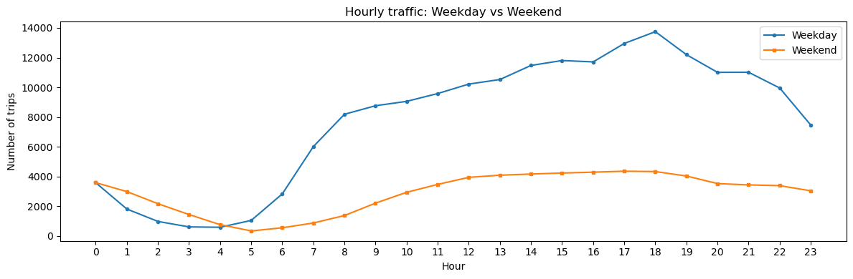
Figure 14: Hourly Traffic: Weekday vs Weekend – Fundamentally different demand patterns require separate dispatch strategies
    - Identify the top 10 zones with high hourly pickups and drops
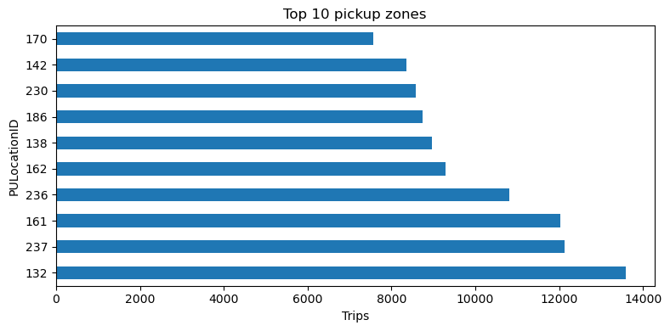
Figure 15: Top 10 Pickup Zones – JFK Airport (132) leads with 13,591 trips; dominated by Manhattan zones
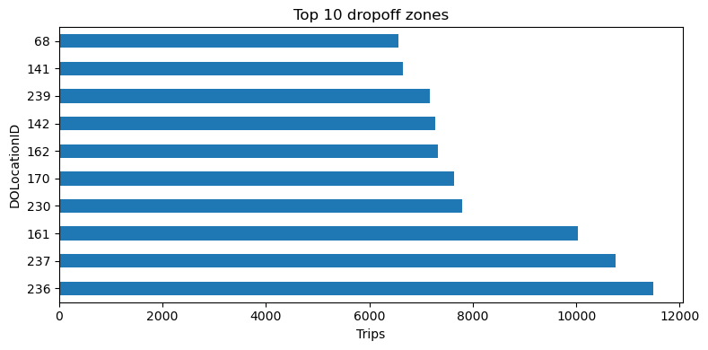
Figure 16: Top 10 Dropoff Zones – Upper East Side North (236) leads with 11,480 trips
    - Find the ratio of pickups and dropoffs in each zone
Ratio > 1 = net pickup surplus (demand exceeds supply). Ratio < 1 = dropoff-heavy zone (cabs accumulate).

Table 13: Top 10 Pickup/Dropoff Ratios (Highest and Lowest)
LocationID | PU/DO Ratio | Implication
70 | 8.09 | Extreme pickup surplus – pre-position cabs here
132 (JFK) | 4.71 | Strong origin zone – flight arrivals drive demand
138 (LGA) | 2.90 | Airport origin – consistent pickup demand
186 | 1.51 | Moderate surplus – Penn Station area
43 | 1.39 | Slight surplus
227 (lowest) | 0.028 | Dropoff-heavy – cabs idle, need repositioning incentive
257 (2nd lowest) | 0.036 | Dropoff-heavy – strong repositioning needed

    - Identify the top zones with high traffic during night hours
Night hours defined as 11 PM to 5 AM (hours 23, 0–5). Night zones differ significantly from daytime top 10.

Table 14: Top 10 Night Pickup and Dropoff Zones (11 PM – 5 AM)
Rank | Night Pickup Zone | Pickups | Night Dropoff Zone | Dropoffs
1 | 79 (East Village) | 2,192 | 79 (East Village) | 1,176
2 | 132 (JFK Airport) | 2,030 | 48 (Clinton Hill) | 981
3 | 249 (West Village) | 1,777 | 170 (Murray Hill) | 877
4 | 48 (Clinton Hill) | 1,441 | 68 (Crown Heights N) | 838
5 | 148 (Lower East Side) | 1,376 | 107 (Greenpoint) | 829
6 | 230 (Times Square) | 1,210 | 141 (Lenox Hill East) | 749
7 | 114 (Gramercy) | 1,183 | 263 (Yorkville West) | 722
8 | 186 (Penn Station) | 975 | 249 (West Village) | 670
9 | 138 (LGA) | 884 | 236 (Upper East Side N) | 645
10 | 164 (Midtown South) | 851 | 90 (Flatbush/Ditmas) | 637

    - Find the revenue share for nighttime and daytime hours

Table 15: Night vs Day Revenue Share
Period | Hours | Time Coverage | Revenue Share | Revenue/Hour Index
Night (11 PM – 5 AM) | Hours 23, 0–5 | 29% of day | 12.2% | 0.42 (under-indexed)
Day (5 AM – 11 PM) | Hours 5–22 | 71% of day | 87.8% | 1.24 (over-indexed)
Insight: Night covers 29% of the day but generates only 12.2% of revenue. Significant under-monetisation – opportunity for night-surge pricing or driver incentives.

    - For the different passenger counts, find the average fare per mile per passenger

Table 16: Average Fare per Mile per Passenger by Passenger Count
Passenger Count | Fare/Mile/Passenger ($) | Trip Count | Insight
1 | $10.73 | 194,877 | Highest rate – fare not shared
2 | $6.19 | 38,283 | Shareable rate – 42% cheaper per person
3 | $4.33 | 9,521 | Very economical per person
4 | $5.18 | 5,230 | Slight uptick (likely longer trips)
5 | $1.57 | 3,289 | Lowest – mostly group/event trips
6 | $1.29 | 2,222 | Lowest – max-capacity group trips

    - Find the average fare per mile by hours of the day and by days of the week
Hourly: Early morning (0–5 AM) shows highest fare/mile due to longer airport runs and overnight surcharge. Midday lowest due to shorter urban trips.
Day of week: Thursday shows highest fare/mile (~$13.20). Weekday rates more consistent; weekends more variable due to trip-mix differences.
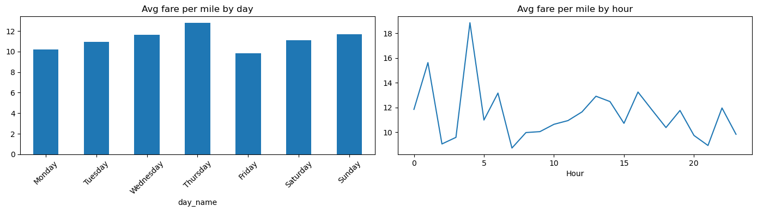
Figure 17: Average Fare per Mile by Day of Week (left) and Hour of Day (right) – early-morning spikes driven by airport runs
    - Analyse the average fare per mile for the different vendors
Vendor 2 (VeriFone) consistently charges more per mile than Vendor 1 (Creative Mobile Technologies), especially at early-morning and night hours. The gap is most pronounced for short trips. Both vendors converge on long-haul trips.
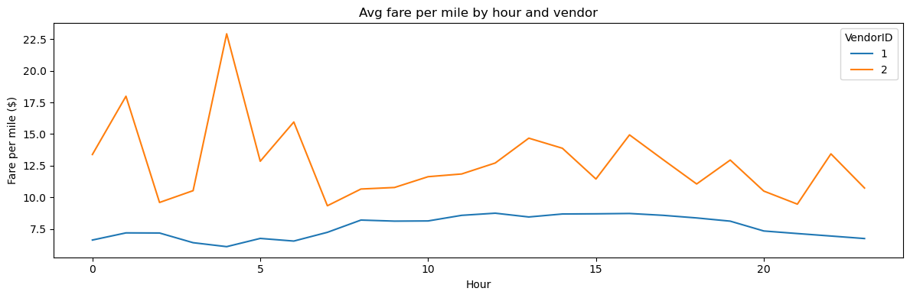
Figure 18: Average Fare per Mile by Hour – Vendor 1 vs Vendor 2 (Vendor 2 premium is largest at night and early morning)
    - Compare the fare rates of different vendors in a distance-tiered fashion

Table 17: Vendor Fare Comparison by Distance Tier
Distance Tier | Vendor 1 ($/mile) | Vendor 2 ($/mile) | V2 Premium (%) | Competitive Impact
Short (0–2 mi) | $9.76 | $17.80 | +82% | Major – most trips are short urban rides
Medium (2–5 mi) | $6.38 | $6.54 | +2.5% | Minimal – near parity
Long (5+ mi) | $4.41 | $4.50 | +2.0% | Minimal – near parity
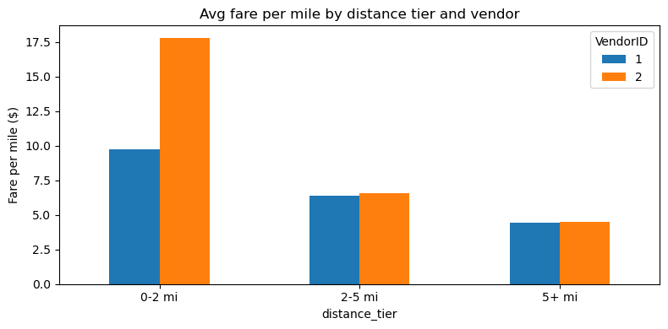
Figure 19: Average Fare per Mile by Distance Tier and Vendor – 82% Vendor 2 premium on short trips (0–2 mi)
    - Analyse the tip percentages
Analysis restricted to credit card payments (~67% of trips) as cash tips are unrecorded.

Table 18: Average Tip Percentage by Distance Category and Passenger Count
Category | Group | Avg Tip (%)
Distance: Short (0–2 mi) | — | 27.9%
Distance: Medium (2–5 mi) | — | 22.2%
Distance: Long (5+ mi) | — | 20.4%
Passenger Count: 1 | — | 25.2%
Passenger Count: 2 | — | 24.7%
Passenger Count: 3 | — | 24.3%
Passenger Count: 4 | — | 24.1%
Passenger Count: 5 | — | 25.3%
Passenger Count: 6 | — | 25.0%

Table 19: Low-Tip vs High-Tip Trip Comparison
Tip Segment | Avg Fare ($) | Avg Distance (mi) | Avg Pax
Low Tip (<10%) | $26.40 | 4.70 | 1.37
High Tip (>25%) | $14.42 | 2.29 | 1.36

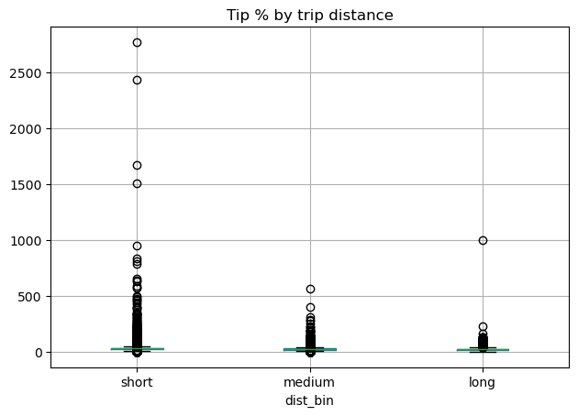
Figure 20: Tip % by Trip Distance Category – Short trips receive highest tip % (27.9%); long trips lowest (20.4%)

    - Analyse the trends in passenger count
Average passenger count is stable across hours (range 1.25–1.55), with a slight uptick at 1 AM and at 22–23 (group outings). Weekend days average marginally more passengers than weekdays.
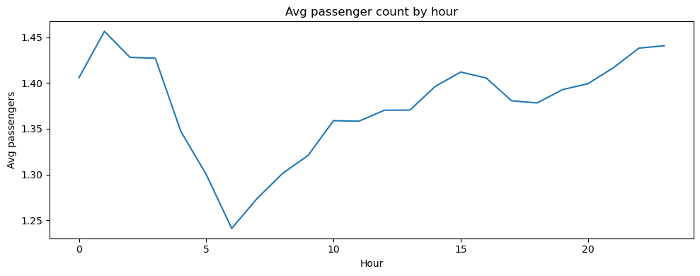
Figure 21: Average Passenger Count by Hour – Relatively stable ~1.3–1.5; slight uptick at 1 AM and late night
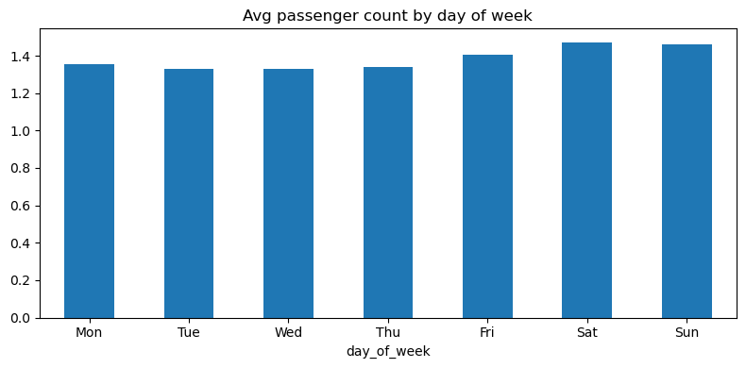
Figure 22: Average Passenger Count by Day of Week – Weekends (Sat/Sun) average slightly higher than weekdays
    - Analyse the variation of passenger counts across zones

Table 20: Top Zones by Average Passenger Count
LocationID | Avg Passenger Count | Interpretation
6 | 2.00 | Consistent group travel
67 | 2.00 | Group travel origin
154 | 2.00 | Group travel origin
175 | 1.83 | Above-average group travel
47 | 1.82 | Above-average group travel
1 (Newark Airport) | 1.67 | Airport – family/group arrivals
Note: Overall dataset average is ~1.4 passengers/trip, confirming dominance of solo urban travel. Zones averaging 2.0 are good candidates for shared-ride pricing promotion.

    - Analyse the pickup/dropoff zones or times when extra charges are applied more frequently

Table 21: Surcharge Application Frequency Across All Trips
Surcharge Column | Applied in (%) of Trips | Notes
improvement_surcharge | 100.0% | Mandatory on all metered rides ($0.30)
mta_tax | 99.1% | Near-universal ($0.50 MTA levy)
congestion_surcharge | 92.3% | Manhattan CBD trips ($2.50)
extra | 61.9% | Night (8 PM–6 AM: $1.00) and rush hour ($1.00)
tolls_amount | 8.1% | Bridge/tunnel trips only

Table 22: Extra Charge Application Rate by Time Period
Time Period | Hours | Extra Charge Applied (%)
Late Night | 0–2 AM | ~95–97%
Early Morning | 3–5 AM | ~90%
Morning Transition | 6 AM | ~32%
Daytime (midday) | 9 AM – 3 PM | ~30%
Evening Peak | 3–7 PM | ~31–33%
Evening/Night | 8–11 PM | ~40–70% (transitioning)

Conclusions

Final Insights and Recommendations
    - Recommendations to optimize routing and dispatching based on demand patterns and operational inefficiencies

Table 23: Routing and Dispatching Recommendations
Recommendation | Supporting Evidence | Expected Impact
Concentrate dispatch 15:00–19:00 in zones 132, 237, 161 | Top 3 pickup volumes; 18:00 busiest at 2.58M annual trips | Higher trip conversion; reduced wait times
Separate night fleet strategy for zones 79, 249, 48 from 22:30 | Zone 79 tops night pickups (2,192); differs from daytime top 10 | Better night coverage; reduced missed trips
Reduce idle positioning 2–5 AM outside key zones | Only ~1,400–2,000 sampled trips/hour at 2–5 AM | Lower driver idle costs; fuel savings
Day-type-aware dispatch algorithms | Weekday bimodal vs weekend late-peak are fundamentally different (Figure 14) | Fleet efficiency; improved SLA hit rates
Proactive congestion rerouting using slow-route data | Table 11: Routes with <0.1 mph identified per hour | Shorter trip durations; higher cab turnover

    - Suggestions on strategically positioning cabs across different zones to make best use of insights uncovered by analysing trip trends across time, days and months

Table 24: Zone Positioning Strategy Recommendations
Recommendation | Supporting Evidence | Expected Impact
Pre-position in zones 132, 138, 70 before peak hours | PU/DO ratios: 70=8.09, 132=4.71, 138=2.90 (Table 13) | Capture more trips at high-demand origins
Incentivise repositioning out of zones 227, 257 after dropoff | PU/DO ratio 0.028 and 0.036 – cabs accumulate with near-zero demand | Reduce idle time; redirect capacity to demand zones
Station night cabs in zones 79, 249, 48 from 22:30 | Night ranking: 79=2,192; 249=1,777; 48=1,441 (Table 14) | Reduce night wait times; grow 12.2% night revenue share
Zone 132 (JFK) 24/7 minimum availability | Appears in both day (13,591) and night (2,030) top-10 rankings | Serve consistent round-the-clock airport demand
Expand seasonal fleet for Q2 and Q4 | Q2 and Q4 combined = 53.5% of annual revenue (Table 7) | Avoid missed trips during revenue-peak months

    - Propose data-driven adjustments to the pricing strategy to maximize revenue while maintaining competitive rates with other vendors

Table 25: Pricing Strategy Recommendations
Recommendation | Supporting Evidence | Expected Impact
Dynamic surge pricing +10–15% during 15:00–19:00 | ~2.3–2.6M actual trips/hour during peak; inelastic commute demand | Material revenue uplift during highest-demand window
Review Vendor 2 short-trip rates ($17.80/mi vs $9.76/mi) | 82% premium on 0–2 mi trips (Table 17, Figure 19) | Reduce competitive disadvantage; increase short-trip volume
Night incentive fare +10% after 11 PM to attract drivers | Night only 12.2% revenue despite 29% of daily time (Table 15) | Grow night revenue share; better driver compensation
Formal shared-ride fare tier | Per-pax cost drops to $4.33 at 3 passengers (Table 16) | Attract group travel without revenue loss per trip
Promote credit card payments | 33% cash trips have no recorded tip; displaces tip revenue data | Increase tip capture; improve revenue analytics
Transparent surcharge communication pre-trip | Congestion surcharge 92.3%; improvement 100% of trips (Table 21) | Reduce disputes; improve customer satisfaction

