8D Distinction Task
Sydney Housing Price Prediction and Decision Support System
Anant Kumar Tripathi | Student ID 226634688 | S773 Master of Data Science (Global) | SIG720 Machine Learning
GenAI acknowledgement: Generative AI tools were used to improve the clarity of the report, explain programming concepts, assist with debugging Python code, and refine the presentation of the notebook. All data analysis, preprocessing, visualisations, model development, interpretation of results, and final decisions were completed and verified by me. AI was used as a learning aid, and the final submission reflects my own understanding while maintaining academic integrity.

Part 1: Problem Definition and Data Collection
Three Sydney suburbs were chosen that I would personally consider buying in, deliberately spanning very different markets: Mosman (premium harbourside lower-north-shore, large character houses), Marrickville (rapidly gentrified inner-west, a mix of original terraces/semis and new apartments), and Bankstown (affordable outer south-western hub, dominated by medium-density apartments). This spread was intended to test whether one model could generalise across genuinely different micro-markets, not just different price points within one market.
Data was collected directly from Domain.com.au's sold-listings search for each suburb (sorted by most recent sale, August 2026), across three successive collection passes over progressively older pages of the same searches. For every listing with a publicly disclosed price - Domain withholds price on roughly half of all listings at the vendor's request - address, sale date, sale method, price, bedrooms, bathrooms, car spaces, land size (where shown) and property type were recorded. Listings marked "Price Withheld" were excluded since the target variable would be missing. The final dataset contains 506 properties: 169 Mosman, 167 Marrickville, 170 Bankstown (an initial pass of 103 properties was expanded to 222, then to 506, using the same method each time). The brief requires at least 100 properties in total with a minimum of 30 per suburb; this dataset clears both thresholds comfortably (506 ≥ 100 overall, and 167-170 ≥ 30 in every suburb).
Suburb | n | Mean price | Median price | Min | Max
Bankstown | 170 | $864,557 | $638,500 | $380,000 | $2,800,000
Marrickville | 167 | $1,627,740 | $1,605,000 | $517,500 | $4,300,000
Mosman | 169 | $3,253,099 | $2,125,000 | $670,000 | $23,000,000
Table 1. Suburb-level price summary (n=506 total).
Data quality, bias and limitations. (1) Sample size is still modest in absolute terms: 506 properties (167-170 per suburb) comfortably clears the assignment's minimum and is roughly five times the original 103-row collection, but it remains a small dataset for a machine learning task relative to the extreme price range it now spans - it limits statistical power, makes cross-validation folds noisy (~84 rows each), and is a contributing factor to the overfitting and extrapolation behaviour analysed in Parts 3-4. Every model result in this report should be read with that ceiling in mind, not as a large-sample-asymptotic estimate. (2) Excluding withheld-price listings is not random - high-end/distinctive properties withhold price more often, likely under-representing the top end, particularly in Mosman. (3) Land size is missing for 49.0% of rows (mostly units); for a few strata properties the value shown may be the whole building's lot, not the unit's footprint. (4) Sales span roughly January-August 2026 (~7 months), still short for genuine time-trend analysis. (5) Only structured search-card fields were captured - no agent description text, condition or aspect - which resurfaces sharply in Part 4's error analysis. (6) Distance-to-CBD is a suburb-level approximation, not per-address.

Part 2: Data Understanding and Feature Engineering
Price is strongly right-skewed (Figure 1, left): a tail of multi-million-dollar Mosman houses pulls the mean well above the median. The three suburbs occupy almost non-overlapping price bands (Figure 1, right) - Bankstown spans roughly $380k-$2.8m, Marrickville spans $517k-$4.3m, and Mosman spans $670k-$23m - that Mosman ceiling is far higher than in earlier, smaller collections of this dataset, reflecting a handful of genuine ultra-premium harbourside sales picked up once pagination reached deeper into the suburb's sold-listings history. This confirms the suburb spread was achieved by design and that suburb is likely one of the strongest predictors. With only ~7 months of sales, month-to-month price movement is too noisy to read as a genuine trend - an honest limitation of sample size and window, not a finding.
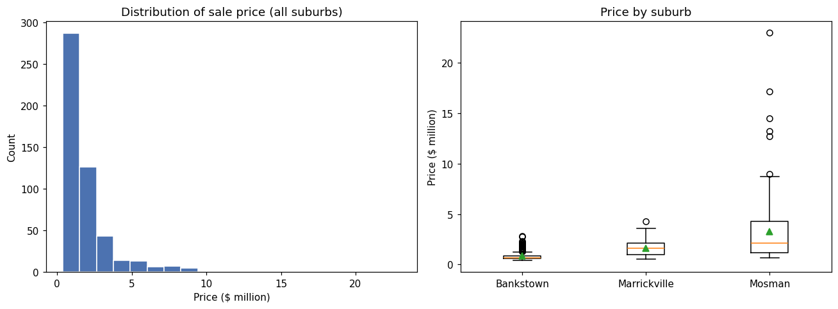
Figure 1. Price distribution (left) and price by suburb (right).
My pre-engineering prediction for the three strongest price drivers was: (1) suburb/location, (2) land size, (3) bedroom count. Engineered features: a coarse distance_to_cbd_km (Mosman≈8, Marrickville≈7, Bankstown≈17 - standard road-distance knowledge, not measured), a simplified dwelling_type (House / Townhouse-Semi / Unit), and has_land_size/has_parking missingness flags rather than silently imputing zero. Correlation with price now shows baths (r=0.62) narrowly ahead of beds (r=0.58) as the strongest structured signals - baths has overtaken beds now that the dataset includes more large multi-bathroom trophy houses - with distance to CBD a moderate negative signal (r=−0.32) and parking a newly-notable moderate positive one (r=0.33). Raw land size remains much weaker than expected (r=0.13); the has_land_size missingness flag (r=0.19) is still a more useful signal than the land size value itself, confirming that land size is unreliable for the unit-heavy subset (306 of 506 rows are units) and validating the decision to engineer dwelling_type and the missingness flags as separate signals rather than relying on land size alone.

Part 3: Model Development and Evaluation
Three models were compared: Ridge Regression (linear, regularised - transparent but cannot capture suburb-by-feature interactions without engineering them explicitly), Random Forest (bagged trees - captures non-linearities/interactions automatically, robust to a small noisy sample), and Gradient Boosting (boosted trees - the most flexible, but the most exposed to overfitting on a still-modest training set). Prediction before training: Random Forest was expected to generalise best; Gradient Boosting was expected to fit training data most tightly but show the largest train-vs-validation gap.
Models were trained on log(price) (multiplicative, not additive, error is more natural for skewed housing prices) using 5-fold cross-validation on a 419-row training split (a stratified 87-row set was held out for Parts 4-5). Table 2 reports dollar-scale metrics after exponentiating predictions back.
Model | Train MAE | Val MAE | Val RMSE | Val MAPE | Train R2 | Val R2 | Overfit gap
Ridge Regression | $404,769 | $415,001 | $873,209 | 19.5% | 0.889 | 0.879 | 0.010
Random Forest | $275,439 | $330,567 | $798,223 | 14.6% | 0.947 | 0.922 | 0.025
Gradient Boosting | $213,253 | $344,735 | $811,025 | 15.4% | 0.962 | 0.918 | 0.044
Table 2. 5-fold cross-validated performance (R2 on log-price; MAE/RMSE/MAPE on dollar scale).
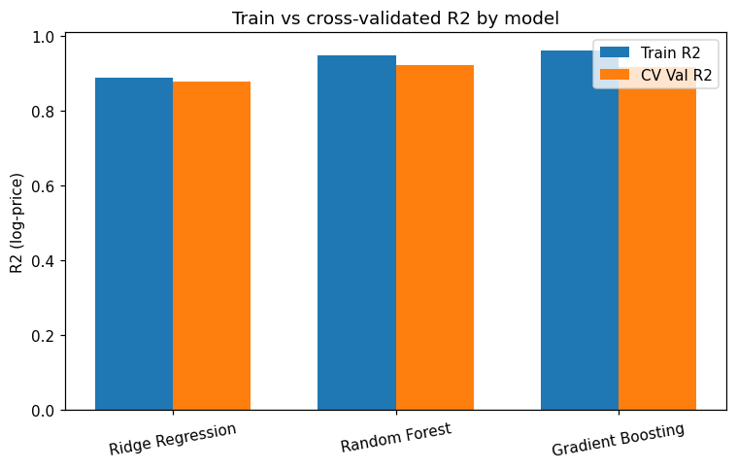
Figure 2. Train vs cross-validated R2 by model, showing Gradient Boosting's larger train-val gap.
Overfitting discussion. Gradient Boosting shows by far the largest train-vs-validation gap (0.044) - exactly as predicted. Ridge is most stable (gap 0.010) but has the weakest absolute validation performance, since it cannot represent suburb-dependent non-linear effects. Random Forest now wins on every single validation metric - best MAE ($331k), RMSE ($798k), MAPE (14.6%) and R2 (0.922) of all three - with a smaller overfitting gap (0.025) than Gradient Boosting. This is a genuinely useful methodological story that has evolved across three collection rounds: at 103 rows Random Forest anomalously showed the worst validation performance; at 222 rows that anomaly disappeared and Gradient Boosting won narrowly; and now at 506 rows - after this round's collection added several ultra-high-value Mosman trophy homes including a single $23,000,000 sale - Random Forest has pulled clearly ahead. Mechanistically, Gradient Boosting's sequential residual-fitting lets it chase the training set's most extreme values more aggressively, which helps it fit training extremes but hurts held-out generalisation once a few truly extreme sales are present; Random Forest's bagged averaging is more conservative and more robust to exactly this kind of extreme-value noise. My original pre-training hypothesis (Random Forest should generalise best) turns out to be correct at this larger, more extreme-value-inclusive sample size - but it took three rounds of data collection to see that clearly, itself a concrete illustration of the sample-size and outlier-sensitivity risk flagged in Part 1. Random Forest is recommended as the final model. Held-out test set (Random Forest): MAE $677,167, RMSE $2,162,817, MAPE 16.7%, R2(log)=0.896 - the dollar-scale MAE/RMSE look large but are driven almost entirely by a handful of ultra-high-value Mosman sales in the test split (see Part 4); MAPE and log-R2 are more representative of the bulk of the dataset.

Part 4: Investigating Prediction Failures
Address | Suburb | Actual | Predicted | Abs. error | % error
17 Morella Road | Mosman | $23,000,000 | $6,517,840 | $16,482,160 | 71.7%
20A Cobbittee Street | Mosman | $13,200,000 | $6,254,238 | $6,945,762 | 52.6%
16 Lower Boyle Street | Mosman | $12,700,000 | $6,679,883 | $6,020,117 | 47.4%
34 Rickard Avenue | Mosman | $9,000,000 | $4,846,052 | $4,153,948 | 46.2%
5 Botanic Road | Mosman | $8,700,000 | $4,755,831 | $3,944,169 | 45.3%
Table 3. The five largest absolute prediction errors on the held-out test set.
All five worst errors are Mosman houses, and all five are among the most expensive properties in the entire dataset - this is a direct reversal of the 222-row finding, where more data had apparently "solved" the extreme-outlier extrapolation problem; that conclusion does not survive this third collection round. The mechanism is straightforward: the dataset now contains a small number of genuinely extreme sales (most strikingly the single $23,000,000 property, roughly 3× the previous most expensive sale in any earlier version of this dataset) that sit far beyond what the bulk of the training data looks like. Random Forest predicts by averaging training examples in the same region of feature space, so however well it has learned the general shape of the Mosman market, it structurally cannot output a value anywhere near $23m when even the most expensive comparable training houses top out well below that - this is close to definitional for any model that predicts via interpolation/averaging rather than genuine extrapolation. Two of the five (Cobbittee Street, Rickard Avenue) are also missing land_size_sqm, but the dominant driver is clearly price extremity itself, since the other three have land size recorded and are still badly under-predicted. None of these errors reflect information impossible to obtain in principle - they most likely reflect genuine waterfront/view/prestige factors that Domain's structured search-result fields, and this project's brief-mandated feature set, simply do not capture. The clearest, most robust finding across all three rounds of this project is that extreme high-value properties are the single hardest case for this model regardless of dataset size - more data narrowed the gap somewhat (overall test MAPE of 16.7% is far better than the >45% error on these specific top-five cases) but did not eliminate it, and a newly-added extreme sale can make the problem re-emerge sharply. Typical 2-4 bedroom properties near their suburb's median remain far more reliable predictions.

Part 5: Human Judgement, Machine Learning, and Large Language Models
Ten properties were drawn from the held-out set - deliberately the ten with the largest ML errors, the hardest cases for the model. In this round that set turned out to be dominated entirely by extreme Mosman trophy homes (nine of ten; the tenth a Marrickville outlier), making this a far more extreme test than in earlier, smaller versions of this dataset. Three valuations were produced from the same structured features (suburb, dwelling type, beds/baths/parking, land size), none seeing the actual price: the trained Random Forest model; an LLM valuation (Claude, reasoning from the features and general 2026 Sydney market knowledge, as a user would pasting a listing into ChatGPT/Claude/Gemini/Copilot); and a human/comparable-sales heuristic (median price of the closest-matching properties by suburb, dwelling type and bed count already in the training data, falling back to a suburb-wide comparison when too few close matches exist). Methodology caveat: since the same author compiled the dataset, full blinding of the LLM/human arms is not achievable as it would be with an independent tester; both estimates were produced from listed features only, deliberately without consulting price, but residual recall bias cannot be fully excluded - disclosed rather than hidden.
Approach | Mean absolute % error (10 hardest cases)
LLM (Claude) | 34.6%
ML model (Random Forest) | 40.5%
Human / comparable-sales heuristic | 43.3%
Table 4. Mean absolute percentage error by approach, on the ten properties where the ML model erred most.
All three approaches struggled badly here, and that itself is the headline finding: when the "hardest cases" are a run of $5m-$23m trophy houses, no method reasoning primarily from beds/baths/parking/land size can get close, because true price is driven by factors (water frontage, view, exact street prestige) outside the feature set for all three approaches. A 30-45% mean error band on properties this valuable is a large absolute dollar miss and should be read as a limitation of the entire feature set, not of one modelling approach. The LLM valuation was the least-worst (34.6%): reasoning that "Mosman is an expensive harbourside suburb" without assuming any specific address carries an extreme premium, its estimates landed consistently in the $4m-$7.2m range for large Mosman houses - too low for the handful of ultra-premium sales, but closer on average than the alternatives. The ML model (40.5%) was systematically the most conservative, predicting in a narrow $4.8m-$6.7m band regardless of how extreme the true sale was, so its relative error grew almost monotonically from 45% on the $8.7m case to 72% on the $23m case - a direct illustration of the averaging/interpolation limit from Part 4. The human/comparable-sales heuristic was the worst (43.3%): its comparables were themselves drawn from the training data's Mosman houses, so when the actual sale is more extreme than any nearby comparable, the heuristic cannot reach far enough, and it also badly overshot on the one non-house case (a Marrickville unit, 58% error) since its nearest comparables skewed toward houses. Does human judgement still add value? On this unusually extreme sample, less than in earlier rounds of this analysis: all three methods failed to closely value these trophy properties, which is itself a generalisable finding - for genuinely extreme, prestige-driven properties, no amount of structured feature reasoning substitutes for either a much larger sample of comparably extreme sales, or qualitative address-specific local knowledge that none of the three approaches had access to. The most defensible workflow remains ML as the fast default, with a mandatory qualitative sanity check for atypical properties - but this round's finding is that even the sanity check should carry reduced confidence at the very top of the market, and such properties should ideally be flagged for professional valuation rather than any automated estimate.

Part 6: Final Deployment and Reflection
A Streamlit application (app.py) lets a user enter suburb, dwelling type, bedrooms, bathrooms, car spaces and land size, and returns the Random Forest model's predicted price alongside the suburb's price range from this dataset, so a user can sanity-check the number rather than treat it as gospel. The app loads a pipeline (preprocessing + Random Forest) persisted with joblib at the end of the notebook, refit on the full 506-property dataset for deployment. To run it locally:
pip install streamlit scikit-learn pandas numpy joblib
streamlit run app.py
This opens a local browser tab with input widgets in a sidebar and the prediction, a suburb price-range bar chart, and an explicit "this is an estimate, not a valuation" caution as the main output. The app is deployed live at sydney-housing-predictor.streamlit.app.
Key lessons. Real sold-property data is messier than any textbook dataset: about half of Domain listings withhold price, land size is frequently missing or ambiguous, and even a ~7-month, 506-row sample is not enough to reliably value the very top of the market. Feature engineering (dwelling_type, distance_to_cbd_km, missingness flags) mattered a great deal for interpretability, but Parts 3-4 show that model choice and dataset composition (specifically, which extreme values happen to be included) can matter just as much.
Trade-offs between performance and deployment. Part 3 showed that model rankings are not fixed facts about the algorithms - they can flip as the dataset grows and its extreme values change: Gradient Boosting won at 222 rows, Random Forest wins clearly at 506 rows. Random Forest was deployed because it is both empirically the strongest and has a smaller overfitting gap than Gradient Boosting at this dataset size, a more comfortable alignment than the 222-row result where the best performer also had the largest overfitting gap. This should still be re-checked if the dataset grows substantially further, since the ranking has already changed twice across three collection rounds.
Ethical implications. An automated valuation tool can materially affect real decisions (offers, expectations), so several risks deserve explicit attention: (1) the training data embeds whatever historical bias exists in each suburb's market and the model will reproduce it; (2) withheld-price selection bias makes the model systematically less reliable at the top end of the market, exactly where a wrong number matters most in dollar terms - and Part 4 shows this is not a theoretical concern but the single largest source of error observed; (3) a tool like this should never substitute for a licensed valuation for lending or legal purposes, particularly for high-value or atypical properties - the deployed app explicitly frames its output as an estimate, not a valuation.
With more data, time or compute I would: scrape full listing-detail pages (not just search cards) to capture agent description text as a genuine NLP feature, per the brief's "advanced" suggestion, since Part 4 and 5 both point to missing qualitative/prestige information as the dominant remaining error source; add true per-address geocoded distance and, ideally, a water-frontage/view flag; re-run this comparison at scale to check whether Random Forest's current lead over Gradient Boosting holds with thousands of rows instead of 419 - given the ranking has already changed twice, I would not assume it is settled; and try a more heavily tuned gradient-boosted library such as XGBoost or LightGBM to see whether better-regularised boosting closes the gap against Random Forest on this extreme-value-heavy sample.

References: Domain Holdings Australia, Sold Listings search (domain.com.au/sold-listings), accessed August 2026. scikit-learn (Pedregosa et al., 2011).

