ASSIGNMENT 1

1. 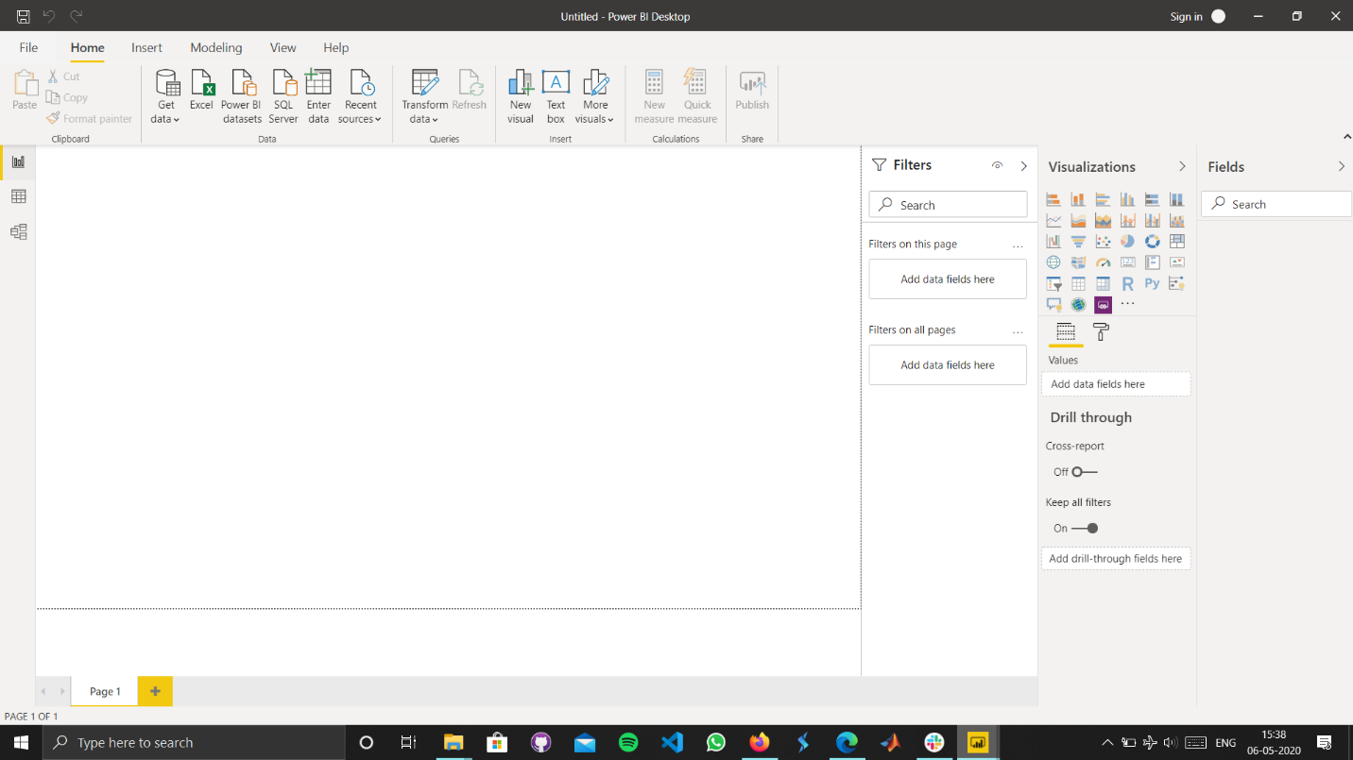Report View
2. 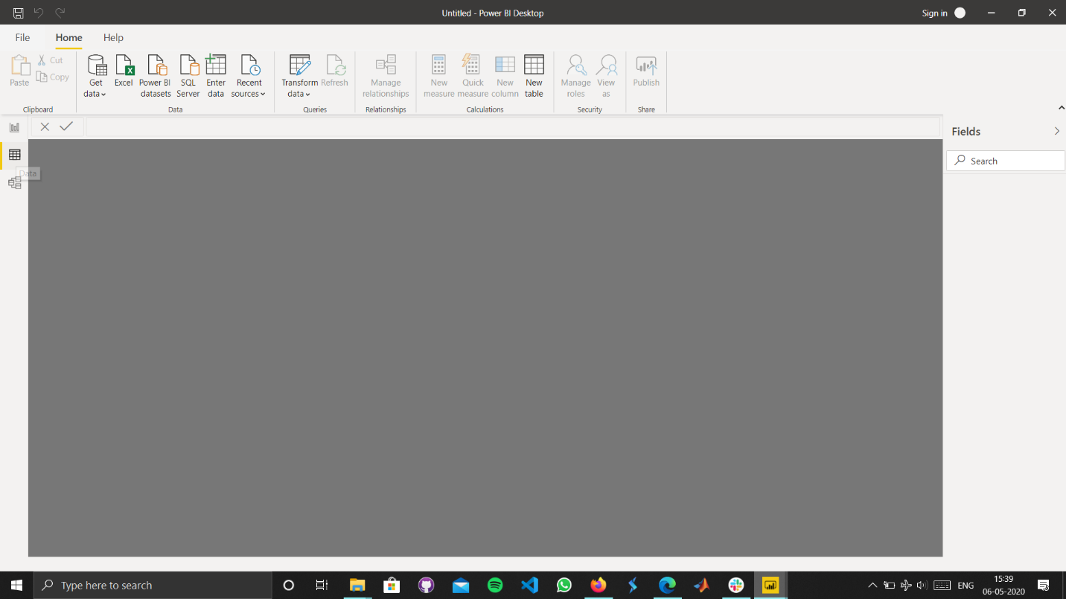Data View
3. 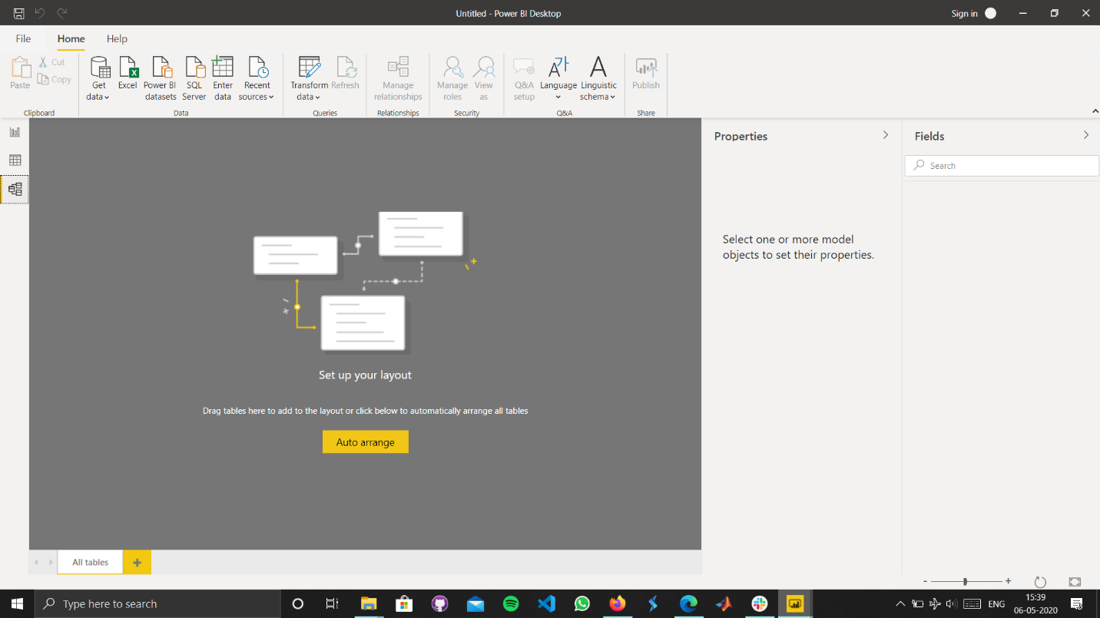Model View
4. 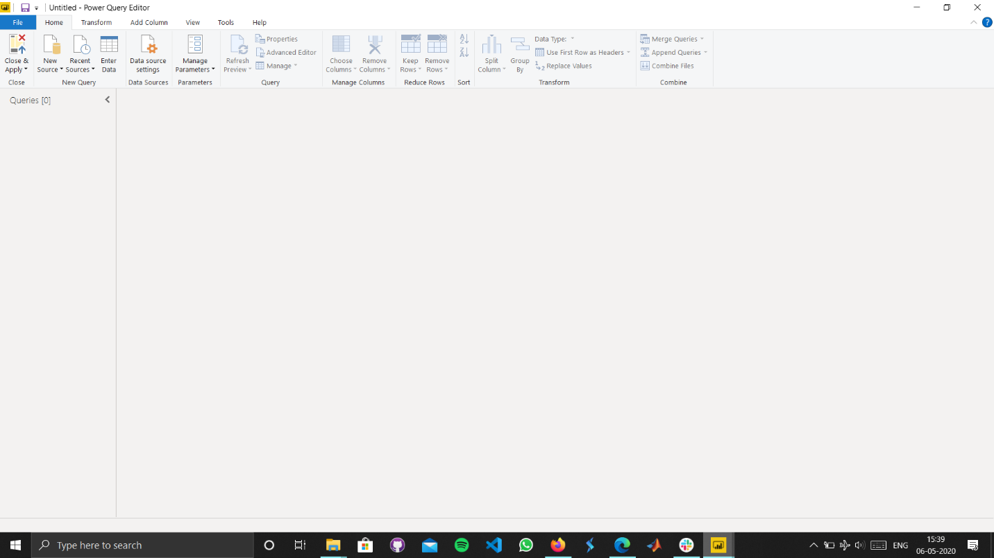Power Query Editor
5. 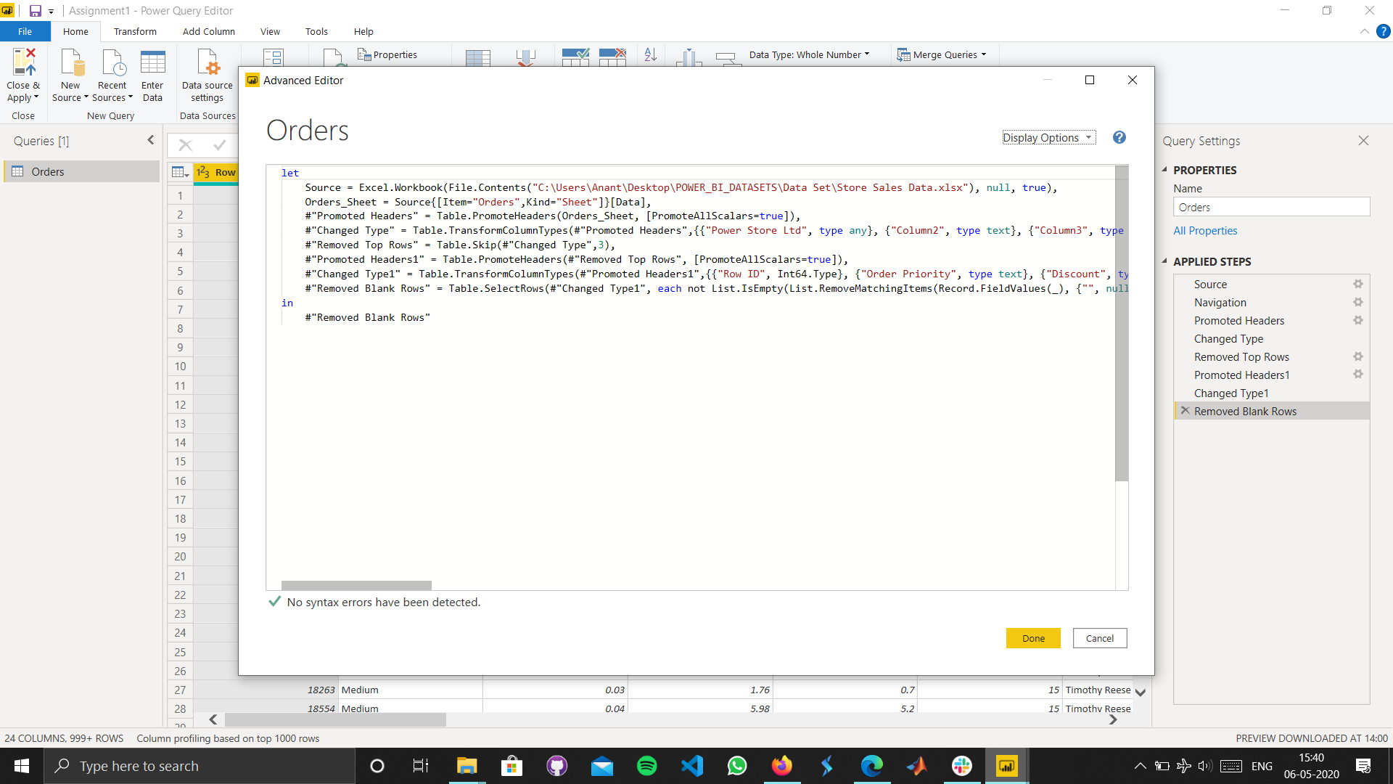Advanced Editor

Details and Price of Power BI Software

**Power BI** is a business analytics service by **Microsoft**. It aims to provide interactive visualizations and **business intelligence** capabilities with an interface simple enough for end users to create their own reports and dashboards.

1. Power BI Desktop :

We use the free Power BI Desktop tool to author reports and prepare, model, and create data visualizations.

1. Power BI Pro

We can collaborate with colleagues, model data, author content, share dashboards, publish reports, and perform ad-hoc analysis with a Power BI Pro license that costs Rs. 660/- per month per user.

1. Power BI Premium

We can read and interact with pre-published dashboards and reports with either a per-user Power BI Pro license or a Power BI Premium license for large-scale databases that costs Rs. 3,30,190 /- per month per dedicated cloud compute and storage resource with annual subscription.