**1. E. Coli**

|  |  |  |  |  |  |  |
| --- | --- | --- | --- | --- | --- | --- |
| Name of Model | Missing | | Missing_Penta | | Missing_Hexa | |
| RSS/ESS | Constant | RSS/ESS | Constant | RSS/ESS | Constant |
| S | 4.679 | 4.353 | 7.443 | 1.624 | 3.713 | 1.487 |
| Growth | 5.483 | 2.284 | 5.204 | 3.845 | 4.534 | 3.377 |
| Logistic | 5.483 | 0.102 | 5.204 | 0.021 | 4.534 | 0.034 |
| Cubic | 32.395 | 2.144 | 8177.934 | 116.001 | 5588.456 | 75.464 |
| Quadratic | 32.724 | 1.920 | 12967.818 | 89.810 | 7849.155 | 57.471 |
| Linear | 124.223 | -1.012 | 18439.859 | 67.574 | 9971.285 | 43.624 |
| Logarithmic | 23011.967 | -324.96 | 6714.480 | 292.064 | 4660.690 | 191.732 |
| Inverse | 57128.434 | 112.68 | 27.092 | 0.906 | 180.731 | -1.542 |

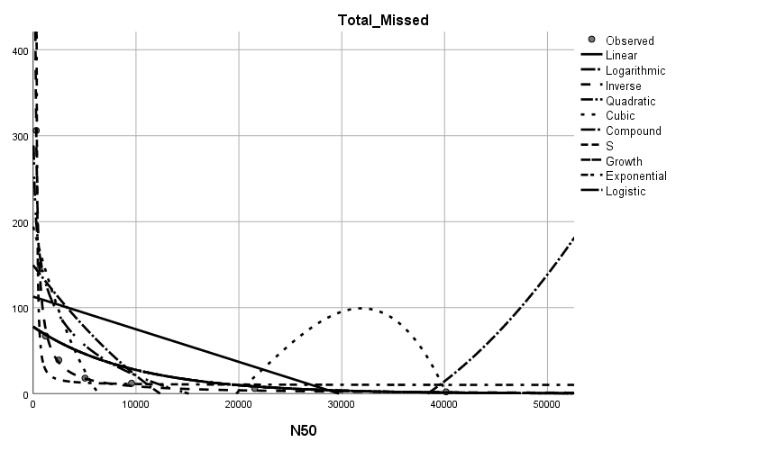

**2. B. Subtilis**

|  |  |  |  |  |  |  |
| --- | --- | --- | --- | --- | --- | --- |
| Name of Model | Missing | | Missing_Penta | | Missing_Hexa | |
| RSS/ESS | Constant | RSS/ESS | Constant | RSS/ESS | Constant |
| S | 10.949 | 2.004 | 11.416 | 1.450 | 35.798 | 0.562 |
| Growth | 14.494 | 3.892 | 12.475 | 3.449 | 41.755 | 2.674 |
| Logistic | 14.494 | 0.020 | 12.475 | 0.032 | 41.755 | 0.069 |
| Cubic | 29580.167 | 163.870 | 9341.084 | 101.074 | 5371.602 | 59.558 |
| Quadratic | 42726.978 | 129.089 | 14411.741 | 79.473 | 7067.077 | 47.067 |
| Linear | 58457.574 | 97.139 | 20336.026 | 59.866 | 9178.061 | 35.363 |
| Logarithmic | 21236.971 | 427.433 | 6609.342 | 261.563 | 4011.063 | 157.339 |
| Inverse | 203.623 | 4.249 | 456.370 | 4.019 | 106.050 | 0.216 |

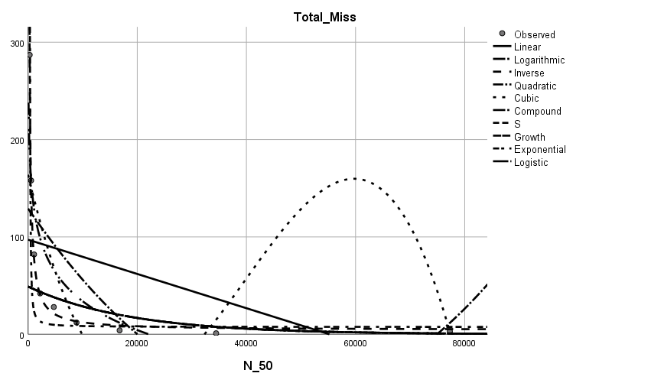

**3. C. Botulin**

|  |  |  |  |  |  |  |
| --- | --- | --- | --- | --- | --- | --- |
| Name of Model | Missing | | Missing_Penta | | Missing_Hexa | |
| RSS/ESS | Constant | RSS/ESS | Constant | RSS/ESS | Constant |
| S | 8.546 | 2.700 | 10.711 | 2.011 | 7.154 | 1.896 |
| Growth | 8.089 | 4.716 | 8.223 | 4.189 | 8.517 | 3.733 |
| Logistic | 8.089 | 0.009 | 8.223 | 0.015 | 8.517 | 0.024 |
| Cubic | 121773.245 | 306.851 | 42210.821 | 182.919 | 16433.103 | 113.313 |
| Quadratic | 167444.253 | 244.795 | 58911.286 | 145.394 | 22336.284 | 91.003 |
| Linear | 216056.970 | 190.489 | 76336.796 | 112.880 | 28837.012 | 71.144 |
| Logarithmic | 84531.883 | 822.061 | 29379.528 | 490.086 | 11290.889 | 302.403 |
| Inverse | 236.625 | 4.924 | 159.906 | 2.417 | 162.479 | 3.127 |

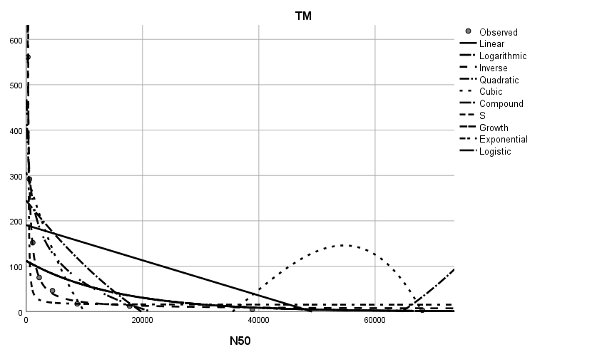

**4. S. Aureus**

|  |  |  |  |  |  |  |
| --- | --- | --- | --- | --- | --- | --- |
| Name of Model | Missing | | Missing_Penta | | Missing_Hexa | |
| RSS/ESS | Constant | RSS/ESS | Constant | RSS/ESS | Constant |
| S | 8.335 | 2.331 | 44.092 | 0.821 | 5.711 | 1.673 |
| Growth | 9.874 | 4.332 | 36.596 | 3.625 | 10.230 | 3.440 |
| Logistic | 9.874 | 0.013 | 36.596 | 0.027 | 10.230 | 0.032 |
| Cubic | 67368.519 | 224.151 | 20710.865 | 123.356 | 12315.175 | 96.065 |
| Quadratic | 90751.857 | 179.429 | 27558.624 | 99.155 | 16769.424 | 76.547 |
| Linear | 117139.735 | 139.545 | 35685.220 | 77.022 | 21496.591 | 59.666 |
| Logarithmic | 47189.546 | 581.214 | 14447.043 | 321.151 | 8734.212 | 247.649 |
| Inverse | 663.274 | 2.537 | 398.251 | 1.136 | 125.831 | 1.445 |

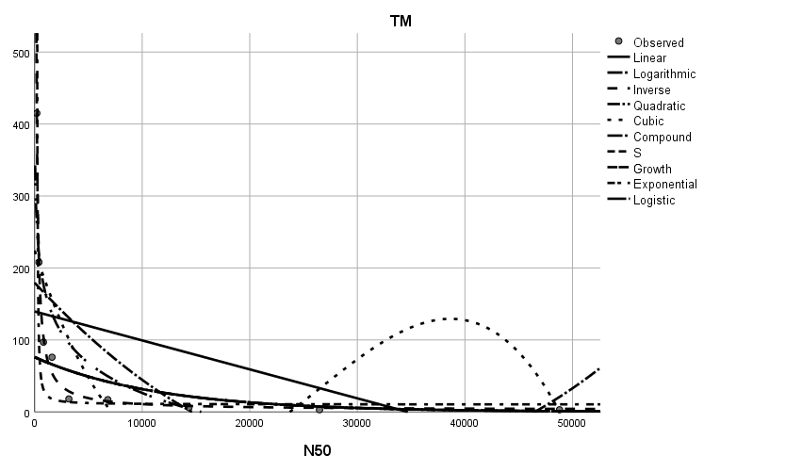

**5. S. Anterica**

|  |  |  |  |  |  |  |
| --- | --- | --- | --- | --- | --- | --- |
| Name of Model | Missing | | Missing_Penta | | Missing_Hexa | |
| RSS/ESS | Constant | RSS/ESS | Constant | RSS/ESS | Constant |
| S | 9.833 | 1.964 | 40.599 | 0.827 | 7.343 | 1.003 |
| Growth | 13.402 | 3.861 | 43.959 | 3.167 | 11.264 | 2.802 |
| Logistic | 13.402 | .021 | 43.959 | 0.042 | 11.264 | 0.061 |
| Cubic | 30956.480 | 155.454 | 10798.524 | 96.081 | 3973.957 | 52.512 |
| Quadratic | 42791.725 | 122.691 | 15276.049 | 75.929 | 5332.635 | 41.411 |
| Linear | 56437.236 | 93.628 | 20526.848 | 57.900 | 6861.378 | 31.683 |
| Logarithmic | 22061.986 | 420.634 | 7562.823 | 259.062 | 2894.899 | 142.547 |
| Inverse | 92.501 | 2.260 | 159.541 | 2.249 | 26.555 | 0.331 |

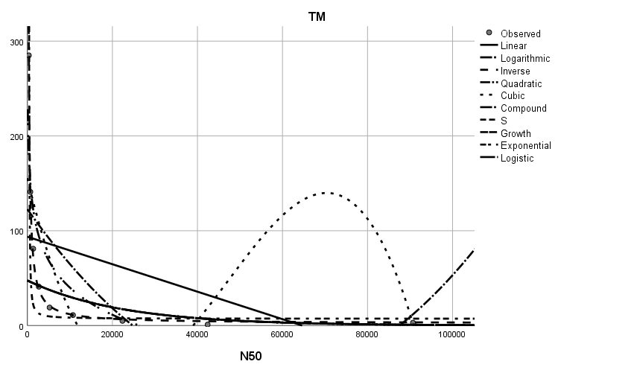

|  |  |  |  |  |  |  |
| --- | --- | --- | --- | --- | --- | --- |
| Name of Model | Missing | | Missing_Penta | | Missing_Hexa | |
| RSS/ESS | Constant | RSS/ESS | Constant | RSS/ESS | Constant |
| S | 9.889 | 2.310 | 40.171 | 0.663 | 6.871 | 1.876 |
| Growth | 7.241 | 4.492 | 10.871 | 3.918 | 6.166 | 3.813 |
| Logistic | 7.241 | 0.011 | 10.871 | 0.020 | 6.166 | 0.022 |
| Cubic | 100239.090 | 243.595 | 25998.451 | 121.553 | 20313.233 | 115.577 |
| Quadratic | 130365.753 | 192.535 | 33888.933 | 95.422 | 26753.077 | 91.970 |
| Linear | 160434.552 | 149.735 | 41612.607 | 73.730 | 33281.890 | 72.026 |
| Logarithmic | 73423.187 | 698.611 | 19289.207 | 350.593 | 14531.450 | 328.304 |
| Inverse | 1256.267 | -4.732 | 380.887 | -4.142 | 102.298 | 0.232 |

**6. P. Aeruginosa**

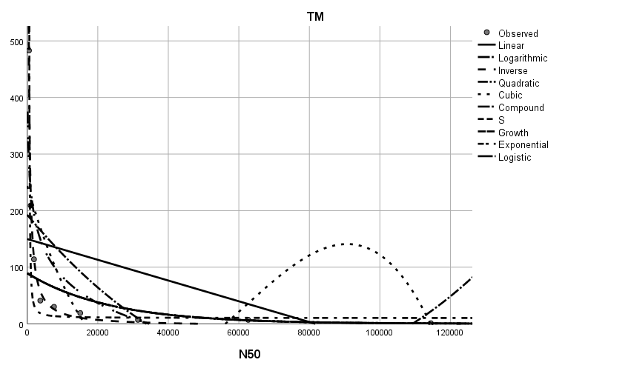

**7. S. Cerevisiae**

|  |  |  |  |  |  |  |
| --- | --- | --- | --- | --- | --- | --- |
| Name of Model | Missing | | Missing_Penta | | Missing_Hexa | |
| RSS/ESS | Constant | RSS/ESS | Constant | RSS/ESS | Constant |
| S | 9.946 | 5.009 | 8.769 | 4.418 | 12.427 | 3.763 |
| Growth | 8.851 | 7.081 | 9.434 | 6.415 | 8.481 | 5.977 |
| Logistic | 8.851 | 0.001 | 9.434 | 0.002 | 8.481 | 0.003 |
| Cubic | 12627809.924 | 3347.680 | 3583709.926 | 1785.372 | 1307772.675 | 1072.143 |
| Quadratic | 17967715.643 | 2655.516 | 5120968.338 | 1413.994 | 1851705.981 | 851.234 |
| Linear | 23984425.255 | 2040.153 | 6839680.204 | 1085.102 | 2467475.443 | 654.372 |
| Logarithmic | 8789527.967 | 7432.824 | 2506635.625 | 3960.655 | 905090.486 | 2385.043 |
| Inverse | 83172.842 | 73.106 | 30875.887 | 37.970 | 9043.074 | 22.518 |



**8. C. Auris**

|  |  |  |  |  |  |  |
| --- | --- | --- | --- | --- | --- | --- |
| Name of Model | Missing | | Missing_Penta | | Missing_Hexa | |
| RSS/ESS | Constant | RSS/ESS | Constant | RSS/ESS | Constant |
| S | 8.880 | 4.029 | 9.056 | 3.399 | 9.418 | 2.971 |
| Growth | 9.417 | 6.026 | 10.811 | 5.382 | 7.973 | 4.996 |
| Logistic | 9.417 | 0.002 | 10.811 | 0.005 | 7.973 | 0.007 |
| Cubic | 1691931.909 | 1233.734 | 521956.219 | 678.420 | 174185.487 | 410.808 |
| Quadratic | 2437491.736 | 972.106 | 747262.831 | 534.596 | 256085.154 | 324.095 |
| Linear | 3270013.806 | 740.739 | 1002056.845 | 406.599 | 346708.592 | 247.760 |
| Logarithmic | 1195093.550 | 3000.443 | 372242.896 | 1650.522 | 121171.636 | 995.172 |
| Inverse | 13219.316 | 25.147 | 2662.396 | 11.864 | 3717.789 | 12.287 |

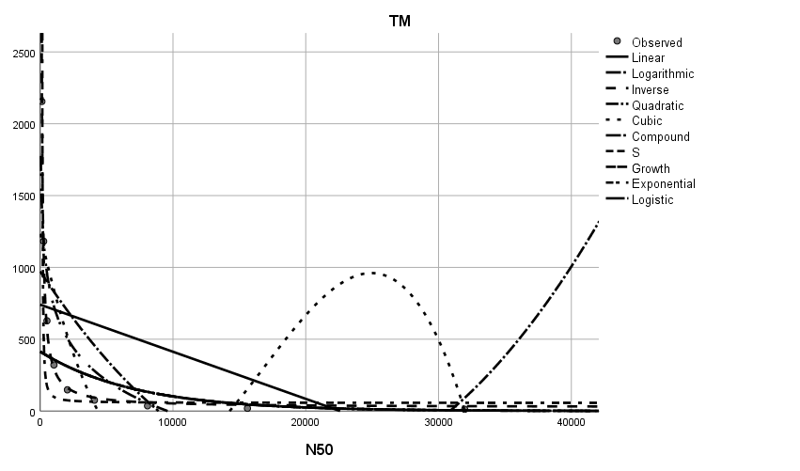

**9. A. Vaga**

|  |  |  |  |  |  |  |
| --- | --- | --- | --- | --- | --- | --- |
| Name of Model | Missing | | Missing_Penta | | Missing_Hexa | |
| RSS/ESS | Constant | RSS/ESS | Constant | RSS/ESS | Constant |
| S | 8.880 | 4.029 | 10.128 | 3.933 | 9.390 | 3.389 |
| Growth | 9.417 | 6.026 | 8.382 | 6.072 | 8.505 | 5.475 |
| Logistic | 9.417 | 0.002 | 8.382 | 0.002 | 8.505 | 0.004 |
| Cubic | 1691931.909 | 1233.734 | 2232320.101 | 1266.198 | 668683.153 | 701.619 |
| Quadratic | 2437491.736 | 972.106 | 3039348.113 | 995.669 | 921250.024 | 550.278 |
| Linear | 3270013.806 | 740.739 | 3910222.767 | 760.463 | 1185335.063 | 420.756 |
| Logarithmic | 1195093.550 | 3000.443 | 1615385.927 | 3858.900 | 481640.030 | 2134.819 |
| Inverse | 13219.316 | 25.147 | 11349.815 | -2.167 | 839.083 | 0.259 |

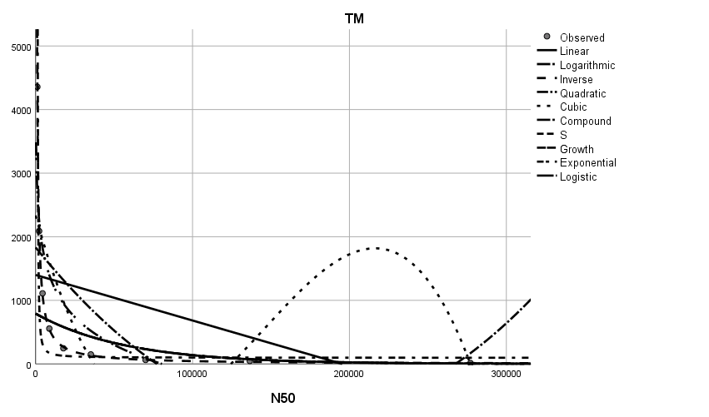

**10. A. Thaliana**

|  |  |  |  |  |  |  |
| --- | --- | --- | --- | --- | --- | --- |
| Name of Model | Missing | | Missing_Penta | | Missing_Hexa | |
| RSS/ESS | Constant | RSS/ESS | Constant | RSS/ESS | Constant |
| S | 17.973 | 3.956 | 13.745 | 3.408 | 59.630 | 2.106 |
| Growth | 6.278 | 6.484 | 7.223 | 5.759 | 6.559 | 5.661 |
| Logistic | 6.278 | 0.002 | 7.223 | 0.003 | 6.559 | 0.003 |
| Cubic | 3693018.165 | 1631.492 | 993315.306 | 850.206 | 324175.919 | 495.875 |
| Quadratic | 5008378.475 | 1292.099 | 1355708.477 | 672.062 | 443882.102 | 393.489 |
| Linear | 6423312.631 | 993.952 | 1740093.952 | 516.663 | 574016.285 | 303.070 |
| Logarithmic | 2623379.604 | 5201.593 | 706889.914 | 2708.163 | 228309.591 | 1576.021 |
| Inverse | 3693.253 | 0.048 | 741.074 | -.064 | 377.411 | 3.117 |

`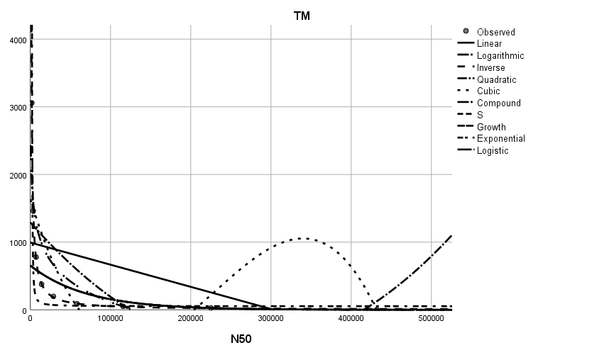

**11. C. Elegans**

|  |  |  |  |  |  |  |
| --- | --- | --- | --- | --- | --- | --- |
| Name of Model | Missing | | Missing_Penta | | Missing_Hexa | |
| RSS/ESS | Constant | RSS/ESS | Constant | RSS/ESS | Constant |
| S | 8.492 | 4.324 | 10.103 | 3.463 | 7.923 | 3.178 |
| Growth | 9.794 | 6.359 | 10.257 | 5.617 | 10.071 | 5.160 |
| Logistic | 9.794 | 0.002 | 10.257 | 0.004 | 10.071 | 0.006 |
| Cubic | 4297295.862 | 1797.314 | 1019267.078 | 871.025 | 380309.109 | 548.257 |
| Quadratic | 5905025.694 | 1416.226 | 1401010.356 | 685.328 | 530087.200 | 431.940 |
| Linear | 7685110.283 | 1078.760 | 1822320.349 | 521.152 | 695560.694 | 329.050 |
| Logarithmic | 3077791.339 | 5466.154 | 732327.199 | 2654.182 | 271530.272 | 1661.201 |
| Inverse | 4538.024 | 1.492 | 303.383 | -2.779 | 2052.654 | 3.367 |

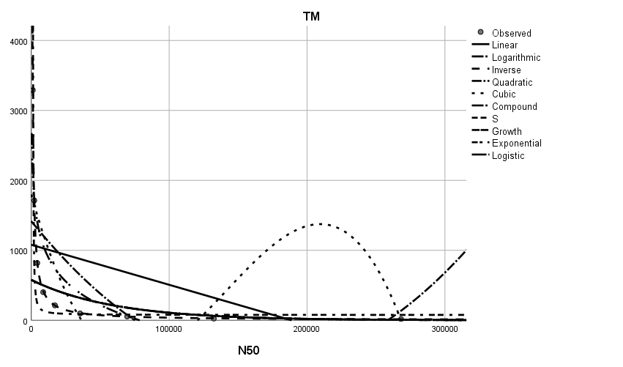

**12. O. Latipes**

|  |  |  |  |  |  |  |
| --- | --- | --- | --- | --- | --- | --- |
| Name of Model | Missing | | Missing_Penta | | Missing_Hexa | |
| RSS/ESS | Constant | RSS/ESS | Constant | RSS/ESS | Constant |
| S | 9.406 | 5.735 | 8.972 | 5.179 | 10.800 | 4.422 |
| Growth | 8.869 | 7.821 | 9.213 | 7.241 | 8.837 | 6.580 |
| Logistic | 8.869 | 0.000 | 9.213 | 0.001 | 8.837 | 0.001 |
| Cubic | 74749164.139 | 7427.625 | 25030440.326 | 4248.585 | 5893439.477 | 2109.215 |
| Quadratic | 102754156.437 | 5842.630 | 34227374.292 | 3340.280 | 8121348.489 | 1662.162 |
| Linear | 132764096.336 | 4467.221 | 44079713.037 | 2552.203 | 10548949.129 | 1270.971 |
| Logarithmic | 53468570.026 | 23830.925 | 17966001.526 | 13651.153 | 4194341.792 | 6762.491 |
| Inverse | 9141.385 | 14.274 | 1110.422 | -3.468 | 5022.822 | 9.406 |

|  |  |  |
| --- | --- | --- |
| S.No. | Variant | Correlation between N50 and Total Missing |
|  | E. Coli | -0.997 |
|  | B. Subtilis | -0.988 |
|  | C. Botulin | -1.000 |
|  | S. Aureus | -0.996 |
|  | S. Anterica | -0.983 |
|  | P. Aeruginosa | -0.996 |
|  | S. Cerevisiae | -1.000 |
|  | C. Auris | -1.000 |
|  | A. Vaga | -1.000 |
|  | A. Thaliana | -1.000 |
|  | C. Elegans | -1.000 |
|  | O. Latipes | -1.000 |