OS_SKILL
- Step 1: Search for Windows Powershell & click on “Run As Administor”
- Step 2:
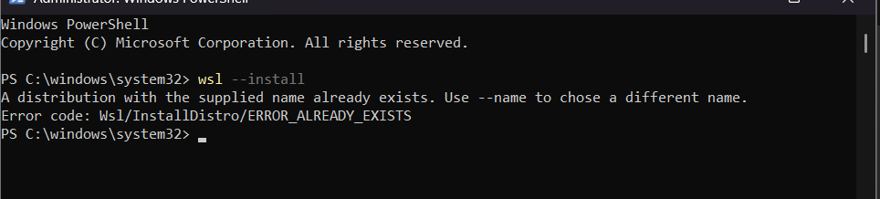
Step 3: Restart Your Computer
After installation, restart your PC when prompted.
Step 4: Complete Ubuntu Setup
After restarting:
1. Ubuntu opens automatically (or search for Ubuntu in the Start menu).
2. Wait for the installation to finish.
3. Create a Linux username.
Example:
Enter new UNIX username: Shreenitha
Step 5: Create a Password
You'll then be prompted to create a password.
New password: ****
Retype new password:****
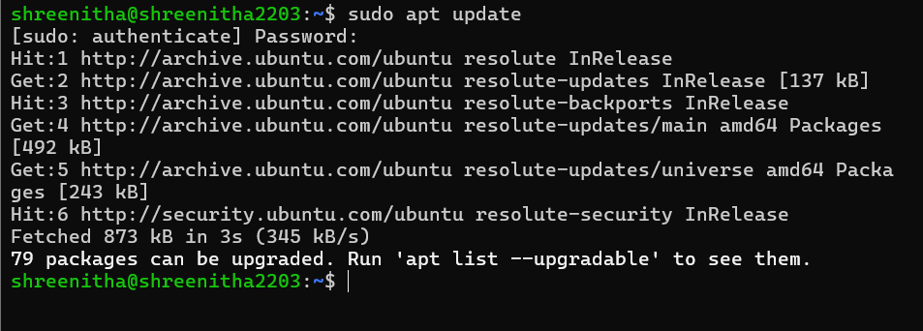

Step 7: Install GCC (C Compiler)

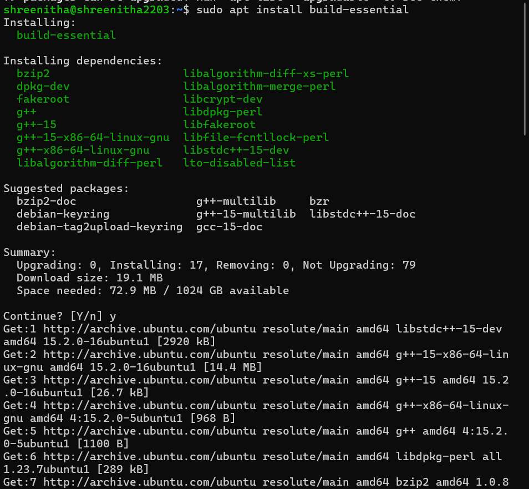
Step 8: Verify the Installation
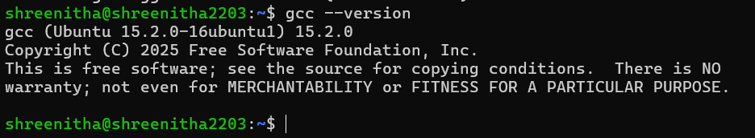

GITHUB REPOSITORY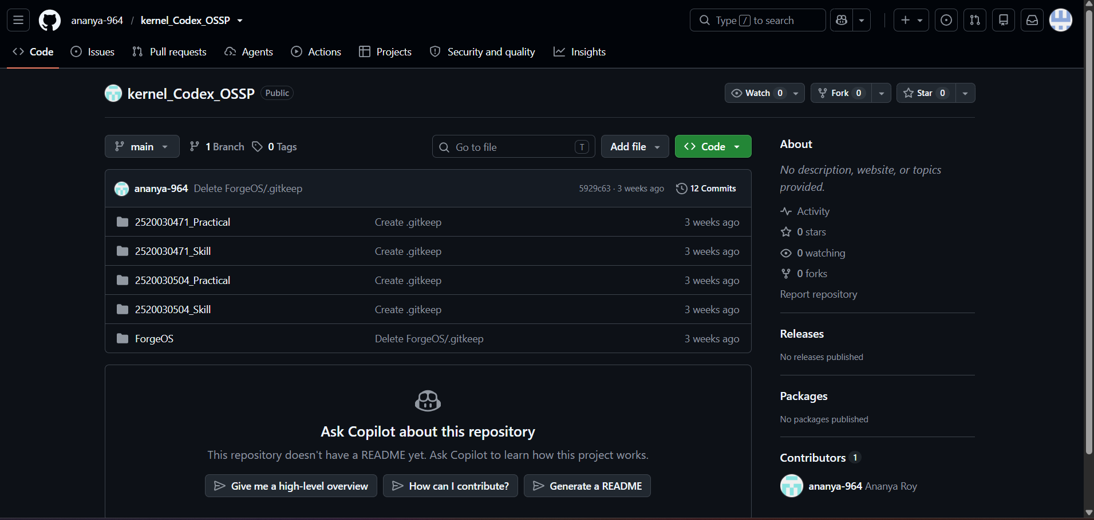
1)
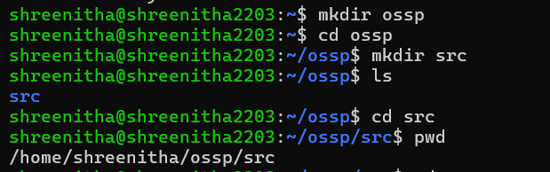
Fork():

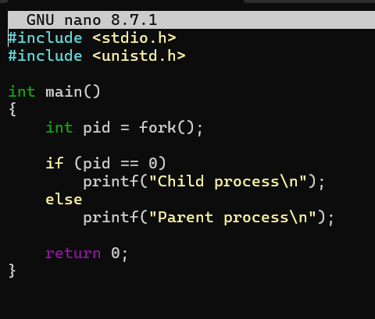
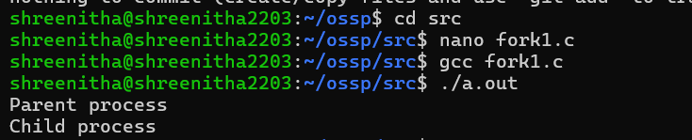

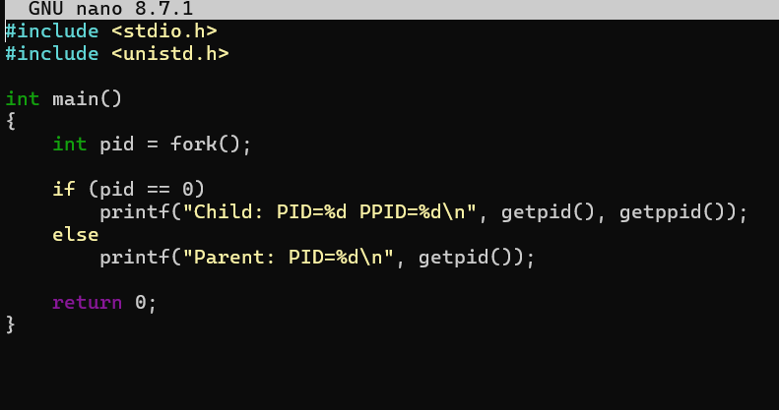
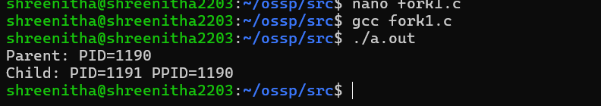
Exec()

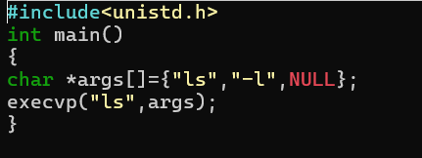
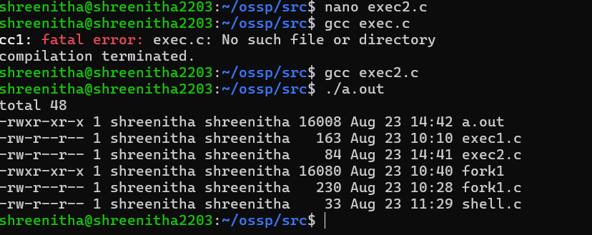
Ps tree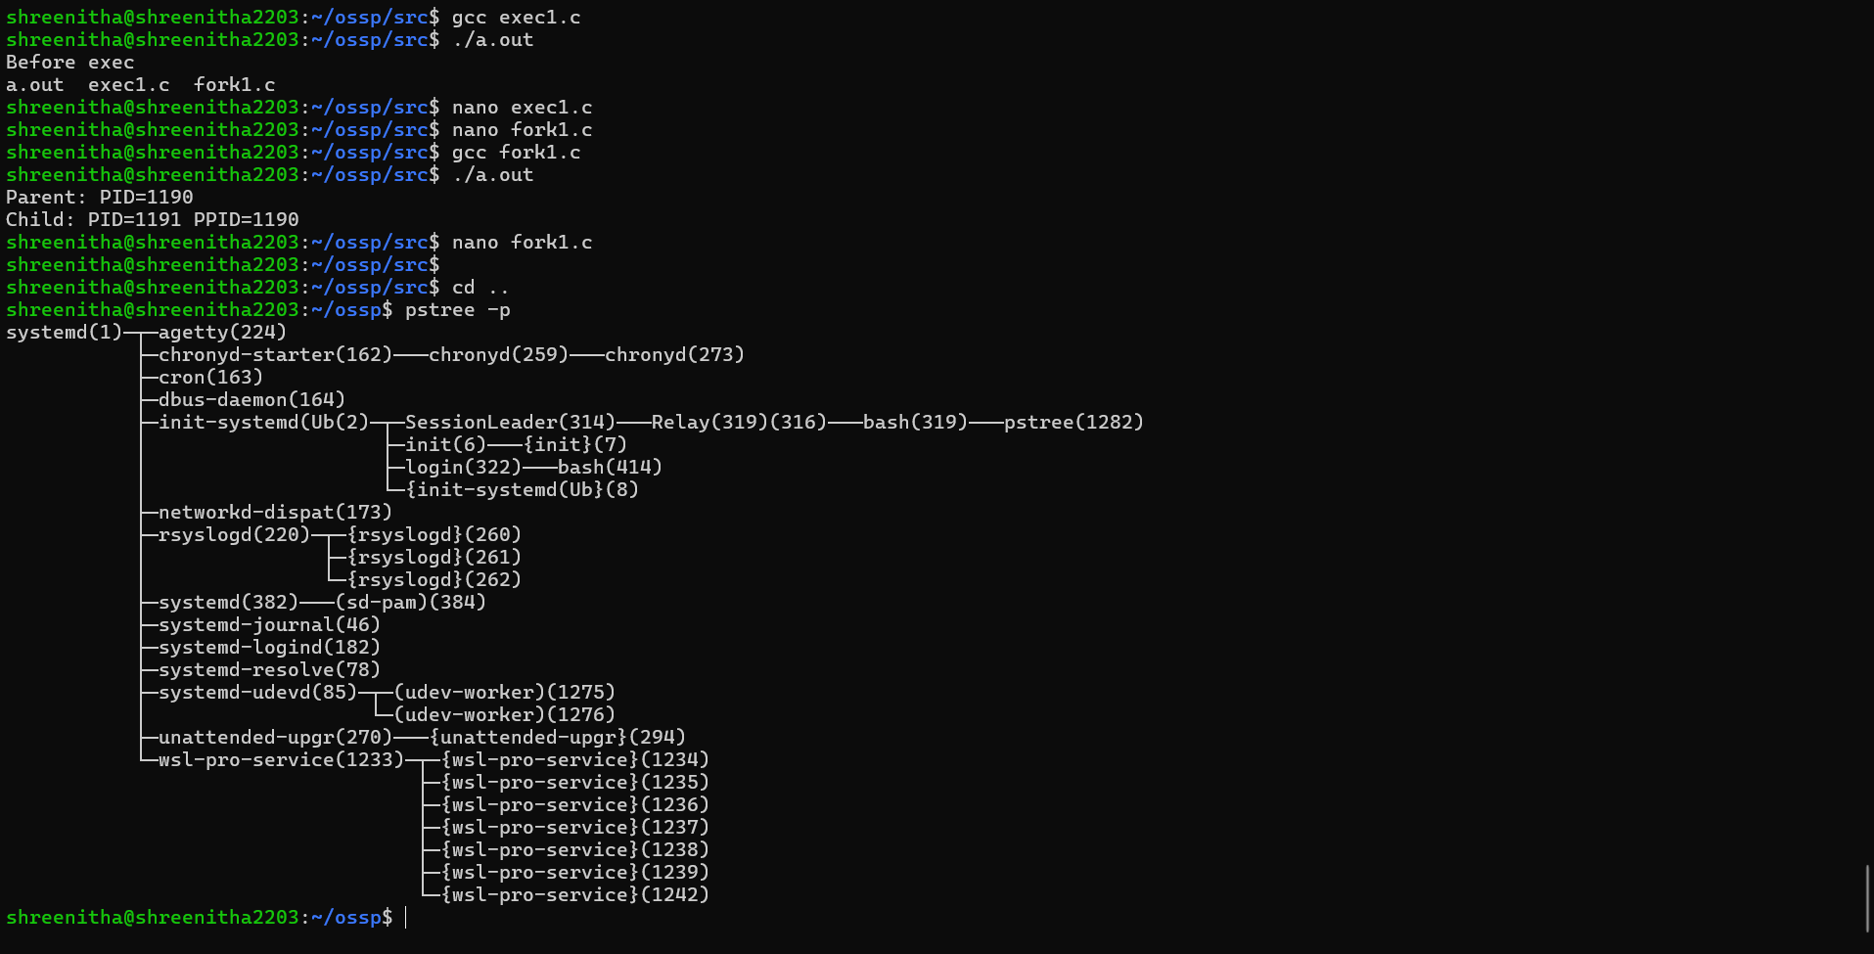QUESTION2

