OOSP (OPERATING SYSTEM AND SYSTEM PROGRAMMING)
COURSE CODE : 25CS2104E
PRACTICAL-01 wait() and waitpid(),Zombie Process
Code output:
A)
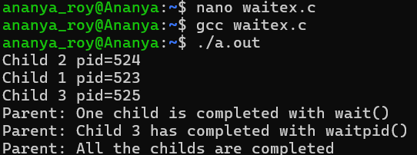
B) Zombie.c
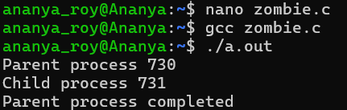
Terminal2
Eliminate zombie process
