DBMS

PL/SQL

LAB ASSIGNMENT – 2



Ananya Agarwal

102083036

2CO14

1. PL/SQL block to update total sal for empno 100. Eno,ename, bp,da,hra,total.

create table emp(empno number(10) primary key, ename varchar(10),bp number(10),da number(10),hra number(10),total number(10));

insert into emp values(100,'Ani',200000,700000,500000,NULL);

select \* from emp;

declare

a emp.bp%type;

b emp.da%type;

c emp.hra%type;

begin

select bp,da,hra into a,b,c from emp where empno=100;

update emp set total=a+b+c where empno=100;

end;

select \* from emp;

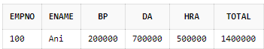

1. PL/SQL block to calculate fine for rno 100 Rno, bookno, doi, dor, fine Fine is rs 1 if days7 Fine is rs 3 if days>14 Amount mentioned is for each day.

create table book(rno number(10), bookno number(10),doi date,dor date,fine number(10));

insert into book values(100,12345,'12-mar-2020','28-mar-2020',0);

select \* from book;

declare

i book.doi%type;

r book.dor%type;

f book.fine%type;

days number(10);

begin

select doi,dor,fine into i,r,f from book where rno=100;

days:=r-i;

dbms\_output.put\_line('The days are '||days);

if days<7

then f:=f+(days\*1);

elsif days<14 and days>=7

then f:=f+days\*2;

elsif days>14

then f:=f+days\*3;

end if;

dbms\_output.put\_line('The fine for student of rollno=100 is '||f);

update book set fine=f where rno=100;

end;

select \* from book;

C:\Users\User\Desktop\1_2.PNG

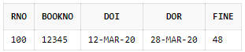

1. PL/SQL block that performs addition (+), subtraction (-), multiplication (\*) and division (/) of two numbers as choice by the user.

declare

a number:=33;

b number:=69;

result number;

n number:=1;--enter choice

begin

if n=1 then

result:=a+b;

dbms\_output.put\_line('addition is: '||result);

elsif n=2 then

result:=a-b;

dbms\_output.put\_line('subtraction is: '||result);

elsif n=3 then

result:=a\*b;

dbms\_output.put\_line('multiplication is: '||result);

elsif n=4 then

result:=a/b;

dbms\_output.put\_line('division is: '||result);

else

dbms\_output.put\_line('wrong choice is: '||result);

end if;

end;

C:\Users\User\Desktop\1_3.PNG

1. PL/SQL block to generate multiplication table for 3 to n.

declare

result number;

n number:=5;--table number

begin

for i in 3..n loop

dbms\_output.put\_line('Table of '||i||' is:');

for j in 1..10 loop

result:=i\*j;

dbms\_output.put\_line( i||' = '||j||' = '||result);

end loop;

end loop;

end;

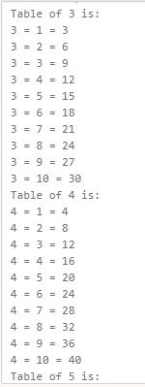

1. PL/SQL block to print 5, 10, 15,20 by using For Loop.

begin

for i in 1..20 loop

if mod(i,5)=0 then

dbms\_output.put\_line(i);

end if;

end loop;

end;

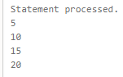

1. Pl/SQL block to display welcome message like good morning, good afternoon, good night depending on system time.

begin

dbms\_output.put\_line(to\_char(sysdate, 'DD-MM-YYYY HH24:MI:SS'));

if to\_char(sysdate,'HH24')>0 and to\_char(sysdate,'HH24')<12 then

dbms\_output.put\_line('Good Morning');

elsif to\_char(sysdate,'HH24')>= 12 and to\_char(sysdate,'HH24')<18 then

dbms\_output.put\_line('Good Afternoon');

else

dbms\_output.put\_line('Good Night');

end if;

end;

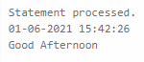

7. WAP that calculate simple interest for principal 1000, time 2 years and rate of interest varies from 5 to 15.

Store it in a table. Principal time rate interest.

create table simple\_interest (principle number(10),time number(10),rate number(10),interest number(10));

declare

principle number(10):=1000;

time number(10):=2;

rate number(10):=5;

si number(10);

begin

while rate<=15 loop

si:=(principle\*time\*rate)/100;

insert into simple\_interest values(principle,time,rate,si);

rate:=rate+1;

end loop;

end;

select \* from simple\_interest;

