FINAL REPORT
Early Prediction of Corporate Insolvency for Indian Listed Companies Using Annual-Report Text and Financial Ratios
Do the words in an annual report warn of insolvency earlier, or better, than the numbers do? A matched study of 135 Indian listed companies admitted to insolvency under the Insolvency and Bankruptcy Code, 2016, and 135 healthy peers.
Courses | Natural Language Processing and Deep Learning (third-year project)
Team | Kartik Agrawal (I001), Ananya Baweja (I003)
Report date | 3 October 2026
Stage | Complete: data, models, evaluation, the checks promised in the progress report of 1 October 2026, and a tool that scores a new company's annual report
Data | 135 matched pairs, 1,154 annual reports read, 763 company-years modelled (362 that later entered insolvency, 401 healthy)
Code and data | github.com/ananya-baweja/bankruptcy-prediction; the dataset folder processed/; the final-run scripts and every saved prediction in final_run/ (Section 12)

Summary
When an Indian company goes bankrupt it rarely happens suddenly, but the usual warning signs (debt ratios, interest coverage) are lagging: by the time the accounts look clearly bad, the company is often already at the tribunal. The annual report also contains words: management explaining the year and the auditor giving an opinion. This project asks whether those words warn earlier, or better, than the numbers.
The system reads the reports of 135 companies later admitted to insolvency and 135 healthy companies in the same industry and of similar size, published one to three years before admission, and tries to tell them apart. Every result is the mean over five cross-validation folds that never split a matched pair, on folds fixed in a file so that the numbers can be reproduced exactly. The headline metric is PR-AUC (0.5 is roughly a coin flip on this balanced sample, 1.0 is perfect).

What was found
- The words carry real information. Models given only report language, with no financial data, separate the two groups clearly better than chance: ROC-AUC 0.737 from the engineered language features, 0.699 from the auditor's report as a bag of words, and 0.685 from FinBERT reading the auditor's report. Management's discussion alone is much weaker (ROC-AUC 0.554 to 0.592). The tone difference reported by Gupta and Banerjee (2023) replicates in direction on this larger sample.
- Words plus numbers beat numbers alone. The full system, a fixed 50/50 blend of the deep model and gradient boosting on ratios and language, scores PR-AUC 0.807 against 0.747 for ratios alone, and 0.838 against 0.786 on the strict matched subset. It wins in every fold on both samples (DeLong p < 0.001 on ROC-AUC), and the pair-bootstrap interval for the gain (+0.009 to +0.105) excludes zero, although its lower end is close to it.
- The words matter most exactly where the numbers fail. Among the 314 company-years whose Altman Z″ is above the median, 86 still went insolvent. There the ratio model is weak (PR-AUC 0.399 against a chance level of 0.274); adding language raises it to 0.555, a gain of +0.156 that holds in 4 of 5 folds with a 95% interval of +0.056 to +0.275; the full system reaches 0.563 (+0.164). The gain is about three times the gain on the full sample, holds with the conventional Altman "safe zone" cut-off as well, and is the most robust finding of the project.
- The warning is early. The full system scores PR-AUC 0.842 on the last report before admission, 0.814 two years before and 0.823 three years before. The gain over ratios alone is largest two years out (+0.081).
- The auditor's report is the stronger text, alone and on top of the ratios. Read alone, it predicts better than the MD&A by every method, FinBERT included (ROC-AUC 0.685 against 0.576). Added to the ratios, the auditor's features add +0.033 PR-AUC and the MD&A features +0.025, both in every fold. The single most useful language feature is the auditor's CARO statement that the company has defaulted on its borrowings. This reverses the progress report's claim that management's discussion beat the auditor's report.

What did not work, and is reported as such
- The transformer did not help. The network with its FinBERT stream removed scores the same as the full network (PR-AUC 0.789 against 0.783); FinBERT reading the MD&A alone is barely above chance (ROC-AUC 0.576); its attention is almost uniform across sentences. The language signal comes from counting things, such as the auditor's loan-default flag, rather than from reading sentences. The deep model earns its place as a second model family in the blend.
- Perplexity was a dud: ROC-AUC 0.503 as a single predictor. Indian management discussions are too templated for a trigram model to find anything unusual.
- Year-on-year language drift added nothing: removing the drift features changed PR-AUC by −0.001. Contribution A of the plan is not supported.
- Tuning did not help: with ~120 validation rows the inner score and the test score correlate at r = +0.07. Averaging several models helped; searching harder did not.
- A non-language flag sat among the language features: a flag recording that a company's financial statements were incomplete had been filed with them. On its own it is worth +0.012 PR-AUC over the ratios; once language is in the model it adds nothing (−0.003). Section 7.4 separates it out; the conclusions hold without it.
- Two auditor flags had been misread, and were corrected. The rule that reads the CARO annexure cut sentences at every line break of the PDF, so a wrapped denial ("the Company has not / defaulted in repayment") counted as a default. 14% of healthy company-years carried a loan-default flag and 26% an unpaid-dues flag; after the correction 6% and 2%, and every remaining healthy-firm default flag was confirmed against the report. Every number in this report uses the corrected flags (Section 8).

1. Introduction and Objective
Corporate insolvency is rarely sudden. Before a creditor files an insolvency petition before the National Company Law Tribunal (NCLT), signs of stress appear in two places: in the financial statements and in the language of the annual report. Financial ratios such as debt-to-equity and interest coverage are the conventional warning signals, but they are lagging indicators, and accounts can be presented favourably or filed late.
Under stress, management hedges more, writes defensively about working capital and refinancing, and the auditor adds qualifications, going-concern paragraphs and, in the CARO annexure, a statement that the company has defaulted on its borrowings. This project measures how much early-warning signal that language carries, which part of the report carries it, and how early it appears. It does not assume that language performs better than ratios; each hypothesis was fixed in advance with an outcome stated in either direction (Section 6).
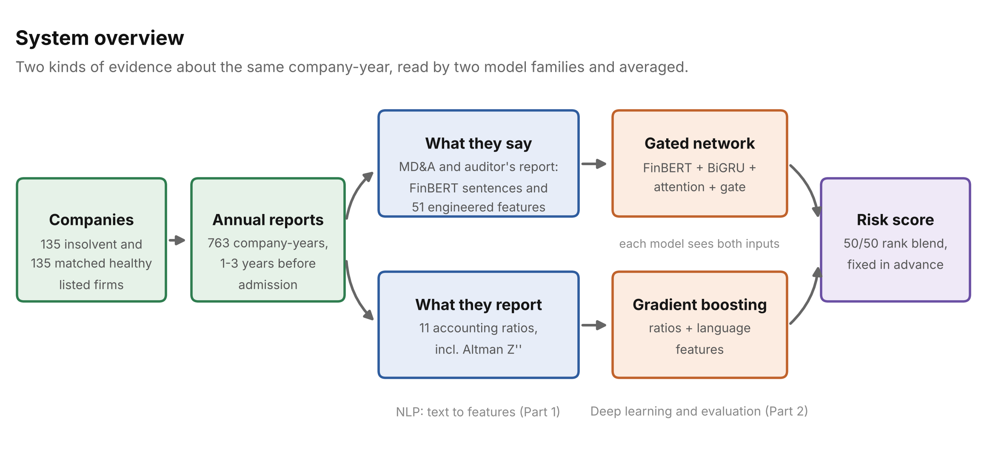
Figure 1. Overview of the final system.
Table 1. Terms used in this report.
Term | Meaning
IBC, 2016 | Insolvency and Bankruptcy Code, the law under which insolvent Indian companies are resolved.
NCLT | National Company Law Tribunal, which admits a company into insolvency. Admission is the event predicted.
IBBI | Insolvency and Bankruptcy Board of India, which publishes every insolvency announcement; the source of the labels.
MD&A | Management Discussion and Analysis: management's account of the year and the outlook.
CARO annexure | The part of the audit report in which the auditor must state loan defaults and unpaid statutory dues.
Going concern | A formal statement by the auditor that the company may be unable to continue operating.
PR-AUC, ROC-AUC | Area under the precision-recall and the receiver-operating-characteristic curves; ranking quality, 1.0 perfect.
t-1, t-2, t-3 | The last annual report published before the insolvency reference date, the one before it, and the one before that.

2. Literature Reviewed
Ten studies shaped the design; each fixed a baseline, a feature, a model choice or a risk to control. Four standard method papers and the statistical references are listed with them in Section 13.
Table 2. The ten studies and what was taken from each.
# | Study | What it found | What the project took from it
1 | Altman (1968), Journal of Finance | Five ratios combined by discriminant analysis separate bankrupt and healthy US firms. | The classical benchmark; its emerging-market form Z″ is a baseline and a feature.
2 | Loughran and McDonald (2011), Journal of Finance | General sentiment lists misclassify financial text; a finance dictionary. | Tone features use the finance dictionary, with raw word counts as the denominator.
3 | Mai, Tian, Lee and Ma (2019), EJOR | Text adds to ratios; averaged embeddings beat CNNs on small samples. | The averaged-FinBERT baseline, and the expectation that simple text models do well here.
4 | Cohen, Malloy and Nguyen (2020), Journal of Finance | Year-on-year changes in filings predict returns and bankruptcies. | The drift features (tested; not supported here).
5 | Huang, Wang and Yang (2023), CAR | FinBERT outperforms general models on financial text. | The frozen sentence encoder.
6 | Arno, Mulier, Baeck and Demeester (2024), ECL | Text and financial data are complementary for bankruptcy prediction. | The fusion design and the separate horizons.
7 | Mancisidor and Aas (2022/2024) | Multimodal model; text missing for ~40% of firms. | Missing text and missing accounts are recorded, not dropped.
8 | Gupta (2022), J. Prediction Markets | 57 IBC firms vs 55 matched; ratio models above 75% accuracy. | The matched design and the ratio benchmark.
9 | Gupta and Banerjee (2023), IMFI | Insolvent IBC firms use more negative words (2.21% vs 1.30%). | The tone comparison replicated in Section 7.3.
10 | Ganin and Lempitsky (2015), ICML | Gradient reversal removes a nuisance attribute from a representation. | The planned business-group test (not built; Section 9).

3. Data and Sample Design
Every input is public. The planned CMIE Prowess database was not available, so the standardised financial statements were built from the exchanges' XBRL filings (FY2018 onwards) and, for earlier years and as a cross-check, read from the annual reports themselves.
Table 3. Data sources as used.
Source | Data taken | Purpose
IBBI public announcements | 9,147 CIRP announcements, January 2017 to September 2026, with the debtor's CIN | Labels and admission dates
BSE and NSE lists | Active, suspended and delisted companies; BSE industry sub-groups | Finding listed debtors; matching peers
Annual reports (PDF) | 1,154 reports, 148,424 pages (7,490 read by OCR) | MD&A, auditor's report, CARO annexure
Exchange XBRL results | Standardised statements for FY2018 onwards | Ratios; cross-check of the report reader
Loughran-McDonald dictionary | Finance word lists | Tone features
Each insolvent company is matched to a healthy company from the same BSE industry sub-group with total assets within 30%, following Gupta (2022). All 135 insolvent companies were confirmed by the corporate identity number (CIN) printed in their own reports, and the report reader agrees with the companies' own XBRL filings to within 1% on 91.8% of 10,081 checked figures.
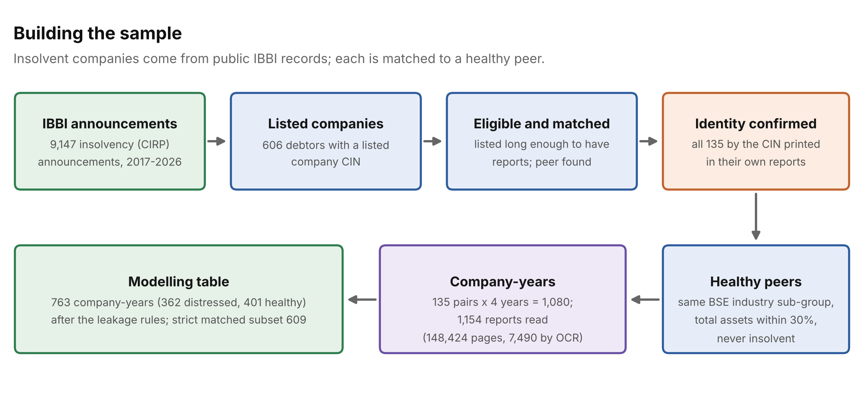
Figure 2. Construction of the matched sample, with the final counts.
Labels follow the publication date of each report, not its fiscal year. A report published once insolvency proceedings are under way usually discusses them, so a model trained on it would be reading the outcome rather than predicting it.
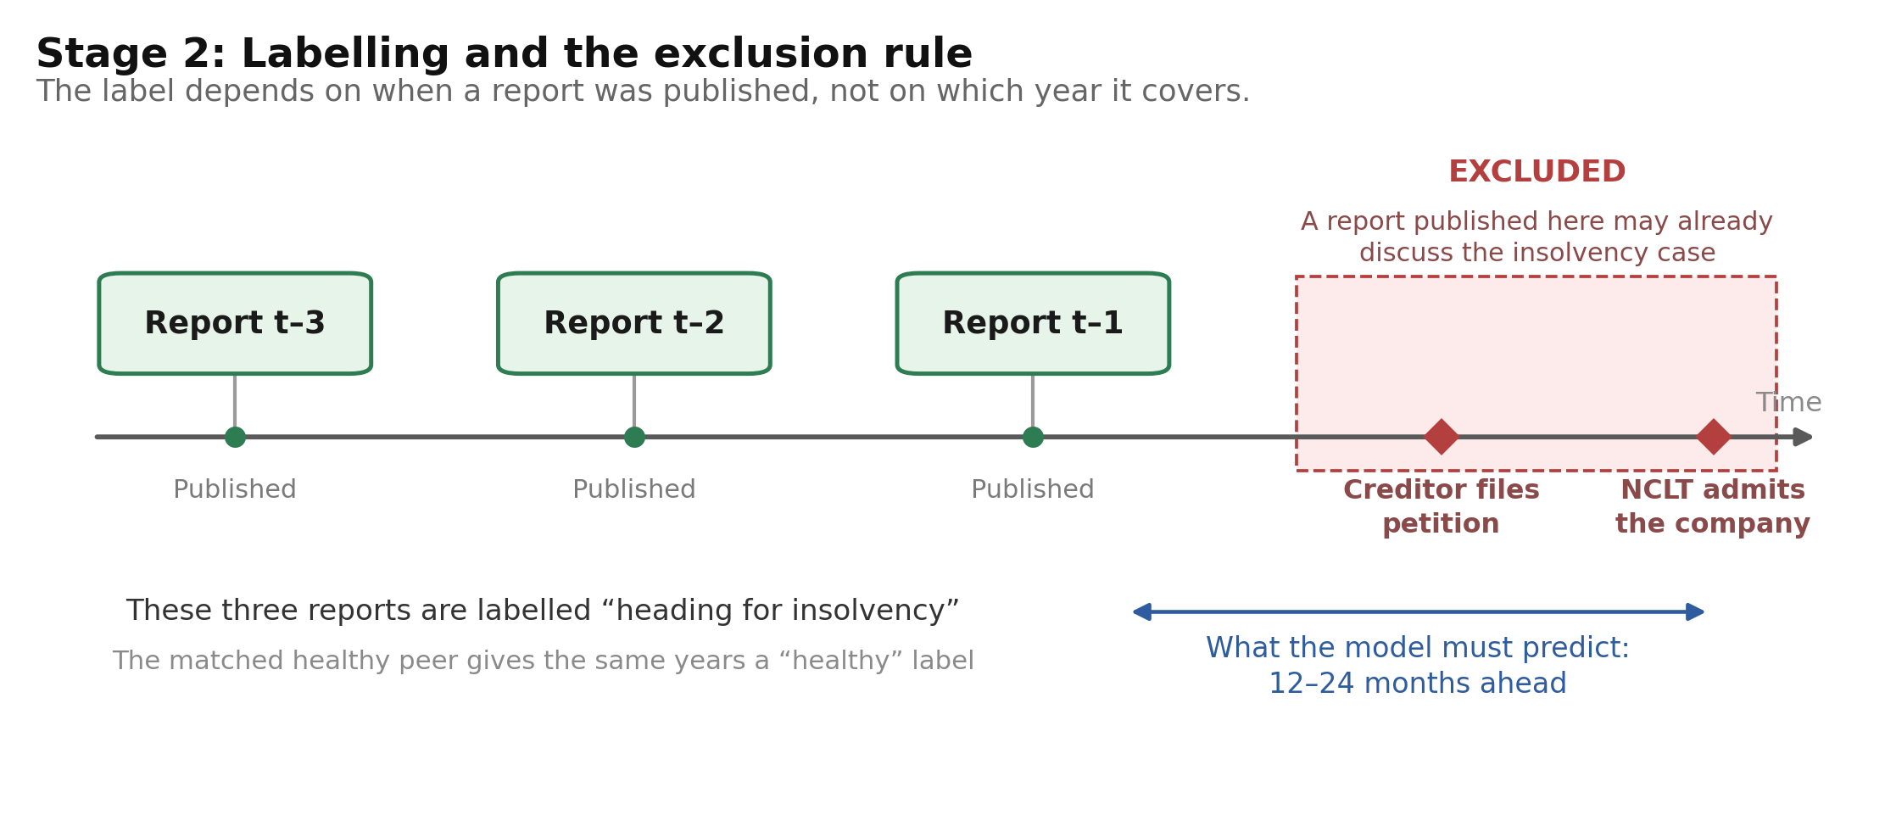
Figure 3. Labelling and the exclusion rule (unchanged from the progress report).
Table 4. Rules that prevent label leakage, and how many reports each removed.
Rule | Reports removed
Published within 180 days of admission | 236
Read by hand and found to discuss a petition against the company itself | 38
Filed by the exchange under the wrong year | 3
No report available, or more than three years before | 40
Training and test folds split by matched pair, never by report | (design rule)
Two explicit mentions-of-insolvency counts dropped from the features | (design rule)
The modelling sample. 763 company-years: the 719 that pass every rule (362 distressed, 357 healthy) plus 44 healthy reports that were removed only because their distressed partner's report was removed. A healthy company's report cannot disclose an insolvency that never happened, so these 44 carry no leakage, but they do relax the rule that both halves of a pair are kept or dropped together. The main results are therefore also reported on the strict matched subset of 609 company-years that satisfy the original pair rule and have complete financial statements (318 distressed, 291 healthy: the completeness filter applies to each company-year, so the subset is not exactly balanced), and in Section 7.4 the models are retrained on the strict rows alone.

4. Data Preparation
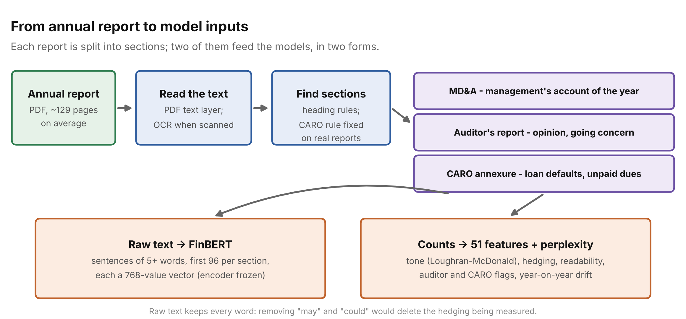
Figure 4. From an annual report to the two kinds of language input.
Two sections feed the models. The MD&A is management's own account; the auditor's report and CARO annexure are the independent auditor's. The directors' report is extracted but not used. Text is kept in two forms: raw, for FinBERT and for hedging (removing stopwords would delete "may" and "could", the hedging being measured), and as counts, for dictionary features and bag-of-words models.
Table 5. The 51 engineered language features, computed separately for the MD&A and the auditor's report.
Family | Examples | Why it might signal distress
Tone | Loughran-McDonald negative, positive, uncertainty, litigious, constraining, strong and weak modal word shares | Distressed firms write more negatively and less certainly
Hedging | hedge-word and hedge-phrase density ("may", "subject to") | Management hedges when unsure of the outcome
Distress phrases | an India-specific seed list (e.g. one time settlement, wilful defaulter, SARFAESI, erosion of net worth) | Local phrasing no US dictionary covers
Readability and length | Gunning Fog, sentence length, complex-word share, word and sentence counts | Obfuscation; short, minimal disclosure
Auditor's formal flags | going concern, emphasis of matter, modified opinion and its severity, CARO loan default, CARO unpaid statutory dues | The auditor's own assessment, stated before the event
Section found | whether the MD&A, auditor's report, CARO annexure and opinion were located | Missing or non-standard disclosure
Year-on-year drift | Jaccard and cosine change against the firm's previous MD&A, change in tone, hedging and Fog | A firm changing how it writes (Cohen et al., 2020)
The two CARO flags are read clause by clause: a phrase such as "defaulted in repayment" or "statutory dues ... outstanding" counts only if no negation ("not", "no", "neither", "whether") precedes it in the same clause (for the statutory-dues phrase, or sits inside it: "... and no such statutory dues were outstanding"). A clause ends at a full stop, a semicolon or a new numbered item, never at the PDF's own line breaks, which fall in the middle of sentences (Section 8).
Two further columns travel with the language features: perplexity of the MD&A under a Kneser-Ney trigram model fitted, fold by fold, on the healthy reports of the training folds only; and financials_missing, a flag for company-years whose financial statements could not be fully recovered. The second is not language, and Section 7.4 separates it out.

5. Models

5.1 The deep model as trained
The progress report described the network as planned. The network actually trained is smaller, because a nested hyperparameter search (and its failure to beat a fixed configuration; Section 7.10) pointed that way. Figure 5 and Table 6 describe what was trained.
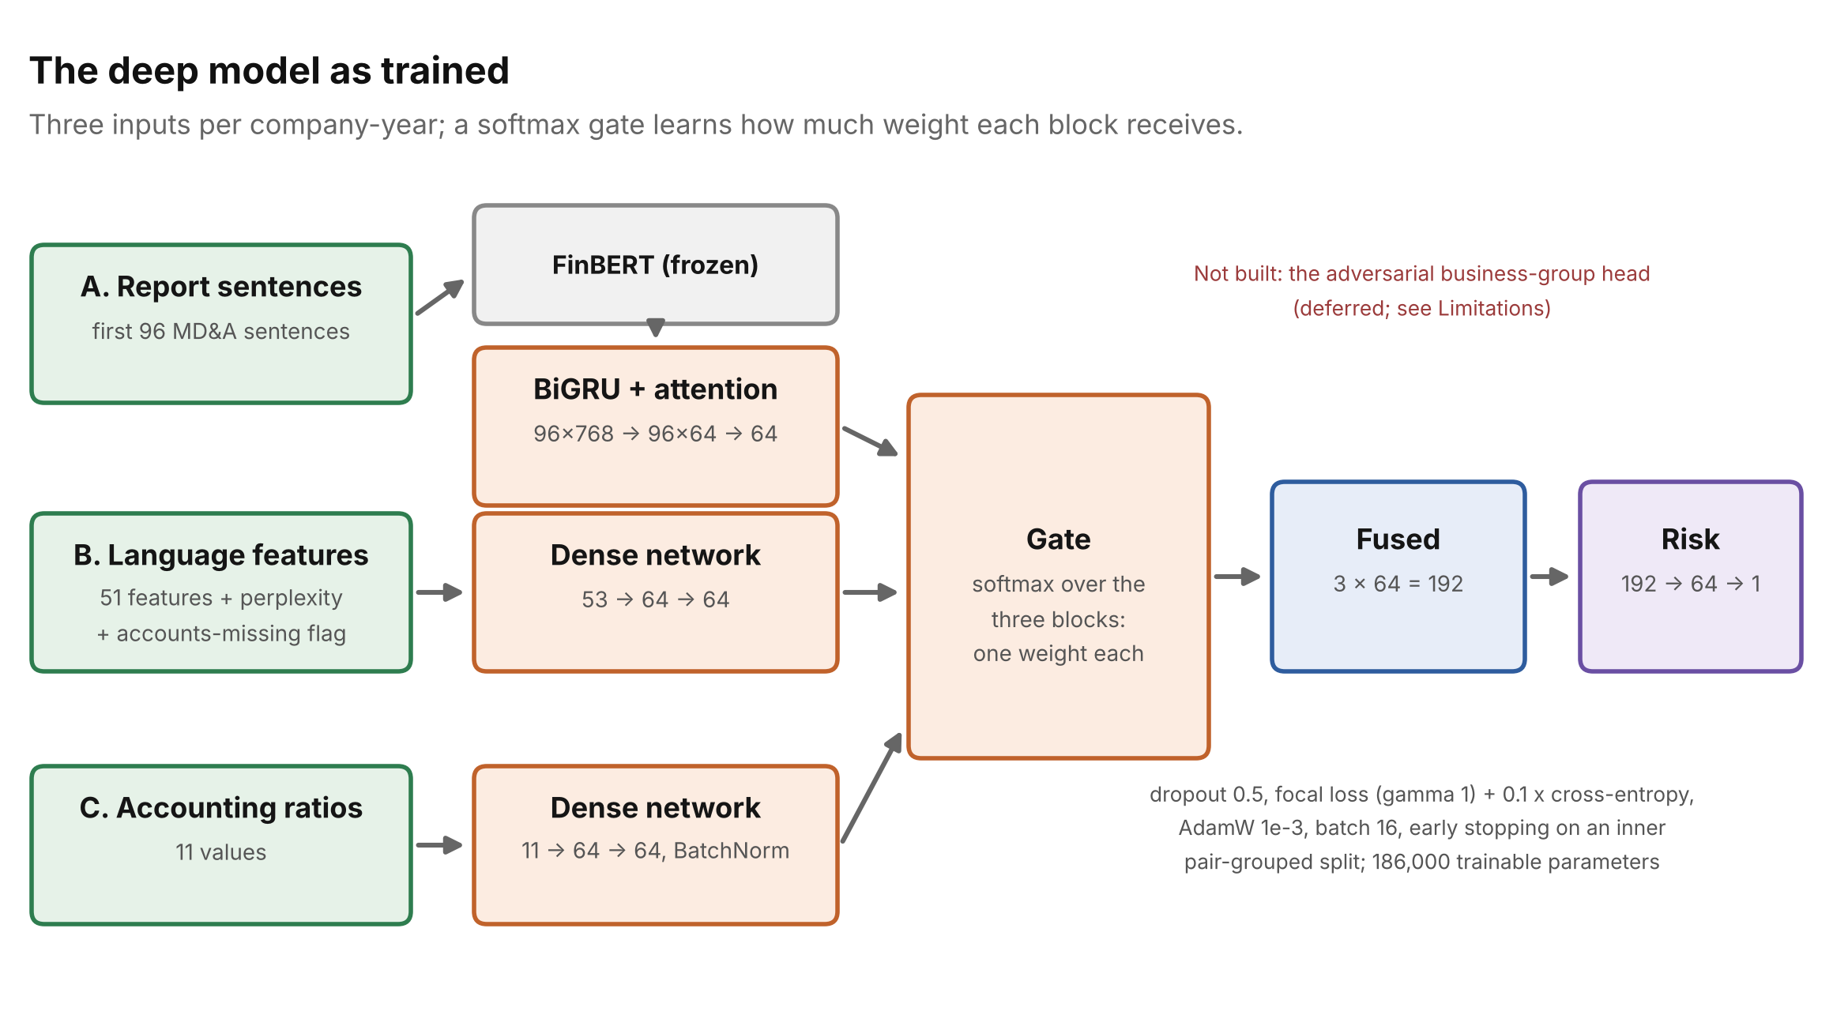
Figure 5. The gated fusion network as trained.
Table 6. Planned (progress report) against trained (this report).
Setting | Progress report | As trained
Sentences read per report | up to 200 | first 96 of the MD&A
BiGRU hidden units per direction | 64 | 32
Attention hidden size | 64 | 32
Dropout | 0.3 | 0.5
Focal-loss gamma | 2 | 1 (plus 0.1 x cross-entropy)
Optimiser | AdamW, lr 1e-3, weight decay 1e-4 | AdamW, lr 1e-3, no weight decay
Batch size / epochs / patience | 32 / 100 / 10 | 16 / up to 40 / 8, on an inner pair-grouped split
Language inputs | 25 values | 53 values (51 features, perplexity, accounts-missing flag)
Ratio inputs | 12, incl. promoter pledge | 11 (pledge filings were not collected)
Business-group adversarial head | planned | not built (Section 9)
Seeds | 1 | 7, averaged by rank within each fold
Trainable parameters | ~0.4 million (0.36 million quoted in Section 7.7 of the progress report) | 185,924 (FinBERT's 110 million frozen); the 0.36 million quoted earlier is the 64-unit configuration
One correction to the network itself. In the progress-report run the attention was limited to the first 96 sentences, but the recurrent layer still ran over all 200 sentence slots, including zero padding, so its backward direction saw text it was not meant to read. The final run reads exactly the first 96 sentences and skips the padding (packed sequences). All deep-model numbers in this report come from the corrected network.

5.2 All models compared
Table 7. Models in this report. Everything that learns from data is fitted on the training folds only.
Model | Inputs | Role
Altman Z″ (no training) | one score | classical benchmark
Logistic regression | 11 ratios, winsorised and scaled in-fold | standard baseline
Gradient boosting (ratios) | 11 ratios | the accounting baseline
Gradient boosting (ratios + language) | 11 ratios + 53 language columns | classic NLP added to ratios
Deep model | FinBERT sentences + language + ratios | the gated fusion network, 7 seeds
Blend (full system) | the two previous models | fixed 50/50 average of within-fold ranks; weight set in advance
Text-only models | language features; TF-IDF (unigrams and bigrams); mined lexicon score; FinBERT with no ratios; averaged FinBERT + logistic regression | hypotheses H1 and H4

6. Evaluation Design
Folds. Five-fold cross-validation grouped by matched pair: a distressed company and its peer are always in the same fold, so the model never sees half of a matched comparison during training. The fold of every report is now fixed in a file (folds.csv). This matters more than it sounds: scikit-learn's GroupKFold breaks ties between equally sized pairs differently across library versions, and in current versions it would assign 79% of the rows to a different fold. The frozen assignment reproduces the progress report's folds (the same fold is hardest for every model, and the baselines agree to within 0.004).
Per-fold means. Every figure is the mean over the five folds, with the standard deviation across folds. Each fold trains its own network with its own stopping point, so pooling predictions across folds would penalise the networks for a calibration artefact that has nothing to do with ranking.
Table 8. Metrics.
Metric | What it measures
PR-AUC (headline) | ranking quality with attention to the insolvent class
ROC-AUC | comparability with published studies
Recall at a 10% false-alarm rate | share of insolvencies caught if 10% of healthy firms are flagged for review
PR-AUC at a 1:10 prevalence | the same ranking scored as if insolvent firms were 1 in 11, by reweighting the healthy firms; chance is 0.091
Brier score | calibration of the probability models (the blend is a rank average, not a probability)
Paired tests across folds | t-test and Wilcoxon on the five per-fold differences, and the number of folds won
Pair bootstrap | 95% interval for a difference, resampling matched pairs (2,000 or 1,000 resamples)
DeLong test | ROC-AUC difference, computed within each fold and combined across folds
Reading the tests. With five paired folds the Wilcoxon test cannot go below p = 0.0625; that value means every fold favoured the same model, the strongest outcome available. DeLong treats reports as independent although each company contributes up to three; the pair bootstrap does not, so it is the more conservative of the two and is preferred where they disagree.
Table 9. Hypotheses fixed in advance (progress report, Table 14).
Hypothesis | Test
H1 Report language separates insolvent from healthy firms | text-only models against chance; replication of the Gupta and Banerjee (2023) tone comparison
H2 Language adds information beyond the ratios | ratios + language, and the full system, against ratios only, with intervals
H3 Language stays informative further from the event | performance at t-1, t-2 and t-3
H4 The signal is not only the auditor's flags | MD&A only, auditor only and both

7. Results
All numbers below come from one run on the frozen folds: 763 company-years (362 distressed) and the strict matched subset of 609 (318 distressed). Where the same model was run, they differ from the progress report by a few thousandths for the ratio models, by up to about 0.02 for the models that read the language features, and by up to about 0.03 on the small subsets, because of library versions, the corrected network and the corrected auditor flags (Section 8); the progress-report figures are not reused.

7.1 Main comparison
Table 10. Predictive performance. Mean across five folds ± standard deviation.
Model | PR-AUC (763) | PR-AUC (609) | ROC-AUC (763) | ROC-AUC (609) | Recall at 10% false alarms | PR-AUC at 1:10
Altman Z″ (no training) | 0.712 ± 0.080 | 0.778 ± 0.074 | 0.732 ± 0.054 | 0.759 ± 0.049 | 38% | 0.315
Logistic regression, ratios | 0.710 ± 0.074 | 0.773 ± 0.078 | 0.734 ± 0.057 | 0.759 ± 0.061 | 35% | 0.283
Gradient boosting, ratios only | 0.747 ± 0.080 | 0.786 ± 0.077 | 0.772 ± 0.066 | 0.784 ± 0.065 | 45% | 0.346
Gradient boosting, ratios + language | 0.795 ± 0.070 | 0.822 ± 0.066 | 0.809 ± 0.058 | 0.815 ± 0.054 | 52% | 0.415
Deep model (7 seeds) | 0.783 ± 0.070 | 0.823 ± 0.060 | 0.793 ± 0.043 | 0.805 ± 0.029 | 50% | 0.408
Blend: full system | 0.807 ± 0.073 | 0.838 ± 0.067 | 0.822 ± 0.053 | 0.831 ± 0.043 | 53% | 0.443
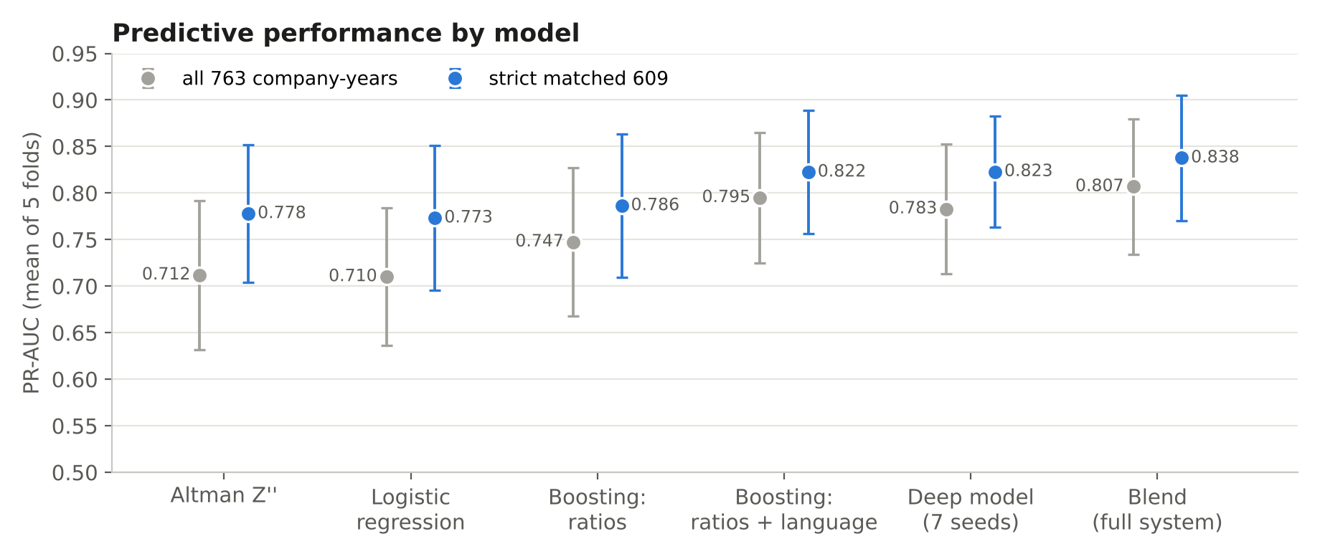
Figure 6. PR-AUC by model; whiskers show the standard deviation across the five folds.
The deep model on its own scores PR-AUC 0.783: above gradient boosting on ratios (+0.035, 4 of 5 folds, interval −0.026 to +0.088) and slightly below gradient boosting on ratios and language (−0.012, 1 of 5). Averaging seven seeds matters: a single seed averages 0.745 (± 0.013 across seeds), the seven-seed ensemble 0.783. The blend of the deep model and the language-aware booster is the best of the models in Table 10 on every summary measure: PR-AUC 0.807, ROC-AUC 0.822, recall 53% at a 10% false-alarm rate and PR-AUC 0.443 at a 1:10 prevalence. The two families make different mistakes, which is why averaging them helps even though the network alone is not better than the booster. The figures are about 0.01 above the progress report's (0.797 and 0.830 then, 0.807 and 0.838 now); the difference is the corrected auditor flags (Section 8).
At a realistic prevalence. The sample is balanced by design, which flatters precision. Re-weighted so that insolvent firms are 1 in 11, chance PR-AUC is 0.091; the ratio model reaches 0.346 and ratios plus language 0.415, the full system 0.443. The ranking survives, but an analyst would still see several false alarms for every true case. The Altman distress zone (Z″ below 1.1) used as a rule flags 43% of the insolvent company-years at a 13% false-alarm rate.

7.2 Are the differences real?
Table 11. Paired differences in PR-AUC. Folds won out of 5; p from the paired t-test; interval from the pair bootstrap; DeLong p for the ROC-AUC difference.
Comparison | Difference | Folds won | t-test p | 95% interval | DeLong p
Ratios + language − ratios only (763) | +0.048 | 5 of 5 | 0.027 | [+0.006, +0.089] | 0.006
Full system − ratios only (763) | +0.059 | 5 of 5 | 0.026 | [+0.009, +0.105] | < 0.001
Full system − ratios + language (763) | +0.012 | 2 of 5 | 0.323 | [−0.009, +0.031] | 0.067
Full system − deep model (763) | +0.024 | 4 of 5 | 0.025 | [+0.010, +0.046] | < 0.001
Deep model − ratios only (763) | +0.035 | 4 of 5 | 0.202 | [−0.026, +0.088] | 0.237
Ratios + language − ratios only (609) | +0.036 | 5 of 5 | 0.039 | [−0.002, +0.080] | 0.047
Full system − ratios only (609) | +0.051 | 5 of 5 | 0.040 | [+0.004, +0.106] | 0.007
Full system − ratios + language (609) | +0.015 | 4 of 5 | 0.170 | [−0.006, +0.031] | 0.047
Full system − deep model (609) | +0.015 | 4 of 5 | 0.120 | [+0.001, +0.031] | 0.001
Deep model − ratios only (609) | +0.037 | 4 of 5 | 0.186 | [−0.018, +0.100] | 0.308
The full system beats ratios alone in every fold on both samples (Wilcoxon p = 0.0625 where all five folds agree, the smallest value five folds allow; DeLong p < 0.001 and p = 0.007). The pair-bootstrap intervals (+0.009 to +0.105 and +0.004 to +0.106) both exclude zero, so the gain of about 0.05 to 0.06 PR-AUC is consistent and statistically distinguishable from zero, although the lower ends of the intervals are close to it. Trained on the strict rows alone, the full system beats strict-trained ratios by +0.059 with an interval of +0.004 to +0.113. The blend also beats the deep model alone (+0.024, 4 of 5 folds, interval +0.010 to +0.046). Its advantage over the booster with language features (+0.012, 2 of 5 folds) is inside the noise: most of the full system's gain comes from the language features, not from the network.

7.3 H1: does report language alone separate the two groups?
Table 12. Models that see only report language: no ratios and no accounts-missing flag.
Text-only model | ROC-AUC | PR-AUC | Recall at 10% false alarms
Engineered language features (boosting) | 0.737 ± 0.044 | 0.737 ± 0.033 | 42%
Engineered language features (logistic) | 0.720 ± 0.023 | 0.720 ± 0.040 | 39%
TF-IDF bag of words: MD&A | 0.554 ± 0.042 | 0.530 ± 0.054 | 15%
TF-IDF bag of words: auditor's report | 0.699 ± 0.071 | 0.670 ± 0.054 | 32%
Mined lexicon score: MD&A | 0.573 ± 0.068 | 0.521 ± 0.054 | 12%
Mined lexicon score: auditor's report | 0.706 ± 0.061 | 0.680 ± 0.057 | 33%
Averaged FinBERT + logistic: MD&A | 0.557 ± 0.028 | 0.550 ± 0.041 | 14%
Averaged FinBERT + logistic: auditor | 0.655 ± 0.049 | 0.652 ± 0.041 | 31%
FinBERT + BiGRU, text only: MD&A (5 seeds) | 0.576 ± 0.090 | 0.547 ± 0.075 | 13%
FinBERT + BiGRU, text only: auditor (5 seeds) | 0.685 ± 0.054 | 0.679 ± 0.038 | 33%
FinBERT + BiGRU, text only: both (5 seeds) | 0.655 ± 0.039 | 0.643 ± 0.054 | 30%
H1 is supported, by the auditor's words more than management's. Every model that reads the auditor's report, or the full set of engineered features, is clearly above chance (ROC-AUC 0.5). The MD&A-only models are barely above it (ROC-AUC 0.554 to 0.592, below 0.5 in some folds). The engineered features reach ROC-AUC 0.737; the strongest single text is the auditor's report, at 0.699 as a bag of words and 0.706 as a mined-lexicon score. The FinBERT network gives the same picture: reading only the auditor's report it reaches ROC-AUC 0.685, somewhat better than averaging the FinBERT vectors and fitting a logistic regression (0.655); reading only the MD&A it reaches 0.576, no better than the averaged vectors (0.557). The progress report quoted 0.69 to 0.72 for text alone. That came from one run of the uncorrected network reading the MD&A, on the 609-row sample, scored on pooled predictions. With the recurrent layer corrected and five seeds, FinBERT on the MD&A alone reaches 0.576; the figure of about 0.7 holds only for text-only models of the auditor's report.
Table 13. Replication of the Gupta and Banerjee (2023) tone comparison. Means; Mann-Whitney test across reports; matched comparison within pair and horizon.
Measure | Distressed | Healthy | Mann-Whitney p | Pairs where distressed is higher | Wilcoxon p (pairs)
MD&A negative words (LM) | 1.45% | 1.24% | < 0.001 | 58% | < 0.001
Auditor's report negative words | 1.90% | 1.78% | 0.016 | 62% | < 0.001
MD&A uncertainty words | 0.92% | 0.82% | 0.029 | 54% | 0.095
MD&A hedging density | 0.77% | 0.68% | 0.004 | 55% | 0.075
MD&A Fog index | 13.24 | 12.69 | < 0.001 | 62% | < 0.001
MD&A positive words | 1.28% | 1.23% | 0.427 | 51% | 0.494
Insolvent companies' management discussions use more negative words (1.45% against 1.24%), more hedging and harder-to-read prose, and their auditors' reports are more negative; positive words do not differ. The direction matches Gupta and Banerjee (2.21% against 1.30%), but the gap is about a quarter of theirs (0.21 against 0.91 percentage points): within a matched pair the distressed report is more negative only 58% of the time. Tone is a real but weak signal on its own, which is why the models that combine many such features do better than any single count.

7.4 H2: what does language add beyond the ratios, and from where?
Table 14. Separating the accounts-missing flag from language. Gradient boosting; PR-AUC.
Inputs | PR-AUC (763) | Gain over ratios | PR-AUC (609) | Gain over ratios
Ratios only | 0.747 |  | 0.786
Ratios + accounts-missing flag | 0.760 | +0.012 | 0.789 | +0.003
Ratios + language (no flag) | 0.798 | +0.050 | 0.826 | +0.040
Ratios + language + flag (the model of Table 10) | 0.795 | +0.048 | 0.822 | +0.036
Ratios + language, trained on the strict rows only |  |  | 0.828 | +0.052 (over strict-trained ratios)
The flag recording that a company-year's financial statements were incomplete had been stored with the language features. It is informative (healthy company-years are more often incomplete: 17% against 12%), and on its own it adds +0.012 PR-AUC to the ratio model (5 of 5 folds). It is not language. Language without the flag adds +0.050 (5 of 5 folds; DeLong p = 0.002; bootstrap interval +0.006 to +0.095). On the strict subset, where the flag is always zero at test time, the two gains coincide, and retraining on the strict rows alone gives the same picture, so the 44 additional healthy reports do not drive the result.
H2 is supported. Language without the flag adds +0.050 PR-AUC to the booster (all five folds; +0.040 on the strict subset), the DeLong test on ROC-AUC gives p = 0.002, and the pair-bootstrap interval for PR-AUC (+0.006 to +0.095) excludes zero, though only just. The full system, which adds the deep model, gains +0.059 over ratios alone in all five folds (Table 11). The gain is concentrated in particular companies (Section 7.5) rather than spread evenly.
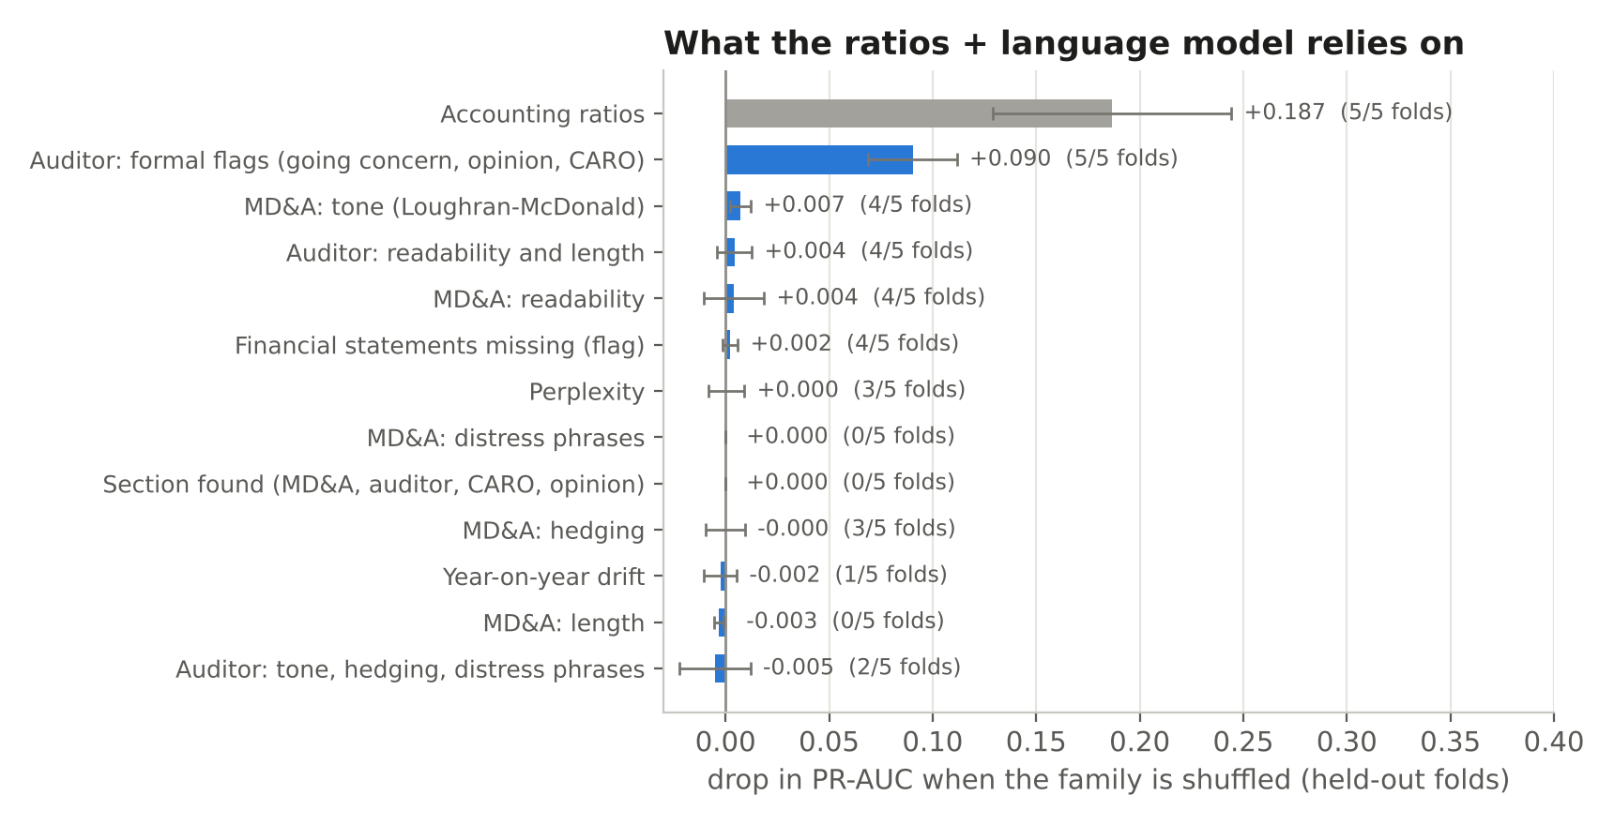
Figure 7. Permutation importance by feature family in the ratios + language model, on held-out folds (30 shuffles per family per fold).
What the language gain consists of. The accounting ratios carry most of the model, as expected. Among the language features one family stands out: the auditor's formal flags, and within them the CARO loan-default flag, the auditor's statement that the company has defaulted on borrowings, which is the single most important feature in the model (the six largest are CARO loan-default flag (+0.066), cash to assets (+0.017), retained earnings to assets (+0.017), CARO unpaid-dues flag (+0.013), return on assets (+0.009), interest coverage (+0.009)). Its companion, the flag for unpaid statutory dues, is now among them too: before the correction of Section 8 it was raised for a quarter of the healthy companies and carried little information. MD&A tone and readability contribute a little; hedging, drift and perplexity contribute nothing measurable once the ratios are present. Permutation importance measures what a model leans on, not what it could do without, and Section 7.7 shows that the MD&A features carry information of their own. Still, the progress report's statement that the signal came from "tone, hedging and readability" should be narrowed: the most-used language feature is a formal statement by the auditor.

7.5 Companies whose accounts look healthy
The case for reading the narrative is strongest where the numbers give no warning. The progress report showed this for one definition of "healthy-looking". Table 15 adds the confidence intervals it lacked and two further definitions, one of them the conventional Altman cut-off fixed long before this project and one defined by the ratio model's own scores, so that the finding cannot be an artefact of where the line was drawn.
Table 15. PR-AUC on healthy-looking company-years. Each cell: PR-AUC; gain over ratios only and folds won; 95% pair-bootstrap interval for the gain.
Subset | n (insolvent) | Chance | Ratios only | Ratios + language | Full system
Altman Z″ above the sample median | 314 (86) | 0.274 | 0.399 | 0.555  +0.156, 4 of 5 folds  [+0.056, +0.275] | 0.563  +0.164, 4 of 5 folds  [+0.050, +0.305]
Altman Z″ in the "safe" zone (above 2.6) | 345 (98) | 0.284 | 0.413 | 0.566  +0.154, 5 of 5 folds  [+0.065, +0.259] | 0.577  +0.164, 5 of 5 folds  [+0.077, +0.290]
Ratio model places the company in its lower-risk half | 383 (106) | 0.277 | 0.469 | 0.574  +0.105, 4 of 5 folds  [+0.006, +0.227] | 0.618  +0.149, 4 of 5 folds  [+0.063, +0.278]
All company-years, for comparison | 763 (362) | 0.474 | 0.747 | 0.795  +0.048, 5 of 5 folds  [+0.006, +0.089] | 0.807  +0.059, 5 of 5 folds  [+0.009, +0.105]
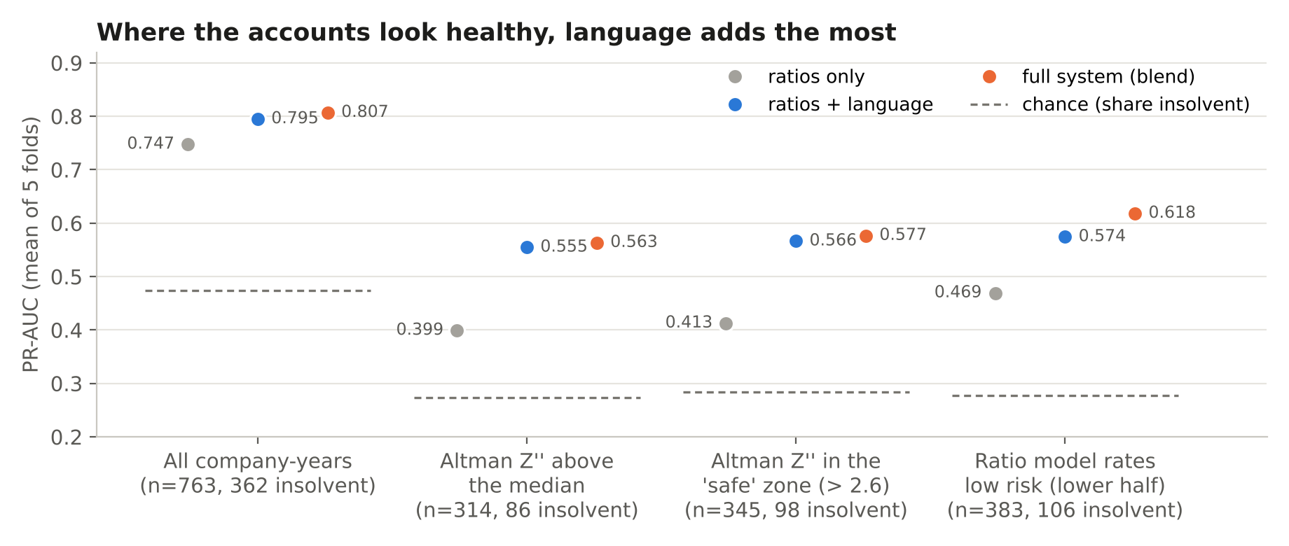
Figure 8. PR-AUC on healthy-looking subsets; dashed lines mark chance (the share of insolvent company-years).
This is the clearest result in the project. Among the company-years with above-median Altman Z″, the ratio model scores PR-AUC 0.399 against a chance level of 0.274. Adding language raises it to 0.555, a gain of +0.156 that is positive in 4 of 5 folds and whose 95% interval excludes zero; it is about three times the gain on the sample as a whole. With the conventional safe-zone cut-off the gain is +0.154 (5 of 5 folds), and without the accounts-missing flag it is +0.163 (4 of 5). On the ratio model's own lower-risk half, adding the language features gains less (+0.105, 4 of 5 folds, interval +0.006 to +0.227). The full system reaches 0.563 on the above-median subset (+0.164 over ratios, 4 of 5 folds, interval +0.050 to +0.305) and 0.618 on the ratio model's own lower-risk half (+0.149, interval +0.063 to +0.278).
Put plainly: the numbers already tell you when a company is visibly sick; the words help with the ones that look fine. One caution belongs with this result. Selecting companies on a ratio narrows the range of the ratios inside the subset, which handicaps the ratio model by construction; this is strongest for the subset defined by the ratio model's own scores, which is therefore only a robustness check. The Altman-based subsets are less affected, since Altman Z″ summarises only part of what the eleven ratios measure (it shares retained earnings to assets with them), and every model is scored on exactly the same companies.

7.6 H3: how early does the warning appear?
Table 16. Performance by horizon: the same out-of-fold predictions, scored within each horizon group.
Horizon | n (insolvent) | Ratios only | Ratios + language | Full system | Recall at 10% false alarms (full system)
t-1 (last report before admission) | 261 (131) | 0.819 | 0.834 | 0.842 | 59.7%
t-2 | 250 (125) | 0.733 | 0.794 | 0.814 | 52.1%
t-3 (three years before) | 208 (106) | 0.758 | 0.794 | 0.823 | 50.5%
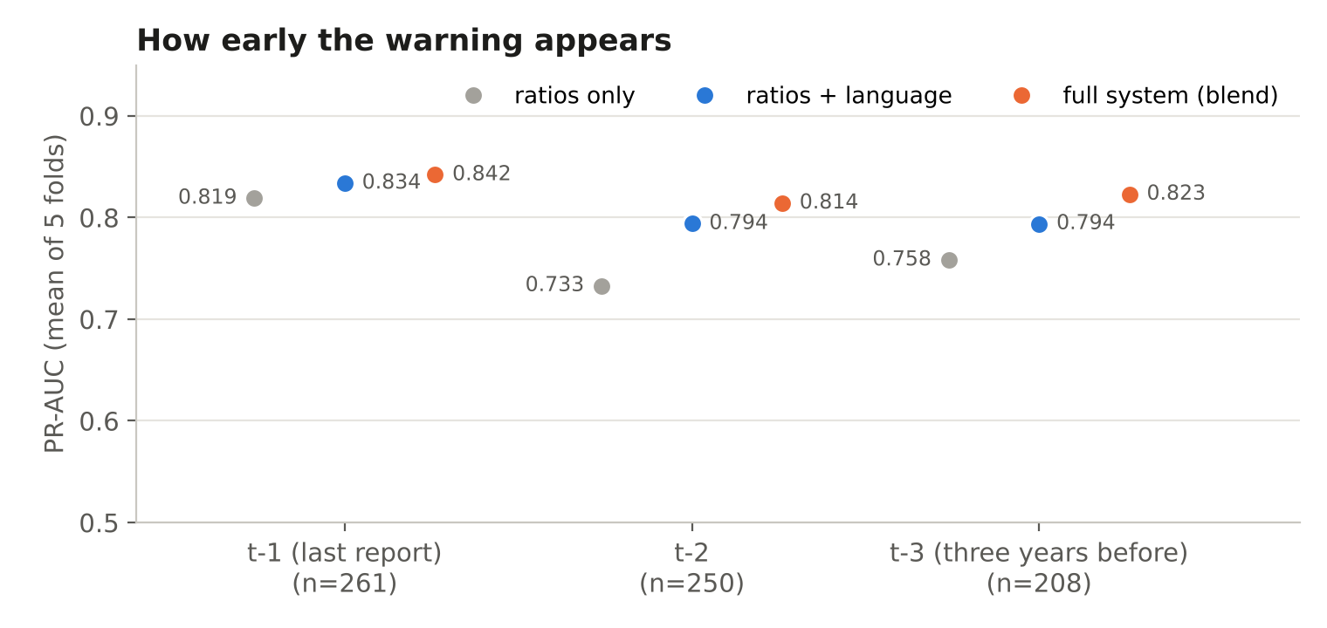
Figure 9. PR-AUC by horizon.
H3 is supported. The direct test is the language-only model: it stays well above chance at every horizon (ROC-AUC 0.749, 0.712 and 0.730 at t-1, t-2 and t-3), so report language is informative three years before admission. The full system beats ratios alone at every horizon (+0.023, +0.081 and +0.065), although with 208 to 261 company-years per horizon only the gain two years out reaches conventional significance (t-test p = 0.048; DeLong p = 0.016), and its PR-AUC stays between 0.814 and 0.842 across the three horizons. Language adds least where the accounts are already deteriorating (the last report) and most further out, which is the useful direction: a warning that appeared only weeks before the tribunal would have little value. The operational target set in the progress report, at least 60% of insolvencies caught one year ahead at a 10% false-alarm rate, is met by ratios plus language (61.0%) and just missed by the full system (59.7%).

7.7 H4: which part of the report carries the signal?
The progress report answered H4 by retraining the fusion network three times with a different text stream (MD&A 0.755, auditor 0.707, both 0.712 PR-AUC). That test was weaker than it looked: all three runs received the same 53 language features, including every auditor flag, so only the FinBERT stream changed; the gate gave that stream a weight of 0.07; and each run used one seed. Table 17 repeats the comparison in ways that isolate the section.
Table 17. PR-AUC by section of the report (763 company-years). The last column is auditor minus MD&A.
Model | MD&A | Auditor's report | Both | Auditor − MD&A
Engineered features, text only | 0.569 | 0.717 | 0.737 | +0.148 (5 of 5)
TF-IDF bag of words, text only | 0.530 | 0.670 | – | +0.140 (5 of 5)
Mined lexicon score, text only | 0.521 | 0.680 | – | +0.159 (5 of 5)
Averaged FinBERT + logistic, text only | 0.550 | 0.652 | – | +0.102 (5 of 5)
FinBERT + BiGRU network, text only (5 seeds) | 0.547 | 0.679 | 0.643 | +0.132 (5 of 5)
Ratios + that section's features (boosting) | 0.773 | 0.780 | 0.798
Fusion network, all features, text stream varied (5 seeds) | 0.782 | 0.793 | 0.791
On their own, the auditor's words are the stronger text. In every text-only comparison that isolates the section, the auditor's report beats the MD&A, and by a wide margin for the bag-of-words and lexicon models (+0.140 and +0.159 PR-AUC, five folds of five). The auditor's formal flags alone reach ROC-AUC 0.714. The FinBERT network confirms it: reading only the auditor's report it reaches PR-AUC 0.679, reading only the MD&A 0.547 (+0.132, 5 of 5 folds, interval +0.054 to +0.217). Inside the fusion network, giving it the auditor's report instead of the MD&A raises PR-AUC (0.793 against 0.782 over the same five seeds; the MD&A version wins 1 of 5 folds), the reverse of the single-seed result in the progress report.
Added to the ratios, the auditor's features also count slightly more. The auditor's features lift PR-AUC by +0.033 (5 of 5 folds, DeLong p = 0.003, pair-bootstrap interval −0.005 to +0.069) and the MD&A features by +0.025 (5 of 5 folds, interval −0.012 to +0.059); on the strict subset +0.024 and +0.015. Neither interval excludes zero, so the two sections are close once the ratios are known: much of what the auditor reports, defaults and losses, is already visible in the accounts. Before the correction of the CARO flags (Section 8) the order was the other way round (auditor +0.013, MD&A +0.025): the misread flags were what made the auditor's features look weak. Added on top of the ratios and the auditor's features, the MD&A adds a further +0.017 (4 of 5 folds, within the noise), and +0.024 on the above-median-Z″ subset (3 of 5, also within the noise).
Verdict on H4: supported in direction. The hypothesis as pre-registered, that the signal is not only the auditor's flags, holds in the sense that the MD&A features improve on the ratios in every fold; that they add to the auditor's own features is likely but not demonstrated at this sample size. The progress report's stronger claim, that management's discussion carries more signal than the auditor's report, is not supported and is withdrawn: on every comparison in Table 17 the auditor's report is at least as informative.

7.8 What the network uses
Three measurements say the same thing. The gate gives the FinBERT stream an average weight of 0.233, the language features 0.494 and the ratios 0.273 (the progress-report network gave text 0.07; the corrected network uses it more, and more for healthy companies, 0.283 against 0.177). Removing the stream does not hurt: the network without text scores 0.789 against 0.783 with it (2 of 5 folds favour the version with text). The attention is close to uniform: its normalised entropy averages 0.98 (1.00 means equal weight on every sentence), and the three most-attended sentences of a report are no more templated than the rest (mostly made of phrases found in ten or more other companies' reports: 3.7% of the top three, 3.7% of all sentences). The progress report's observation that attention landed on boilerplate does not survive the correction; the better description is that the network never learned to single out sentences at all. With about 490 training reports per fold, and early stopping after about a dozen epochs, this is the expected outcome: the sentence encoder needs far more examples than the sample provides, while counts such as the CARO default flag carry the same information in a form a small model can use.

7.9 An India-specific distress lexicon (contribution C)
Contribution C of the plan was to mine distress vocabulary from the reports themselves rather than borrow a US list. Terms (single words and two-word phrases) are ranked by the log-odds ratio with an informative Dirichlet prior (Monroe, Colaresi and Quinn, 2008), comparing distressed with healthy reports. Two safeguards: a term counts once per report, so one firm repeating an industry word hundreds of times cannot dominate; and a term must appear in the reports of at least ten different companies, which keeps company and place names out.
Table 18. Highest-ranked terms, with the number of distressed / healthy companies whose reports use them. Fitted on all reports (a descriptive output; the scores used for prediction are refitted inside each training fold).
 | Typical of insolvent companies | Typical of healthy companies
MD&A | net loss (36/13), lenders (30/10), global markets (16/6), loss before (33/15), of risks (31/23), their business (18/3), and information (16/9), management systems (23/14), grow in (25/12), the regulation (20/6), by its (28/19), attraction (10/2), of name (11/5), integrity and (22/11), growth path (15/6), sector for (17/8), material cost (13/3), downward trend (10/3) | interest coverage (22/53), operating profit (24/54), last financial (6/27), credit rating (7/27), exceptional circumstances (2/17), the salaries (4/18), aspects of (13/36), acquisition of (8/31), are any (2/16), ratings (10/26), margin (40/71), employee benefits (4/21)
Auditor's report | of rs (66/29), recovery (36/13), rs (82/49), accumulated (33/5), qualified (53/26), qualified opinion (46/16), lenders (37/7), to comment (33/10), unable (42/16), unable to (42/16), interest on (31/7), current assets (43/15), comment (36/12), comment on (30/5), for qualified (43/16), are unable (37/14), provision of (47/21), matter described (42/16) | statements key (26/48), overview (11/32), icai firm (5/16), process and (10/23), were applied (2/13), and judgements (2/14), is regular (4/16), overview statutory (10/27), directors either (10/21), reports financial (12/29), of reporting (4/15), the design (45/68)
The lists read sensibly. Among the highest-ranked terms, insolvent companies' auditors write "qualified opinion", "unable to comment", "accumulated losses", "net worth", "eroded", "lenders", "interest on" and "not provided"; their management writes about a "net loss", "lenders", a "downward trend" and "fluctuating" and "difficult" conditions. Healthy companies' management discusses its "interest coverage", "operating profit", "credit rating" and "margin", and their auditors' reports carry more of the standard wording of the modern audit report ("overview", "ICAI firm", "judgements"). Some generic phrases also rank highly, a reminder that the lists are statistical associations to be read with care. Used as a fold-safe score, the lexicon is a strong single text signal for the auditor's report (ROC-AUC 0.706), changes the language-only model by +0.011 PR-AUC (interval −0.013 to +0.036; DeLong p = 0.078) and adds +0.010 once ratios are present (5 of 5 folds; interval −0.003 to +0.026): small, and not distinguishable from zero. The full ranked lists are released with the project (Section 12).

7.10 Negative and null results
- Perplexity. A Kneser-Ney trigram model fitted on healthy companies' MD&A in the training folds only scores ROC-AUC 0.503 as a single predictor; removing it from the ratios + language model changes PR-AUC by +0.003 (4 of 5 folds favour the model without it). Indian MD&A sections are heavily templated, so a trigram model mostly learns boilerplate shared by both groups.
- Year-on-year drift (contribution A). Removing the seven drift features changes PR-AUC by −0.001 (3 of 5 folds favour the model without them). The Lazy Prices effect does not appear in this sample, possibly because only up to three consecutive reports per firm are available and the first has no predecessor.
- Hyperparameter search. In the progress-report runs, a nested Optuna search over nine settings improved PR-AUC by 0.007, while averaging three seeds improved it by 0.023 and cut the fold-to-fold spread from 0.090 to 0.064; inner-validation and test scores correlated at r = +0.07. With ~120 validation rows the search cannot tell a good configuration from a bad one, which is why the final network uses one fixed configuration and seven seeds.
- Calibration. The probability models are not well calibrated on this sample (Brier score 0.202 for ratios + language, against 0.249 for always predicting the base rate; 0.195 for the network's averaged probabilities). Scores should be read as rankings; a deployed screen would need recalibrating on data at the real prevalence.

7.11 Leak test
The network was retrained on all five folds with the labels randomly permuted. It scores ROC-AUC 0.525 (mean of the five folds, which range from 0.48 to 0.56; 0.513 pooled), as it should: nothing in the inputs encodes the outcome. The progress report's version of this test used two folds and gave 0.475.

8. What Changed Since the Progress Report
The progress report of 1 October was written from a sequence of notebook runs. Rebuilding the whole analysis from the dataset, on frozen folds and with every prediction saved, confirmed its main conclusions and corrected several details. They are listed here so that no number in the earlier report is relied on without its correction.
Table 19. Corrections and additions.
Progress report | Final report | Why
Text alone reached ROC-AUC 0.69 to 0.72 (FinBERT network on the MD&A) | About 0.7 only from the auditor's report (0.699 to 0.706); the FinBERT network on the MD&A alone 0.576 (Table 12) | One run of the uncorrected network, 609 rows, pooled scoring; repeated with five seeds
MD&A beats the auditor's report (0.755 vs 0.707); "it is management's own words" | Withdrawn. The auditor's report is the stronger text on its own and, slightly, on top of the ratios (Section 7.7) | The earlier test varied only the FinBERT stream, which the gate largely ignored, with one seed
The language signal comes from tone, hedging and readability | Mostly from the auditor's formal flags, above all the CARO loan-default flag (Figure 7) | Permutation importance was not run before
CARO loan-default and unpaid-dues flags as extracted: raised for 14% and 26% of healthy company-years | Corrected: 6% and 2% of healthy company-years (41% and 16% of insolvent ones); 288 values changed, all listed with the sentence read | The rule cut clauses at the PDF's line breaks, so "has not / defaulted" read as a default; found while building the scoring tool (Section 10)
Ratios + language +0.035 over ratios | +0.048; language without the accounts-missing flag +0.050; the flag alone +0.012 (Table 14) | The flag had been filed with the language features
Healthy-looking firms: full system +0.160 over ratios, no interval | Full system +0.164, 95% interval +0.050 to +0.305; ratios + language +0.156, five folds of five; holds with the Altman safe-zone cut-off (Table 15) | Interval and robustness checks added
Network: 200 sentences, GRU 64, dropout 0.3, gamma 2, adversarial head | As trained: 96 sentences, GRU 32, dropout 0.5, gamma 1, no adversarial head (Table 6) | The report described the plan, not the trained model
About 0.36 million trainable parameters | 185,924 in the trained 32-unit network | 0.36 million is the 64-unit configuration
The recurrent layer read all 200 slots including padding | Reads exactly the first 96 sentences, padding skipped | Implementation error, fixed
Folds re-created by GroupKFold at run time | Folds frozen in folds.csv | Library versions assign 79% of rows differently
Recall at 10% false alarms, Brier, DeLong, 1:10 prevalence, Altman and logistic baselines promised | All reported (Tables 10 and 11; Brier in Section 7.10) | Pre-registered; not delivered before
Distress lexicon "to be published" | Mined, evaluated fold-safely and released (Section 7.9) | Contribution C completed

9. Limitations
- Sample size is the binding constraint. 763 company-years from 135 pairs, for a network with about 186,000 trainable parameters; five folds give little statistical power, which is why intervals accompany the main estimates and why several honest differences remain inside the noise.
- A balanced, matched sample flatters precision. The 1:10 re-weighting in Table 10 shows what the ranking is worth at a more realistic prevalence; a deployed screen would see many more healthy companies than this study does.
- Hand checks only partly done. The corrected CARO flags were checked against the reports' wording, and every changed flag is listed with the sentence the rule read (handcheck/) for the team to confirm. The 10% spot check of extracted financial figures against the PDFs (108 company-years) and the hand check of section extraction have not been completed, so extraction accuracy is measured against XBRL (91.8% within 1%) but not yet by hand.
- A single company's score is less certain than the averages. Retraining the boosting model after a change to the statutory-dues flag of 7 of the 763 company-years moved one test company's percentile by 18 points; the cross-validated averages moved by less than 0.01. Scores near a band boundary should be read as borderline.
- Not built from the plan: the adversarial business-group head (the sample contains at least one same-group pair), company-name masking, coreference and subject-verb-object features, and the Word2Vec + CNN baseline. Grouping folds by pair prevents any company from appearing on both sides of a split, and the lexicon's ten-company rule keeps names out of the vocabulary, but neither is a substitute for the planned group test.
- Promoter pledge is missing because the exchange shareholding filings were not collected.
- The 44 additional healthy reports relax the pair rule; the main results are also given on the strict subset and, for the gradient-boosting models, after retraining on strict rows only.
- The healthy-looking subsets are selected on ratios, which narrows the ratios' range inside them and so favours the other models somewhat, most for the subset defined by the ratio model's own scores; the absolute scores there should not be compared with the full sample.

10. Scoring a New Company
The project's purpose is a tool: an annual report goes in, and a statement of insolvency risk comes out. score.py does this for any listed company's report as a PDF, in under a minute on the GPU computer (about 20 seconds without the network). It runs the same code that built the training data, so a new report is read exactly as the 763 training reports were: on two training reports it reproduced all 51 language features exactly, and the ratios wherever the financial statements have a text layer.
Table 20. What score.py does with one annual report.
Step | What happens
Read | Text of every page (OCR for scanned pages when Tesseract is installed); the MD&A, auditor's report and CARO annexure located; the report year checked
Language features | The 51 engineered features, the CARO flags, perplexity under the five fold language models (so its scale matches training), and drift when last year's report is supplied
Ratios | The balance sheet and profit and loss read from the report; the 11 ratios; figures the reader misses can be supplied in a file
Models | Gradient boosting fitted on all 763 company-years, and the gated network trained seven times on all of them (FinBERT reads the MD&A)
Score | Each model's output is placed among its own cross-validated scores and the two are averaged 50/50; the risk score is the share of healthy company-years that scored lower
Band | High: above 90% of healthy company-years (in cross-validation this band caught 49% of insolvent company-years); Watch: above 70% (caught 78%); Low: the rest
Reasons | Score change when each family of features is swapped for that of 150 real healthy company-years; the auditor's own sentences behind every flag; each ratio against healthy companies; the MD&A sentences the network weighted most; warnings about anything the reader could not find
Three companies the models never saw. None of these firms is in the training data: two insolvent companies that had no eligible peer and one healthy company whose pair was retired from the cohort.
Table 21. Scores of three unseen annual reports (full system).
Company and report | What happened | Risk score | Band | What the tool showed
SEL Manufacturing, FY2017 report | Admitted to insolvency 27 April 2018 | 97 | High | Qualified audit opinion (interest of Rs 359 crore not provided on bank loans classed as NPA), the CARO statement that it "has defaulted in repayment of loans", debt 22.6 times equity, all shown on the card
Rane (Madras), FY2022 report | Healthy (a matched peer; never admitted) | 40 | Low | No auditor's flags beyond a COVID-19 emphasis of matter; current ratio 0.89 and debt/equity 1.19 are weak, the other ratios near healthy medians
JVL Agro Industries, FY2017 report | Admitted to insolvency 27 July 2018 | 58 | Low | Missed. Only 1,968 characters of the auditor's report were found and the opinion was not identified (both flagged as warnings on the card); ratios middling
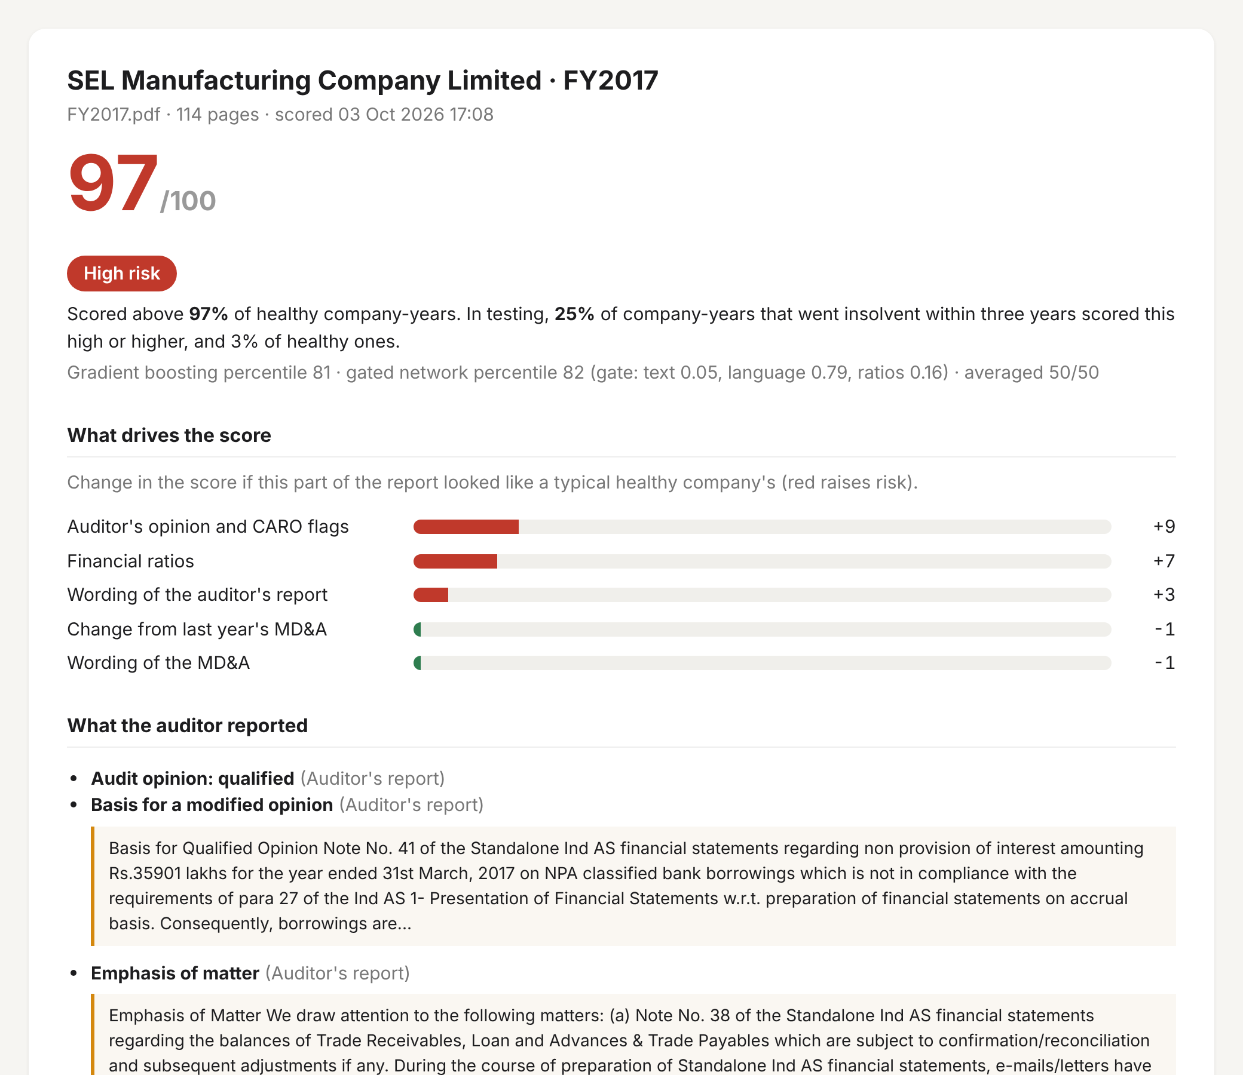
Figure 10. The score card for SEL Manufacturing's FY2017 report (top of the page).
The two correct calls behave as intended: SEL Manufacturing, a year before admission, is flagged on its auditor's qualified opinion and its loan default, both quoted; Rane (Madras) scores below most healthy companies. JVL Agro is a miss, and the card says why it may be one: only 1,968 characters of its auditor's report were found and the opinion could not be identified, so the strongest family of features was largely missing. A score is a ranking against the study's sample, not a probability: the sample is one insolvent company for every healthy one, while insolvency is far rarer among listed companies.

11. Conclusion
Do the words in an Indian annual report warn of insolvency earlier, or better, than the numbers? Better, modestly; and most where the numbers look fine. The full system, which adds report language and a deep model to the ratios, lifts PR-AUC from 0.747 to 0.807, in every fold, with a pair-bootstrap interval that excludes zero; on companies whose accounts look healthy the gain is about three times larger (+0.164). Earlier, yes: the signal holds three years before admission, and language adds least on the last report, when the accounts already show the trouble. The words that matter are mostly the auditor's, above all the CARO statements that the company has defaulted on its borrowings or left statutory dues unpaid; management's discussion may add a little on top of them (within the noise). A transformer reading the sentences did not add to that at this sample size; counting did. The most useful next step is therefore more data (wider peer matching, more years per company), not a larger model. The finished system scores a new company's annual report in under a minute and shows the auditor's own words behind its score (Section 10).

12. Reproducibility
Everything in this report can be regenerated from the dataset folder and the files below. The folds are fixed in a file, the deep-learning run checks that it has built the identical table (checksum 7aadd5825d32c806), and every out-of-fold prediction is saved so that any table can be recomputed without retraining.
Table 22. Files of the final run (folder final_run/ in the project directory).
File | What it is
bpp_final/run_gpu.py, bppfinal/dl.py, bppfinal/table.py | The deep-learning run: table, FinBERT embeddings, 45 network runs (resumable; 178 minutes on an RTX 5060 Ti; after the CARO correction the 30 runs that read the language features were repeated in 75 minutes and the 15 text-only runs reused)
bpp_final/data_v2/language_features.csv | The language features with the corrected CARO flags (the only file of the dataset that changed)
bpp_final/folds.csv | The frozen fold of every company-year
gpu_v2/results_v2/ (dl_oof.csv, runs/, attn_*.npy, run_info.json) | What the GPU run saved: every network's out-of-fold predictions, gate and attention weights (analysis/archive_v1/ keeps the run before the correction)
analysis/run_cpu.py, bppfinal/cpu_models.py | Every model that needs no GPU: baselines, text-only models, lexicon
analysis/extras_cpu.py, attention.py | Permutation importance, the tone replication, the attention analysis
analysis/analyze.py, bppfinal/stats.py | All metrics, paired tests, bootstrap and DeLong; writes results_final/tables.json
analysis/results_cpu/, analysis/results_final/ | Out-of-fold predictions of every model (all_oof.csv), tables.json, importance, the released lexicons (contribution C)
report/build_report.js, make_narrative.py, charts.py, diagrams.py | This document and its figures, generated from tables.json
score.py, scorer/, train_final.py, train_final_dl.py, gpu_v2/final_models/ | The scoring tool of Section 10 and the final models it loads
handcheck/ | Every CARO flag the correction changed, and a sample it did not, with the sentence the rule read, for checking by hand

13. References
[1] Altman, E. I. (1968). Financial ratios, discriminant analysis and the prediction of corporate bankruptcy. The Journal of Finance, 23(4), 589–609.
[2] Loughran, T., & McDonald, B. (2011). When is a liability not a liability? Textual analysis, dictionaries, and 10-Ks. The Journal of Finance, 66(1), 35–65.
[3] Mai, F., Tian, S., Lee, C., & Ma, L. (2019). Deep learning models for bankruptcy prediction using textual disclosures. European Journal of Operational Research, 274(2), 743–758.
[4] Cohen, L., Malloy, C., & Nguyen, Q. (2020). Lazy prices. The Journal of Finance, 75(3), 1371–1415.
[5] Huang, A. H., Wang, H., & Yang, Y. (2023). FinBERT: A large language model for extracting information from financial text. Contemporary Accounting Research, 40(2), 806–841.
[6] Arno, H., Mulier, K., Baeck, J., & Demeester, T. (2024). From numbers to words: Multi-modal bankruptcy prediction using the ECL dataset. arXiv:2401.12652.
[7] Mancisidor, R. A., & Aas, K. (2024). Multimodal generative models for bankruptcy prediction using textual data. arXiv:2211.08405.
[8] Gupta, V. (2022). Bankruptcy prediction using machine learning techniques: Evidence on Indian companies under Insolvency and Bankruptcy Code. The Journal of Prediction Markets, 16(2), 77–100.
[9] Gupta, V., & Banerjee, A. (2023). Using textual analysis in bankruptcy prediction: Evidence from Indian firms under IBC. Investment Management and Financial Innovations, 20(3), 22–34.
[10] Ganin, Y., & Lempitsky, V. (2015). Unsupervised domain adaptation by backpropagation. Proceedings of the 32nd International Conference on Machine Learning, PMLR 37, 1180–1189.
[11] Devlin, J., Chang, M.-W., Lee, K., & Toutanova, K. (2019). BERT: Pre-training of deep bidirectional transformers for language understanding. Proceedings of NAACL-HLT 2019, 4171–4186.
[12] Lin, T.-Y., Goyal, P., Girshick, R., He, K., & Dollár, P. (2017). Focal loss for dense object detection. Proceedings of ICCV 2017, 2980–2988.
[13] Monroe, B. L., Colaresi, M. P., & Quinn, K. M. (2008). Fightin' words: Lexical feature selection and evaluation for identifying the content of political conflict. Political Analysis, 16(4), 372–403.
[14] DeLong, E. R., DeLong, D. M., & Clarke-Pearson, D. L. (1988). Comparing the areas under two or more correlated receiver operating characteristic curves: A nonparametric approach. Biometrics, 44(3), 837–845.
[15] Sun, X., & Xu, W. (2014). Fast implementation of DeLong's algorithm for comparing the areas under correlated receiver operating characteristic curves. IEEE Signal Processing Letters, 21(11), 1389–1393.

