PROGRESS REPORT
Early Prediction of Corporate Insolvency for Indian Listed Companies Using Annual-Report Text and Financial Ratios
A deep learning system that combines the language of annual reports with financial ratios to identify companies likely to be admitted to the NCLT under the Insolvency and Bankruptcy Code, 2016.
Courses | Natural Language Processing and Deep Learning (third-year project)
Report date | 21 September 2026
Current stage | Data pipeline built and tested; dataset collection in progress
Objective | To measure how much early-warning signal annual-report language carries, which part of the disclosure carries it, and how early it appears. The project does not assume that language performs better than financial ratios.

1. Introduction and Objective
Corporate insolvency is rarely sudden. Before a creditor files an insolvency petition before the National Company Law Tribunal (NCLT), signs of stress appear in two places: in the financial statements and in the language of the annual report. Financial ratios such as debt-to-equity and interest coverage are the conventional warning signals, but they are lagging indicators. By the time the accounts show clear weakness, the case has often already reached the tribunal. Accounts may also be presented favourably or filed late.
The language of the report changes earlier. Under stress, management hedges more often, writes defensively about working capital and refinancing, and the auditor begins to add qualifications and going-concern warnings. This project builds a deep learning model that reads both sources of evidence for the same company-year and produces a risk score 12 to 24 months before admission, together with the sentences and ratios responsible for that score.
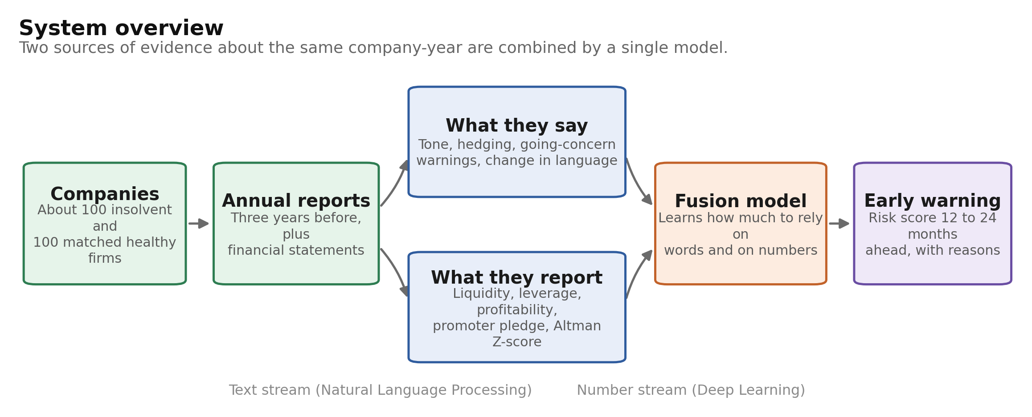
Figure 1. Overview of the proposed system.
Table 1. Terms used in this report.
Term | Meaning
IBC, 2016 | Insolvency and Bankruptcy Code, the law under which insolvent Indian companies are resolved.
NCLT | National Company Law Tribunal, the body that admits a company into insolvency. Admission is the event being predicted.
IBBI | Insolvency and Bankruptcy Board of India, the regulator that publishes every insolvency announcement. This is the source of the labels.
MD&A | Management Discussion and Analysis, the section in which management explains the year and the outlook.
CARO annexure | The annexure in which the auditor must report loan defaults and unpaid statutory dues.
Going concern | A formal statement by the auditor that the company may be unable to continue operating.

2. Literature Reviewed
Ten studies form the basis of the design. Each one determines a specific choice: the baseline to beat, the features to extract, the model to use, or the risk to control. The final column states what has been taken from each.
Table 2. The ten studies and their contribution to this project.
# | Study | What it studied | What is taken from it
1 | Altman (1968), Journal of Finance | 33 bankrupt and 33 healthy US firms; five ratios combined by discriminant analysis (the Z-score). | The classical ratio model. Its emerging-market form is implemented as a baseline.
2 | Loughran and McDonald (2011), Journal of Finance | General sentiment word lists misclassify financial text; a finance-specific dictionary was built. | Tone features are computed with the finance dictionary rather than a general one.
3 | Mai, Tian, Lee and Ma (2019), European Journal of Operational Research | 11,827 US firms; deep learning on report text. Text with ratios outperformed ratios alone, and averaged word embeddings outperformed CNNs. | Evidence that text adds information, and a caution that simple text models perform best on small samples.
4 | Cohen, Malloy and Nguyen (2020), Journal of Finance | Year-on-year changes in a company's annual filing predict returns, earnings and bankruptcies. | The basis of the drift features: the model receives the change in language across three years.
5 | Huang, Wang and Yang (2023), Contemporary Accounting Research | FinBERT, a BERT model further trained on financial text, outperforms general models on financial disclosure. | The sentence encoder used in the model. It is kept frozen so that few parameters are trained.
6 | Arno, Mulier, Baeck and Demeester (2024), ECL dataset | A public dataset of report text and financial data with bankruptcy labels; the two modalities were found to be complementary. | Support for the fusion design, and the reason the one-year and two-year horizons are tested separately.
7 | Mancisidor and Aas (2022, revised 2024) | A multimodal model using accounting, market and MD&A data; text was unavailable for roughly 40 per cent of firms. | Missing reports are recorded rather than ignored, and late or absent filing is treated as a feature.
8 | Gupta (2022), The Journal of Prediction Markets | 57 Indian firms insolvent under the IBC and 55 matched solvent firms; 31 variables; random forest performed best, all models above 75 per cent accuracy. | The Indian benchmark on ratios alone, the matched-sample design, and the variables to include.
9 | Gupta and Banerjee (2023), Investment Management and Financial Innovations | The same Indian sample studied as text: insolvent firms showed significantly greater negative tone (2.21 per cent against 1.30 per cent of words). | The closest existing study and the direct motivation. It uses dictionary counts only, with no model and no horizon test.
10 | Ganin and Lempitsky (2015), ICML | Domain-adversarial training with a gradient reversal layer, so that a second head cannot identify the source of the input. | The method used to test whether the model has learnt distress language rather than company identity.

- Ratios are effective but late. Altman (1968) and Gupta (2022) both achieve useful accuracy from ratios alone, so both are implemented as baselines.
- Text carries additional information. Mai et al. (2019) and Arno et al. (2024) report complementary signals on large samples, and Gupta and Banerjee (2023) show that the tone difference is present in Indian filings.
- Reported gains are moderate rather than large, typically a few points of AUC. With about 100 insolvent firms, a gain of this size may not reach statistical significance, so results will be reported with confidence intervals.
Table 3. Limitations of existing Indian studies and the corresponding extension in this project.
Aspect | Existing Indian studies | This project
Use of text | Words are counted with a dictionary and averages are compared between groups. No prediction is made from the text. | The text is given to a trained model that produces a prediction, and that model is compared directly against a ratios-only model.
Prediction horizon | A one-to-two-year lead is stated, but each year is not tested separately. | Separate models are trained for one year and two years before admission, and results are reported for each.
Risk of memorising firms | Not examined. | Company names are masked, and an adversarial test checks that business-group identity cannot be recovered from the model.
Vocabulary | US dictionaries are applied to Indian filings without modification. | An India-specific distress phrase list is built from the reports themselves and published.
Sections used | Mainly the Management Discussion and Analysis. | The auditor's report and CARO annexure are also extracted, since they contain going-concern warnings and reported defaults.

3. Data and Sample Design
All sources are public, except the financial database, for which annual reports serve as a substitute if access is unavailable.
Table 4. Data sources.
Source | Data taken | Purpose
IBBI public announcements | Every insolvency admission since 2016, with company name and date | The label and the event date
BSE and NSE company lists | Listed companies, including suspended and delisted ones | Insolvent firms are usually suspended, so an active-only list would exclude them
Annual report PDFs | MD&A, Board's Report, Auditor's Report, CARO annexure | The text input to the model
CMIE Prowess or the reports | Industry code, total assets and ratio inputs | Peer matching and the numerical input
Loughran-McDonald dictionary | Finance-specific word lists | Tone and uncertainty features

Each insolvent company is matched to a healthy company in the same industry and of similar size, following the design used by Gupta (2022). Every name match is confirmed manually, because an incorrect match places a healthy company in the insolvent group and distorts all later results.
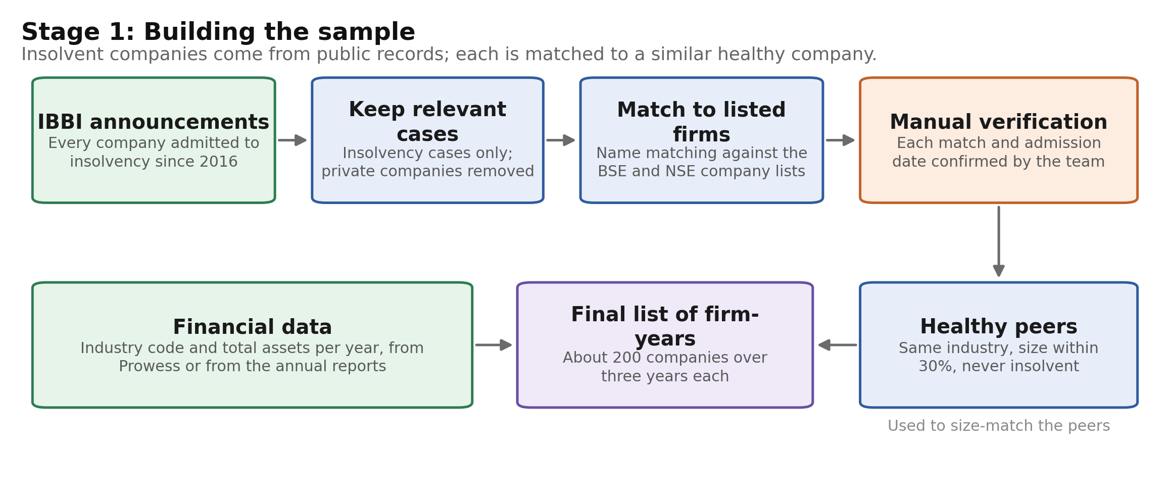
Figure 2. Construction of the matched sample.
Labelling is based on the publication date of each report. A report published after the insolvency petition has been filed usually discusses the case directly, so a model trained on it would be reading the outcome rather than predicting it. The rules below remove this possibility.
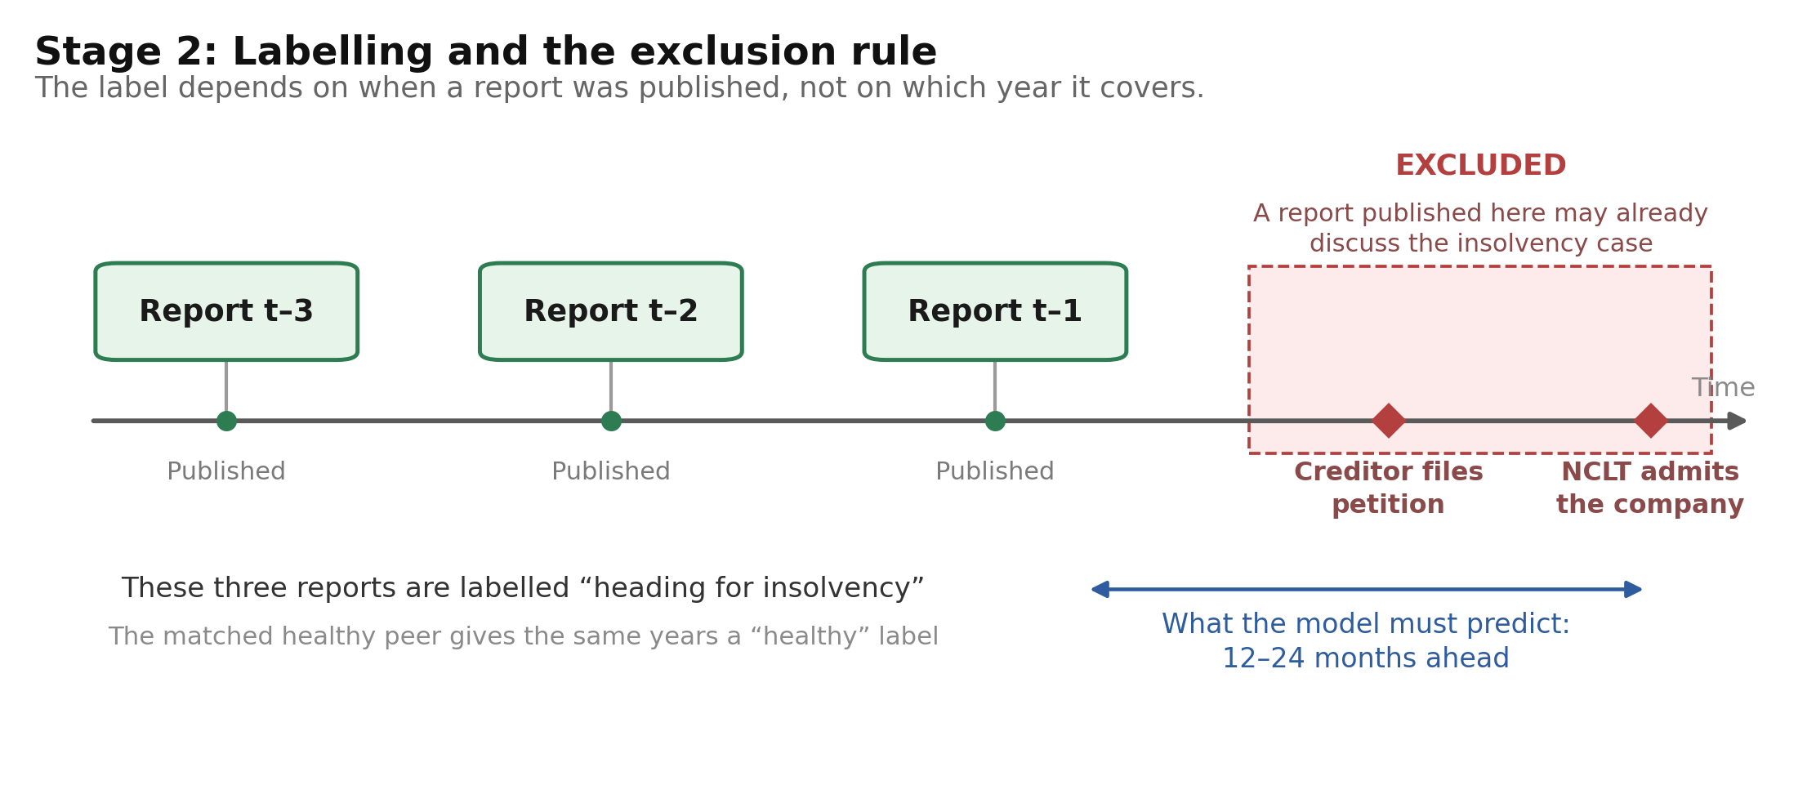
Figure 3. Labelling and the exclusion rule.
Table 5. Rules that prevent label leakage.
Rule | Reason
Reports are labelled by publication date, not by fiscal year | The label must reflect what a reader could have known at that time
Reports published after the insolvency petition are excluded | They describe the case itself
Reports published within 180 days of admission are excluded | The same risk applies when the petition date is unknown
If a year is excluded for an insolvent firm, it is excluded for its matched peer | Prevents the model from learning the calendar year instead of distress
Training and test sets are split by company, never by report | Two reports of the same company must not appear on both sides

4. Data Preparation
Each annual report is converted into structured text before it reaches the model. Every stage writes one output file, so stages can be re-run independently.
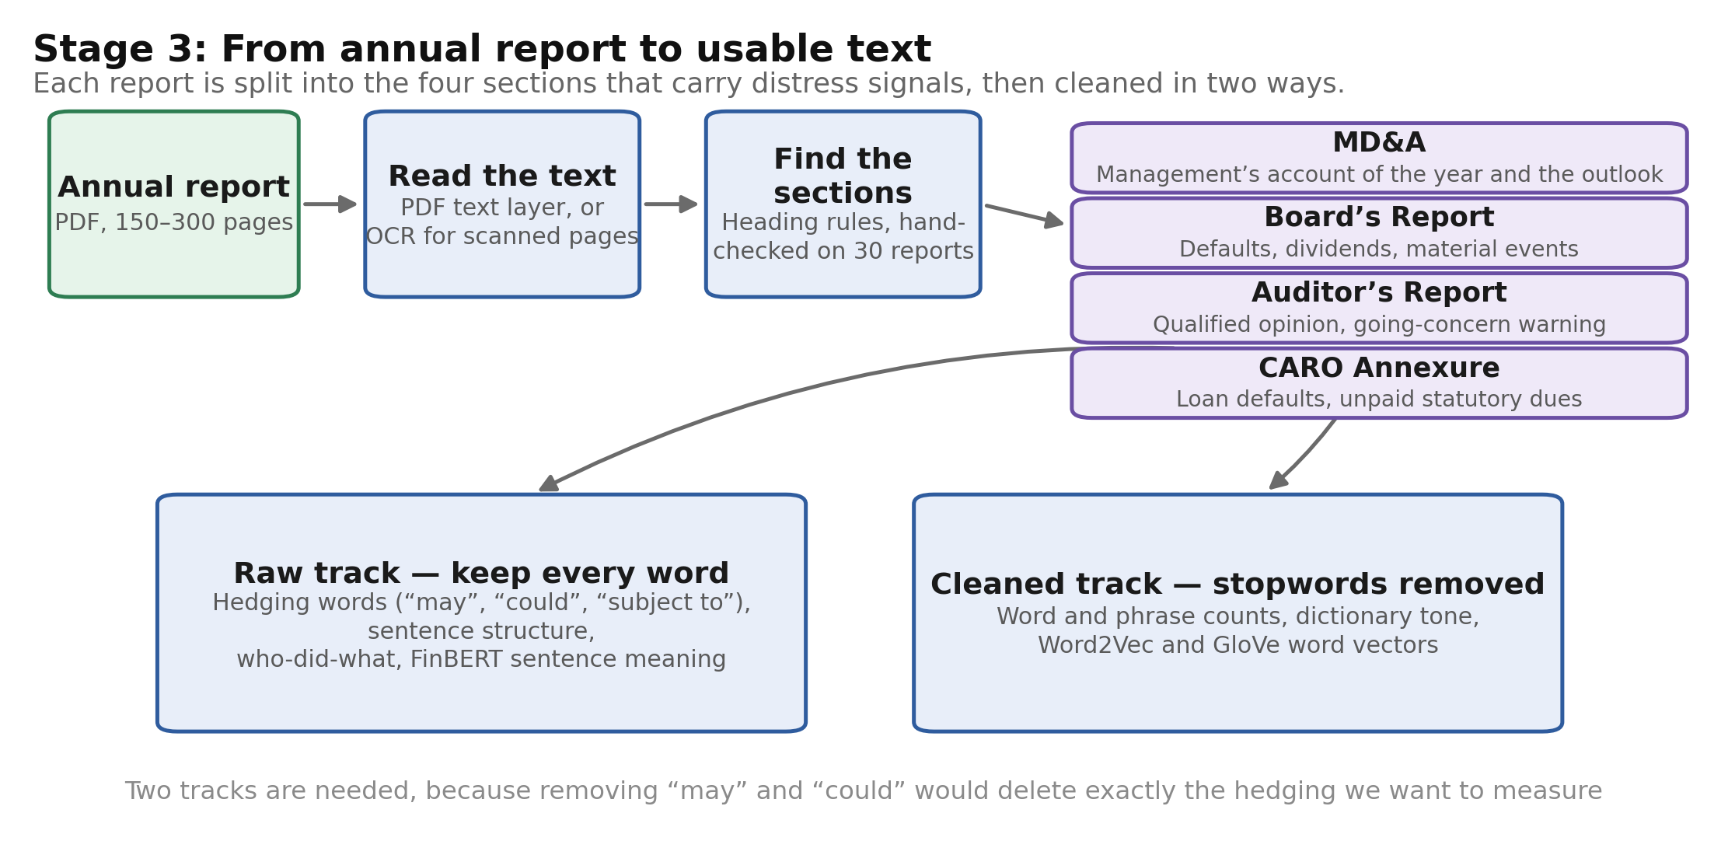
Figure 4. Conversion of an annual report into model-ready text.
Table 6. Data preparation stages.
Stage | Process | Output
1. Sample construction | Insolvency records filtered, matched to listed companies, verified manually | About 100 matched pairs
2. Report collection | Three annual reports per company downloaded, with publication dates recorded | 600 to 800 PDF files
3. Text extraction | PDF text layer read; OCR applied to scanned pages | Page-level text
4. Section splitting | MD&A, Board's Report, Auditor's Report and CARO annexure located by heading patterns | Four sections per report
5. Labelling | Exclusion rules applied; label and horizon (t-1, t-2, t-3) assigned | The modelling table
6. Language features | Tone, hedging, going-concern and default flags, readability, perplexity, year-on-year drift; FinBERT sentence vectors | 25 values and one sentence matrix per report
7. Financial features | Liquidity, profitability, leverage and solvency ratios, promoter pledge, Altman Z-score | 12 values per company-year

The text is cleaned in two ways. Standard cleaning removes stopwords, but words such as “may”, “could” and “subject to” are stopwords and are also the hedging that the project sets out to measure. A raw version therefore retains every word for grammatical analysis and for FinBERT, while a cleaned version is used for word counts and word vectors.

5. Deep Learning Model

5.1 Input to the model
One training example is a single company-year: one annual report and the financial data for that year. It is represented by three streams.
Table 7. Input streams for one company-year.
Stream | Content | Shape
A. Report sentences | Sentences from the MD&A, Board's Report and Auditor's Report, with company names masked, encoded by FinBERT | Up to 200 sentences, each a 768-value vector, with a padding mask
B. Language features | Negative, uncertainty and weak-modal tone ratios; hedging density; going-concern, qualified-opinion and CARO default flags; readability; perplexity; year-on-year drift | 25 values
C. Financial ratios | Current ratio, quick ratio, cash to assets, EBITDA margin, ROCE, ROA, debt-to-equity, debt-to-EBITDA, interest coverage, retained earnings to assets, promoter pledge, Altman Z-score | 12 values

5.2 Architecture
Each stream is encoded separately and the three encodings are combined by a gate, which learns how much weight each stream should receive for that company-year. This matters in practice: when a report is largely boilerplate the ratios should dominate, and when the ratios still appear sound but the auditor has added a going-concern paragraph the text should.
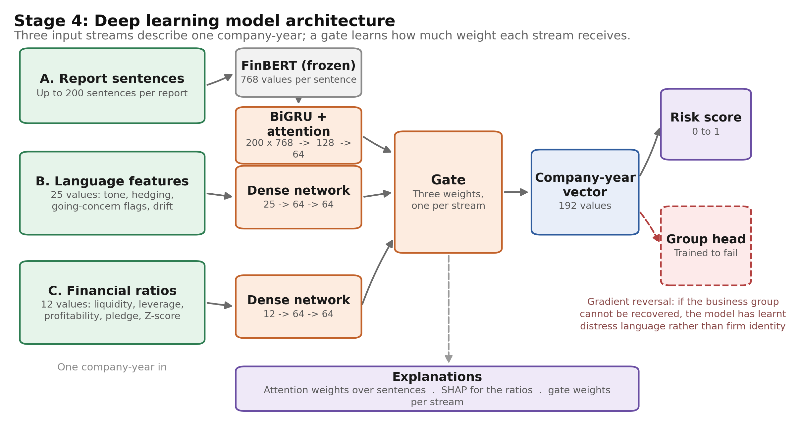
Figure 5. Model architecture with layer sizes.
Table 8. Layer-by-layer specification.
Component | Input to output | Details
FinBERT encoder (frozen) | sentence text to 200 x 768 | Pre-trained financial BERT; not updated during training
Bidirectional GRU | 200 x 768 to 200 x 128 | 64 hidden units per direction
Attention pooling | 200 x 128 to 128 | Additive attention; the weights identify the sentences used
Text projection | 128 to 64 | Linear layer with ReLU
Language-feature network | 25 to 64 to 64 | Two dense layers, ReLU, dropout 0.3
Ratio network | 12 to 64 to 64 | Two dense layers, batch normalisation, ReLU, dropout 0.3
Gate | 192 to 3 | Softmax over the three streams; each 64-value block is scaled by its weight
Fused representation | 3 x 64 to 192 | Concatenation of the weighted streams
Prediction head | 192 to 64 to 1 | ReLU, dropout 0.3, sigmoid output
Business-group head | 192 to 64 to G | Preceded by a gradient reversal layer; G is the number of groups

The trainable model has approximately 0.4 million parameters. The FinBERT encoder, with about 110 million parameters, is frozen, which is what makes deep learning feasible on a dataset of a few hundred reports.

5.3 Training configuration
Table 9. Training settings.
Setting | Value | Reason
Loss function | Focal loss (gamma = 2) plus 0.1 x cross-entropy on the business-group head | Insolvency is the rare class; focal loss concentrates on it
Optimiser | AdamW, learning rate 1e-3, weight decay 1e-4 | Standard for small networks with regularisation
Batch size and epochs | 32, up to 100 epochs | Early stopping on validation PR-AUC, patience 10
Validation | Five-fold cross-validation grouped by company | No company appears in both training and test folds
Hyper-parameter search | Optuna, inside the training folds only | Prevents tuning on the test fold
Hardware and time | Google Colab T4 GPU; a few minutes per fold | FinBERT vectors are computed once and cached

5.4 Model variants and baselines
Table 10. Models to be trained.
Model | Type | Purpose
Altman Z-score threshold | Formula | Classical benchmark
Logistic regression on ratios | Statistical | Standard baseline
XGBoost on ratios | Tree ensemble | Strongest model in the comparable Indian study
Word2Vec with 1D-CNN | Deep learning | Text baseline following Kim (2014); filter widths 3, 4 and 5
FinBERT with BiGRU (text only) | Deep learning | Measures the text stream on its own
Gated fusion network | Deep learning | The proposed model
Fusion with temporal GRU | Deep learning | Adds the three-year sequence of company-year vectors to capture language drift

5.5 Expected output and target performance
For each company-year the model outputs a probability between 0 and 1 that the company will be admitted to the NCLT within 12 to 24 months of the report's publication. Alongside it, the model returns the attention weights over sentences, the SHAP values for the ratios, and the gate weights showing how far the prediction relied on text rather than numbers. The decision threshold is fixed on the validation folds at a 10 per cent false-alarm rate.
Table 11. Indicative performance targets at one year before admission.
Model | Inputs | Target ROC-AUC | Basis
Altman Z-score | One score | About 0.70 | Classical benchmark
Logistic regression | 12 ratios | 0.74 to 0.78 | Standard baseline
XGBoost | 12 ratios | 0.78 to 0.82 | Gupta (2022) reports over 75 per cent accuracy on a similar Indian sample
FinBERT with BiGRU | Text only | 0.70 to 0.78 | Text-only models in Mai et al. (2019) and Arno et al. (2024)
Gated fusion (proposed) | All three streams | 0.82 to 0.86 | Both studies report gains when text is added to financial data
Gated fusion at two years | All three streams | 0.72 to 0.78 | Signal weakens as the horizon lengthens

These are planning targets drawn from comparable published studies, not results. Two points should be read with them. First, with about 100 insolvent firms the 95 per cent confidence interval on AUC is roughly plus or minus 0.07, so point estimates will always be reported with intervals. Second, the secondary target is operational rather than statistical: at a 10 per cent false-alarm rate the fused model should identify at least 60 per cent of the insolvent firms one year ahead.

6. Evaluation Plan
A balanced sample and plain accuracy would overstate performance, so the metrics, experiments and hypotheses are fixed in advance.
Table 12. Metrics.
Metric | What it measures
PR-AUC | Performance when the positive class is rare; the headline metric
ROC-AUC | Comparability with published studies
Recall at a 10 per cent false-alarm rate | The operational question: how many insolvencies are identified at an acceptable review load
Brier score | Whether the predicted probabilities are well calibrated
DeLong test | Whether a difference between two models is statistically significant

Table 13. Experiments.
Experiment | Question answered
Ratios only, text only, language features only, all three | Does text add information beyond the ratios?
Word2Vec with CNN against FinBERT with BiGRU | Is the larger language model justified at this sample size?
With and without company-name masking | Is the model memorising company identity?
With and without the adversarial head | Does removing business-group information affect accuracy?
Single year against three-year drift | Does the change in language add information?
Horizon t-1 against t-2 | How much accuracy is lost at two years?
MD&A only, auditor's report only, both | Is the signal management's wording or the auditor's disclosure?
Firms with healthy-looking ratios | Does language identify failures that the ratios miss?

Table 14. Hypotheses fixed in advance, with the outcome reported in either direction.
Hypothesis | Test | If supported | If not supported
H1. Report language separates insolvent from healthy firms | Text-only model against chance; replication of the tone comparison in Gupta and Banerjee (2023) | Confirms the Indian tone result on a larger sample and extends it to hedging and auditor language | Indicates a data problem; extraction quality and sample size are diagnosed and reported
H2. Language adds information beyond the ratios | Fused model against ratios only, with DeLong test and confidence intervals | Reported as the headline result with the size of the gain | The gap and its interval are reported, with the conclusion that language is largely redundant at this sample size
H3. Language remains informative further from the event | Separate models at t-1 and t-2 | Supports the 12 to 24 month claim | The horizon at which each stream stops working is reported
H4. The signal is not only the auditor's flags | MD&A only against auditor only against both | Management's own wording carries independent signal | The signal is reported as concentrated in auditor disclosure, which is itself an extraction result

Several outputs do not depend on the direction of these results: the section-extraction system with measured accuracy, the language feature set, the India-specific distress phrase list, the horizon and section ablations, and the sentence-level explanations. These form the NLP contribution of the project in every case.

7. Progress to Date
Stages 1 to 5 of Table 6 have been implemented, documented and tested. The code runs from end to end on a synthetic dataset of generated companies and reports, which allows every rule to be verified before real data is collected. Collection of real reports is the current work.
Table 15. Status by stage.
Stage | Status | Evidence
Project setup and testing | Complete | 35 automated tests pass; one command runs the full pipeline
1. Sample construction | Code complete, data in progress | Runs end to end on synthetic data; uncertain name matches are sent for manual review
2. Report collection | Code complete, data in progress | Download from NSE works; the BSE endpoint requires verification; manual collection is supported
3-4. Text and section extraction | Complete, accuracy check pending | All four sections located in 31 of 31 synthetic reports; 30 real reports to be checked manually
5. Labelling and exclusion rules | Complete | Reports too close to admission were correctly excluded, together with the matched peer
6-7. Feature extraction and models | Not started | Planned for weeks 4 to 12

- Verified against real sources: the structure of the IBBI announcement table, the exchange company lists, and the format of the NSE annual-report listings.
- Not yet known: how many usable reports can be obtained for suspended and delisted companies, and how much language adds over ratios.
- Not yet measured: section-extraction accuracy on real reports, which will be assessed manually on 30 reports and reported.

8. Plan and Risks
Table 16. Plan to completion.
Weeks | Work
1-3 | Sample construction, peer matching and manual verification of matches
2-4 | Report collection, text and section extraction, manual accuracy check on 30 reports
3-4 | Financial ratios; pilot signal check on the first 30 pairs using tone, hedging and auditor flags
4-8 | Language engine: masking, hedging extraction, dictionary counts, perplexity, FinBERT vectors, drift features, distress phrase list
8-11 | Baselines, then the gated fusion network, adversarial head and drift variant
11-14 | Experiments, statistical tests, explanations and final report

Table 17. Principal risks.
Risk | Effect | Mitigation
Language adds little beyond the ratios | The headline comparison is inconclusive | Hypotheses fixed in advance (Table 14); effect sizes reported with intervals; the pilot check in weeks 3 and 4 gives early warning
Too few insolvent firms | Wide confidence intervals | Sample extended beyond 100 pairs where data allows; three report-years per firm
Reports unavailable for delisted firms | Fewer usable pairs | Company websites, MCA filings and web archives; missing filings recorded as a feature
No access to CMIE Prowess | Ratios must be collected manually | Start with insolvent firms and a limited set of candidate peers, taken from the reports
Label leakage | Results that appear too strong | Publication-date rules of Table 5, applied automatically and audited manually

9. References
[1] Altman, E. I. (1968). Financial ratios, discriminant analysis and the prediction of corporate bankruptcy. The Journal of Finance, 23(4), 589–609.
[2] Loughran, T., & McDonald, B. (2011). When is a liability not a liability? Textual analysis, dictionaries, and 10-Ks. The Journal of Finance, 66(1), 35–65.
[3] Mai, F., Tian, S., Lee, C., & Ma, L. (2019). Deep learning models for bankruptcy prediction using textual disclosures. European Journal of Operational Research, 274(2), 743–758.
[4] Cohen, L., Malloy, C., & Nguyen, Q. (2020). Lazy prices. The Journal of Finance, 75(3), 1371–1415.
[5] Huang, A. H., Wang, H., & Yang, Y. (2023). FinBERT: A large language model for extracting information from financial text. Contemporary Accounting Research, 40(2), 806–841.
[6] Arno, H., Mulier, K., Baeck, J., & Demeester, T. (2024). From numbers to words: Multi-modal bankruptcy prediction using the ECL dataset. arXiv preprint. https://arxiv.org/abs/2401.12652
[7] Mancisidor, R. A., & Aas, K. (2024). Multimodal generative models for bankruptcy prediction using textual data. arXiv preprint (original version 2022). https://arxiv.org/abs/2211.08405
[8] Gupta, V. (2022). Bankruptcy prediction using machine learning techniques: Evidence on Indian companies under Insolvency and Bankruptcy Code. The Journal of Prediction Markets, 16(2), 77–100.
[9] Gupta, V., & Banerjee, A. (2023). Using textual analysis in bankruptcy prediction: Evidence from Indian firms under IBC. Investment Management and Financial Innovations, 20(3), 22–34.
[10] Ganin, Y., & Lempitsky, V. (2015). Unsupervised domain adaptation by backpropagation. Proceedings of the 32nd International Conference on Machine Learning (ICML), PMLR 37, 1180–1189.
[11] Kim, Y. (2014). Convolutional neural networks for sentence classification. Proceedings of EMNLP 2014, 1746–1751.
[12] Devlin, J., Chang, M.-W., Lee, K., & Toutanova, K. (2019). BERT: Pre-training of deep bidirectional transformers for language understanding. Proceedings of NAACL-HLT 2019, 4171–4186.
[13] Lin, T.-Y., Goyal, P., Girshick, R., He, K., & Dollár, P. (2017). Focal loss for dense object detection. Proceedings of the IEEE International Conference on Computer Vision (ICCV), 2980–2988.
[14] Monroe, B. L., Colaresi, M. P., & Quinn, K. M. (2008). Fightin' words: Lexical feature selection and evaluation for identifying the content of political conflict. Political Analysis, 16(4), 372–403.
References 11 to 14 are the standard method papers behind individual components of the model.

