MANIPAL UNIVERSITY JAIPUR
Department of Computer Science and Engineering
Game Theory: Course Project Report
Game-Theoretic Analysis of
Online Advertising Competition
Ad budgets as a Prisoner's Dilemma, Tullock contests, GSP / VCG / GFP keyword auctions,
bidding dynamics and display-ad auction design, implemented and verified in Python
Submitted by
S. No. | Name | Registration No.
1 | Ananya Shukla | 2427030029
2 | Ansh | 2427030307
3 | Aryan Tyagi | 2427030344
4 | Shaurya Singh | 2427030357
5 | Rohit Kumar Yadav | 2427030335

Programme: B.Tech Computer Science and Engineering, 5th Semester (Batch 2024–28)
Platform: Python 3 (NumPy, Matplotlib, Pandas, Streamlit, Pytest)
GitHub Repository: https://github.com/ananya-csai/game-theoretic-simulations
Submitted to: ______________________________
Date of submission: ____________________

Table of Contents
Abstract 4
1. Introduction and problem statement 5
1.1 Background 5
1.2 Problem statement 5
1.3 Scope 5
2. Objectives 5
3. Game-theory concepts used 6
4. Methodology 7
4.1 Model 1: the advertising war (two firms) 7
4.2 Model 1b: the repeated advertising war 7
4.3 Model 2: continuous budgets for n firms (Tullock contest) 7
4.4 Model 3: keyword (sponsored search) auctions 8
4.5 Model 4: bidding dynamics 8
4.6 Model 5: display-ad auctions (real-time bidding) 9
5. Implementation 9
5.1 Tools 9
5.2 Code structure 9
5.3 Key algorithms 10
5.4 Testing 10
6. Results 12
6.1 Model 1: the advertising war is a Prisoner’s Dilemma 12
6.2 Model 1b: repeated play can keep budgets low 14
6.3 Model 2: more competitors, more value lost to the platform 15
6.4 Model 3: GSP in equilibrium earns exactly the VCG revenue 16
6.5 Model 4: first-price bidding never settles; GSP does 17
6.6 Model 5: display-ad auctions and platform design 18
6.7 Summary of results 19
7. Screenshots 21
7.1 Program output (python main.py) 21
7.2 Automated tests (python -m pytest -v) 22
7.3 Interactive dashboard (streamlit run app.py) 22
8. Applications 27
9. Limitations and future scope 27
10. Conclusion 28
References 29
Appendix: how to run the project 29

Abstract
Firms that sell online compete for the same customers through ad budgets and ad auctions. The value of every rupee a firm spends depends on what its rivals spend and bid, so this is a strategic problem that game theory can solve.
We built five game-theoretic models of this competition in Python, solved each one exactly, checked each solution by simulation, and compared the results with published theory. The main findings are:
- Advertising war (2 firms). High spending is a dominant strategy, so both firms spend High and lose 50% of their joint profit. This is a Prisoner’s Dilemma.
- Repeated game. If firms care about the future (discount factor δ ≥ 0.20), they can keep budgets low without any agreement. Reciprocal strategies such as Tit-for-Tat and Grim Trigger beat “Always High” in a 200-month tournament.
- Budget contest (n firms). In equilibrium total ad spend is (n−1)/n of the customer value. With 10 rivals, 90% of the value goes to the ad platform.
- Keyword auctions. Truthful bidding is not stable under Google’s GSP auction, but GSP in equilibrium earns exactly the VCG revenue (₹4.40 per search in our example; ₹2.67 average over 10,000 random auctions).
- Bidding dynamics. First-price keyword auctions produce an endless saw-tooth bidding war. GSP bidding settles to the equilibrium in 20 out of 20 random runs.
- Display ads. The best bid in a first-price auction is (n−1)/n of the bidder’s value, first-price and second-price auctions earn the same revenue, and a reserve price of 0.5 raises platform revenue by 25%.
The project includes a command-line program, an interactive dashboard for live “what-if” analysis, and 20 automated tests that check every model against theory. All 20 tests pass.

1. Introduction and problem statement

1.1 Background
Online advertising is the main way firms reach customers on the internet. Platforms such as Google, Meta and Amazon sell ad space through automatic auctions that run in milliseconds, billions of times a day.
Three features make this market strategic:
- Shared customers. When one firm advertises more, it takes customers from its rivals. Its gain depends on how much the rivals spend.
- Auctions set the price. A firm does not pay a fixed price for an ad slot. It pays what the auction rules and the other bidders’ bids decide.
- Repeated play. Firms revise budgets and bids every day and watch how rivals react.
When one decision-maker’s best choice depends on the choices of others, the right tool is game theory: the study of strategic decisions between rational players.

1.2 Problem statement
How do competing firms choose advertising budgets and bids, what outcome does this competition reach, and how do the platform’s auction rules change who gains and who loses?
We split this into five questions:
- When two firms choose how much to spend on ads, why do both often overspend?
- Can firms avoid overspending when they compete month after month?
- How much of the customers’ value is lost to advertising when n firms compete?
- Which keyword-auction rule (GSP, VCG or first-price) is stable, and which earns more for the platform?
- In display-ad auctions, how much should a firm bid, and what reserve price should the platform set?

1.3 Scope
- Players: advertisers (firms) and, where relevant, the ad platform that designs the auction.
- Settings covered: brand-level budget competition, sponsored search (keyword) ads, and display ads sold by real-time bidding.
- All money values are in illustrative units (₹ lakh for budgets, ₹ per click for bids). The models show how the outcome depends on the numbers, so the conclusions hold for other values too.

2. Objectives
- Model advertising competition as games with clear players, strategies and payoffs.
- Find the Nash equilibrium of each model, both by formula and by computer search.
- Show when competition leads to wasteful overspending, and when firms can avoid it.
- Compare the three main keyword-auction rules (GSP, VCG, GFP) on stability, revenue and efficiency.
- Simulate how bids change over time, to check whether equilibrium is actually reached.
- Study platform design choices: bid shading in first-price auctions and the best reserve price.
- Build working software: a program that runs every experiment, an interactive dashboard, and automated tests that check each result against theory.

3. Game-theory concepts used
Concept | Simple meaning | Where we use it
Player, strategy, payoff | Who decides, what they can choose, and what they get | Every model
Best response | Your best choice given what the others are doing | Models 1, 2, 4
Nash equilibrium (NE) | A set of choices where nobody can gain by changing only their own choice | Every model
Dominant strategy | A choice that is best no matter what the others do | Model 1
Pareto efficiency | An outcome where nobody can be made better off without making someone worse off | Model 1
Prisoner’s Dilemma | Each player’s selfish best choice leaves everyone worse off | Model 1
Mixed strategy | Choosing between options at random with set probabilities | Model 1 (solver)
Repeated game, discount factor δ | The same game played many times; δ measures how much a player cares about the future (0 to 1) | Model 1b
Trigger strategies | Cooperate until the rival cheats, then punish | Model 1b
Contest (Tullock) | Players spend resources to win a share of a prize | Model 2
Mechanism design | Choosing the rules of a game (here, the auction) to get a desired outcome | Models 3, 5
Truthful (incentive-compatible) mechanism | Rules under which bidding your true value is your best strategy | Model 3 (VCG)
Bayesian Nash equilibrium | Equilibrium when players do not know each other’s values, only their probability distribution | Model 5
Revenue equivalence | Different auction formats earn the same expected revenue under standard conditions | Model 5
Reserve price | A minimum price below which the item is not sold | Model 5

4. Methodology
Each model follows the same four steps:
- Define the game: players, strategies and payoffs.
- Solve it by theory: derive the Nash equilibrium formula where one exists.
- Solve it by computer: search all choices, or let players update their choices until nobody changes.
- Compare: check that the computer result matches the theory, then vary the inputs to see what drives the outcome.

4.1 Model 1: the advertising war (two firms)
Two rival firms, A and B, each choose a Low (₹10 lakh) or High (₹30 lakh) ad budget. A firm’s market share depends on its spend relative to its rival’s, and advertising may also grow the total market.
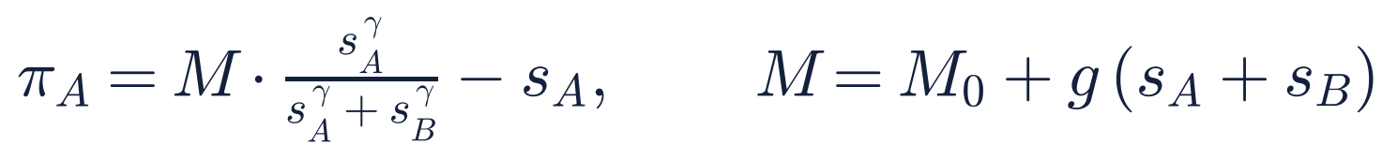
- π (pi) is profit, s is ad spend, M₀ = ₹100 lakh is the market value.
- g is how much each rupee of advertising grows the market (g = 0 means advertising only steals customers).
- γ (gamma) is how strongly share responds to spend (base case γ = 1).
Solution method. We wrote our own solver for two-player games. It finds pure Nash equilibria by checking every cell for mutual best responses, finds dominant strategies, removes dominated strategies step by step (IESDS), and finds mixed equilibria by support enumeration. It also lists the Pareto-efficient outcomes. We then classify the game (Prisoner’s Dilemma, Harmony, and so on) and repeat this for 5,670 combinations of High budget (11 to 80) and market growth (0 to 2).

4.2 Model 1b: the repeated advertising war
The same game is played every month. Using the standard payoff names (T = temptation, R = reward, P = punishment), the Grim Trigger strategy keeps both firms at Low if the discount factor is high enough:
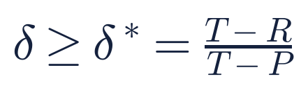
We also ran a round-robin tournament (in the style of Axelrod, 1984) among seven strategies over 200 months: Always High, Always Low, Tit-for-Tat, Grim Trigger, Pavlov, Generous Tit-for-Tat and Random. We repeated it with a 5% chance that any move is carried out wrongly.

4.3 Model 2: continuous budgets for n firms (Tullock contest)
Now each firm i can choose any budget xᵢ ≥ 0. V is the value of the customer pool and cᵢ is firm i’s cost per unit of advertising (a weaker product needs more spend per customer).
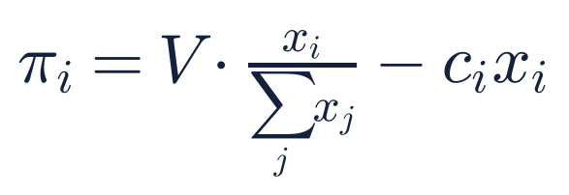
Solving the first-order conditions gives the Nash equilibrium. For the set S of firms that advertise, with m firms in it:
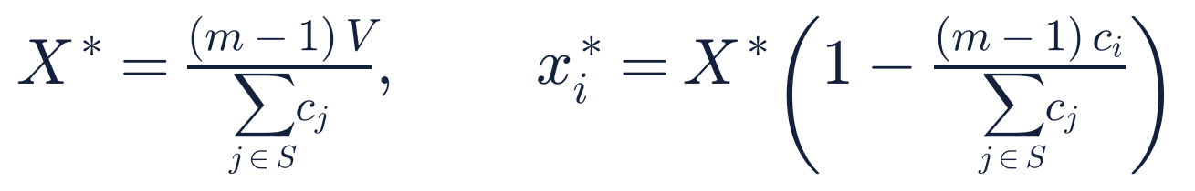
Firms are added cheapest first; a firm whose xᵢ* would be zero or negative does not advertise. With n identical firms (c = 1) this becomes x* = (n−1)V/n² per firm. We check the formula with best-response dynamics: firms take turns choosing their best reply,
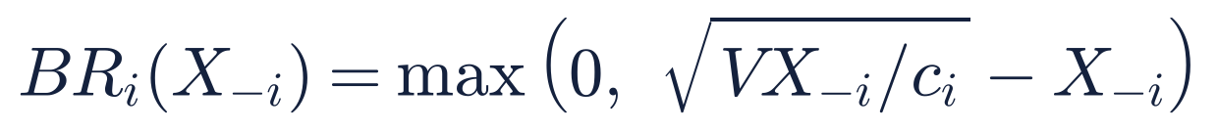
where X₋ᵢ is the total spend of all other firms.

4.4 Model 3: keyword (sponsored search) auctions
When someone searches a keyword, K ad slots are shown. Slot k gets a click-through rate (CTR) αₖ, with α₁ > α₂ > …. Advertiser i values a click at vᵢ and bids bᵢ per click. Ads are ranked by bid (optionally bid × quality score, as Google does). We compare three payment rules:
Rule | Winner of slot k pays per click | Used by
GSP (Generalized Second Price) | The next-highest bid, b₍ₖ₊₁₎ | Google Ads, Microsoft Ads
VCG (Vickrey–Clarke–Groves) | The loss its presence causes to the others | Meta (Facebook) ads
GFP (Generalized First Price) | Its own bid | Overture, 1997–2002
The VCG price for slot k, when everyone bids truthfully, follows this recursion (v₍ₖ₎ is the k-th highest value, αₖ₊₁ = 0 after the last slot):
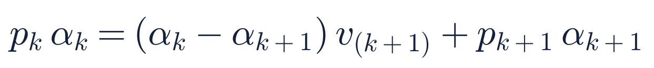
Edelman, Ostrovsky and Schwarz (2007) and Varian (2007) showed that GSP has a stable equilibrium in which the bidder in slot k+1 bids pₖ. We implemented this equilibrium and a deviation checker that tries every meaningful alternative bid for every advertiser to test whether any bid profile is a Nash equilibrium. Worked example: five advertisers with values ₹12, 10, 8, 6, 4 per click and three slots with CTRs 30%, 20%, 10%. We then ran 10,000 random auctions with values drawn uniformly from ₹0 to ₹10.

4.5 Model 4: bidding dynamics
- GFP: two advertisers (values ₹10 and ₹8) take turns. Each either outbids the rival by ₹0.10 to take slot 1, or drops to the ₹0.50 reserve and takes slot 2, whichever earns more.
- GSP: we use the balanced bidding rule of Cary et al. (2007). An advertiser picks the slot that earns it the most, then bids the amount that makes it indifferent between that slot and the one above. One random advertiser updates at a time. We ran this from 20 random starting points.

4.6 Model 5: display-ad auctions (real-time bidding)
Each page view sells one ad impression. Bidders do not know each other’s values, so we model values as random, uniform between 0 and 1, and use Bayesian Nash equilibrium.
- The first formula is the equilibrium bid in a first-price auction with n bidders. We test it by letting one bidder try every shading factor k (bid = k × value) while the others use the formula.
- The second is the expected revenue of both first-price and second-price auctions (revenue equivalence).
- The third is the revenue of a second-price auction with reserve price r. Its maximum is at r* = 0.5 (Myerson, 1981).
Each result is checked with 200,000 simulated auctions.

5. Implementation

5.1 Tools
Tool | Purpose
Python 3.10+ | Programming language
NumPy | Payoff matrices, linear equations, Monte Carlo simulation
Matplotlib | All 12 result figures
Pandas | Tables in the dashboard
Streamlit | Interactive web dashboard for the live demo
Pytest | 20 automated tests
nashpy | Used only in tests, to cross-check our own equilibrium solver
The game solvers themselves are written from scratch. We did not use a game-theory library to compute any result.

5.2 Code structure
File | What it contains
adgame/normal_form.py | Two-player game solver: pure and mixed Nash equilibria, dominance, IESDS, Pareto check
adgame/ad_spend_game.py | Model 1: builds the ad-war payoff matrix, classifies the game type, finds δ*
adgame/repeated_game.py | Model 1b: seven strategies and the round-robin tournament
adgame/budget_contest.py | Model 2: closed-form Tullock equilibrium, best-response dynamics
adgame/position_auctions.py | Model 3: GSP, VCG and GFP auctions, EOS equilibrium bids, deviation checker, Monte Carlo
adgame/dynamics.py | Model 4: GFP saw-tooth dynamics, GSP balanced bidding
adgame/auction_design.py | Model 5: bid shading, revenue equivalence, reserve prices
adgame/plotting.py | All figures, in one consistent style
main.py | Runs all experiments, prints the results, saves figures, CSV tables and results.json
app.py | Streamlit dashboard with one page per model
tests/test_models.py | 20 tests comparing each model with theory

5.3 Key algorithms
- Pure Nash equilibrium search. For every cell (i, j) of the payoff matrix, check that the row player’s payoff is the highest in its column and the column player’s payoff is the highest in its row.
- Mixed Nash equilibrium by support enumeration. For each pair of equal-size strategy sets, solve the linear equations that make the opponent indifferent, then keep the solution only if all probabilities are non-negative and no outside strategy does better.
- Closed-form Tullock equilibrium with an active set: add firms cheapest first and stop when the next firm’s equilibrium budget would be zero or negative.
- Generic VCG payment. Each winner pays (total value of the others without it) minus (total value of the others with it). This works for any number of slots and with quality scores.
- Deviation checker. Because an auction outcome depends only on the ranking, we try bids just above and just below every rival’s bid, plus 0 and the bidder’s value. If no advertiser gains, the bid profile is a Nash equilibrium.
- Monte Carlo simulation. 10,000 random keyword auctions and 200,000 random display auctions with a fixed random seed, so every run gives the same numbers.

5.4 Testing
Every model has at least one test that compares the program’s answer with a published result:
Test | Theory it checks
Ad war is a Prisoner’s Dilemma with δ* = 0.20 | Standard repeated-game result
Mixed equilibria match nashpy on 3 games | Support enumeration is correct
Tullock NE matches closed form; no firm gains from any of 601 other budgets | Equilibrium condition
Truthful bidding is a NE under VCG (25 random auctions) | VCG is truthful
Truthful GSP fails on the EOS example (profit 1,200 vs 1,592) | Edelman et al. (2007)
EOS bids are a NE and earn VCG revenue (25 random auctions) | Edelman et al. (2007); Varian (2007)
Balanced bidding converges to VCG revenue (10 seeds) | Cary et al. (2007)
Best shading factor is (n−1)/n for n = 2, 3, 5 | First-price Bayesian NE
First-price and second-price revenue equal (n−1)/(n+1) | Revenue equivalence
Optimal reserve is 0.5 for n = 1, 2, 3, 5 | Myerson (1981)
All 20 tests pass in under 1 second (Section 7, Figure 16).

6. Results

6.1 Model 1: the advertising war is a Prisoner’s Dilemma
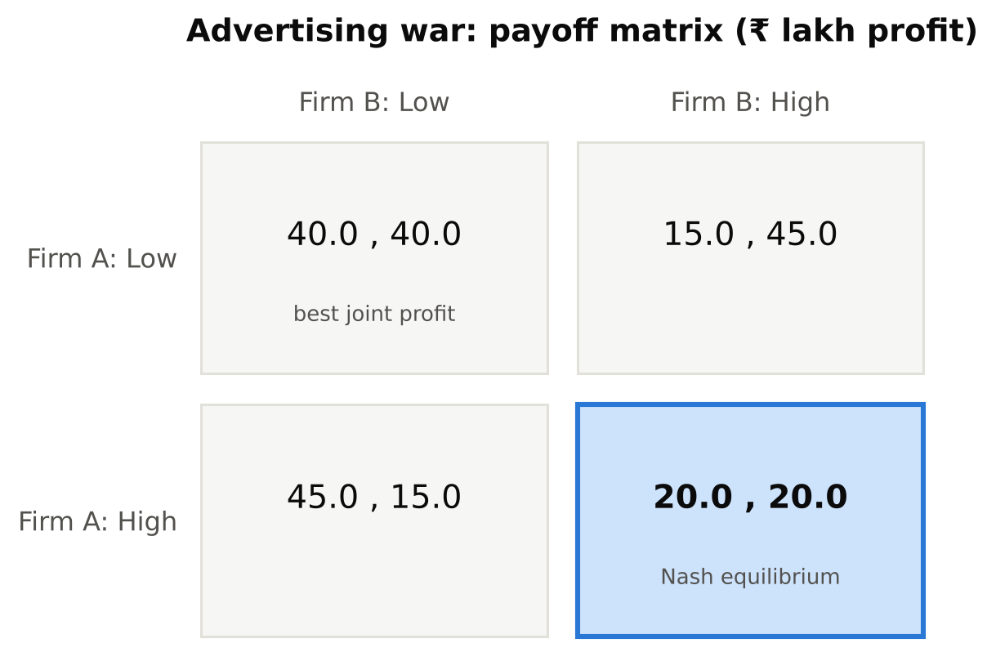
Figure 1. Payoff matrix of the two-firm advertising war (₹ lakh profit). The blue cell is the Nash equilibrium.
- High is a dominant strategy for both firms: 45 > 40 if the rival spends Low, and 20 > 15 if the rival spends High.
- The only Nash equilibrium is (High, High), with profit 20 each.
- Both firms would earn 40 each at (Low, Low), so the equilibrium wastes ₹40 lakh, or 50% of joint profit. The extra money goes to the ad platform.
- The payoffs follow the Prisoner’s Dilemma order T = 45 > R = 40 > P = 20 > S = 15.
With three budget levels (10, 25, 40), Low and High are both strictly dominated by Medium. The unique equilibrium is (Medium, Medium) at ₹25 lakh each, exactly the budget the continuous model (Model 2) predicts for two firms. The mixed-strategy search confirms there is no other equilibrium.
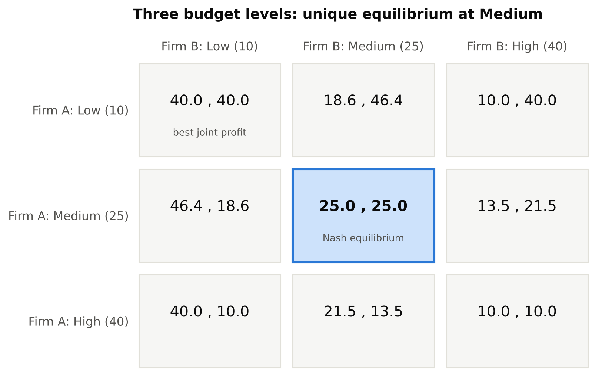
Figure 2. Three budget levels: the unique Nash equilibrium is Medium for both firms.
Which game are firms playing? We changed the High budget (11 to 80) and the market growth g (0 to 2) and classified each of the 5,670 games:
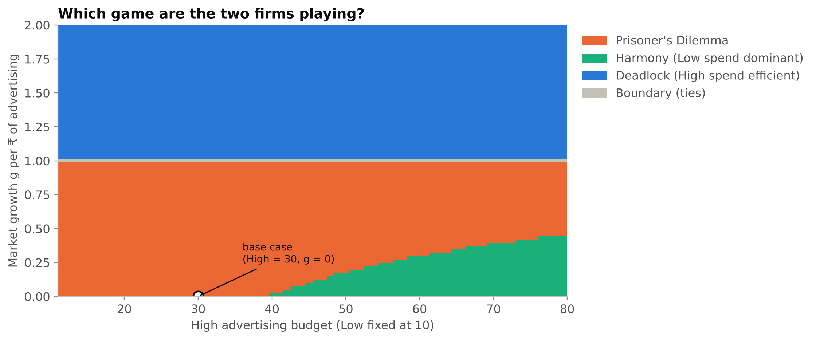
Figure 3. Game type for each High budget and market growth. The dot marks the base case.
Game type | Share of scenarios | When it happens
Deadlock (High is dominant and efficient) | 49.4% | g > 1: each rupee of ads grows the market by more than a rupee
Prisoner’s Dilemma (overspending) | 41.4% | g < 1: ads mostly steal customers
Harmony (Low is dominant) | 8.0% | High budget too large for the market and little growth
Boundary (ties) | 1.2% | g = 1 exactly
The lesson: overspending is a problem only when advertising mainly shifts customers between firms. When advertising creates new demand, spending High is good for both.

6.2 Model 1b: repeated play can keep budgets low
Grim Trigger keeps both firms at Low when the discount factor δ ≥ (45 − 40) / (45 − 20) = 0.20. Any firm that values next month’s profit at more than 20% of this month’s can sustain cooperation without a contract.
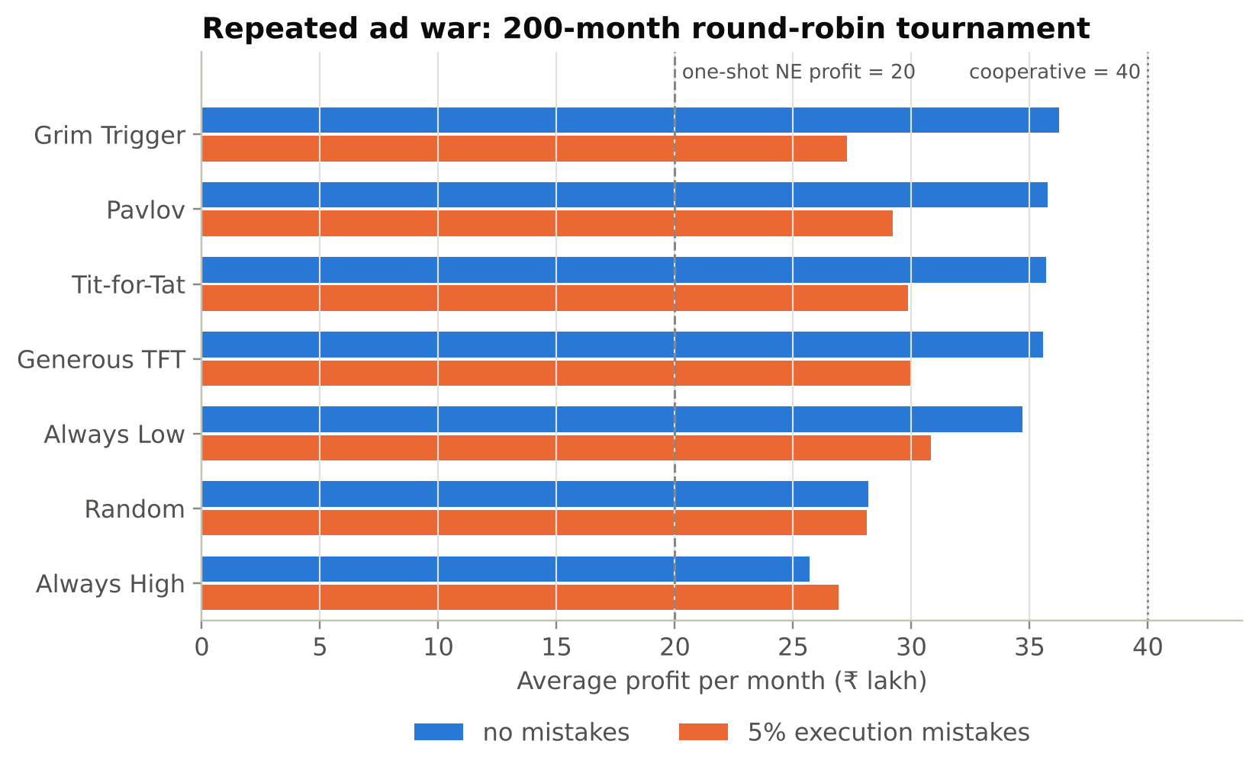
Figure 4. Average monthly profit of each strategy in the 200-month round-robin tournament.
Rank | Strategy | Avg profit, no mistakes | Avg profit, 5% mistakes | Months at Low spend
1 | Grim Trigger | 36.25 | 27.28 | 75%
2 | Pavlov | 35.76 | 29.21 | 82%
3 | Tit-for-Tat | 35.70 | 29.87 | 81%
4 | Generous TFT | 35.55 | 29.99 | 83%
5 | Always Low | 34.68 | 30.82 | 100%
6 | Random | 28.19 | 28.10 | 49%
7 | Always High | 25.70 | 26.91 | 0%
- Strategies that reward cooperation and punish defection (Grim Trigger, Pavlov, Tit-for-Tat) earn about 36 per month, close to the cooperative 40 and far above the one-shot equilibrium of 20.
- Always High finishes last without mistakes.
- With 5% mistakes, Grim Trigger drops to 6th: one accidental High move starts a price war that never ends. Forgiving strategies (Generous TFT, Tit-for-Tat) hold up better. In real markets, where a rival’s budget is hard to observe exactly, forgiveness matters.
- Always Low wins with mistakes only because most rivals in this pool are cooperative; against Always High it earns the worst payoff (15). The ranking depends on the mix of strategies.

6.3 Model 2: more competitors, more value lost to the platform
With V = ₹100 lakh and three firms with costs 1.0, 1.2 and 1.5:
Firm | Cost per ₹ of ads | NE budget (₹ lakh) | Market share | Profit (₹ lakh)
Firm 1 | 1.0 | 24.84 | 45.9% | 21.11
Firm 2 | 1.2 | 18.99 | 35.1% | 12.34
Firm 3 | 1.5 | 10.23 | 18.9% | 3.58
Best-response dynamics reach this equilibrium within 3 rounds and match the formula exactly after 15 rounds (Figure 5). With costs (1.0, 1.5, 3.0), the formula gives budgets (24, 16, 0): the weakest firm stops advertising because it cannot profitably compete.
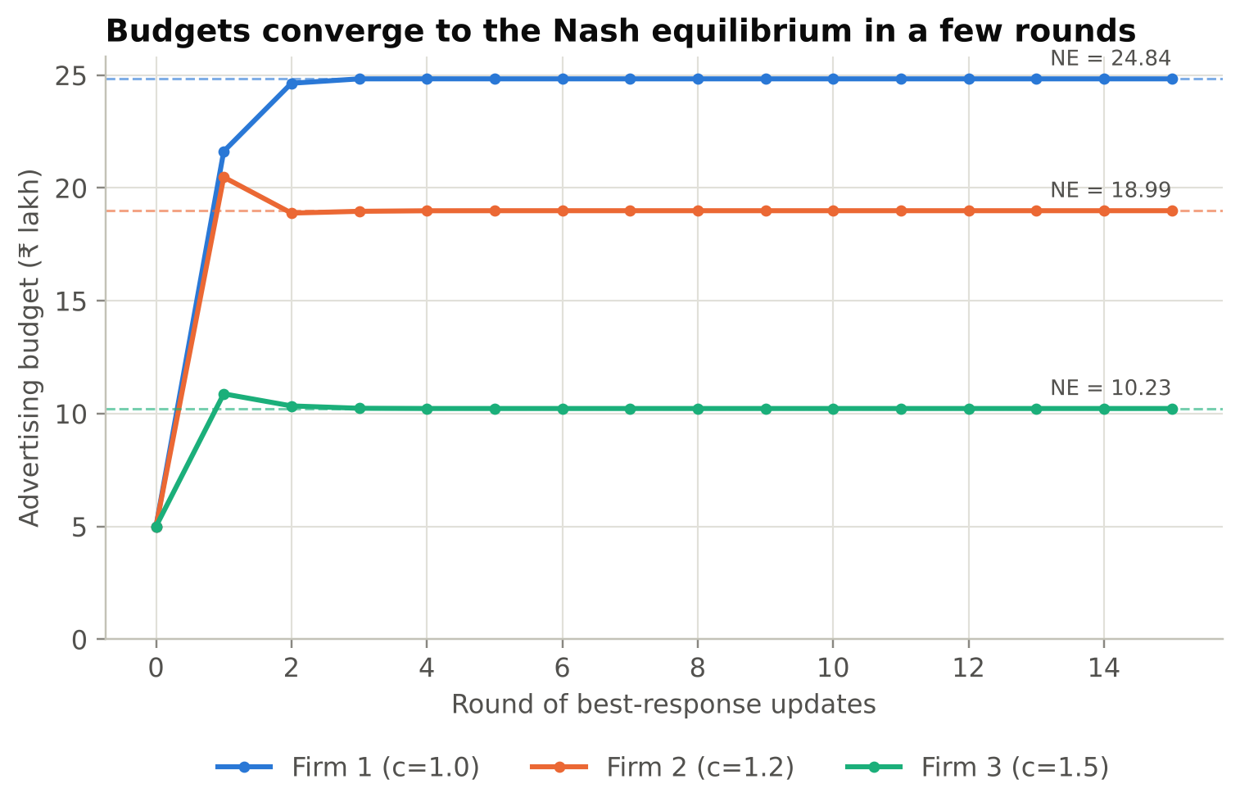
Figure 5. Best-response dynamics converge to the Nash equilibrium (dashed lines).
With n identical firms, total ad spend equals (n−1)/n of V:
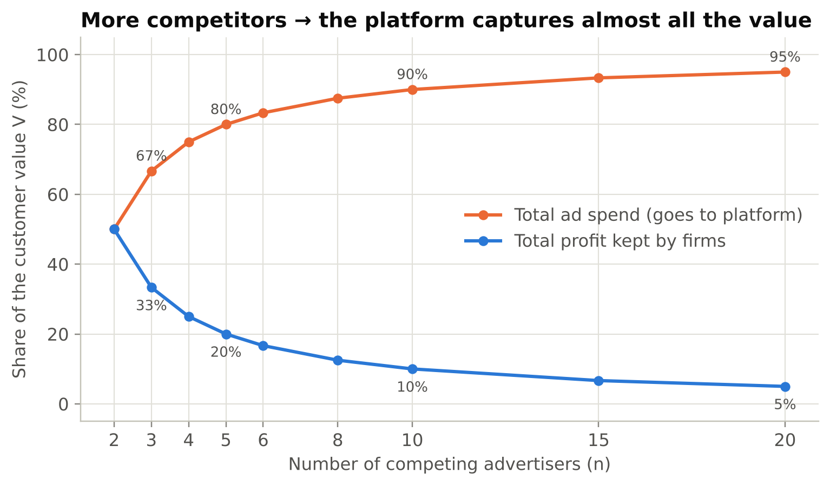
Figure 6. Share of the customer value V paid to the platform as ad spend, and kept by firms as profit.
With 2 firms, half the value goes to the platform; with 10 firms, 90%; with 20 firms, 95%. This is called rent dissipation. It explains why ad platforms gain from crowded markets and why profit per firm falls very fast as rivals enter (₹25 lakh with 2 firms, ₹1 lakh with 10).

6.4 Model 3: GSP in equilibrium earns exactly the VCG revenue
Worked example: five advertisers (values ₹12, 10, 8, 6, 4 per click), three slots (CTR 30%, 20%, 10%). In every case Brands A, B and C win slots 1, 2 and 3, so total value created (welfare) is the same, ₹6.40 per search. Only the payments differ.
Mechanism | Bids | Price per click, slots 1–3 (₹) | Revenue per search (₹) | Stable?
VCG, truthful | 12, 10, 8, 6, 4 | 8.0, 7.0, 6.0 | 4.40 | Yes
GSP, truthful bids | 12, 10, 8, 6, 4 | 10.0, 8.0, 6.0 | 5.20 | No
GSP, equilibrium bids | 12, 8, 7, 6, 4 | 8.0, 7.0, 6.0 | 4.40 | Yes
GFP, truthful bids | 12, 10, 8, 6, 4 | 12.0, 10.0, 8.0 | 6.40 | No
- Truthful bidding is not stable under GSP. Brand A earns 0.30 × (12 − 10) = ₹0.60 in slot 1. By lowering its bid to just above ₹8 it drops to slot 2 and earns 0.20 × (12 − 8) = ₹0.80. The program also reproduces the textbook example of Edelman et al. (2007): profit rises from 1,200 to 1,592 by shading.
- Truthful bidding is stable under VCG, as theory says. We checked 25 random auctions and found no profitable deviation.
- The EOS equilibrium bids (12, 8, 7, 6, 4) are a Nash equilibrium of GSP and charge exactly the VCG prices.
- Under GFP, truthful bids leave every advertiser with zero profit, so everyone shades and bids never settle (Model 4).
Monte Carlo, 10,000 random auctions with 5 bidders and values uniform on ₹0–10:
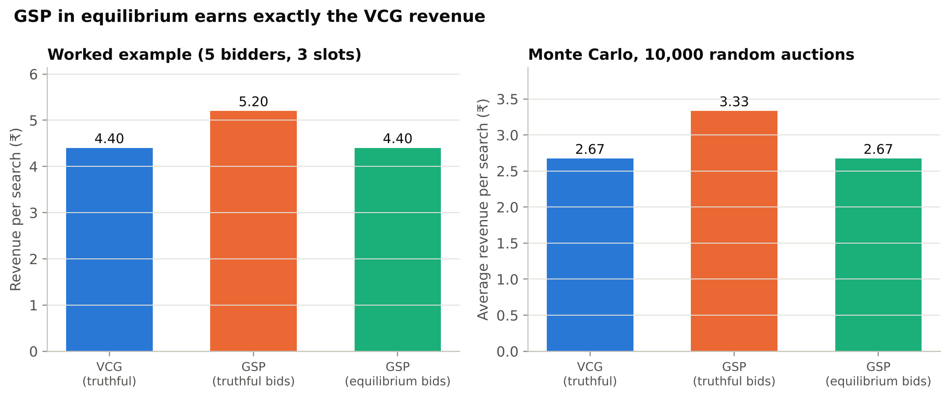
Figure 7. Platform revenue under each rule: worked example (left) and 10,000 random auctions (right).
Mechanism | Average revenue (₹) | Average welfare (₹) | Revenue as % of welfare
VCG, truthful | 2.672 | 4.327 | 61.7%
GSP, truthful bids | 3.333 | 4.327 | 77.0%
GSP, equilibrium bids | 2.672 | 4.327 | 61.7%
GSP looks 25% more profitable than VCG if one assumes advertisers bid truthfully. But they do not: once they bid strategically, GSP and VCG earn the same. This is the central result of Edelman et al. (2007) and Varian (2007), and our simulation reproduces it in every one of the 10,000 auctions.

6.5 Model 4: first-price bidding never settles; GSP does
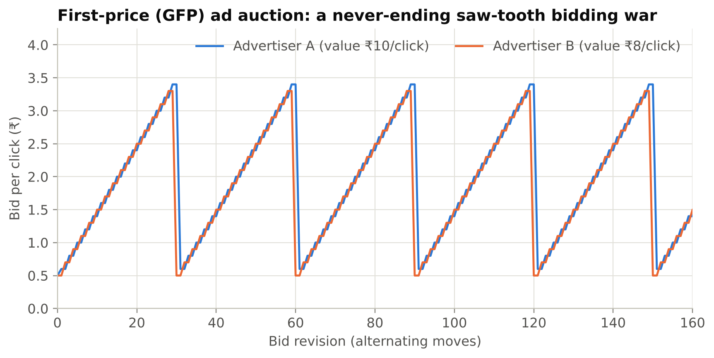
Figure 8. Two advertisers in a first-price (GFP) auction: bids rise step by step, crash, and rise again.
- Under GFP each advertiser outbids the other by ₹0.10 to take slot 1. When the price reaches ₹3.40, Advertiser B finds slot 2 at the ₹0.50 reserve more profitable and drops out of the race. Advertiser A then drops its bid too, and the war restarts.
- In 400 bid revisions the bids crashed 13 times. There is no pure-strategy equilibrium, so bids never settle. This saw-tooth pattern was seen in real Overture data (Edelman and Ostrovsky, 2007) and is one reason the industry moved to GSP.
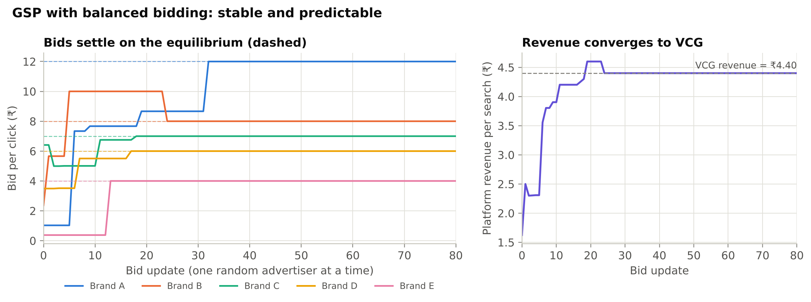
Figure 9. GSP with balanced bidding: bids settle on the equilibrium (left) and revenue settles on the VCG value (right).
- Under GSP with balanced bidding, all 20 random starting points converged to the EOS equilibrium bids (12, 8, 7, 6, 4), after 11 to 41 updates (about 30 on average).
- Final revenue is ₹4.40 per search in every run, exactly the VCG revenue.

6.6 Model 5: display-ad auctions and platform design
Bid shading. In a first-price auction, bidding your full value earns zero profit. The simulation finds the profit-maximising shading factor:
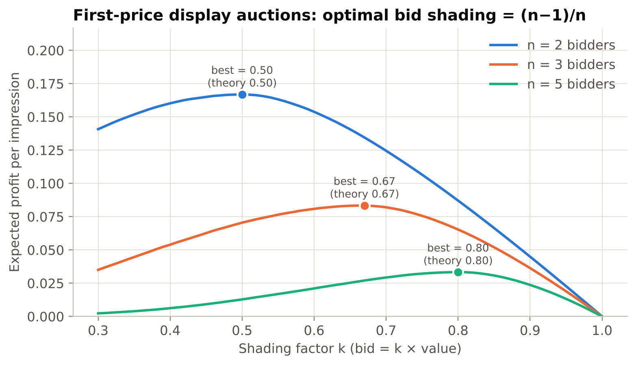
Figure 10. Expected profit for each shading factor when rivals use the equilibrium strategy.
Bidders n | Best shading (simulated) | Theory (n−1)/n
2 | 0.50 | 0.50
3 | 0.67 | 0.67
5 | 0.80 | 0.80
More competition means less shading. This is why bid-shading tools became a major ad-tech product after Google Ad Manager moved to first-price auctions in 2019.
Revenue equivalence. First-price and second-price auctions earn the same expected revenue, matching (n−1)/(n+1) to within 0.001 for every n tested (2 to 10):
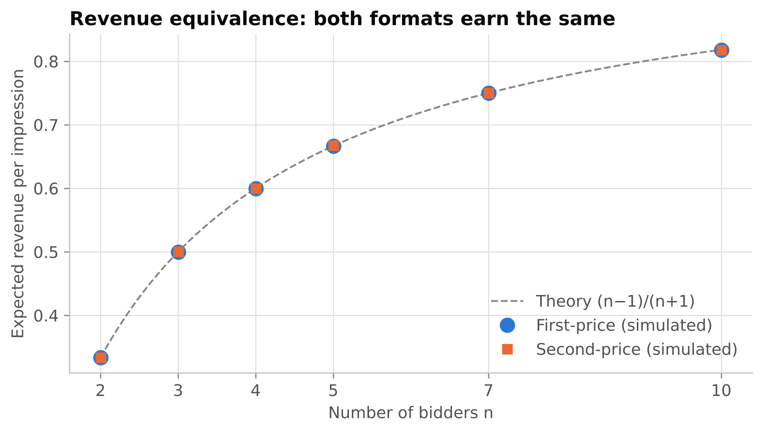
Figure 11. Simulated revenue of first-price and second-price auctions against the theoretical curve.
Reserve price. With two bidders, a reserve (floor) price of 0.50 raises expected revenue from 0.333 to 0.417 (+25%), even though the impression goes unsold 25% of the time. Simulation and formula agree at every reserve level tested:
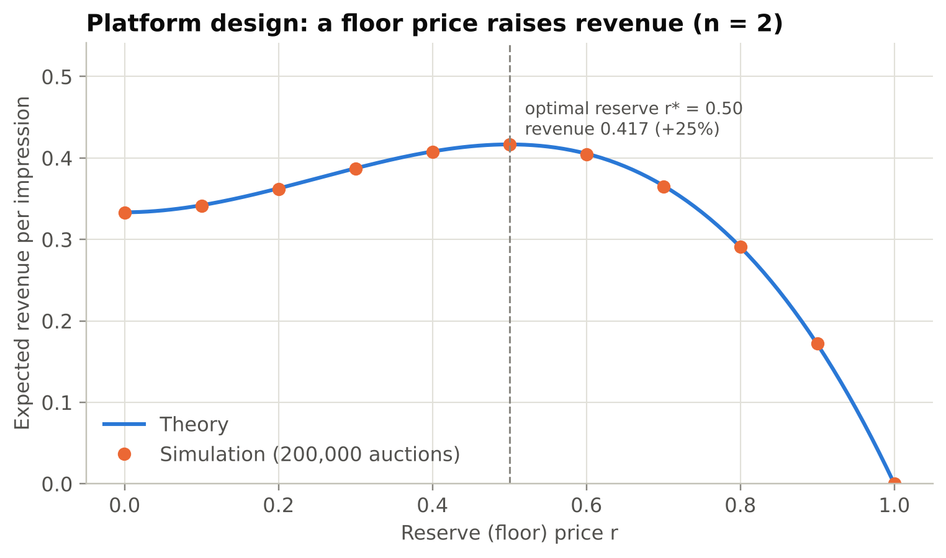
Figure 12. Expected revenue for each reserve price (n = 2): theory (line) and 200,000 simulated auctions (dots).

6.7 Summary of results
Model | Theory predicts | Our program finds | Match
1 Ad war | (High, High) is the unique NE | (High, High); 50% joint profit lost | Yes
1b Repeated game | Cooperation if δ ≥ (T−R)/(T−P) | δ* = 0.20; reciprocal strategies win | Yes
2 Budget contest | Total spend = (n−1)V/n | Exact for n = 2 to 20; dynamics converge | Yes
3 Keyword auctions | VCG truthful; GSP-EOS revenue = VCG | Both confirmed on 25 random cases and 10,000 simulations | Yes
4 Dynamics | GFP cycles; GSP balanced bidding converges | 13 crashes in 400 moves; 20/20 runs converge | Yes
5 Display auctions | Shading (n−1)/n; revenue (n−1)/(n+1); r* = 0.5 | 0.50 / 0.67 / 0.80; within 0.001; r* = 0.50 | Yes

7. Screenshots

7.1 Program output (python main.py)
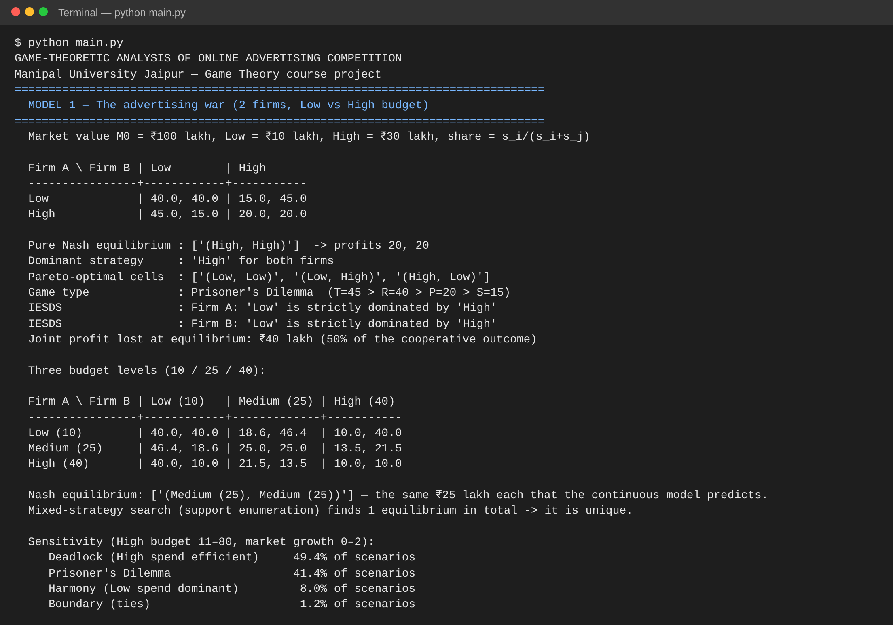
Figure 13. Terminal output of Model 1: payoff matrices, equilibrium, dominance and sensitivity.
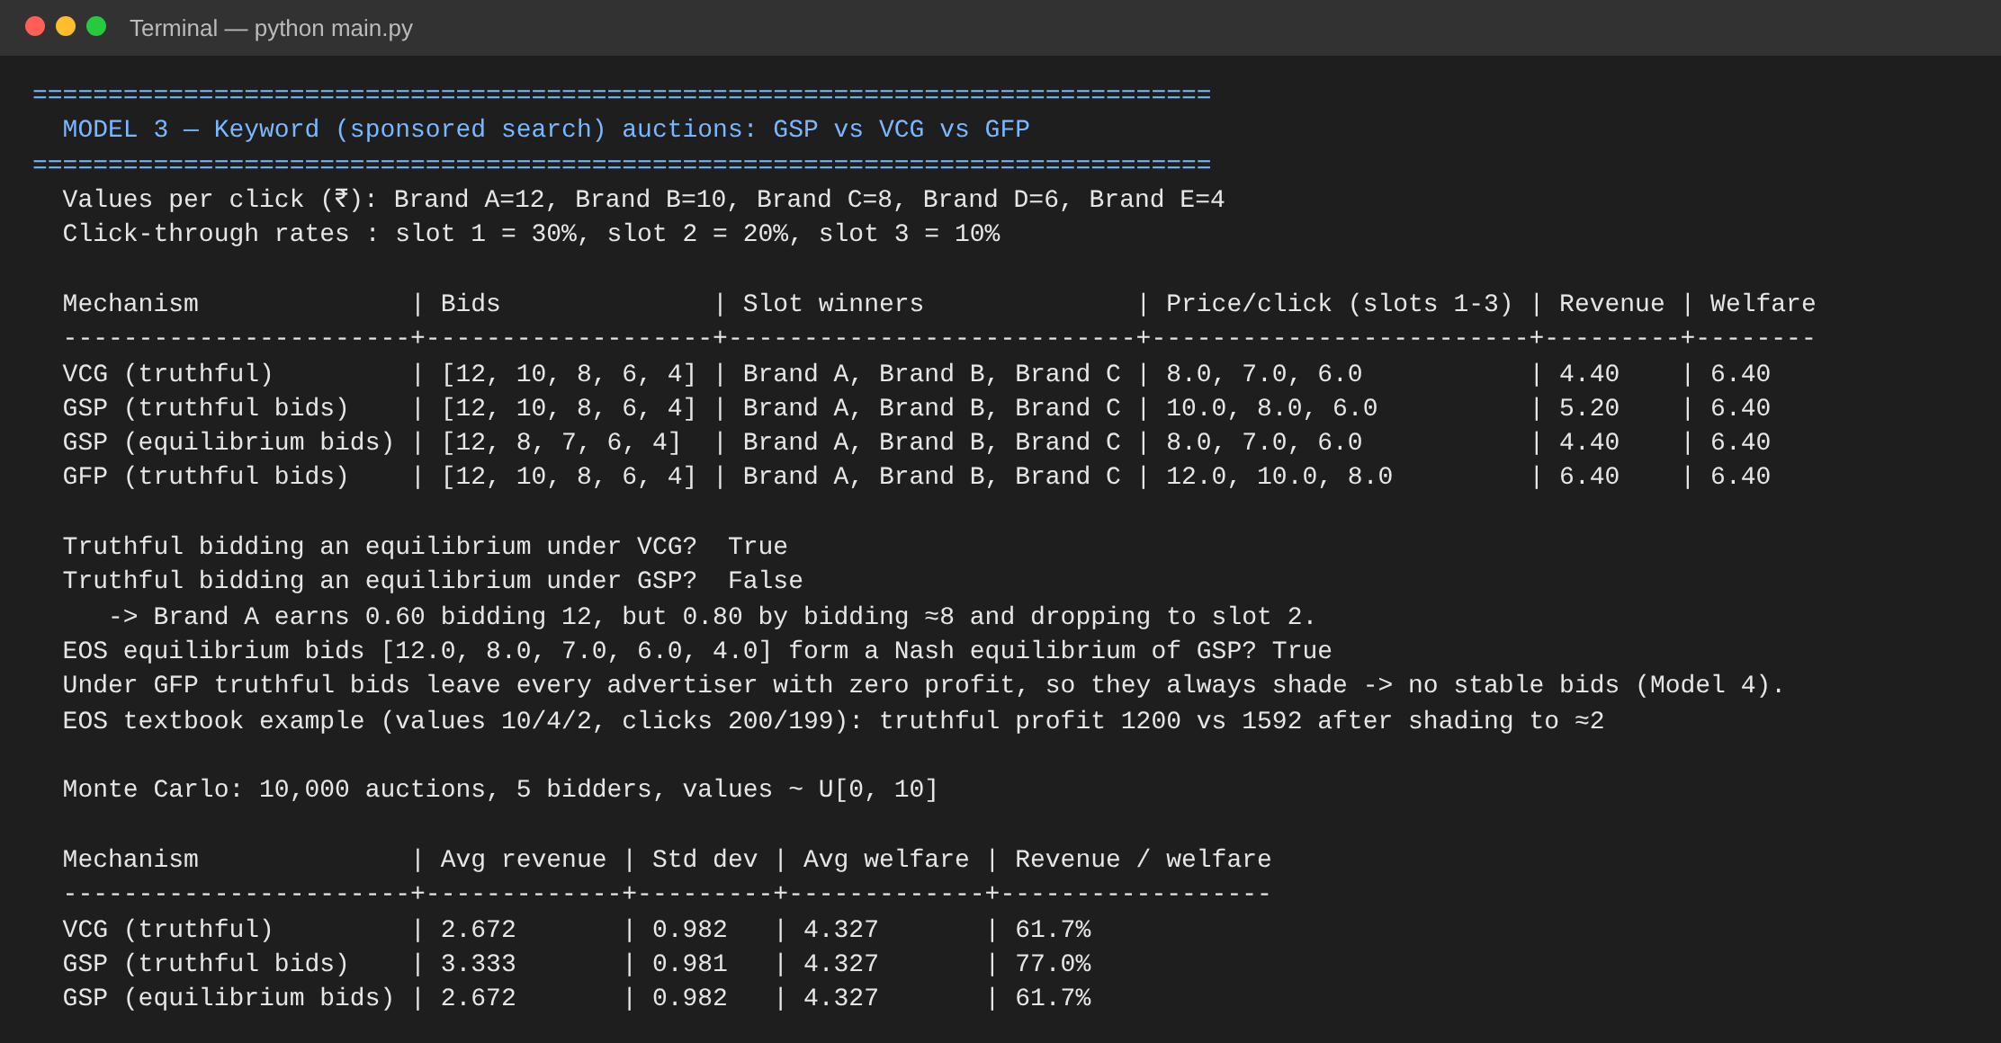
Figure 14. Terminal output of Model 3: worked keyword auction, stability checks and Monte Carlo.
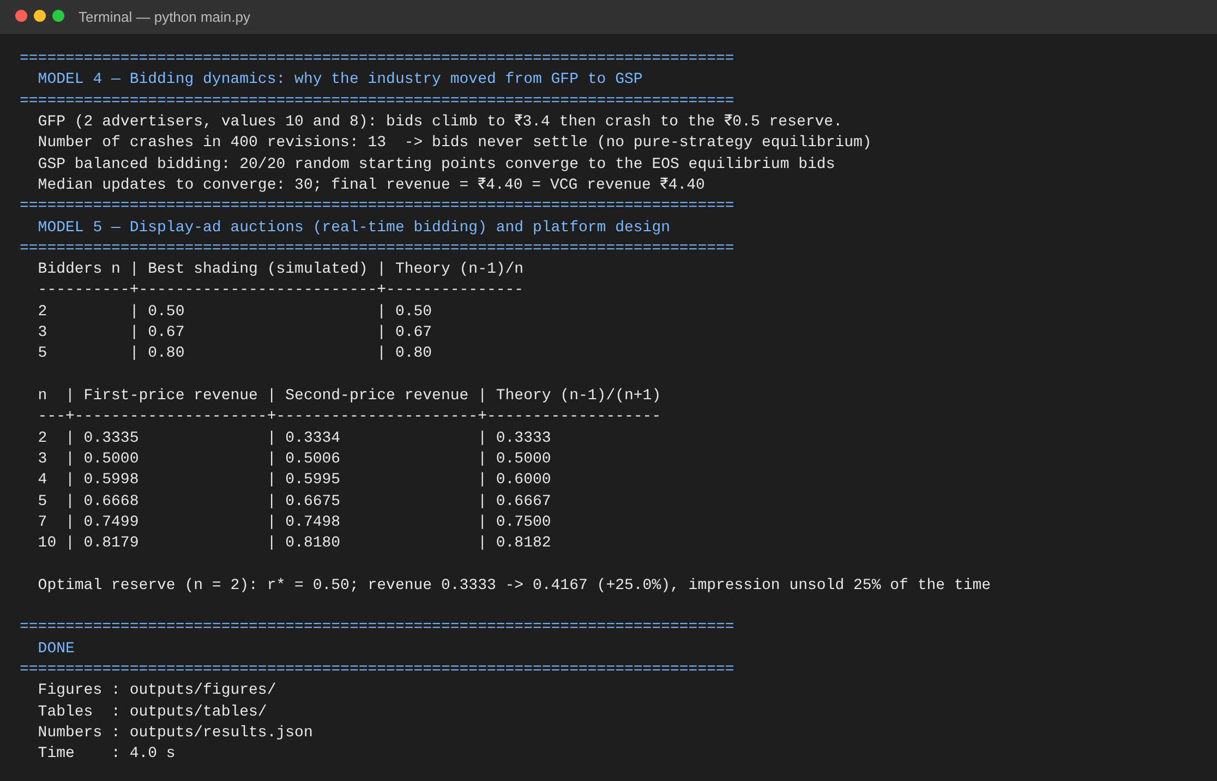
Figure 15. Terminal output of Models 4 and 5: bidding dynamics and display-auction results.

7.2 Automated tests (python -m pytest -v)
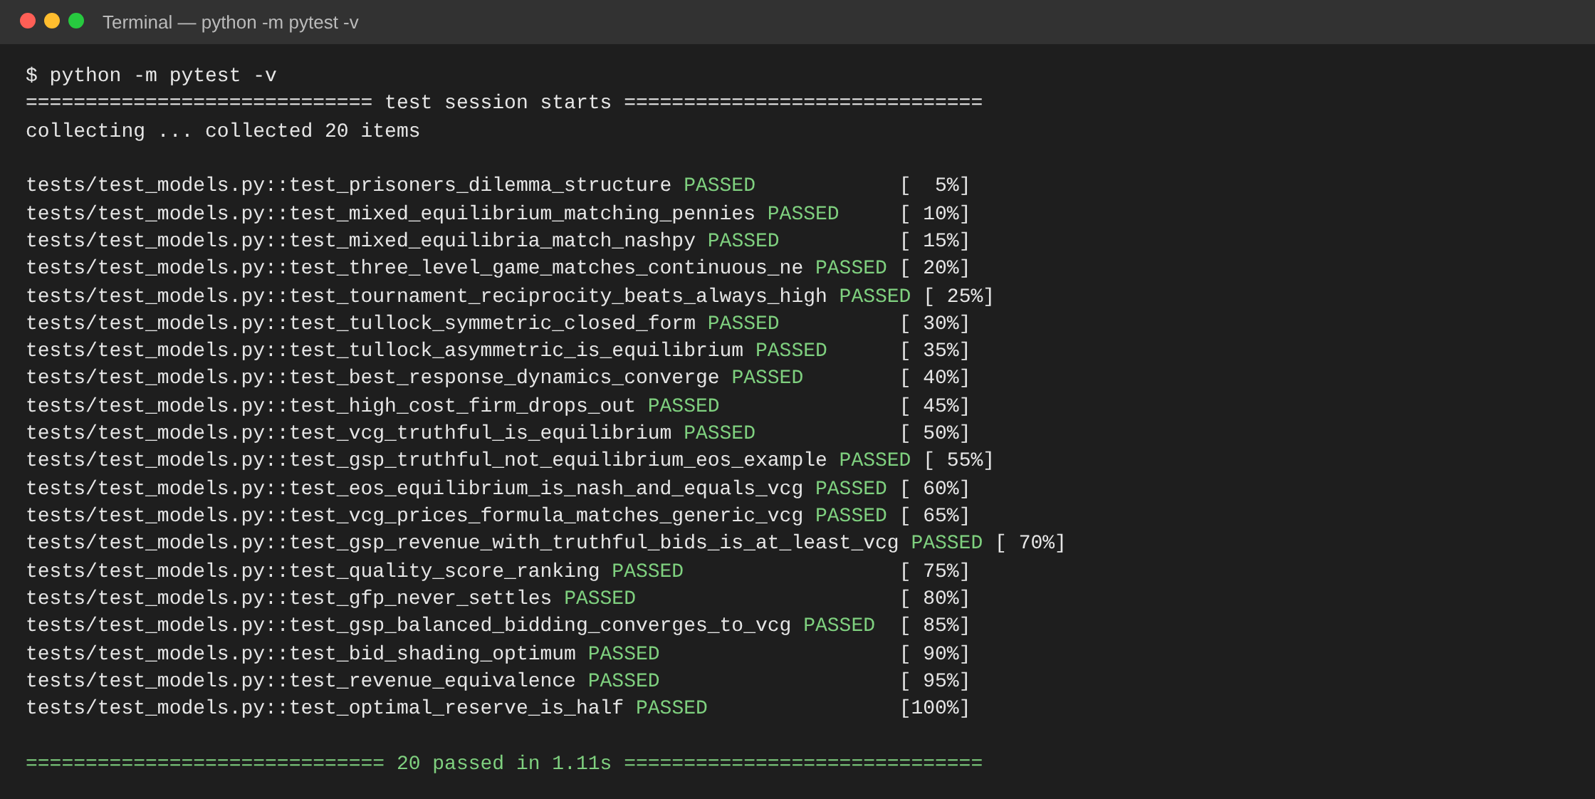
Figure 16. All 20 tests pass.

7.3 Interactive dashboard (streamlit run app.py)
The dashboard has one page per model. Every slider or input re-solves the game instantly, so the audience can ask “what if?” during the presentation.
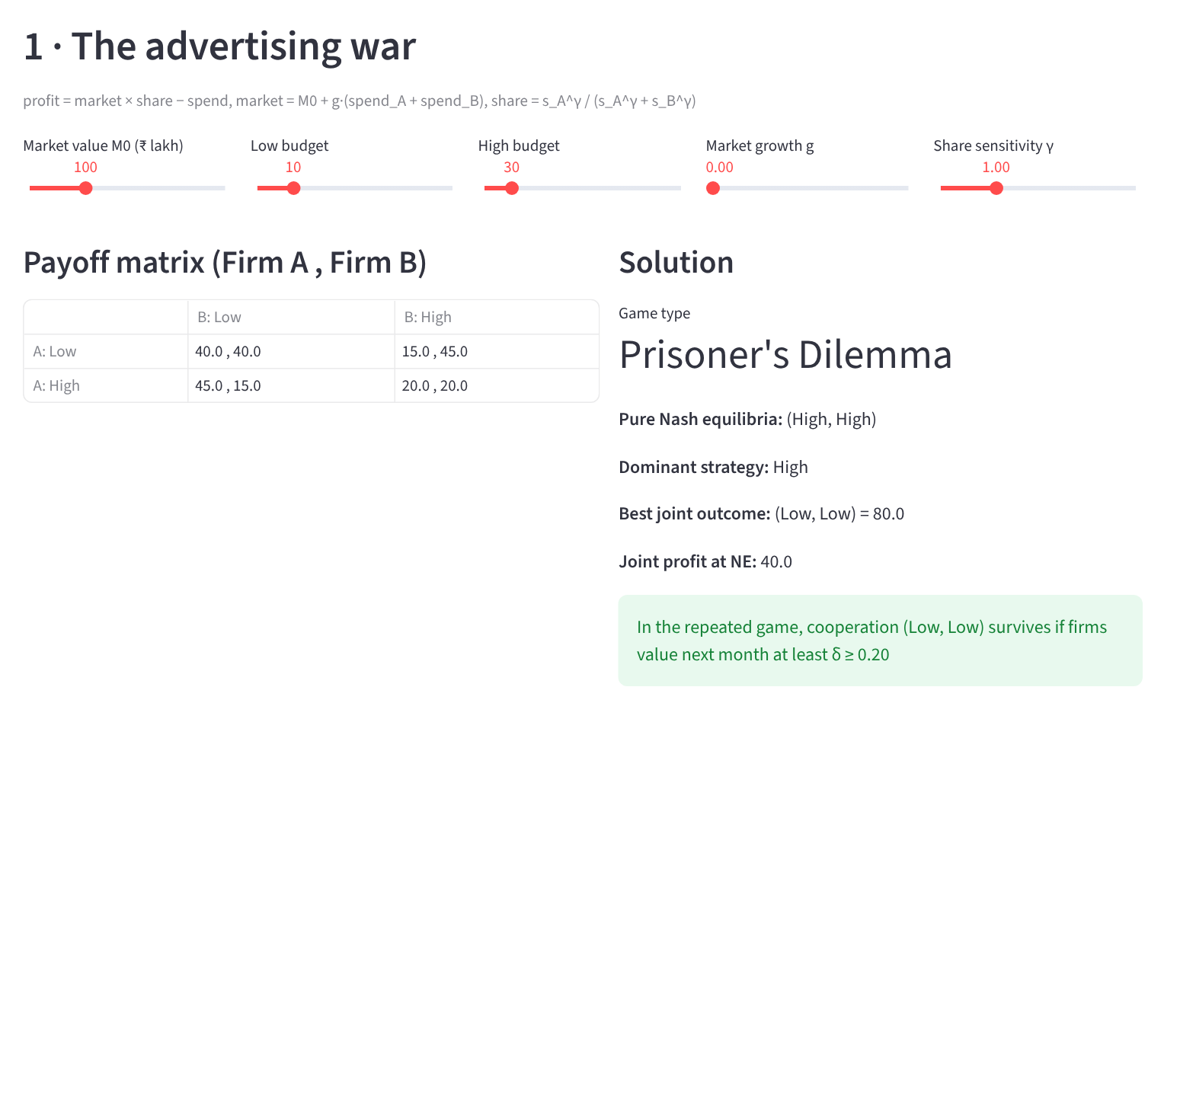
Figure 17. Dashboard, advertising war page: sliders for market size, budgets, growth and share sensitivity; the game is classified and solved live.
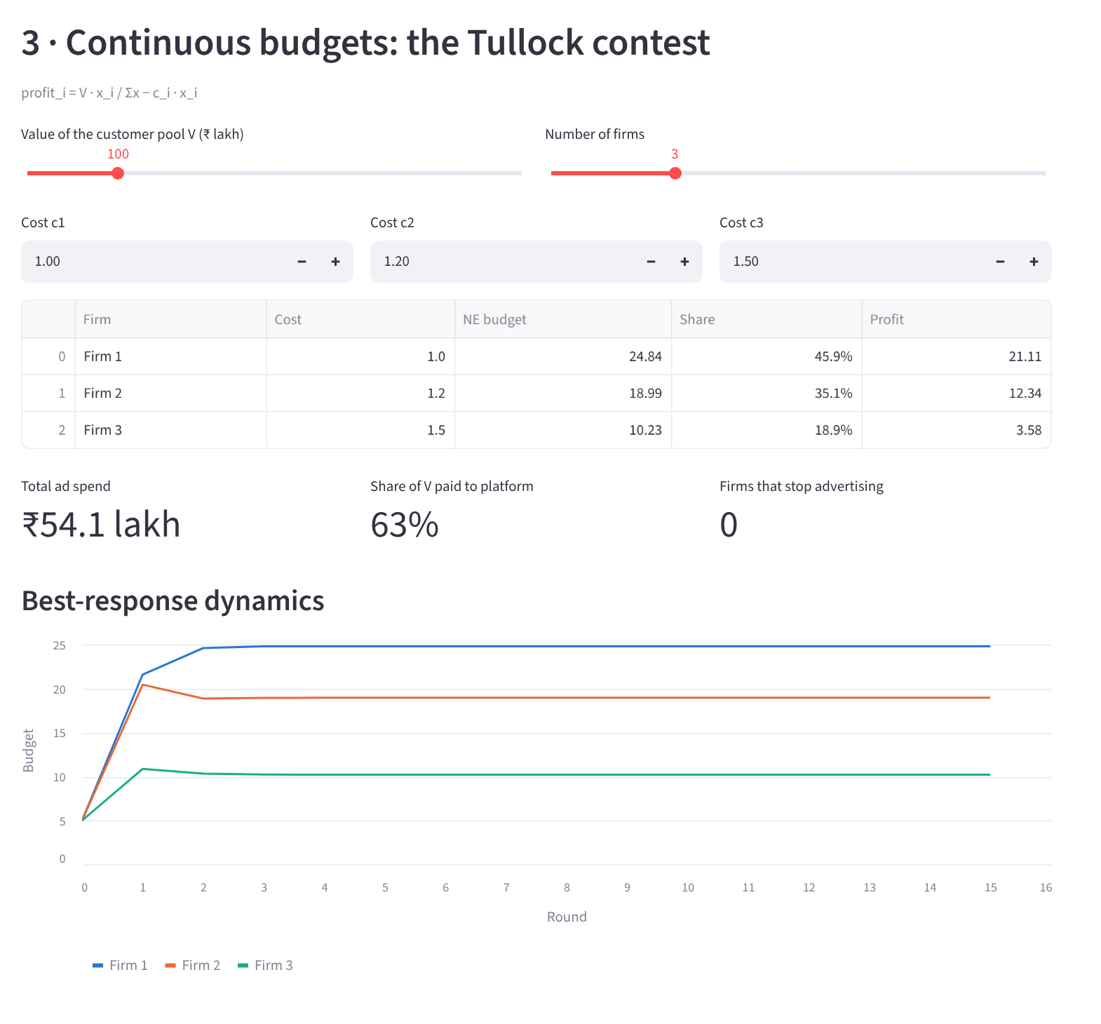
Figure 18. Dashboard, budget contest page: set the number of firms and their costs; equilibrium budgets and convergence update live.
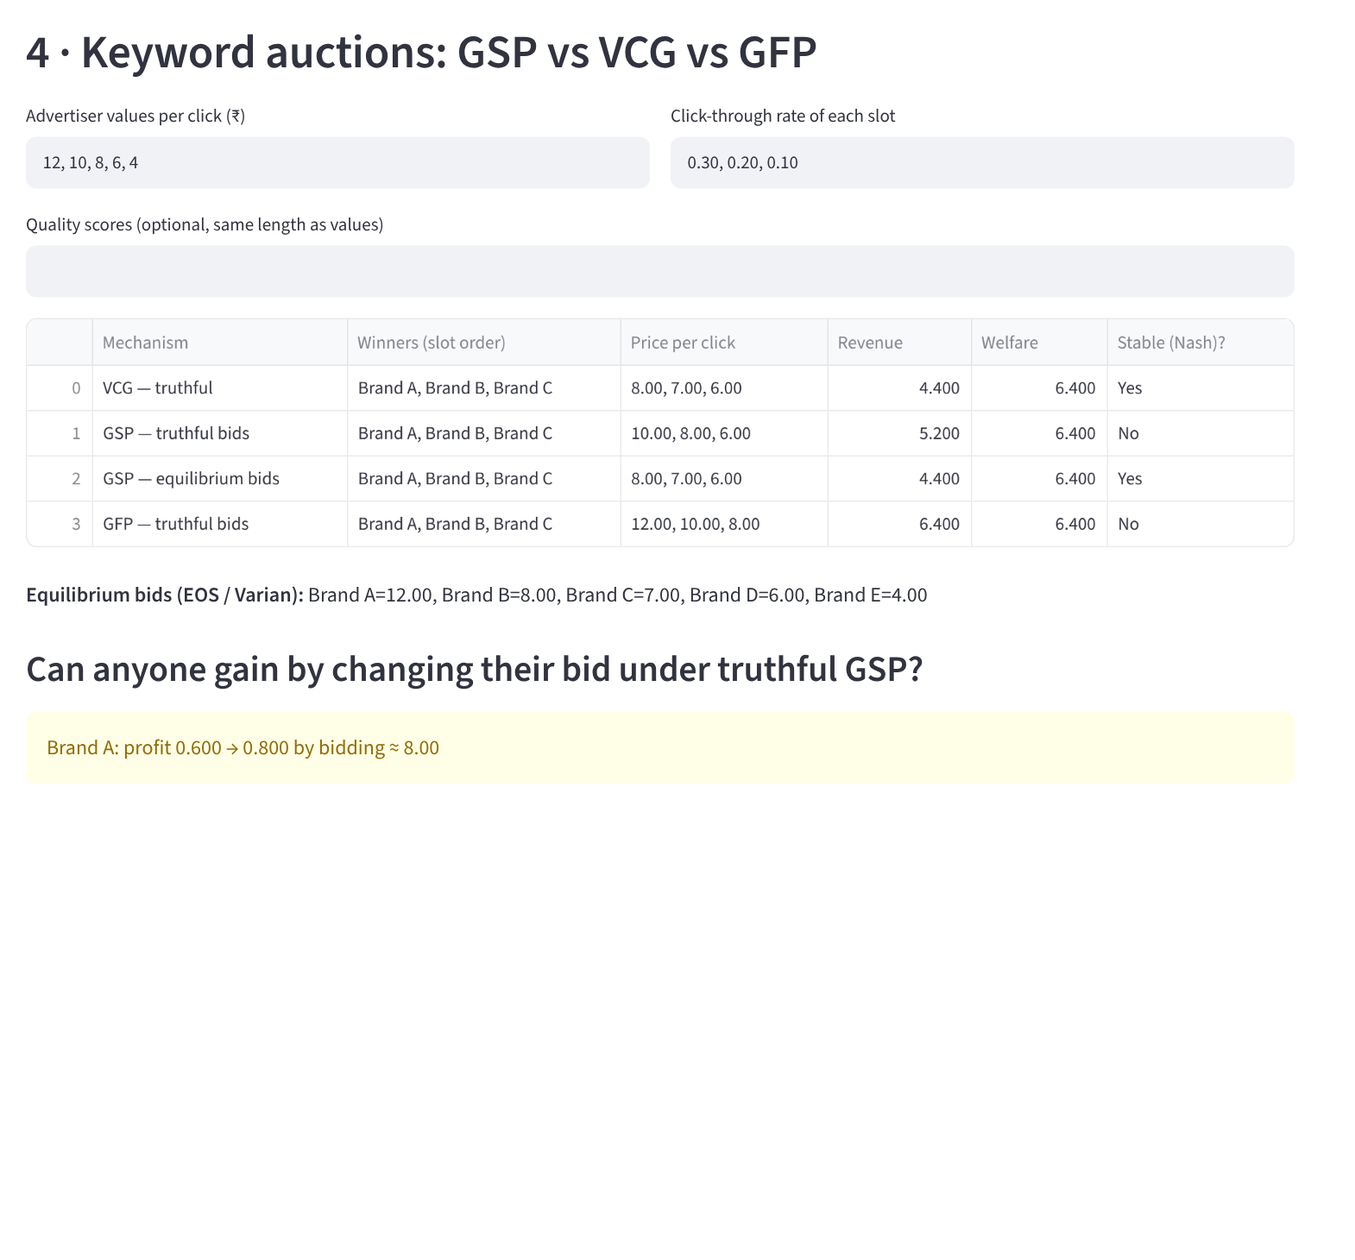
Figure 19. Dashboard, keyword auction page: type any values, CTRs and quality scores; the page compares GSP, VCG and GFP and finds profitable deviations.
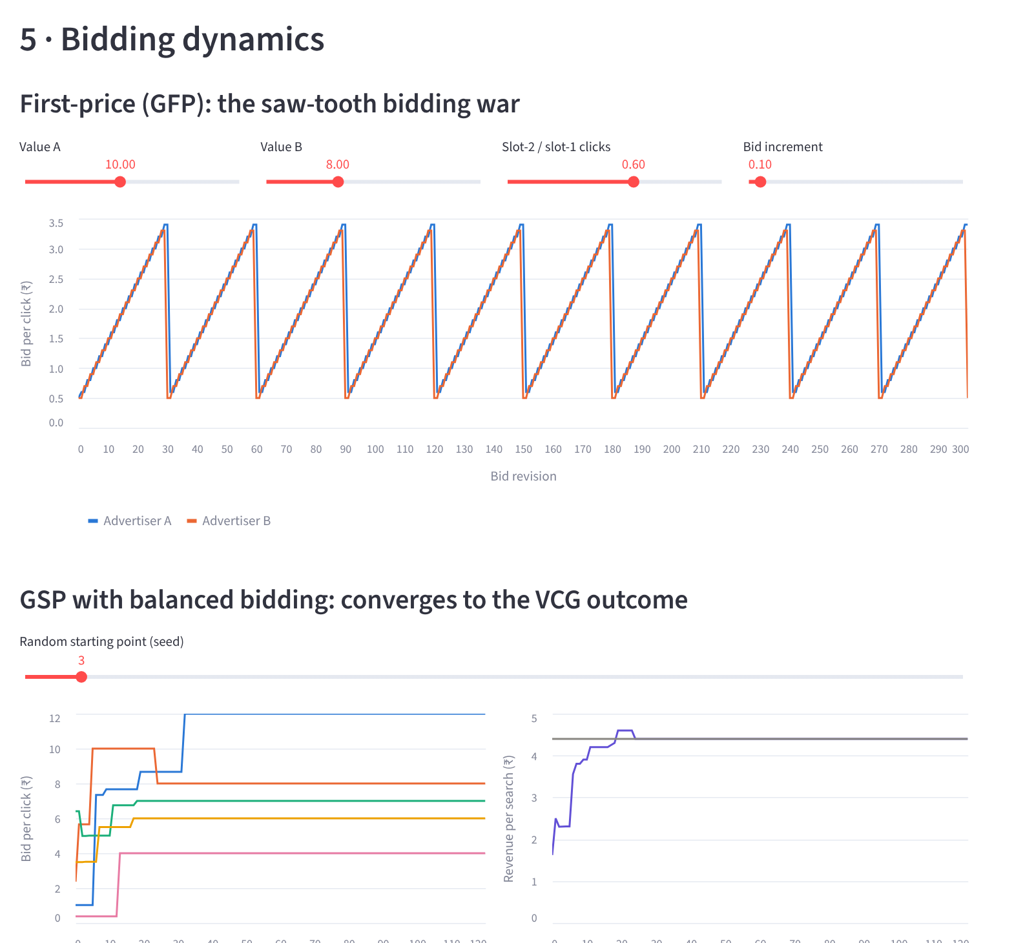
Figure 20. Dashboard, bidding dynamics page: the GFP saw-tooth and GSP convergence.

8. Applications
Who | How these results apply
Advertisers and marketing teams | Spend more only when ads grow the market (g > 1, Model 1). In a crowded market, expect most of the value to go to the platform (Model 2). Do not bid your full value in GSP or first-price auctions; shade by about (n−1)/n in first-price (Models 3, 5).
Ad platforms (Google, Meta, Amazon) | Choose auction rules that are stable: GSP and VCG settle, first-price keyword auctions cycle (Model 4). Set reserve prices to raise revenue (Model 5). Quality scores change the ranking and the prices (implemented in Model 3).
Ad-tech companies | Bid-shading algorithms for first-price display auctions; automated bidding tools that follow best-response or balanced-bidding rules.
Competition regulators | Repeated play can produce tacit coordination on ad budgets without any agreement (Model 1b). Rent dissipation shows how platform market power grows with the number of advertisers.
Other strategic spending | The same contest model fits political campaign spending, R&D races, lobbying and sports sponsorship.

9. Limitations and future scope
Limitations
- Illustrative numbers. Values, budgets and click rates are chosen to show the mechanisms, not fitted to real market data.
- Rational, fully informed players in Models 1–4. Real advertisers have limited information and use rules of thumb.
- Simple click model. Clicks depend only on slot position and a quality score; we ignore ad fatigue, user intent and conversion rates.
- No budget limits inside auctions. Real advertisers run out of daily budget, which changes their bidding.
- Fixed strategy pool in the tournament. Its ranking depends on which strategies take part.
Future scope
- Fit the models to public ad-auction datasets (for example, the Criteo or Yahoo! search-auction data).
- Replace best-response rules with learning algorithms (multiplicative weights, reinforcement learning) and test whether they still reach equilibrium.
- Add budget-constrained bidding and auto-bidding agents, which now dominate Google and Meta ads.
- Evolutionary dynamics (replicator equations) for the repeated ad war, so strategy shares change over time.
- Study platform competition: two platforms competing for the same advertisers.

10. Conclusion
We modelled online advertising competition as five connected games and solved each one in working, tested Python code.
- Budgets: competing firms overspend on ads whenever advertising mainly steals customers. The loss is 50% of joint profit for two firms and grows with every new rival, and the ad platform collects it.
- Repetition helps: firms that care about the future (δ ≥ 0.20) and use reciprocal strategies can keep spending low without any agreement, but this is fragile when moves are observed with errors.
- Auction rules matter: GSP is not truthful, yet in equilibrium it earns exactly what VCG earns. First-price keyword auctions never settle, which explains the industry’s move to GSP.
- Design choices: in first-price display auctions bidders should shade to (n−1)/n of their value, first-price and second-price formats earn the same, and a reserve price of 0.5 raises revenue by 25%.
Every numerical result matched the theory it was tested against, and all 20 automated tests pass. The interactive dashboard lets anyone change the inputs and see the equilibrium move, which makes the theory easy to explore and explain.

References
- B. Edelman, M. Ostrovsky and M. Schwarz, “Internet advertising and the generalized second-price auction: Selling billions of dollars worth of keywords,” American Economic Review, vol. 97, no. 1, pp. 242–259, 2007. doi:10.1257/aer.97.1.242
- H. R. Varian, “Position auctions,” International Journal of Industrial Organization, vol. 25, no. 6, pp. 1163–1178, 2007. doi:10.1016/j.ijindorg.2006.10.002
- M. Cary, A. Das, B. Edelman, I. Giotis, K. Heimerl, A. R. Karlin, C. Mathieu and M. Schwarz, “Greedy bidding strategies for keyword auctions,” in Proc. 8th ACM Conference on Electronic Commerce, 2007, pp. 262–271.
- B. Edelman and M. Ostrovsky, “Strategic bidder behavior in sponsored search auctions,” Decision Support Systems, vol. 43, no. 1, pp. 192–198, 2007.
- G. Tullock, “Efficient rent seeking,” in Toward a Theory of the Rent-Seeking Society, J. M. Buchanan, R. D. Tollison and G. Tullock, Eds. College Station: Texas A&M University Press, 1980, pp. 97–112.
- R. B. Myerson, “Optimal auction design,” Mathematics of Operations Research, vol. 6, no. 1, pp. 58–73, 1981. doi:10.1287/moor.6.1.58
- W. Vickrey, “Counterspeculation, auctions, and competitive sealed tenders,” Journal of Finance, vol. 16, no. 1, pp. 8–37, 1961. doi:10.1111/j.1540-6261.1961.tb02789.x
- J. F. Nash, “Equilibrium points in n-person games,” Proceedings of the National Academy of Sciences, vol. 36, no. 1, pp. 48–49, 1950. doi:10.1073/pnas.36.1.48
- R. Axelrod, The Evolution of Cooperation. New York: Basic Books, 1984.
- Google, “Rolling out first price auctions to Google Ad Manager partners,” Google Ad Manager blog, 5 September 2019. https://blog.google/products/ads-commerce/rolling-out-first-price-auctions-google-ad-manager-partners/
- M. J. Osborne, An Introduction to Game Theory. New York: Oxford University Press, 2004.

Appendix: how to run the project
Requires Python 3.10 or newer.
pip install -r requirements.txt
python main.py # runs every experiment (about 5 seconds), prints results, saves figures and tables
python main.py --quick # fewer simulation trials, for a fast demo
python -m pytest -v # runs the 20 automated tests
streamlit run app.py # opens the interactive dashboard in the browser
Outputs are written to the outputs/ folder: figures/ (12 PNG figures), tables/ (CSV tables), results.json (every number in this report) and screenshots/. All simulations use fixed random seeds, so every run reproduces the numbers in this report exactly.

