Critical Mineral Company Stocks: VMD-Based Forecasting and Systematic Trading
Group 3

Note: This .docx bundles all tables and figures from the LaTeX report (see Critical_Mineral_Final_Report.pdf for the full narrative). Tables are full-size with a narrow font so wide multi-column tables fit without losing columns.

Tables
Table 1. Summarized research works in the literature review.
Reference | Domain | Method | Main finding
Henriques & Sadorsky (2023) | Critical mineral / rare-earth equities | ML (RF, SVR, ANN) | ML beats AR baselines on directional accuracy
Ge et al.\ (2023) | Rare-earth pricing review | Review / structural | Chinese policy + supply controls dominate price formation
Reboredo & Ugolini (2020) | Critical minerals vs renewables | Quantile dependence | Strong tail co-movement with EV / clean-energy assets
Zheng et al.\ (2021) | Rare earths vs financial markets | Time-frequency spillover | VIX, S&P 500 spill over to rare-earth returns
Akram (2009) | Commodity prices & USD | VAR | USD strength inversely related to commodity returns
Dragomiretskiy & Zosso (2014) | Signal decomposition | VMD | VMD used as the decomposition step in this study
Pincus (1991) | Series complexity | Approximate Entropy | Used here to route IMFs to ARX vs LSTM
Tibshirani (1996) | Feature selection | LASSO | Prunes exogenous predictors per IMF
Liu et al.\ (2024) | Interval forecasting | iMLP / conformal band | Architecture for the interval trading gate
This study | Eight critical-mineral equities | VMD + LASSO + ARX/LSTM + conformal | Per-company forecasting + interval-gated trading

Table 2. Parameter settings used in this study.
Block | Parameter | Value
VMD | K (min / max) | 4 / 5
VMD | $\alpha$ (bandwidth) | 2000
VMD | $\tau$ | 0
VMD | DC component | 0
VMD | init | 1
VMD | tolerance | 1e-07
ApEn | embedding dim $m$ | 2
ApEn | tolerance $r$ | 0.2$\times\sigma$
LASSO | CV folds | 5
LASSO | lags of own IMF | 5
LASSO | max iterations | 20000
Trading | transaction cost | 0.05%
Trading | annualisation | 252
Split | test fraction | 20%

Table 3. Indicators used in this study.
Category | Variable | Source | Role
Target | Target_Close | Refinitiv | Daily close price per company (8 critical-mineral equities)
Sector | mvis_critical_minerals | MarketVector (MVIS) | MVIS Global Rare Earth / Strategic Metals Index
Macro | SP500 | Yahoo (\^GSPC) | Western equity risk appetite
Macro | Shanghai_Index | Yahoo (000001.SS) | Chinese demand / policy proxy
Macro | Crude_Oil | Yahoo (CL=F) | Energy cost / EV-transition driver
Macro | VIX | Yahoo (\^VIX) | Volatility / supply-chain stress
Macro | US_Dollar_Index | Yahoo (DX-Y.NYB) | FX denomination effect
Attention | Search_Index | Google Trends | Search volume for ``rare earth''
Sentiment | News_Sentiment | SF Fed (NESI) | Daily news-tone score

Table 4. Descriptive statistics of targets and predictors.
Category | Variable | n | Mean | Std | Min | Max | Skew | Kurtosis
Target | Glencore | 3751 | 4.44 | 1.394 | 0.97 | 8.32 | -0.332 | -0.32
Target | BHP Group | 3751 | 24.371 | 6.05 | 8.378 | 42.014 | -0.382 | -0.352
Target | Rio Tinto | 3751 | 62.027 | 17.437 | 24.026 | 120.15 | 0.185 | -0.321
Target | Freeport-McMoRan | 3751 | 28.398 | 13.727 | 3.74 | 68.82 | 0.032 | -1.088
Target | Albemarle | 3751 | 106.684 | 60.691 | 39.0 | 325.38 | 1.383 | 0.93
Target | Zijin Mining | 3751 | 0.932 | 0.975 | 0.177 | 5.912 | 2.261 | 6.054
Target | Ganfeng Lithium | 3751 | 4.797 | 4.723 | 0.309 | 24.324 | 1.334 | 1.217
Target | Anglo American | 3751 | 26.002 | 9.957 | 2.98 | 53.42 | 0.172 | -0.281
Sector | MVIS Global Rare Earth / Strategic Metals Index | 5396 | 491.655 | 266.98 | 161.2 | 1701.68 | 1.633 | 3.249
Macro | S&P 500 | 5420 | 3166.229 | 1512.076 | 1099.23 | 6978.6 | 0.761 | -0.37
Macro | Shanghai Composite | 5317 | 3006.342 | 536.9 | 1950.012 | 5166.35 | 0.036 | 0.207
Macro | Crude oil (WTI) | 5420 | 70.285 | 20.952 | -37.63 | 123.7 | 0.059 | -0.742
Macro | VIX | 5420 | 18.078 | 6.86 | 9.14 | 82.69 | 2.43 | 10.868
Macro | US Dollar Index | 5420 | 94.007 | 8.795 | 73.47 | 114.11 | -0.5 | -0.642
Attention | Google Trends ``rare earth'' | 5420 | 8.601 | 9.591 | 5.0 | 100.0 | 6.296 | 49.237
Sentiment | News Sentiment Index (NESI) | 5420 | -0.015 | 0.17 | -0.666 | 0.334 | -0.964 | 1.611

Table 5. Decomposed IMF diagnostics (VMD + ApEn routing).
Company | Mode | Omega | Period (days) | Variance ratio | Correlation | Mean |IMF| | ApEn | Routed to
Glencore | IMF1 | 0.00068 | 3750.0 | 0.8829 | 0.9628 | 1.0903 | 0.0153 | ARX
Glencore | IMF2 | 0.00571 | 208.3 | 0.0508 | 0.3258 | 0.2516 | 0.1335 | ARX
Glencore | IMF3 | 0.02167 | 52.8 | 0.0076 | 0.1397 | 0.0926 | 0.5229 | LSTM
Glencore | IMF4 | 0.05329 | 18.7 | 0.0021 | 0.0779 | 0.0497 | 0.631 | LSTM
Glencore | IMF5 | 0.10574 | 9.9 | 0.0009 | 0.0515 | 0.0307 | 0.6033 | LSTM
BHP Group | IMF1 | 0.00048 | 3750.0 | 0.8598 | 0.9525 | 4.7093 | 0.0123 | ARX
BHP Group | IMF2 | 0.00539 | 197.4 | 0.0669 | 0.3533 | 1.2007 | 0.1218 | ARX
BHP Group | IMF3 | 0.02215 | 52.8 | 0.0096 | 0.1468 | 0.4509 | 0.5213 | LSTM
BHP Group | IMF4 | 0.04812 | 19.3 | 0.0027 | 0.0883 | 0.2437 | 0.6296 | LSTM
BHP Group | IMF5 | 0.09623 | 10.1 | 0.0012 | 0.0574 | 0.1518 | 0.5897 | LSTM
Rio Tinto | IMF1 | 0.00036 | 3750.0 | 0.8669 | 0.9551 | 13.7071 | 0.0098 | ARX
Rio Tinto | IMF2 | 0.00503 | 250.0 | 0.067 | 0.3487 | 3.4528 | 0.1123 | ARX
Rio Tinto | IMF3 | 0.02369 | 36.1 | 0.0081 | 0.1307 | 1.192 | 0.5499 | LSTM
Rio Tinto | IMF4 | 0.05121 | 18.7 | 0.0021 | 0.0757 | 0.6019 | 0.6241 | LSTM
Rio Tinto | IMF5 | 0.09749 | 10.9 | 0.0009 | 0.0507 | 0.3845 | 0.5907 | LSTM
Freeport-McMoRan | IMF1 | 0.00038 | 3750.0 | 0.9073 | 0.9693 | 11.9864 | 0.0086 | ARX
Freeport-McMoRan | IMF2 | 0.00499 | 208.3 | 0.0431 | 0.2879 | 2.2036 | 0.1093 | ARX
Freeport-McMoRan | IMF3 | 0.01818 | 53.6 | 0.0053 | 0.1178 | 0.7415 | 0.4758 | LSTM
Freeport-McMoRan | IMF4 | 0.03588 | 31.5 | 0.0027 | 0.0807 | 0.5117 | 0.5895 | LSTM
Freeport-McMoRan | IMF5 | 0.08098 | 13.6 | 0.0009 | 0.0489 | 0.2879 | 0.6096 | LSTM
Albemarle | IMF1 | 0.00048 | 3750.0 | 0.9261 | 0.9772 | 45.8792 | 0.0099 | ARX
Albemarle | IMF2 | 0.0051 | 208.3 | 0.0278 | 0.2563 | 7.3455 | 0.1129 | ARX
Albemarle | IMF3 | 0.01834 | 64.7 | 0.0078 | 0.1272 | 3.2578 | 0.3552 | LSTM
Albemarle | IMF4 | 0.0616 | 18.7 | 0.0013 | 0.062 | 1.3762 | 0.562 | LSTM
Albemarle | IMF5 | 0.32201 | 3.1 | 0.0001 | 0.0195 | 0.3479 | 0.6244 | LSTM
Zijin Mining | IMF1 | 0.00039 | 3750.0 | 0.9812 | 0.9953 | 0.7308 | 0.0039 | ARX
Zijin Mining | IMF2 | 0.01117 | 107.1 | 0.0056 | 0.1316 | 0.0425 | 0.2049 | ARX
Zijin Mining | IMF3 | 0.03623 | 29.5 | 0.0013 | 0.0561 | 0.0191 | 0.4043 | LSTM
Zijin Mining | IMF4 | 0.08693 | 11.5 | 0.0003 | 0.032 | 0.0096 | 0.4756 | LSTM
Zijin Mining | IMF5 | 0.41063 | 2.4 | 0.0 | 0.0116 | 0.0029 | 0.4881 | LSTM
Ganfeng Lithium | IMF1 | 0.00043 | 3750.0 | 0.9554 | 0.9862 | 3.5771 | 0.0086 | ARX
Ganfeng Lithium | IMF2 | 0.00737 | 208.3 | 0.0204 | 0.2035 | 0.3783 | 0.1474 | ARX
Ganfeng Lithium | IMF3 | 0.02986 | 35.0 | 0.0025 | 0.0775 | 0.1264 | 0.3791 | LSTM
Ganfeng Lithium | IMF4 | 0.08209 | 13.3 | 0.0005 | 0.0382 | 0.0569 | 0.4802 | LSTM
Ganfeng Lithium | IMF5 | 0.44457 | 2.3 | 0.0001 | 0.0133 | 0.0176 | 0.4621 | LSTM
Anglo American | IMF1 | 0.00049 | 3750.0 | 0.8854 | 0.9603 | 7.6123 | 0.0112 | ARX
Anglo American | IMF2 | 0.00501 | 250.0 | 0.0555 | 0.3162 | 1.7586 | 0.108 | ARX
Anglo American | IMF3 | 0.02031 | 52.8 | 0.0086 | 0.1349 | 0.6593 | 0.4649 | LSTM
Anglo American | IMF4 | 0.04576 | 24.7 | 0.0025 | 0.0807 | 0.3754 | 0.6257 | LSTM
Anglo American | IMF5 | 0.09231 | 11.5 | 0.001 | 0.0531 | 0.219 | 0.6044 | LSTM

Table 6. LASSO-selected predictors per (company, IMF).
Company | IMF | Kept | Top features
Glencore | IMF1 | 1 | IMF1_lag1
Glencore | IMF2 | 4 | IMF2_lag1, IMF2_lag5, VIX, SP500
Glencore | IMF3 | 4 | IMF3_lag1, IMF3_lag5, Search_Index, VIX
Glencore | IMF4 | 5 | IMF4_lag1, IMF4_lag2, IMF4_lag3, IMF4_lag5, VIX
Glencore | IMF5 | 5 | IMF5_lag1, IMF5_lag2, IMF5_lag4, IMF5_lag5, VIX
BHP Group | IMF1 | 1 | IMF1_lag1
BHP Group | IMF2 | 3 | IMF2_lag1, IMF2_lag5, VIX
BHP Group | IMF3 | 4 | IMF3_lag1, IMF3_lag5, IMF3_lag4, VIX
BHP Group | IMF4 | 5 | IMF4_lag1, IMF4_lag3, IMF4_lag5, IMF4_lag2, VIX
BHP Group | IMF5 | 5 | IMF5_lag1, IMF5_lag2, IMF5_lag4, IMF5_lag5, VIX
Rio Tinto | IMF1 | 1 | IMF1_lag1
Rio Tinto | IMF2 | 4 | IMF2_lag1, IMF2_lag5, Search_Index, VIX
Rio Tinto | IMF3 | 4 | IMF3_lag1, IMF3_lag5, IMF3_lag4, VIX
Rio Tinto | IMF4 | 5 | IMF4_lag1, IMF4_lag2, IMF4_lag3, IMF4_lag5, VIX
Rio Tinto | IMF5 | 5 | IMF5_lag1, IMF5_lag2, IMF5_lag4, IMF5_lag5, VIX
Freeport-McMoRan | IMF1 | 1 | IMF1_lag1
Freeport-McMoRan | IMF2 | 4 | IMF2_lag1, IMF2_lag5, SP500, VIX
Freeport-McMoRan | IMF3 | 3 | IMF3_lag1, IMF3_lag5, Search_Index
Freeport-McMoRan | IMF4 | 3 | IMF4_lag1, IMF4_lag3, IMF4_lag4
Freeport-McMoRan | IMF5 | 4 | IMF5_lag1, IMF5_lag2, IMF5_lag4, IMF5_lag5
Albemarle | IMF1 | 3 | IMF1_lag1, Shanghai_Index, Search_Index
Albemarle | IMF2 | 5 | IMF2_lag1, IMF2_lag5, VIX, News_Sentiment, SP500
Albemarle | IMF3 | 2 | IMF3_lag1, IMF3_lag5
Albemarle | IMF4 | 3 | IMF4_lag1, IMF4_lag2, IMF4_lag5
Albemarle | IMF5 | 11 | IMF5_lag2, IMF5_lag1, IMF5_lag3, IMF5_lag4, IMF5_lag5, VIX, mvis_critical_minerals, SP500 …
Zijin Mining | IMF1 | 2 | IMF1_lag1, Search_Index
Zijin Mining | IMF2 | 2 | IMF2_lag1, IMF2_lag5
Zijin Mining | IMF3 | 4 | IMF3_lag1, IMF3_lag3, IMF3_lag4, VIX
Zijin Mining | IMF4 | 5 | IMF4_lag1, IMF4_lag2, IMF4_lag4, IMF4_lag5, VIX
Zijin Mining | IMF5 | 8 | IMF5_lag1, IMF5_lag2, IMF5_lag3, IMF5_lag5, mvis_critical_minerals, Shanghai_Index, Search_Index, News_Sentiment
Ganfeng Lithium | IMF1 | 1 | IMF1_lag1
Ganfeng Lithium | IMF2 | 2 | IMF2_lag1, IMF2_lag5
Ganfeng Lithium | IMF3 | 3 | IMF3_lag1, IMF3_lag3, IMF3_lag4
Ganfeng Lithium | IMF4 | 4 | IMF4_lag1, IMF4_lag2, IMF4_lag4, IMF4_lag5
Ganfeng Lithium | IMF5 | 6 | IMF5_lag1, IMF5_lag2, IMF5_lag5, mvis_critical_minerals, Shanghai_Index, Search_Index
Anglo American | IMF1 | 2 | IMF1_lag1, SP500
Anglo American | IMF2 | 3 | IMF2_lag1, IMF2_lag5, VIX
Anglo American | IMF3 | 3 | IMF3_lag1, IMF3_lag5, Search_Index
Anglo American | IMF4 | 4 | IMF4_lag1, IMF4_lag3, IMF4_lag5, VIX
Anglo American | IMF5 | 5 | IMF5_lag1, IMF5_lag2, IMF5_lag4, IMF5_lag5, VIX

Table 7. Forecasting errors on the test set --- single models.
Company | Model | RMSE | MAE | MAPE | DA
Glencore | ARIMA | 1.012921501286257 | 0.7838961614617798 | 17.622367841330135 | 6.933333333333333
Glencore | Naive | 1.0241763928258831 | 0.793249001331558 | 17.852228902321748 | 5.2
Glencore | RF | 1.061497937506974 | 0.8263303595206398 | 18.638077546606237 | 47.46666666666667
Glencore | Linear | 0.966298101283112 | 0.7078543993872534 | 12.995574188841458 | 46.13333333333333
Glencore | LSTM | 0.1145717414797363 | 0.0858687448189914 | 1.67635643574499 | 47.86666666666667
BHP Group | ARIMA | 3.901715024107975 | 3.248143242291302 | 11.979572485007866 | 6.0
BHP Group | Naive | 3.9036484941541687 | 3.250436750998668 | 11.988163182602008 | 1.3333333333333337
BHP Group | RF | 4.373856429290866 | 3.7767785352862897 | 13.962311390100766 | 48.13333333333333
BHP Group | Linear | 4.257784861207991 | 2.930154622017041 | 9.59222593686781 | 49.733333333333334
BHP Group | LSTM | 0.5375271517013549 | 0.3975029364043999 | 1.3694252199716097 | 50.93333333333333
Rio Tinto | ARIMA | 10.187249555204192 | 6.818526822461462 | 7.898765404785692 | 7.333333333333333
Rio Tinto | Naive | 10.222493420313958 | 6.800631158455392 | 7.855389084999888 | 1.2
Rio Tinto | RF | 10.313898327655284 | 6.775229267643142 | 7.7783641101471375 | 49.2
Rio Tinto | Linear | 19.417699280801735 | 15.220030690487777 | 17.727579517105998 | 48.93333333333334
Rio Tinto | LSTM | 1.7438380361379309 | 1.2310654392784124 | 1.4779068372501598 | 51.2
Freeport-McMoRan | ARIMA | 7.527577542572782 | 5.11106558468324 | 10.75511338948367 | 19.333333333333332
Freeport-McMoRan | Naive | 7.538506838417195 | 5.116924101198402 | 10.762291392314111 | 2.8000000000000003
Freeport-McMoRan | RF | 7.541958250314078 | 5.123771238348864 | 10.778688708367058 | 47.2
Freeport-McMoRan | Linear | 15.204717073161408 | 12.35626361934884 | 26.60875464404941 | 48.0
Freeport-McMoRan | LSTM | 1.366390674410927 | 0.9586159177866432 | 2.163007224075847 | 47.599999999999994
Albemarle | ARIMA | 110.87748182852503 | 101.01955516561902 | 110.19563153071844 | 11.2
Albemarle | Naive | 110.71816663569312 | 100.85512649800266 | 110.03468684099528 | 2.666666666666667
Albemarle | RF | 109.42734734575528 | 99.48118508655114 | 108.71096205674544 | 31.733333333333334
Albemarle | Linear | 92.92289260393802 | 83.6192119685866 | 91.92339345862293 | 48.66666666666667
Albemarle | LSTM | 4.884913704354098 | 3.59853513523812 | 3.10221657473597 | 48.4
Zijin Mining | ARIMA | 1.3570299105687953 | 0.847047553078918 | 25.746973626422093 | 44.4
Zijin Mining | Naive | 1.356494947260798 | 0.8466058588548603 | 25.73473686271221 | 5.6000000000000005
Zijin Mining | RF | 1.345980511416015 | 0.838077137150466 | 25.505594912965172 | 6.800000000000001
Zijin Mining | Linear | 1.360187986627518 | 0.8497524041889033 | 25.835440195180265 | 45.33333333333333
Zijin Mining | LSTM | 0.9891983711581634 | 0.5279728978575319 | 14.177745907945766 | 48.8
Ganfeng Lithium | ARIMA | 4.010027393700223 | 3.5076014095784713 | 71.42671941893815 | 15.066666666666666
Ganfeng Lithium | Naive | 4.026035260994324 | 3.523616511318242 | 71.7283772993551 | 7.333333333333333
Ganfeng Lithium | RF | 4.091666994416202 | 3.5902183488681727 | 72.97304926983347 | 8.4
Ganfeng Lithium | Linear | 3.6432413856020736 | 3.210757561989715 | 65.02541348863936 | 50.0
Ganfeng Lithium | LSTM | 0.2472567281091822 | 0.1707128674983996 | 2.671664345205691 | 43.733333333333334
Anglo American | ARIMA | 6.342190267272663 | 5.284043688990492 | 18.02495909586346 | 35.06666666666667
Anglo American | Naive | 6.318522103406646 | 5.245046604527297 | 17.86916163966712 | 0.9333333333333336
Anglo American | RF | 6.30432842613341 | 5.2216732356857305 | 17.77505974083121 | 47.06666666666667
Anglo American | Linear | 7.964542165988109 | 5.750979012219159 | 17.362635111983565 | 49.333333333333336
Anglo American | LSTM | 0.8338111902091015 | 0.611249160296185 | 2.015379518576985 | 50.0

Table 8. Forecasting errors on the test set --- decomposition models.
Company | Model | RMSE | MAE | MAPE | DA
Glencore | CEEMDAN-ARIMA | 0.4499501338643531 | 0.3511547874702277 | 6.815132498271679 | 6.141522029372497
Glencore | VMD-ARIMA | 0.4265449704353158 | 0.3357458163506357 | 6.562936221243356 | 6.141522029372497
Glencore | CEEMDAN-LSTM | 0.3375192047460313 | 0.2239230287978199 | 4.28579901604176 | 75.70093457943925
Glencore | VMD-LSTM | 0.0658828318654704 | 0.0502943669609472 | 0.9775386955944756 | 65.82109479305741
Glencore | VMD-LASSO-ARX/LSTM | 0.3838728087033689 | 0.2773112492617244 | 5.370291522862141 | 64.75300400534046
BHP Group | CEEMDAN-ARIMA | nan | nan | nan | 1.4686248331108145
BHP Group | VMD-ARIMA | 1.9906409869544728 | 1.401337424950157 | 4.749612978178484 | 1.7356475300400531
BHP Group | CEEMDAN-LSTM | 0.7475660321338934 | 0.6091755842654605 | 2.1657654316546804 | 75.16688918558077
BHP Group | VMD-LSTM | 0.3013815848512819 | 0.226636410265371 | 0.7867731431370234 | 66.48865153538051
BHP Group | VMD-LASSO-ARX/LSTM | 1.6919775053584325 | 1.1323290532573649 | 3.804088418425431 | 66.22162883845127
Rio Tinto | CEEMDAN-ARIMA | nan | nan | nan | 1.4686248331108145
Rio Tinto | VMD-ARIMA | 6.030654272504372 | 4.463155327920769 | 5.340388488219545 | 1.4686248331108145
Rio Tinto | CEEMDAN-LSTM | 1.6052254102199073 | 1.3378045809076455 | 1.6503603814030834 | 77.4365821094793
Rio Tinto | VMD-LSTM | 1.499852094529983 | 0.9125813190977052 | 1.0434852764195617 | 69.02536715620828
Rio Tinto | VMD-LASSO-ARX/LSTM | 5.085242383601404 | 3.669462366060737 | 4.304466136622328 | 66.48865153538051
Freeport-McMoRan | CEEMDAN-ARIMA | 4.211568899134776 | 3.2417087759609395 | 7.488463132216442 | 3.7383177570093458
Freeport-McMoRan | VMD-ARIMA | 4.090354087846353 | 3.173169750112566 | 7.352494512997653 | 3.6048064085447264
Freeport-McMoRan | CEEMDAN-LSTM | 1.2043903876968691 | 0.9684699187018866 | 2.157702524959321 | 74.09879839786382
Freeport-McMoRan | VMD-LSTM | 0.9393196087669652 | 0.6763865621109181 | 1.5168166024247756 | 64.75300400534046
Freeport-McMoRan | VMD-LASSO-ARX/LSTM | 3.852391156766117 | 2.9284268101734936 | 6.562921602782007 | 62.75033377837116
Albemarle | CEEMDAN-ARIMA | 18.52154964611948 | 13.507321956589696 | 12.121332555962356 | 3.7383177570093458
Albemarle | VMD-ARIMA | 17.986837336506323 | 12.929950564707996 | 11.590736686443895 | 3.7383177570093458
Albemarle | CEEMDAN-LSTM | 8.82330796747375 | 6.712857480384501 | 7.513179645039244 | 76.10146862483312
Albemarle | VMD-LSTM | 3.3512429569451023 | 2.51324122137698 | 2.1334651920600143 | 72.63017356475301
Albemarle | VMD-LASSO-ARX/LSTM | 16.451314469880117 | 11.325309693541213 | 10.16208535688132 | 70.22696929238985
Zijin Mining | CEEMDAN-ARIMA | 0.3394966684944922 | 0.2182432807991986 | 8.068114461816482 | 6.5420560747663545
Zijin Mining | VMD-ARIMA | 0.3307117371526513 | 0.2087329381470117 | 7.761620181616426 | 6.275033377837117
Zijin Mining | CEEMDAN-LSTM | 0.7109105441335577 | 0.3923577641149371 | 11.216112868315118 | 69.826435246996
Zijin Mining | VMD-LSTM | 1.1978594832099725 | 0.6706509128984777 | 18.526673973075447 | 68.75834445927904
Zijin Mining | VMD-LASSO-ARX/LSTM | 0.3127466241674121 | 0.1957915658665767 | 7.30558247920038 | 68.75834445927904
Ganfeng Lithium | CEEMDAN-ARIMA | 0.8527803981980848 | 0.5726948195375611 | 9.333655941086644 | 8.144192256341789
Ganfeng Lithium | VMD-ARIMA | 0.841047524902994 | 0.5548045789128546 | 9.019741112450422 | 8.01068090787717
Ganfeng Lithium | CEEMDAN-LSTM | 1.401124611504585 | 1.0934763482880332 | 23.009638122030825 | 71.96261682242991
Ganfeng Lithium | VMD-LSTM | 0.1344200438985734 | 0.1011807874157773 | 1.6219856444732523 | 67.55674232309747
Ganfeng Lithium | VMD-LASSO-ARX/LSTM | 0.8028226905360861 | 0.5169436553579047 | 8.448944564114278 | 65.68758344459279
Anglo American | CEEMDAN-ARIMA | 3.224535479973999 | 2.234940839100784 | 7.217630339399794 | 2.2696929238985315
Anglo American | VMD-ARIMA | 3.214521682154034 | 2.2399559640265143 | 7.221859732902638 | 2.2696929238985315
Anglo American | CEEMDAN-LSTM | 0.9094505077263392 | 0.6925400853257423 | 2.128364507698046 | 76.7690253671562
Anglo American | VMD-LSTM | 0.4948463518165356 | 0.3724678499565487 | 1.2318891777603038 | 66.22162883845127
Anglo American | VMD-LASSO-ARX/LSTM | 2.313620572447314 | 1.5733180246837537 | 5.007983726687586 | 66.88918558077437

Table 9. Diebold--Mariano test results (VMD-LASSO-ARX/LSTM vs benchmarks).
Company | vs | DM statistic | p-value
Glencore | ARIMA | -3.307 | 0.001
Glencore | Naive | -3.321 | 0.0009
Glencore | RF | -3.379 | 0.0008
Glencore | Linear | -2.668 | 0.0078
Glencore | LSTM | 3.421 | 0.0007
Glencore | CEEMDAN-ARIMA | -3.54 | 0.0004
Glencore | VMD-ARIMA | -2.694 | 0.0072
Glencore | CEEMDAN-LSTM | 1.155 | 0.2484
Glencore | VMD-LSTM | 3.602 | 0.0003
BHP Group | ARIMA | -4.154 | 0.0
BHP Group | Naive | -4.156 | 0.0
BHP Group | RF | -4.582 | 0.0
BHP Group | Linear | -2.262 | 0.024
BHP Group | LSTM | 2.762 | 0.0059
BHP Group | CEEMDAN-ARIMA | nan | nan
BHP Group | VMD-ARIMA | -1.999 | 0.046
BHP Group | CEEMDAN-LSTM | 2.518 | 0.012
BHP Group | VMD-LSTM | 2.87 | 0.0042
Rio Tinto | ARIMA | -1.783 | 0.075
Rio Tinto | Naive | -1.773 | 0.0766
Rio Tinto | RF | -1.759 | 0.0789
Rio Tinto | Linear | -2.996 | 0.0028
Rio Tinto | LSTM | 3.739 | 0.0002
Rio Tinto | CEEMDAN-ARIMA | nan | nan
Rio Tinto | VMD-ARIMA | -2.073 | 0.0385
Rio Tinto | CEEMDAN-LSTM | 3.539 | 0.0004
Rio Tinto | VMD-LSTM | 3.956 | 0.0001
Freeport-McMoRan | ARIMA | -2.019 | 0.0439
Freeport-McMoRan | Naive | -2.021 | 0.0436
Freeport-McMoRan | RF | -2.023 | 0.0435
Freeport-McMoRan | Linear | -3.751 | 0.0002
Freeport-McMoRan | LSTM | 3.886 | 0.0001
Freeport-McMoRan | CEEMDAN-ARIMA | -1.206 | 0.2283
Freeport-McMoRan | VMD-ARIMA | -0.802 | 0.4227
Freeport-McMoRan | CEEMDAN-LSTM | 4.009 | 0.0001
Freeport-McMoRan | VMD-LSTM | 4.087 | 0.0
Albemarle | ARIMA | -7.37 | 0.0
Albemarle | Naive | -7.362 | 0.0
Albemarle | RF | -7.3 | 0.0
Albemarle | Linear | -7.013 | 0.0
Albemarle | LSTM | 2.768 | 0.0058
Albemarle | CEEMDAN-ARIMA | -1.706 | 0.0884
Albemarle | VMD-ARIMA | -1.499 | 0.1342
Albemarle | CEEMDAN-LSTM | 1.996 | 0.0463
Albemarle | VMD-LSTM | 2.898 | 0.0039
Zijin Mining | ARIMA | -2.476 | 0.0135
Zijin Mining | Naive | -2.475 | 0.0135
Zijin Mining | RF | -2.461 | 0.0141
Zijin Mining | Linear | -2.479 | 0.0134
Zijin Mining | LSTM | -2.095 | 0.0365
Zijin Mining | CEEMDAN-ARIMA | -2.789 | 0.0054
Zijin Mining | VMD-ARIMA | -1.648 | 0.0998
Zijin Mining | CEEMDAN-LSTM | -1.815 | 0.07
Zijin Mining | VMD-LSTM | -2.339 | 0.0196
Ganfeng Lithium | ARIMA | -6.468 | 0.0
Ganfeng Lithium | Naive | -6.484 | 0.0
Ganfeng Lithium | RF | -6.549 | 0.0
Ganfeng Lithium | Linear | -6.327 | 0.0
Ganfeng Lithium | LSTM | 1.839 | 0.0664
Ganfeng Lithium | CEEMDAN-ARIMA | -1.827 | 0.068
Ganfeng Lithium | VMD-ARIMA | -1.65 | 0.0993
Ganfeng Lithium | CEEMDAN-LSTM | -2.239 | 0.0255
Ganfeng Lithium | VMD-LSTM | 1.945 | 0.0522
Anglo American | ARIMA | -3.529 | 0.0004
Anglo American | Naive | -3.48 | 0.0005
Anglo American | RF | -3.451 | 0.0006
Anglo American | Linear | -2.444 | 0.0147
Anglo American | LSTM | 2.849 | 0.0045
Anglo American | CEEMDAN-ARIMA | -3.11 | 0.0019
Anglo American | VMD-ARIMA | -3.164 | 0.0016
Anglo American | CEEMDAN-LSTM | 2.805 | 0.0052
Anglo American | VMD-LSTM | 3.102 | 0.002

Table 10. Interval forecasting errors (calibration + test, per company).
Company | Subset | PICP (%) | PINAW (%) | Band width
Glencore | Calibration | 90.0 | 24.32 | 1.0506
Glencore | Test | 73.07 | 24.32 | 1.0506
BHP Group | Calibration | 90.0 | 24.61 | 5.2478
BHP Group | Test | 82.67 | 24.61 | 5.2478
Rio Tinto | Calibration | 90.0 | 28.3 | 15.9018
Rio Tinto | Test | 84.27 | 28.3 | 15.9018
Freeport-McMoRan | Calibration | 90.0 | 29.26 | 11.6078
Freeport-McMoRan | Test | 83.2 | 29.26 | 11.6078
Albemarle | Calibration | 90.0 | 29.19 | 56.2348
Albemarle | Test | 92.8 | 29.19 | 56.2348
Zijin Mining | Calibration | 90.0 | 10.14 | 0.4623
Zijin Mining | Test | 57.87 | 10.14 | 0.4623
Ganfeng Lithium | Calibration | 90.0 | 22.56 | 1.6132
Ganfeng Lithium | Test | 84.0 | 22.56 | 1.6132
Anglo American | Calibration | 90.0 | 21.9 | 6.8413
Anglo American | Test | 86.4 | 21.9 | 6.8413

Table 11. Trading performance with VMD-LASSO-ARX/LSTM forecasts (4 schemes).
Company | Scheme | Return (%) | Sharpe | Max DD (%) | N Trades | N Blocked | Hit Rate (%)
Glencore | Scheme 1 | 1286.26 | 2.92 | -23.05 | 97 | 0 | 54.34
Glencore | Scheme 1' | 1150.65 | 3.02 | -19.25 | 125 | 130 | 56.54
Glencore | Scheme 2 | 1267.01 | 2.91 | -23.05 | 101 | 0 | 54.37
Glencore | Scheme 2' | 1133.28 | 3.01 | -19.25 | 129 | 130 | 56.61
BHP Group | Scheme 1 | 562.07 | 2.66 | -33.98 | 115 | 0 | 57.01
BHP Group | Scheme 1' | 478.25 | 2.71 | -20.54 | 135 | 99 | 57.85
BHP Group | Scheme 2 | 577.92 | 2.71 | -33.98 | 121 | 0 | 56.95
BHP Group | Scheme 2' | 492.09 | 2.76 | -20.54 | 141 | 99 | 57.79
Rio Tinto | Scheme 1 | 328.76 | 2.03 | -38.76 | 85 | 0 | 53.67
Rio Tinto | Scheme 1' | 240.53 | 1.83 | -34.94 | 115 | 88 | 53.71
Rio Tinto | Scheme 2 | 356.38 | 2.12 | -38.76 | 96 | 0 | 53.99
Rio Tinto | Scheme 2' | 262.47 | 1.93 | -34.94 | 126 | 88 | 54.07
Freeport-McMoRan | Scheme 1 | 457.29 | 1.62 | -36.64 | 79 | 0 | 51.13
Freeport-McMoRan | Scheme 1' | 206.33 | 1.18 | -49.34 | 113 | 93 | 50.61
Freeport-McMoRan | Scheme 2 | 437.49 | 1.59 | -36.64 | 81 | 0 | 51.08
Freeport-McMoRan | Scheme 2' | 195.45 | 1.15 | -49.34 | 115 | 93 | 50.54
Albemarle | Scheme 1 | 1079.91 | 1.75 | -63.8 | 107 | 0 | 53.54
Albemarle | Scheme 1' | 1183.97 | 1.85 | -55.35 | 125 | 65 | 53.95
Albemarle | Scheme 2 | 1038.19 | 1.73 | -63.8 | 110 | 0 | 53.42
Albemarle | Scheme 2' | 1138.57 | 1.83 | -55.35 | 128 | 65 | 53.82
Zijin Mining | Scheme 1 | 389.63 | 1.54 | -41.52 | 95 | 0 | 51.67
Zijin Mining | Scheme 1' | 237.73 | 1.41 | -51.54 | 145 | 191 | 51.79
Zijin Mining | Scheme 2 | 391.55 | 1.54 | -41.58 | 101 | 0 | 51.75
Zijin Mining | Scheme 2' | 239.05 | 1.41 | -51.54 | 151 | 191 | 51.9
Ganfeng Lithium | Scheme 1 | 146.22 | 0.89 | -59.42 | 86 | 0 | 48.73
Ganfeng Lithium | Scheme 1' | 83.14 | 0.7 | -55.45 | 132 | 100 | 48.23
Ganfeng Lithium | Scheme 2 | 145.23 | 0.89 | -59.42 | 88 | 0 | 48.59
Ganfeng Lithium | Scheme 2' | 82.59 | 0.7 | -54.11 | 132 | 100 | 48.06
Anglo American | Scheme 1 | 2892.06 | 3.06 | -31.03 | 112 | 0 | 56.48
Anglo American | Scheme 1' | 1712.16 | 2.75 | -39.34 | 141 | 92 | 56.16
Anglo American | Scheme 2 | 2742.26 | 3.03 | -31.03 | 118 | 0 | 56.33
Anglo American | Scheme 2' | 1621.44 | 2.72 | -39.34 | 147 | 92 | 56.0

Table 12. Trading performance with ARIMA single-model forecasts (4 schemes).
Company | Scheme | Return (%) | Sharpe | Max DD (%) | N Trades | N Blocked | Hit Rate (%)
Glencore | Scheme 1 | 140.27 | 1.07 | -47.11 | 38 | 0 | 50.6
Glencore | Scheme 1' | 114.48 | 1.24 | -16.89 | 57 | 355 | 53.55
Glencore | Scheme 2 | 147.74 | 1.1 | -47.11 | 47 | 0 | 50.81
Glencore | Scheme 2' | 121.15 | 1.3 | -16.89 | 66 | 355 | 54.01
BHP Group | Scheme 1 | 44.3 | 0.61 | -31.77 | 25 | 0 | 49.0
BHP Group | Scheme 1' | 11.76 | 0.29 | -21.51 | 58 | 298 | 48.34
BHP Group | Scheme 2 | 46.24 | 0.63 | -31.77 | 28 | 0 | 49.13
BHP Group | Scheme 2' | 13.26 | 0.32 | -21.51 | 61 | 298 | 48.55
Rio Tinto | Scheme 1 | 37.31 | 0.54 | -36.22 | 39 | 0 | 48.73
Rio Tinto | Scheme 1' | 23.74 | 0.44 | -23.51 | 70 | 140 | 48.77
Rio Tinto | Scheme 2 | 34.51 | 0.51 | -36.22 | 44 | 0 | 48.72
Rio Tinto | Scheme 2' | 21.22 | 0.41 | -23.4 | 75 | 140 | 48.76
Freeport-McMoRan | Scheme 1 | 88.67 | 0.73 | -43.4 | 43 | 0 | 49.93
Freeport-McMoRan | Scheme 1' | 41.49 | 0.5 | -39.59 | 68 | 107 | 50.0
Freeport-McMoRan | Scheme 2 | 97.07 | 0.76 | -43.4 | 49 | 0 | 49.93
Freeport-McMoRan | Scheme 2' | 47.78 | 0.54 | -38.62 | 74 | 107 | 50.0
Albemarle | Scheme 1 | -9.9 | 0.22 | -76.52 | 7 | 0 | 49.53
Albemarle | Scheme 1' | -35.44 | -0.1 | -69.76 | 23 | 234 | 48.93
Albemarle | Scheme 2 | -9.9 | 0.22 | -76.52 | 7 | 0 | 49.53
Albemarle | Scheme 2' | -35.44 | -0.1 | -69.76 | 23 | 234 | 48.93
Zijin Mining | Scheme 1 | -58.1 | -0.53 | -80.11 | 19 | 0 | 44.86
Zijin Mining | Scheme 1' | -30.91 | -0.29 | -57.05 | 44 | 297 | 45.8
Zijin Mining | Scheme 2 | -58.87 | -0.55 | -80.11 | 20 | 0 | 44.79
Zijin Mining | Scheme 2' | -32.18 | -0.31 | -57.05 | 45 | 297 | 45.68
Ganfeng Lithium | Scheme 1 | 167.45 | 0.95 | -63.22 | 29 | 0 | 44.86
Ganfeng Lithium | Scheme 1' | 98.23 | 0.73 | -70.01 | 47 | 38 | 44.44
Ganfeng Lithium | Scheme 2 | 187.45 | 1.0 | -63.22 | 31 | 0 | 44.85
Ganfeng Lithium | Scheme 2' | 113.05 | 0.79 | -70.01 | 49 | 38 | 44.43
Anglo American | Scheme 1 | 15.41 | 0.32 | -38.46 | 14 | 0 | 48.6
Anglo American | Scheme 1' | -22.53 | -0.04 | -40.21 | 34 | 85 | 48.19
Anglo American | Scheme 2 | 18.53 | 0.34 | -38.46 | 17 | 0 | 48.73
Anglo American | Scheme 2' | -20.44 | -0.02 | -40.21 | 37 | 85 | 48.34

Table 13. Margin sweep: Scheme 1' at multiple band margins.
Company | Rule | Margin | Return (%) | Sharpe | N Trades | N Blocked | Hit Rate (%)
Glencore | Scheme 1 | 0.0 | 1286.26 | 2.92 | 97 | 0 | 54.34
Glencore | Buy & Hold | nan | 23.19 | 0.38 | 1 | 0 | nan
Glencore | Scheme 1' | 0.03 | 1141.56 | 3.01 | 127 | 127 | 56.43
Glencore | Scheme 1' | 0.05 | 1157.91 | 3.01 | 123 | 123 | 56.23
Glencore | Scheme 1' | 0.07 | 1089.38 | 2.94 | 131 | 115 | 55.84
Glencore | Scheme 1' | 0.1 | 1062.22 | 2.91 | 131 | 110 | 55.71
BHP Group | Scheme 1 | 0.0 | 562.07 | 2.66 | 115 | 0 | 57.01
BHP Group | Buy & Hold | nan | 8.51 | 0.24 | 1 | 0 | nan
BHP Group | Scheme 1' | 0.03 | 429.68 | 2.56 | 141 | 88 | 57.19
BHP Group | Scheme 1' | 0.05 | 427.59 | 2.54 | 145 | 85 | 57.08
BHP Group | Scheme 1' | 0.07 | 418.94 | 2.52 | 145 | 80 | 57.1
BHP Group | Scheme 1' | 0.1 | 417.37 | 2.5 | 141 | 74 | 57.04
Rio Tinto | Scheme 1 | 0.0 | 328.76 | 2.03 | 85 | 0 | 53.67
Rio Tinto | Buy & Hold | nan | 33.53 | 0.5 | 1 | 0 | nan
Rio Tinto | Scheme 1' | 0.03 | 240.1 | 1.82 | 113 | 81 | 53.74
Rio Tinto | Scheme 1' | 0.05 | 237.22 | 1.81 | 113 | 78 | 53.65
Rio Tinto | Scheme 1' | 0.07 | 233.34 | 1.79 | 113 | 73 | 53.4
Rio Tinto | Scheme 1' | 0.1 | 252.24 | 1.85 | 105 | 66 | 53.59
Freeport-McMoRan | Scheme 1 | 0.0 | 457.29 | 1.62 | 79 | 0 | 51.13
Freeport-McMoRan | Buy & Hold | nan | 31.07 | 0.43 | 1 | 0 | nan
Freeport-McMoRan | Scheme 1' | 0.03 | 197.37 | 1.15 | 115 | 92 | 50.53
Freeport-McMoRan | Scheme 1' | 0.05 | 198.96 | 1.15 | 117 | 86 | 50.53
Freeport-McMoRan | Scheme 1' | 0.07 | 182.43 | 1.1 | 119 | 82 | 50.22
Freeport-McMoRan | Scheme 1' | 0.1 | 191.42 | 1.12 | 115 | 75 | 50.3
Albemarle | Scheme 1 | 0.0 | 1079.91 | 1.75 | 107 | 0 | 53.54
Albemarle | Buy & Hold | nan | -26.14 | 0.11 | 1 | 0 | nan
Albemarle | Scheme 1' | 0.03 | 1237.42 | 1.88 | 123 | 59 | 54.06
Albemarle | Scheme 1' | 0.05 | 1320.14 | 1.91 | 119 | 57 | 54.19
Albemarle | Scheme 1' | 0.07 | 1246.74 | 1.87 | 119 | 54 | 54.1
Albemarle | Scheme 1' | 0.1 | 1246.74 | 1.87 | 119 | 54 | 54.1
Zijin Mining | Scheme 1 | 0.0 | 389.63 | 1.54 | 95 | 0 | 51.67
Zijin Mining | Buy & Hold | nan | 165.11 | 1.02 | 1 | 0 | nan
Zijin Mining | Scheme 1' | 0.03 | 251.22 | 1.44 | 141 | 182 | 51.68
Zijin Mining | Scheme 1' | 0.05 | 227.13 | 1.36 | 145 | 176 | 51.31
Zijin Mining | Scheme 1' | 0.07 | 230.82 | 1.37 | 147 | 170 | 51.3
Zijin Mining | Scheme 1' | 0.1 | 264.65 | 1.45 | 145 | 160 | 51.44
Ganfeng Lithium | Scheme 1 | 0.0 | 146.22 | 0.89 | 86 | 0 | 48.73
Ganfeng Lithium | Buy & Hold | nan | -5.01 | 0.19 | 1 | 0 | nan
Ganfeng Lithium | Scheme 1' | 0.03 | 78.99 | 0.68 | 132 | 97 | 48.31
Ganfeng Lithium | Scheme 1' | 0.05 | 108.44 | 0.8 | 124 | 88 | 48.56
Ganfeng Lithium | Scheme 1' | 0.07 | 128.63 | 0.88 | 118 | 80 | 48.88
Ganfeng Lithium | Scheme 1' | 0.1 | 132.74 | 0.89 | 118 | 79 | 48.96
Anglo American | Scheme 1 | 0.0 | 2892.06 | 3.06 | 112 | 0 | 56.48
Anglo American | Buy & Hold | nan | 22.56 | 0.37 | 1 | 0 | nan
Anglo American | Scheme 1' | 0.03 | 1796.92 | 2.79 | 137 | 87 | 56.19
Anglo American | Scheme 1' | 0.05 | 1914.74 | 2.84 | 135 | 85 | 56.33
Anglo American | Scheme 1' | 0.07 | 1967.69 | 2.85 | 135 | 80 | 56.5
Anglo American | Scheme 1' | 0.1 | 2127.35 | 2.91 | 129 | 75 | 56.68

Table 14. Holding-period comparison (daily / weekly / monthly + Buy & Hold).
Company | Rule | Hold (days) | Return (%) | Sharpe | N Trades | Hit Rate (%)
Glencore | Daily (Scheme 1) | 1 | 1286.26 | 2.92 | 97 | 54.34
Glencore | 1 week (5 days) | 5 | 131.0 | 1.03 | 97 | 54.34
Glencore | 1 month (20 days) | 20 | -11.37 | 0.04 | 97 | 54.34
Glencore | Buy & Hold | 749 | 23.19 | 0.38 | 1 | nan
BHP Group | Daily (Scheme 1) | 1 | 562.07 | 2.66 | 115 | 57.01
BHP Group | 1 week (5 days) | 5 | 68.39 | 0.82 | 115 | 57.01
BHP Group | 1 month (20 days) | 20 | -10.98 | -0.03 | 115 | 57.01
BHP Group | Buy & Hold | 749 | 8.51 | 0.24 | 1 | nan
Rio Tinto | Daily (Scheme 1) | 1 | 328.76 | 2.03 | 85 | 53.67
Rio Tinto | 1 week (5 days) | 5 | 71.12 | 0.83 | 85 | 53.67
Rio Tinto | 1 month (20 days) | 20 | -17.95 | -0.13 | 85 | 53.67
Rio Tinto | Buy & Hold | 749 | 33.53 | 0.5 | 1 | nan
Freeport-McMoRan | Daily (Scheme 1) | 1 | 457.29 | 1.62 | 79 | 51.13
Freeport-McMoRan | 1 week (5 days) | 5 | 175.39 | 1.04 | 79 | 51.13
Freeport-McMoRan | 1 month (20 days) | 20 | -58.84 | -0.52 | 79 | 51.13
Freeport-McMoRan | Buy & Hold | 749 | 31.07 | 0.43 | 1 | nan
Albemarle | Daily (Scheme 1) | 1 | 1079.91 | 1.75 | 107 | 53.54
Albemarle | 1 week (5 days) | 5 | 84.37 | 0.64 | 107 | 53.54
Albemarle | 1 month (20 days) | 20 | -73.75 | -0.5 | 107 | 53.54
Albemarle | Buy & Hold | 749 | -26.14 | 0.11 | 1 | nan
Zijin Mining | Daily (Scheme 1) | 1 | 389.63 | 1.54 | 95 | 51.67
Zijin Mining | 1 week (5 days) | 5 | -35.97 | -0.17 | 95 | 51.67
Zijin Mining | 1 month (20 days) | 20 | -71.79 | -0.86 | 95 | 51.67
Zijin Mining | Buy & Hold | 749 | 165.11 | 1.02 | 1 | nan
Ganfeng Lithium | Daily (Scheme 1) | 1 | 146.22 | 0.89 | 86 | 48.73
Ganfeng Lithium | 1 week (5 days) | 5 | -46.24 | -0.22 | 86 | 48.73
Ganfeng Lithium | 1 month (20 days) | 20 | -69.2 | -0.63 | 86 | 48.73
Ganfeng Lithium | Buy & Hold | 749 | -5.01 | 0.19 | 1 | nan
Anglo American | Daily (Scheme 1) | 1 | 2892.06 | 3.06 | 112 | 56.48
Anglo American | 1 week (5 days) | 5 | 462.76 | 1.64 | 112 | 56.48
Anglo American | 1 month (20 days) | 20 | -41.56 | -0.24 | 112 | 56.48
Anglo American | Buy & Hold | 749 | 22.56 | 0.37 | 1 | nan

Table 15. Final comparison: Scheme 1 vs Scheme 1' (with TC drag).
Company | Scheme | Return (%) | Sharpe | Max DD (%) | N Trades | N Blocked | Hit Rate (%) | TC drag (%)
Glencore | Scheme 1 | 1286.26 | 2.92 | -23.05 | 97 | 0 | 54.34 | 577.2
Glencore | Scheme 1' | 1150.65 | 3.02 | -19.25 | 125 | 130 | 56.54 | 408.78
BHP Group | Scheme 1 | 562.07 | 2.66 | -33.98 | 115 | 0 | 57.01 | 270.84
BHP Group | Scheme 1' | 478.25 | 2.71 | -20.54 | 135 | 99 | 57.85 | 206.64
Rio Tinto | Scheme 1 | 328.76 | 2.03 | -38.76 | 85 | 0 | 53.67 | 182.62
Rio Tinto | Scheme 1' | 240.53 | 1.83 | -34.94 | 115 | 88 | 53.71 | 126.82
Freeport-McMoRan | Scheme 1 | 457.29 | 1.62 | -36.64 | 79 | 0 | 51.13 | 241.18
Freeport-McMoRan | Scheme 1' | 206.33 | 1.18 | -49.34 | 113 | 93 | 50.61 | 114.9
Albemarle | Scheme 1 | 1079.91 | 1.75 | -63.8 | 107 | 0 | 53.54 | 486.23
Albemarle | Scheme 1' | 1183.97 | 1.85 | -55.35 | 125 | 65 | 53.95 | 487.86
Zijin Mining | Scheme 1 | 389.63 | 1.54 | -41.52 | 95 | 0 | 51.67 | 204.52
Zijin Mining | Scheme 1' | 237.73 | 1.41 | -51.54 | 145 | 191 | 51.79 | 98.59
Ganfeng Lithium | Scheme 1 | 146.22 | 0.89 | -59.42 | 86 | 0 | 48.73 | 108.62
Ganfeng Lithium | Scheme 1' | 83.14 | 0.7 | -55.45 | 132 | 100 | 48.23 | 70.18
Anglo American | Scheme 1 | 2892.06 | 3.06 | -31.03 | 112 | 0 | 56.48 | 1301.44
Anglo American | Scheme 1' | 1712.16 | 2.75 | -39.34 | 141 | 92 | 56.16 | 689.16

Figures
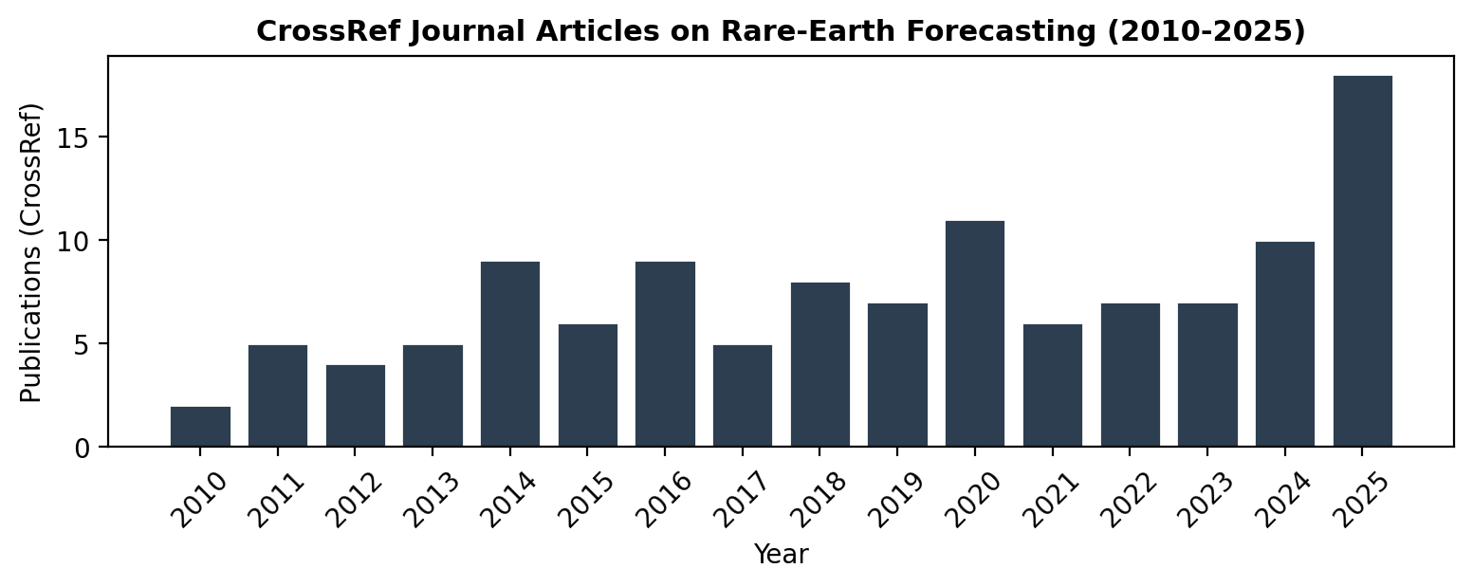
Fig. 1. CrossRef publications on rare-earth forecasting, 2010-2025.

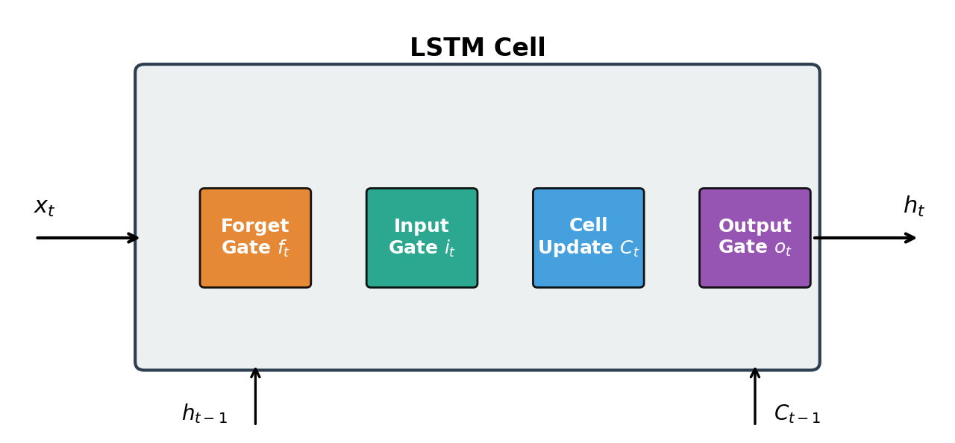
Fig. 2. Structure of the LSTM cell used in the high-ApEn modes.

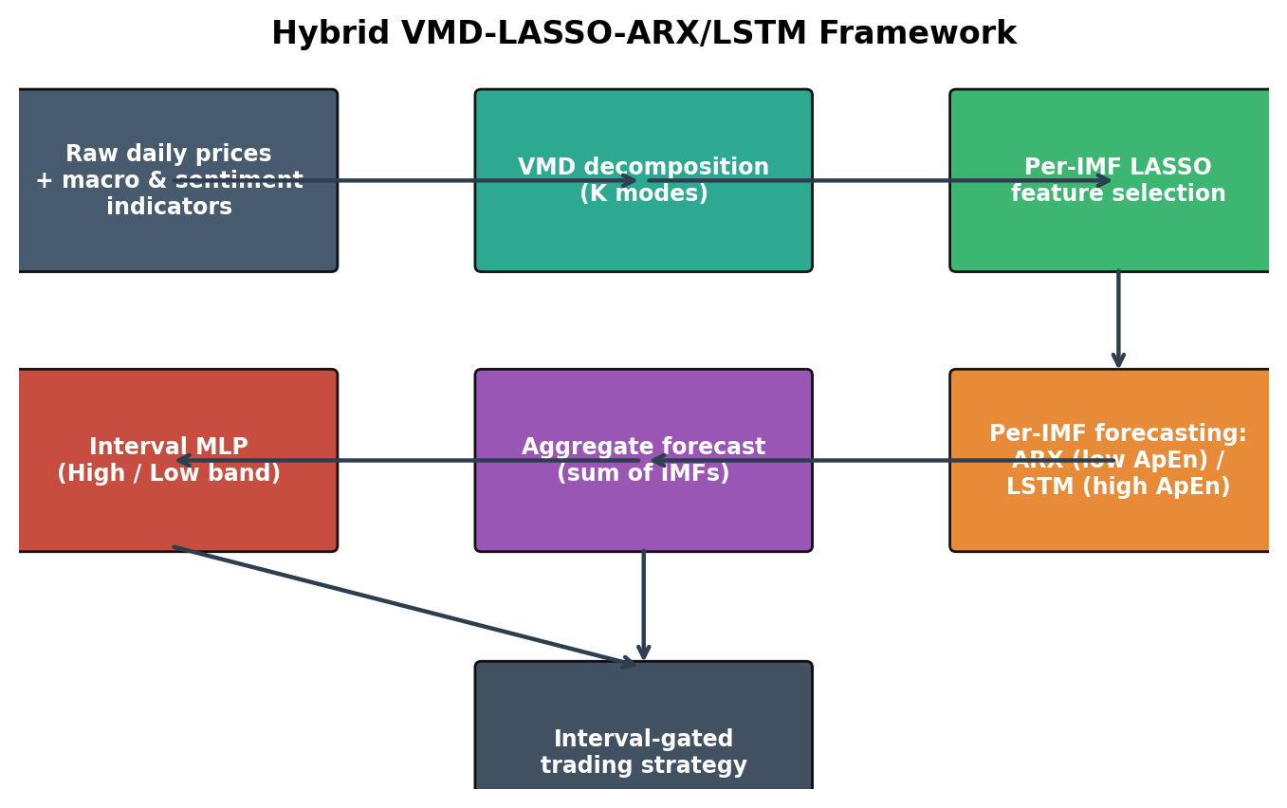
Fig. 3. Forecasting framework used in this study.

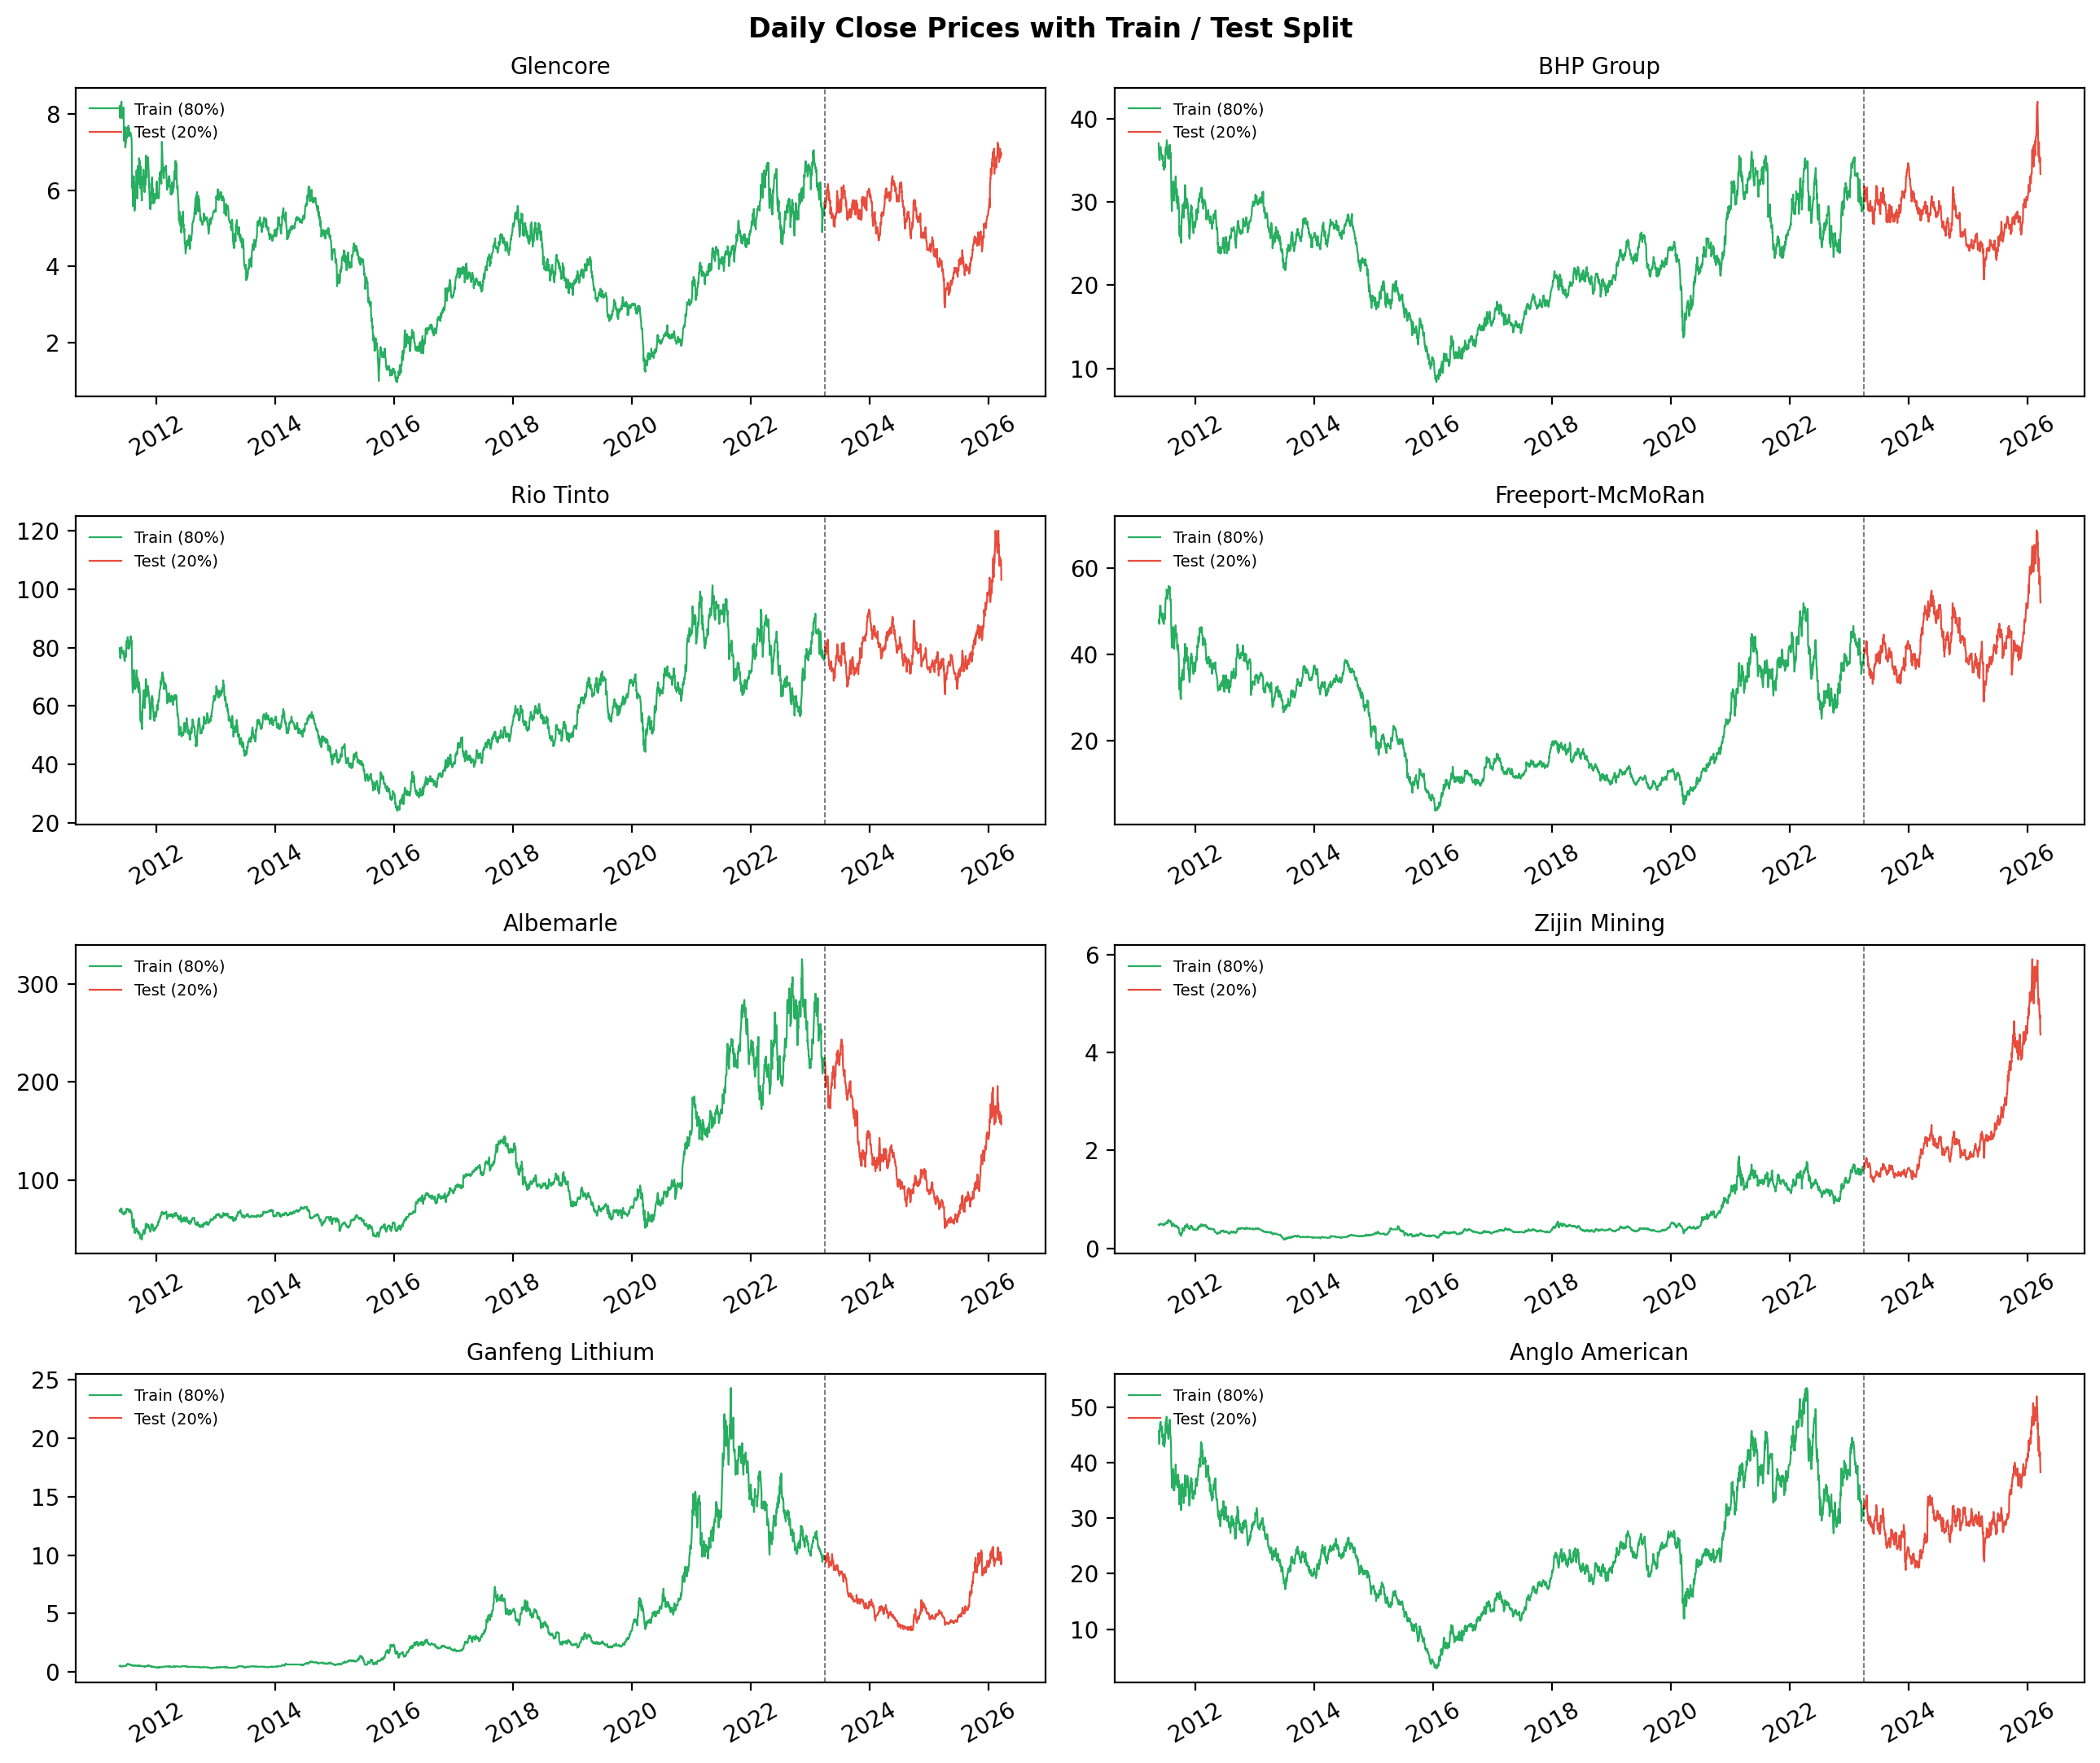
Fig. 4. Daily close prices with train/test split for all eight companies.

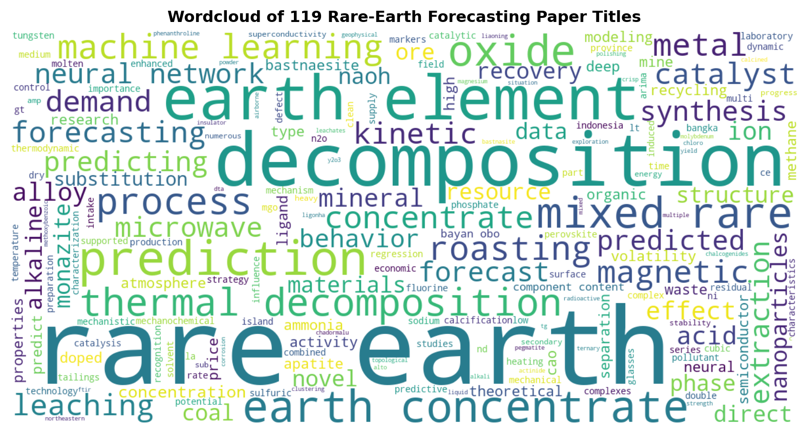
Fig. 5. Wordcloud built from titles of 118 rare-earth forecasting papers.

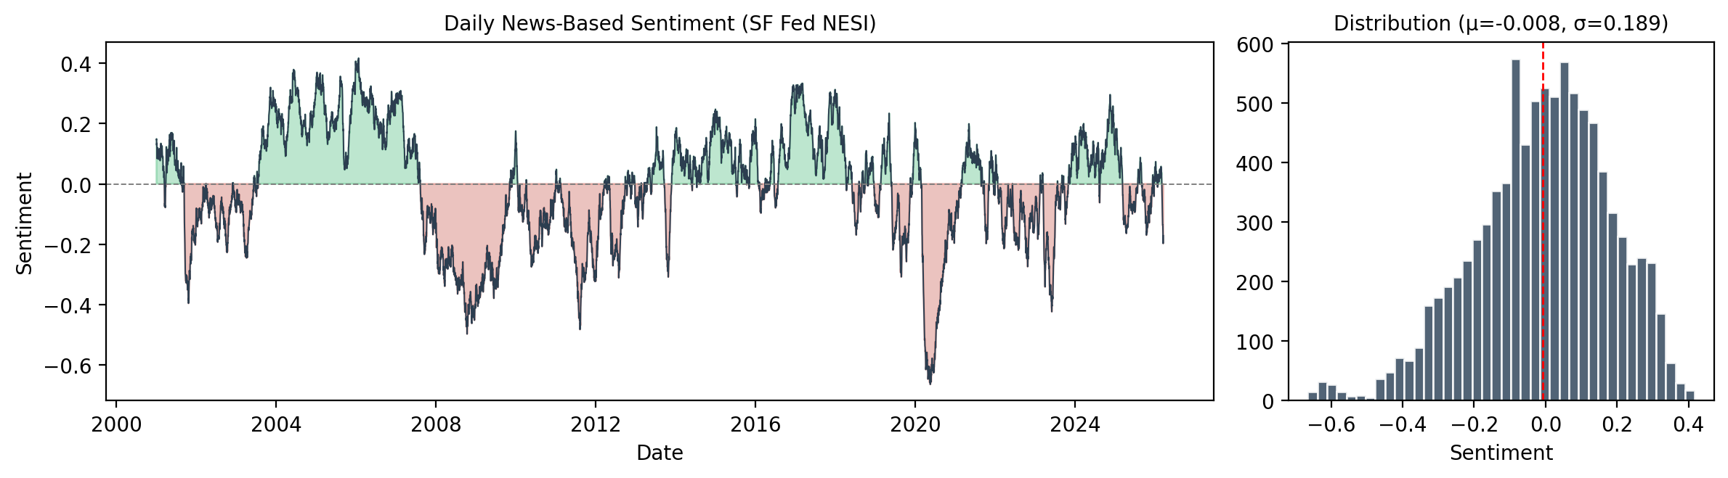
Fig. 6. SF Fed News-Based Sentiment Index series and distribution.

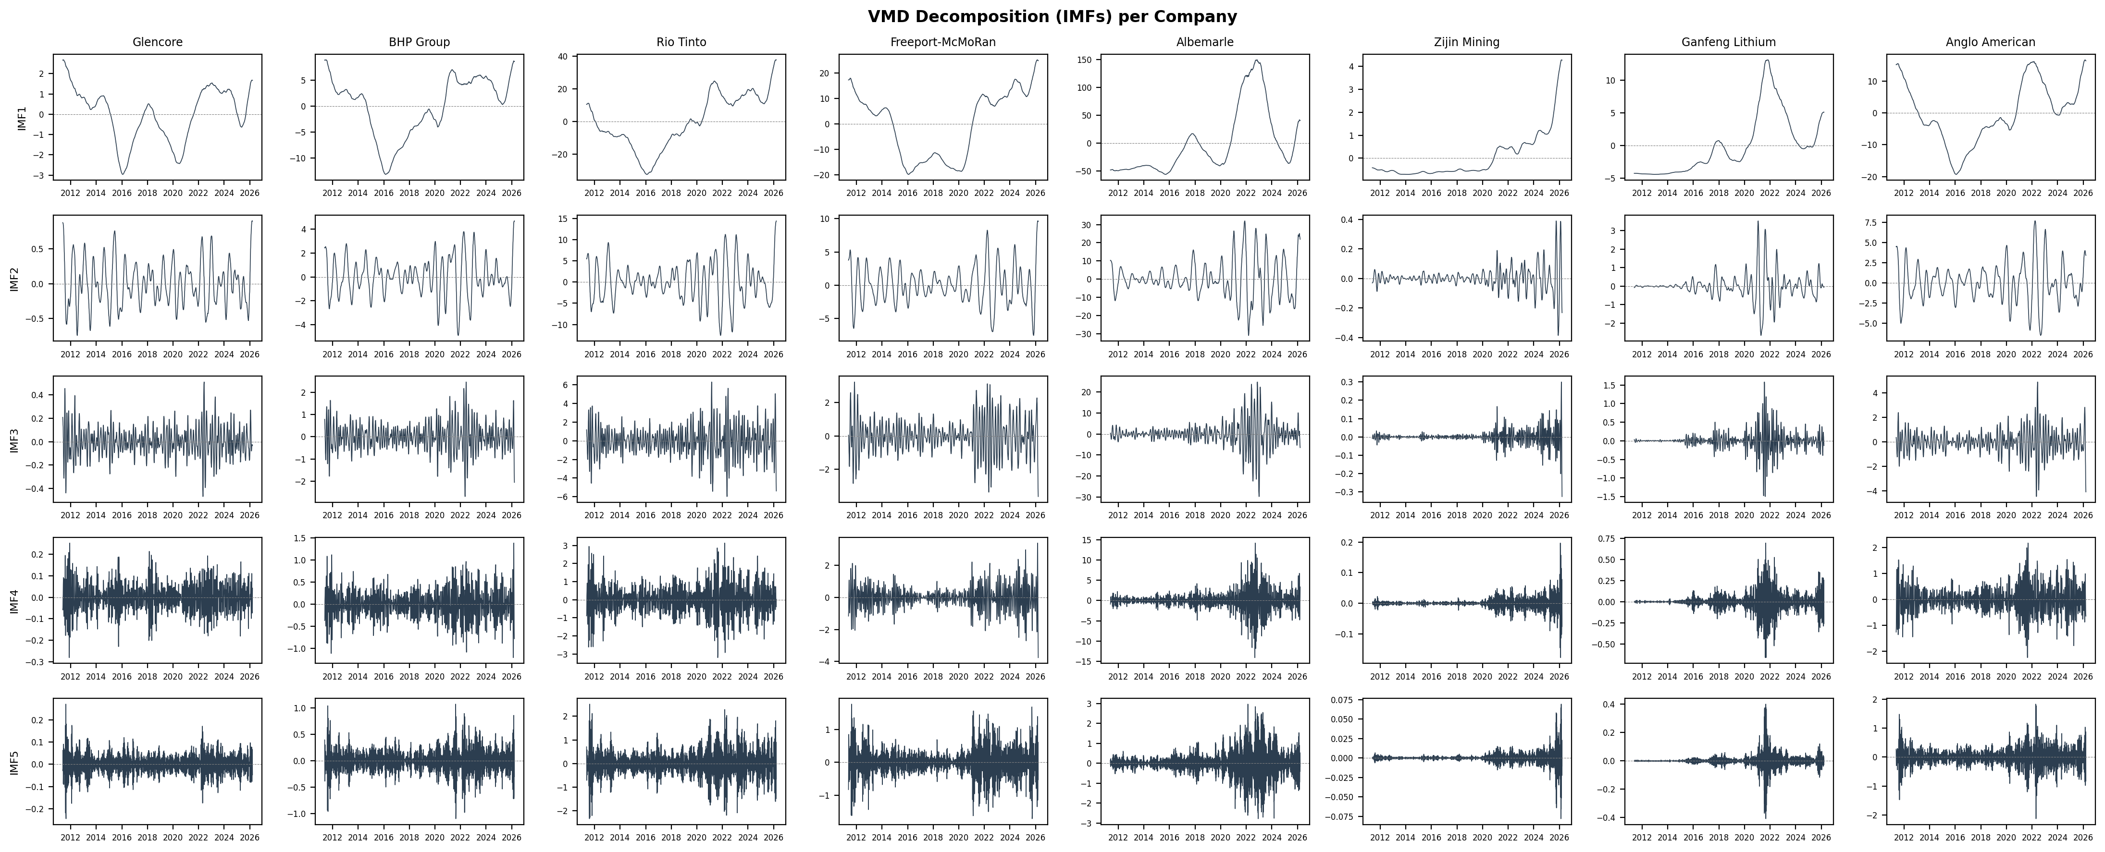
Fig. 7. VMD decomposition (IMFs) per company.

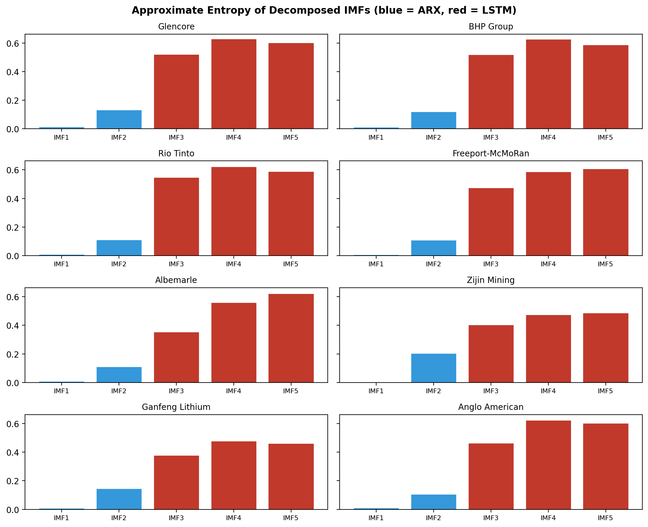
Fig. 8. Approximate Entropy of decomposed IMFs (blue = ARX routing, red = LSTM).

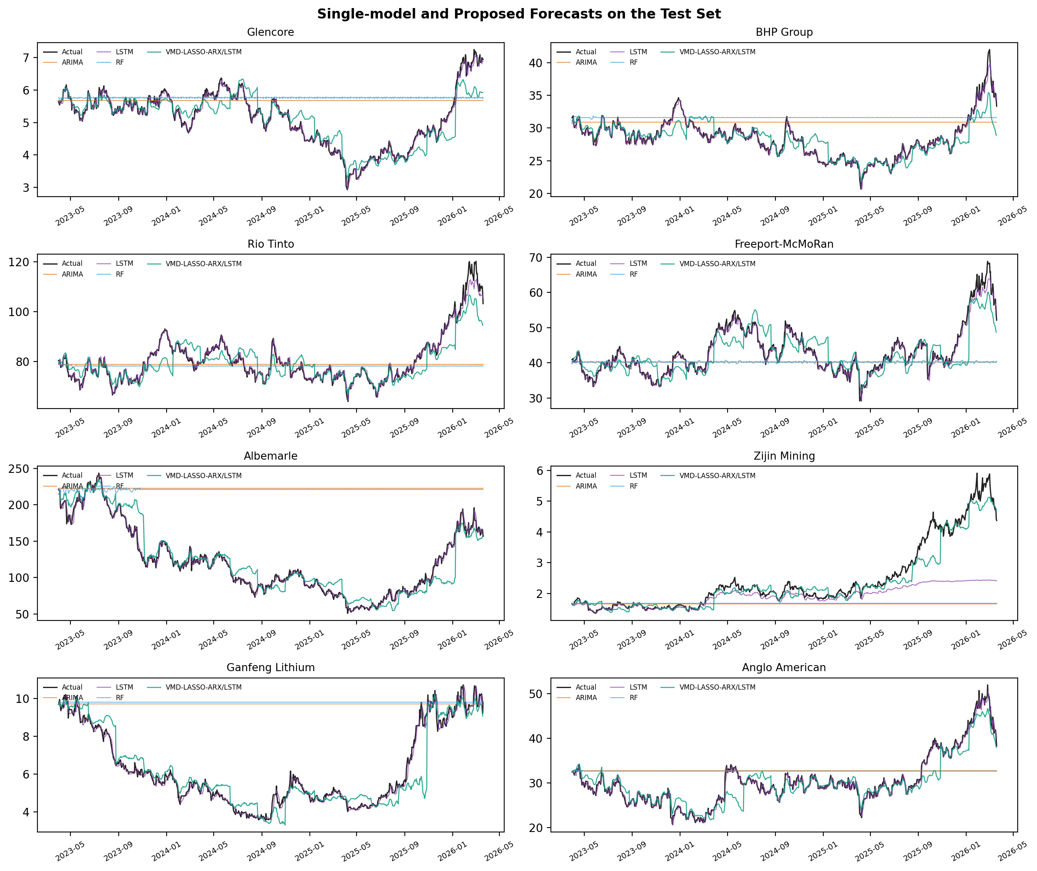
Fig. 9. Single-model forecasts on the test set.

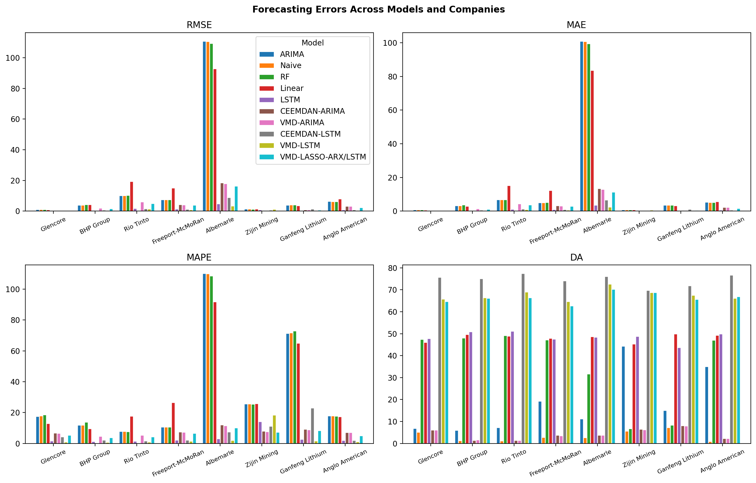
Fig. 10. Bar plots of forecasting errors across models and companies.

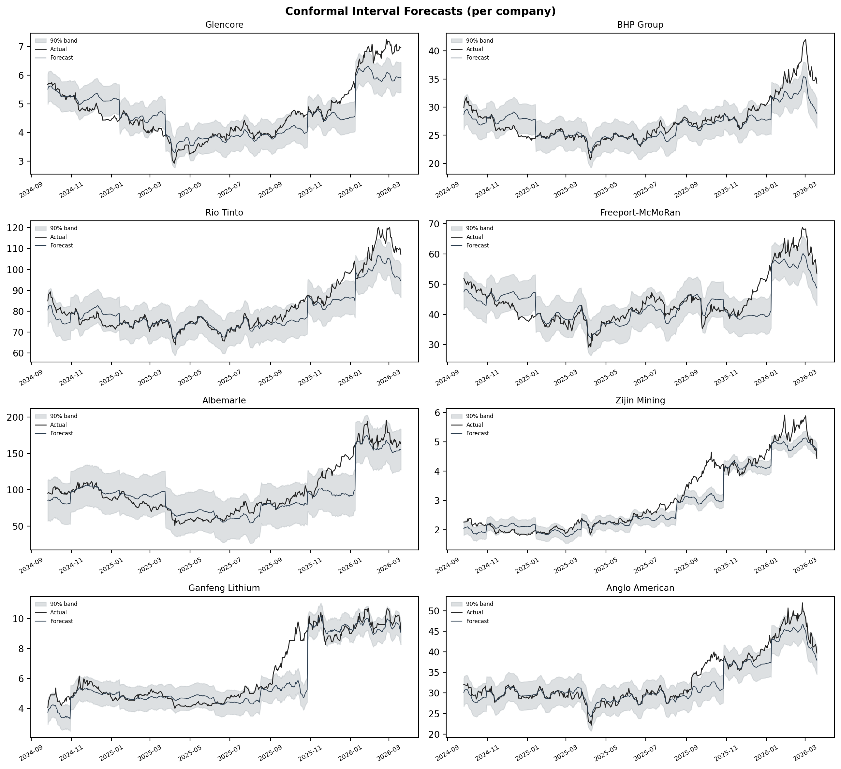
Fig. 11. Conformal interval forecasts per company.

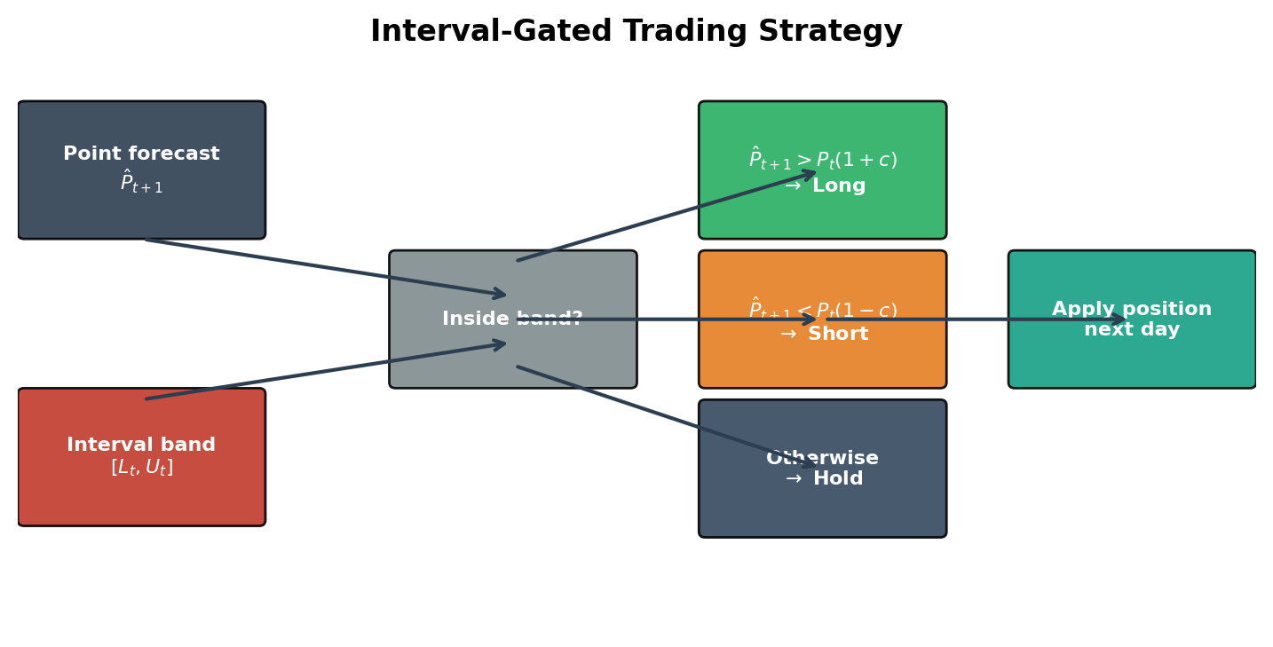
Fig. 12. Interval-gated trading strategy.

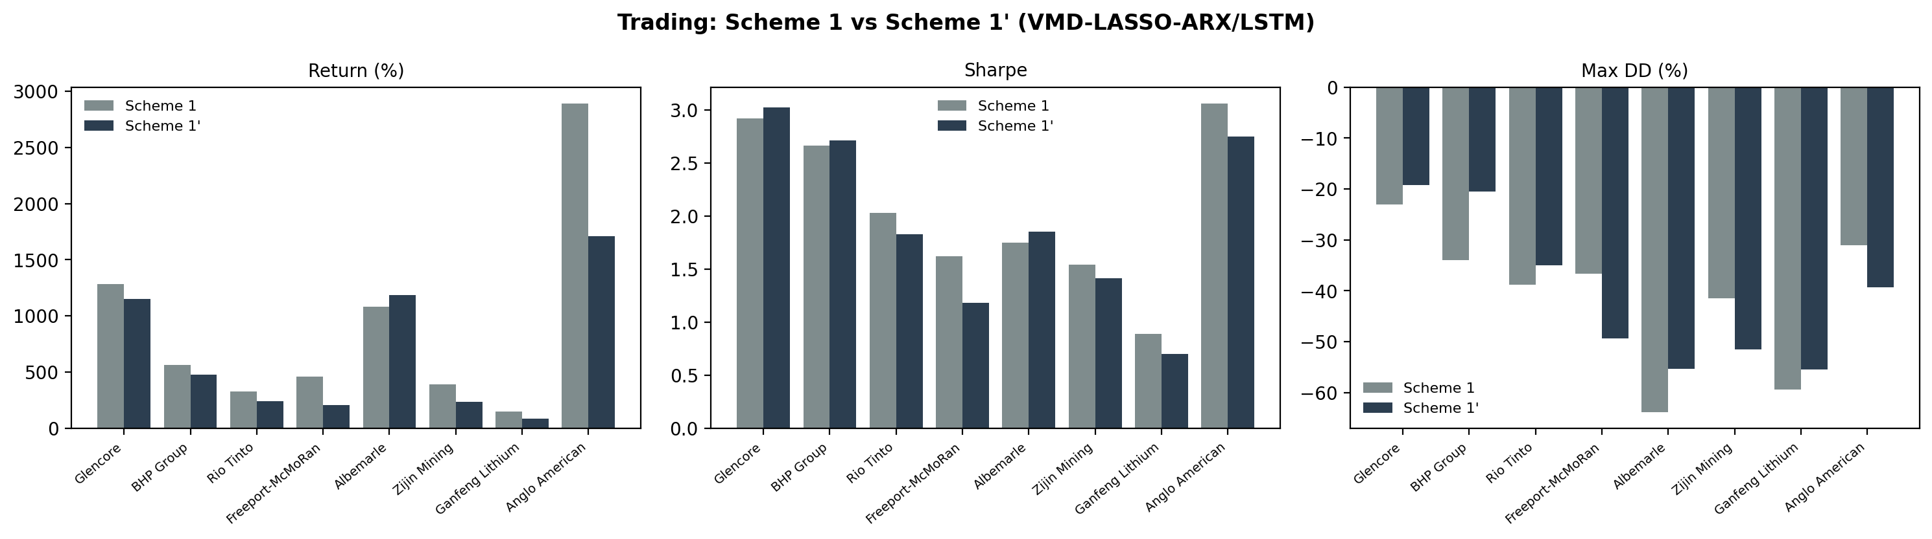
Fig. 13. Scheme 1 vs Scheme 1' (VMD-LASSO-ARX/LSTM): Return, Sharpe, Max DD.

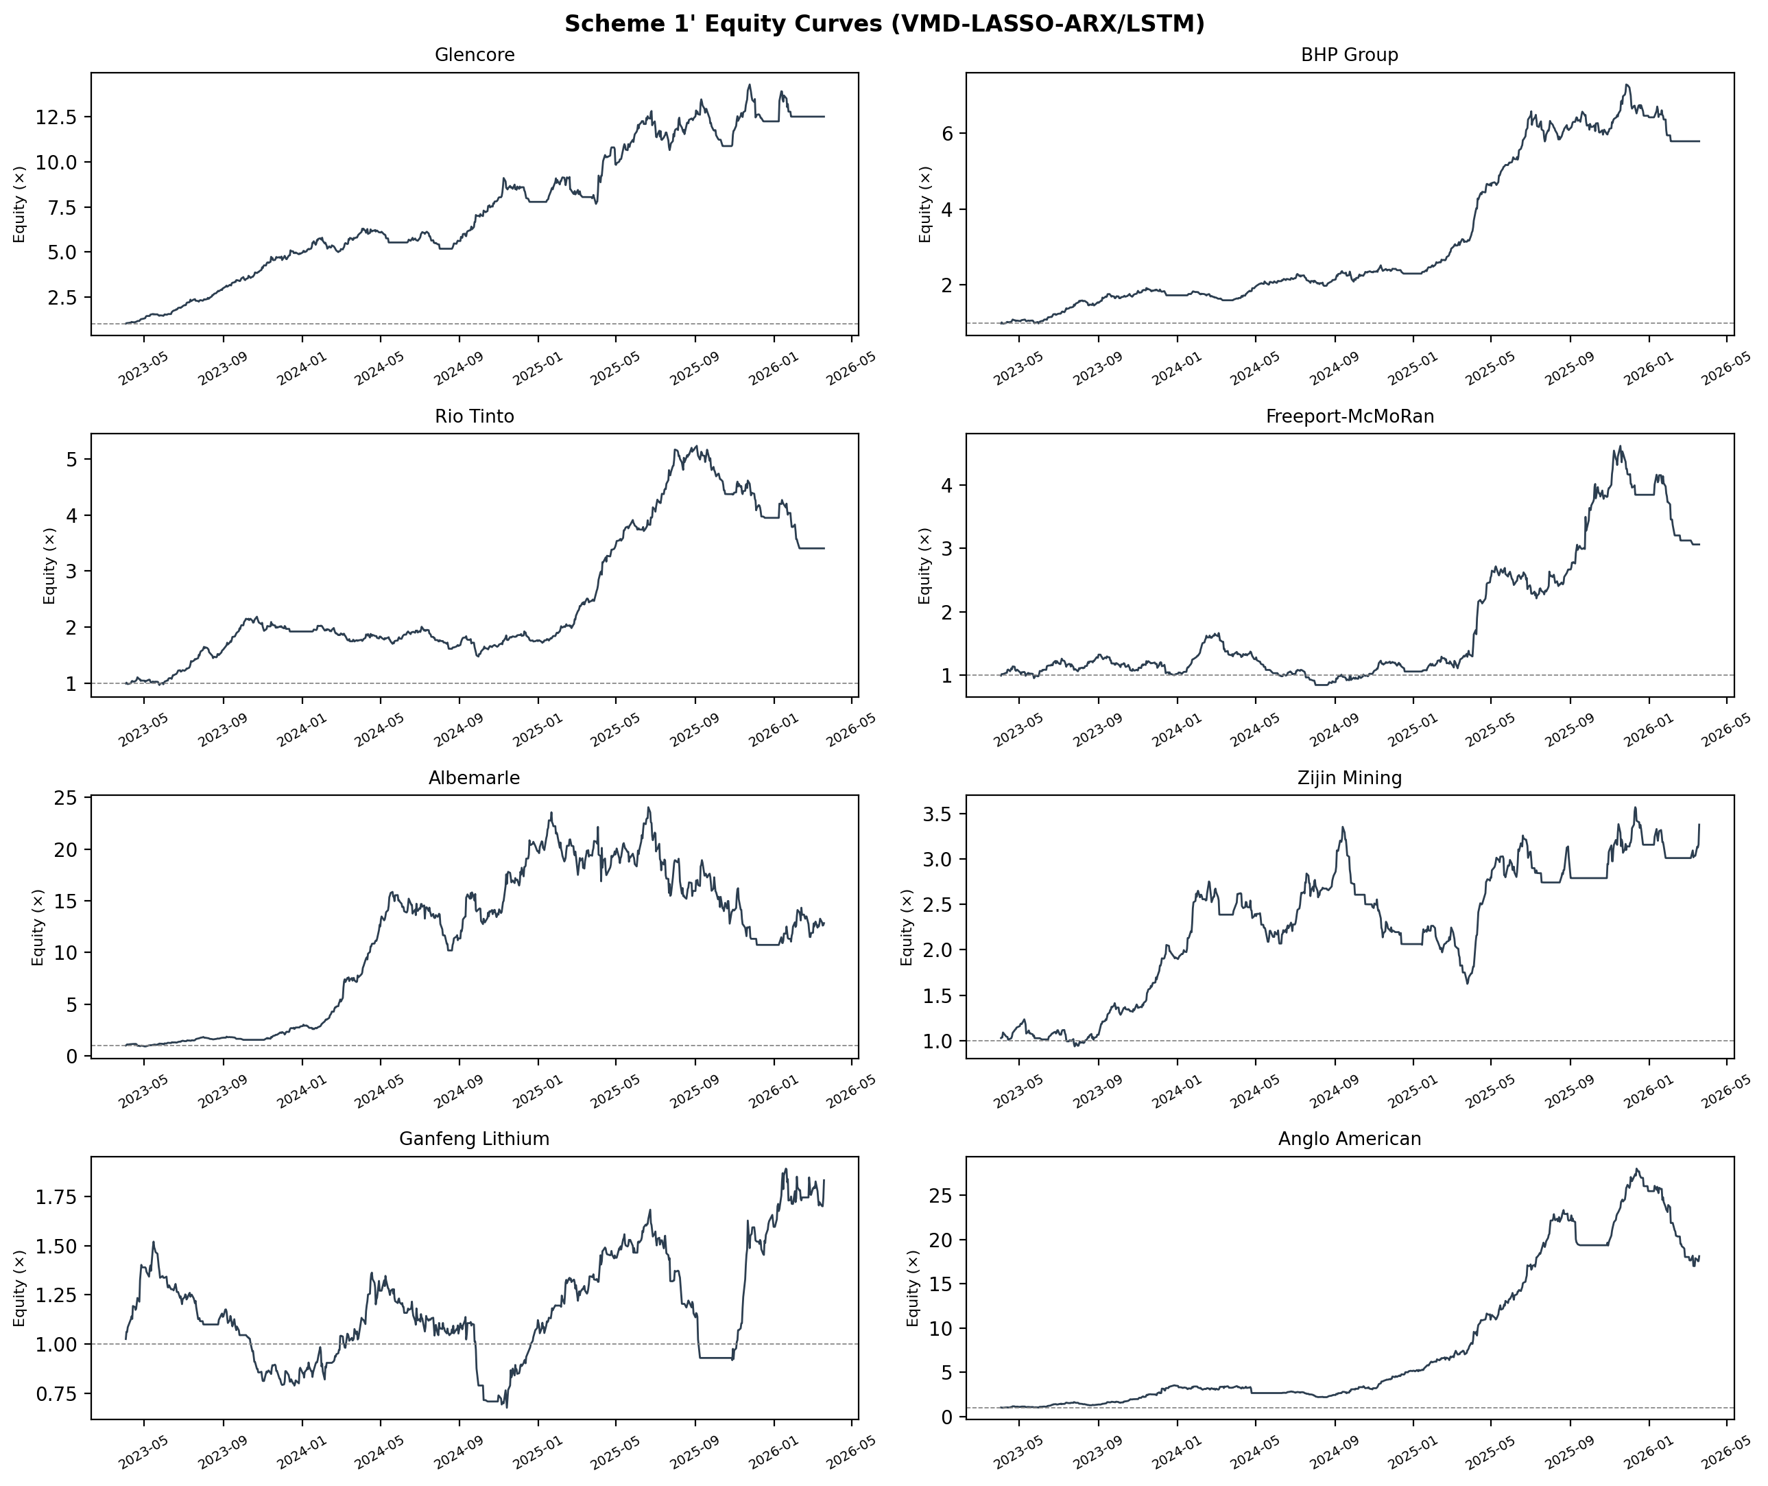
Fig. 13b. Equity curves under Scheme 1' (per company).

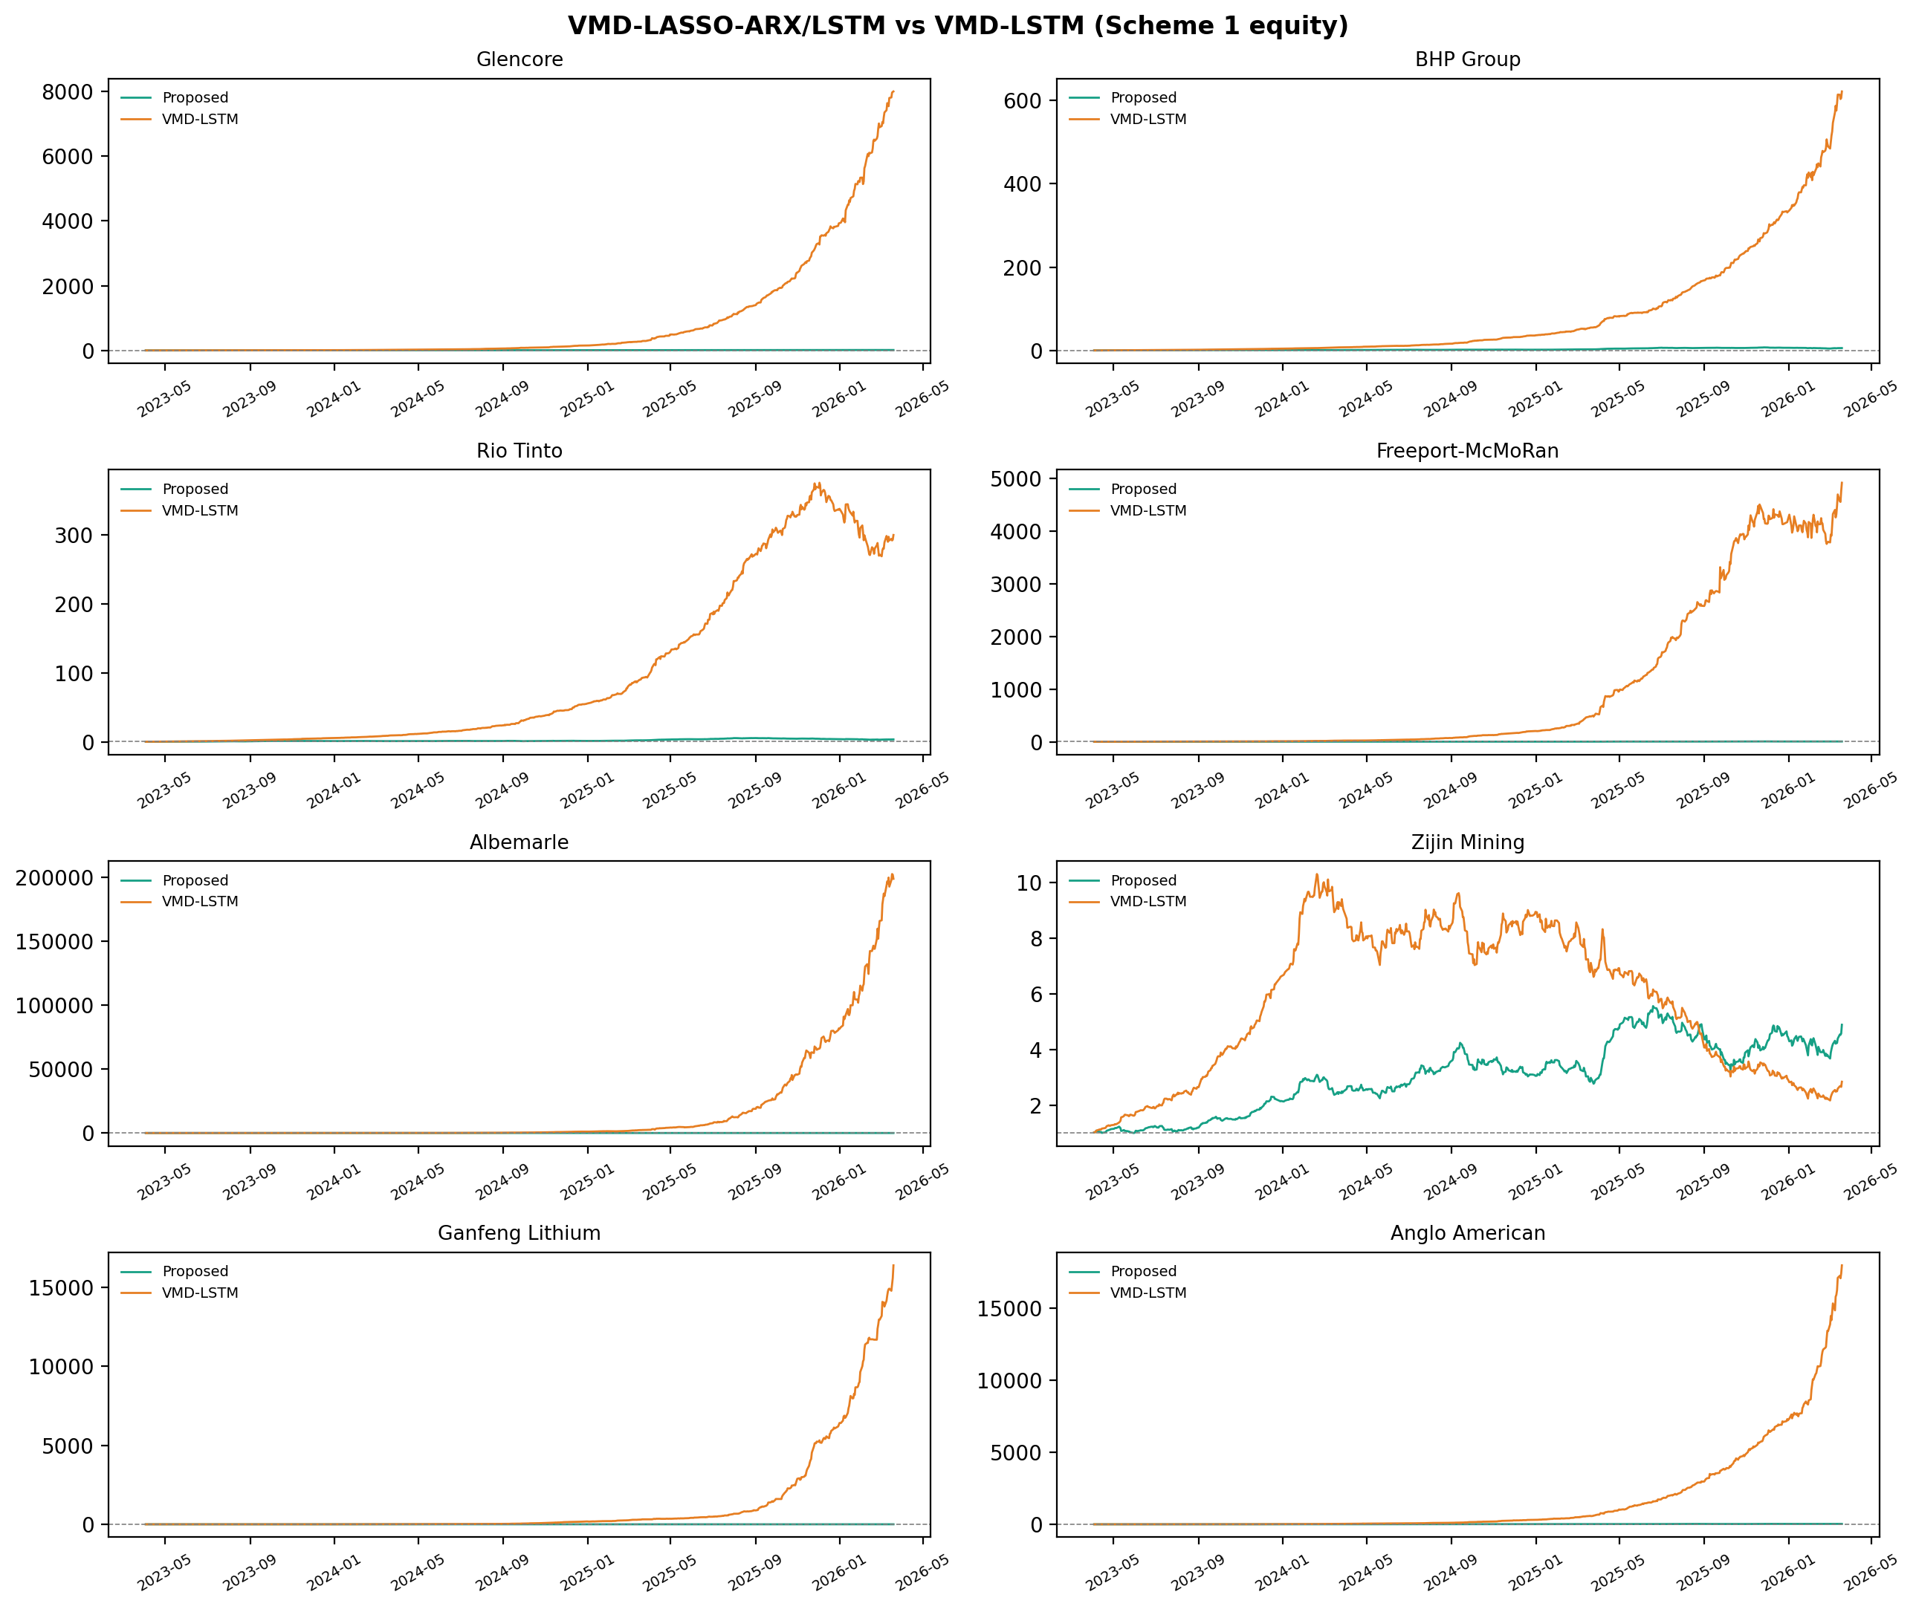
Fig. (extra). VMD-LASSO-ARX/LSTM vs VMD-LSTM: head-to-head equity curves.

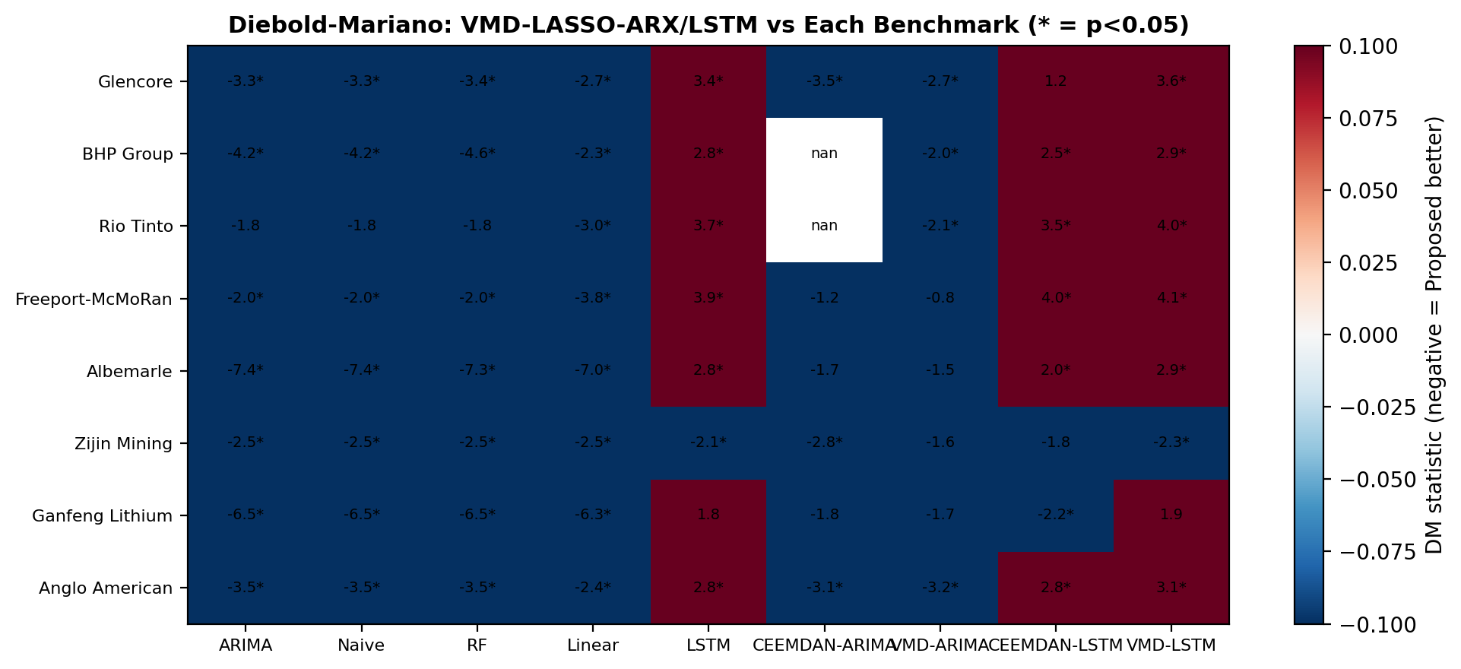
Fig. (extra). Diebold--Mariano signed-statistic heatmap.

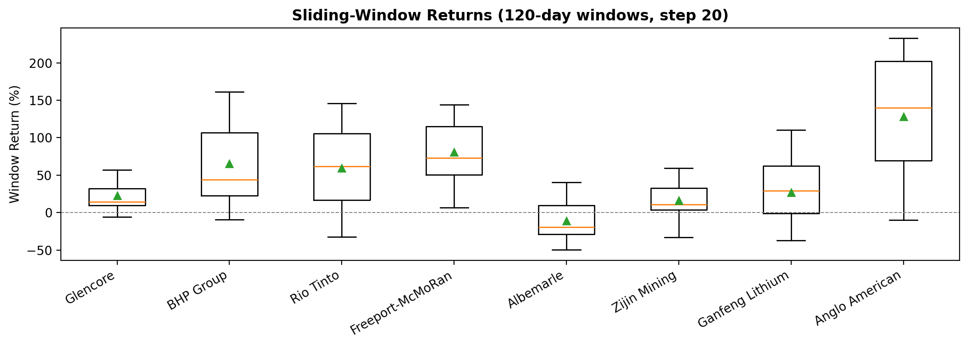
Fig. (extra). Sliding-window return distributions per company.

