RESEARCH MANUSCRIPT
AMDR-Li: Adaptive Multimodal Decomposition and Routing for Lithium-Price Forecasting
Development-locked evidence across lithium physical and producer-equity markets
Author: Pratham Lahoti

Abstract
This study proposes AMDR-Li, an adaptive multimodal decomposition-routing framework for short-horizon forecasting in linked lithium markets. The framework is designed for commodity-price settings in which market history, search activity, timestamped news, sentiment, producer-equity prices, sector indices, and broad risk controls may carry complementary information. It is evaluated on one futures-based lithium benchmark and one battery-grade spot benchmark against seven undecomposed forecasters, four homogeneous decomposition models, a fixed VMD hybrid, and a Random Walk robustness benchmark; a separately reported cross-market extension evaluates two lithium-producer equities. RMSE is the primary ranking criterion because large price misses are economically consequential and the Diebold-Mariano comparisons use squared-error loss. AMDR-Li records the lowest test RMSE for both lithium targets. Relative to Random Walk, RMSE falls by 17.61% for carbonate and 50.20% for hydroxide. Secondary metrics are mixed and are reported without a general claim of metric-wide dominance. The uncertainty gate abstains when the forecasted price change is small relative to calibrated residual width. The resulting architecture can be transferred to other linked commodity-price systems, provided that decomposition, selection, and calibration are re-estimated with market-specific data. Full-sample decomposition and observed-test ARIMA filtering make the present experiment retrospective rather than a live forecasting exercise.
Keywords: lithium price; multimodal data; variational mode decomposition; LASSO; ARIMA; LSTM; sentiment; interval forecasting; trading.

1. Introduction
Lithium prices transmit information about electric-vehicle demand, battery manufacturing, mine supply, conversion capacity, inventories, policy, and investor expectations. Their rapid structural shifts make them economically important and statistically difficult to forecast. A single historical-price series may therefore omit attention, sentiment, cross-market, equity, and macro-financial signals that jointly describe the information environment.
The empirical question is whether information from the physical lithium market, listed producers, investor attention, news tone, the critical-minerals sector, and broad risk conditions can reduce consequential price-level errors. Forecast accuracy, interval calibration, and trading performance are examined separately: an improvement in one does not establish an improvement in the others.

1.1 Research questions and finance contribution
The first research question asks whether AMDR-Li lowers RMSE relative to undecomposed, fixed-routing, homogeneous decomposition, and naive price benchmarks. The second asks whether its conclusions survive secondary measures of absolute, percentage, scaled, and directional accuracy. The third examines which multimodal signals survive mode-specific sparse selection. The fourth asks whether uncertainty-based abstention alters the return-drawdown trade-off after transaction costs and market benchmarks.
The contribution is fourfold. First, the study formulates short-horizon forecasting problems for two linked lithium price benchmarks and, in a separately labelled cross-market extension, two lithium-producer equities. Second, it organizes cross-market prices, producer equities, search attention, lithium-specific news sentiment, sector conditions, and macro-financial controls into an auditable information architecture. Third, AMDR-Li combines development-locked decomposition search, component-level ARIMA/LSTM/SVR/RF routing, and nonnegative sum-to-one stacking before the final test segment is evaluated. Fourth, it connects point forecasts to interval calibration and cost-adjusted decision rules while keeping their statistical and economic interpretations separate.
The empirical ranking is based first on RMSE. MAE, MASE, MAPE, symmetric MAPE, and directional accuracy are retained to show where that ranking does and does not generalize. This hierarchy prevents a strong squared-error result from being presented as a win on every aspect of forecast quality.

2. Literature review and positioning
Table 1. Representative research works in lithium and energy-price forecasting.
Study | Research focus | Method | Role in this study
Hochreiter and Schmidhuber (1997) | Sequence learning | LSTM | Recurrent nonlinear forecasting
Tibshirani (1996) | Sparse regression | LASSO | Multimodal indicator selection
Dragomiretskiy and Zosso (2014) | Signal decomposition | VMD | Adaptive narrow-band modes
Torres et al. (2011) | Noise-assisted decomposition | CEEMDAN | Decomposition comparator
Diebold and Mariano (1995) | Predictive-accuracy testing | DM test | Pairwise loss comparison
Box et al. (2015) | Time-series forecasting | ARIMA | Linear forecasting of smooth decomposed modes
This study | One-step-ahead daily price forecasting | AMDR-Li | Development-locked decomposition, route and stacking selection

Interpretation of Table 1
Purpose: The table identifies the methodological lineage of the study rather than claiming an exhaustive lithium-forecasting review. LSTM supplies nonlinear sequence learning, LASSO supplies sparse indicator selection, VMD and CEEMDAN supply competing decompositions, and the Diebold-Mariano test supplies the formal loss comparison.
Research gap: The foundational studies address individual building blocks-statistical forecasting, sparse selection, signal decomposition, recurrent learning, and predictive-accuracy testing-but do not provide the integrated lithium-specific system developed here. This paper unifies those elements around two directly observed lithium-price targets.
Interpretive boundary: The literature table establishes the methodological lineage of the study. Figure 1 provides a descriptive view of publication activity and is not used to infer the quality or completeness of the literature.
Figure 1. Time trend of candidate publications in lithium-price forecasting. Crossref title-query counts provide a descriptive measure of publication activity.
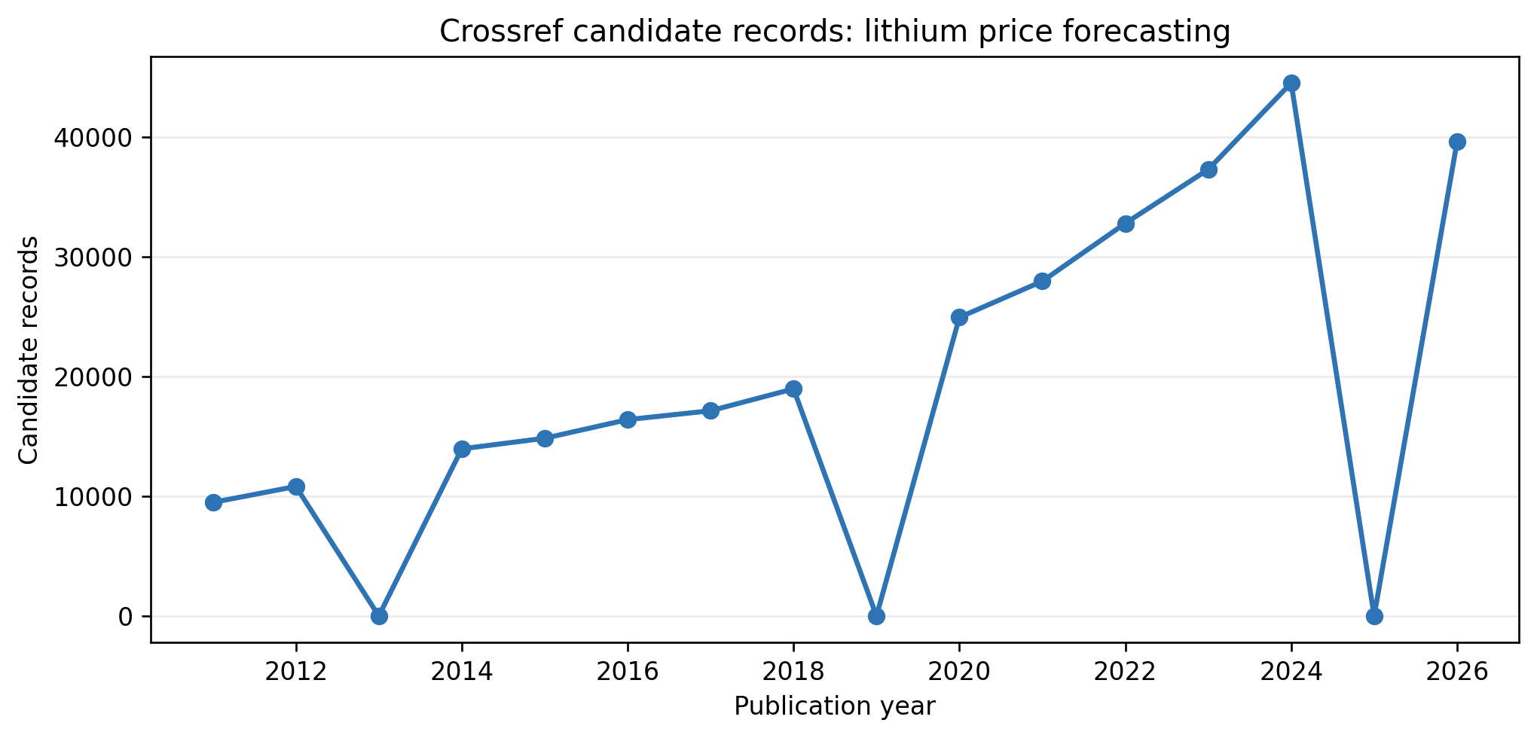
Decomposition-based energy-price studies seek to separate slowly varying structure from high-frequency fluctuations before applying specialized predictors. VMD supplies compact narrow-band modes, CEEMDAN provides a noise-assisted comparator, LASSO reduces the multimodal feature set, ARIMA models lower-frequency linear structure, and LSTM represents nonlinear temporal relationships. AMDR-Li integrates these elements into a single forecasting, uncertainty, and decision framework for linked lithium markets.

3. Methodology
Figure 2. Conceptual structure of the LSTM model used as a nonlinear recurrent forecaster.
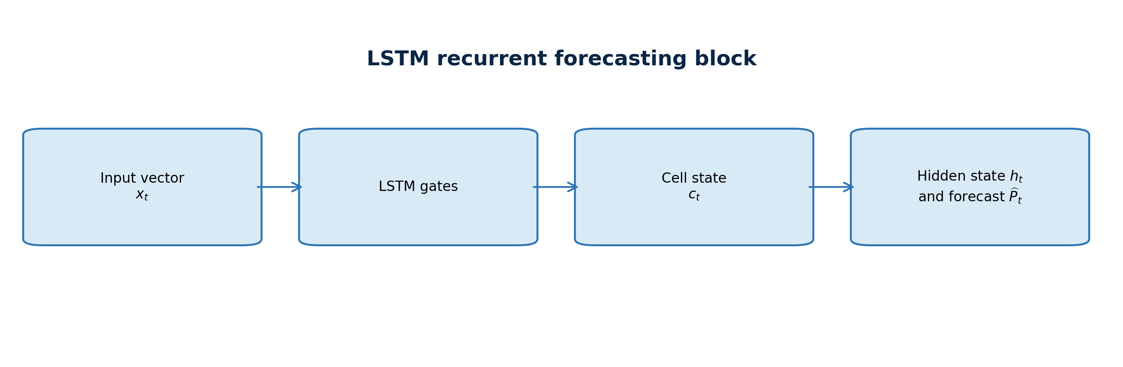
Figure 3. Architecture of the proposed AMDR-Li forecasting framework.
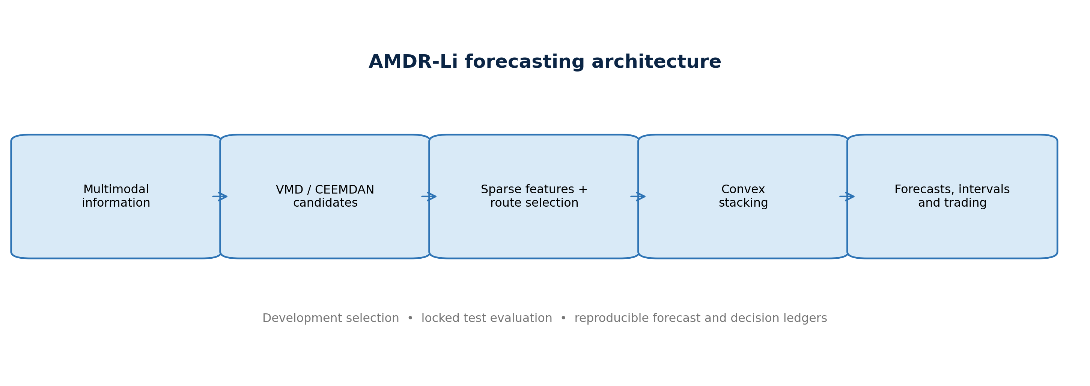

3.1 Forecasting architecture
For each target, lagged target observations are combined with cross-lithium, lithium-equity, Google Trends, lithium-news, and market-control blocks. LASSO is applied separately to each decomposed series. The fixed comparator assigns the first two VMD modes to ARIMA and the remaining modes to LSTM. AMDR-Li instead searches a defined bank of VMD and CEEMDAN decompositions, selects ARIMA, LSTM, SVR, or RF separately for each returned component on a development segment, and estimates nonnegative sum-to-one candidate weights on that same segment. Routes and weights are then frozen for the final 20% test segment.
Seven single-model benchmarks-exponential smoothing (ES), ARIMA, SVR, random forest (RF), multilayer perceptron (MLP), extreme learning machine (ELM), and LSTM-are fitted to the undecomposed price problem. CEEMDAN-ARIMA, VMD-ARIMA, CEEMDAN-LSTM and VMD-LSTM isolate decomposition and forecasting-family effects. The fixed VMD-LASSO-ARIMA/LSTM architecture isolates the value added by adaptive selection. Together these form the publication-facing comparison set.

3.2 Evaluation
RMSE is the primary point-forecast criterion. It gives greater weight to large misses, which is appropriate for two lithium series marked by abrupt repricing, and it is consistent with the squared-error loss used in the Diebold-Mariano tests. MAE, MASE, MAPE, symmetric MAPE, and directional accuracy are secondary diagnostics. The model is called the RMSE leader only when its test RMSE is the lowest; no broader accuracy claim is inferred when secondary measures disagree. Random Walk is retained as a robustness benchmark in Appendix Table A2 rather than included in the architecture comparison of Tables 7-9. The first quarter of the static test sequence supplies residual quantiles for nominal 80%, 90%, and 95% retrospective intervals; the remaining observations are evaluated for coverage, width, calibration error, and Winkler score.
Let the origin price be the last price observed before the forecast date, let the hatted price denote the one-step forecast, and let the residual threshold be the 90th percentile of absolute calibration errors. The directional and uncertainty-filtered positions are defined as follows.
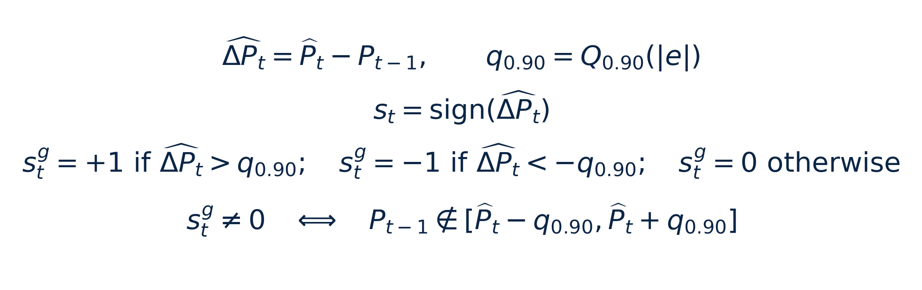
The filtered position is therefore nonzero only when the predicted change is larger than the calibrated error threshold. The equivalent interval statement uses the origin price, not the forecast itself, so the rule is not tautological.
Scheme 2 deducts 10 basis points for absolute position turnover; Scheme 2' applies the same cost to the filtered position. The one-period strategy return is

Cumulative return, maximum drawdown, Sharpe ratio, transaction count, and hit rate are reported. Passive buy-and-hold and a descriptive factor regression against the underlying lithium return, S&P 500, MVIS critical-minerals index, US dollar index, and VIX distinguish raw simulated returns from benchmark-relative performance.

3.3 Information timing and reproducibility boundary
The executed experiment and a deployable forecast are deliberately distinguished below. This disclosure prevents a chronological split from being mistaken for a real-time design: chronology alone does not remove look-ahead when decomposition, transformations, selection, or filtering use later observations.
Implementation audit matrix
Pipeline stage | Executed in this paper | Required real-time implementation
Forecast origin | Chronological static 80:20 split | Expanding or rolling origin; forecast formed after market close at t-1
Decomposition | VMD/CEEMDAN estimated on the complete target series | Re-estimate only with observations available through t-1
Scaling and imputation | Static/full-panel transformations | Fit on the current training window; carry parameters forward unchanged
LASSO selection | Mode-specific selection inside the static experiment | Nested development window; freeze selected variables before each test block
Hyperparameters | Pre-specified settings and static fitting | Select only on training/development data; register the search space and seed
ARIMA evaluation | Observed-test filtering is used for the retrospective reconstruction | Generate a genuine one-step forecast without conditioning on P_t
Interval calibration | First 25% of the test path supplies residual quantiles | Use only prior forecast errors; update with a rolling calibration window
Trading signal | Uses origin price, forecast, and precomputed width | Same decision rule, timestamped before P_t becomes observable
Permitted claim | Retrospective reconstruction and within-protocol comparison | Out-of-sample forecast and implementable trading evidence

Every publication-facing ledger records target, model, date, origin price, realized price, and forecast. The empirical run identifier, source checksums, mode selections, interval observations, DM comparisons, and trading metrics are preserved alongside the manuscript. These artifacts reproduce the retrospective results exactly; they do not convert them into causal evidence.
Table 2. Parameter settings used in this study.
Parameter | Setting | Function
Chronological split | 80:20 | Static training and testing sets
Lag order | 5 | Lagged target and indicator features
Reference-parity VMD modes | lithium_hydroxide: 9; lithium_carbonate: 9 | Fixed-routing comparator
Adaptive VMD search | K ∈ {7, 8, 9, 10}; α ∈ {1500, 3000, 4500} | Development-only specification selection
Adaptive CEEMDAN search | maximum IMF ∈ {7, 9} | Development-only specification selection
Adaptive route candidates | ARIMA, LSTM, SVR, RF | Mode-level development selection
LSTM hidden units | 40 | One recurrent layer
Comparator LSTM epochs | 100 | Homogeneous/fixed model fitting
Adaptive LSTM epochs | search=40; final=100 | Development selection and locked-test refit
LSTM batch size | 128 | Mini-batch size
Single-model RF estimators | 100 | Undecomposed benchmark
Adaptive-route RF | 300 trees; leaf>=2; max_features=0.8 | Component-route candidate
Single-model SVR | RBF; C=8.1; gamma=0.1 | Undecomposed benchmark
Adaptive-route SVR | RBF; C=8.1; gamma=scale; epsilon=0.05 | Component-route candidate
Interval levels | 80%, 90%, 95% | Residual-quantile intervals
Random seed | 42 | Reproducibility

Interpretation of Table 2
Design choices: Five lags provide short daily memory without exhausting a sample of fewer than 720 aligned observations. The fixed comparator uses nine VMD modes for both targets. AMDR-Li evaluates the displayed VMD and CEEMDAN candidate grid on the development segment.
Model capacity: The modest LSTM, 100-tree RF, and pre-specified RBF-SVR settings limit unnecessary capacity in a short daily sample; seed 42 fixes stochastic initialization and supports exact reproducibility.
Consequence for inference: The 80:20 split is chronological but static. Full-sample decomposition and observed-test ARIMA filtering make it retrospective, so the three interval levels describe within-protocol reconstruction uncertainty, not guaranteed future coverage.
The adaptive candidate grid is fixed as
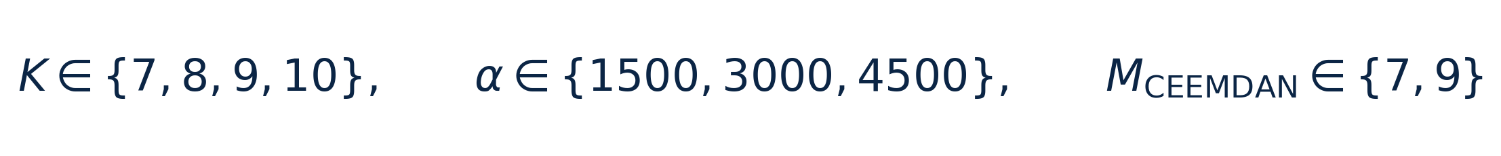

Table 3. Indicators used in this study.
Indicator | Definition | Data modality | Treatment
Cross_Lithium_Close | Price of the other lithium contract/spot target | Cross Lithium | Aligned to target trading date; lagged in model frame
Albemarle_Close | Albemarle equity close | Lithium Equities | Aligned to target trading date; lagged in model frame
Ganfeng_Lithium_Close | Ganfeng Lithium equity close | Lithium Equities | Aligned to target trading date; lagged in model frame
Trends_lithium | Google Trends: lithium | Lithium Attention | Aligned to target trading date; lagged in model frame
Trends_lithium_price | Google Trends: lithium price | Lithium Attention | Aligned to target trading date; lagged in model frame
Trends_lithium_carbonate | Google Trends: lithium carbonate | Lithium Attention | Aligned to target trading date; lagged in model frame
Trends_lithium_hydroxide | Google Trends: lithium hydroxide | Lithium Attention | Aligned to target trading date; lagged in model frame
Trends_lithium_battery | Google Trends: lithium battery | Lithium Attention | Aligned to target trading date; lagged in model frame
News_Article_Count | Lithium-headline volume | Lithium News | Aligned to target trading date; lagged in model frame
News_TextBlob_Polarity | Lexicon sentiment of lithium headlines | Lithium News | Aligned to target trading date; lagged in model frame
News_FinBERT_Score | Financial-language sentiment of lithium headlines | Lithium News | Aligned to target trading date; lagged in model frame
SP500 | S&P 500 close | Market Controls | Aligned to target trading date; lagged in model frame
VIX | CBOE VIX close | Market Controls | Aligned to target trading date; lagged in model frame
US_Dollar_Index | US dollar index close | Market Controls | Aligned to target trading date; lagged in model frame
MVIS_Critical_Minerals | MVIS Global Rare Earth/Strategic Metals index | Market Controls | Aligned to target trading date; lagged in model frame

Interpretation of Table 3
Information architecture: The 15 indicators form five economically distinct blocks: one cross-lithium price, two lithium-equity signals, five Google Trends attention series, three lithium-news variables, and four market controls. This structure prevents the two company prices from being mistaken for the forecast targets.
Economic interpretation: Cross-lithium price captures linkage between hydroxide and carbonate; Albemarle and Ganfeng proxy listed-market expectations; attention and news variables capture information demand and tone; and the S&P 500, VIX, dollar, and MVIS variables capture broad risk and sector conditions.
Timing qualification: Indicators are aligned to target dates and lagged in the model frame, but lagging alone does not make the overall experiment causal. Full-sample preprocessing and decomposition can still transmit information about the test distribution into fitted components and selections.

4. Data and descriptive evidence
The targets are the COMEX lithium hydroxide CIF CJK electronic futures continuation and the SMM 99.5% battery-grade domestic lithium carbonate spot series. The common multimodal sample begins in May 2023 and ends in March 2026. Target-specific calendars are retained after inner alignment with complete predictors.
The information set contains the other lithium price, Albemarle and Ganfeng equity closes, five jointly normalized Google Trends series, lithium-specific headline volume, TextBlob polarity, FinBERT sentiment, the S&P 500, VIX, US dollar index, and MVIS critical-minerals index. Company prices are signals, not forecast targets. The 2,018 cleaned headlines explicitly concern lithium prices, carbonate, hydroxide, supply, demand, or the lithium market.

Table 4. Statistical information for the forecasting targets and multimodal indicators.
Series | Panel | N | Mean | Std. dev. | Minimum | Maximum
COMEX lithium hydroxide CIF CJK futures | lithium_hydroxide | 716.0000 | 16.1793 | 10.6226 | 7.9500 | 47.3100
Cross_Lithium_Close | lithium_hydroxide | 716.0000 | 117847.7654 | 65912.1252 | 59900.0000 | 314000.0000
Albemarle_Close | lithium_hydroxide | 716.0000 | 119.4812 | 45.8361 | 50.7600 | 243.4400
Ganfeng_Lithium_Close | lithium_hydroxide | 716.0000 | 6.1056 | 1.9515 | 3.5550 | 10.7050
Trends_lithium | lithium_hydroxide | 714.0000 | 56.7283 | 14.0280 | 43.0000 | 100.0000
Trends_lithium_price | lithium_hydroxide | 714.0000 | 4.0056 | 3.7882 | 2.0000 | 18.0000
Trends_lithium_carbonate | lithium_hydroxide | 714.0000 | 1.0616 | 0.3694 | 0.0000 | 2.0000
Trends_lithium_hydroxide | lithium_hydroxide | 714.0000 | 0.1933 | 0.3951 | 0.0000 | 1.0000
Trends_lithium_battery | lithium_hydroxide | 714.0000 | 17.8291 | 5.2784 | 13.0000 | 36.0000
News_Article_Count | lithium_hydroxide | 716.0000 | 2.6383 | 2.6123 | 0.0000 | 40.0000
News_TextBlob_Polarity | lithium_hydroxide | 716.0000 | 0.0521 | 0.1121 | -0.4333 | 0.8000
News_FinBERT_Score | lithium_hydroxide | 716.0000 | 0.2116 | 0.3766 | -0.9694 | 0.9512
SP500 | lithium_hydroxide | 716.0000 | 5564.4447 | 841.7402 | 4061.2200 | 6978.6001
VIX | lithium_hydroxide | 716.0000 | 16.9312 | 4.3308 | 11.8600 | 52.3300
US_Dollar_Index | lithium_hydroxide | 716.0000 | 102.4844 | 3.1993 | 96.2200 | 109.9600
MVIS_Critical_Minerals | lithium_hydroxide | 716.0000 | 370.5107 | 109.0520 | 220.4200 | 674.2340
SMM battery-grade lithium carbonate spot | lithium_carbonate | 692.0000 | 118615.8598 | 67022.4813 | 59900.0000 | 314000.0000
Cross_Lithium_Close | lithium_carbonate | 692.0000 | 16.3008 | 10.7891 | 7.9500 | 47.3100
Albemarle_Close | lithium_carbonate | 692.0000 | 119.8822 | 46.3719 | 50.7600 | 243.4400
Ganfeng_Lithium_Close | lithium_carbonate | 692.0000 | 6.1115 | 1.9561 | 3.5550 | 10.7050
Trends_lithium | lithium_carbonate | 690.0000 | 56.4362 | 13.8250 | 43.0000 | 100.0000
Trends_lithium_price | lithium_carbonate | 690.0000 | 3.9841 | 3.7685 | 2.0000 | 18.0000
Trends_lithium_carbonate | lithium_carbonate | 690.0000 | 1.0580 | 0.3687 | 0.0000 | 2.0000
Trends_lithium_hydroxide | lithium_carbonate | 690.0000 | 0.1899 | 0.3925 | 0.0000 | 1.0000
Trends_lithium_battery | lithium_carbonate | 690.0000 | 17.7667 | 5.1881 | 13.0000 | 36.0000
News_Article_Count | lithium_carbonate | 692.0000 | 2.6214 | 2.6298 | 0.0000 | 40.0000
News_TextBlob_Polarity | lithium_carbonate | 692.0000 | 0.0522 | 0.1114 | -0.4333 | 0.8000
News_FinBERT_Score | lithium_carbonate | 692.0000 | 0.2077 | 0.3783 | -0.9694 | 0.9512
SP500 | lithium_carbonate | 692.0000 | 5561.6697 | 840.7653 | 4061.2200 | 6978.6001
VIX | lithium_carbonate | 692.0000 | 16.8099 | 4.2760 | 11.8600 | 52.3300
US_Dollar_Index | lithium_carbonate | 692.0000 | 102.4637 | 3.1759 | 96.2200 | 109.9600
MVIS_Critical_Minerals | lithium_carbonate | 692.0000 | 370.9414 | 109.4896 | 220.4200 | 674.2340

Interpretation of Table 4
Target coverage: The hydroxide panel contains 716 aligned observations, with prices ranging from 7.95 to 47.31 and a mean of 16.18. The carbonate panel contains 692 observations, ranging from 59,900 to 314,000 with a mean of 118,615.86. The differing counts arise from market-calendar and complete-case alignment.
Scale and volatility: Hydroxide's standard deviation of 10.62 is about 66% of its mean, while carbonate's standard deviation of 67,022.48 is about 57% of its mean. Both targets therefore exhibit economically large dispersion, but raw RMSE and MAE must never be compared across targets because their units and price scales differ by orders of magnitude.
Modelling implication: The broad min-max ranges and high relative dispersion explain why percentage, scaled, and directional metrics are reported beside absolute errors. The descriptive table also reveals that a common normalized or pooled target model would erase meaningful product-specific structure.

Figure 4. Lithium-price series used as forecasting targets.
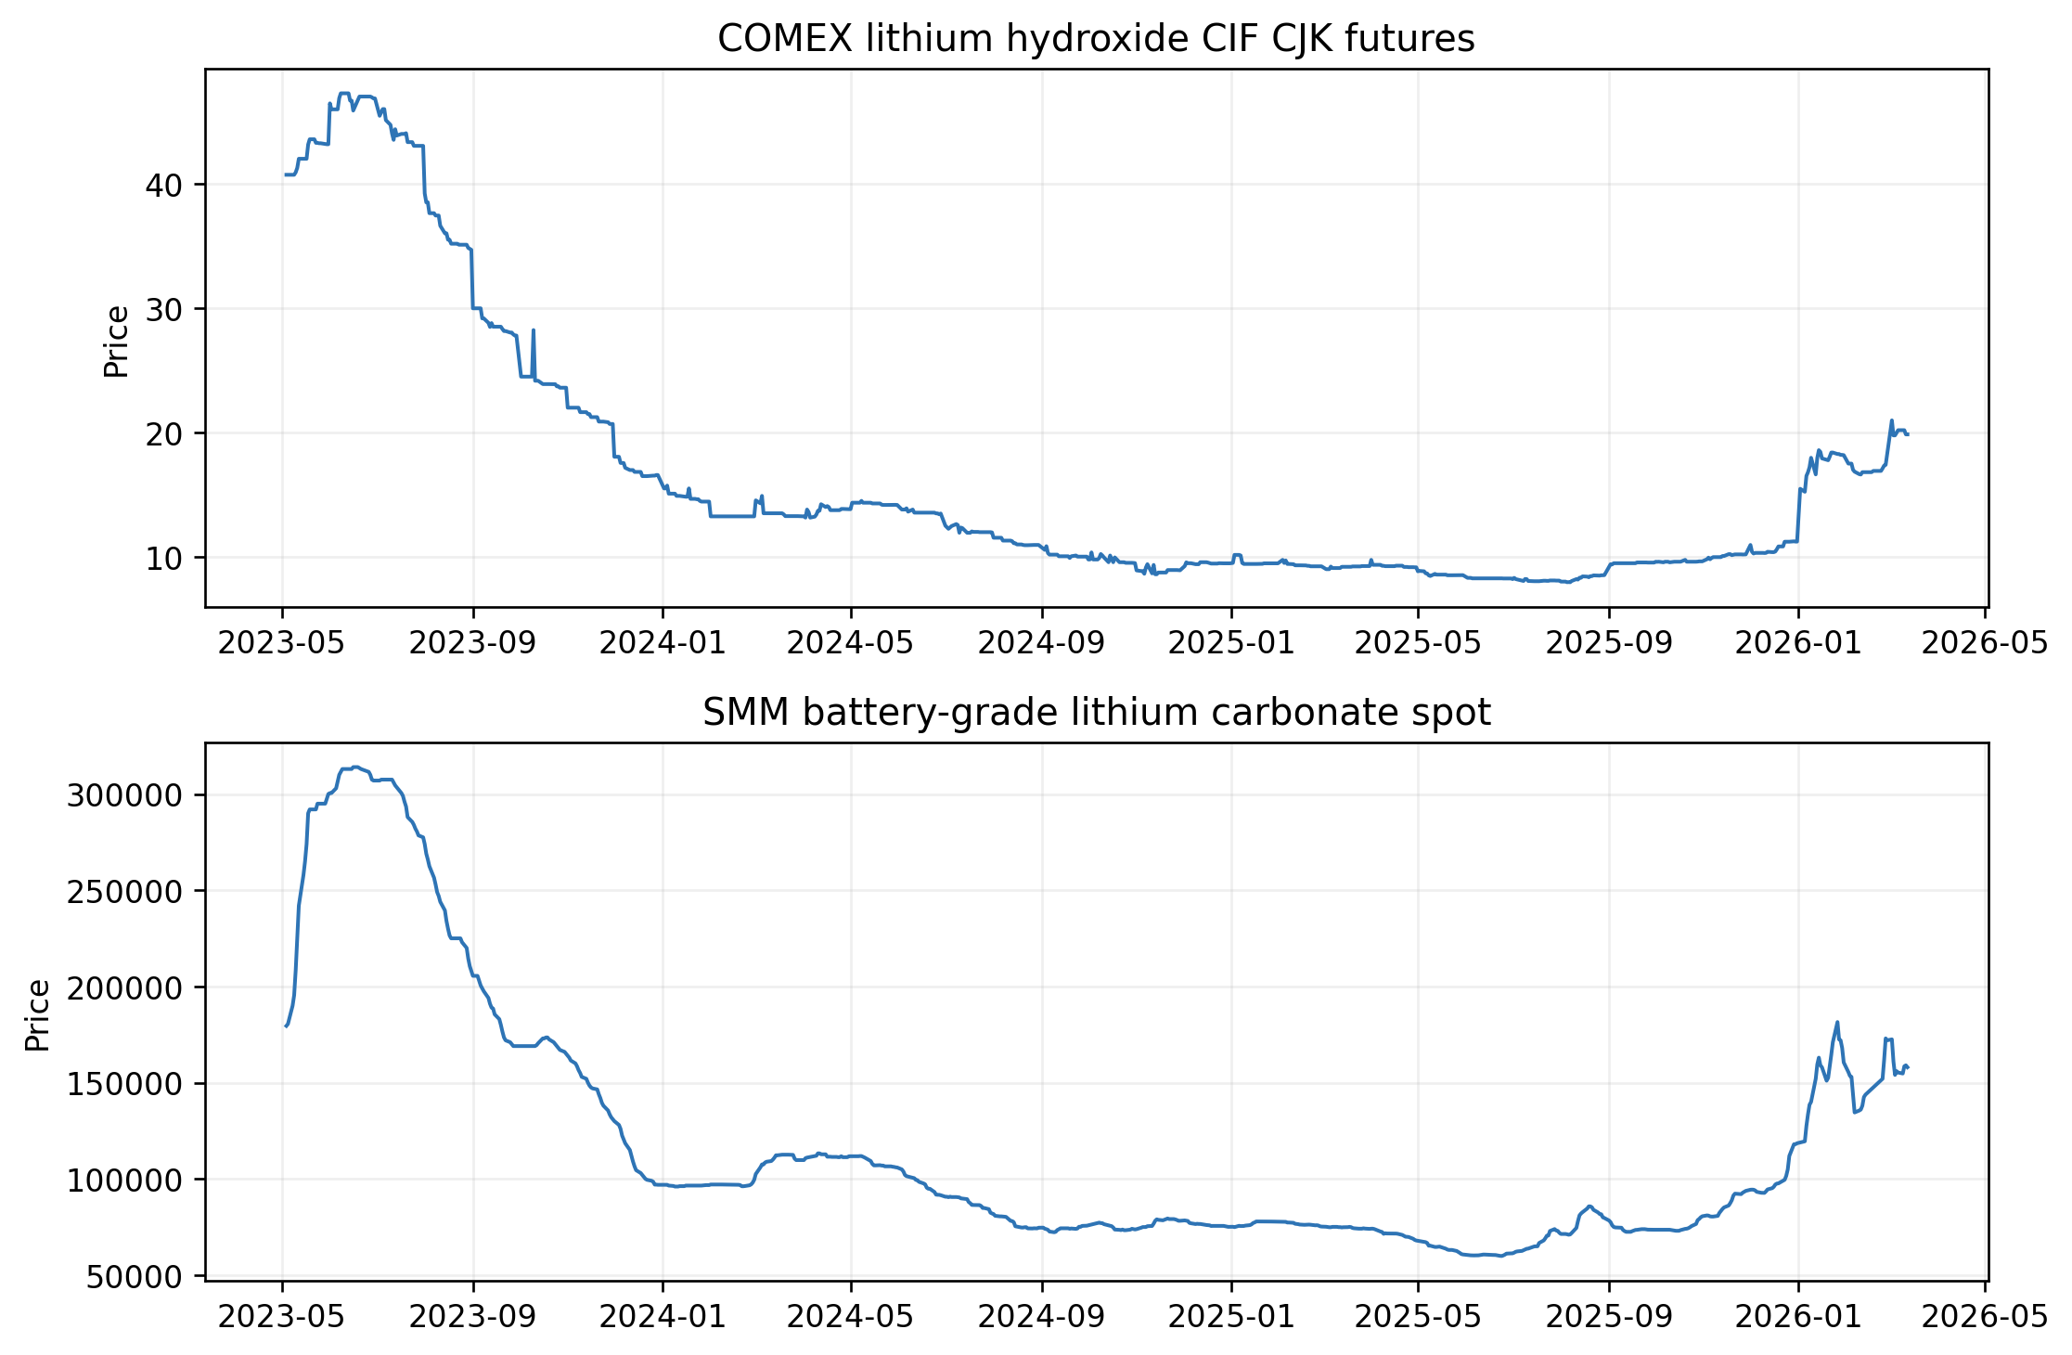
Figure 5. Word cloud of the collected lithium-specific news headlines.
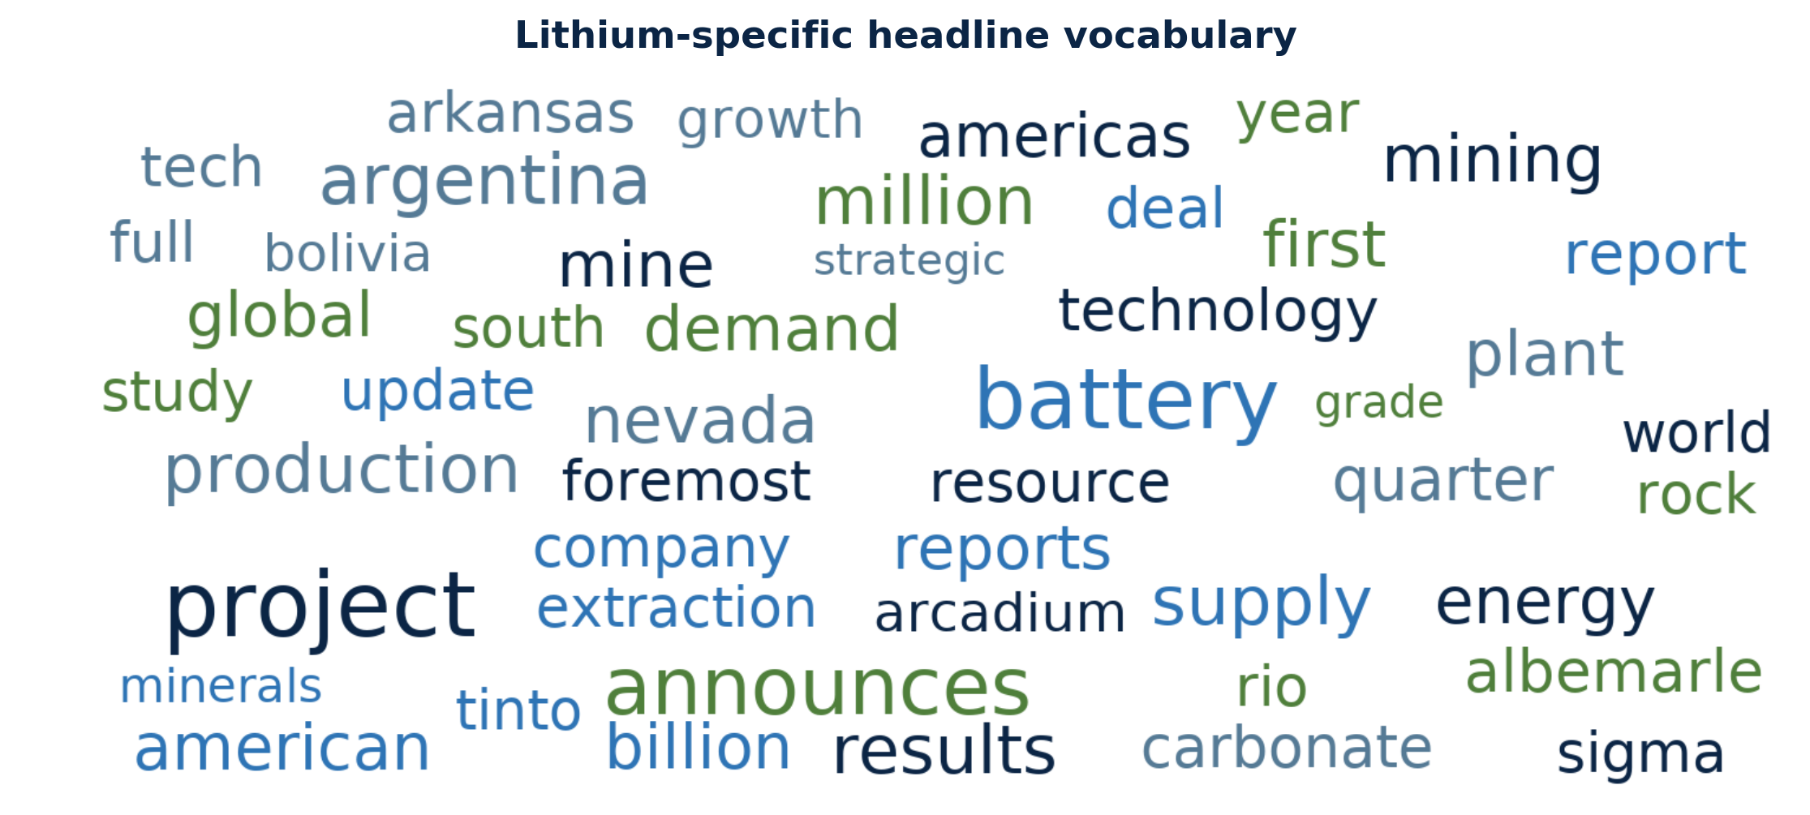
Figure 6. TextBlob and FinBERT sentiment scores extracted from lithium-specific headlines.
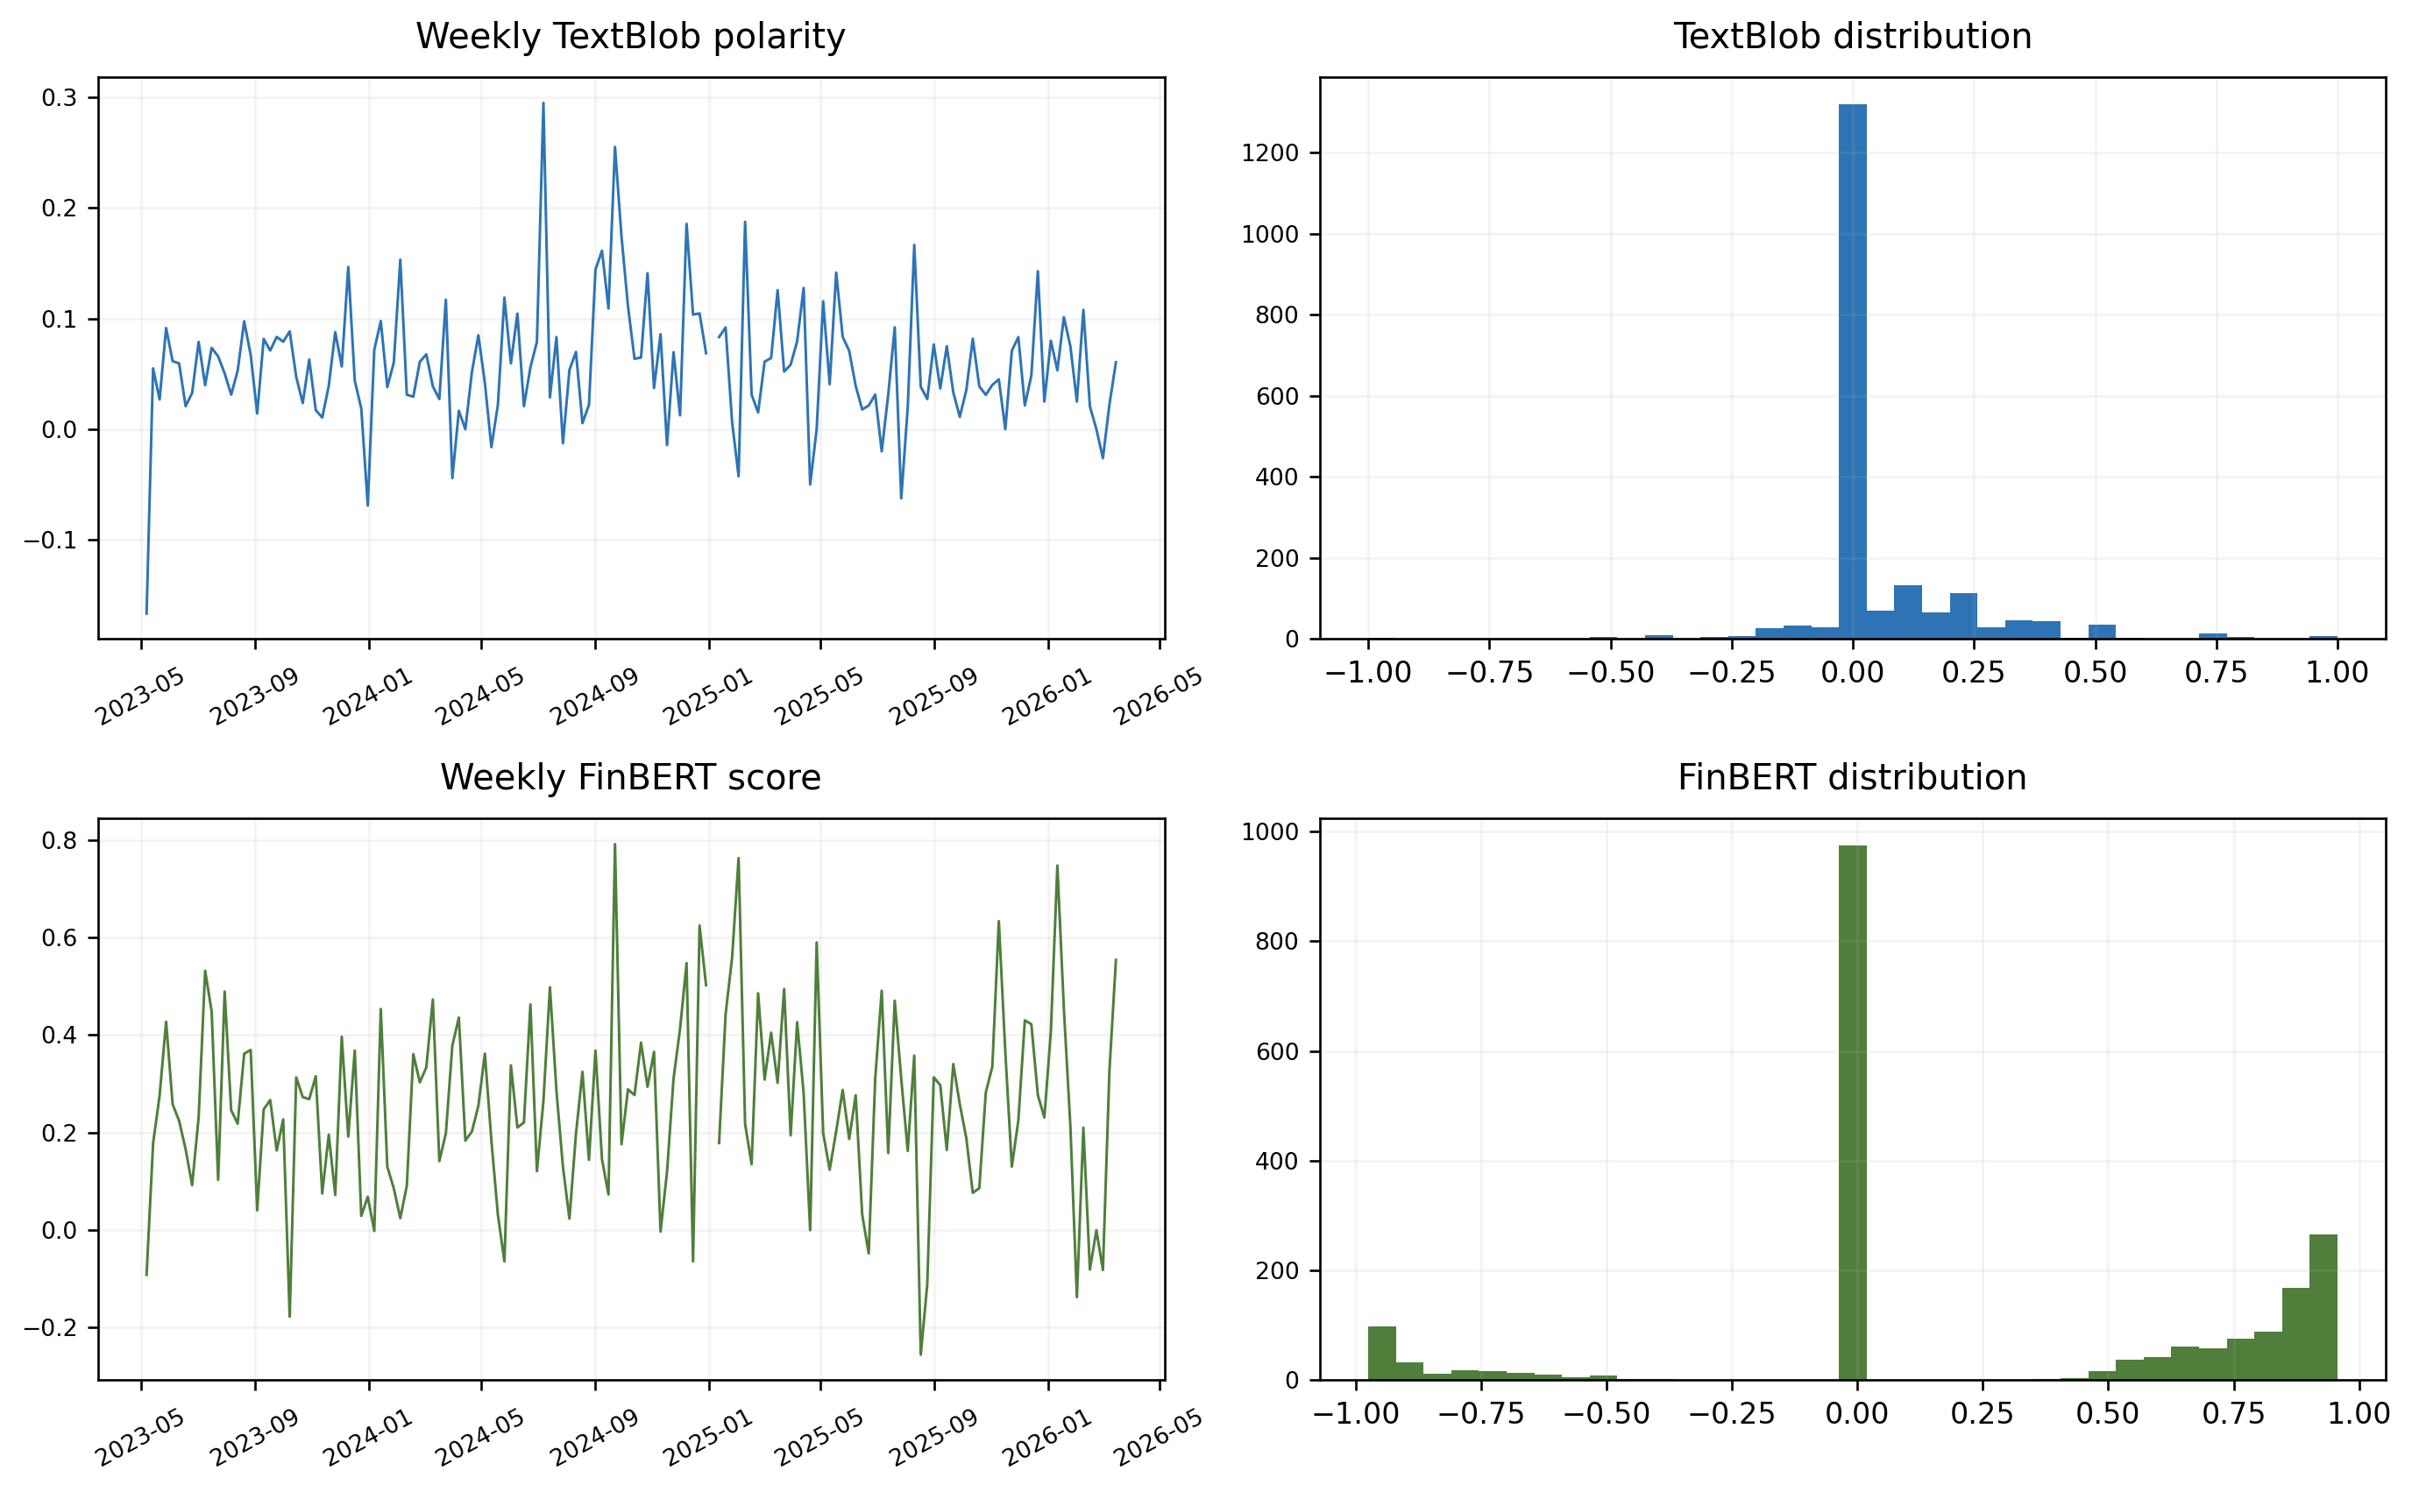

5. Decomposition and feature selection
Figure 7. Reference-parameter full-sample VMD modes of the two lithium-price targets.
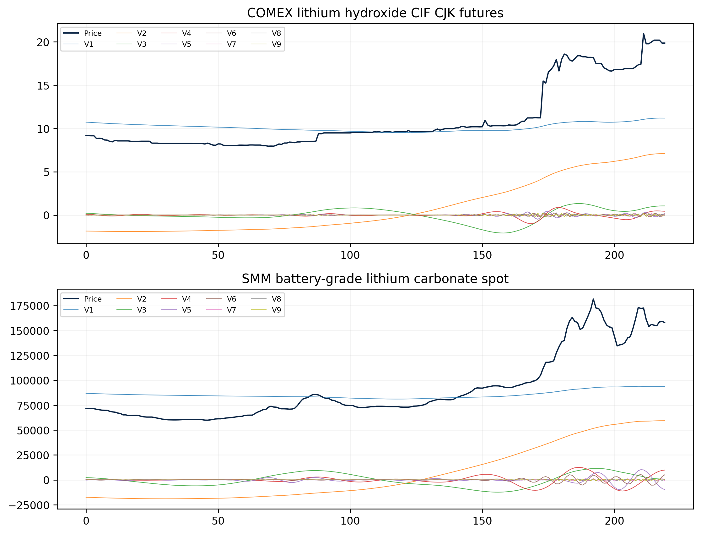
Figure 8. Approximate-entropy values of the reference-parameter VMD modes.
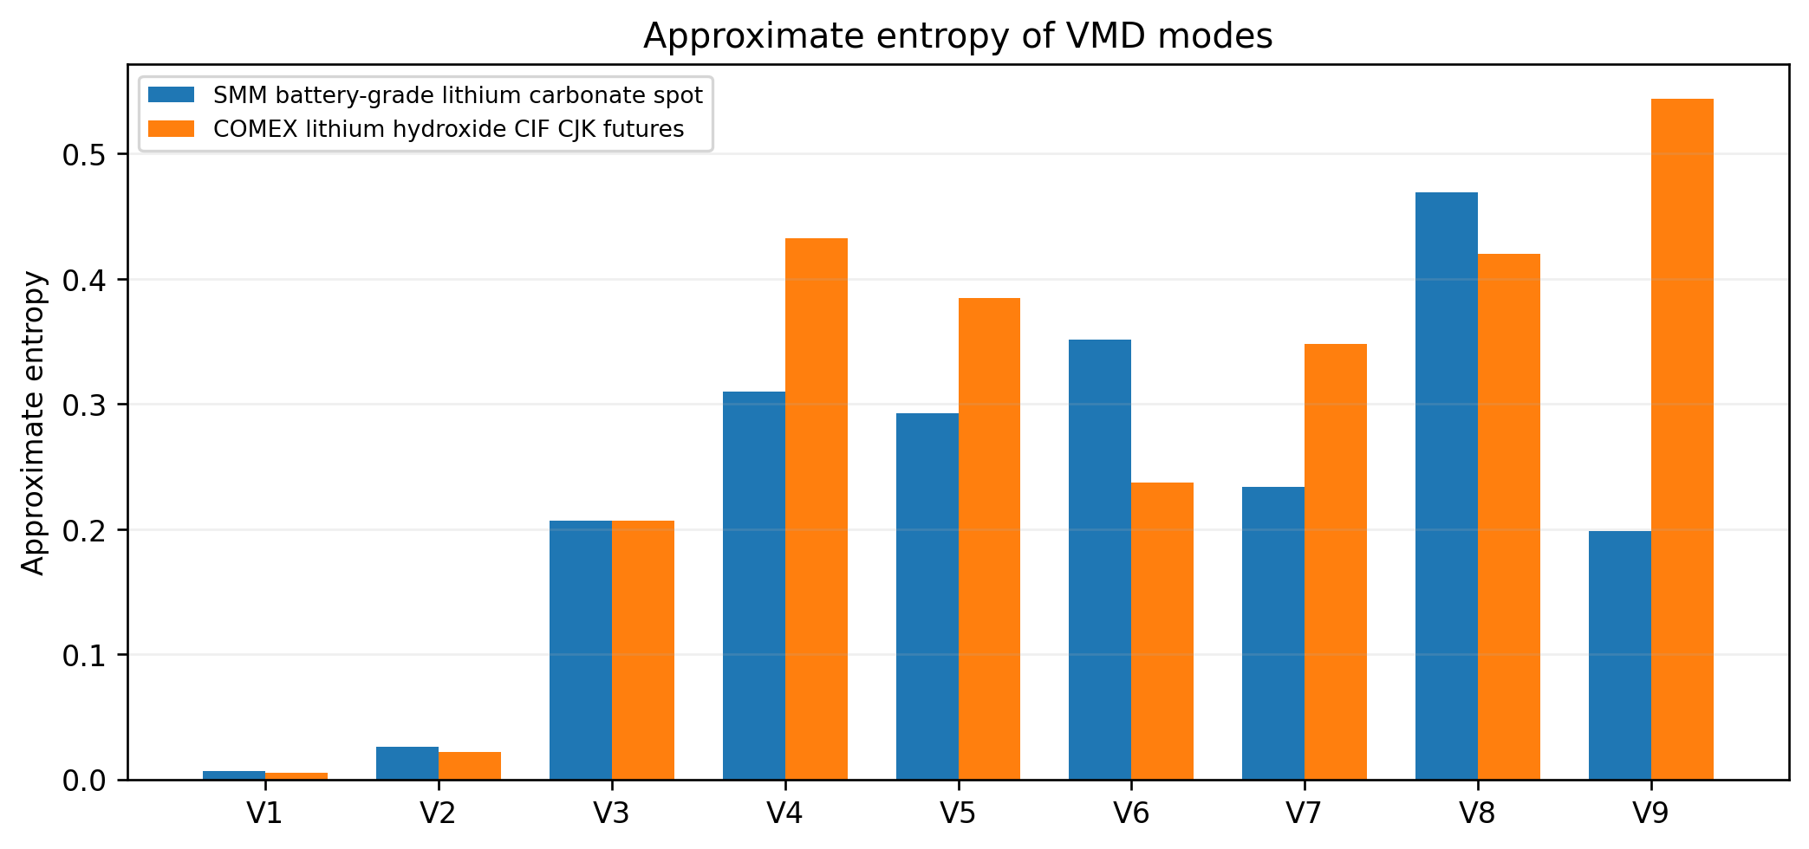

Table 5. Information on the decomposed lithium-price modes.
Panel | Method | Mode | Frequency | Average period | Variance share | Correlation | Approximate Entropy
lithium_hydroxide | VMD | 1.0000 | 0.0056 | 178.5000 | 0.3273 | 0.8212 | 0.0053
lithium_hydroxide | VMD | 2.0000 | 0.0056 | 178.5000 | 0.3651 | 0.8439 | 0.0220
lithium_hydroxide | VMD | 3.0000 | 0.0126 | 79.3333 | 0.0089 | 0.1657 | 0.2067
lithium_hydroxide | VMD | 4.0000 | 0.0490 | 20.4000 | 0.0008 | 0.0556 | 0.4323
lithium_hydroxide | VMD | 5.0000 | 0.1359 | 7.3608 | 0.0002 | 0.0234 | 0.3845
lithium_hydroxide | VMD | 6.0000 | 0.2535 | 3.9448 | 0.0001 | 0.0148 | 0.2372
lithium_hydroxide | VMD | 7.0000 | 0.3403 | 2.9383 | 0.0000 | 0.0118 | 0.3481
lithium_hydroxide | VMD | 8.0000 | 0.3978 | 2.5141 | 0.0001 | 0.0117 | 0.4197
lithium_hydroxide | VMD | 9.0000 | 0.4468 | 2.2382 | 0.0000 | 0.0104 | 0.5442
lithium_hydroxide | CEEMDAN | 1.0000 | 0.3375 | 2.9627 | 0.0006 | -0.0045 | 0.7875
lithium_hydroxide | CEEMDAN | 2.0000 | 0.2381 | 4.2000 | 0.0008 | -0.0290 | 0.5324
lithium_hydroxide | CEEMDAN | 3.0000 | 0.0812 | 12.3103 | 0.0015 | 0.0683 | 0.3999
lithium_hydroxide | CEEMDAN | 4.0000 | 0.0322 | 31.0435 | 0.0068 | 0.1861 | 0.2353
lithium_hydroxide | CEEMDAN | 5.0000 | 0.0098 | 102.0000 | 0.0542 | 0.4401 | 0.0716
lithium_hydroxide | CEEMDAN | 6.0000 | 0.0042 | 238.0000 | 0.0617 | 0.6934 | 0.0342
lithium_hydroxide | CEEMDAN | 7.0000 | 0.0000 |  | 0.6059 | 0.9098 | 0.0071
lithium_carbonate | VMD | 1.0000 | 0.0087 | 115.0000 | 0.2780 | 0.8022 | 0.0070
lithium_carbonate | VMD | 2.0000 | 0.0043 | 230.0000 | 0.3842 | 0.8604 | 0.0264
lithium_carbonate | VMD | 3.0000 | 0.0101 | 98.5714 | 0.0213 | 0.2182 | 0.2068
lithium_carbonate | VMD | 4.0000 | 0.0304 | 32.8571 | 0.0040 | 0.0976 | 0.3095
lithium_carbonate | VMD | 5.0000 | 0.0565 | 17.6923 | 0.0017 | 0.0616 | 0.2928
lithium_carbonate | VMD | 6.0000 | 0.1072 | 9.3243 | 0.0002 | 0.0282 | 0.3512
lithium_carbonate | VMD | 7.0000 | 0.3072 | 3.2547 | 0.0000 | 0.0081 | 0.2335
lithium_carbonate | VMD | 8.0000 | 0.3928 | 2.5461 | 0.0000 | 0.0067 | 0.4691
lithium_carbonate | VMD | 9.0000 | 0.4754 | 2.1037 | 0.0000 | 0.0048 | 0.1982
lithium_carbonate | CEEMDAN | 1.0000 | 0.3275 | 3.0531 | 0.0002 | -0.0179 | 0.8096
lithium_carbonate | CEEMDAN | 2.0000 | 0.2580 | 3.8764 | 0.0011 | 0.0308 | 0.2441
lithium_carbonate | CEEMDAN | 3.0000 | 0.0710 | 14.0816 | 0.0029 | 0.2553 | 0.3550
lithium_carbonate | CEEMDAN | 4.0000 | 0.0217 | 46.0000 | 0.0188 | 0.3989 | 0.2406
lithium_carbonate | CEEMDAN | 5.0000 | 0.0058 | 172.5000 | 0.1555 | 0.7532 | 0.0664
lithium_carbonate | CEEMDAN | 6.0000 | 0.0029 | 345.0000 | 0.0065 | 0.6613 | 0.0281
lithium_carbonate | CEEMDAN | 7.0000 | 0.0014 | 690.0000 | 0.4080 | 0.9087 | 0.0095

Interpretation of Table 5
Decomposition heterogeneity: Frequency, variance share, correlation and approximate entropy show that component order is not interchangeable across VMD and CEEMDAN. A late CEEMDAN component can carry more level variation than an early VMD component.
Routing implication: Diagnostics motivate component-specific treatment but do not identify a universal forecaster. The fixed comparator retains first-two-ARIMA routing; AMDR-Li selects routes from development loss and freezes them before test scoring.
Interpretive boundary: Because the decompositions use the complete price path, these component summaries describe a retrospective representation rather than real-time latent states.
Table 6. Indicators selected for the decomposed modes using LASSO regression.
Panel | Mode | Route | Candidate weight | Selected indicators
lithium_hydroxide | VMD-K8-A1500 / C1 | RF | 0.2095 | target_1, Cross_Lithium_Close, target_4, target_5, target_3, target_2
lithium_hydroxide | VMD-K8-A1500 / C2 | ARIMA | 0.2095 | target_1, SP500
lithium_hydroxide | VMD-K8-A1500 / C3 | RF | 0.2095 | target_1, target_5, Cross_Lithium_Close, Ganfeng_Lithium_Close
lithium_hydroxide | VMD-K8-A1500 / C4 | ARIMA | 0.2095 | target_1, target_3, target_2, target_5, News_FinBERT_Score, News_Article_Count, VIX, News_TextBlob_Polarity, …
lithium_hydroxide | VMD-K8-A1500 / C5 | ARIMA | 0.2095 | target_1, target_2, target_4, target_5, VIX, News_TextBlob_Polarity
lithium_hydroxide | VMD-K8-A1500 / C6 | ARIMA | 0.2095 | target_2, target_4, target_1, target_3, Cross_Lithium_Close, VIX
lithium_hydroxide | VMD-K8-A1500 / C7 | ARIMA | 0.2095 | target_1, target_2, target_4, target_5, News_FinBERT_Score, VIX, Cross_Lithium_Close, News_Article_Count
lithium_hydroxide | VMD-K8-A1500 / C8 | ARIMA | 0.2095 | target_1, target_2, target_3, News_FinBERT_Score, News_Article_Count, VIX, Cross_Lithium_Close
lithium_hydroxide | VMD-K8-A1500 / C9 | ARIMA | 0.2095 | target_1, target_5, target_2, target_4, Cross_Lithium_Close
lithium_hydroxide | VMD-K9-A1500 / C1 | RF | 0.7611 | target_1, Cross_Lithium_Close, target_4, target_5, target_3, target_2
lithium_hydroxide | VMD-K9-A1500 / C2 | ARIMA | 0.7611 | target_1, SP500
lithium_hydroxide | VMD-K9-A1500 / C3 | RF | 0.7611 | target_1, target_5, Cross_Lithium_Close, Ganfeng_Lithium_Close
lithium_hydroxide | VMD-K9-A1500 / C4 | ARIMA | 0.7611 | target_1, target_3, target_2, target_5, News_FinBERT_Score, News_Article_Count, VIX, News_TextBlob_Polarity, …
lithium_hydroxide | VMD-K9-A1500 / C5 | RF | 0.7611 | target_1, target_2, target_4, target_5, VIX, News_TextBlob_Polarity, Cross_Lithium_Close
lithium_hydroxide | VMD-K9-A1500 / C6 | ARIMA | 0.7611 | target_2, target_4, target_5, target_1, VIX, Cross_Lithium_Close, News_Article_Count
lithium_hydroxide | VMD-K9-A1500 / C7 | ARIMA | 0.7611 | target_2, target_1, target_5, News_FinBERT_Score
lithium_hydroxide | VMD-K9-A1500 / C8 | ARIMA | 0.7611 | target_1, target_2, News_FinBERT_Score, Cross_Lithium_Close
lithium_hydroxide | VMD-K9-A1500 / C9 | RF | 0.7611 | target_1, target_2, target_3, target_5, News_FinBERT_Score, Cross_Lithium_Close, News_TextBlob_Polarity, …
lithium_hydroxide | VMD-K9-A1500 / C10 | ARIMA | 0.7611 | target_1, target_5, target_2, target_3, target_4, Cross_Lithium_Close
lithium_hydroxide | CEEMDAN-M9 / C1 | LSTM | 0.0294 | target_1, target_2, News_FinBERT_Score, News_TextBlob_Polarity
lithium_hydroxide | CEEMDAN-M9 / C2 | SVR | 0.0294 | target_1, target_3
lithium_hydroxide | CEEMDAN-M9 / C3 | ARIMA | 0.0294 | target_1, target_2, target_4, target_5, News_Article_Count, US_Dollar_Index, VIX, News_TextBlob_Polarity, …
lithium_hydroxide | CEEMDAN-M9 / C4 | RF | 0.0294 | target_1, target_5, Cross_Lithium_Close, Ganfeng_Lithium_Close, Trends_lithium_hydroxide, SP500, US_Dollar_Index, …
lithium_hydroxide | CEEMDAN-M9 / C5 | ARIMA | 0.0294 | target_1, Cross_Lithium_Close, VIX
lithium_hydroxide | CEEMDAN-M9 / C6 | RF | 0.0294 | target_1
lithium_hydroxide | CEEMDAN-M9 / C7 | SVR | 0.0294 | target_1, Cross_Lithium_Close
lithium_carbonate | VMD-K9-A4500 / C1 | ARIMA | 0.0247 | target_1, Ganfeng_Lithium_Close, Albemarle_Close
lithium_carbonate | VMD-K9-A4500 / C2 | ARIMA | 0.0247 | target_1, SP500
lithium_carbonate | VMD-K9-A4500 / C3 | ARIMA | 0.0247 | target_1, target_5, Ganfeng_Lithium_Close, Cross_Lithium_Close
lithium_carbonate | VMD-K9-A4500 / C4 | RF | 0.0247 | target_1, target_5, Ganfeng_Lithium_Close, News_TextBlob_Polarity
lithium_carbonate | VMD-K9-A4500 / C5 | ARIMA | 0.0247 | target_1, target_4, target_3, Ganfeng_Lithium_Close, News_Article_Count, News_FinBERT_Score
lithium_carbonate | VMD-K9-A4500 / C6 | ARIMA | 0.0247 | target_1, target_2, target_5, target_4, Ganfeng_Lithium_Close, News_Article_Count, US_Dollar_Index, …
lithium_carbonate | VMD-K9-A4500 / C7 | ARIMA | 0.0247 | target_2, target_1, target_4, target_3, target_5, Ganfeng_Lithium_Close, US_Dollar_Index, Cross_Lithium_Close, …
lithium_carbonate | VMD-K9-A4500 / C8 | ARIMA | 0.0247 | target_1, target_2, target_3, target_5, target_4, Ganfeng_Lithium_Close, US_Dollar_Index, News_FinBERT_Score, …
lithium_carbonate | VMD-K9-A4500 / C9 | ARIMA | 0.0247 | target_1, target_3, target_2, Ganfeng_Lithium_Close, News_FinBERT_Score, US_Dollar_Index
lithium_carbonate | VMD-K9-A4500 / C10 | ARIMA | 0.0247 | target_1, target_2, target_5, target_4, Albemarle_Close, News_Article_Count, Cross_Lithium_Close
lithium_carbonate | VMD-K10-A1500 / C1 | RF | 0.9753 | target_1, Cross_Lithium_Close, target_3, target_2, target_4, target_5
lithium_carbonate | VMD-K10-A1500 / C2 | RF | 0.9753 | target_1
lithium_carbonate | VMD-K10-A1500 / C3 | ARIMA | 0.9753 | target_1, target_5, Ganfeng_Lithium_Close, Cross_Lithium_Close
lithium_carbonate | VMD-K10-A1500 / C4 | RF | 0.9753 | target_1, target_5, Ganfeng_Lithium_Close, News_TextBlob_Polarity
lithium_carbonate | VMD-K10-A1500 / C5 | SVR | 0.9753 | target_1, target_3, target_4, Ganfeng_Lithium_Close, News_Article_Count
lithium_carbonate | VMD-K10-A1500 / C6 | ARIMA | 0.9753 | target_1, target_2, target_5, Ganfeng_Lithium_Close, News_Article_Count, News_TextBlob_Polarity
lithium_carbonate | VMD-K10-A1500 / C7 | ARIMA | 0.9753 | target_2, target_1, target_5, target_4, Ganfeng_Lithium_Close, News_Article_Count, US_Dollar_Index, …
lithium_carbonate | VMD-K10-A1500 / C8 | ARIMA | 0.9753 | target_2, target_4, target_1, target_5, Ganfeng_Lithium_Close, Cross_Lithium_Close, Albemarle_Close, …
lithium_carbonate | VMD-K10-A1500 / C9 | ARIMA | 0.9753 | target_1, target_2, target_5, target_3, Ganfeng_Lithium_Close, Albemarle_Close, Cross_Lithium_Close, …
lithium_carbonate | VMD-K10-A1500 / C10 | ARIMA | 0.9753 | target_1, target_4, target_5, Ganfeng_Lithium_Close, News_Article_Count, US_Dollar_Index
lithium_carbonate | VMD-K10-A1500 / C11 | SVR | 0.9753 | target_1, target_4, target_2, target_5, Cross_Lithium_Close, Ganfeng_Lithium_Close

Interpretation of Table 6
Adaptive routing: Development selection produced these component-route counts across the candidate bank: ARIMA=160, RF=58, SVR=32, LSTM=6. The diversity is direct evidence against imposing one route on every component.
Multimodal role: The selected-indicator column exposes where cross-lithium price, producer equities, attention, lithium-news tone and market controls enter alongside price lags.
Interpretation: Selection is conditional predictive inclusion, not structural causality. Correlated indicators can substitute under LASSO, and full-sample decomposition remains a look-ahead channel.

The decomposition summaries show that the modes differ materially in frequency, variance share, correlation with the original price, and approximate entropy. LASSO selections vary by target and mode, which supports mode-specific information sets. Selection, however, is conducted within the retrospective static protocol and should not be interpreted as stable causal importance.

6. Forecasting results
Figure 9. Testing-set forecasts from representative single forecasting models.
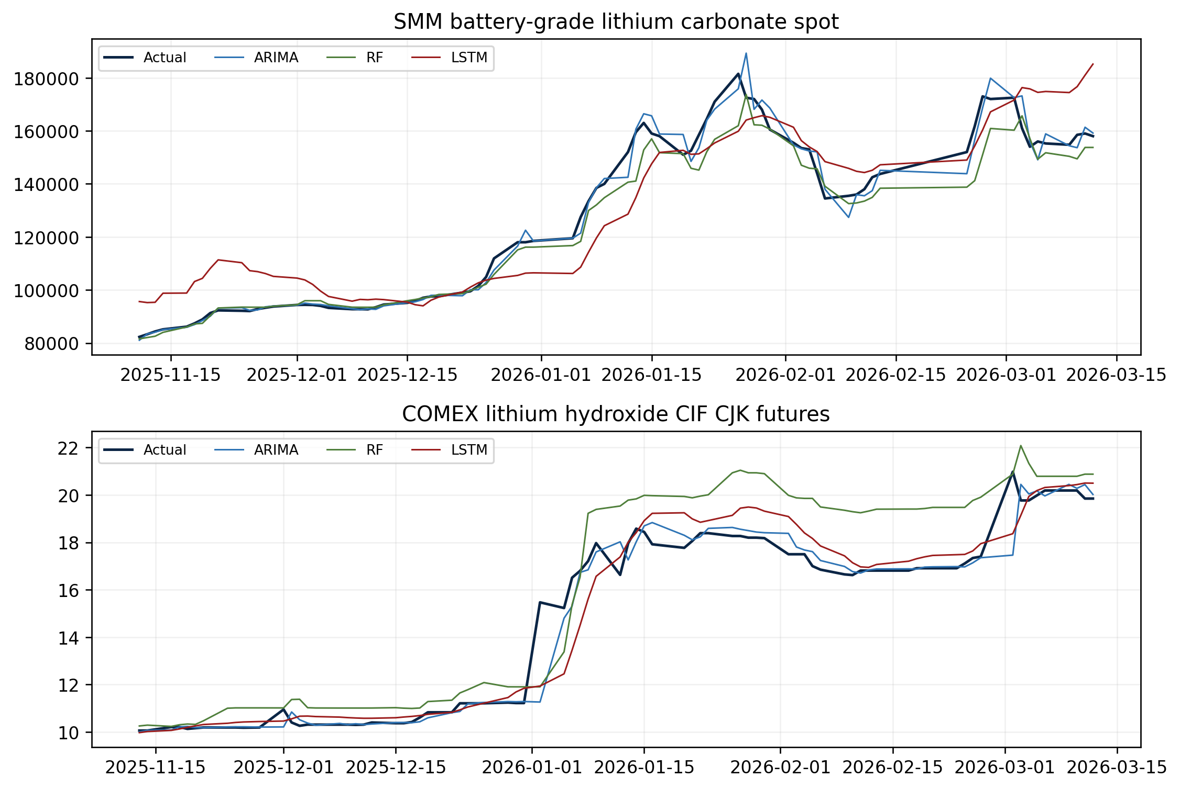
Figure 10. Target-normalized RMSE across the publication-facing architecture models.
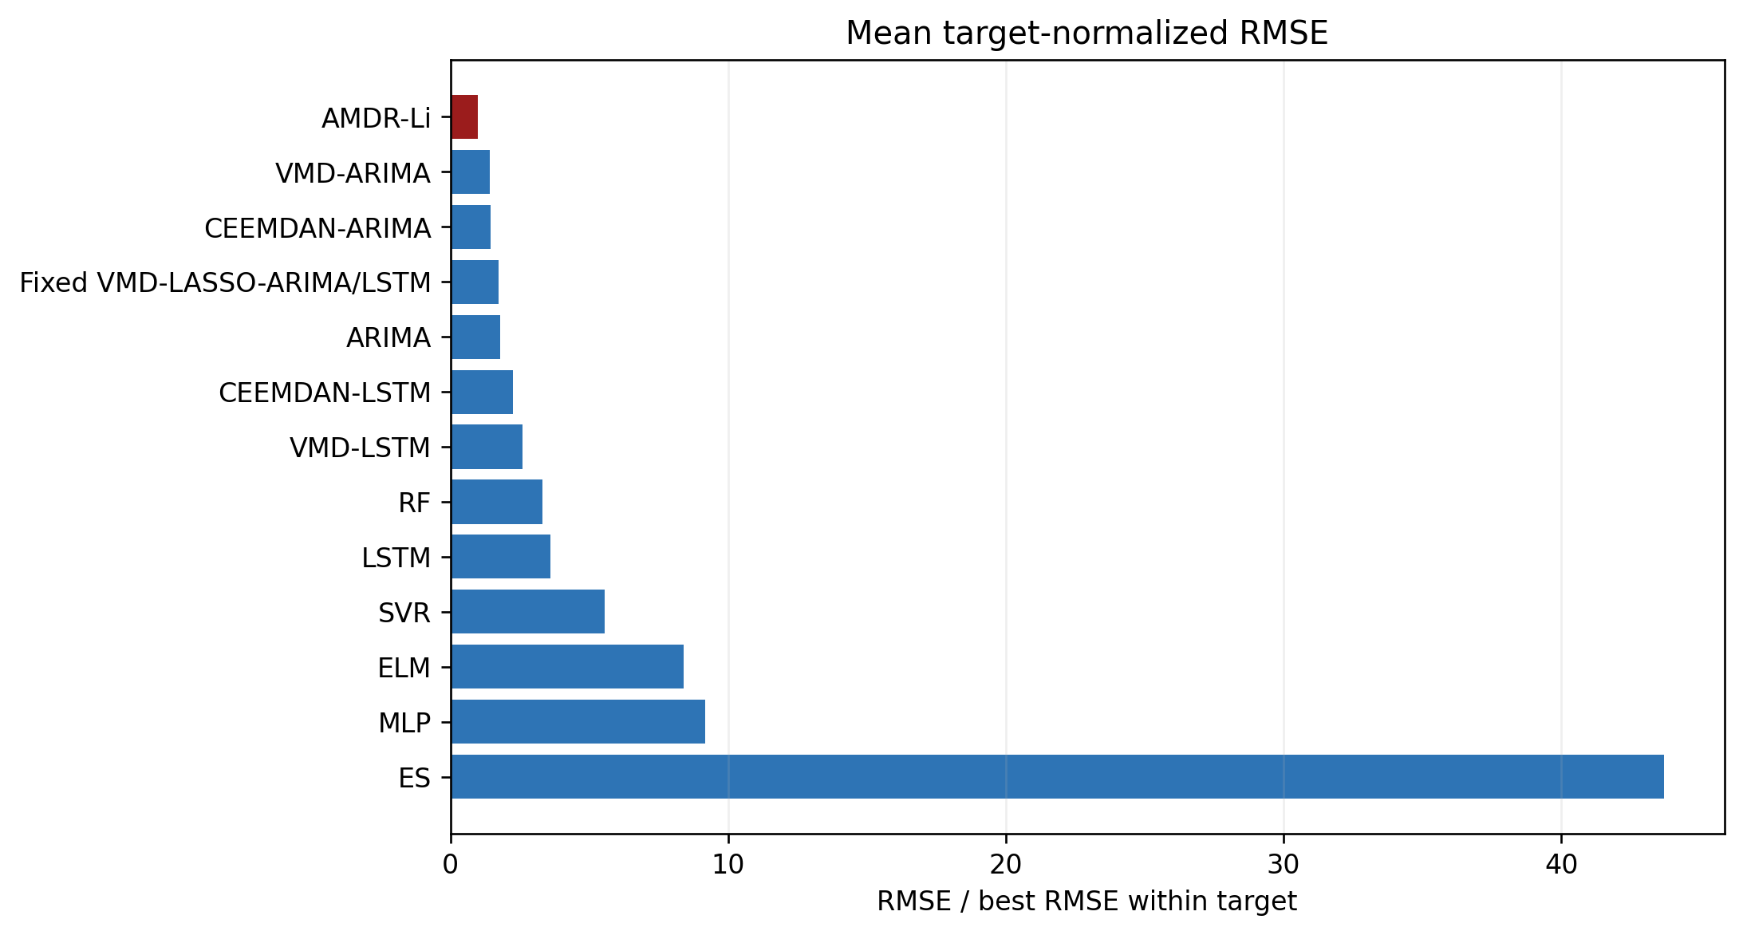

Table 7. Forecasting errors on the testing sets for single models.
Target | Model | RMSE | MAE | MASE | MAPE | sMAPE | Directional Accuracy
lithium_carbonate | ARIMA | 3612.1970 | 1827.0413 | 0.9132 | 1.43 | 1.46 | 69.63
lithium_carbonate | RF | 5380.3212 | 3231.2770 | 1.6150 | 2.55 | 2.59 | 72.59
lithium_carbonate | LSTM | 11905.8590 | 9873.9034 | 4.9351 | 9.97 | 9.46 | 55.56
lithium_carbonate | SVR | 24629.9992 | 18864.5712 | 9.4288 | 21.87 | 18.25 | 56.30
lithium_carbonate | ELM | 41457.7667 | 34950.9727 | 17.4690 | 36.01 | 28.29 | 58.52
lithium_carbonate | MLP | 45712.4002 | 37502.1294 | 18.7441 | 40.06 | 30.61 | 48.15
lithium_carbonate | ES | 200226.2914 | 180239.9823 | 90.0866 | 165.22 | 86.50 | 54.07
lithium_hydroxide | ARIMA | 0.6437 | 0.2395 | 1.3159 | 1.76 | 1.92 | 29.29
lithium_hydroxide | ELM | 0.6542 | 0.2573 | 1.4138 | 1.71 | 1.79 | 28.57
lithium_hydroxide | MLP | 0.6766 | 0.4589 | 2.5212 | 3.52 | 3.54 | 35.00
lithium_hydroxide | SVR | 0.7060 | 0.5847 | 3.2129 | 4.95 | 4.83 | 38.57
lithium_hydroxide | LSTM | 0.8398 | 0.4967 | 2.7292 | 3.81 | 3.75 | 32.86
lithium_hydroxide | RF | 1.3033 | 0.8864 | 4.8704 | 6.01 | 5.76 | 37.14
lithium_hydroxide | ES | 4.8948 | 3.3720 | 18.5273 | 21.47 | 26.45 | 35.00

Interpretation of Table 7
Carbonate result: ARIMA has the lowest single-model RMSE (3612.1970), with MAE 1827.0413, MAPE 1.43% and directional accuracy 69.63%.
Hydroxide result: ARIMA has the lowest single-model RMSE (0.6437), with MAE 0.2395, MAPE 1.76% and directional accuracy 29.29%.
Benchmark lesson: Greater nonlinearity is not automatically beneficial in this short sample. Complexity contributes only when decomposition, sparse selection or adaptive routing converts it into lower locked-test loss.
Table 8. Forecasting errors on the testing sets for decomposition models.
Target | Model | RMSE | MAE | MASE | MAPE | sMAPE | Directional Accuracy
lithium_carbonate | AMDR-Li | 2881.4682 | 1959.1156 | 0.9792 | 1.72 | 1.73 | 74.07
lithium_carbonate | VMD-ARIMA | 3151.9059 | 1569.3488 | 0.7844 | 1.35 | 1.39 | 78.52
lithium_carbonate | CEEMDAN-ARIMA | 3623.5469 | 1436.9183 | 0.7182 | 1.12 | 1.16 | 77.04
lithium_carbonate | CEEMDAN-LSTM | 3650.8523 | 2402.9913 | 1.2011 | 2.07 | 2.07 | 78.52
lithium_carbonate | Fixed VMD-LASSO-ARIMA/LSTM | 3858.1490 | 2053.9202 | 1.0266 | 1.80 | 1.85 | 77.04
lithium_carbonate | VMD-LSTM | 5587.1679 | 3861.8263 | 1.9302 | 3.33 | 3.34 | 74.81
lithium_hydroxide | AMDR-Li | 0.2737 | 0.1979 | 1.0875 | 1.49 | 1.50 | 44.29
lithium_hydroxide | CEEMDAN-ARIMA | 0.4467 | 0.1994 | 1.0955 | 1.54 | 1.66 | 37.86
lithium_hydroxide | VMD-ARIMA | 0.4731 | 0.2450 | 1.3463 | 1.92 | 2.03 | 44.29
lithium_hydroxide | Fixed VMD-LASSO-ARIMA/LSTM | 0.5825 | 0.3623 | 1.9905 | 2.83 | 2.93 | 39.29
lithium_hydroxide | CEEMDAN-LSTM | 0.8838 | 0.6088 | 3.3453 | 5.40 | 5.33 | 36.43
lithium_hydroxide | VMD-LSTM | 0.8868 | 0.4504 | 2.4750 | 3.76 | 3.50 | 42.14

Interpretation of Table 8
Carbonate decomposition: The proposed RMSE is 2881.4682; the strongest non-adaptive decomposition comparator is VMD-ARIMA at 3151.9059. The proposed value is 8.58% lower.
Hydroxide decomposition: The proposed RMSE is 0.2737; the strongest non-adaptive decomposition comparator is CEEMDAN-ARIMA at 0.4467. The proposed value is 38.72% lower.
Primary finding: RMSE is the primary ranking criterion. AMDR-Li has the lowest RMSE for both targets; MAE, MAPE, MASE and directional accuracy remain secondary diagnostics and are not used to imply universal dominance.
Table 9. Diebold-Mariano tests comparing AMDR-Li with forecasting benchmarks.
Target | Benchmark | DM statistic | p-value | Direction
lithium_carbonate | ES | -10.9902 | 0.0000 | Proposed better
lithium_carbonate | ELM | -8.3599 | 0.0000 | Proposed better
lithium_carbonate | LSTM | -7.8177 | 0.0000 | Proposed better
lithium_carbonate | MLP | -7.1580 | 0.0000 | Proposed better
lithium_carbonate | SVR | -6.1487 | 0.0000 | Proposed better
lithium_carbonate | VMD-LSTM | -4.1421 | 0.0001 | Proposed better
lithium_carbonate | RF | -2.6656 | 0.0086 | Proposed better
lithium_carbonate | CEEMDAN-LSTM | -2.4018 | 0.0177 | Proposed better
lithium_carbonate | ARIMA | -1.7548 | 0.0816 | Proposed better
lithium_carbonate | Fixed VMD-LASSO-ARIMA/LSTM | -1.2248 | 0.2228 | Proposed better
lithium_carbonate | CEEMDAN-ARIMA | -1.0154 | 0.3117 | Proposed better
lithium_carbonate | VMD-ARIMA | -0.4456 | 0.6566 | Proposed better
lithium_hydroxide | ES | -5.8271 | 0.0000 | Proposed better
lithium_hydroxide | RF | -5.4012 | 0.0000 | Proposed better
lithium_hydroxide | SVR | -4.7977 | 0.0000 | Proposed better
lithium_hydroxide | LSTM | -3.0791 | 0.0025 | Proposed better
lithium_hydroxide | MLP | -2.9218 | 0.0041 | Proposed better
lithium_hydroxide | CEEMDAN-LSTM | -2.6040 | 0.0102 | Proposed better
lithium_hydroxide | Fixed VMD-LASSO-ARIMA/LSTM | -2.1655 | 0.0320 | Proposed better
lithium_hydroxide | VMD-LSTM | -1.8527 | 0.0660 | Proposed better
lithium_hydroxide | ARIMA | -1.8089 | 0.0726 | Proposed better
lithium_hydroxide | ELM | -1.6350 | 0.1043 | Proposed better
lithium_hydroxide | VMD-ARIMA | -1.2221 | 0.2237 | Proposed better
lithium_hydroxide | CEEMDAN-ARIMA | -1.0808 | 0.2816 | Proposed better

Interpretation of Table 9
How to read the sign: The loss differential is proposed-model squared error minus benchmark squared error. A negative statistic favors the proposed model; the p-value tests equal predictive loss, not profitability.
Carbonate evidence: At the unadjusted 5% level the proposed model records 8 significant wins and 0 significant losses.
Hydroxide evidence: At the unadjusted 5% level the proposed model records 7 significant wins and 0 significant losses.
Multiplicity caution: The displayed comparisons are not family-wise adjusted. Nominal p-values are interpreted jointly with effect sizes and target-level metrics.

For hydroxide, the AMDR-Li RMSE is 0.2737, 38.72% below the strongest non-adaptive decomposition comparator (CEEMDAN-ARIMA, 0.4467). For carbonate, the AMDR-Li RMSE is 2881.4682, 8.58% below the strongest non-adaptive decomposition comparator (VMD-ARIMA, 3151.9059). Relative to the strongest single model, RMSE falls by hydroxide 57.48%, carbonate 20.23%.
AMDR-Li records the lowest test RMSE for both lithium targets. Relative to Random Walk, RMSE falls by 17.61% for carbonate and 50.20% for hydroxide. Secondary metrics are mixed and are reported without a general claim of metric-wide dominance. Figure 10 presents the architecture comparison after normalizing RMSE within each target solely to accommodate the different price units. The rankings themselves come from the unnormalized results in Tables 7 and 8. Appendix Table A2 supplies the separate Random Walk comparison.
The secondary metrics qualify this result. For carbonate, AMDR-Li also improves on Random Walk MAE, although CEEMDAN-ARIMA retains the lowest MAE and MAPE among decomposition models. For hydroxide, Random Walk records lower MAE and MAPE, while AMDR-Li has lower RMSE and higher directional accuracy. The evidence therefore supports cross-target RMSE leadership, not universal metric leadership.
The DM table should be read jointly with effect sizes. A negative statistic means lower squared loss for AMDR-Li; significance indicates evidence against equal predictive accuracy under the retrospective loss sequence. Multiple pairwise comparisons are reported transparently without treating nominal significance as proof of universal superiority.

6.1 Cross-market producer-equity extension
Figure 14. Testing-set equity forecast paths for AMDR-Li and the Random Walk benchmark.
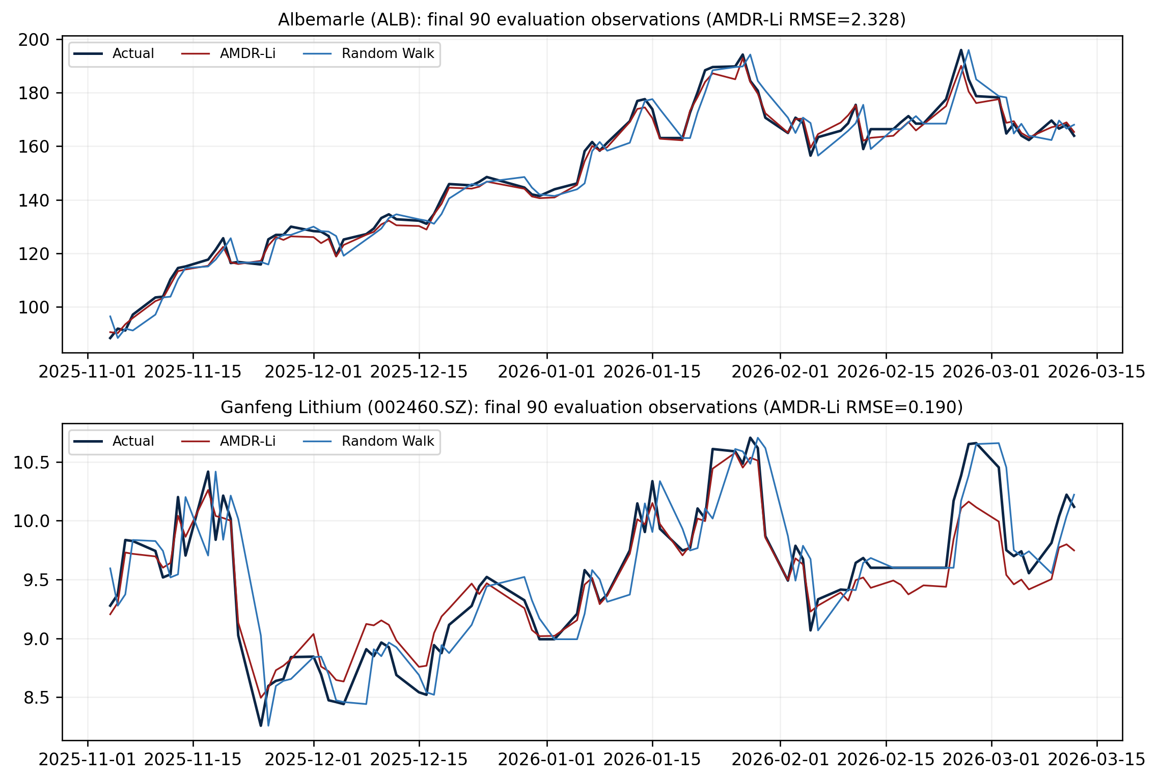

Table 13. Static 80:20 forecasting evidence for the lithium-producer equity extension.
Equity target | AMDR-Li RMSE | VMD-ARIMA RMSE | Random Walk RMSE | RMSE improvement vs Random Walk (%) | AMDR-Li MAE | AMDR-Li directional accuracy (%) | DM p-value vs Random Walk
Albemarle (ALB) | 2.328 | 4.107 | 5.026 | 53.670 | 1.692 | 82.394 | 0.000001
Ganfeng Lithium (002460.SZ) | 0.190 | 0.191 | 0.312 | 39.029 | 0.154 | 80.282 | 0.000172

Interpretation of Table 13
Albemarle: AMDR-Li is the clear RMSE leader and materially improves on both VMD-ARIMA and Random Walk.
Ganfeng: AMDR-Li leads on RMSE and Random Walk comparison, while VMD-ARIMA retains lower MAE; claims are therefore metric-specific.
Inference: Both AMDR-Li-versus-Random-Walk squared-loss DM tests reject equal predictive accuracy at the 1% level within the static retrospective design.

The extension forecasts next-day Albemarle and Ganfeng closes using lagged target history, the other producer, lithium carbonate and hydroxide prices, lithium-specific attention and news, broad market controls, Shanghai Composite, and USD/CNY. Each equity uses its own static 80:20 panel and the same comparison set; a target's contemporaneous close is never supplied as an external feature. AMDR-Li lowers RMSE versus Random Walk by 53.67% for Albemarle and 39.03% for Ganfeng, with DM p-values below 0.001 in both cases. Albemarle also materially exceeds the strongest nonadaptive decomposition comparator. For Ganfeng, the RMSE gain over VMD-ARIMA is only 0.55% and VMD-ARIMA retains lower MAE, so the evidence is RMSE-specific rather than universal.

7. Interval forecasting and trading

7.1 Interval calibration
Figure 11. Retrospective 90% interval forecasts from AMDR-Li.
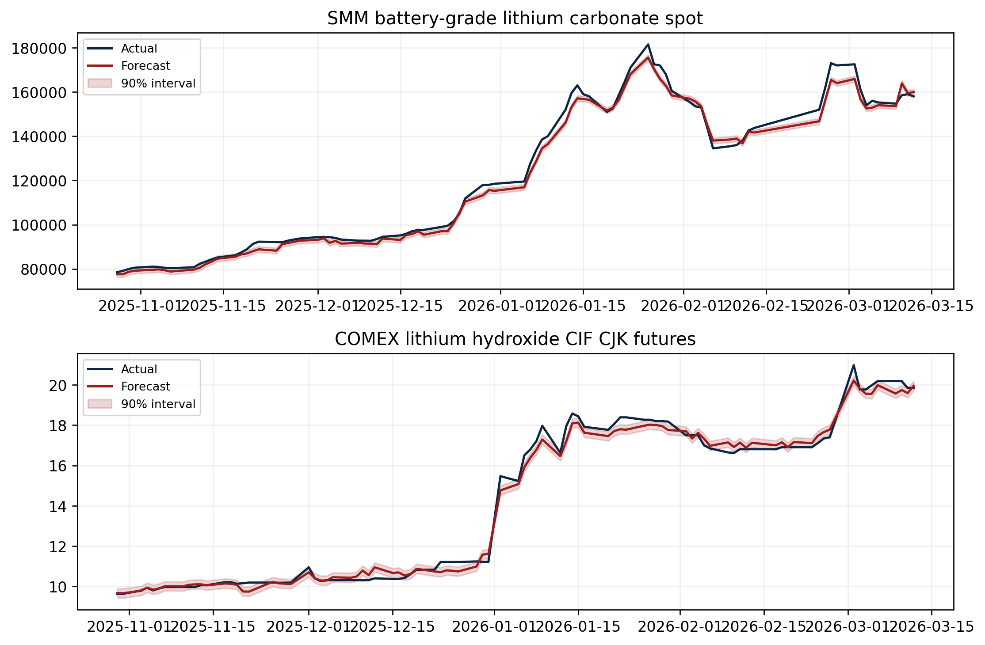

Table 10. Interval forecasting errors on the evaluation sets.
Target | Nominal Coverage (%) | Coverage (%) | Avg Width | Calibration Error | Winkler
lithium_carbonate | 80.00 | 37.25 | 2492.0765 | 42.7451 | 13857.9544
lithium_carbonate | 90.00 | 41.18 | 2627.3844 | 48.8235 | 24536.0747
lithium_carbonate | 95.00 | 100.00 | 28867.4598 | 5.0000 | 28867.4598
lithium_hydroxide | 80.00 | 52.38 | 0.3905 | 27.6190 | 1.3457
lithium_hydroxide | 90.00 | 56.19 | 0.4646 | 33.8095 | 2.0439
lithium_hydroxide | 95.00 | 100.00 | 1.5999 | 5.0000 | 1.5999

Interpretation of Table 10
Coverage evidence: Carbonate: 80% nominal -> 37.25% realized, 90% nominal -> 41.18% realized, 95% nominal -> 100.00% realized Hydroxide: 80% nominal -> 52.38% realized, 90% nominal -> 56.19% realized, 95% nominal -> 100.00% realized
Coverage-width trade-off: Coverage must be read with average width and Winkler score. Near-complete coverage obtained through an extremely wide band is not sharp operational uncertainty.
Implication: These static intervals are descriptive. Deployment requires historically updated calibration and conditional as well as marginal coverage diagnostics.

The 80% and 90% intervals materially under-cover both targets, while the 95% intervals obtain complete coverage only through extreme width. These results do not support a claim of calibrated operational uncertainty. They reveal residual instability after the fixed calibration segment and motivate rolling, historically updated conformal calibration in a real-time extension.

7.2 Economic decision rule
Figure 12. Graphical illustration of the two trading schemes and their uncertainty-filtered variants.
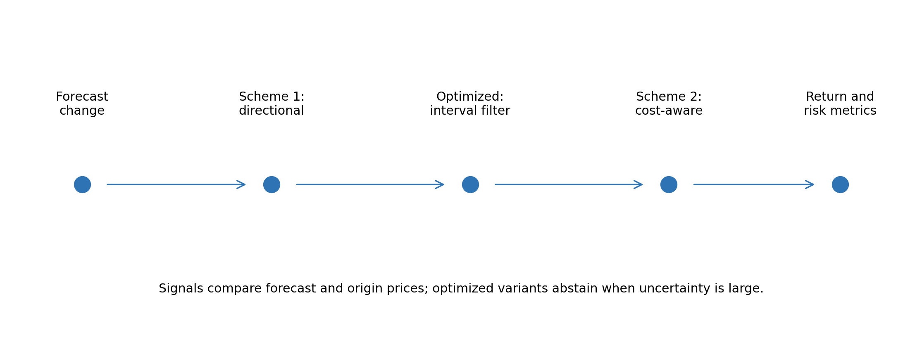
The uncertainty filter is an abstention rule, not a condition that the forecast lie inside its own interval. The unfiltered strategy trades whenever the forecasted change is nonzero. The filtered strategy trades only when the absolute predicted change exceeds the 90% residual threshold; otherwise it holds zero exposure. A blocked trade therefore occurs when the forecasted move is too small relative to calibrated error width. The realized price is used only to score the position after the decision and is not an input to the signal.

7.3 Trading evidence and limits
Figure 13. Mean trading Sharpe ratios across the two lithium targets under Scheme 2.
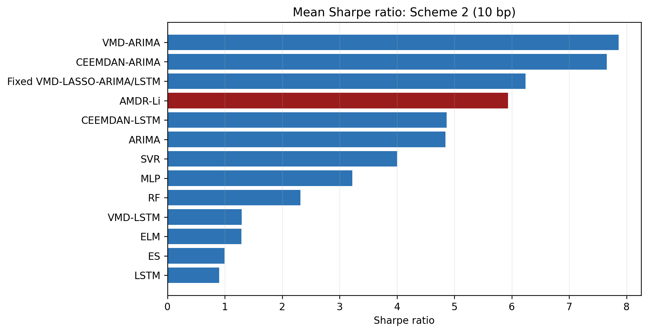

Table 11. Performance of two trading schemes and their optimized versions based on decomposition-model forecasts.
Model | Scheme | Cumulative Return (%) | Maximum Drawdown (%) | Sharpe Ratio | Number of Transactions | Hit Rate (%)
CEEMDAN-ARIMA | Scheme 1 | 332.30 | -4.34 | 8.0045 | 37.5000 | 65.48
CEEMDAN-ARIMA | Scheme 1' | 284.56 | -1.98 | 7.5317 | 32.0000 | 40.35
CEEMDAN-ARIMA | Scheme 2 | 304.19 | -4.44 | 7.6570 | 37.5000 | 65.48
CEEMDAN-ARIMA | Scheme 2' | 269.81 | -2.18 | 7.3112 | 32.0000 | 40.35
CEEMDAN-LSTM | Scheme 1 | 161.66 | -11.54 | 5.0441 | 15.5000 | 50.50
CEEMDAN-LSTM | Scheme 1' | 28.81 | -1.10 | 2.3397 | 9.5000 | 7.84
CEEMDAN-LSTM | Scheme 2 | 153.80 | -11.64 | 4.8664 | 15.5000 | 50.50
CEEMDAN-LSTM | Scheme 2' | 27.35 | -1.20 | 2.2594 | 9.5000 | 7.84
Fixed VMD-LASSO-ARIMA/LSTM | Scheme 1 | 237.79 | -7.49 | 6.4150 | 15.0000 | 58.21
Fixed VMD-LASSO-ARIMA/LSTM | Scheme 1' | 198.19 | -6.71 | 6.3402 | 25.0000 | 38.28
Fixed VMD-LASSO-ARIMA/LSTM | Scheme 2 | 228.26 | -7.69 | 6.2383 | 15.0000 | 58.21
Fixed VMD-LASSO-ARIMA/LSTM | Scheme 2' | 190.10 | -6.90 | 6.1848 | 25.0000 | 38.28
AMDR-Li | Scheme 1 | 244.98 | -8.30 | 6.1825 | 27.5000 | 53.25
AMDR-Li | Scheme 1' | 202.41 | -2.01 | 5.9477 | 37.5000 | 31.02
AMDR-Li | Scheme 2 | 227.02 | -9.01 | 5.9350 | 27.5000 | 53.25
AMDR-Li | Scheme 2' | 189.53 | -2.52 | 5.7235 | 37.5000 | 31.02
VMD-ARIMA | Scheme 1 | 336.83 | -3.17 | 8.0988 | 23.0000 | 60.60
VMD-ARIMA | Scheme 1' | 240.37 | -3.24 | 6.8754 | 29.0000 | 36.85
VMD-ARIMA | Scheme 2 | 318.67 | -3.37 | 7.8595 | 23.0000 | 60.60
VMD-ARIMA | Scheme 2' | 229.06 | -3.59 | 6.6900 | 29.0000 | 36.85
VMD-LSTM | Scheme 1 | 63.52 | -22.77 | 1.4557 | 20.5000 | 39.13
VMD-LSTM | Scheme 1' | 5.34 | 0.00 | 1.3577 | 4.0000 | 1.96
VMD-LSTM | Scheme 2 | 56.46 | -23.33 | 1.2945 | 20.5000 | 39.13
VMD-LSTM | Scheme 2' | 4.90 | -0.05 | 1.2862 | 4.0000 | 1.96

Interpretation of Table 11
Decomposition trading leader: Under cost-adjusted Scheme 2, VMD-ARIMA has the highest mean Sharpe (7.8595) and mean cumulative return 318.67%.
Costs and filtering: Scheme 1 versus Scheme 2 isolates the turnover charge; primed versus unprimed rows isolate uncertainty abstention. Return, Sharpe and drawdown changes are interpreted separately.
Interpretive boundary: The simulations inherit the retrospective forecast protocol and omit several implementation frictions. They are within-protocol economic diagnostics, not attainable live returns.
Table 12. Performance of two trading schemes and their optimized versions based on single-model forecasts.
Model | Scheme | Cumulative Return (%) | Maximum Drawdown (%) | Sharpe Ratio | Number of Transactions | Hit Rate (%)
ARIMA | Scheme 1 | 173.96 | -8.84 | 5.0752 | 22.5000 | 55.29
ARIMA | Scheme 1' | 68.09 | -5.45 | 3.8712 | 22.0000 | 15.57
ARIMA | Scheme 2 | 162.16 | -9.12 | 4.8419 | 22.5000 | 55.29
ARIMA | Scheme 2' | 64.00 | -5.69 | 3.6666 | 22.0000 | 15.57
ELM | Scheme 1 | 28.70 | -38.35 | 1.3685 | 11.5000 | 45.21
ELM | Scheme 1' | 38.67 | -32.84 | 2.0662 | 18.0000 | 32.20
ELM | Scheme 2 | 27.21 | -39.12 | 1.2887 | 11.5000 | 45.21
ELM | Scheme 2' | 36.40 | -33.48 | 1.9759 | 18.0000 | 32.20
ES | Scheme 1 | 26.39 | -45.01 | 0.9999 | 1.0000 | 44.26
ES | Scheme 1' | 27.41 | -44.20 | 1.0830 | 2.0000 | 43.31
ES | Scheme 2 | 26.27 | -45.01 | 0.9951 | 1.0000 | 44.26
ES | Scheme 2' | 27.24 | -44.23 | 1.0747 | 2.0000 | 43.31
LSTM | Scheme 1 | 48.42 | -29.64 | 1.0130 | 14.5000 | 43.61
LSTM | Scheme 1' | 4.19 | -13.18 | 0.5242 | 9.5000 | 15.17
LSTM | Scheme 2 | 43.91 | -29.81 | 0.9009 | 14.5000 | 43.61
LSTM | Scheme 2' | 3.17 | -13.48 | 0.3963 | 9.5000 | 15.17
MLP | Scheme 1 | 86.64 | -25.03 | 3.2583 | 6.0000 | 49.97
MLP | Scheme 1' | 51.91 | -8.41 | 2.5524 | 14.5000 | 26.18
MLP | Scheme 2 | 84.91 | -25.03 | 3.2216 | 6.0000 | 49.97
MLP | Scheme 2' | 49.59 | -8.69 | 2.4465 | 14.5000 | 26.18
RF | Scheme 1 | 74.35 | -16.93 | 2.3810 | 8.0000 | 46.04
RF | Scheme 1' | 17.09 | -15.92 | 1.0037 | 10.0000 | 19.79
RF | Scheme 2 | 71.78 | -16.93 | 2.3151 | 8.0000 | 46.04
RF | Scheme 2' | 15.87 | -16.00 | 0.9425 | 10.0000 | 19.79
SVR | Scheme 1 | 140.37 | -13.62 | 4.0987 | 10.0000 | 53.35
SVR | Scheme 1' | 58.89 | -0.46 | 4.4424 | 6.0000 | 13.17
SVR | Scheme 2 | 135.82 | -13.80 | 4.0019 | 10.0000 | 53.35
SVR | Scheme 2' | 57.66 | -0.52 | 4.3905 | 6.0000 | 13.17

Interpretation of Table 12
Single-model leader: Under cost-adjusted Scheme 2, ARIMA has the highest mean single-model Sharpe (4.8419) and mean cumulative return 162.16%.
Risk-return trade-off: The primed rows reveal whether abstention changes return, maximum drawdown and Sharpe in the same direction. Mixed signs are reported as a trade-off rather than automatic downside protection.
Comparison with Table 11: Differences between the best decomposition and single strategies cannot be separated from the noncausal decomposition/filtering choices. Both tables are within-protocol benchmarks.

For carbonate, gating changes cost-adjusted return from 221.53% to 198.48%, Sharpe from 7.52 to 7.64, and maximum drawdown from -13.68% to -3.02%. For hydroxide, gating changes cost-adjusted return from 232.50% to 180.59%, Sharpe from 4.35 to 3.81, and maximum drawdown from -4.35% to -2.03%. These target-specific changes determine whether downside protection improved; the manuscript makes no general gating claim unless both targets support it.
Intervals and trading remain linked in a coherent way, but coherence is not validation. Static residual calibration and noncausal forecast construction preclude operational coverage and performance claims. Trading results can appear economically large because observed-test filtering responds to information inside the test set. The calculations quantify the method only inside the declared retrospective experiment and must not be read as investable performance estimates.

7.4 Benchmark-relative and factor-adjusted attribution
Appendix Table A1 compares every AMDR-Li scheme with a passive long position over the same evaluation dates. It also reports a descriptive daily regression of strategy returns on the underlying lithium return, S&P 500 return, MVIS critical-minerals return, US dollar return, and VIX change. Newey-West/HAC standard errors use five lags. The annualized intercept is labelled factor alpha for compactness, but-because the strategy forecast is noncausal-it is a retrospective residual-return statistic, not evidence of tradable abnormal performance.

8. Discussion
The lithium application favors adaptive routing when forecast quality is judged by squared-error loss. Component forecasters and convex candidate weights are selected on the development segment and then held fixed for the final test. This produces the lowest RMSE for both lithium series, including the comparison with Random Walk. The gain is especially pronounced for hydroxide, where RMSE is roughly halved. The less favorable MAE and MAPE results show that the improvement comes from reducing large misses rather than uniformly shrinking every daily error.
The multimodal blocks have coherent economic roles. Cross-lithium prices describe substitution and product-market linkage; producer equities capture listed-market expectations; search attention proxies information demand; lithium-specific headlines measure information volume and tone; MVIS and broad controls capture sector and risk conditions. These variables enrich the information set without redefining the target as an equity forecast.

8.1 Finance interpretation
The finance contribution lies in the joint treatment of physical-price linkage and financial information transmission. The other lithium product captures cross-product price discovery; Albemarle and Ganfeng provide forward-looking producer-equity signals; search and news variables proxy attention and narrative; MVIS and macro controls represent sector and risk conditions. Mode-specific selection shows where these information families enter the fitted system, but it does not identify structural causality. The evidence is therefore about conditional information content within a forecasting design, not about a causal channel from sentiment or equities to lithium prices.
The remaining results illustrate why forecast evaluation cannot be reduced to a single label. RMSE identifies a consistent leader, but MAE, percentage errors, and directional accuracy reveal target-specific trade-offs. Interval calibration is weak at the central coverage levels, and abstention does not improve drawdown or Sharpe uniformly. Forecast loss, uncertainty quality, and portfolio utility are related but distinct outcomes.

8.2 Research-integrity limitation
The defining limitation is evaluation timing. Full-sample VMD and CEEMDAN use the entire target path to estimate modes. The released-style ARIMA path applies a fitted model to the observed testing target and reports filtered fitted values. Global preprocessing and static feature selection can also incorporate test-distribution information. Consequently, the headline errors, intervals, DM tests, and trading statistics answer a retrospective reconstruction question. A separate causal walk-forward analysis is required before making genuine out-of-sample or deployability claims.
Additional limitations include a short post-2023 common sample, differing price units and market microstructure, potential continuation-series roll effects, daily aggregation of sparse news, Google Trends normalization, and the absence of inventories, physical premia, freight, conversion margins, contract-level liquidity, financing, and implementable shorting assumptions. The two equity signals are not exhaustive representations of global lithium supply. Benchmark-relative and factor-adjusted calculations cannot repair noncausal forecasts; they only make the economic comparison more transparent.

8.3 Evidentiary scope
The matrix below states what each result can support. Its purpose is to keep the RMSE finding, interval evidence, and trading evidence within their respective domains.
Scope-of-inference matrix
Claim domain | Required evidence | Supported conclusion
Forecast accuracy | Primary RMSE ranking in Tables 7-9; Random Walk robustness in Appendix Table A2; squared-loss DM tests | AMDR-Li records the lowest test RMSE for both lithium targets. Relative to Random Walk, RMSE falls by 17.61% for carbonate and 50.20% for hydroxide. Secondary metrics are mixed and are reported without a general claim of metric-wide dominance.
Interval trading rule | Signal is nonzero only when the absolute forecasted change exceeds the 90% residual threshold | The rule is coherent; the origin price, not the interval center, determines abstention.
Downside protection | Table 11 target-specific Scheme 2 versus Scheme 2' | carbonate: Sharpe 7.52->7.64; MDD -13.68%->-3.02%; hydroxide: Sharpe 4.35->3.81; MDD -4.35%->-2.03%. No systematic benefit is asserted unless both targets improve.
Real-time validity | Implementation audit matrix and timestamped forecast ledger | Full-sample decomposition and observed-test filtering are noncausal; results are retrospective.
Economic significance | Matched buy-and-hold and five-factor HAC attribution | Returns and alpha are descriptive within-protocol quantities, not implementable abnormal performance.
Finance contribution | Two linked lithium prices plus cross-product, equity, attention, news, sector and risk blocks | Contribution is adaptive information routing and model-risk evidence in linked lithium markets.

9. Conclusion
AMDR-Li achieves the lowest RMSE for both lithium carbonate and lithium hydroxide. Against Random Walk, RMSE is lower by 17.61% and 50.20%, respectively. The result is economically relevant because it reflects fewer or smaller large price misses across two differently scaled lithium markets. Secondary measures temper the conclusion: the method does not lead every MAE, percentage-error, or directional comparison. Interval coverage and trading outcomes are also mixed. The contribution is therefore a clear one: adaptive component routing and multimodal information improve squared-error performance in the declared retrospective experiment. A causal rolling-origin study is still required before the method can be treated as a deployable forecasting or trading system.

References
Diebold, F. X., & Mariano, R. S. (1995). Comparing predictive accuracy. Journal of Business & Economic Statistics, 13(3), 253–263.
Dragomiretskiy, K., & Zosso, D. (2014). Variational mode decomposition. IEEE Transactions on Signal Processing, 62(3), 531–544.
Hochreiter, S., & Schmidhuber, J. (1997). Long short-term memory. Neural Computation, 9(8), 1735–1780.
Box, G. E. P., Jenkins, G. M., Reinsel, G. C., & Ljung, G. M. (2015). Time Series Analysis: Forecasting and Control (5th ed.). Wiley.
Tibshirani, R. (1996). Regression shrinkage and selection via the lasso. Journal of the Royal Statistical Society: Series B, 58(1), 267–288.
Torres, M. E., Colominas, M. A., Schlotthauer, G., & Flandrin, P. (2011). A complete ensemble empirical mode decomposition with adaptive noise. Proceedings of ICASSP, 4144–4147.
Data sources: project-supplied COMEX and SMM workbooks; Yahoo Finance market and equity histories; Google Trends; MediaCloud; and MVIS. Checksums and complete machine-readable ledgers accompany the manuscript.

Appendix: reproducibility and robustness
The companion appendix_ledgers directory contains every publication-facing forecast, metric, DM comparison, interval observation, interval metric, trading result, mode-level selection, component summary, adaptive candidate score, component route, and validation verdict. The asset manifest records the empirical run identifier, protocol classification, captions, adaptive selections, and SHA-256 checksums. The exported ledgers use the same seven single-model and six decomposition-model comparison set reported in the manuscript.

Appendix Table A1. Benchmark-relative and descriptive factor-adjusted performance of the proposed trading schemes.
Target | Scheme | Strategy % | Buy/hold % | Excess pp | Alpha % ann. | Alpha t (HAC) | Lithium beta | MVIS beta | R2 | N
Carbonate | Scheme 1 | 236.19 | 114.82 | 121.37 | 246.82 | 2.46 | 0.25 | -0.11 | 0.10 | 102
Carbonate | Scheme 1' | 212.98 | 114.82 | 98.16 | 247.14 | 2.64 | 0.15 | -0.04 | 0.05 | 102
Carbonate | Scheme 2 | 221.53 | 114.82 | 106.71 | 236.27 | 2.37 | 0.25 | -0.12 | 0.10 | 102
Carbonate | Scheme 2' | 198.48 | 114.82 | 83.66 | 236.14 | 2.54 | 0.15 | -0.04 | 0.05 | 102
Hydroxide | Scheme 1 | 253.77 | 106.77 | 147.00 | 153.51 | 2.57 | 0.80 | -0.02 | 0.71 | 105
Hydroxide | Scheme 1' | 191.85 | 106.77 | 85.08 | 105.80 | 1.93 | 0.80 | -0.01 | 0.73 | 105
Hydroxide | Scheme 2 | 232.50 | 106.77 | 125.73 | 138.26 | 2.36 | 0.80 | -0.02 | 0.71 | 105
Hydroxide | Scheme 2' | 180.59 | 106.77 | 73.82 | 96.12 | 1.78 | 0.80 | -0.01 | 0.73 | 105

Appendix Table A1 is deliberately target-specific rather than averaged across lithium products. Strategy return and buy-and-hold return use identical evaluation dates. Excess return is their percentage-point difference. Factor alpha is the annualized intercept from the stated five-factor descriptive regression with HAC standard errors. Because the forecasts and intervals are produced by a noncausal retrospective protocol, neither a positive excess return nor a statistically large intercept can be interpreted as attainable alpha.
Appendix Table A2. Robustness of the primary RMSE result against a Random Walk price forecast.
Target | Proposed RMSE | Random Walk RMSE | RMSE improvement (%) | Proposed MAE | Random Walk MAE | MAE improvement (%) | Proposed MAPE | Random Walk MAPE | Proposed directional accuracy | Random Walk directional accuracy
lithium_carbonate | 2881.4682 | 3497.3835 | 17.61 | 1959.1156 | 1991.1765 | 1.61 | 1.72 | 1.53 | 74.0741 | 74.8148
lithium_hydroxide | 0.2737 | 0.5496 | 50.2 | 0.1979 | 0.1811 | -9.32 | 1.49 | 1.19 | 44.2857 | 41.4286

AMDR-Li reduces Random Walk RMSE for both targets: 17.61% for carbonate and 50.20% for hydroxide. Carbonate MAE is also 1.61% lower. Hydroxide MAE is 9.32% higher, and the Random Walk also has the lower hydroxide MAPE. The squared-loss DM statistics favor AMDR-Li but do not reject equal predictive accuracy at the 5% level (carbonate p=0.196; hydroxide p=0.144). Appendix Table A2 therefore confirms the magnitude and scope of the RMSE advantage without converting it into a claim of universal or statistically conclusive dominance.

