RESEARCH MANUSCRIPT
Causal Multimodal Forecasting and Trading Evaluation for Critical-Mineral Equities
A transparent one-step walk-forward assessment across eight global companies
Canonical run: run_20260813T090457Z
Prepared: 2026-08-13
Research-integrity note: all principal results use a causal design. The noncausal released-paper shadow is excluded from the empirical findings.

Abstract
This paper evaluates one-day-ahead forecasts and economically motivated trading signals for eight global critical-mineral equities. The design uses a chronological final holdout, a calibration segment that precedes it, and scheduled model re-estimation that consumes only information available at each forecast origin. Candidate models include statistical, regularized, tree-based, recurrent, and decomposition-based approaches. All prediction intervals are sequential conformal intervals and all trading results deduct specified transaction costs. Across companies, the mean final-test RMSE is reported transparently for the random walk, ARIMA, and the proposed VMD-LASSO-ARX/LSTM architecture rather than inferred from a static split. The manuscript therefore emphasizes empirical comparison and limitations over a claim of universal model superiority.
Keywords: critical minerals; equity forecasting; causal evaluation; variational mode decomposition; LASSO; conformal prediction; transaction costs.

1. Introduction
Critical-mineral producers are exposed to commodity cycles, market stress, currency conditions, sector benchmarks, public attention, and information tone. These channels motivate multimodal predictor sets, but they also create a substantial risk of look-ahead bias when features, decompositions, or model choices are fitted on a final test period. This study treats causal timing as a design constraint rather than a post-hoc diagnostic.
The empirical contribution is an auditable eight-company one-step evaluation that records the origin date, model-fit date, forecast, interval, and trading signal for every final-test observation. It provides a direct comparison with both simple benchmarks and complex decomposition models under the same timing convention.

2. Literature and research positioning
Table 1. Representative research and methodological references informing the study.
Study | Focus | Methodological Contribution | Relevance to This Paper
Dragomiretskiy and Zosso (2014) | Variational mode decomposition | Signal decomposition | Introduces VMD as a variational signal-decomposition method.
Tibshirani (1996) | Least absolute shrinkage and selection operator | Feature selection | Provides the LASSO regularization used for sparse predictor selection.
Hochreiter and Schmidhuber (1997) | Long short-term memory | Sequence modelling | Introduces the recurrent architecture used by the LSTM candidates.
Diebold and Mariano (1995) | Comparing predictive accuracy | Forecast comparison | Provides the forecast-loss comparison framework.
Liu et al. (2025) | Multimodal carbon-price forecasting | VMD, LASSO, ARIMA/LSTM and trading | Methodological reference; this study changes the target domain and enforces a causal walk-forward evaluation.
This study | Critical-mineral equities | Causal one-step forecasting and trading | Uses scheduled train-only decomposition, historical calibration, conformal intervals and transaction-cost evaluation.

Figure 1. Publication-record trend for a narrowly defined Crossref title query. This is a descriptive search snapshot, not a systematic review.
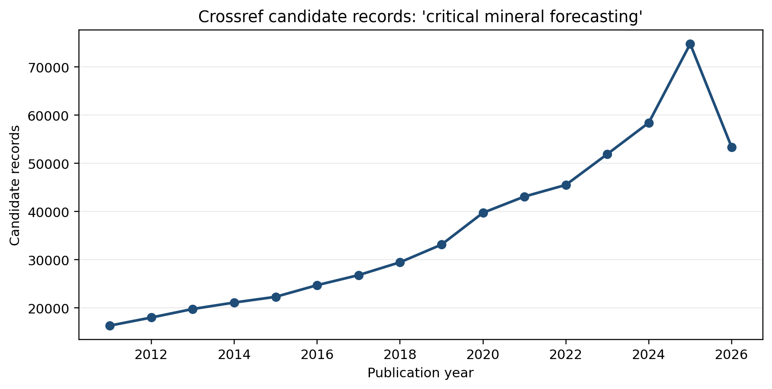
The methodological reference integrates VMD, LASSO-selected multimodal inputs, ARIMA/LSTM forecasting, and trading analysis. This study retains the broad modelling motivation but changes the target to listed critical-mineral companies and, crucially, uses train-only decomposition and one-step walk-forward evaluation.

3. Methodology
Figure 2. Conceptual structure of the LSTM cell used as one candidate forecaster.
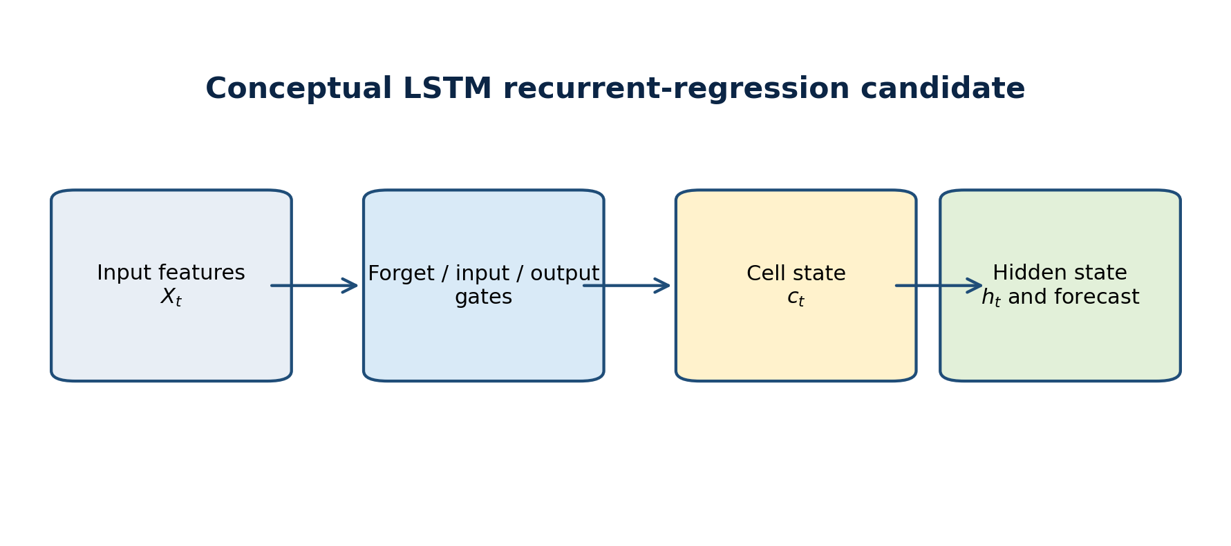
Figure 3. Causal one-step framework. Every operation at a forecast origin has access only to information available before the target close.
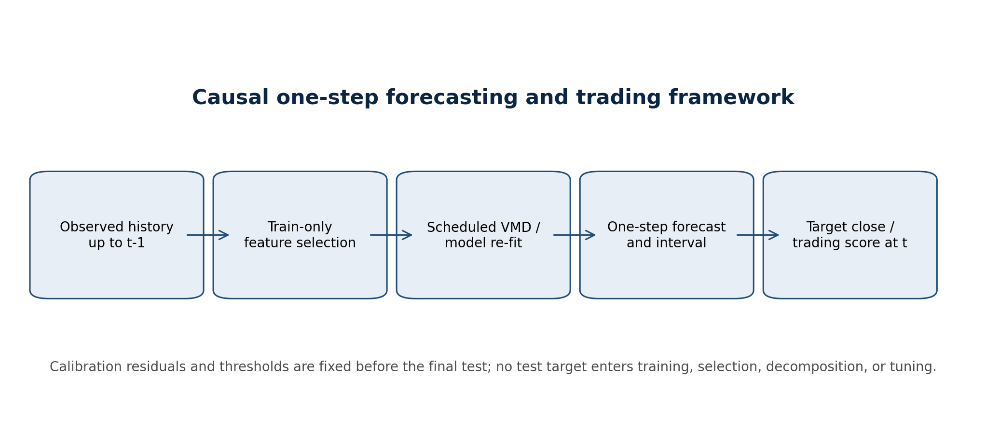
Table 2. Actual parameter settings used in the causal empirical run.
Parameter | Value | Role
Forecast horizon | 1 | One trading day
Final-test share | 0.2 | Chronological final holdout
Calibration observations | 60 | Pre-test residual and threshold calibration
Model refit interval | 20 | Trading observations
VMD components | 5 | Train-only VMD at scheduled refits
VMD alpha | 2000 | VMD penalty parameter
RNN epochs | 5 | LSTM/GRU candidate fitting
Conformal alpha | 0.1 | Two-sided interval nominal error
Run identifier | run_20260813T090457Z | Provenance registry

Table 3. Predictors used in the causal multimodal feature frame.
Variable | Construct | Feature Group | Availability Treatment
mvis_critical_minerals | MVIS Global Rare Earth / Strategic Metals index | Sector benchmark | Lagged one trading day before use
SP500 | S&P 500 | Global equity-market condition | Lagged one trading day before use
Shanghai_Index | Shanghai Composite | China equity-market condition | Lagged one trading day before use
Crude_Oil | Crude-oil futures close | Energy-market condition | Lagged one trading day before use
VIX | CBOE VIX | Market uncertainty | Lagged one trading day before use
US_Dollar_Index | US Dollar Index | Foreign-exchange condition | Lagged one trading day before use
Search_Index | Google Trends: rare earth | Public attention | Lagged one trading day before use
News_Sentiment | SF Fed news-sentiment index | News sentiment | Lagged one trading day before use

For each target date t, the feature frame uses lagged target information and exogenous values available by t-1. Parameters and full decompositions are re-estimated only at the configured refit cadence. Between those dates, the decomposition state is advanced causally with newly observed history. The final 20% is reserved as a chronological test period, while the preceding calibration segment supports residual-based intervals and threshold selection only.

4. Data and exploratory evidence
Table 4. Descriptive statistics for the eight company closing-price series.
Company | Observations | Start | End | Mean Close | Std. Dev. | Minimum | Maximum
Glencore | 3751 | 2011-05-19 | 2026-03-20 | 4.4396 | 1.3938 | 0.9700 | 8.3200
BHP Group | 3751 | 2011-05-19 | 2026-03-20 | 24.3711 | 6.0505 | 8.3780 | 42.0140
Rio Tinto | 3751 | 2011-05-19 | 2026-03-20 | 62.0266 | 17.4373 | 24.0260 | 120.1500
Freeport-McMoRan | 3751 | 2011-05-19 | 2026-03-20 | 28.3982 | 13.7271 | 3.7400 | 68.8200
Albemarle | 3751 | 2011-05-19 | 2026-03-20 | 106.6836 | 60.6907 | 39.0000 | 325.3800
Zijin Mining | 3751 | 2011-05-19 | 2026-03-20 | 0.9325 | 0.9747 | 0.1770 | 5.9120
Ganfeng Lithium | 3751 | 2011-05-19 | 2026-03-20 | 4.7968 | 4.7225 | 0.3090 | 24.3240
Anglo American | 3751 | 2011-05-19 | 2026-03-20 | 26.0021 | 9.9571 | 2.9800 | 53.4200

Figure 4. Normalized closing-price paths for the eight critical-mineral equities.
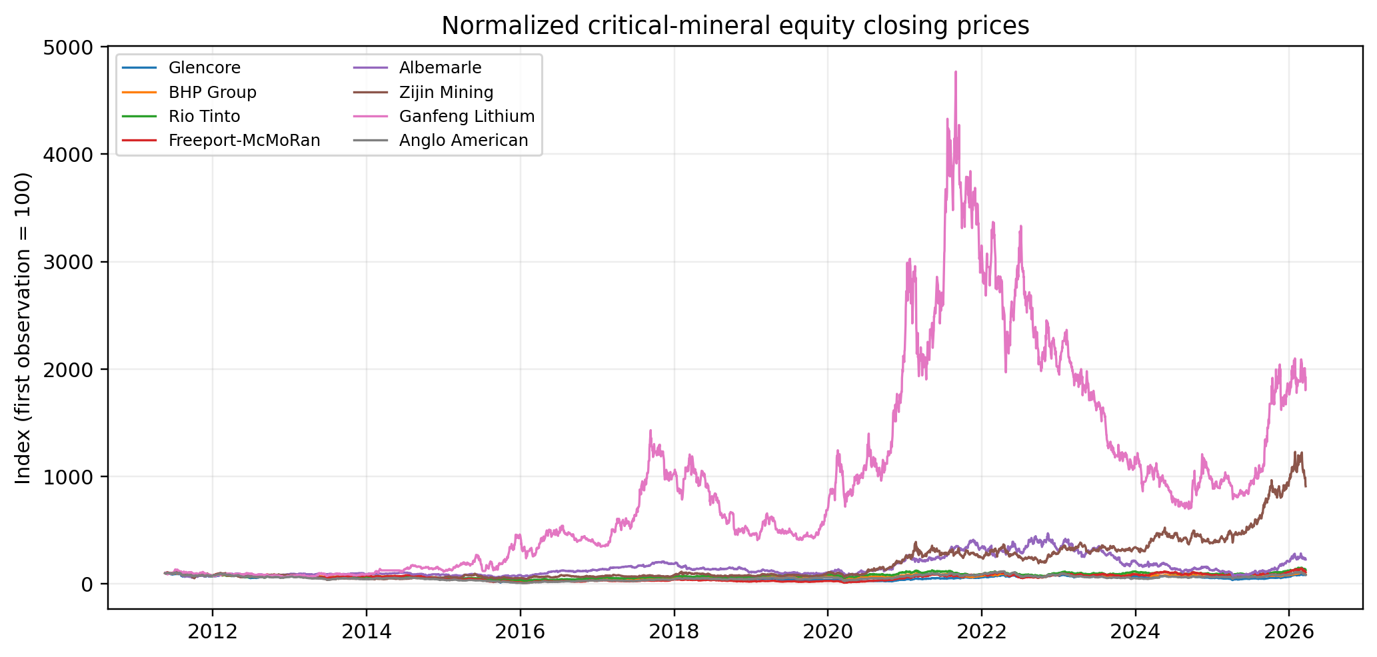
Figure 5. Word cloud of predictors repeatedly selected by the causal ARX procedure; it is not a raw-news-headline word cloud.
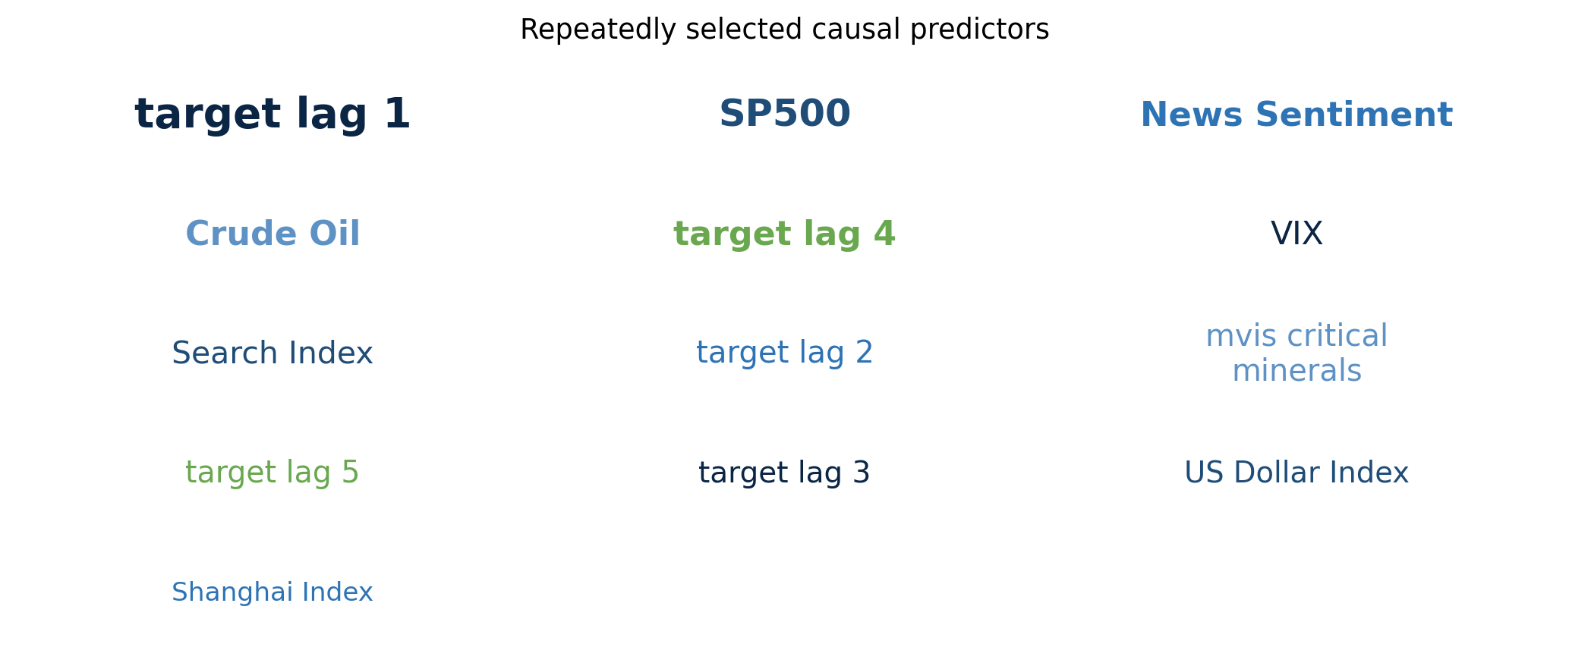
Figure 6. SF Fed news-sentiment index during the sample and its empirical distribution.
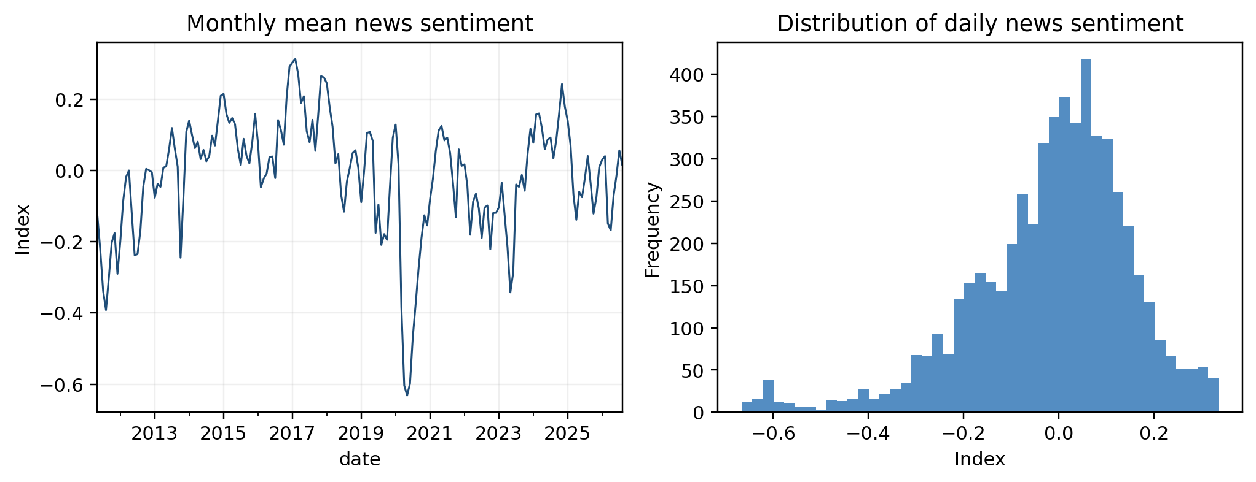

5. Decomposition and causal feature selection
Figure 7. Illustrative VMD components fitted only to Glencore's pre-test training segment; the display is not a full-sample decomposition.
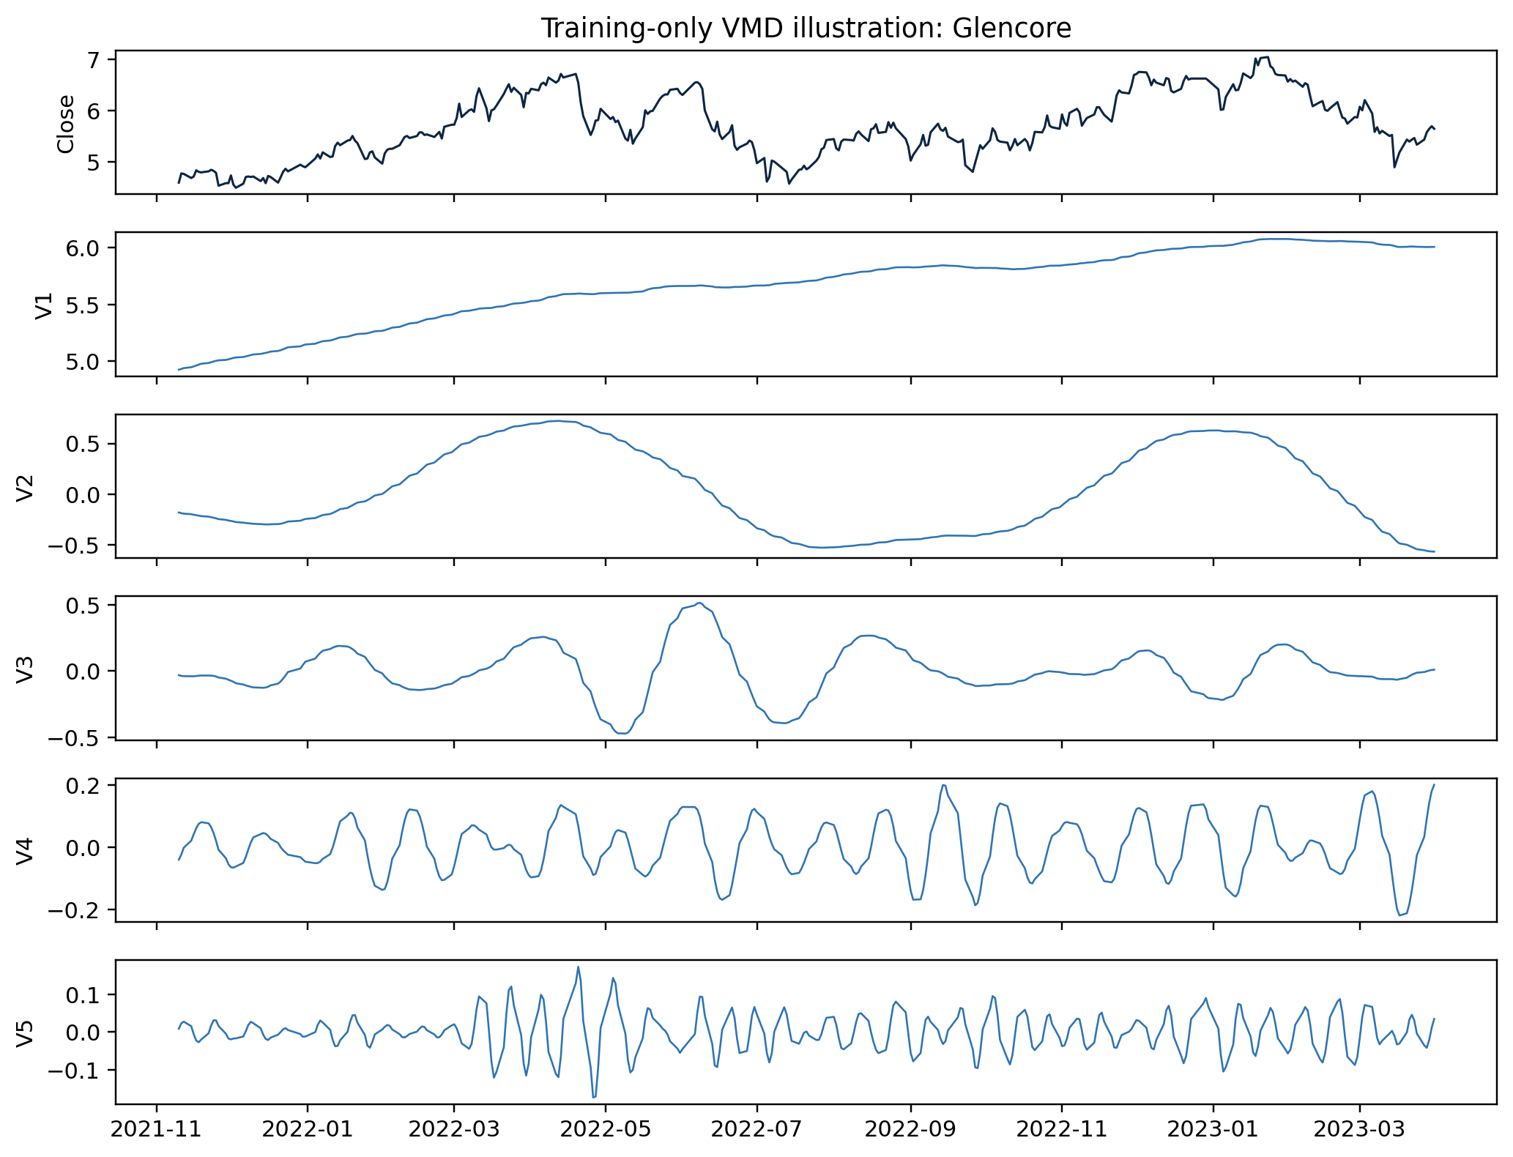
Figure 8. Approximate-entropy values for the Figure 7 training-only VMD components.
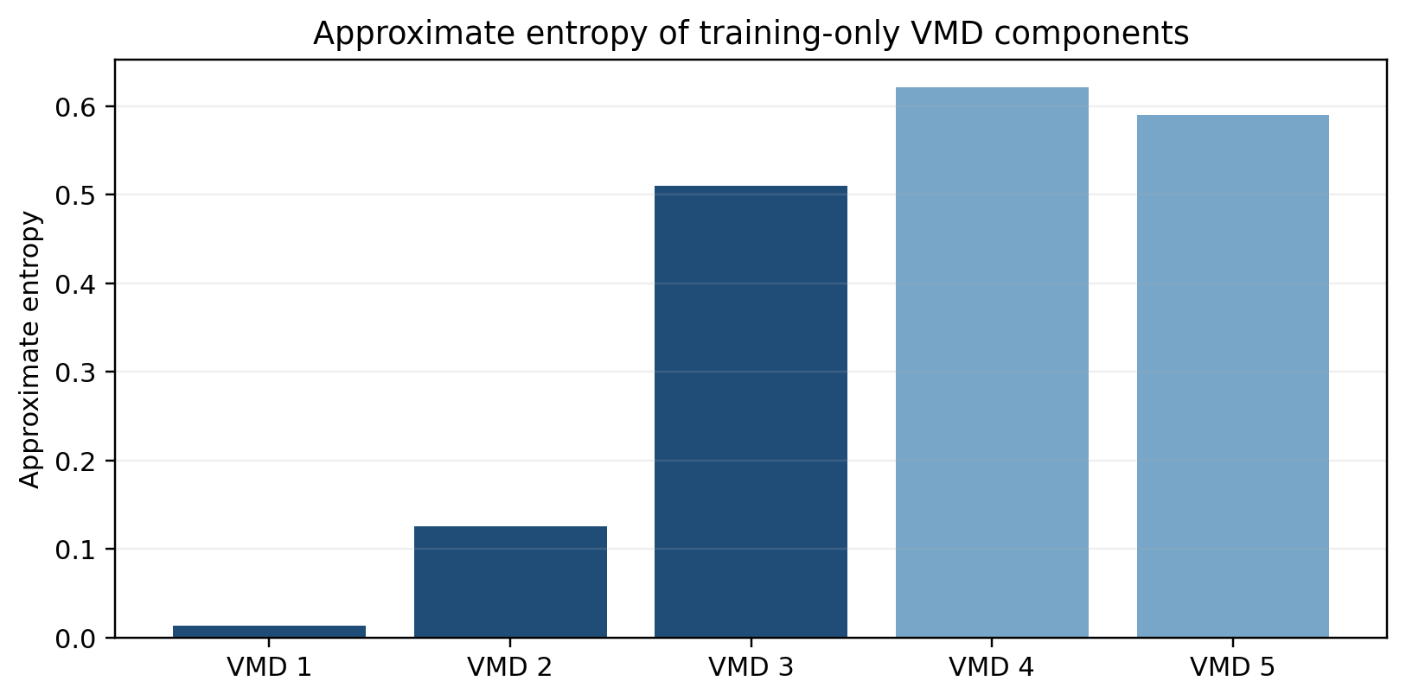
Table 5. Descriptive characteristics of training-only Glencore VMD components.
Mode | Variance Share (%) | Average Peak Period (obs.) | Approximate Entropy | Illustrative Route | Training Observations
VMD 1 | 86.3399 | 55.5556 | 0.0132 | LASSO-ARX | 3000
VMD 2 | 5.5077 | 75.0000 | 0.1259 | LASSO-ARX | 3000
VMD 3 | 0.7103 | 36.5854 | 0.5095 | LASSO-ARX | 3000
VMD 4 | 0.2096 | 17.3410 | 0.6213 | LSTM | 3000
VMD 5 | 0.0803 | 8.9820 | 0.5904 | LSTM | 3000

Table 6. Most frequently selected ARX predictors across scheduled causal refits.
Company | Feature | Selection Count | Selection Rate (%)
Albemarle | News_Sentiment | 41 | 100.0000
Albemarle | target_lag_1 | 41 | 100.0000
Albemarle | SP500 | 29 | 70.7317
Albemarle | target_lag_5 | 24 | 58.5366
Albemarle | VIX | 14 | 34.1463
Anglo American | target_lag_1 | 41 | 100.0000
Anglo American | SP500 | 7 | 17.0732
BHP Group | News_Sentiment | 41 | 100.0000
BHP Group | target_lag_1 | 41 | 100.0000
BHP Group | SP500 | 30 | 73.1707
BHP Group | Crude_Oil | 29 | 70.7317
BHP Group | Search_Index | 1 | 2.4390
Freeport-McMoRan | target_lag_1 | 41 | 100.0000
Freeport-McMoRan | VIX | 18 | 43.9024
Freeport-McMoRan | SP500 | 17 | 41.4634
Freeport-McMoRan | News_Sentiment | 15 | 36.5854
Freeport-McMoRan | Shanghai_Index | 12 | 29.2683
Ganfeng Lithium | Crude_Oil | 41 | 100.0000
Ganfeng Lithium | SP500 | 41 | 100.0000
Ganfeng Lithium | US_Dollar_Index | 41 | 100.0000
Ganfeng Lithium | VIX | 41 | 100.0000
Ganfeng Lithium | target_lag_1 | 41 | 100.0000
Glencore | Crude_Oil | 41 | 100.0000
Glencore | target_lag_1 | 41 | 100.0000
Glencore | target_lag_4 | 41 | 100.0000
Glencore | target_lag_5 | 39 | 95.1220
Glencore | target_lag_3 | 15 | 36.5854
Rio Tinto | target_lag_1 | 41 | 100.0000
Rio Tinto | SP500 | 40 | 97.5610
Zijin Mining | SP500 | 41 | 100.0000
Zijin Mining | target_lag_1 | 41 | 100.0000
Zijin Mining | target_lag_4 | 40 | 97.5610
Zijin Mining | Search_Index | 36 | 87.8049
Zijin Mining | target_lag_2 | 29 | 70.7317

The decomposition display is descriptive. The actual forecasting pipeline repeats train-only decomposition at scheduled origins, so no component shown or fitted in the final test is derived from later test observations. Feature-selection rates summarize the causal selections recorded across model refits.

6. Forecasting results
Figure 9. Illustrative final-test forecasts for Glencore using single-model candidates.
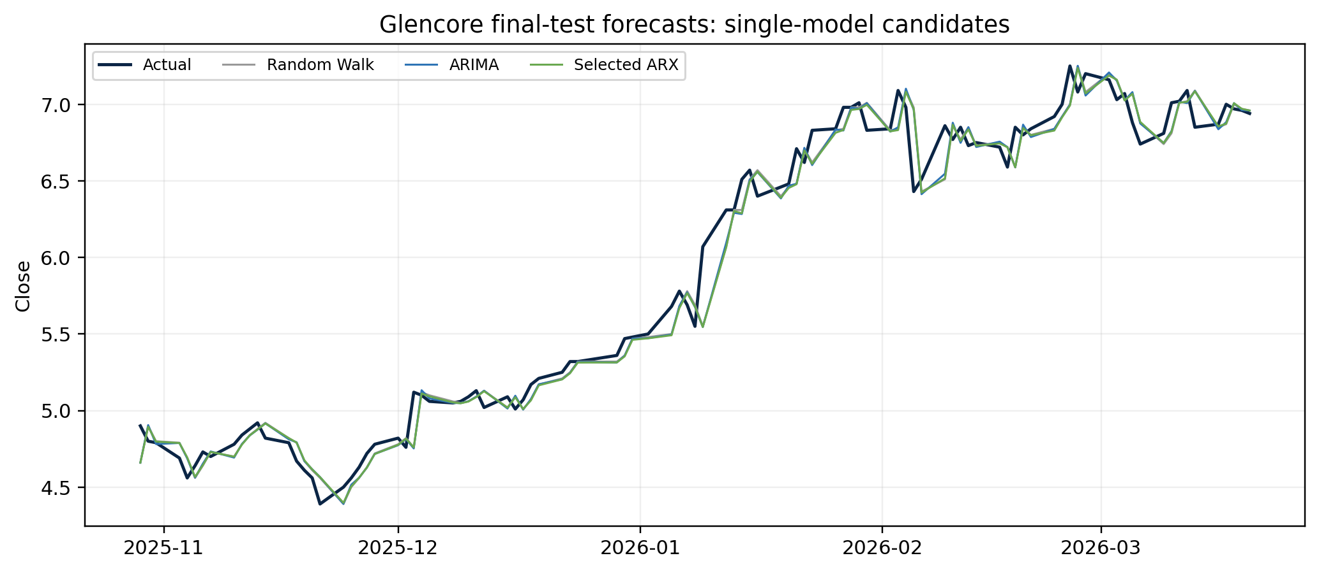
Figure 10. Cross-company mean final-test RMSE by model, normalized to the random-walk mean RMSE.
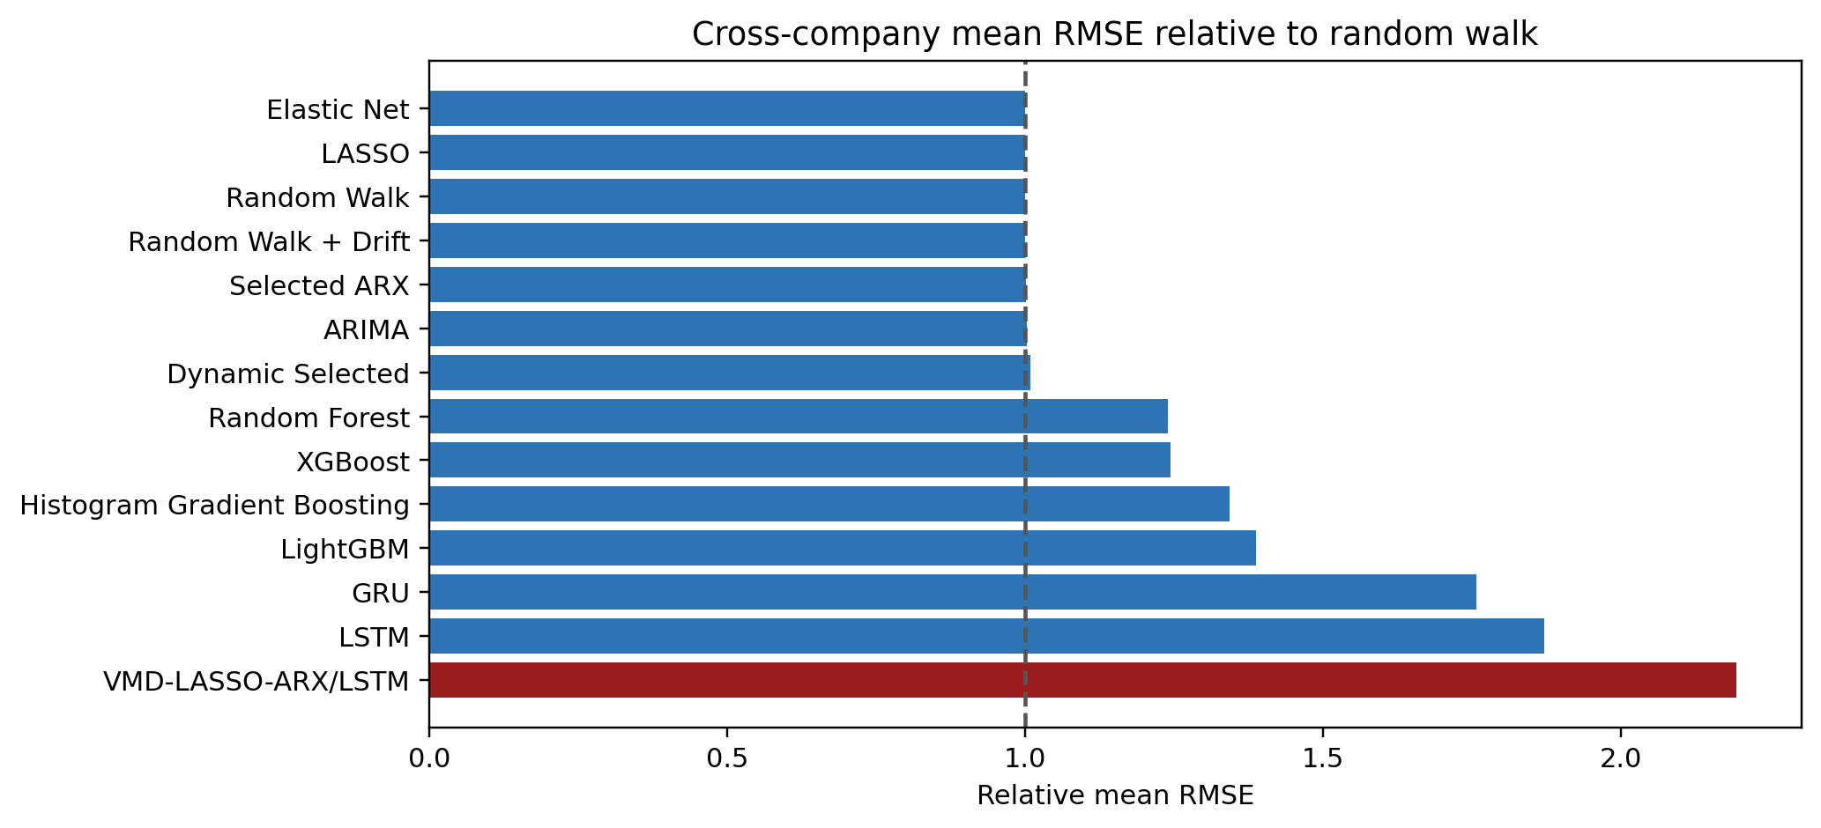
Table 7. Final-test forecasting errors for single-model candidates, averaged across companies.
Model | RMSE | MAE | MASE | MAPE | Directional Accuracy | Within-Company RMSE Rank
Elastic Net | 1.0511 | 0.7643 | 1.0016 | 1.7864 | 48.6983 | 3.3750
LASSO | 1.0511 | 0.7643 | 1.0016 | 1.7864 | 48.6983 | 3.3750
Random Walk | 1.0515 | 0.7638 | 0.9998 | 1.7842 | 48.3812 | 2.6250
Random Walk + Drift | 1.0517 | 0.7640 | 1.0004 | 1.7853 | 48.3812 | 3.3750
Selected ARX | 1.0530 | 0.7667 | 1.0058 | 1.7973 | 48.7316 | 3.8750
ARIMA | 1.0546 | 0.7663 | 1.0039 | 1.7934 | 48.8985 | 4.3750
Random Forest | 1.3040 | 0.8994 | 1.2995 | 2.2270 | 47.7470 | 7.6250
XGBoost | 1.3088 | 0.8895 | 1.3277 | 2.2629 | 47.4299 | 7.6250
Histogram Gradient Boosting | 1.4122 | 0.9345 | 1.4204 | 2.3794 | 46.1949 | 9.0000
LightGBM | 1.4583 | 0.9776 | 1.4618 | 2.4620 | 46.8625 | 9.7500
GRU | 1.8478 | 1.2998 | 1.9724 | 3.3649 | 48.5814 | 11.1250
LSTM | 1.9668 | 1.4380 | 2.1202 | 3.6343 | 48.3812 | 11.8750

Table 8. Final-test forecasting errors for decomposition-based candidates, averaged across companies.
Model | RMSE | MAE | MASE | MAPE | Directional Accuracy | Within-Company RMSE Rank
VMD-LASSO-ARX/LSTM | 2.3069 | 1.7193 | 2.2436 | 4.1221 | 49.2323 | 1.8750
VMD-GRU | 2.4562 | 1.7335 | 2.3576 | 4.0713 | 48.8151 | 2.1250
VMD-LSTM | 2.4970 | 1.7437 | 2.3336 | 4.0384 | 48.5314 | 2.6250
CEEMDAN-LSTM | 2.7155 | 2.0606 | 2.7779 | 4.9089 | 49.3324 | 3.3750

Table 9. Diebold-Mariano comparisons of the proposed model with each benchmark across companies.
Benchmark | Companies | Proposed Better (5%) | Proposed Worse (5%) | Median DM Statistic | Median p-value
CEEMDAN-LSTM | 8 | 5 | 0 | -3.8103 | 0.0007
VMD-GRU | 8 | 4 | 2 | -1.9615 | 0.0000
VMD-LSTM | 8 | 4 | 2 | -2.3975 | 0.0002
LSTM | 8 | 3 | 3 | 1.1270 | 0.0000
GRU | 8 | 3 | 5 | 5.2927 | 0.0000
Histogram Gradient Boosting | 8 | 1 | 5 | 5.3921 | 0.0000
LightGBM | 8 | 1 | 5 | 5.1790 | 0.0000
Random Forest | 8 | 0 | 5 | 5.9495 | 0.0000
XGBoost | 8 | 0 | 5 | 5.5980 | 0.0000
ARIMA | 8 | 0 | 8 | 10.8244 | 0.0000
Dynamic Selected | 8 | 0 | 8 | 10.7573 | 0.0000
Elastic Net | 8 | 0 | 8 | 10.8011 | 0.0000
LASSO | 8 | 0 | 8 | 10.8011 | 0.0000
Random Walk | 8 | 0 | 8 | 10.8147 | 0.0000
Random Walk + Drift | 8 | 0 | 8 | 10.8122 | 0.0000
Selected ARX | 8 | 0 | 8 | 10.8251 | 0.0000

The cross-company mean RMSEs are 1.0515 for the random walk, 1.0546 for ARIMA, and 2.3069 for the proposed decomposition architecture. These averages are descriptive across heterogeneous price scales; the within-company rankings and the company-level DM results should therefore be read alongside them. A negative DM statistic favours the proposed model because the loss difference is defined as proposed squared loss minus benchmark squared loss.

7. Interval forecasts and trading evaluation
Figure 11. Illustrative conformal interval forecasts for the proposed causal model on Glencore's final test set.
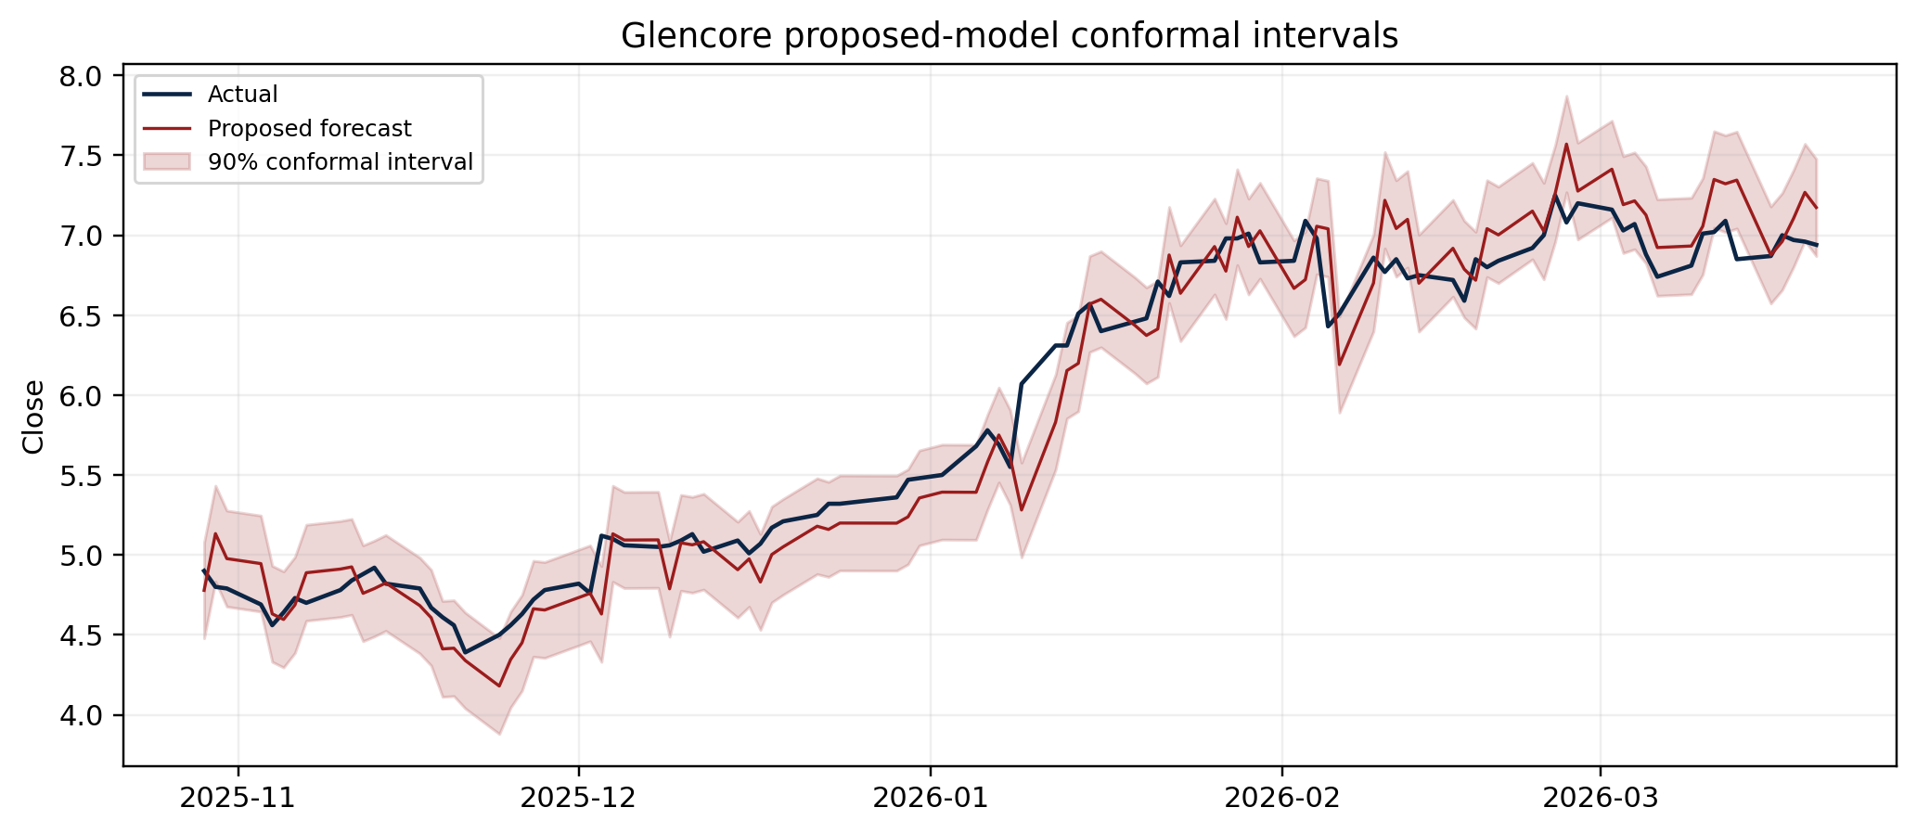
Figure 12. Timing of the causal one-step trading evaluation.
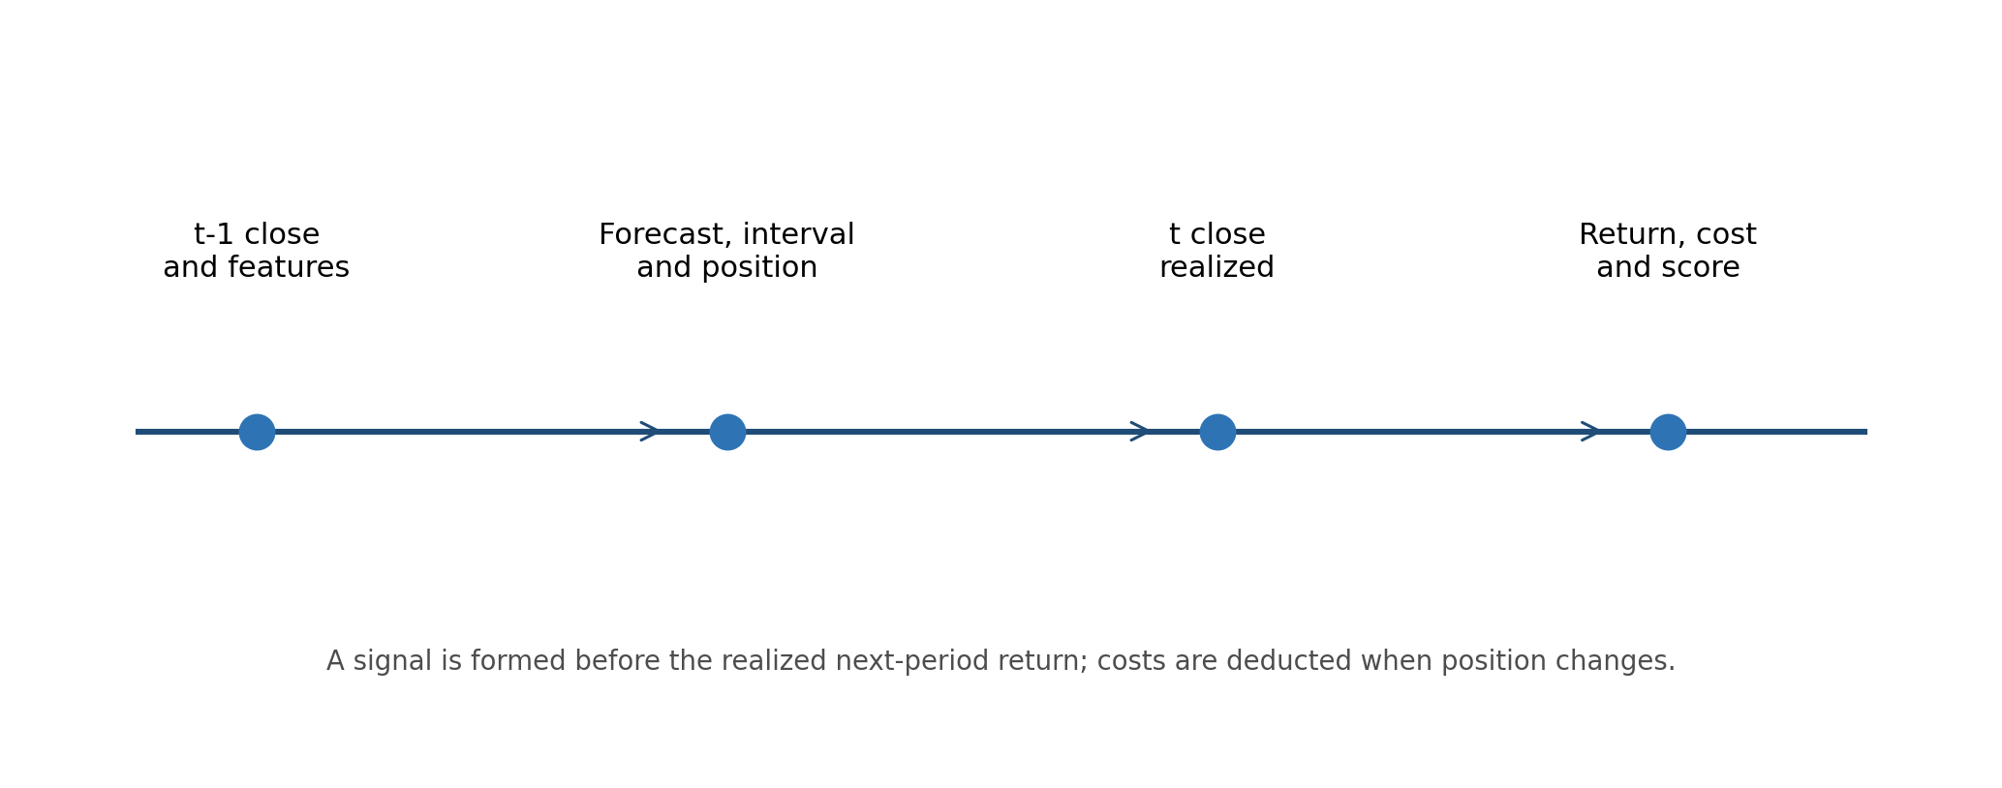
Figure 13. Cross-company mean Sharpe ratios for directional strategies at 10 bp transaction costs.
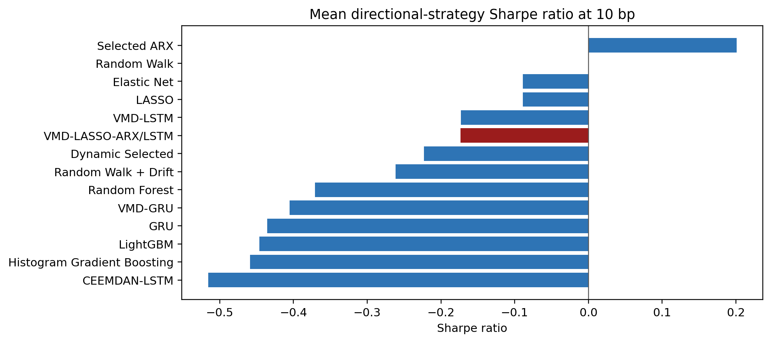
Table 10. Final-test conformal interval quality, averaged across companies.
Model | Coverage (%) | Avg Width | Sharpness | Calibration Error | Winkler
Elastic Net | 89.0667 | 3.8041 | 3.8041 | 3.1667 | 4.8908
LASSO | 89.0667 | 3.8041 | 3.8041 | 3.1667 | 4.8908
Random Walk | 89.0500 | 3.8020 | 3.8020 | 3.2833 | 4.8917
Random Walk + Drift | 88.9500 | 3.8018 | 3.8018 | 3.1833 | 4.8921
Selected ARX | 89.1167 | 3.8136 | 3.8136 | 3.2500 | 4.8940
ARIMA | 88.9000 | 3.8220 | 3.8220 | 3.1667 | 4.9164
Dynamic Selected | 88.8333 | 3.8492 | 3.8492 | 3.2000 | 4.9589
Random Forest | 88.3500 | 4.0557 | 4.0557 | 4.2500 | 6.1574
XGBoost | 88.4667 | 3.9899 | 3.9899 | 3.9667 | 6.2232
Histogram Gradient Boosting | 88.4167 | 4.1120 | 4.1120 | 4.3500 | 6.8129
LightGBM | 89.4167 | 4.4620 | 4.4620 | 4.4833 | 7.0132
GRU | 88.6167 | 6.2564 | 6.2564 | 5.2833 | 8.9122
LSTM | 89.1333 | 6.8449 | 6.8449 | 5.0000 | 9.3294
VMD-LASSO-ARX/LSTM | 89.4333 | 8.7203 | 8.7203 | 2.9667 | 10.7620
VMD-GRU | 88.8000 | 8.7415 | 8.7415 | 4.5000 | 11.7141
VMD-LSTM | 88.4667 | 8.3963 | 8.3963 | 3.5333 | 11.9498
CEEMDAN-LSTM | 89.5500 | 10.7160 | 10.7160 | 3.2167 | 12.7943

Trading results are evaluated at zero, 10, 25, and 50 basis points. Signals are formed at the stored forecast origin and executed against the next realized return; the uncertainty-adjusted version may abstain when the conformal interval is too wide. Thresholds are selected on calibration observations before the final test.

7.1 Trading-performance schedules
Table 11. Trading performance of decomposition-model forecasts under calibrated strategies, averaged across companies.
Model | Strategy | Cost | Annualized Return | Sharpe | Sortino | Calmar | Max Drawdown (%) | Turnover | Hit Rate (%) | Final Equity
CEEMDAN-LSTM | Directional (no uncertainty) | 0.0000 | -0.1601 | -0.3351 | -0.4390 | -0.2334 | -61.1963 | 0.2593 | 48.1500 | 0.6580
CEEMDAN-LSTM | Directional (no uncertainty) | 0.0010 | -0.2140 | -0.5158 | -0.6822 | -0.3052 | -65.6450 | 0.2593 | 48.1500 | 0.5379
CEEMDAN-LSTM | Directional (no uncertainty) | 0.0025 | -0.2884 | -0.7842 | -1.0351 | -0.3892 | -71.8761 | 0.2593 | 48.1500 | 0.3977
CEEMDAN-LSTM | Directional (no uncertainty) | 0.0050 | -0.3973 | -1.2196 | -1.5869 | -0.4860 | -80.7271 | 0.2593 | 48.1500 | 0.2405
CEEMDAN-LSTM | Uncertainty-adjusted | 0.0000 | -0.0667 | -0.0759 | -0.0965 | -0.1088 | -40.4382 | 0.1700 | 25.2000 | 0.8356
CEEMDAN-LSTM | Uncertainty-adjusted | 0.0010 | -0.1043 | -0.2386 | -0.3254 | -0.1849 | -43.7836 | 0.1700 | 25.2000 | 0.7468
CEEMDAN-LSTM | Uncertainty-adjusted | 0.0025 | -0.1571 | -0.4814 | -0.6596 | -0.2739 | -48.3809 | 0.1700 | 25.2000 | 0.6359
CEEMDAN-LSTM | Uncertainty-adjusted | 0.0050 | -0.2368 | -0.8797 | -1.1868 | -0.3665 | -56.8746 | 0.1700 | 25.2000 | 0.4962
VMD-GRU | Directional (no uncertainty) | 0.0000 | -0.1326 | -0.1922 | -0.2535 | -0.1677 | -58.2151 | 0.3050 | 47.8667 | 0.7252
VMD-GRU | Directional (no uncertainty) | 0.0010 | -0.1982 | -0.4055 | -0.5504 | -0.2756 | -62.9734 | 0.3050 | 47.8667 | 0.5698
VMD-GRU | Directional (no uncertainty) | 0.0025 | -0.2874 | -0.7224 | -0.9783 | -0.3905 | -69.7950 | 0.3050 | 47.8667 | 0.3972
VMD-GRU | Directional (no uncertainty) | 0.0050 | -0.4144 | -1.2366 | -1.6386 | -0.5003 | -81.6965 | 0.3050 | 47.8667 | 0.2186
VMD-GRU | Uncertainty-adjusted | 0.0000 | -0.0449 | -0.1136 | -0.1421 | -0.0825 | -39.5258 | 0.2105 | 28.6833 | 0.9089
VMD-GRU | Uncertainty-adjusted | 0.0010 | -0.0947 | -0.3030 | -0.4069 | -0.1824 | -43.5603 | 0.2105 | 28.6833 | 0.7729
VMD-GRU | Uncertainty-adjusted | 0.0025 | -0.1628 | -0.5840 | -0.7874 | -0.2868 | -49.7030 | 0.2105 | 28.6833 | 0.6187
VMD-GRU | Uncertainty-adjusted | 0.0050 | -0.2607 | -1.0383 | -1.3708 | -0.3852 | -60.7735 | 0.2105 | 28.6833 | 0.4515
VMD-LASSO-ARX/LSTM | Directional (no uncertainty) | 0.0000 | 0.0622 | 0.3808 | 0.6031 | 0.4096 | -55.0825 | 0.8363 | 49.6333 | 1.4747
VMD-LASSO-ARX/LSTM | Directional (no uncertainty) | 0.0010 | -0.1338 | -0.1735 | -0.1988 | -0.1056 | -62.6002 | 0.8363 | 49.6333 | 0.8064
VMD-LASSO-ARX/LSTM | Directional (no uncertainty) | 0.0025 | -0.3548 | -0.9984 | -1.3051 | -0.4283 | -76.8885 | 0.8363 | 49.6333 | 0.3572
VMD-LASSO-ARX/LSTM | Directional (no uncertainty) | 0.0050 | -0.5927 | -2.3311 | -2.8916 | -0.6380 | -90.9226 | 0.8363 | 49.6333 | 0.1141
VMD-LASSO-ARX/LSTM | Uncertainty-adjusted | 0.0000 | 0.0633 | 0.3751 | 0.5937 | 0.2790 | -30.4364 | 0.3645 | 15.6000 | 1.2476
VMD-LASSO-ARX/LSTM | Uncertainty-adjusted | 0.0010 | -0.0327 | -0.0608 | -0.0551 | -0.0611 | -35.4141 | 0.3645 | 15.6000 | 0.9271
VMD-LASSO-ARX/LSTM | Uncertainty-adjusted | 0.0025 | -0.1529 | -0.7113 | -0.9452 | -0.2938 | -47.5981 | 0.3645 | 15.6000 | 0.6403
VMD-LASSO-ARX/LSTM | Uncertainty-adjusted | 0.0050 | -0.3067 | -1.7632 | -2.2054 | -0.4551 | -63.1072 | 0.3645 | 15.6000 | 0.3913
VMD-LSTM | Directional (no uncertainty) | 0.0000 | -0.0374 | 0.0601 | 0.1072 | 0.0050 | -53.6651 | 0.3373 | 48.5167 | 0.9988
VMD-LSTM | Directional (no uncertainty) | 0.0010 | -0.1160 | -0.1732 | -0.2239 | -0.1461 | -56.9954 | 0.3373 | 48.5167 | 0.7740
VMD-LSTM | Directional (no uncertainty) | 0.0025 | -0.2222 | -0.5204 | -0.7020 | -0.2988 | -64.9119 | 0.3373 | 48.5167 | 0.5282
VMD-LSTM | Directional (no uncertainty) | 0.0050 | -0.3717 | -1.0848 | -1.4419 | -0.4641 | -77.1904 | 0.3373 | 48.5167 | 0.2798
VMD-LSTM | Uncertainty-adjusted | 0.0000 | -0.0180 | 0.0715 | 0.1203 | 0.0483 | -34.2806 | 0.1608 | 16.9833 | 0.9771
VMD-LSTM | Uncertainty-adjusted | 0.0010 | -0.0557 | -0.0982 | -0.1224 | -0.0557 | -36.6664 | 0.1608 | 16.9833 | 0.8749
VMD-LSTM | Uncertainty-adjusted | 0.0025 | -0.1087 | -0.3518 | -0.4766 | -0.1880 | -40.0465 | 0.1608 | 16.9833 | 0.7471
VMD-LSTM | Uncertainty-adjusted | 0.0050 | -0.1886 | -0.7684 | -1.0347 | -0.3451 | -47.5091 | 0.1608 | 16.9833 | 0.5857

Table 12. Trading performance of single-model forecasts under calibrated strategies at 10 bp, averaged across companies. All cost schedules are provided in the appendix ledger.
Model | Strategy | Cost | Annualized Return | Sharpe | Sortino | Calmar | Max Drawdown (%) | Turnover | Hit Rate (%) | Final Equity
ARIMA | Directional (no uncertainty) | 0.0010 | -0.2688 | -0.6540 | -0.8569 | -0.2645 | -69.1693 | 1.0697 | 48.6000 | 0.5125
ARIMA | Uncertainty-adjusted | 0.0010 | 0.0280 | 0.2332 | 0.4001 | 0.3691 | -15.7382 | 0.2125 | 10.2667 | 1.1008
Elastic Net | Directional (no uncertainty) | 0.0010 | -0.0626 | -0.0891 | -0.1062 | -0.0797 | -58.7708 | 0.1953 | 48.8667 | 0.9370
Elastic Net | Uncertainty-adjusted | 0.0010 | -0.1028 | -0.1729 | -0.2334 | -0.1283 | -47.6068 | 0.1312 | 37.3833 | 0.7612
GRU | Directional (no uncertainty) | 0.0010 | -0.1987 | -0.4356 | -0.6003 | -0.3009 | -65.2752 | 0.4367 | 47.7500 | 0.5255
GRU | Uncertainty-adjusted | 0.0010 | -0.0151 | 0.0284 | 0.2204 | 0.1160 | -22.0719 | 0.0638 | 5.4500 | 0.9769
Histogram Gradient Boosting | Directional (no uncertainty) | 0.0010 | -0.2042 | -0.4588 | -0.6262 | -0.3011 | -66.6503 | 0.7517 | 48.4833 | 0.5340
Histogram Gradient Boosting | Uncertainty-adjusted | 0.0010 | -0.0804 | -0.1807 | -0.1084 | 0.0289 | -31.6045 | 0.1958 | 10.0333 | 0.8112
LASSO | Directional (no uncertainty) | 0.0010 | -0.0626 | -0.0891 | -0.1062 | -0.0797 | -58.7708 | 0.1953 | 48.8667 | 0.9370
LASSO | Uncertainty-adjusted | 0.0010 | -0.1028 | -0.1729 | -0.2334 | -0.1283 | -47.6068 | 0.1312 | 37.3833 | 0.7612
LSTM | Directional (no uncertainty) | 0.0010 | -0.2371 | -0.6201 | -0.8290 | -0.3279 | -66.0140 | 0.3730 | 47.4333 | 0.4880
LSTM | Uncertainty-adjusted | 0.0010 | -0.0667 | -0.1747 | -0.1958 | -0.0201 | -30.9325 | 0.1272 | 12.1000 | 0.8708
LightGBM | Directional (no uncertainty) | 0.0010 | -0.1871 | -0.4465 | -0.5942 | -0.2609 | -62.3326 | 0.7303 | 48.3667 | 0.5901
LightGBM | Uncertainty-adjusted | 0.0010 | -0.0394 | -0.1001 | -0.1029 | -0.0528 | -29.5731 | 0.2835 | 16.8333 | 0.9086
Random Forest | Directional (no uncertainty) | 0.0010 | -0.1624 | -0.3711 | -0.4901 | -0.2318 | -62.9743 | 0.7467 | 48.2833 | 0.6467
Random Forest | Uncertainty-adjusted | 0.0010 | -0.0453 | -0.1443 | -0.1736 | -0.0918 | -35.4691 | 0.3868 | 21.5667 | 0.8882
Random Walk | Directional (no uncertainty) | 0.0010 | 0.0000 | 0.0000 | 0.0000 |  | 0.0000 | 0.0000 | 0.0000 | 1.0000
Random Walk | Uncertainty-adjusted | 0.0010 | 0.0000 | 0.0000 | 0.0000 |  | 0.0000 | 0.0000 | 0.0000 | 1.0000
Random Walk + Drift | Directional (no uncertainty) | 0.0010 | -0.1286 | -0.2615 | -0.3372 | -0.0892 | -63.8649 | 0.0073 | 47.6333 | 0.8018
Random Walk + Drift | Uncertainty-adjusted | 0.0010 | -0.1042 | -0.2014 | -0.2648 | -0.0647 | -48.2209 | 0.0043 | 36.1833 | 0.8608
Selected ARX | Directional (no uncertainty) | 0.0010 | 0.0051 | 0.2009 | 0.3058 | 0.1122 | -49.4064 | 0.1457 | 49.0167 | 1.1048
Selected ARX | Uncertainty-adjusted | 0.0010 | 0.0078 | 0.2552 | 0.4220 | 0.2149 | -45.0981 | 0.1185 | 43.7333 | 1.1148
XGBoost | Directional (no uncertainty) | 0.0010 | -0.2470 | -0.6589 | -0.8631 | -0.3265 | -66.0514 | 0.7387 | 48.1500 | 0.4994
XGBoost | Uncertainty-adjusted | 0.0010 | -0.0626 | -0.0670 | -0.0321 | -0.0231 | -30.8114 | 0.3102 | 18.1000 | 0.8720

8. Discussion and limitations
The empirical record does not support a blanket conclusion that a complex decomposed neural architecture dominates simple forecasts. Performance differs by company and metric, while transaction costs can materially change the attractiveness of a directional strategy. This is why the report retains random walk and ARIMA benchmarks, reports intervals and DM comparisons, and discloses factor-adjusted trading estimates in the companion ledger.
The analysis uses closing prices and daily proxy variables. It does not model tradability, market impact, borrow constraints, asynchronous disclosures, or company-specific corporate actions beyond the supplied price histories. Factor coverage is also frequency-dependent for emerging-market assets. These are limitations, not evidence of zero risk.

9. Conclusion
This paper provides a fully traceable causal framework for evaluating multimodal critical-mineral equity forecasts. Its value is the integrity of the timing, model comparison, interval evaluation, and cost-aware trading analysis. The attached ledgers preserve the complete company/model metrics needed to reproduce or challenge each summary result.

References
Diebold, F.X. and Mariano, R.S. (1995). Comparing predictive accuracy. Journal of Business & Economic Statistics, 13(3), 253-263.
Dragomiretskiy, K. and Zosso, D. (2014). Variational mode decomposition. IEEE Transactions on Signal Processing, 62(3), 531-544.
Hochreiter, S. and Schmidhuber, J. (1997). Long short-term memory. Neural Computation, 9(8), 1735-1780.
Liu, S., Li, M., Yang, K., Wei, Y. and Wang, S. (2025). From forecasting to trading: A multimodal-data-driven approach to reversing carbon market losses. Energy Economics, 144, 108350. https://doi.org/10.1016/j.eneco.2025.108350.
Tibshirani, R. (1996). Regression shrinkage and selection via the lasso. Journal of the Royal Statistical Society: Series B, 58(1), 267-288.
Data sources: project-provided price and MVIS workbooks; Yahoo Finance macro closes; Google Trends; Federal Reserve Bank of San Francisco news sentiment; and regional Fama-French factor files. Exact URLs, retrieval times, and SHA-256 checksums are in the canonical run registry.

Appendix: complete empirical ledgers and reproducibility
The companion appendix_ledgers directory contains the full, unaggregated final-test forecast metrics, interval metrics, DM comparisons, trading metrics for every company/model/strategy/cost combination, and feature-selection records. The asset manifest records the causal run identifier, input checksums, figure/table captions, and the versioned Crossref search snapshot used in Figure 1.
The released-paper shadow output is intentionally absent from these ledgers and from the reported findings because it is a noncausal forensic reconstruction rather than a valid forecast evaluation.

