RESEARCH MANUSCRIPT
From Multimodal Signals to Lithium-Price Forecasting and Trading
A Liu-structured retrospective replication for lithium hydroxide and lithium carbonate
Pratham Lahoti
Empirical run: lithium_paper_20260817T102754Z
Prepared: 2026-08-17
Protocol disclosure: this manuscript intentionally reproduces the reference study's static, full-sample decomposition style. It is retrospective and noncausal; results must not be interpreted as live out-of-sample performance.

Abstract
This study transfers the multimodal decomposition-and-trading framework of Liu et al. (2025) from carbon allowances to two lithium markets: COMEX lithium hydroxide CIF CJK futures and SMM battery-grade lithium carbonate spot prices. Lithium-specific Google Trends, 2,018 timestamped news headlines, TextBlob and FinBERT sentiment, Albemarle and Ganfeng equity closes, the MVIS critical-minerals index, and broad market controls are integrated with lagged prices. Seven single forecasters, four decomposition comparators, and a proposed VMD-LASSO-ARIMA/LSTM hybrid are evaluated on chronological 80:20 testing sets. The proposed model records RMSE 0.5360 for hydroxide, improving on the best single model (ARIMA, 0.6437), and RMSE 3672.30 for carbonate, close to the best single model (ARIMA, 3612.20). Decomposition competitors sometimes perform better, so the evidence supports conditional rather than universal model superiority. Interval, Diebold-Mariano, and trading analyses complete the reference-style evaluation. Because full-sample decomposition and observed-test ARIMA filtering use test-period information, all findings are explicitly classified as retrospective replication evidence.
Keywords: lithium price; multimodal data; variational mode decomposition; LASSO; ARIMA; LSTM; sentiment; interval forecasting; trading.

1. Introduction
Lithium prices transmit information about electric-vehicle demand, battery manufacturing, mine supply, conversion capacity, inventories, policy, and investor expectations. Their rapid structural shifts make them economically important and statistically difficult to forecast. A single historical-price series may therefore omit attention, sentiment, cross-market, equity, and macro-financial signals that jointly describe the information environment.
Liu et al. (2025) combine multimodal indicators, VMD, LASSO, ARIMA and LSTM forecasts, prediction intervals, and trading rules for Chinese carbon markets. This paper asks whether the same empirical architecture can be transferred coherently to lithium markets. It retains the reference study's twelve-table and thirteen-figure organization and implements its static 80:20 logic in a new domain.
The contribution is threefold. First, it constructs a lithium-specific multimodal dataset rather than treating eight heterogeneous mining equities as separate prediction targets. Second, it evaluates two directly relevant lithium price series and uses Albemarle and Ganfeng only as lagged information signals. Third, it makes the evaluation convention explicit: full-sample decompositions and observed-test filtering produce a retrospective fit assessment, not a causal forecast backtest.

2. Literature review and positioning
Table 1. Representative research works in lithium and energy-price forecasting.
Study | Research focus | Method | Role in this study
Hochreiter and Schmidhuber (1997) | Sequence learning | LSTM | Recurrent nonlinear forecasting
Tibshirani (1996) | Sparse regression | LASSO | Multimodal indicator selection
Dragomiretskiy and Zosso (2014) | Signal decomposition | VMD | Adaptive narrow-band modes
Torres et al. (2011) | Noise-assisted decomposition | CEEMDAN | Decomposition comparator
Diebold and Mariano (1995) | Predictive-accuracy testing | DM test | Pairwise loss comparison
Liu et al. (2025) | Carbon prices and trading | VMD-LASSO-ARIMA/LSTM | Structural methodological template
This study | Lithium hydroxide and carbonate | Multimodal Liu-structured replication | Cross-market lithium application and protocol audit

Interpretation of Table 1
Purpose: The table identifies the methodological lineage of the study rather than claiming an exhaustive lithium-forecasting review. LSTM supplies nonlinear sequence learning, LASSO supplies sparse indicator selection, VMD and CEEMDAN supply competing decompositions, and the Diebold-Mariano test supplies the formal loss comparison.
Research gap: Liu et al. (2025) is the direct structural reference because it joins decomposition, multimodal predictors, point forecasts, intervals, and trading in one design. The present paper changes both the economic domain and the targets: it forecasts traded or assessed lithium prices rather than carbon allowances or mining-company shares.
Interpretive boundary: The literature table positions a replication and transfer study. It does not establish that the listed methods are uniquely optimal, and Figure 1's Crossref counts should not be treated as a PRISMA-style systematic review.
Figure 1. Time trend of candidate publications in lithium-price forecasting. Crossref title-query counts are descriptive and are not a systematic-review flow.
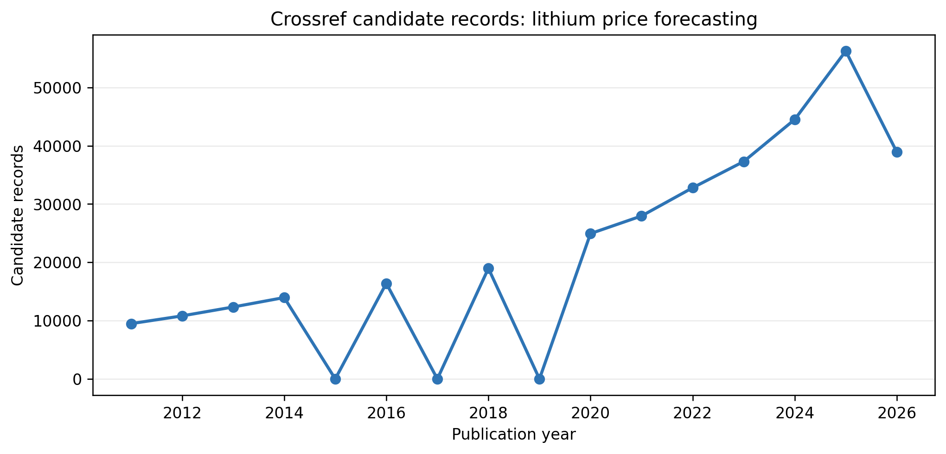
Decomposition-based energy-price studies seek to separate slowly varying structure from high-frequency fluctuations before applying specialized predictors. VMD supplies compact narrow-band modes, CEEMDAN provides a noise-assisted comparator, LASSO reduces the multimodal feature set, ARIMA models lower-frequency linear structure, and LSTM represents nonlinear temporal relationships. The present study is a domain replication and protocol audit rather than a claim that model complexity is intrinsically superior.

3. Methodology
Figure 2. Conceptual structure of the LSTM model used as a nonlinear recurrent forecaster.
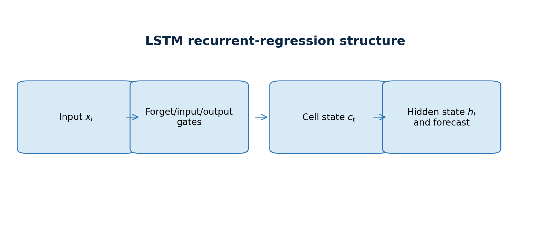
Figure 3. Framework of the Liu-structured retrospective multimodal lithium-price study.
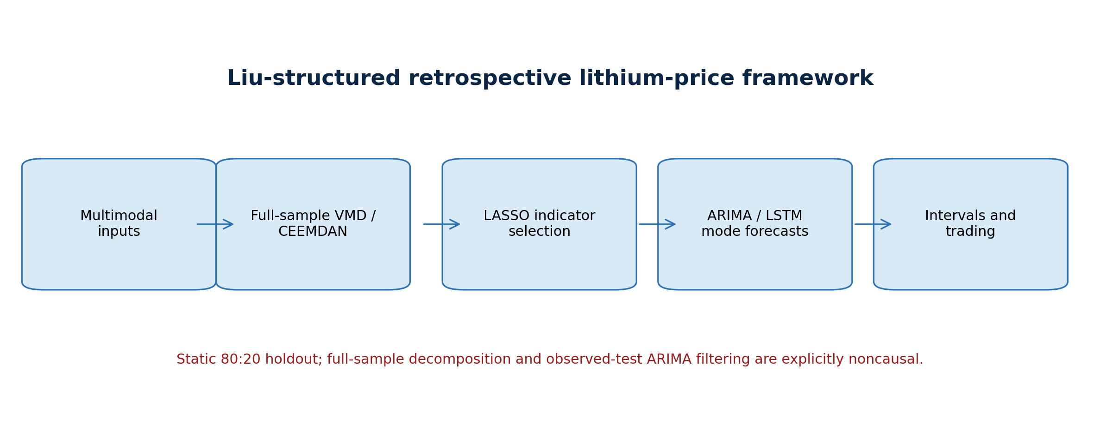

3.1 Forecasting architecture
For each target, lagged target observations are combined with cross-lithium, lithium-equity, Google Trends, lithium-news, and market-control blocks. LASSO is applied separately to each decomposed series. The first two VMD modes are routed to ARIMA and the remaining modes to LSTM, following the reference implementation's operational routing. Component forecasts and the forecast VMD reconstruction residual are summed to recover the price forecast.
Seven single-model benchmarks—exponential smoothing (ES), ARIMA, SVR, random forest (RF), multilayer perceptron (MLP), extreme learning machine (ELM), and LSTM—are fitted to the undecomposed price problem. CEEMDAN-ARIMA, VMD-ARIMA, CEEMDAN-LSTM and VMD-LSTM isolate the contribution of decomposition and forecasting family. The random walk is retained in a companion robustness ledger but excluded from Table 7 to match the reference paper's benchmark design.

3.2 Evaluation
Point accuracy is summarized by RMSE, MAE, MASE, MAPE, symmetric MAPE, and directional accuracy. Pairwise Diebold-Mariano tests use squared-error loss. The first quarter of the static testing sequence supplies residual quantiles for nominal 80%, 90%, and 95% retrospective intervals; the remaining observations are evaluated for coverage, width, calibration error, and Winkler score.
Scheme 1 takes the sign of the forecast price change. Scheme 1' applies an interval-width filter. Scheme 2 deducts 10 basis points when the position changes, and Scheme 2' combines costs and the uncertainty filter. Cumulative return, daily return, maximum drawdown, Sharpe ratio, transaction count, and hit rate are reported. These are mechanical retrospective simulations and do not include bid-ask spreads beyond the stated charge, market impact, liquidity constraints, margin, or contract-roll implementation.
Table 2. Parameter settings used in this study.
Parameter | Setting | Function
Chronological split | 80:20 | Static training and testing sets
Lag order | 5 | Lagged target and indicator features
VMD modes | lithium_hydroxide: 9; lithium_carbonate: 8 | Target-specific decomposition
LSTM hidden units | 64 | One recurrent layer
LSTM epochs | 100 | Training iterations
LSTM batch size | 64 | Mini-batch size
RF estimators | 100 | Single-model benchmark
SVR | RBF; C=8.1; gamma=0.1 | Single-model benchmark
Interval levels | 80%, 90%, 95% | Residual-quantile intervals
Random seed | 42 | Reproducibility

Interpretation of Table 2
Design choices: Five lags provide short daily memory without exhausting a sample of fewer than 720 aligned observations. Hydroxide uses nine VMD modes and carbonate eight because the two price series have different decomposition structures.
Model capacity: The modest LSTM, 100-tree RF, and reference-style SVR settings support reproducibility and comparability with Liu et al.; seed 42 fixes stochastic initialization.
Consequence for inference: The 80:20 split is chronological but static. Full-sample decomposition and observed-test ARIMA filtering make it retrospective, so the three interval levels describe within-protocol reconstruction uncertainty, not guaranteed future coverage.

Table 3. Indicators used in this study.
Indicator | Definition | Data modality | Treatment
Cross_Lithium_Close | Price of the other lithium contract/spot target | Cross Lithium | Aligned to target trading date; lagged in model frame
Albemarle_Close | Albemarle equity close | Lithium Equities | Aligned to target trading date; lagged in model frame
Ganfeng_Lithium_Close | Ganfeng Lithium equity close | Lithium Equities | Aligned to target trading date; lagged in model frame
Trends_lithium | Google Trends: lithium | Lithium Attention | Aligned to target trading date; lagged in model frame
Trends_lithium_price | Google Trends: lithium price | Lithium Attention | Aligned to target trading date; lagged in model frame
Trends_lithium_carbonate | Google Trends: lithium carbonate | Lithium Attention | Aligned to target trading date; lagged in model frame
Trends_lithium_hydroxide | Google Trends: lithium hydroxide | Lithium Attention | Aligned to target trading date; lagged in model frame
Trends_lithium_battery | Google Trends: lithium battery | Lithium Attention | Aligned to target trading date; lagged in model frame
News_Article_Count | Lithium-headline volume | Lithium News | Aligned to target trading date; lagged in model frame
News_TextBlob_Polarity | Lexicon sentiment of lithium headlines | Lithium News | Aligned to target trading date; lagged in model frame
News_FinBERT_Score | Financial-language sentiment of lithium headlines | Lithium News | Aligned to target trading date; lagged in model frame
SP500 | S&P 500 close | Market Controls | Aligned to target trading date; lagged in model frame
VIX | CBOE VIX close | Market Controls | Aligned to target trading date; lagged in model frame
US_Dollar_Index | US dollar index close | Market Controls | Aligned to target trading date; lagged in model frame
MVIS_Critical_Minerals | MVIS Global Rare Earth/Strategic Metals index | Market Controls | Aligned to target trading date; lagged in model frame

Interpretation of Table 3
Information architecture: The 15 indicators form five economically distinct blocks: one cross-lithium price, two lithium-equity signals, five Google Trends attention series, three lithium-news variables, and four market controls. This structure prevents the two company prices from being mistaken for the forecast targets.
Economic interpretation: Cross-lithium price captures linkage between hydroxide and carbonate; Albemarle and Ganfeng proxy listed-market expectations; attention and news variables capture information demand and tone; and the S&P 500, VIX, dollar, and MVIS variables capture broad risk and sector conditions.
Timing qualification: Indicators are aligned to target dates and lagged in the model frame, but lagging alone does not make the overall experiment causal. Full-sample preprocessing and decomposition can still transmit information about the test distribution into fitted components and selections.

4. Data and descriptive evidence
The targets are the COMEX lithium hydroxide CIF CJK electronic futures continuation and the SMM 99.5% battery-grade domestic lithium carbonate spot series. The common multimodal sample begins in May 2023 and ends in March 2026. Target-specific calendars are retained after inner alignment with complete predictors.
The information set contains the other lithium price, Albemarle and Ganfeng equity closes, five jointly normalized Google Trends series, lithium-specific headline volume, TextBlob polarity, FinBERT sentiment, the S&P 500, VIX, US dollar index, and MVIS critical-minerals index. Company prices are signals, not forecast targets. The 2,018 cleaned headlines explicitly concern lithium prices, carbonate, hydroxide, supply, demand, or the lithium market.

Table 4. Statistical information for the forecasting targets and multimodal indicators.
Series | Panel | N | Mean | Std. dev. | Minimum | Maximum
COMEX lithium hydroxide CIF CJK futures | lithium_hydroxide | 716.0000 | 16.1793 | 10.6226 | 7.9500 | 47.3100
Cross_Lithium_Close | lithium_hydroxide | 716.0000 | 117847.7654 | 65912.1252 | 59900.0000 | 314000.0000
Albemarle_Close | lithium_hydroxide | 716.0000 | 119.4812 | 45.8361 | 50.7600 | 243.4400
Ganfeng_Lithium_Close | lithium_hydroxide | 716.0000 | 6.1056 | 1.9515 | 3.5550 | 10.7050
Trends_lithium | lithium_hydroxide | 714.0000 | 56.7283 | 14.0280 | 43.0000 | 100.0000
Trends_lithium_price | lithium_hydroxide | 714.0000 | 4.0056 | 3.7882 | 2.0000 | 18.0000
Trends_lithium_carbonate | lithium_hydroxide | 714.0000 | 1.0616 | 0.3694 | 0.0000 | 2.0000
Trends_lithium_hydroxide | lithium_hydroxide | 714.0000 | 0.1933 | 0.3951 | 0.0000 | 1.0000
Trends_lithium_battery | lithium_hydroxide | 714.0000 | 17.8291 | 5.2784 | 13.0000 | 36.0000
News_Article_Count | lithium_hydroxide | 716.0000 | 2.6383 | 2.6123 | 0.0000 | 40.0000
News_TextBlob_Polarity | lithium_hydroxide | 716.0000 | 0.0521 | 0.1121 | -0.4333 | 0.8000
News_FinBERT_Score | lithium_hydroxide | 716.0000 | 0.2116 | 0.3766 | -0.9694 | 0.9512
SP500 | lithium_hydroxide | 716.0000 | 5564.4447 | 841.7402 | 4061.2200 | 6978.6001
VIX | lithium_hydroxide | 716.0000 | 16.9312 | 4.3308 | 11.8600 | 52.3300
US_Dollar_Index | lithium_hydroxide | 716.0000 | 102.4844 | 3.1993 | 96.2200 | 109.9600
MVIS_Critical_Minerals | lithium_hydroxide | 716.0000 | 370.5107 | 109.0520 | 220.4200 | 674.2340
SMM battery-grade lithium carbonate spot | lithium_carbonate | 692.0000 | 118615.8598 | 67022.4813 | 59900.0000 | 314000.0000
Cross_Lithium_Close | lithium_carbonate | 692.0000 | 16.3008 | 10.7891 | 7.9500 | 47.3100
Albemarle_Close | lithium_carbonate | 692.0000 | 119.8822 | 46.3719 | 50.7600 | 243.4400
Ganfeng_Lithium_Close | lithium_carbonate | 692.0000 | 6.1115 | 1.9561 | 3.5550 | 10.7050
Trends_lithium | lithium_carbonate | 690.0000 | 56.4362 | 13.8250 | 43.0000 | 100.0000
Trends_lithium_price | lithium_carbonate | 690.0000 | 3.9841 | 3.7685 | 2.0000 | 18.0000
Trends_lithium_carbonate | lithium_carbonate | 690.0000 | 1.0580 | 0.3687 | 0.0000 | 2.0000
Trends_lithium_hydroxide | lithium_carbonate | 690.0000 | 0.1899 | 0.3925 | 0.0000 | 1.0000
Trends_lithium_battery | lithium_carbonate | 690.0000 | 17.7667 | 5.1881 | 13.0000 | 36.0000
News_Article_Count | lithium_carbonate | 692.0000 | 2.6214 | 2.6298 | 0.0000 | 40.0000
News_TextBlob_Polarity | lithium_carbonate | 692.0000 | 0.0522 | 0.1114 | -0.4333 | 0.8000
News_FinBERT_Score | lithium_carbonate | 692.0000 | 0.2077 | 0.3783 | -0.9694 | 0.9512
SP500 | lithium_carbonate | 692.0000 | 5561.6697 | 840.7653 | 4061.2200 | 6978.6001
VIX | lithium_carbonate | 692.0000 | 16.8099 | 4.2760 | 11.8600 | 52.3300
US_Dollar_Index | lithium_carbonate | 692.0000 | 102.4637 | 3.1759 | 96.2200 | 109.9600
MVIS_Critical_Minerals | lithium_carbonate | 692.0000 | 370.9414 | 109.4896 | 220.4200 | 674.2340

Interpretation of Table 4
Target coverage: The hydroxide panel contains 716 aligned observations, with prices ranging from 7.95 to 47.31 and a mean of 16.18. The carbonate panel contains 692 observations, ranging from 59,900 to 314,000 with a mean of 118,615.86. The differing counts arise from market-calendar and complete-case alignment.
Scale and volatility: Hydroxide's standard deviation of 10.62 is about 66% of its mean, while carbonate's standard deviation of 67,022.48 is about 57% of its mean. Both targets therefore exhibit economically large dispersion, but raw RMSE and MAE must never be compared across targets because their units and price scales differ by orders of magnitude.
Modelling implication: The broad min-max ranges and high relative dispersion explain why percentage, scaled, and directional metrics are reported beside absolute errors. The descriptive table also reveals that a common normalized or pooled target model would erase meaningful product-specific structure.

Figure 4. Lithium-price series used as forecasting targets.
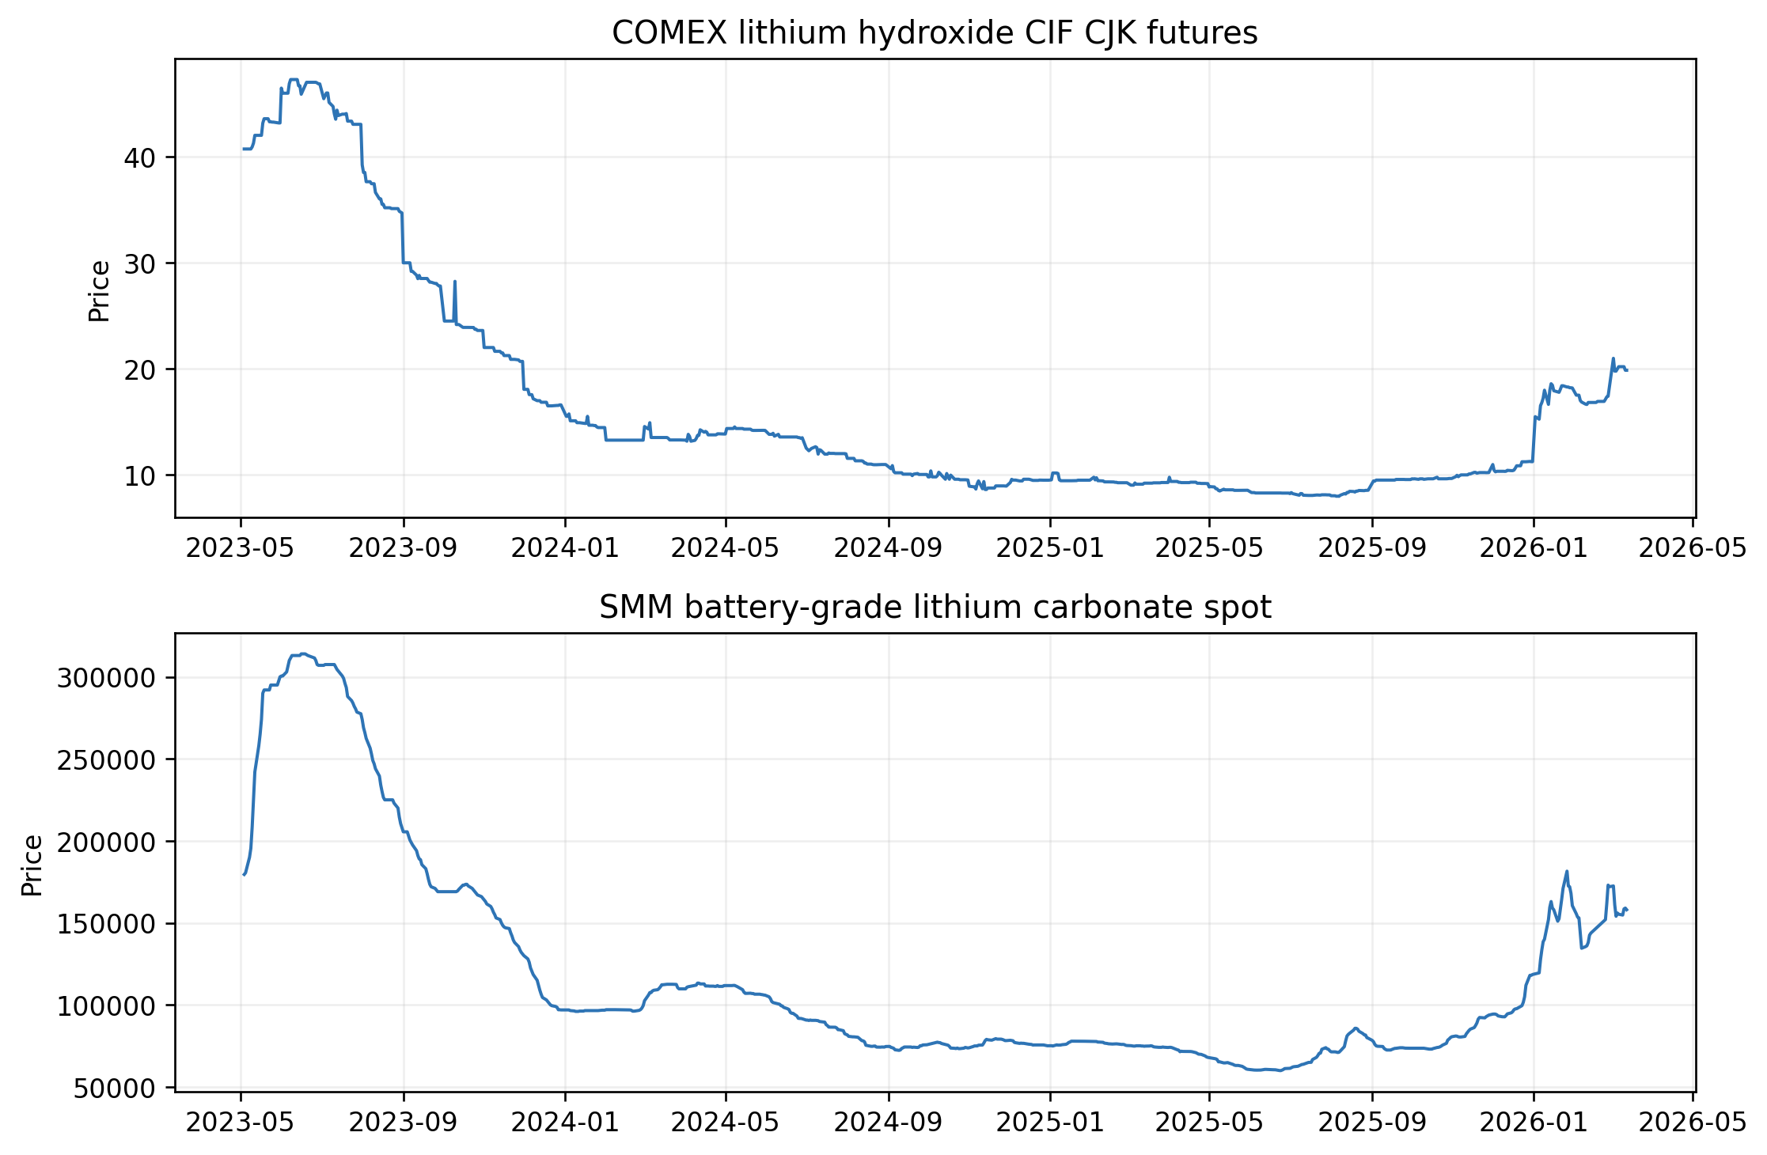
Figure 5. Word cloud of the collected lithium-specific news headlines.
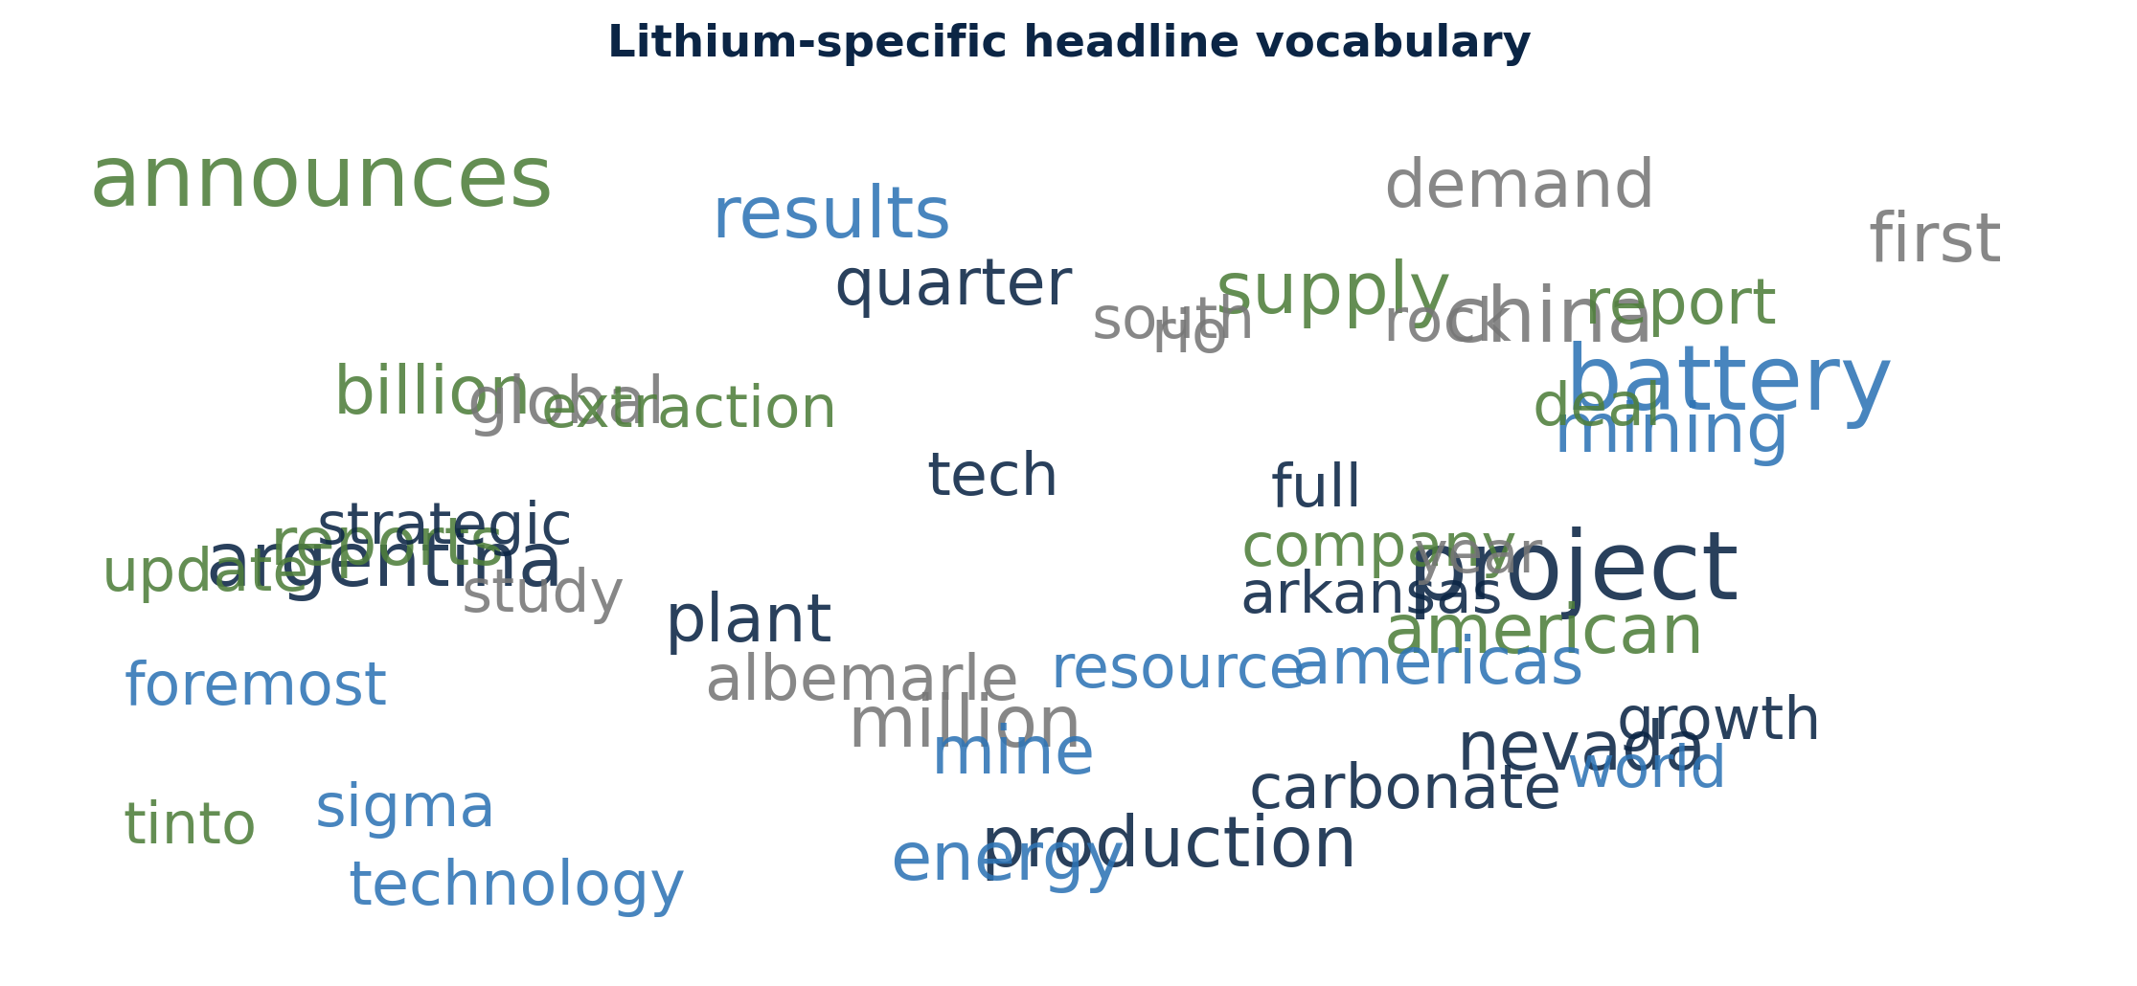
Figure 6. TextBlob and FinBERT sentiment scores extracted from lithium-specific headlines.
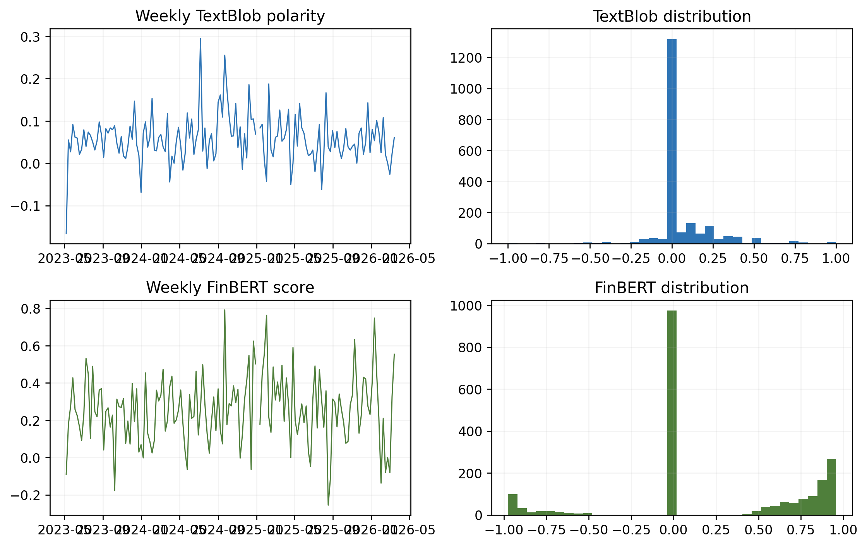

5. Decomposition and feature selection
Figure 7. Full-sample VMD modes of the two lithium-price targets.
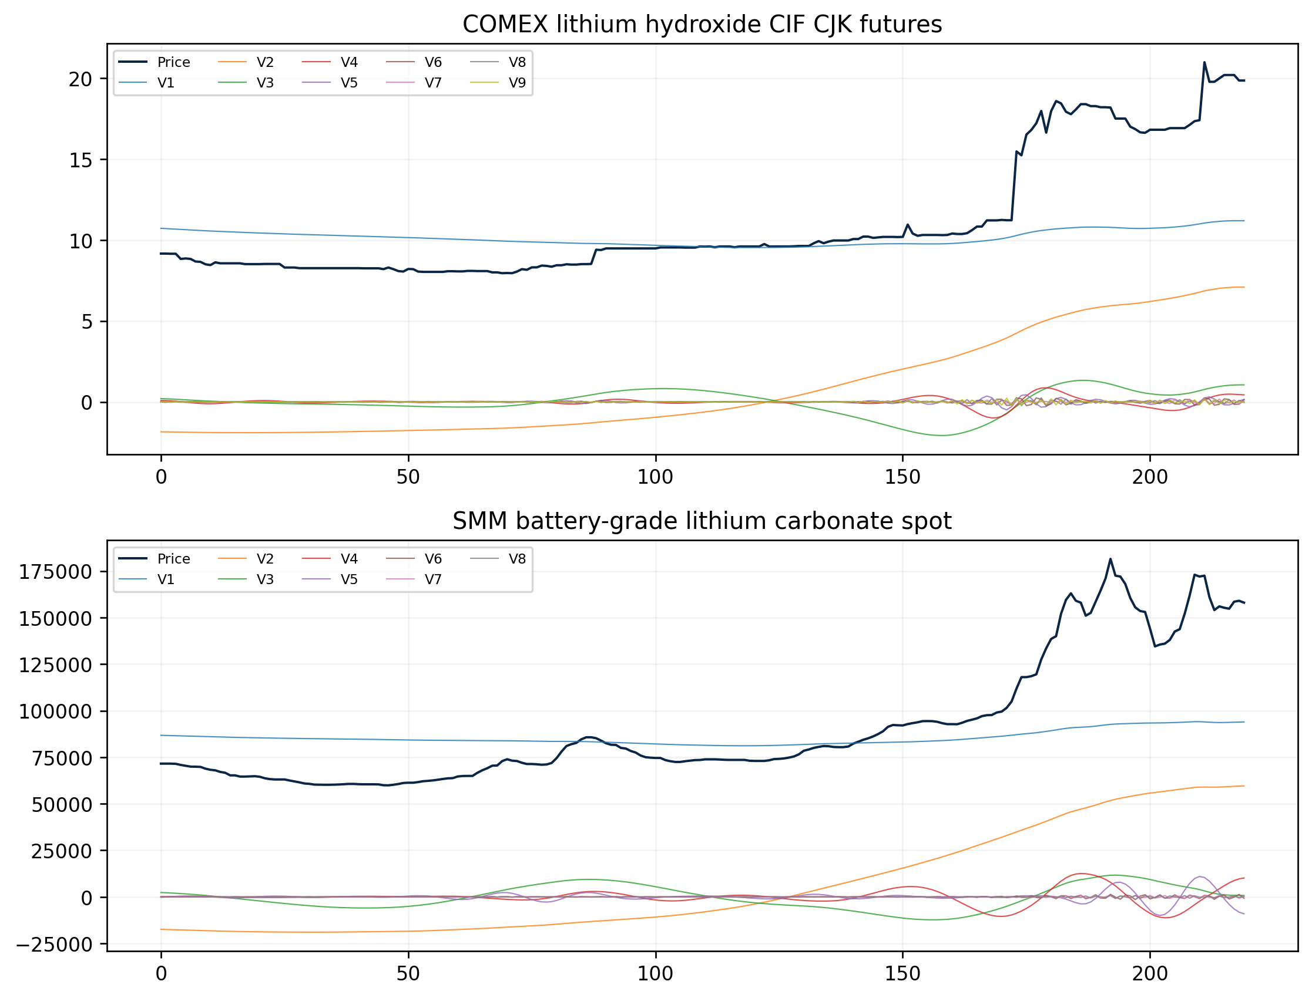
Figure 8. Approximate-entropy values of the decomposed VMD modes.
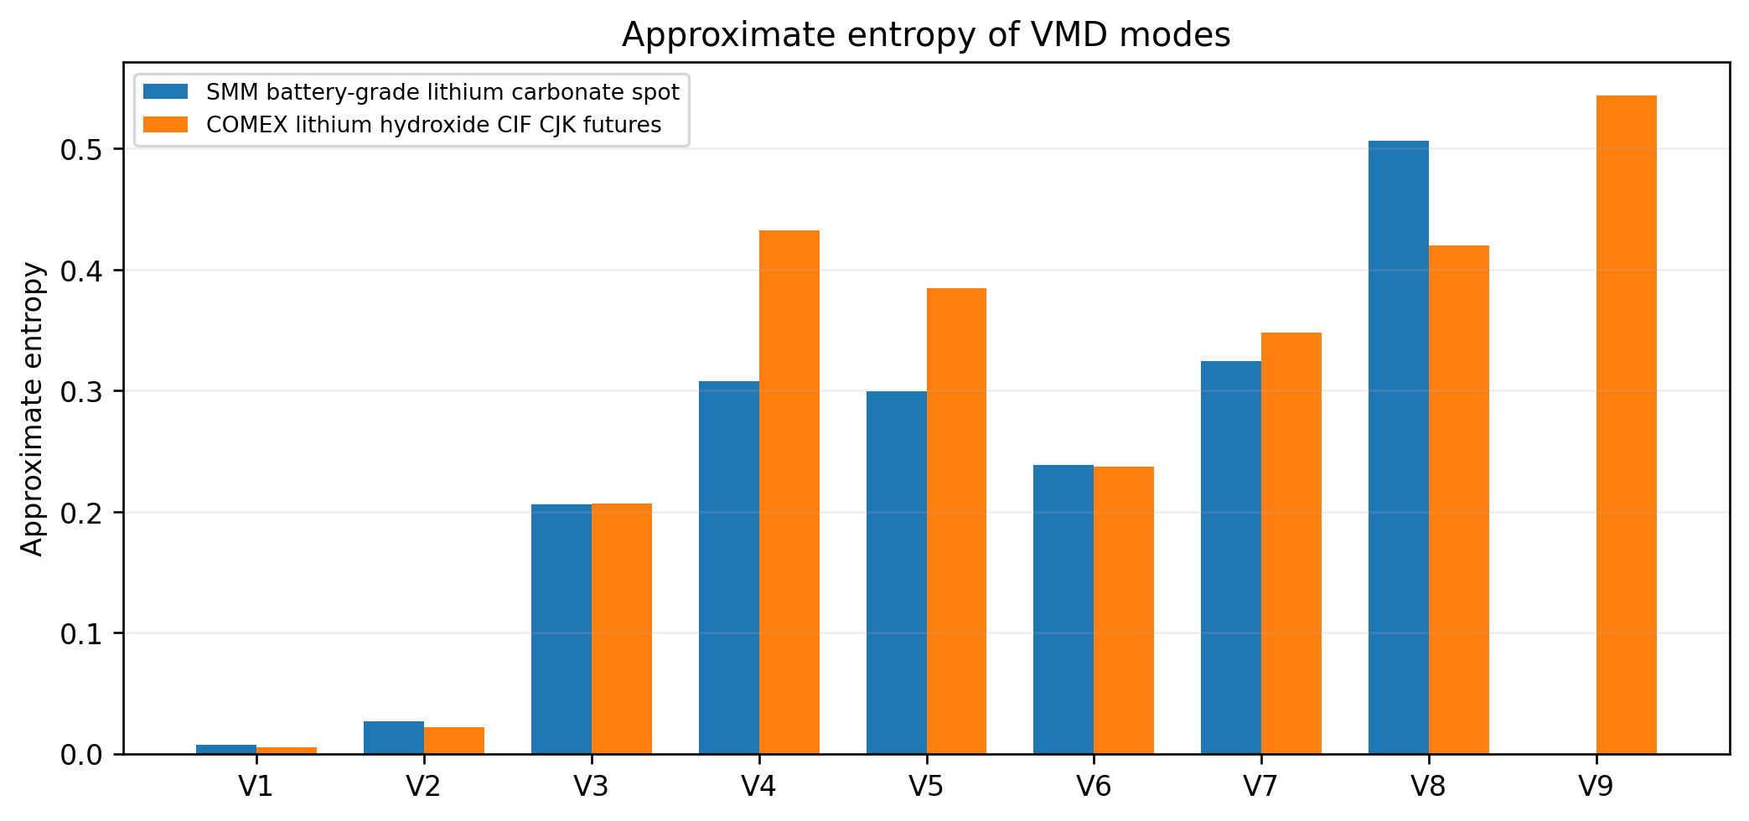

Table 5. Information on the decomposed lithium-price modes.
Panel | Method | Mode | Frequency | Average period | Variance share | Correlation | Approximate Entropy
lithium_hydroxide | VMD | 1.0000 | 0.0056 | 178.5000 | 0.3273 | 0.8212 | 0.0053
lithium_hydroxide | VMD | 2.0000 | 0.0056 | 178.5000 | 0.3651 | 0.8439 | 0.0220
lithium_hydroxide | VMD | 3.0000 | 0.0126 | 79.3333 | 0.0089 | 0.1657 | 0.2067
lithium_hydroxide | VMD | 4.0000 | 0.0490 | 20.4000 | 0.0008 | 0.0556 | 0.4323
lithium_hydroxide | VMD | 5.0000 | 0.1359 | 7.3608 | 0.0002 | 0.0234 | 0.3845
lithium_hydroxide | VMD | 6.0000 | 0.2535 | 3.9448 | 0.0001 | 0.0148 | 0.2372
lithium_hydroxide | VMD | 7.0000 | 0.3403 | 2.9383 | 0.0000 | 0.0118 | 0.3481
lithium_hydroxide | VMD | 8.0000 | 0.3978 | 2.5141 | 0.0001 | 0.0117 | 0.4197
lithium_hydroxide | VMD | 9.0000 | 0.4468 | 2.2382 | 0.0000 | 0.0104 | 0.5442
lithium_hydroxide | CEEMDAN | 1.0000 | 0.3375 | 2.9627 | 0.0006 | -0.0045 | 0.7875
lithium_hydroxide | CEEMDAN | 2.0000 | 0.2381 | 4.2000 | 0.0008 | -0.0290 | 0.5324
lithium_hydroxide | CEEMDAN | 3.0000 | 0.0812 | 12.3103 | 0.0015 | 0.0683 | 0.3999
lithium_hydroxide | CEEMDAN | 4.0000 | 0.0322 | 31.0435 | 0.0068 | 0.1861 | 0.2353
lithium_hydroxide | CEEMDAN | 5.0000 | 0.0098 | 102.0000 | 0.0542 | 0.4401 | 0.0716
lithium_hydroxide | CEEMDAN | 6.0000 | 0.0042 | 238.0000 | 0.0617 | 0.6934 | 0.0342
lithium_hydroxide | CEEMDAN | 7.0000 | 0.0000 |  | 0.6059 | 0.9098 | 0.0071
lithium_carbonate | VMD | 1.0000 | 0.0072 | 138.0000 | 0.2786 | 0.8026 | 0.0071
lithium_carbonate | VMD | 2.0000 | 0.0058 | 172.5000 | 0.3836 | 0.8602 | 0.0265
lithium_carbonate | VMD | 3.0000 | 0.0101 | 98.5714 | 0.0213 | 0.2181 | 0.2060
lithium_carbonate | VMD | 4.0000 | 0.0304 | 32.8571 | 0.0040 | 0.0977 | 0.3076
lithium_carbonate | VMD | 5.0000 | 0.0580 | 17.2500 | 0.0018 | 0.0619 | 0.2997
lithium_carbonate | VMD | 6.0000 | 0.3058 | 3.2701 | 0.0000 | 0.0086 | 0.2383
lithium_carbonate | VMD | 7.0000 | 0.3522 | 2.8395 | 0.0000 | 0.0074 | 0.3242
lithium_carbonate | VMD | 8.0000 | 0.4029 | 2.4820 | 0.0000 | 0.0068 | 0.5062
lithium_carbonate | CEEMDAN | 1.0000 | 0.3275 | 3.0531 | 0.0002 | -0.0179 | 0.8096
lithium_carbonate | CEEMDAN | 2.0000 | 0.2580 | 3.8764 | 0.0011 | 0.0308 | 0.2441
lithium_carbonate | CEEMDAN | 3.0000 | 0.0710 | 14.0816 | 0.0029 | 0.2553 | 0.3550
lithium_carbonate | CEEMDAN | 4.0000 | 0.0217 | 46.0000 | 0.0188 | 0.3989 | 0.2406
lithium_carbonate | CEEMDAN | 5.0000 | 0.0058 | 172.5000 | 0.1555 | 0.7532 | 0.0664
lithium_carbonate | CEEMDAN | 6.0000 | 0.0029 | 345.0000 | 0.0065 | 0.6613 | 0.0281
lithium_carbonate | CEEMDAN | 7.0000 | 0.0014 | 690.0000 | 0.4080 | 0.9087 | 0.0095

Interpretation of Table 5
VMD structure: For hydroxide, VMD modes 1 and 2 carry variance shares of 0.3273 and 0.3651 and correlate 0.8212 and 0.8439 with the original series. For carbonate, the corresponding shares are 0.2786 and 0.3836 with correlations 0.8026 and 0.8602. Much of the smooth price path is therefore concentrated in the first two modes.
CEEMDAN contrast: CEEMDAN concentrates its dominant low-frequency structure later: mode 7 accounts for 0.6059 of hydroxide variance and 0.4080 of carbonate variance, with correlations above 0.90 in both panels. Mode numbering is decomposition-specific, so VMD mode 1 cannot be interpreted as equivalent to CEEMDAN mode 1.
Routing implication: Approximate entropy generally rises for faster modes, supporting different treatment of smooth and irregular components. However, the proposed model's fixed first-two-mode ARIMA routing is inherited from the reference protocol; Table 5 does not prove that this routing is optimal for either lithium target.
Table 6. Indicators selected for the decomposed modes using LASSO regression.
Panel | Mode | Route | Selected indicators | LASSO alpha
lithium_hydroxide | 1 | ARIMA | target_1, Cross_Lithium_Close | 0.0013
lithium_hydroxide | 2 | ARIMA | target_1 | 0.0398
lithium_hydroxide | 3 | LSTM | target_1, target_5, Cross_Lithium_Close, Ganfeng_Lithium_Close | 0.001
lithium_hydroxide | 4 | LSTM | target_1, target_3, target_5, News_FinBERT_Score, News_TextBlob_Polarity, News_Article_Count, … | 0.001
lithium_hydroxide | 5 | LSTM | target_1, target_2, target_4, target_5, VIX, News_TextBlob_Polarity, Cross_Lithium_Close, News_FinBERT_Score | 0.0011
lithium_hydroxide | 6 | LSTM | target_2, target_4, target_3, Cross_Lithium_Close, VIX, News_Article_Count, News_TextBlob_Polarity | 0.0026
lithium_hydroxide | 7 | LSTM | target_2, target_1, target_5, target_4, News_FinBERT_Score, VIX, Cross_Lithium_Close | 0.0021
lithium_hydroxide | 8 | LSTM | target_1, target_2, News_FinBERT_Score, Cross_Lithium_Close, VIX, News_TextBlob_Polarity | 0.0015
lithium_hydroxide | 9 | LSTM | target_1, target_3, target_2, target_5, News_FinBERT_Score, News_Article_Count, Cross_Lithium_Close | 0.001
lithium_hydroxide | Residual | LSTM | target_1, target_5, target_3, target_2, target_4, Cross_Lithium_Close | 0.0395
lithium_carbonate | 1 | ARIMA | target_1, Cross_Lithium_Close, Ganfeng_Lithium_Close | 0.0014
lithium_carbonate | 2 | ARIMA | target_1, SP500 | 0.0018
lithium_carbonate | 3 | LSTM | target_1, target_5, Ganfeng_Lithium_Close, Cross_Lithium_Close | 0.001
lithium_carbonate | 4 | LSTM | target_1, target_5, Ganfeng_Lithium_Close, News_TextBlob_Polarity | 0.001
lithium_carbonate | 5 | LSTM | target_1, target_4, target_3, Ganfeng_Lithium_Close, News_Article_Count, News_FinBERT_Score | 0.001
lithium_carbonate | 6 | LSTM | target_2, target_4, target_1, target_5, target_3, Ganfeng_Lithium_Close, US_Dollar_Index, Cross_Lithium_Close, … | 0.001
lithium_carbonate | 7 | LSTM | target_2, target_1, target_4, target_5, Ganfeng_Lithium_Close, US_Dollar_Index, News_FinBERT_Score, … | 0.001
lithium_carbonate | 8 | LSTM | target_1, target_2, target_4, target_3, Ganfeng_Lithium_Close, US_Dollar_Index, News_TextBlob_Polarity, … | 0.001
lithium_carbonate | Residual | LSTM | target_1, target_2, target_5, target_4, Albemarle_Close, News_Article_Count, Ganfeng_Lithium_Close, US_Dollar_Index | 0.0153

Interpretation of Table 6
Persistence dominates: The immediately lagged decomposed target, target_1, is selected in all nine target-specific mode rows for both panels. Longer lags also recur, showing that the decomposed components retain meaningful autoregressive memory after VMD.
External-signal differences: Cross_Lithium_Close appears in eight hydroxide mode models, whereas Ganfeng_Lithium_Close appears in eight carbonate mode models. Hydroxide also selects FinBERT sentiment in five modes and TextBlob polarity in four; carbonate more often selects the US dollar index and Ganfeng equity signal.
Interpretation: Selection frequency indicates predictive inclusion under this fitted sample, not structural causality. Correlated indicators can substitute for one another under LASSO, and the full-sample/static protocol can make the selected set look more stable than it would be in a rolling real-time experiment.

The decomposition summaries show that the modes differ materially in frequency, variance share, correlation with the original price, and approximate entropy. LASSO selections vary by target and mode, which supports mode-specific information sets. Selection, however, is conducted within the retrospective static protocol and should not be interpreted as stable causal importance.

6. Forecasting results
Figure 9. Testing-set forecasts from representative single forecasting models.
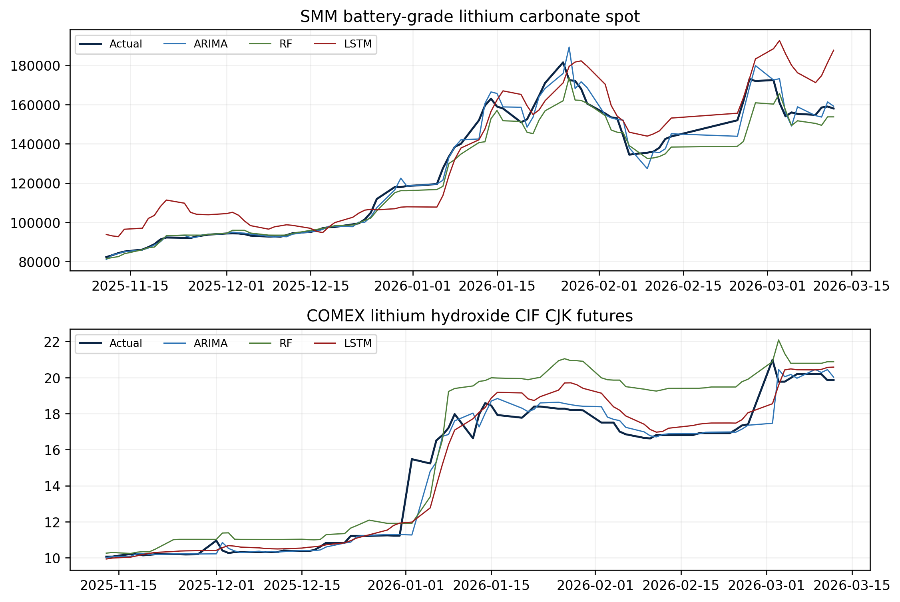
Figure 10. Target-normalized forecasting errors across all evaluated models.
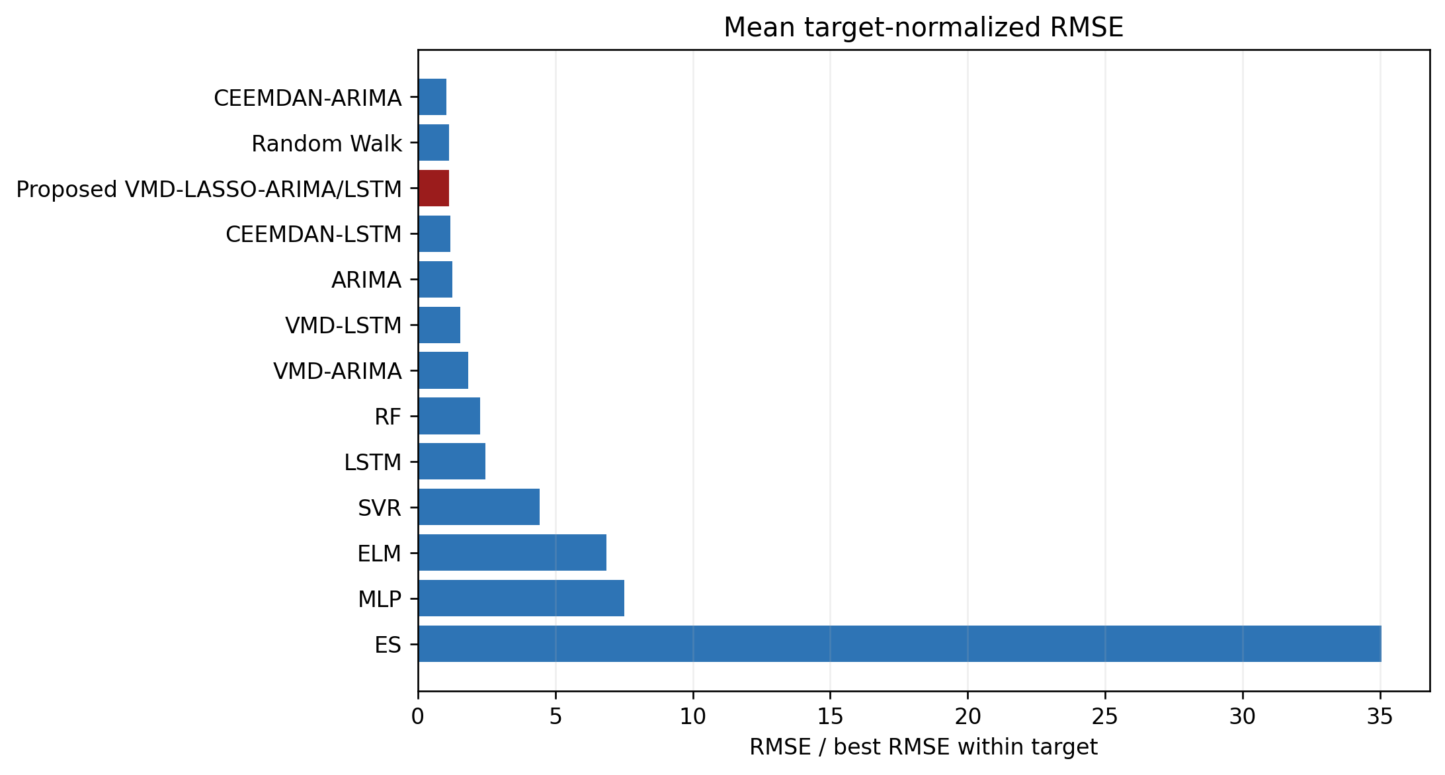

Table 7. Forecasting errors on the testing sets for single models.
Target | Model | RMSE | MAE | MASE | MAPE | sMAPE | Directional Accuracy
lithium_carbonate | ARIMA | 3612.1970 | 1827.0413 | 0.9132 | 1.43 | 1.46 | 69.63
lithium_carbonate | RF | 5380.3212 | 3231.2770 | 1.6150 | 2.55 | 2.59 | 72.59
lithium_carbonate | LSTM | 11222.0126 | 9516.7432 | 4.7566 | 9.56 | 9.04 | 54.81
lithium_carbonate | SVR | 24629.9992 | 18864.5712 | 9.4288 | 21.87 | 18.25 | 56.30
lithium_carbonate | ELM | 41457.7667 | 34950.9727 | 17.4690 | 36.01 | 28.29 | 58.52
lithium_carbonate | MLP | 45712.4002 | 37502.1294 | 18.7441 | 40.06 | 30.61 | 48.15
lithium_carbonate | ES | 200226.2914 | 180239.9823 | 90.0866 | 165.22 | 86.50 | 54.07
lithium_hydroxide | ARIMA | 0.6437 | 0.2395 | 1.3159 | 1.76 | 1.92 | 29.29
lithium_hydroxide | ELM | 0.6542 | 0.2573 | 1.4138 | 1.71 | 1.79 | 28.57
lithium_hydroxide | MLP | 0.6766 | 0.4589 | 2.5212 | 3.52 | 3.54 | 35.00
lithium_hydroxide | SVR | 0.7060 | 0.5847 | 3.2129 | 4.95 | 4.83 | 38.57
lithium_hydroxide | LSTM | 0.7220 | 0.4668 | 2.5646 | 3.46 | 3.46 | 30.71
lithium_hydroxide | RF | 1.3033 | 0.8864 | 4.8704 | 6.01 | 5.76 | 37.14
lithium_hydroxide | ES | 4.8948 | 3.3720 | 18.5273 | 21.47 | 26.45 | 35.00

Interpretation of Table 7
Carbonate result: ARIMA is the strongest single model for carbonate by RMSE (3,612.20), MAE (1,827.04), MASE (0.9132), and MAPE (1.43%). RF has the highest directional accuracy (72.59%) but a materially worse RMSE of 5,380.32, showing that direction and price-level accuracy answer different questions.
Hydroxide result: ARIMA again has the lowest single-model RMSE (0.6437) and MAE (0.2395), but its directional accuracy is only 29.29%. SVR raises directional accuracy to 38.57% while worsening RMSE to 0.7060. A model can track the price level yet fail to identify small one-day changes around a persistent series.
Benchmark lesson: ES performs especially poorly after structural shifts, while MLP, ELM, and LSTM do not automatically benefit from greater nonlinearity in this short sample. Table 7 therefore establishes a demanding statistical baseline: complexity is valuable only when decomposition or information selection converts it into lower loss.
Table 8. Forecasting errors on the testing sets for decomposition models.
Target | Model | RMSE | MAE | MASE | MAPE | sMAPE | Directional Accuracy
lithium_carbonate | CEEMDAN-LSTM | 3385.6721 | 2193.4135 | 1.0963 | 1.89 | 1.89 | 76.30
lithium_carbonate | CEEMDAN-ARIMA | 3623.5469 | 1436.9183 | 0.7182 | 1.12 | 1.16 | 77.04
lithium_carbonate | Proposed VMD-LASSO-ARIMA/LSTM | 3672.3030 | 2086.1666 | 1.0427 | 1.84 | 1.87 | 76.30
lithium_carbonate | VMD-LSTM | 5592.2187 | 3718.5097 | 1.8586 | 3.01 | 3.06 | 74.81
lithium_carbonate | VMD-ARIMA | 8886.6128 | 7428.7803 | 3.7130 | 7.36 | 7.36 | 68.89
lithium_hydroxide | CEEMDAN-ARIMA | 0.4467 | 0.1994 | 1.0955 | 1.54 | 1.66 | 37.86
lithium_hydroxide | VMD-ARIMA | 0.4731 | 0.2450 | 1.3463 | 1.92 | 2.03 | 44.29
lithium_hydroxide | Proposed VMD-LASSO-ARIMA/LSTM | 0.5360 | 0.2986 | 1.6407 | 2.30 | 2.41 | 41.43
lithium_hydroxide | CEEMDAN-LSTM | 0.6157 | 0.4043 | 2.2216 | 3.44 | 3.43 | 39.29
lithium_hydroxide | VMD-LSTM | 0.6450 | 0.4285 | 2.3546 | 3.22 | 3.19 | 44.29

Interpretation of Table 8
Carbonate decomposition: CEEMDAN-LSTM achieves the lowest carbonate RMSE at 3,385.67, while CEEMDAN-ARIMA achieves the lowest MAE at 1,436.92 and the highest directional accuracy at 77.04%. The proposed hybrid records RMSE 3,672.30 and directional accuracy 76.30%, so it is competitive but not the metric leader.
Hydroxide decomposition: CEEMDAN-ARIMA leads hydroxide on RMSE (0.4467) and MAE (0.1994). VMD-ARIMA has the highest directional accuracy (44.29%). The proposed RMSE of 0.5360 improves on every single-model RMSE but is roughly 20% above CEEMDAN-ARIMA.
Main conclusion: Decomposition is useful, but the evidence does not support universal superiority of the proposed VMD-LASSO-ARIMA/LSTM architecture. The best decomposition family and component forecaster depend on the target and metric, which is more informative than selecting a single winner from one error column.
Table 9. Diebold-Mariano tests comparing the proposed model with forecasting benchmarks.
Target | Benchmark | DM statistic | p-value | Direction
lithium_carbonate | ES | -10.9885 | 0.0000 | Proposed better
lithium_carbonate | ELM | -8.3139 | 0.0000 | Proposed better
lithium_carbonate | VMD-ARIMA | -7.3929 | 0.0000 | Proposed better
lithium_carbonate | MLP | -7.1313 | 0.0000 | Proposed better
lithium_carbonate | SVR | -6.0575 | 0.0000 | Proposed better
lithium_carbonate | LSTM | -5.8798 | 0.0000 | Proposed better
lithium_carbonate | VMD-LSTM | -2.4724 | 0.0147 | Proposed better
lithium_carbonate | RF | -1.5777 | 0.1170 | Proposed better
lithium_carbonate | CEEMDAN-LSTM | 0.4198 | 0.6753 | Benchmark better
lithium_carbonate | Random Walk | 0.2038 | 0.8388 | Benchmark better
lithium_carbonate | ARIMA | 0.1201 | 0.9046 | Benchmark better
lithium_carbonate | CEEMDAN-ARIMA | 0.1090 | 0.9134 | Benchmark better
lithium_hydroxide | ES | -5.7732 | 0.0000 | Proposed better
lithium_hydroxide | RF | -4.3195 | 0.0000 | Proposed better
lithium_hydroxide | VMD-ARIMA | 3.8883 | 0.0002 | Benchmark better
lithium_hydroxide | CEEMDAN-ARIMA | 3.5153 | 0.0006 | Benchmark better
lithium_hydroxide | CEEMDAN-LSTM | -1.9666 | 0.0512 | Proposed better
lithium_hydroxide | VMD-LSTM | -1.8898 | 0.0608 | Proposed better
lithium_hydroxide | SVR | -1.4518 | 0.1488 | Proposed better
lithium_hydroxide | LSTM | -1.4003 | 0.1636 | Proposed better
lithium_hydroxide | MLP | -0.9658 | 0.3358 | Proposed better
lithium_hydroxide | ARIMA | -0.8962 | 0.3717 | Proposed better
lithium_hydroxide | ELM | -0.5723 | 0.5681 | Proposed better
lithium_hydroxide | Random Walk | -0.0748 | 0.9404 | Proposed better

Interpretation of Table 9
How to read the sign: The loss differential is proposed-model squared error minus benchmark squared error. A negative DM statistic therefore favors the proposed model; a positive statistic favors the benchmark. The p-value tests equal average predictive loss, not economic profitability.
Carbonate evidence: The proposed model is significantly better at the 5% level than seven of twelve comparators: ES, ELM, VMD-ARIMA, MLP, SVR, LSTM, and VMD-LSTM. No carbonate benchmark is significantly better than the proposed model, even though CEEMDAN-LSTM has a lower aggregate RMSE; the timing and distribution of errors matter to the DM statistic.
Hydroxide evidence: The pattern is less favorable for hydroxide. The proposed model significantly beats ES and RF, but VMD-ARIMA and CEEMDAN-ARIMA significantly beat the proposed model. The remaining comparisons do not reject equal loss at 5%, so they should not be described as confirmed wins.
Multiplicity caution: Twenty-four pairwise tests are displayed without a family-wise multiplicity correction to preserve comparability with the reference-style presentation. Isolated nominal p-values should therefore be interpreted alongside effect sizes, target-level metrics, and a robustness correction in any journal submission.

For lithium hydroxide, the proposed model's RMSE of 0.5360 is 16.7% below the best single-model RMSE. CEEMDAN-ARIMA nevertheless achieves the lowest overall RMSE. For lithium carbonate, the proposed RMSE of 3672.30 is 1.7% above the best single model, and CEEMDAN-LSTM obtains the lowest overall RMSE. The proposed architecture strongly outperforms several weak nonlinear and smoothing benchmarks but does not dominate every decomposition alternative.
The DM table should be read jointly with effect sizes. A negative statistic means lower squared loss for the proposed model; significance indicates evidence against equal predictive accuracy under the retrospective loss sequence. Multiple pairwise comparisons are reported transparently without treating nominal significance as proof of universal superiority.

7. Interval forecasting and trading
Figure 11. Retrospective 90% interval forecasts from the proposed model.
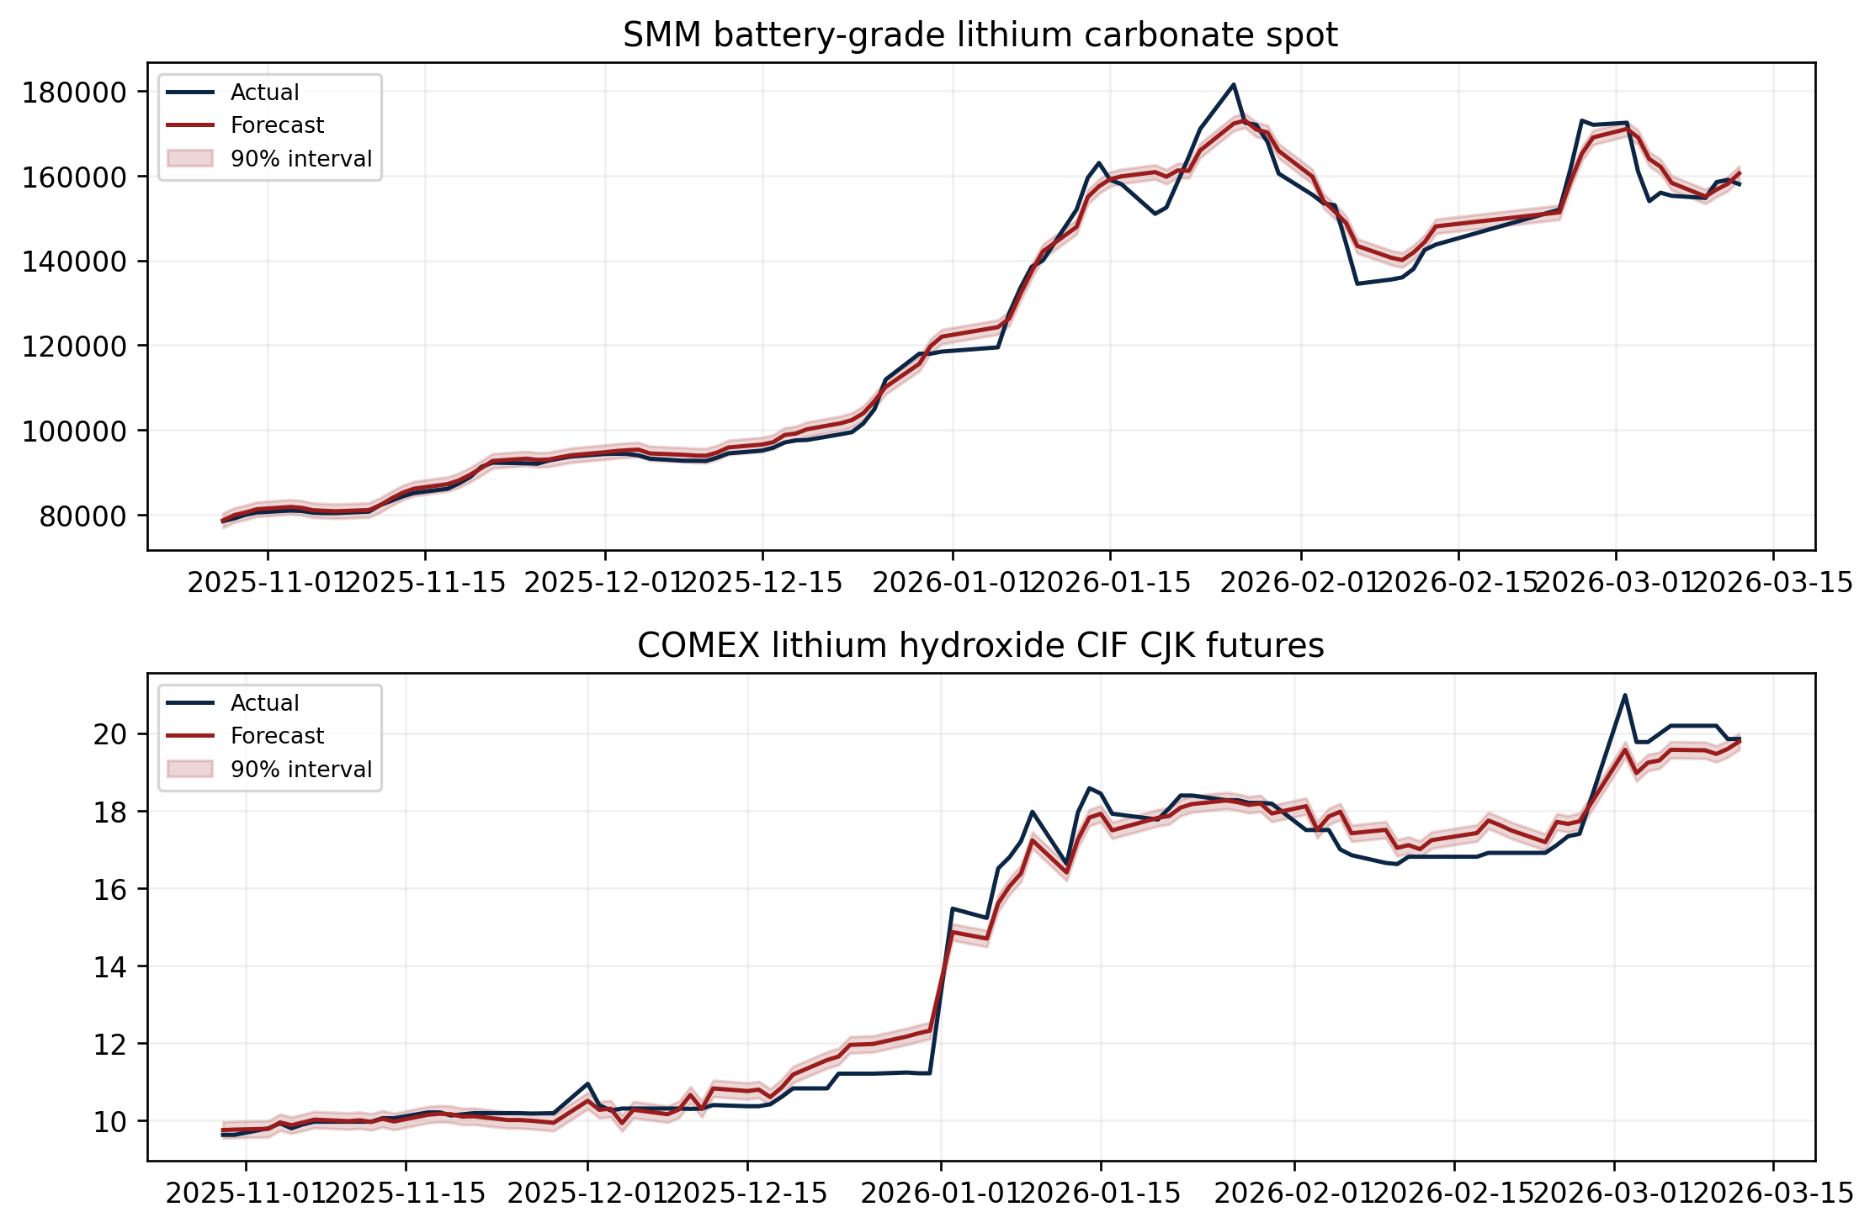

Table 10. Interval forecasting errors on the evaluation sets.
Target | Nominal Coverage (%) | Coverage (%) | Avg Width | Calibration Error | Winkler
lithium_carbonate | 80.00 | 52.94 | 2703.6971 | 27.0588 | 14374.2201
lithium_carbonate | 90.00 | 59.80 | 3424.6967 | 30.1961 | 23738.9808
lithium_carbonate | 95.00 | 100.00 | 55769.7036 | 5.0000 | 55769.7036
lithium_hydroxide | 80.00 | 38.10 | 0.2402 | 41.9048 | 2.6397
lithium_hydroxide | 90.00 | 48.57 | 0.4251 | 41.4286 | 4.1833
lithium_hydroxide | 95.00 | 100.00 | 8.5249 | 5.0000 | 8.5249

Interpretation of Table 10
Coverage failure: The 80% and 90% intervals under-cover both targets. Carbonate realizes only 52.94% and 59.80% coverage, while hydroxide realizes 38.10% and 48.57%. Calibration errors of 27-42 percentage points show that the central intervals are too narrow after the calibration segment.
Why 95% is misleading: Both 95% intervals reach 100% empirical coverage only by expanding dramatically: average width rises to 55,769.70 for carbonate and 8.5249 for hydroxide. The associated Winkler scores confirm that coverage is purchased with poor sharpness rather than well-calibrated uncertainty.
Implication: Table 10 does not validate the intervals for deployment. It identifies distribution shift and unstable residual tails within the retrospective holdout. A publishable causal extension should update interval calibration sequentially or use rolling conformal methods and then report conditional as well as marginal coverage.

Figure 12. Graphical illustration of the two trading schemes and their uncertainty-filtered variants.
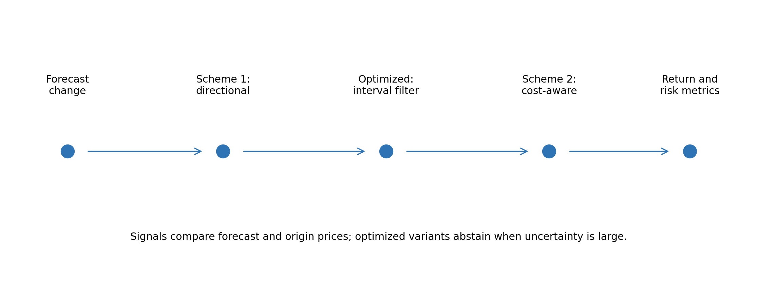
Figure 13. Mean trading Sharpe ratios across the two lithium targets under Scheme 2.
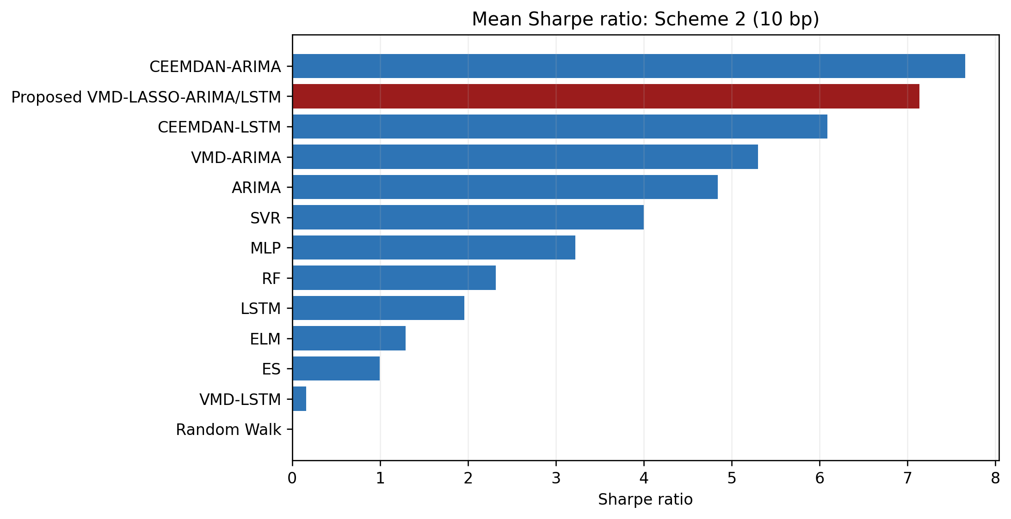

Table 11. Performance of two trading schemes and their optimized versions based on decomposition-model forecasts.
Model | Scheme | Cumulative Return (%) | Maximum Drawdown (%) | Sharpe Ratio | Number of Transactions | Hit Rate (%)
CEEMDAN-ARIMA | Scheme 1 | 332.30 | -4.34 | 8.0045 | 37.5000 | 65.48
CEEMDAN-ARIMA | Scheme 1' | 284.56 | -1.98 | 7.5317 | 32.0000 | 40.35
CEEMDAN-ARIMA | Scheme 2 | 304.19 | -4.44 | 7.6570 | 37.5000 | 65.48
CEEMDAN-ARIMA | Scheme 2' | 269.81 | -2.18 | 7.3112 | 32.0000 | 40.35
CEEMDAN-LSTM | Scheme 1 | 222.50 | -6.63 | 6.2857 | 18.5000 | 49.09
CEEMDAN-LSTM | Scheme 1' | 90.07 | -3.98 | 4.0305 | 20.0000 | 12.14
CEEMDAN-LSTM | Scheme 2 | 211.16 | -6.73 | 6.0866 | 18.5000 | 49.09
CEEMDAN-LSTM | Scheme 2' | 86.32 | -4.17 | 3.9278 | 20.0000 | 12.14
Proposed VMD-LASSO-ARIMA/LSTM | Scheme 1 | 292.81 | -5.03 | 7.3150 | 18.5000 | 59.16
Proposed VMD-LASSO-ARIMA/LSTM | Scheme 1' | 203.26 | -4.73 | 6.1325 | 26.0000 | 36.41
Proposed VMD-LASSO-ARIMA/LSTM | Scheme 2 | 279.87 | -5.22 | 7.1346 | 18.5000 | 59.16
Proposed VMD-LASSO-ARIMA/LSTM | Scheme 2' | 194.24 | -5.06 | 5.9622 | 26.0000 | 36.41
VMD-ARIMA | Scheme 1 | 218.58 | -8.71 | 5.4567 | 19.5000 | 55.70
VMD-ARIMA | Scheme 1' | 127.14 | -3.17 | 4.8670 | 17.0000 | 27.54
VMD-ARIMA | Scheme 2 | 206.06 | -8.90 | 5.2996 | 19.5000 | 55.70
VMD-ARIMA | Scheme 2' | 121.97 | -3.42 | 4.7688 | 17.0000 | 27.54
VMD-LSTM | Scheme 1 | 38.13 | -31.43 | 0.2697 | 14.0000 | 37.23
VMD-LSTM | Scheme 1' | 56.59 | -10.00 | 1.7830 | 13.5000 | 13.59
VMD-LSTM | Scheme 2 | 34.26 | -31.70 | 0.1590 | 14.0000 | 37.23
VMD-LSTM | Scheme 2' | 54.32 | -10.25 | 1.7066 | 13.5000 | 13.59

Interpretation of Table 11
Decomposition trading leader: CEEMDAN-ARIMA has the strongest average results in every scheme: Scheme 1 returns 332.30% with Sharpe 8.0045, and cost-adjusted Scheme 2 returns 304.19% with Sharpe 7.6570. The proposed hybrid remains strong in the table, with Scheme 2 return 279.87%, Sharpe 7.1346, and maximum drawdown -5.22%.
Costs and filtering: Moving from Scheme 1 to Scheme 2 lowers the proposed average cumulative return from 292.81% to 279.87%, quantifying the effect of the 10-basis-point turnover charge. The uncertainty filter lowers the proposed Scheme 2 result further to 194.24% and Sharpe 5.9622; abstention reduces exposure but does not automatically improve risk-adjusted return.
Interpretive boundary: These high annualized-looking outcomes are averages across two heterogeneous retrospective simulations, not live portfolios. Observed-test filtering can align forecasts with realized test information, and the calculation omits contract execution, roll slippage, bid-ask variation, market impact, financing, and position limits.
Table 12. Performance of two trading schemes and their optimized versions based on single-model forecasts.
Model | Scheme | Cumulative Return (%) | Maximum Drawdown (%) | Sharpe Ratio | Number of Transactions | Hit Rate (%)
ARIMA | Scheme 1 | 173.96 | -8.84 | 5.0752 | 22.5000 | 55.29
ARIMA | Scheme 1' | 68.09 | -5.45 | 3.8712 | 22.0000 | 15.57
ARIMA | Scheme 2 | 162.16 | -9.12 | 4.8419 | 22.5000 | 55.29
ARIMA | Scheme 2' | 64.00 | -5.69 | 3.6666 | 22.0000 | 15.57
ELM | Scheme 1 | 28.70 | -38.35 | 1.3685 | 11.5000 | 45.21
ELM | Scheme 1' | 38.67 | -32.84 | 2.0662 | 18.0000 | 32.20
ELM | Scheme 2 | 27.21 | -39.12 | 1.2887 | 11.5000 | 45.21
ELM | Scheme 2' | 36.40 | -33.48 | 1.9759 | 18.0000 | 32.20
ES | Scheme 1 | 26.39 | -45.01 | 0.9999 | 1.0000 | 44.26
ES | Scheme 1' | 27.41 | -44.20 | 1.0830 | 2.0000 | 43.31
ES | Scheme 2 | 26.27 | -45.01 | 0.9951 | 1.0000 | 44.26
ES | Scheme 2' | 27.24 | -44.23 | 1.0747 | 2.0000 | 43.31
LSTM | Scheme 1 | 62.12 | -21.25 | 2.0651 | 12.5000 | 43.66
LSTM | Scheme 1' | 47.84 | -10.96 | 2.5043 | 14.5000 | 18.50
LSTM | Scheme 2 | 58.35 | -21.98 | 1.9585 | 12.5000 | 43.66
LSTM | Scheme 2' | 45.50 | -11.27 | 2.4026 | 14.5000 | 18.50
MLP | Scheme 1 | 86.64 | -25.03 | 3.2583 | 6.0000 | 49.97
MLP | Scheme 1' | 51.91 | -8.41 | 2.5524 | 14.5000 | 26.18
MLP | Scheme 2 | 84.91 | -25.03 | 3.2216 | 6.0000 | 49.97
MLP | Scheme 2' | 49.59 | -8.69 | 2.4465 | 14.5000 | 26.18
RF | Scheme 1 | 74.35 | -16.93 | 2.3810 | 8.0000 | 46.04
RF | Scheme 1' | 17.09 | -15.92 | 1.0037 | 10.0000 | 19.79
RF | Scheme 2 | 71.78 | -16.93 | 2.3151 | 8.0000 | 46.04
RF | Scheme 2' | 15.87 | -16.00 | 0.9425 | 10.0000 | 19.79
SVR | Scheme 1 | 140.37 | -13.62 | 4.0987 | 10.0000 | 53.35
SVR | Scheme 1' | 58.89 | -0.46 | 4.4424 | 6.0000 | 13.17
SVR | Scheme 2 | 135.82 | -13.80 | 4.0019 | 10.0000 | 53.35
SVR | Scheme 2' | 57.66 | -0.52 | 4.3905 | 6.0000 | 13.17

Interpretation of Table 12
Single-model leader: ARIMA produces the highest unfiltered single-model results: Scheme 1 returns 173.96% with Sharpe 5.0752, while cost-adjusted Scheme 2 returns 162.16% with Sharpe 4.8419. This trading ranking is consistent with ARIMA's strong level-error performance in Table 7.
Risk-return trade-off: SVR's optimized schemes sharply reduce average maximum drawdown—from -13.62% in Scheme 1 to -0.46% in Scheme 1'—and raise Sharpe from 4.0987 to 4.4424, but cumulative return falls from 140.37% to 58.89%. The filter therefore changes the exposure profile rather than providing a free performance improvement.
Comparison with Table 11: The best decomposition strategies exceed the best single-model strategies on average, but the difference cannot be separated from the noncausal decomposition and filtering choices. Table 12 is a within-protocol benchmark, not evidence that a trader could have earned the reported returns in real time.

Intervals illustrate the uncertainty surrounding point paths, but the static residual calibration and noncausal forecast construction preclude operational coverage claims. Trading results can appear economically large because the observed-test filtering path responds to information inside the test set. They are useful for reproducing the reference study's reporting sequence, not as investable performance estimates.

8. Discussion
The lithium application supports the central modelling intuition that decomposition can improve difficult price forecasts, but it qualifies the stronger claim that one hybrid is always best. Low-frequency modes are handled effectively by ARIMA in hydroxide, while CEEMDAN-LSTM tracks carbonate well. This heterogeneity suggests that routing and decomposition family should be justified by development-only evidence rather than fixed universally.
The multimodal blocks have coherent economic roles. Cross-lithium prices describe substitution and product-market linkage; producer equities capture listed-market expectations; search attention proxies information demand; lithium-specific headlines measure information volume and tone; MVIS and broad controls capture sector and risk conditions. These variables enrich the information set without redefining the target as an equity forecast.

8.1 Research-integrity limitation
The defining limitation is evaluation timing. Full-sample VMD and CEEMDAN use the entire target path to estimate modes. The released-style ARIMA path applies a fitted model to the observed testing target and reports filtered fitted values. Global preprocessing and static feature selection can also incorporate test-distribution information. Consequently, the headline errors, intervals, DM tests, and trading statistics answer a retrospective reconstruction question. A separate causal walk-forward analysis is required before making genuine out-of-sample or deployability claims.
Additional limitations include a short post-2023 common sample, differing price units and market microstructure, potential continuation-series roll effects, daily aggregation of sparse news, Google Trends normalization, and the absence of inventories, physical premia, freight, conversion margins, and contract-level liquidity. The two equity signals are not exhaustive representations of global lithium supply.

9. Conclusion
This study delivers an end-to-end Liu-structured lithium-price replication with the same twelve-table and thirteen-figure reporting logic as its methodological reference. It constructs a lithium-specific multimodal database, evaluates two price targets, compares single and decomposition models, tests predictive-loss differences, reports intervals, and translates forecasts into four trading schemes. The proposed hybrid is competitive and improves on the best single model for hydroxide, but decomposition alternatives lead on overall RMSE for both targets. The most defensible conclusion is therefore conditional: multimodal decomposition is useful in this sample, while architecture superiority and economic performance depend on the target and evaluation protocol.

References
Diebold, F. X., & Mariano, R. S. (1995). Comparing predictive accuracy. Journal of Business & Economic Statistics, 13(3), 253–263.
Dragomiretskiy, K., & Zosso, D. (2014). Variational mode decomposition. IEEE Transactions on Signal Processing, 62(3), 531–544.
Hochreiter, S., & Schmidhuber, J. (1997). Long short-term memory. Neural Computation, 9(8), 1735–1780.
Liu, S., Li, M., Yang, K., Wei, Y., & Wang, S. (2025). From forecasting to trading: A multimodal-data-driven approach to reversing carbon market losses. Energy Economics, 144, 108350. https://doi.org/10.1016/j.eneco.2025.108350.
Tibshirani, R. (1996). Regression shrinkage and selection via the lasso. Journal of the Royal Statistical Society: Series B, 58(1), 267–288.
Torres, M. E., Colominas, M. A., Schlotthauer, G., & Flandrin, P. (2011). A complete ensemble empirical mode decomposition with adaptive noise. Proceedings of ICASSP, 4144–4147.
Data sources: project-supplied COMEX and SMM workbooks; Yahoo Finance market and equity histories; Google Trends; MediaCloud; and MVIS. Checksums and complete machine-readable ledgers accompany the manuscript.

Appendix: reproducibility and robustness
The companion appendix_ledgers directory contains every forecast, metric, DM comparison, interval observation, interval metric, trading result, mode-level selection, and component summary. The asset manifest records the empirical run identifier, protocol classification, captions, and SHA-256 checksums. Random-walk results are retained in the complete forecast and trading ledgers as an explicitly labelled robustness benchmark even though the reference-style Table 7 follows Liu et al.'s seven single-model set.

