Chapter 1

INTRODUCTION
  - Introduction
Natural Language Processing (NLP) is built upon the intersection of linguistics, computer science, and artificial intelligence. Its goal is to enable computers to understand, interpret, and generate human language in a manner that mimics human-like comprehension. At its core, NLP seeks to decipher the meaning, context, and intent behind human language. It grapples with the nuances of language, such as ambiguity, context-dependence, and cultural variations. NLP leverages a plethora of techniques and algorithms, including statistical methods, rule-based systems, machine learning, and deep learning. These approaches enable NLP systems to learn patterns from large amounts of text data and make predictions or generate text based on learned patterns. Despite significant advancements, NLP grapples with several challenges. These include dealing with language ambiguity, understanding context, handling rare or unseen words, addressing biases in data, and achieving cross-lingual understanding. The applications of NLP are vast and diverse. They span across industries such as healthcare (clinical documentation, patient monitoring), finance (sentiment analysis, fraud detection), e-commerce (recommendation systems, customer support), education (automated grading, language learning), and more. NLP powers virtual assistants, chatbots, language translation services, and sentiment analysis tools, among others. As NLP systems become more pervasive, ethical considerations come to the forefront. Issues such as bias in language models, privacy concerns, and the responsible use of NLP technology necessitate careful attention from researchers, developers, and policymakers. The field of NLP is evolving rapidly, driven by advancements in machine learning, deep learning, and computational resources. Future directions include improving the robustness and interpretability of NLP models, addressing societal and ethical implications, and pushing the boundaries of language understanding and generation.

NLP spans a broad spectrum of tasks, ranging from fundamental processes like tokenization and part-of-speech tagging to more intricate ones such as sentiment analysis, language translation, and question-answering. Each task serves to tackle distinct facets of language understanding and generation. Within this landscape, Grammatical Error Correction stands out as a crucial task aimed at rectifying grammatical errors within the text.
Grammar Error Correction (GEC) refers to the task of detecting and correcting errors in grammar of a grammatically incorrect sentence. These errors can include all kinds of grammatical errors like spelling mistakes, incorrect use of articles, prepositions, pronouns, nouns, etc or even poor sentence construction. GEC is essentially an NLP task, which makes our machines think like us, by learning how to correct grammar like any human would. There are a wide range of applications grammatical error correction is used in, which test the grammar of the input text, for example, in email applications, text editors, notepads, etc.

The GEC model for Kannada is a pioneering initiative integrating Natural Language Processing (NLP) technology to enhance the quality of written Kannada language. NLP, a branch of artificial intelligence, empowers the project to delve deep into the intricacies of Kannada grammar, syntax, and vocabulary, offering a robust and intelligent language processing solution.

1.2 Challenges and Open Issues Identified
- Contextual Understanding: Many grammatical errors depend on the context in which a sentence is used. Understanding the context is crucial for accurate error correction. Developing models that can grasp the broader context of a sentence to make more accurate corrections.
- Ambiguity Resolution: Ambiguities in language can lead to incorrect corrections. Resolving ambiguity is challenging, especially when multiple corrections are possible.
- Non-Standard Language and Creativity: Some users intentionally use non-standard language or employ creative expressions, making it difficult for correction tools to distinguish between errors and intentional language use. Developing models that can recognize and respect intentional deviations from standard grammar while still providing helpful suggestions.
- Handling Style Variations: Writing styles vary widely, and what may be considered correct in one style may be incorrect in another. Correction tools should be sensitive to diverse writing styles.
- Limited Availability of Training Data: High-quality, diverse training data is essential for training effective grammatical error correction models. Collecting and curating large and diverse datasets to train models that generalize well across various writing styles, genres, and domains.
- Idiomatic Expressions and Colloquialisms: Correcting idiomatic expressions and colloquialisms can be challenging, as literal corrections may result in unnatural language.

1.3 Problem statement
Kannada has a unique linguistic structure, and publicly no Kannada grammar-correcting tools are available. Hence development of a tool to fix grammar errors in Kannada documents is proposed in this project.

1.4 Objectives
- Creation of Kannada lexicon for spell-checking.
- Creation of a labelled dataset for grammatical error detection.
- Spell checker: Detects misspelt words and offers suggestions, ensuring accurate spellings.
- Grammatical error detection using the BERT model.
- Grammatical error correction by identifying and correcting grammatical errors based on subject-verb agreement.

Chapter 2
LITERATURE SURVEY
2.1 A Rule-Based Bengali Grammar Checker
Authors:A.N.M Fahim Faisal, Md. Afikur Rahman, Tanjila Farah
Year:2021

The study introduces a novel system for checking the grammar of Bengali text, addressing a gap in the existing research landscape that has primarily focused on other aspects like spell checking, Text to Speech (TTS), and Optical Character Recognition (OCR). The aim of the research is to identify and correct grammatical errors in Bengali sentences by employing a rule-based approach.

For this study, the researchers utilised a dataset comprising Bengali sentences to train and validate the system. The approach involved tokenizing the sentences and tagging them with appropriate Parts of Speech (POS) using the BNLP toolkit. The system then matched the POS-tagged sentences against predefined grammar rules specific to Bengali sentence structures. These rules covered various grammatical constructs like Adjective Phrases (AP), Noun Phrases (NP), and Verb Phrases (VP), among others.

The results of the system's accuracy testing revealed promising performance. The individual accuracy for Set 1 was 92%, while for Set 2, it was 80%. The average accuracy across both sets was calculated at 86%. In practical terms, the system correctly identified structural grammatical errors in approximately 9 out of 10 sentences, indicating its potential utility in real-world applications.

However, the study also acknowledged certain limitations. The POS tags used in the system were rudimentary and did not differentiate between more specific parts of speech, which might affect the system's precision in some cases. Additionally, the system's reliance on predefined grammar rules could lead to occasional false positives or negatives, particularly with more complex sentence structures.

In conclusion, the research presents a valuable contribution to Bengali natural language processing by offering a rule-based grammar checker tailored to the intricacies of the Bengali language. While the system demonstrates promising accuracy rates, further improvements and refinements are needed to enhance its precision and applicability in diverse linguistic contexts.

2.2 SymSpell and LSTM based SpellCheckers for Tamil
Authors: Selvakumar Murugan, Tamil Arasan Bakthavatchalam, Malaikannan Sankarasubbu
Year: 2020

The paper under review presents a comprehensive exploration of spell checking methods tailored for the Tamil language, highlighting the challenges and complexities specific to Indian languages. The primary aim of the study was to implement and evaluate three distinct spell checkers for Tamil: bloom-filter, symspell, and an LSTM-based approach.

The researchers utilised two primary datasets to build their spell checkers. The first dataset was sourced from collections of words and a Tamil etymological dictionary, while the second was the tamiltext-7M.txt corpus used for language modelling. These datasets formed the basis for constructing the dictionaries required for bloom-filter and symspell algorithms and for generating a corpus of corrupted sentences for LSTM training.

In terms of approach, the study implemented bloom-filter and symspell with space-delimited consecutive streams of alphabets as the single word unit. For the LSTM-based approach, the researchers employed wordpiece-based tokenization using Byte Pair Encoding (BPE) to address the agglutinative nature of Tamil. They chose BPE for its adaptability to the corpus, avoiding the vocabulary explosion problem.

The bloom-filter algorithm was found to be simplistic yet effective for basic spell checking, though limited in its functionality and unable to suggest corrections or remove words once added. Symspell, on the other hand, proved to be fast and efficient in validating and suggesting corrections for misspelled words but came with significant memory requirements, which grew geometrically with the edit distance.

The LSTM-based approach, although innovative, yielded an exact match score of only 0.40, indicating its current impracticality for real-world applications. The LSTM was trained on the tamiltext-7M.txt dataset with specific hyperparameters and achieved this score after 1000 epochs. Additionally, the LSTM-based approach was found to take longer to train and require more memory compared to the other methods.

The study also discussed the practical implications and limitations of these approaches across different runtime environments, from mobile devices to cloud servers. While symspell could be optimized for mobile devices with limited memory, LSTM-based spell checking was found to be more suitable for cloud environments, albeit with slower performance due to its memory and computational requirements.

In conclusion, the paper contributes to the field by exploring various spell checking methods tailored for Tamil, shedding light on the unique linguistic features and complexities of the language. While each approach has its strengths and weaknesses, the study underscores the need for further research and collaborative efforts to develop more robust and efficient spell checking tools for Tamil, benefiting from both rule-based and machine learning approaches.
2.3 A context-sensitive real-time Spell Checker with language adaptability
Author: Prabhakar Gupta
Year: 2020
The literature survey for the paper titled "A Context-Sensitive Real-Time Spell Checker with Language Adaptability" by Prabhakar Gupta focuses on addressing the limitations of existing spell checkers, particularly their lack of adaptability to multiple languages and real-time functionality. The aim of the research is to develop a novel spell checking system capable of detecting and correcting spelling errors in real-time while being adaptable to various languages.

The study employs a comprehensive approach, utilising a combination of Wikipedia articles and manually curated video subtitles to build word frequency dictionaries and n-gram probability dictionaries for multiple languages. The preprocessing step involves tokenizing sentences and identifying misspelt words, followed by the generation and ranking of suggestions using n-gram conditional probabilities. Error detection is focused on non-word errors, with a minimum length criterion set to enhance system efficiency. Candidate suggestions are generated within an edit distance of 2, and various algorithms such as Trie data structure and Directed Acyclic Word Graphs are employed for suggestion generation.

The evaluation of the proposed system involves synthesising spelling errors using three different strategies and assessing its performance on synthetic datasets. The results demonstrate high precision rates across multiple languages, with minimum precision levels of 80% at top-1 suggestions and 98% at top-10 suggestions. Additionally, experiments on publicly available datasets for English reveal superior performance compared to existing spell checker tools such as GNU Aspell and Hunspell. False positive evaluation further confirms the effectiveness of the system in accurately detecting spelling errors.

Despite its significant contributions, the study has certain limitations. The size of the dictionaries generated during preprocessing poses challenges in terms of memory requirements, particularly for languages with extensive vocabulary. Moreover, the system's performance may vary depending on the quality of the datasets used for training and evaluation.

In conclusion, the research presents a promising approach to developing a context-sensitive real-time spell checker with language adaptability, addressing key limitations of existing systems. By leveraging large-scale datasets and innovative techniques, the proposed system demonstrates robust performance across multiple languages, paving the way for improved spell checking capabilities in diverse linguistic contexts.

2.4 Real-Word Errors in Arabic Texts: A Better Algorithm for Detection and Correction
Authors: Aqil M. Azmi , Manal N. Almutery, and Hatim A. Aboalsamh
Year: 2019
The paper by Azmi et al. aims to address the challenge of detecting and correcting real-word errors in Arabic texts. To achieve this, they implement their system in Java, leveraging publicly available modules and libraries for text preprocessing, including stemmers like Khoja, Light10, and MADAMIRA, which are central to their approach. They introduce real-word errors randomly into the text and utilize the Damerau-Levenshtein distance for error generation. For language modelling, they employ the DALM, which efficiently generates n-gram language models. Machine learning techniques are incorporated using Weka for SVM model generation and parameter selection.

The evaluation of their proposed system is conducted using three different Modern Standard Arabic (MSA) datasets: KSU, ANC-KACST, and JM corpus. These datasets consist of articles from various newspapers covering different genres and are widely used for Arabic text processing tasks. Performance metrics such as accuracy (Acc) and F-measure (F1) are employed to assess the system's performance. The results indicate that MADAMIRA outperforms other stemmers across different SVM kernels, and non-linear kernels like RBF and sigmoid are better suited for handling high error rates. Their approach achieves a high accuracy of 91.9% for detecting context errors with distances 1 and 2, showcasing the effectiveness of their method.

Despite the promising results, the study has its limitations. The performance of the system tends to decline with an increase in the number of distinct words in a corpus. Additionally, there are cases where the system fails to select the most appropriate correction candidate, indicating room for improvement in the error correction mechanism.

In conclusion, Azmi et al.'s work presents a comprehensive approach to real-word error detection and correction in Arabic texts. Their system demonstrates robust performance across various corpora and outperforms existing systems in terms of precision, recall, and F1 scores. However, addressing the identified limitations and further refining the error correction mechanism could enhance the system's overall performance and applicability in real-world scenarios.

2.5 A hybrid model for spelling error detection and correction for Urdu language
Authors: Romila Aziz1 · Muhammad Waqas Anwar1 · Muhammad Hasan Jamal1 · Usama Ijaz Bajwa1
Year: 2021
The paper focuses on enhancing Urdu spell checking using hybrid approaches that combine Soundex and Shapex algorithms with other ranking techniques. The aim of the study is to improve the accuracy and efficiency of spell checking in Urdu, a language with unique phonetic and visual characteristics that pose challenges to traditional spell checking methods. The dataset used for the evaluation consists of 147 errors, and multiple combinations of ranking approaches are tested to determine the effectiveness of the proposed hybrid models.

In terms of approach, the study employs Soundex, a phonetic algorithm that assigns fixed-length codes to words based on their pronunciation. This algorithm is particularly effective for matching names and is adapted to handle the phonetic intricacies of Urdu, such as the treatment of certain characters like “ا)“Alif)”, “ع) “Ain)”, and “س) “seen)”. Shapex, on the other hand, is a shape similarity-based algorithm that groups visually similar characters together. It assigns codes to characters based on their visual representation, allowing for matches between visually similar characters. The study combines these algorithms with N-gram ranking, LCS (Longest Common Subsequence), and other ranking techniques to create hybrid models that aim to overcome the limitations of individual algorithms.

One of the limitations observed in the study is that both Soundex and Shapex are primarily effective for substitution errors. For insertion or deletion errors, the codes generated by these algorithms often do not match, leading to incorrect or irrelevant suggestions. To address this limitation, the hybrid models incorporate N-gram and LCS to improve the handling of different types of spelling errors.

The results of the study demonstrate that the hybrid models outperform standalone methods, with significant improvements in recall, precision, and F1-measure. When compared with LCS standalone methods, N-gram-based approaches generally show better performance in terms of recall and suggest more accurate candidate words. Shapex, which is adept at handling visually similar errors, outperforms Soundex in this aspect. Overall, the hybrid models show promising results in enhancing the accuracy of Urdu spell checking, with the best-performing model achieving an F1-measure of 98.68% for top one suggested candidates. The study concludes that combining Soundex and Shapex with N-gram, LCS, and other ranking techniques in hybrid models can effectively address the challenges of Urdu spell checking and pave the way for further advancements in this field.
2.6 A Rule-based Grammar and Spell Checking
Authors: Yash Gondaliya, Poojan Kalariya, Brijeshkumar Y. Panchal, Amit Nayak
Year: 2022
The paper presents a rule-based approach to grammar and spell checking using Python libraries tailored for Natural Language Processing (NLP). The aim of this work is to leverage the functionalities of NLTK for sentence boundary detection and POS tagging, pyEnchant for spell checking against a standard dictionary, and Inflect for handling indefinite articles. The primary dataset employed in this study comprises nearly 100 sentences for spell checking and ten sentences specifically for checking indefinite articles ("a vs. an").

In terms of approach, the study first focuses on sentence boundary detection, using NLTK's "sent_tokenize" to segment the input text into individual sentences for further processing. Subsequently, POS tagging is applied to assign each word its part of speech, aiding in identifying grammatical and spelling errors based on their syntactic roles within sentences. For spell checking, the pyEnchant library is used to compare tagged words against a standard dictionary, allowing for the identification and correction of spelling errors. Additionally, the Inflect library is employed to handle indefinite article errors by considering specific expectations when allocating articles before particular words.

While the paper does not explicitly list limitations, it does discuss challenges faced by previous systems in handling various types of names and short forms, which can lead to false positives in spell checking. To address this, the researchers introduce a feature that allows users to add original words to sentences, enhancing the model's accuracy by reducing false alarms.

In terms of results, the proposed model achieves an overall accuracy of 94% for spell checking and a perfect score of 100% for handling indefinite articles. The high accuracy in spell checking suggests that the model effectively detects and corrects spelling errors in the dataset. However, the study also notes instances where the model correctly detects errors but fails to provide appropriate suggestions, indicating areas for potential improvement. Overall, the paper demonstrates the effectiveness of a rule-based approach using Python libraries in performing grammar and spell checking tasks, with promising results in terms of accuracy.

2.7 Grammatical Error Detection with Self Attention by Pairwise Training
Authors: Quanbin Wang, Ying Tan
Year: 2020
The paper focuses on enhancing grammatical error detection systems for language learners, leveraging advanced techniques and models. The primary aim of this study is to develop an effective method for grammatical error detection by combining pairwise training with pre-trained word embeddings from BERT. This approach is innovative as previous works mainly used batch training, whereas this study adopts pairwise training to better capture differences within pairs of samples, aiding in error distinction.

For their experiments, the researchers utilize three main datasets: FCE, NUS Corpus of Learner English (NUCLE), and Lang-8. These datasets consist of essays written by non-native English learners, annotated by professionals to identify correct and incorrect words. Additionally, the researchers generate synthetic error texts using rules and back translation. They employ various filtering metrics to ensure the quality of the generated data, retaining texts with high fluency and semantic similarity.

The primary model used in the study is BERT, a Transformer-based model known for its superior performance in NLP tasks. To enhance the model's capability, a LSTM layer is added to capture morphological information and avoid issues with unknown words. The model is fine-tuned using the collected and generated datasets.

One of the distinctive features of the proposed method is the pairwise training mechanism. During training, batches are constructed to include both correct and various incorrect versions of the same text, enabling the model to learn the correct form and different incorrect styles. The training loss consists of a list-wise loss function and a pairwise training loss function, encouraging the model to learn differences and commonalities between pairs of samples.

In terms of results, the proposed method achieves state-of-the-art performance on four different standard benchmarks. The overall improvements range around 2.5%, demonstrating the generality and effectiveness of pairwise training across datasets from different domains. Moreover, with the help of data augmentation and filtering, the value of F0.5 is further improved.

While the study demonstrates significant advancements in grammatical error detection, there are some limitations. The use of back translation for synthetic error generation can introduce noise due to variable translation quality. Additionally, the pairwise training approach, although effective, might require more computational resources compared to batch training.

In summary, the paper presents an innovative approach to grammatical error detection by combining pairwise training with BERT embeddings. The approach outperforms existing methods, achieving state-of-the-art results across multiple benchmarks. However, future work could focus on reducing noise in synthetic data generation and optimizing the computational efficiency of the pairwise training mechanism.

2.8 A Research on Online Grammar Checker System Based on Neural Network Model
Authors: Senyue Hao, Gang Hao
Year: 2020
Grammar error correction stands as a pivotal domain within natural language processing, offering indispensable tools to assist individuals in rectifying linguistic inaccuracies. With this emphasis, the study zeroes in on innovating an online grammar checker system aimed at enhancing precision, user-friendliness, and efficiency in grammatical error detection and correction. This novel approach harnesses the prowess of neural networks, specifically the Transformer model, capable of identifying approximately 25 distinct types of grammatical errors in text.
The Transformer model, initially conceptualized by Vaswani et al. (2017), addresses the shortcomings of traditional encoder-decoder architectures by introducing an attention mechanism. This mechanism facilitates the focus on pertinent segments of the input sequence during output generation, mitigating issues related to the dilution of information and enhancing decoding accuracy. This model's potential was further accentuated in 2018 when it emerged as a leading architecture in neural machine translation tasks. In the context of grammar error correction, Junczys-Dowmunt et al. (2018) adapted the Transformer model for the GEC (Grammar Error Correction) task, incorporating pre-trained word embeddings and decoder parameters to augment its efficacy. For this study, the Transformer model was retained in its default configuration with six self-attention blocks, embeddings vector size of 512, and a filter size of 2048.
In addition to the Transformer model, the study employs pre-processing techniques to refine the input data for optimal performance. Byte Pair Encoding (BPE) serves as a pivotal strategy to handle open vocabulary issues and rare words, enhancing the neural network model's word segmentation. With SentencePiece facilitating subword dictionary creation, the BPE algorithm efficiently compresses and reconstructs text data. Furthermore, spaCy tokenization addresses symbols like punctuation and emojis, while a retrained hunspell spellchecker tackles both spelling errors and unknown words, bolstering the robustness of the grammar checker.
The system's design and implementation involve a command-line initiated online grammar checker, integrating the trained Transformer model, spaCy tokenization, BPE, and spellchecking. Python serves as the chosen programming language for both model training and web interface implementation, with Django selected as the framework for its comprehensive documentation and robust error-handling capabilities.
For evaluation, the CoNLL-2014 shared task test, encompassing 1,312 English sentences with 28 distinct grammatical error types, was employed as the benchmark dataset. The study's performance was measured using precision, recall, and F0.5 scores, with the system achieving competitive results. With a beam search size of 12, the system attained an F0.5 score of 61.78%, while a beam search size of 1 yielded an F0.5 score of 60.93%. This suggests that while the model performs admirably, certain optimization techniques, like adjusting beam search sizes, could further enhance its speed without compromising accuracy.
Limitations in this study encompassed the computational overhead associated with using multiple model files as an ensemble. The initial setup, with four model files, proved to be slower during prediction, necessitating the exploration of more efficient configurations. Despite this, the study offers a promising advancement in the realm of online grammar checkers, demonstrating the Transformer model's adaptability and the efficacy of the integrated pre-processing methods.
In conclusion, the study underscores the transformative potential of neural network models like Transformer in enhancing online grammar correction systems. The amalgamation of advanced pre-processing techniques and a robust model architecture heralds a new era in automated grammatical error detection and correction, with this study paving the way for future innovations in the domain.

2.9 Grammatical error detection and correction model for Sinhala language sentences
Authors: H. M. U. Pabasara, S. Jayalal
Year: 2020
The study presented focuses on the development of a novel hybrid approach for detecting and correcting grammatical errors in Sinhala text. The primary motivation behind this research stems from the high complexity of the Sinhala language, which has resulted in the inadequacy of existing grammar checkers to accurately handle its grammar rules. Despite the availability of ample hard copy materials and books, automated systems face challenges due to the unavailability of digital resources tailored for Sinhala.
The dataset used in this study consists of approximately 800 Sinhala active sentences, carefully categorized based on tenses and grammatical person. These sentences were sourced from online Sinhala newspapers and underwent thorough validation by Sinhala language experts to ensure accuracy. For testing purposes, an additional dataset of 250 sentences was employed, which was pre-processed using the NLTK toolkit and Python programming language.
The approach adopted in this research combines traditional rule-based methods with machine learning algorithms. Initially, the sentences were spell-checked and then analyzed using a part-of-speech tagger and a morphological analyzer. These tools were modified to enhance error detection and correction mechanisms specifically for Sinhala. The sentences were further processed using a pattern recognition mechanism to identify sentence patterns.
A decision tree-based machine learning algorithm was employed to evaluate the correctness of the sentences, focusing on identifying grammatical errors related to verbs and their corresponding subjects. The model achieved an impressive accuracy rate of 88.6%. The evaluation metrics, including recall, precision, and F-measure, indicated robust performance, with an F-measure of 92.47%.
However, the study does acknowledge certain limitations. While it addresses the complexity of the Sinhala language to some extent, the approach may still face challenges with certain sentence structures and grammatical rules. Additionally, the absence of a comprehensive lexical analyzer for Sinhala remains a limitation, which necessitated the hybrid approach.
The results of this research contribute significantly to the development of digital resources for the Sinhala language. Notably, the study goes beyond previous research by handling sentences longer than three words and considering a broader range of grammatical features, including post-positions, conjunctions, and specific pronouns. This broader scope allows the system to address more complex sentence structures and enhance its applicability for real-world Sinhala text processing tasks.

2.10 Error Detection and Corrections in Indic OCR using LSTMs
Authors: Rohit Saluja, Devaraj Adiga, Parag Chaudhuri, Ganesh Ramakrishnan, Mark Carman
Year: 2017
The paper presents an innovative approach to spell checking for highly inflectional Indian languages, addressing the challenges posed by the inadequacy of off-the-shelf vocabularies and the lack of reliable language models. The primary aim of the study is to develop a Long Short-Term Memory (LSTM) based character-level language model tailored for post-OCR error detection and correction in Indic OCR documents.

The dataset used in the study consists of OCR words scanned from documents in Sanskrit, Malayalam, Kannada, and Hindi, totaling over 352,000 word pairs. The ground truth for these words was meticulously corrected to ensure accuracy.
The approach employed in the study involves an LSTM model with a fixed delay to enable it to consider both preceding and succeeding character sequences for each character prediction. This fixed delay was empirically determined to optimize performance based on the analysis of edit distances between OCR words and their corresponding ground truths. The LSTM model was trained using one-hot encoded characters from OCR words as input and characters from aligned ground truth words as output. The training process focused on character-level error detection and correction, leveraging the patterns of OCR errors commonly seen in Indian languages.
One of the main limitations of the study is the need for extensive manual effort in creating the ground truth dataset due to the significant percentage of errors in the original OCR outputs. Additionally, the study acknowledges the potential challenges in correcting real word errors and the introduction of new errors by the LSTM model in rare cases.
The results of the experiments demonstrate the effectiveness of the proposed approach. The LSTM-based model achieved F-Scores above 92.4% and reduced Word Error Rates (WER) by at least 26.7% across the four languages. Furthermore, the model outperformed the state-of-the-art results in error detection and correction for Malayalam and Hindi. The approach also proved to be reliable on smaller datasets for Gujarati and Telugu, correcting 75.67% and 73.36% of erroneous words, respectively.
In conclusion, the study presents a robust solution for post-OCR error detection and correction in Indic OCR documents using LSTM-based character-level language modeling. Despite its limitations, the proposed approach significantly improves the accuracy of OCR outputs for Indian languages, paving the way for more efficient and reliable text processing in this domain.

Chapter 3
REQUIREMENT SPECIFICATION
3.1 Functional Requirements
- Spell Error Detection and Correction
  - Input: Kannada text with potential spelling errors.
  - Output: Corrected Kannada text with spelling errors addressed.
  - Description: The system should be able to detect and correct misspelled words in Kannada using the `Hunspell` library.
- Grammar Error Detection and Correction
  - Input: Kannada sentences with potential grammatical errors.
  - Output: Grammatically corrected Kannada sentences.
  - Description: The system should identify and correct grammatical errors in Kannada sentences using a pre-trained BERT model fine-tuned on the custom dataset. The correction process involves using the Masked Language Model (MLM) of BERT to generate alternate sentences and applying a Grammar Error Detection (GED) model for correction suggestions.
- Pre-trained Model Selection
  - Description: The system should support the selection of pre-trained BERT models such as `bert-base-uncased` and `bert-large-uncased` for grammar error detection and correction.
- Fine-tuning Process
  - Input: Labeled data from the custom dataset.
  - Output: Fine-tuned BERT model parameters.
  - Description: The system should facilitate the fine-tuning process by initializing the BERT model with pre-trained parameters and updating the model parameters using labeled data from the our dataset.

3.2 Non-Functional Requirements
- Performance: The system should provide accurate spell and grammar error detection and correction.
- Model Training Time: The fine-tuning process should be efficient. The fine-tuning process should not exceed a specified time limit.
- System Resource Utilization: The system should be resource-efficient.
- Ease of Integration: The system should be easy to integrate into existing applications or workflows.
- Accuracy of Grammar Correction: The grammar correction should maintain semantic meaning.

3.3 System Requirement Specifications
3.3.1 Hardware Requirements
- A 4-core CPU
- At least 8GB of RAM.
- A computational device capable of running a modern browser.

3.3.2 Software Requirements
- The BERT model requires at least Python 3.7 to be installed on the system, for it to run. Other Python-based dependencies are installed from the Python Package Index (PyPI) with the help of common tools in the Python ecosystem.
- Operating system can be either Windows, Linux or Mac.

3.4 Tools and Techniques
3.4.1 Dependencies
- pandas: This library is employed for data manipulation and analysis. It provides powerful data structures like DataFrames that facilitate easy handling of structured data.

- transformers: This library offers a collection of state-of-the-art pre-trained models for NLP. It's particularly useful for tasks such as text classification, sentiment analysis, and more.

- flask: Flask is a lightweight web framework used for building web applications. It's chosen here to create a user-friendly interface for the grammar and spell-checking tool.

- hunspell: Hunspell is a widely used spell-checking and morphological analysis library. It is employed to check words against dictionaries and suggest corrections for spelling errors.

Chapter 4
DESIGN AND ARCHITECTURE
4.1 High Level Design
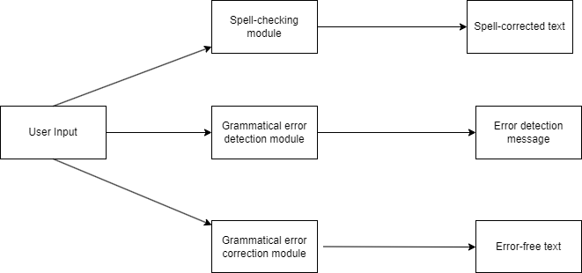

Figure 1- High-level design

- User Input Module:
  - Receives input text from the user through a user interface.
- Spell-Checking Module:
  - Utilizes a lexicon containing correctly spelled words.
  - Checks each word in the input text against the dictionary to identify misspelled words.
  - Provides suggestions for corrections based on similarity measure (Levenshtein distance).
- Grammatical Error Detection Module:
  - Analyzes the structure and syntax of sentences in the input text.
  - Identifies grammatical errors, particularly focusing on subject-verb agreement.
- Grammatical Error Correction Module:
  - Applies linguistic rules and patterns specific to the Kannada to rectify grammatical errors.
  - Focuses on correcting subject-verb agreement errors, tense inconsistencies, and other syntactical issues.
  - Implements rule-based approach.
  - Provides corrected versions of sentences containing grammatical errors.

4.2 Low-Level Design
4.2.1 Spell checking and correction
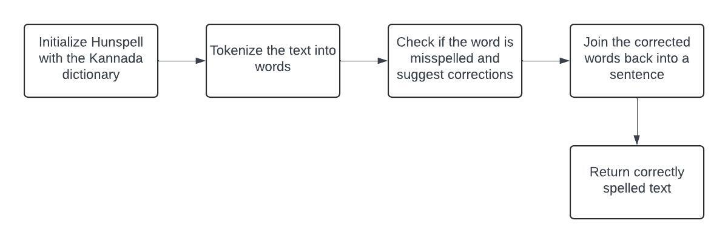
Figure 2- Spell checking and correction

- Importing Hunspell Library: The code begins by importing the `Hunspell` class from the `hunspell` module. This class is used for spell checking and suggesting corrections.
- Initializing Hunspell: Hunpell object is initialized by providing paths for dictionary and affix files. Input text is provided for spell checking.
- Tokenizing the Text: The input text is tokenized into individual words using the `split()` method. The words are stored in the a list.
- Checking and Correcting Spelling: For each word in the tokenized text, check if the word is misspelt. If the word is misspelt, corrections are suggested. If suggestions are available, the first suggestion is taken; otherwise, the original word is kept. The corrected words are stored in a list.
- Joining Corrected Words: The corrected words are joined back into a sentence using the `join()` method with space as the separator.
- Returning Corrected Text: The function returns the corrected Kannada text.

4.2.2 Grammatical error detection
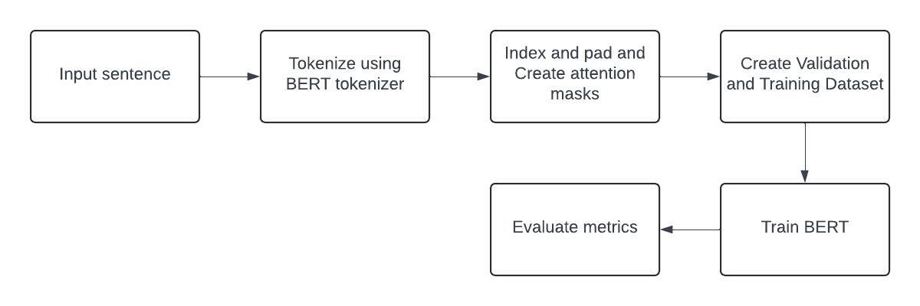
Figure 3- Grammatical error detection

- Database of Kannada Corpus:
  - Implementation: Create a database containing Kannada words and phrases from various sources.
- Data Preprocessing using Tokenization:
  - Tokenization: Implement a Kannada-specific tokenizer to break down the text into individual tokens.
  - Cleaning: Remove unnecessary characters, punctuation, and handle special symbols unique to Kannada.
- Divide the Data into Train, Test, and Validation Sets:
  - Splitting: Randomly divide the pre-processed data into training, testing, and validation sets.
- Load BERT Model and Compile for Training Data:
  - Model Loading: Load the DistilBERT model for Kannada.
  - Integration: Integrate the model with appropriate libraries/frameworks (e.g., TensorFlow, PyTorch).
  - Compile: Compile the BERT model with the training data using appropriate loss functions and optimizers.
- Performance Evaluation using Test Data and Freeze the Model:
  - Evaluation: Use the test set to evaluate the performance of the grammatical error detector.
  - Metrics: Calculate relevant metrics (accuracy, precision, recall) to assess the model's effectiveness.
  - Freezing: Save the model's weights and configurations to prevent further training (freezing).

4.2.3 Grammatical error correction
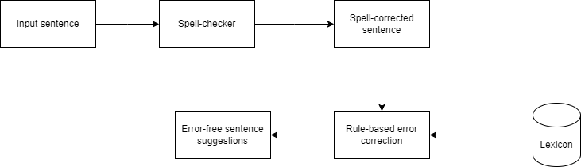
Figure 4- Grammatical error correction

In designing the rule-based approach for grammatical error correction in Kannada, special attention is directed towards addressing subject-verb agreement errors. Subject-verb agreement, a foundational aspect of grammar, ensures that the subject and verb in a sentence align in terms of number and person.
The low-level design of this rule-based approach revolves around leveraging linguistic rules and patterns unique to Kannada to detect and rectify subject-verb agreement discrepancies. This process entails the identification of both the subject and the verb within the sentence, followed by the application of relevant rules to ensure agreement between them.

Chapter 5
METHODOLOGY
5.1 Spell Checking and Correction using Hunspell
Hunspell is an open-source spell-checking and morphological analysis library designed for languages with complex morphology and rich inflections. Originally developed for the Hungarian language, Hunspell has evolved into a versatile tool supporting numerous languages and finding applications in various software applications.

5.1.1 Working of Hunspell
- Spell Checking: Hunspell is primarily known for its spell-checking capabilities. It checks the spelling of words against a given dictionary and provides suggestions for corrections when a word is misspelled. This is particularly useful for identifying and correcting typographical errors in written text.
- Morphological Analysis: The library goes beyond basic spell-checking by offering morphological analysis. It can break down words into their constituent morphemes, providing insights into word structure, inflections, and grammatical variations. This feature is especially valuable for languages with complex morphological patterns.
- Affix File Support: Hunspell uses a combination of dictionary files (`.dic`) and affix files (`.aff`) to perform spell-checking and morphological analysis. The dictionary file contains a list of valid words, while the affix file specifies the rules for word formations, including prefixes, suffixes, and inflections.
- Multi-Language Support: One of Hunspell's strengths is its ability to support multiple languages. Users can create or obtain dictionaries and affix files for different languages and use them with the library. This makes Hunspell a popular choice for developers working on applications that require internationalization and support for diverse linguistic contexts.
- Open Source and Cross-Platform: Hunspell is released under an open-source license, allowing users to view, modify, and distribute the source code. It is designed to be cross-platform, making it compatible with various operating systems, including Windows, Linux, and macOS.
- Integration with Software Applications: Hunspell is widely integrated into software applications, including word processors, text editors, and content management systems. It provides a reliable mechanism for checking and correcting spelling errors in a user-friendly manner. Popular software, such as LibreOffice, Mozilla Firefox, and many others, leverages the capabilities of Hunspell for language checking.

5.2 Grammatical Error Detection using BERT Model
BERT (Bidirectional Encoder Representations from Transformers) is a NLP Model proposed by researchers at Google Research in 2018. When it was proposed it achieved state-of-the-art accuracy on many NLP tasks.
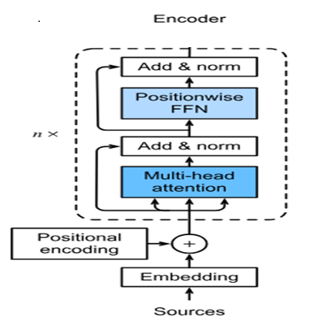
Figure 5- Working of BERT model

5.2.1 Working of the BERT model
BERT is basically an Encoder stack of transformer architecture. A transformer architecture is an encoder-decoder network that uses self-attention on the encoder side and attention on the decoder side. BERT_{BASE} has 12 layers in the Encoder stack while BERT_{LARGE} has 24 layers in the Encoder stack. These are more than the Transformer architecture described in the original paper (6 encoder layers). BERT architectures (BASE and LARGE) also have larger feedforward networks (768 and 1024 hidden units respectively), and more attention heads (12 and 16 respectively) than the Transformer architecture suggested in the original paper. It contains 512 hidden units and 8 attention heads. BERT_{BASE} contains 110M parameters while BERT_{LARGE} has 340M parameters.

This model takes the CLS token as input first, then it is followed by a sequence of words as input. Here CLS is a classification token. It then passes the input to the above layers. Each layer applies self-attention and passes the result through a feedforward network after then it hands off to the next encoder. The model outputs a vector of hidden size (768 for BERT BASE). If we want to output a classifier from this model we can take the output corresponding to the CLS token. Now, this trained vector can be used to perform a number of tasks such as classification, translation, etc.
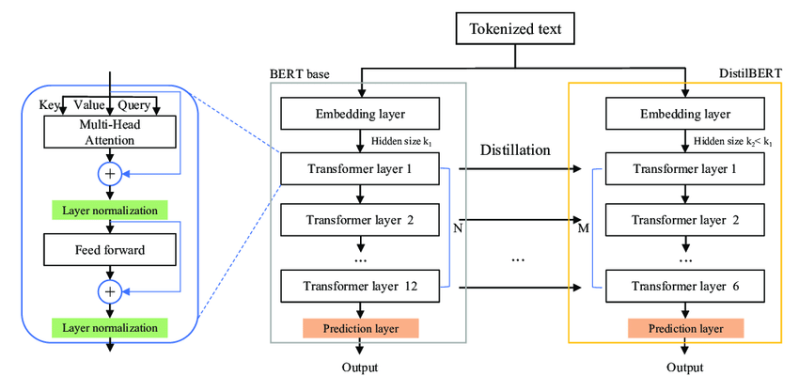
Figure 6- Working of DistilBERT

The proposed system makes use of the DistilBERT pre-trained model for training the data. DistilBERT is a small, fast, cheap and light Transformer model trained by distilling BERT base. It has 40% less parameters than google-BERT/BERT-base-uncased, and runs 60% faster while preserving over 95% of BERT’s performances as measured on the GLUE language understanding benchmark. DistilBERT aims to provide a computationally more efficient version of BERT while maintaining similar performance. It achieves this by applying a technique called "knowledge distillation," where a smaller model is trained to mimic the behaviour of a larger model. In the case of DistilBERT, it learns to mimic the representations generated by the original BERT model while being significantly smaller in terms of parameters and faster in terms of inference time.

5.3 Grammatical Error Correction using Rule-based approach
In grammatical error correction based on a rule-based approach for Kannada, particular emphasis is placed on rectifying subject-verb agreement errors. Subject-verb agreement is a fundamental aspect of grammar that ensures that the subject and verb in a sentence agree in number and person. This agreement is crucial for the clarity and coherence of the sentence.

This rule-based approach utilizes linguistic rules and patterns specific to Kannada to identify and correct subject-verb agreement errors. It involves identifying the subject and verb and applying appropriate rules to ensure agreement between them.
For example, in Kannada, when the subject is singular, the verb must also be singular, and when the subject is plural, the verb should be plural as well.
An example illustrating subject-verb agreement in Kannada:
- Singular subject: "ಅವನು ಹೋಗುತ್ತಾನೆ" (avanu hōguttāne) - "He goes."
- Plural subject: "ಅವರು ಹೋಗುತ್ತಾರೆ" (avaru hōguttāre) - "They go."
In the above examples, the verb "ಹೋಗುತ್ತಾನೆ" (hōguttāne) agrees with the singular subject "ಅವನು" (avanu) and the verb "ಹೋಗುತ್ತಾರೆ" (hōguttāre) agrees with the plural subject "ಅವರು" (avaru).

Chapter 6
IMPLEMENTATION
6.1 Spell-checker using Hunspell
The spell-checker module makes use of the Hunspell library of Python. It compares the input word against a lexicon and looks for affixes in an affix file. The lexicon contains 4879 commonly used Kannada words. Hunspell primarily uses Levenshtein distance as a measure to provide suggestions for misspelt words. Levenshtein distance, also known as edit distance, calculates the minimum number of single-character edits (insertions, deletions, or substitutions) required to change one word into another. When a word is not found in the dictionary, Hunspell searches for similar words within a specified Levenshtein distance and suggests them as potential corrections. These suggestions are based on words in the dictionary that are closest in terms of Levenshtein distance to the misspelt word.

6.2 Grammatical Error Detection
The grammatical error detection module makes use of the pre-trained DistilBERT model to detect grammatical errors. The model is fine-tuned using a custom dataset of 45,798 sentences in present and future tense with labels 0 and 1 indicating correct and incorrect sentences. The grammatical error detection module takes a sentence as input and gives a result indicating whether the subject-verb agreement criterion is met or not.

6.3 Grammatical Error Correction
The grammatical error correction module is designed using a rule-based approach. It focuses on present and future tenses to provide suggestions. It identifies the subject and verb by stemming each word and comparing it against a list of frequently used common nouns and verbs of Kannada. It then suggests verb corrections appropriate to the count, gender, and person of the subject.

6.4 User Interface
The user interface was designed to accept user input, pass it on to the model, and display output. The front-end was developed using html, CSS and Bootstrap. The backend was developed using Flask, which is a popular Python framework.

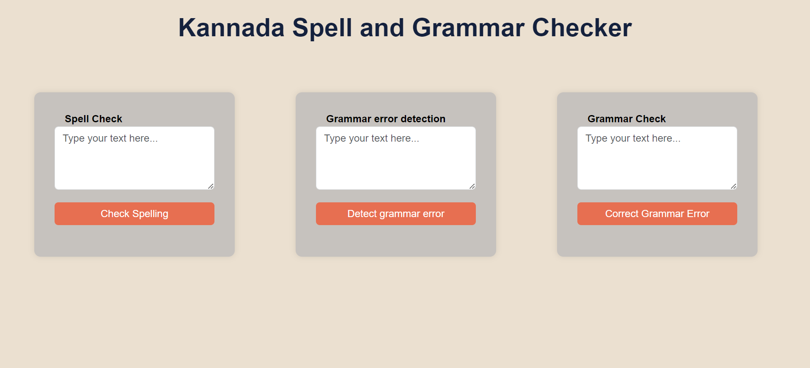
Figure 7- home page
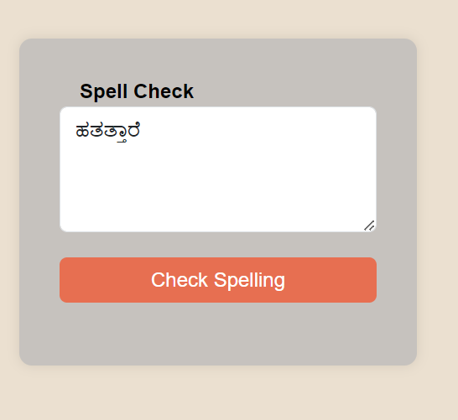
Figure 8- Spell-checker input
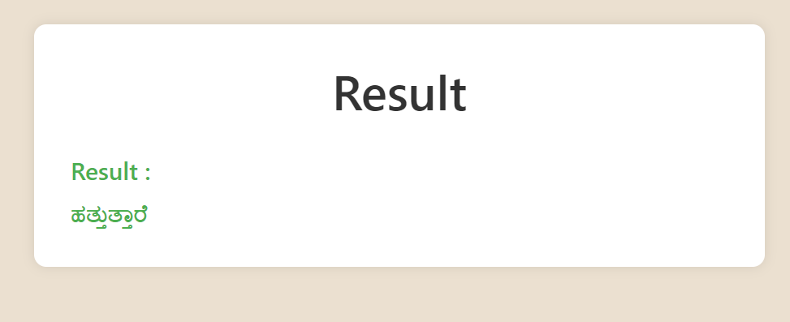
Figure 9- Spell-checker output

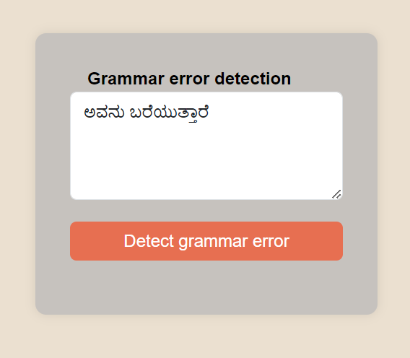
Figure 10- Grammatical error detector input
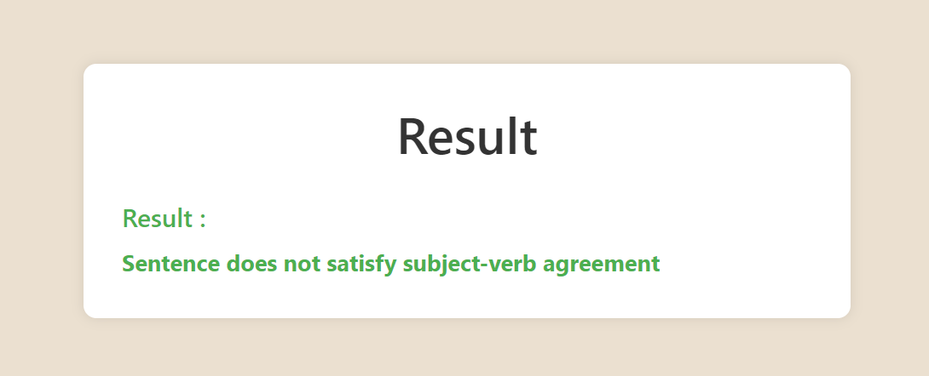
Figure 11- Grammatical error detector output
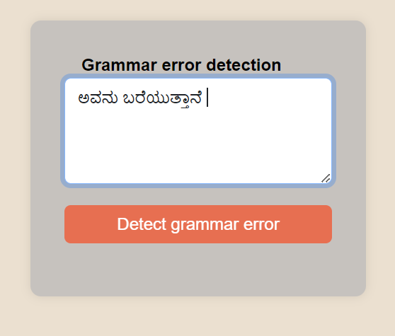
Figure 12- Grammatical error detector input
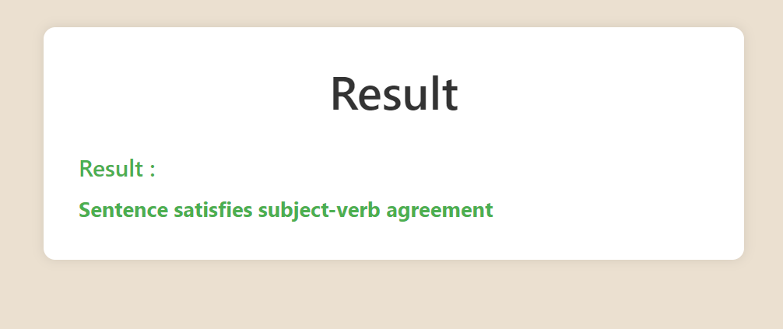
Figure 13- Grammatical error detector output

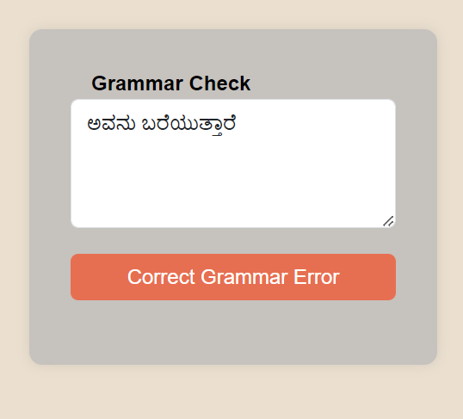
Figure 14- Grammatical error corrector input
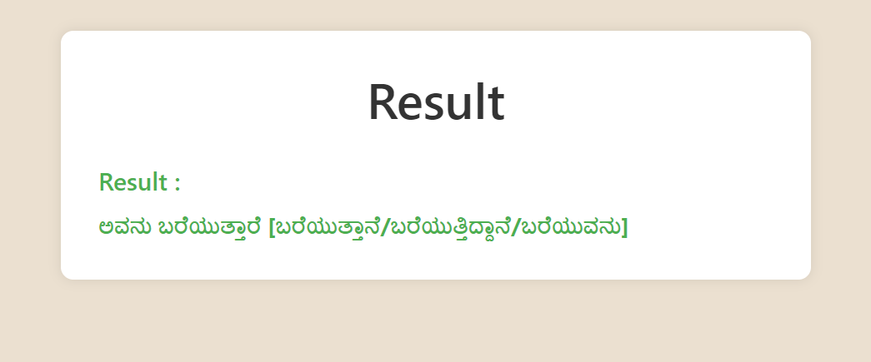
Figure 15- Grammatical error corrector output

Chapter 7
RESULTS AND DISCUSSION
7.1 Spell-checker using Hunspell
The Kannada spell-checker underwent testing with a sample of 20 randomly selected words containing errors. Out of these, expected corrections were provided for 16 words, resulting in an accuracy rate of 80%. This indicates that the spell-checker successfully identified and rectified errors in the majority of the tested words.

7.2 Grammatical error detection using the BERT model
The Kannada grammatical error detection model was trained using DistilBERT. It was able to achieve an accuracy of 92% on the test set containing 5088 sentences.
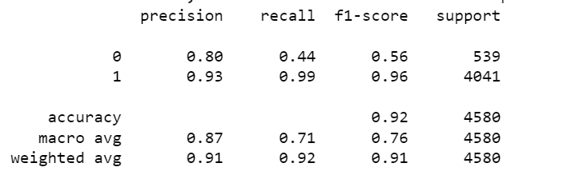
Figure 12- Grammatical error detector classification report

7.3 Grammatical error correction using rule-based approach
The Kannada grammatical error correction module was tested with a sample of 20 randomly chosen sentences in present and future tense, containing errors. Out of these, expected corrections were provided for 18 sentences, resulting in an accuracy rate of 90%.

Bibliography
- Caryappa, B. C., Hulipalled, V. R., & Simha, J. B. (2020, October). Kannada grammar checker using LSTM neural network. In 2020 International Conference on Smart Technologies in Computing, Electrical and Electronics (ICSTCEE) (pp. 332-337). IEEE.
- Omelianchuk, K., Atrasevych, V., Chernodub, A., & Skurzhanskyi, O. (2020). GECToR--grammatical error correction: tag, not rewrite. arXiv preprint arXiv:2005.12592.
- Mesham, S., Bryant, C., Rei, M., & Yuan, Z. (2023). An Extended Sequence Tagging Vocabulary for Grammatical Error Correction. arXiv preprint arXiv:2302.05913.
- Sonawane, A., Vishwakarma, S. K., Srivastava, B., & Singh, A. K. (2020, December). Generating inflectional errors for grammatical error correction in Hindi. In Proceedings of the 1st Conference of the Asia-Pacific Chapter of the Association for Computational Linguistics and the 10th International Joint Conference on Natural Language Processing: Student Research Workshop (pp. 165-171).
- Saluja, R., Adiga, D., Chaudhuri, P., Ramakrishnan, G., & Carman, M. (2017, November). Error detection and corrections in Indic OCR using LSTMs. In 2017 14th IAPR International Conference on Document Analysis and Recognition (ICDAR) (Vol. 1, pp. 17-22). IEEE.
- Aziz, R., Anwar, M. W., Jamal, M. H., & Bajwa, U. I. (2021). A hybrid model for spelling error detection and correction for Urdu language. Neural Computing and Applications, 33, 14707-14721.
- Gupta, P. (2020, February). A context-sensitive real-time Spell Checker with language adaptability. In 2020 IEEE 14th International Conference on Semantic Computing (ICSC) (pp. 116-122). IEEE.
- Azmi, A. M., Almutery, M. N., & Aboalsamh, H. A. (2019). Real-word errors in Arabic texts: A better algorithm for detection and correction. IEEE/ACM Transactions on Audio, Speech, and Language Processing, 27(8), 1308-1320.
- Faisal, A. M. F., Rahman, M. A., & Farah, T. (2021, July). A rule-based bengali grammar checker. In 2021 Fifth World Conference on Smart Trends in Systems Security and Sustainability (WorldS4) (pp. 113-117). IEEE.
- Gondaliya, Y., Kalariya, P., Panchal, B. Y., & Nayak, A. (2022). A Rule-based Grammar and Spell Checking.
- Pabasara, H. M. U., & Jayalal, S. (2020, September). Grammatical error detection and correction model for Sinhala language sentences. In 2020 International Research Conference on Smart Computing and Systems Engineering (SCSE) (pp. 17-24). IEEE.
- Akshatha, A. N., Upadhyaya, C. G., & Murthy, R. S. (2016). Kannada Spell Checker with Sandhi Splitter. arXiv preprint arXiv:1611.08358.
- Ramaneedi, S., & Pati, P. B. (2023, April). Kannada Textual Error Correction Using T5 Model. In 2023 IEEE 8th International Conference for Convergence in Technology (I2CT) (pp. 1-5). IEEE.
- Hao, S., & Hao, G. (2020, November). A research on online grammar checker system based on neural network model. In Journal of Physics: Conference Series (Vol. 1651, No. 1, p. 012135). IOP Publishing.
- Wang, Q., & Tan, Y. (2020, July). Grammatical error detection with self attention by pairwise training. In 2020 International Joint Conference on Neural Networks (IJCNN) (pp. 1-7). IEEE.
- Murugan, S., Bakthavatchalam, T. A., & Sankarasubbu, M. (2020). SymSpell and LSTM based Spell-Checkers for Tamil.

