

**INDIRA GANDHI DELHI TECHNICAL UNIVERSITY FOR WOMEN**

REPORT

**Assessment of pH, conductivity, and total dissolved salts in water samples from the Delhi NCR region was conducted.**

**Name of the Authors:**

Aanya Singh (00401012023)

Akshita Sharma (01501012023)

Ananya Sharma (02301012023)

Atreyi Prasad (03601012023)

**AFFILIATION**

We would like to express our gratitude towards Mr. Bhavani Prasad for guiding us throughout the project,Assessment of pH, conductivity, and total dissolved salts in water samples from the Delhi NCR region and helping to complete it successfully.

We also extend our sincere gratitude to the IGDTUW Computer Science and Engineering (CSE) department and the Environmental Science laboratory for providing invaluable support and facilities throughout the course of this research. Their assistance has been instrumental in the successful completion of this study.

**ABSTRACT**

The purpose of this experiment was to ensure the supply of safe and clean water to everyone regarding public safety. This report deals with the three major parameters such as pH, Conductivity, and Total Dissolved Salts (TDS) that were determined in the lab to study the quality of water supplied in different parts of Delhi, India.

Water quality assessment is crucial for ensuring the safety and sustainability of drinking water sources. By analysing these parameters, we aim to assess the variations in water quality across different regions of Delhi NCR and identify potential sources of contamination or variations.

Understanding these variations is essential for implementing effective water management strategies and ensuring access to safe drinking water for residents. The findings of this study contribute to the broader goal of enhancing water quality monitoring and management efforts in urban environments, particularly in rapidly growing metropolitan areas like Delhi.

Thus, this report discusses the parameters that indicate the quality of domestic water and are followed by a detailed subjective analysis.

**INTRODUCTION**

Water is the most important solvent both industrially and biologically. So, its varied purpose depends on factors like pH, conductivity and TDS.

Discussing these parameters in water quality studies is crucial for assessing health risks, identifying contamination sources & determining treatment needs.

**pH of Water**

pH is a determined value based on a defined scale, similar to temperature. This means that pH of water is not a physical parameter that can be measured as a concentration or in a quantity. Instead, it is a figure between 0 and 14 defining how acidic or basic a body of water is along a logarithmic scale.

## **Why is pH Important?**

If the pH of water is too high or too low, the aquatic organisms living within it will die. pH can also affect the solubility and toxicity of chemicals and heavy metals in the water. The majority of aquatic creatures prefer a pH range of 6.5-9.0, though some can live in water with pH levels outside of this range.

## **Factors that Influence the pH of Water**

There are many factors that can affect pH in water, both natural and man-made. Most natural changes occur due to interactions with surrounding rock (particularly carbonate forms) and other materials. pH can also fluctuate with precipitation (especially acid rain) and wastewater or mining discharges. In addition, CO2 concentrations can influence pH levels.

## **Permissible Values**

|  |  |
| --- | --- |
| pH Range | Drinkability |
| 0-6.5 | Acidic: Unsafe |
| 6.5-8.5 | Slightly acidic-basic: Safe |
| 8.5-14 | Basic: Unsafe |

**Conductivity of Water**

The conductivity of water is a measure of the capability of water to pass electrical flow. This ability directly depends on the concentration of conductive ions in the water. 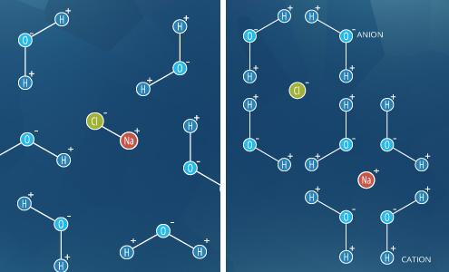

These conductive ions originated due to inorganic materials such as chlorides, alkalis, carbonate and sulphide compounds and dissolved salts. It is measured in Siemens per meter [S/m].

## **Why is Conductivity Important?**

Conductivity, in particular specific conductance, is one of the most useful and commonly measured water quality parameters 3. In addition to being the basis of most salinity and total dissolved solids calculations, conductivity is an early indicator of change in a water system. Most bodies of water maintain a fairly constant conductivity that can be used as a baseline of comparison to future measurements 1. Significant change, whether it is due to natural flooding, evaporation or man-made pollution can be very detrimental to water quality.

## **Factors affecting conductivity**

There are three main factors that affect the conductivity of a solution: the concentrations of ions, the type of ions, and the temperature of the solution.

**The concentration of dissolved ions:** As each ion is able to carry an electrical charge, water with more ions present is able to conduct a greater amount of current.

**The types of ions in solution:**Different ions have different abilities to transmit charge. Inorganic ions such as Na+, K+, Mg+2, Ca+2, HCO 3-, Cl- and SO4-2, tend to conduct electricity well, although each ion has a different ability to conduct electricity. This depends on factors such as the charge of the ion, its size, and its tendency to interact with water molecules.

**Temperature:** This is a relatively small, but significant, effect. Because ions can move faster in warmer water, the conductivity of water increases with rising temperature. Conductivity will increase by approximately 1.9% for each 1°C increase in temperature.

## **Permissible Values**

|  |  |
| --- | --- |
| Types of water | Conductivity Value |
| Pure distilled and Deionized water | 0.05 µS/cm |
| Seawater | 50 mS/cm |
| Drinking water | 200 to 800 µS/cm. |
| Rain or Snow water | 2 to 100 µS/cm |

**Total Dissolved Salts (TDS)**

Total dissolved solids (TDS) combine the sum of all ion particles that are smaller than 2 microns (0.0002 cm) . This includes all of the disassociated electrolytes that make up salinity concentrations, as well as other compounds such as dissolved organic matter. In “clean” water, TDS is approximately equal to salinity. In wastewater or polluted areas, TDS can include organic solutes (such as hydrocarbons and urea) in addition to the salt ions .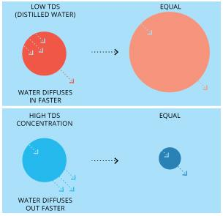

**Why is TDS value important?**

Dissolved solids are also important to aquatic life by keeping cell density balanced. In distilled or deionized water, water will flow into an organism’s cells, causing them to swell. In water with a very high TDS concentration, cells will shrink. These changes can affect an organism’s ability to move in a water column, causing it to float or sink beyond its normal range. TDS can also affect water taste, and often indicates a high alkalinity or hardness.

## **Factors Affecting TDS Levels in Water?**

The quality of the inlet water is one of the most important factors affecting the**TDS levels in water**. If the inlet water has a high TDS level, the percentage increase in TDS levels in the rejected water will be higher. Other factors that can affect the TDS levels in the rejected water include the design of the RO system, the type of membranes used, and the operating conditions, such as the pressure and flow rate.

## **Permissible Values**

|  |  |
| --- | --- |
| TDS in water (ppm) | Drinkability |
| Less than 300 | Excellent for drinking |
| 300-600 | Good |
| 600-900 | Fair |
| 900-1200 | Poor |
| Above 1200 | Unacceptable |

**EXPERIMENT**

**AIM**

To evaluate the quality of water sample by analysing three key parameters: pH, conductivity, and Total Dissolved Salts (TDS).

## **MATERIAL REQUIRED**

* 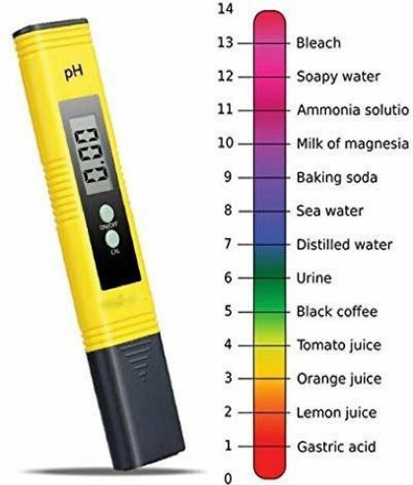**pH Meter**

A pH meter is an instrument used to measure hydrogen ion activity in solutions - in other words, this instrument measures acidity/alkalinity of a solution. The degree of hydrogen ion activity is ultimately expressed as pH level, which generally ranges from 1 to 14.

​This pH measurement is directly related to the ratio of hydrogen ion concentration and hydroxyl ion concentration ([H+] and [OH-], respectively). The general breakdown of pH levels is listed below:

* Neutral solution: pH = 7
* Acidic solution: pH <7
* Basic solution: pH > 7

* **Conductivity Meter**

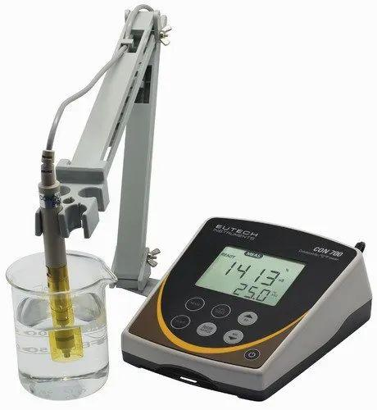Conductivity meter allows us to measure the level of conductivity in solutions. Conductivity is an ability of materials (solutions, metals or gases) to pass an electric current. While all materials possess the ability to pass electric currents, the degree of such ability can vary.

These electrolytes are able to break down into ions when dissolved in water, thus creating free ions in the solution. *Acids, bases, and salts* are examples of electrolytes. Substances with non-conductive aqueous solutions are referred to as *nonelectrolytes*. These substances are often composed of covalent bonds, and examples include Carbon-containing compounds, fat, and sugar.

* 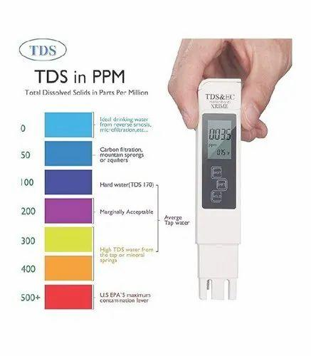**TDS Meter**

A TDS meter is a small hand-held device used to indicate the Total Dissolved Solids in a solution, usually water. Since dissolved ionized solids, such as salts and minerals, increase the conductivity of a solution, a TDS meter measures the conductivity of the solution and estimates the TDS from that reading.

A high TDS level means you have an abundance of dissolved solids in your water, which typically includes minerals. Over time, the constant presence of these minerals in your water can lead to scale buildup in your pipes and appliances which shortens their lifespan and effectiveness.

By knowing your TDS level, you can determine whether you need something to combat this issue, like a salt-free water conditioner or a water softener for, especially hard water.

* **Water sample**

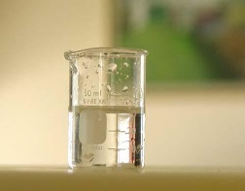Sample of water collected from different parts of Delhi (Central Delhi, North Delhi, South Delhi, West Delhi, East Delhi, North-West Delhi, South-West Delhi and Delhi NCR).

* 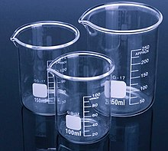**Beaker**

In laboratory equipment, a beaker is generally a cylindrical container with a flat bottom. Most also have a small spout to aid pouring, as shown in the picture.

Beakers are available in a wide range of sizes, from one milliliter up to several liters.

**PROCEDURE:**

**Calibration Process**

1. Connect the pH meter and power it on.

2. Prepare a 100 mL beaker with a pH 7 standard buffer solution and note its temperature.

3. Adjust the pH meter's temperature control accordingly.

4. Rinse the combination electrode with distilled water and dry it gently.

5. Connect the combination electrode to the input socket and immerse it in the pH 7 buffer solution.

6. Set the Function Selector Switch to pH and calibrate using the 'Calibrate' control until the display shows pH 7.

7. Move the switch to 'Standby'.

8. Rinse the electrode with distilled water and dry it.

9. Dip the electrode into a pH 4 buffer solution.

10. Adjust the temperature and calibrate using the 'Slope Correction' control until the display reads pH 4.

**pH Measurement**

1. Rinse the combination electrode and connect it to the input socket.

2. Immerse the electrode into the test solution.

3. Set the Temperature knob to match the solution's temperature.

4. Set the Function Selector Switch to pH.

5. Record the pH reading.

6. Repeat the procedure for each water sample.

**Conductivity Measurement**

1. Thoroughly wash the conductivity cell with distilled water.

2. Rinse the cell several times with KCl solution.

3. Prepare an adequate volume of KCl solution in a beaker and record its temperature.

4. Connect the instrument to the power mains and turn it on using the power switch. Connect the electrode leads to the input sockets at the rear of the instrument.

5. Set the 'Function' switch to the 'check' position and adjust the display to 1.000 using the CAL control on the back panel.

6. Immerse the conductivity cell in the KCl solution and adjust the temperature knob of the conductivity bridge to match the solution temperature.

7. Switch the 'Function' switch to the 'conductance' position and select the appropriate range.

8. Adjust the cell constant knob until the display shows the known value of the KCl solution at the given temperature.

9. Set the 'Function switch' to the 'cell constant' position and read the value displayed on the window.

10. Take a 100 ml sample of the water and record its conductivity.

11. Repeat the conductivity measurement for each sample.

**TDS MEASUREMENT**

1. Connect the conductivity meter with the main power supply.
2. Tap on the TDS mode to observe the value of TDS.
3. Take 50 ml of water sample in the beaker.
4. Dip the electrode connected to the conductivity meter into the beaker containing the sample.
5. The screen of the instrument will start displaying the some numbers(unstable) as soon as the electrode is dipped in water.
6. Note down the stable water value displayed in the conductivity meter.

## **OBSERVATIONS**

|  |  |  |  |  |
| --- | --- | --- | --- | --- |
| Name of location |  | pH | Conductivity  (micro-S) | TDS  (ppm) |
| Central Delhi | 1 | 7.6 | 513 | 199 |
| 2 | 8.3 | 323 | 246 |
| 3 | 7.7 | 440 | 286 |
| 4 | 7.6 | 289 | 312 |
| 5 | 8.1 | 525 | 376 |
| North Delhi | 1 | 7.2 | 268 | 109 |
| 2 | 7.3 | 353 | 112 |
| 3 | 7.6 | 513 | 199 |
| 4 | 7.4 | 275 | 305 |
| 5 | 7.7 | 243 | 275 |
| East Delhi | 1 | 7.2 | 333 | 393 |
| 2 | 7.6 | 434 | 102 |
| 3 | 8.3 | 285 | 147 |
| 4 | 7.2 | 573 | 346 |
| 5 | 8.4 | 232 | 181 |
| North-West Delhi | 1 | 8.4 | 202 | 129 |
| 2 | 7.4 | 704 | 196 |
| 3 | 8.1 | 234 | 109 |
| 4 | 7.4 | 173 | 149 |
| 5 | 7.3 | 423 | 451 |
| South Delhi | 1 | 8.4 | 206 | 310 |
| 2 | 8.5 | 588 | 536 |
| 3 | 7.6 | 368 | 221 |
| 4 | 8.3 | 206 | 312 |
| 5 | 7.5 | 245 | 287 |
| South-West Delhi | 1 | 8.3 | 334 | 450 |
| 2 | 7.3 | 215 | 387 |
| 3 | 8.1 | 336 | 520 |
| 4 | 7.9 | 191 | 588 |
| 5 | 7.4 | 253 | 423 |

|  |  |  |  |  |
| --- | --- | --- | --- | --- |
| West Delhi | 1 | 7.3 | 523 | 450 |
| 2 | 8.2 | 292 | 278 |
| 3 | 8.3 | 667 | 109 |
| 4 | 8.3 | 303 | 452 |
| 5 | 7.8 | 321 | 512 |
| Delhi-NCR | 1 | 7.9 | 257 | 246 |
| 2 | 7.2 | 198 | 510 |
| 3 | 8.4 | 235 | 162 |
| 4 | 8.0 | 210 | 763 |
| 5 | 7.6 | 345 | 326 |

**CALCULATIONS**

|  |  |  |  |  |  |  |  |  |
| --- | --- | --- | --- | --- | --- | --- | --- | --- |
| Area | Central Delhi | North Delhi | East  Delhi | North-West Delhi | South Delhi | South-West Delhi | West  Delhi | Delhi  NCR |
| pH  (mean) | 7.86 | 7.44 | 7.74 | 7.72 | 8.06 | 7.8 | 7.98 | 7.82 |
| TDS  (mean) | 283.8 | 200 | 233.8 | 206.8 | 333.2 | 473.6 | 360.2 | 401.4 |
| Conductivity | 418 | 330.4 | 371.4 | 347.2 | 322.6 | 265.8 | 421.2 | 249 |

**RESULTS AND DISCUSSIONS**

References

<https://www.fondriest.com/environmental-measurements/parameters/water-quality/ph/>

<https://byjus.com/physics/conductivity-of-water/>

<https://www.omega.com/en-us/resources/ph-meter/>

<https://group.chem.iastate.edu/Holme/augmented-reality-in-educational-laboratories/ph-meter/>

https://www.britannica.com/technology/TDS-meter/