LeetCode 2235 | Add Two Integers
Module 1 • C Programming • Accepted Submission
Problem statement link: https://leetcode.com/problems/add-two-integers/
Problem: Given two integers num1 and num2, return their sum.
C source code
int sum(int num1, int num2) {
return num1 + num2;
}
Successful submission screenshot
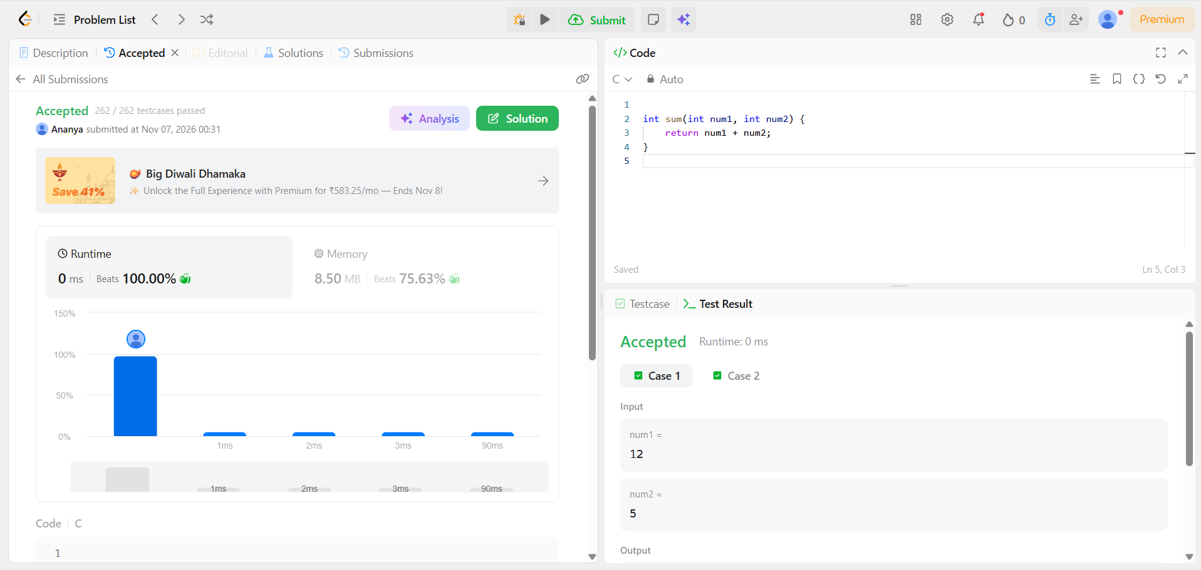
LeetCode result: Accepted | 262 / 262 test cases passed | Language: C

