**Ma 1024 Exam #2** (print neatly) **name**:_____________________

no electronics of any kind, no notes, no books. Ruler OK. Extra paper OK

Show all steps leading to your results if you wish full credit.

1. Consider the surface **z = 196 - 4x2 - 4y2** above the x-y plane
2. **sketch** it
3. set up an integral that would provide the **volume** inside it (do not integrate it)
4. set up an integral that would provide it’s **surface area** (do not integrate)
5. set up an integral that would determine the total **flux** thru the surface of the vector field given by 

please clearly number the sections of your work **( a), b)** etc ) and note that there is a **second**, blank page to use as well.

1. Convert to polar and integrate: 
2. Consider first the upper half of **z2 = (x2 + y2)/3** and assume it is capped by the plane **z = 20.**

Please **set up** an integral in the coordinate system of your choice, which would, if integrated, give its **volume**. Do ***not*** actually integrate.

1. Discuss one ***application*** *o*f **the concept of flux thru a surface** . No computations needed.

**bonus** ( 0.5 points possible) Discuss one interesting thing about cones that you learned in this course.

**Formulas and information of possible interest**

1. spherical coordinate info





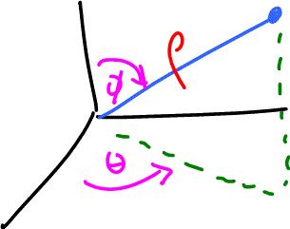

1. cylindrical **dV = r dz dr dθ**
2.  (Pythagorean Theorem)
3. **SOH CAH TOA**

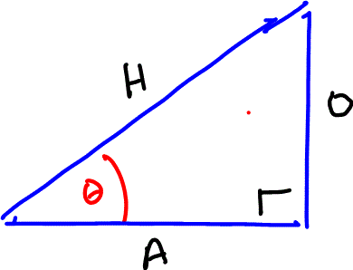

1. **Cross Product**



= < a2 b3 – a3 b2 , a3 b1 - a1 b3, a1 b2 - a2 b1 >