# Laboratory Assignment 1: Introduction to Mechanisms

# Team Members

|  |  |  |  |  |  |
| --- | --- | --- | --- | --- | --- |
|  |  | |  |  | |
| Victoria Heffern | |  | Derik Pignone | |  | Ananya Srinivasa-Gopalan |

# Lab Signoffs*

|  |  |  |
| --- | --- | --- |
| **Task** | **Instructor/TA/SA** | **Date/Time** |
| All Team Members Watched Pre-Lab Video | ***Nathan Savard*** | ***9/10/20 2:30pm*** |
| 4 Inversions of Four-bar (Grashof) | X |  |
| 1 Inversion of Four-bar (Non-Grashof) | X |  |
| Demo Rotation of Six-bar SolidWorks Assemblies (Different Inversion for each Team Member) | X |  |
| Completed Team Robotics Kit BOM Signoff | X |  |

*\***You will be given access to an online file that indicates your signoff status.*

*Team Notes:*

*\* Note that for the grashof link lengths, values given correspond as follows:*

*5 🡪 90mm*

*4 🡪 75mm*

*3 🡪 60mm*

*2 🡪 45mm (this part was also missing from our kit)*

*1 🡪 30mm*

1. A. Grashof Four-bar

***Link Lengths***

Link 1 ____1_____ Link 2 ____4____ Link 3 ____3____

Link 4 ____5____

***Type of Joint***

Joint A (Link 1 to 2) ____Full____ Joint B (Link 2 to 3) ___Full_____

Joint C (Link 3 to 4) ____Full____ Joint D (Link 4 to 1) __Full______

***Mobility Calculation***

***Show work:***

M = 3(4-1)-2(4)-(0)=3(3)-8=9-8=1

***Grashof Condition***

S + L < = > P + Q

__1__ + __5___ __<___ __4__ + __3____ Grashof? YES/NO

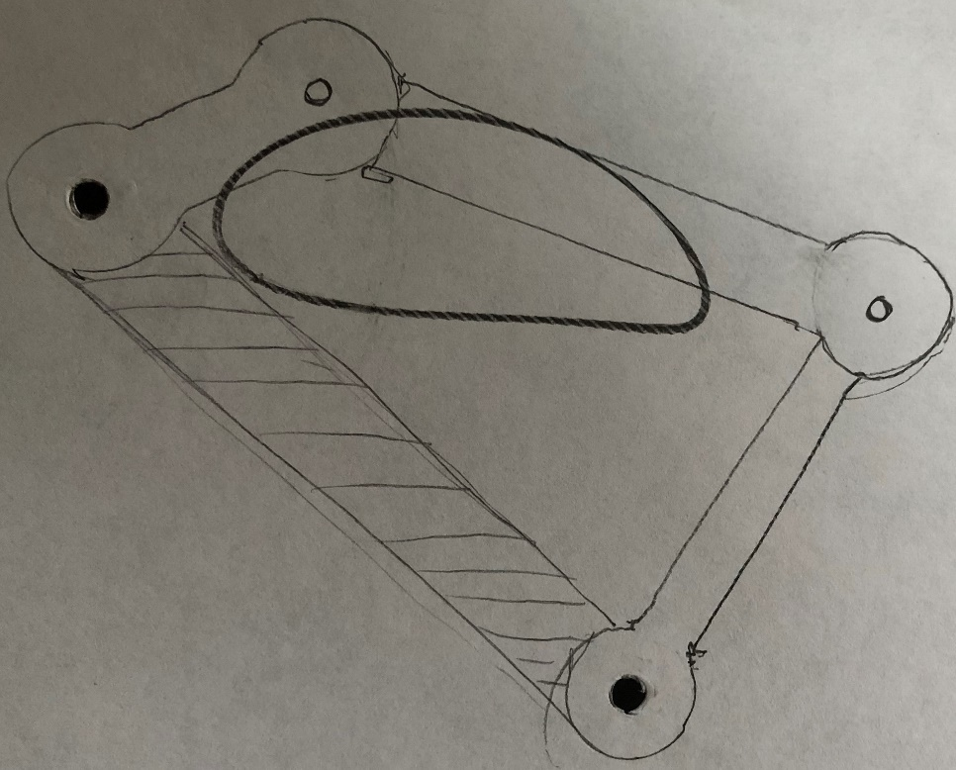

1. B. Grashof Four-bar

***Link Lengths***

Link 1 ____1_____ Link 2 __5_____ Link 3 ____3____

Link 4 ___4_____

***Type of Joint***

Joint A (Link 1 to 2) ____Full____ Joint B (Link 2 to 3) ___Full_____

Joint C (Link 3 to 4) ____Full____ Joint D (Link 4 to 1) __Full______

***Mobility Calculation***

***Show work:***

M = 3(4-1)-2(4)-(0)=3(3)-8=9-8=1

***Grashof Condition***

S + L < = > P + Q

_1___ + __5___ __<___ __3__ + __4____ Grashof? YES/NO

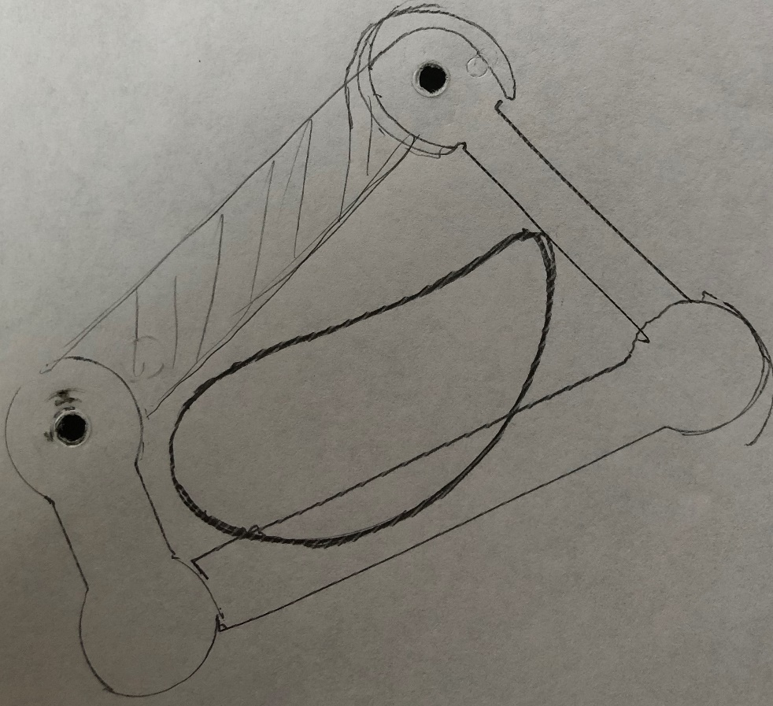

1. C. Grashof Four-bar

***Link Lengths***

Link 1 ____4_____ Link 2 ____3___ Link 3 __5______

Link 4 ____2____

***Type of Joint***

Joint A (Link 1 to 2) ____Full____ Joint B (Link 2 to 3) ___Full_____

Joint C (Link 3 to 4) ____Full____ Joint D (Link 4 to 1) __Full______

***Mobility Calculation***

***Show work:***

M = 3(4-1)-2(4)-(0)=3(3)-8=9-8=1

***Grashof Condition***

S + L < = > P + Q

__2__ + __5___ __=___ __4__ + ___3___ Grashof? YES/NO

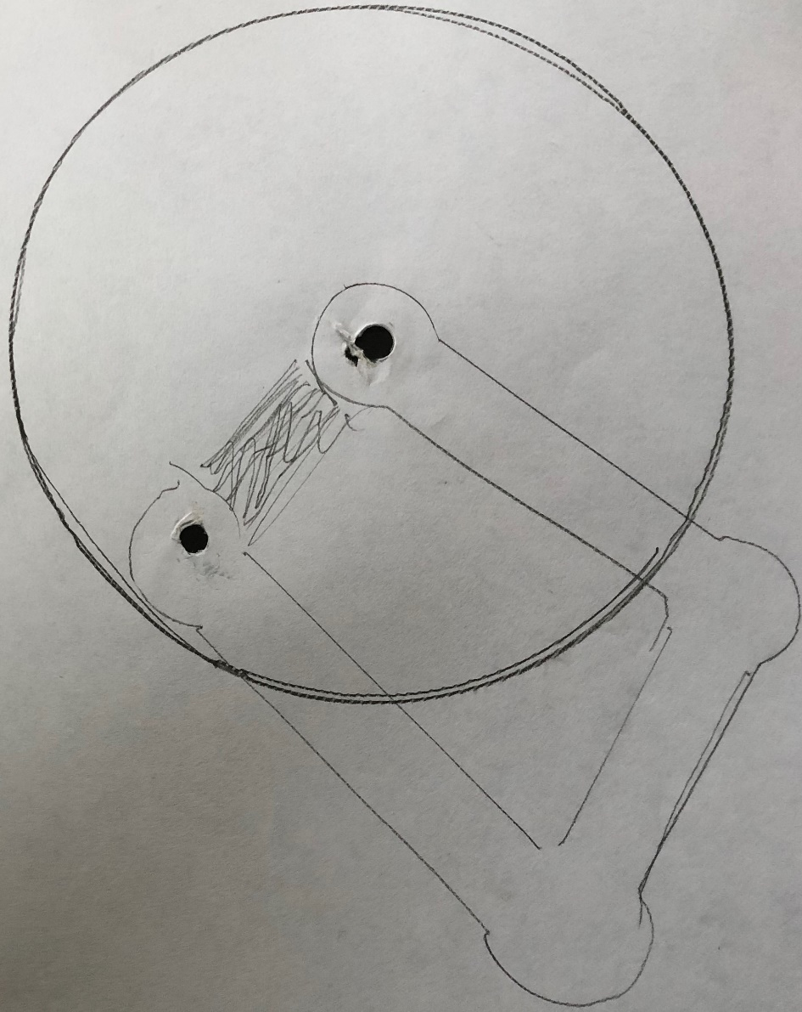

1. D. Grashof Four-bar

***Link Lengths***

Link 1 ____5_____ Link 2 _____1__ Link 3 ____3____

Link 4 ___4_____

***Type of Joint***

Joint A (Link 1 to 2) ____Full____ Joint B (Link 2 to 3) ___Full_____

Joint C (Link 3 to 4) ____Full____ Joint D (Link 4 to 1) __Full______

***Mobility Calculation***

***Show work:***

M = 3(4-1)-2(4)-(0)=3(3)-8=9-8=1

***Grashof Condition***

S + L < = > P + Q

__1__ + __5___ ___<__ __3__ + ___4___ Grashof? YES/NO

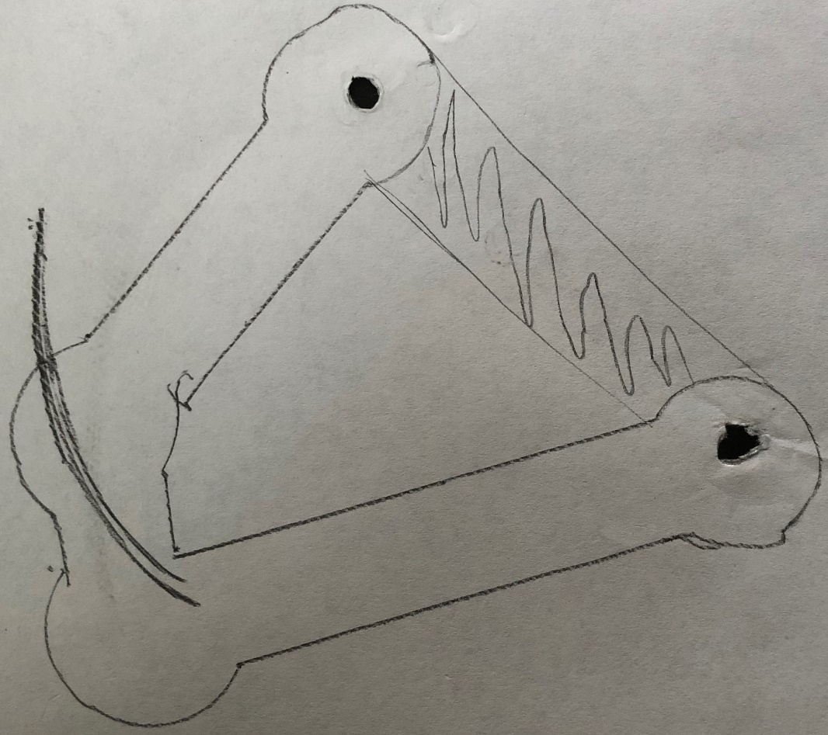

1. Non-Grashof Four-bar (Triple Rocker)

***Link Lengths***

Link 1 ____4_____ Link 2 ____5____ Link 3 ___3____

Link 4 ____7____

***Type of Joint***

Joint A (Link 1 to 2) ____Full____ Joint B (Link 2 to 3) ____Full____

Joint C (Link 3 to 4) ___Full_____ Joint D (Link 4 to 1) ____Full____

***Mobility Calculation***

***Show work:***

M = 3(4-1)-2(4)-(0)=3(3)-8=9-8=1

***Grashof Condition***

S + L < = > P + Q

___3_ + ___7__ __>___ _4___ +___5__ Grashof? YES/NO

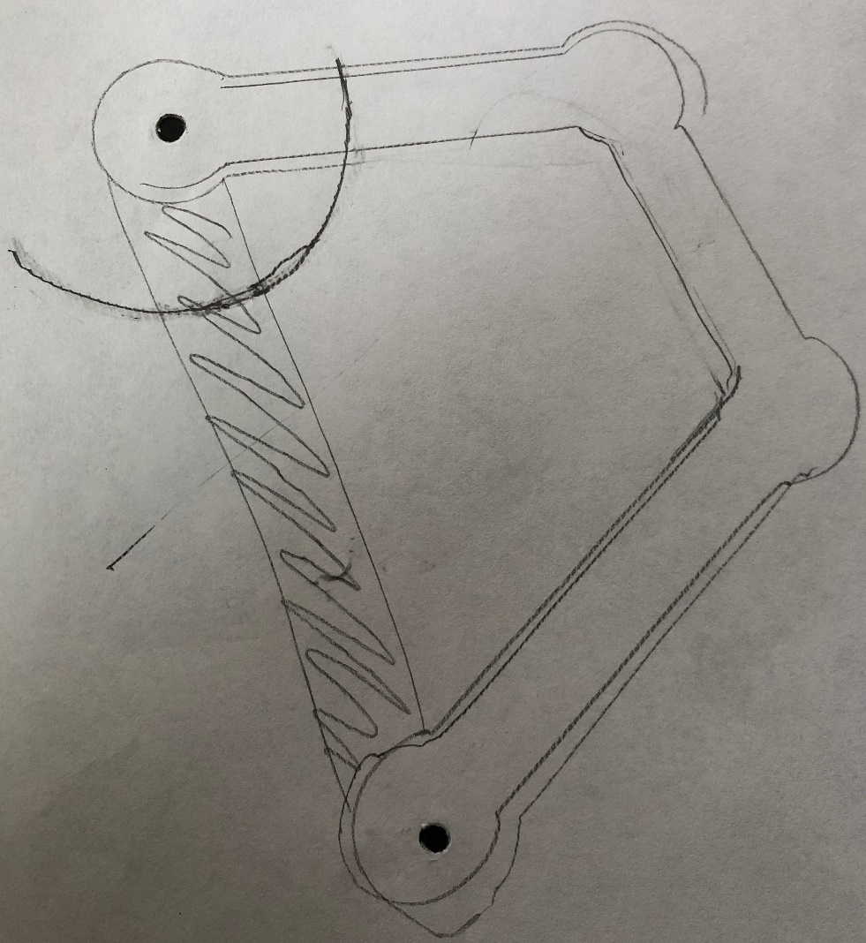

1. Discuss the problems encountered when constructing the physical three dimensional devices as compared to the theoretical planar mechanisms?

*One of the problems we encountered when constructing the physical three-dimensional models is collisions that were not anticipated/expected within the theoretical plane. The thickness and placement of the actual parts, as well as their friction results in differences that were not accounted for.*

1. Include your bill of material and your exploded view 6 bar mechanism from SolidWorks.

*Files have been submitted to the corresponding drop box on canvas*

1. a. The transistor switching frequency___ 13.02 kHz _______

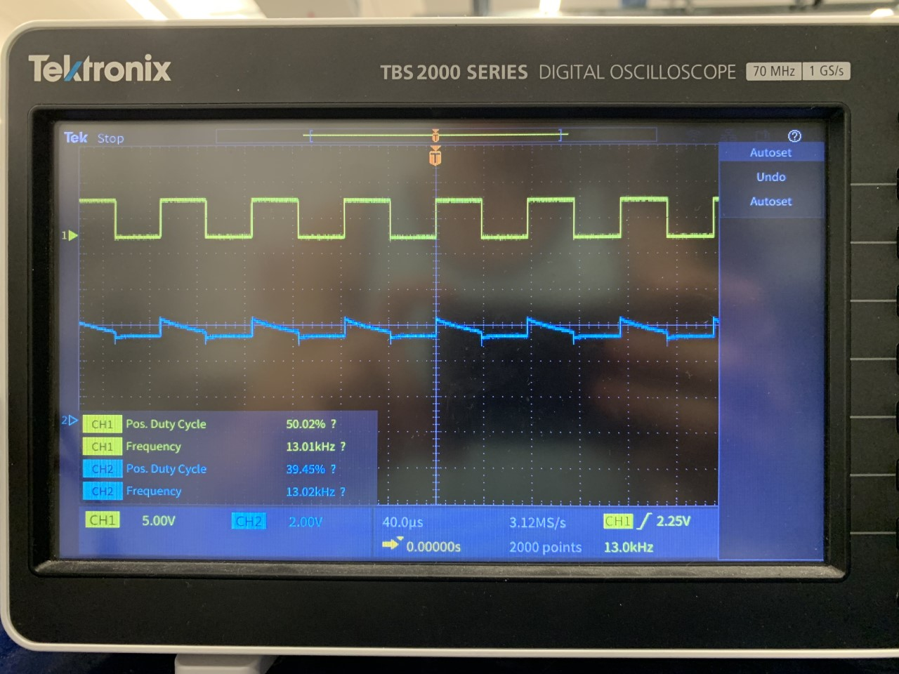

b. Name and describe the 4 modes of operation of a transistor?

The four modes of operation of a transistor are reverse active, saturation, cut-off and forward active. Active means that the current from the emitter to the collector is proportional to the current flowing into the base, while reverse active is the same but with a reverse flow (emitter to collector). In saturation mode, the transistor is a short circuit with a freely flowing current from collector to emitter, and in cut-off the transistor acts as an open circuit with no current from collector to emitter.

c. Under normal use cases, which mode should not be utilized?

The mode that should not be utilized in normal cases is reverse active.

d. If you were given a PNP transistor instead would you design a high or low side switching circuit? __X___High Side ______ Low Side

e. Why do most high power DC motor drivers use MOSFETS instead of BJT’s?

Most high power DC motor drivers use MOSFETS instead of BJT’s because the BJT current comes from the same source/supply as the load, leading to power loss.

1. Relay
   1. Determine the maximum speed the relay can switch by comparing an input frequency to an output frequency. The maximum frequency is when the relay is no longer releasing. Bouncing of the contact should be ignored for this exercise.

The maximum speed the relay can switch is 127 Hz.

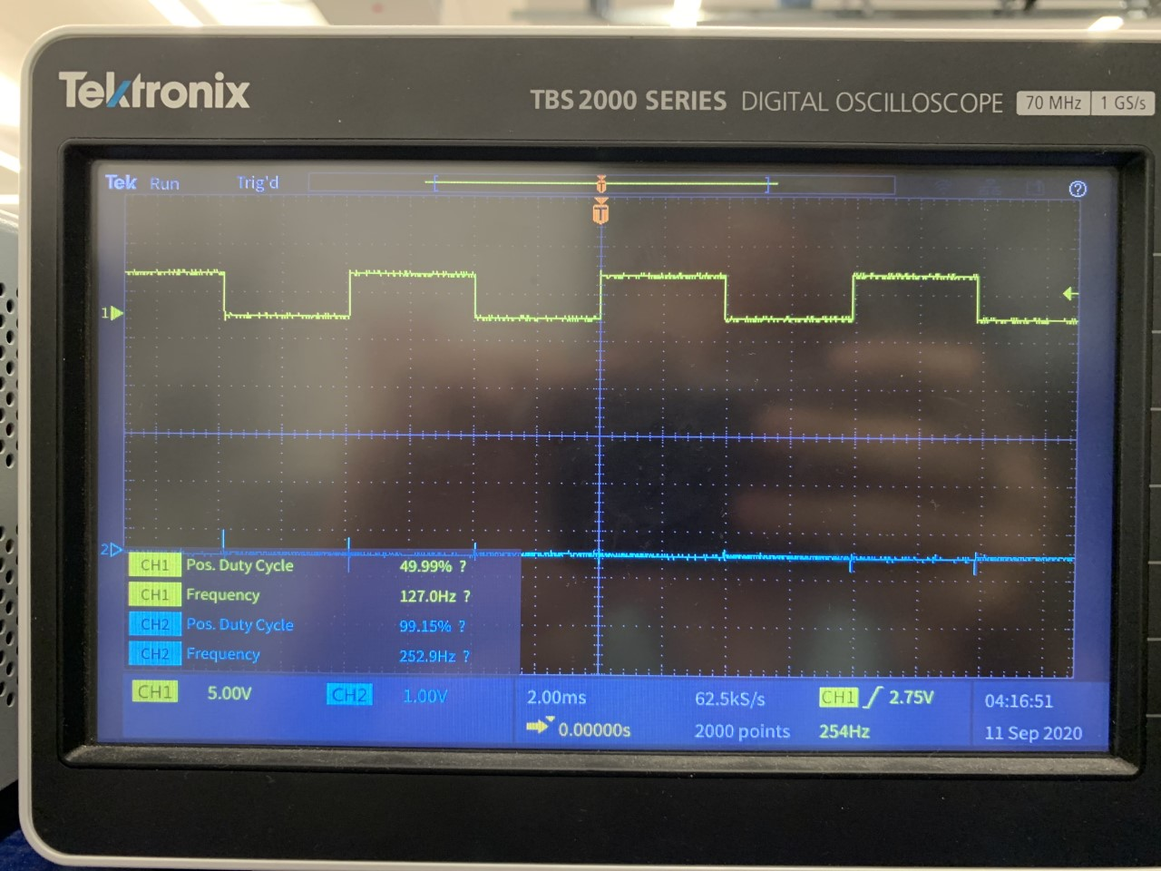

* 1. How long (time) would the relay last at this frequency, both at the rated load and at no load?

The time the relay would last at this frequency at the rated load is 12.12 minutes, while the no load time is 21.87 hours.

* 1. What other benefits does a relay have? Mention at least 3 of them.

Three examples of the benefits of relays are:

1. Relays switch both AC and DC
2. Relays can use High Voltages
3. Relays can switch multiple contacts at once

**Positional Analysis**

1. Select one of the four-bar mechanisms built in the lab and perform the position analysis (using the equations for θ3 and θ4 derived in class) for a given configuration and θ2 value. State all assumptions and show all your work. (Using Mathcad would be a good idea)

We assumed that angle theta2 is 60 degrees, and the four bar configuration is example A from earlier in the lab.

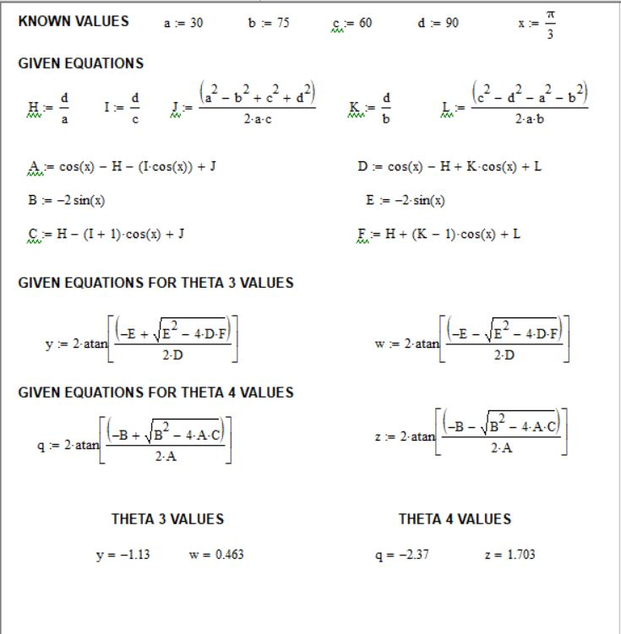

1. Repeat part 1 using the Linkage software. Include a screen shot of the four-bar mechanism (with a coupler curve for a point not on a joint) created with the Linkage software, as well as its corresponding table that includes θ3 and θ4. Compare your results to those obtained in part 1. If you don’t get the same values, you have done something incorrectly.

