Ananya Srinivasa-Gopalan

PLTW: Engineering and Design

February 12, 2019

G Block

horizontal line

**Electronics and Communication Engineering**

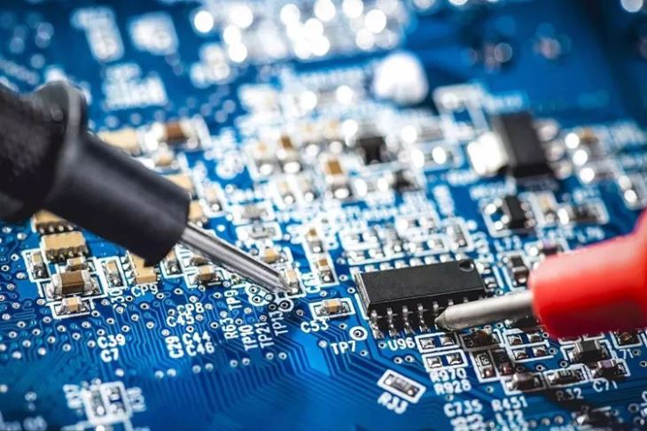

Table of Contents

**Abstract**…………………………………………………………………………....3

**Description of Field**…………………………………………………………….....4

**Demand**………………………………………………………………………....….5

**Salary**………………………………………………………………………………5

**Education**…………………………………………………………………………..5

**Reflection**……………………………………………………………………….….6

**References**………………………………………………………………………….8

# 

# Abstract

I interviewed [1]Srinivas Gopalan, Engineering Program Manager at Kronos Incorporated. He attended Sardar Patel high school as part of the class of 1987 and graduated from S.nijalingappa Preuni College in 1989. Mr. Gopalan earned a Bachelor's of Engineering at the University of Mysore in 1993 and later got a Master’s of Science at Boston University in 2014. Mr. Gopalan is an electronics and communications engineer, encompassing Analog electronics, digit electronics, power, electronics, microwave communications, and microprocessors. This engineering discipline also involves biomedical instrumentation and computer programing. Mr. Gopalan’s particular job entails overlooking application and product security practice at Kronos. He uses security compliance programs aka SOC2, GDPR, ISO27001, FedRamp. He also manages secure development lifestyle programs, secure implementation, secure design, secure testing, and security training initiatives. In his position, Mr. Gopalan provides security guidance to product teams, application security guidance regarding compliance and product development. He runs conduct security assessment for the measurement security posture of the product team. He Interfaces with external vendors for security tool evaluation, works with cross-functional teams to manage security incidents, and reviews product security vulnerabilities from internal testing. Mr. Gopalan’s average work schedule entails working five days a week from nine A.M. to five thirty P.M. for about forty-nine weeks every year.

When asked if he could redo his career, Mr. Gopalan stated that he would pursue medicine on the path to becoming a doctor, as a result of his passion for human physiology and biology. To someone interested in pursuing a career path similar his, Mr. Gopalan would advise them to focus on artificial intelligence, machine learning, semiconductor chip design, and VLSI programming. Technology is becoming more powerful, compact, and integrated. One microchip controls an entire system. Focusing on these areas helps improve connectivity, functionality, and performance: the heart of all electronics today. After the interview, I was most surprised by the versatility of technology and the engineering disciplines. I was also surprised to hear about how rapidly technology evolves and how and how rapidly an engineer has to evolve with these advancements. The most important piece of information that I learned from the interview was that technology is the future and it is better to get a learn as much about it now, to be able to make a meaningful impact on society. This interview has definitely reinforced my aspirations to pursue engineering. I have always been interested in computer science but I think that I’d like to learn more about mechanical engineering and hardware.

# Description of the Field

Electrical and communications engineers design phones, electronics for self-driving cars, chips that power any system, computers, industrial, and wireless systems. They also work on constructing medical devices. This career path enables someone to gain a deep understanding of electronic components, systems, and their interaction on a holistic level. Doing so enables a person to work in R&D, customer support, and in any engineering organization. Electrical and electronics engineers work in industries including research and development, engineering services, manufacturing, telecommunications, and in many federal positions. Electrical and electronics engineers generally work indoors in offices. However, they may have to visit sites to observe a problem or a piece of complex equipment. Electrical engineers design, develop, test, and supervise the manufacturing of electrical equipment, such as electric motors, radar and navigation systems, communications systems, and power generation equipment. Electronics engineers design and develop electronic equipment, including broadcast and communications systems, such as portable music players and Global Positioning System (GPS) devices.

# Demand

There is a very high demand for electronics and communications engineers. Most are able to get jobs out of college. Overall employment of engineers is projected to grow seven percent from 2016 to 2026, about as fast as the average for all occupations. The change in employment is expected to be tempered by slow growth or decline in most manufacturing industries in which electrical and electronics engineers are employed.

# Salary

The starting salary for an engineer of this field is approximately $70,000 right out of college with a Bachelor's degree. The average salary for an experienced electronics and communications engineer is roughly $200,000. On the other end of the spectrum, a possible salary for an experienced architect (depending on the company) is about $300,000. Electronics engineers have an average income of $102,390. Employment opportunities were expected to see little to no growth from 2014-2024, which is slower than the national average for all occupations. Graduates with a bachelor's degree or beyond are sought by companies looking to hire electronics engineers. An electronics engineer may be involved in research, education, or design of many different high tech systems. While the job growth has leveled off, the high average income is an attractive benefit to prospective candidates.

# Education

Companies that hire electronic engineers are looking for graduates with at least a bachelor's degree in this field. Students learn various methodologies and concepts to identify, analyze and solve different types of technical problems. Graduates are prepared to continue their education at the graduate level or find an entry-level position in this profession. The curriculum within an electronics engineering degree program includes courses in DC circuit analysis, digital logic, electronic control systems robotics, and digital signal processing. Electrical and electronics engineers must have a bachelor’s degree. Employers also value practical experience, such as internships or participation in cooperative engineering programs. A minimum of a Master’s or even a Ph.D. degree is necessary for more specialized occupations such as research and development, which are in turn rewarded with a higher salary.

# Reflection

We live in a time where we can press one button and in a matter of minutes we can have just about any food imaginable. We can play movies and music or have an answer to just about any question conceivable with a couple of spoken words. The ability to instantaneously connect with someone across the globe in mere seconds makes the world so much smaller. Advancements in technology have brought about the creation of a whole new virtual world, from bitcoin to the dark web. But what is the most astounding byproduct of technology is its power to about meaningful change: stopping wars, eradicating famines, exploring the unknown, and combating global warming. This is the reason why I aspire to pursue engineering, specifically, computer science.

I chose to research electronics and communications engineering because I didn’t know much about the field of research. I’ve taken many of the programming classes at CHS and have pursued it outside of school. With that said, I didn’t know much about mechanical, or physical computer engineering. For this reason, I chose to learn more about electronics and communications engineering. Some of the best aspects of this career include working on cutting edge technology and broadening your scope of the present day advancements. Pursuing a career in this engineering field is very closely related to other engineering fields, making it easy to learn about other engineering disciplines and switch between them. Technology and the study of engineering as a whole is cross-functional. For example, manufacturing the iPad included collaboration between computer engineers, systems engineer, mechanical engineers, computer scientists, etc. The downside of this career is that technology changes rapidly, making it difficult to keep pace.

Courses in a bachelor’s degree program include general engineering principles and coursework that focuses on electrical engineering. Introductory courses in engineering principles cover problem solving, teamwork and design in a general engineering context. Electrical engineering courses include electric circuits, microelectronics, and electromagnetic fields. Design courses in an electrical engineering program introduce students to computer-aided design tools for simulation and modeling. Master’s degree programs allow students to focus their studies in specific areas, such as communications systems, electromagnetics, computers, and biomedical applications. Master’s degree programs may require students to complete a thesis, but some schools allow students to select a non-thesis option. A four-year degree program also requires students to complete general education courses such as social sciences, humanities, chemistry, physics, and advanced mathematics. A master's degree program in electronics engineering involves a mixture of coursework and research.

Students are able to specialize in one of the many sub-disciplines of electronics engineering, such as control or instrumentation engineering, photonics, telecommunications engineering, signal processing, and network implementation. Doctoral degrees in engineering with a focus in electronics are also available and usually, lead to a career in higher education. Graduates with this degree spend much of their time doing research as well as educating students at the undergraduate and graduate levels. Careers in electronics engineering are offered in research, education, circuitry design and electronic product development. Research and development for electronics engineers involve the conception, design, and prototyping of electronic devices. In manufacturing, electronics engineers are responsible for quality control or process oversight. Academic work is often composed of writing and reviewing professional papers on electronics engineering.

# Reference

Bureau of Labor Statistics, U.S. Department of Labor, Occupational Outlook Handbook, Electrical, and Electronics Engineers, on the Internet at <https://www.bls.gov/ooh/architecture-and-engineering/electrical-and-electronics-engineers.htm> (visited *January 26, 2019*).

1. Interviewee’s email address: [srinivas.gopalan@gmail.com](mailto:srinivas.gopalan@gmail.com)

   Interviewee’s phone number: (978)-221-8514