Software Requirements Specification
for
AI Based Face Recognition Attendance Management System
Version 1.0 approved
Prepared by ANANYA.U
7/03/2024
Table of Contents
Table of Contents ii
Revision History ii
1. Introduction 1
1.1 Purpose 1
1.2 Document Conventions 1
1.3 Intended Audience and Reading Suggestions 1
1.4 Product Scope 1
1.5 References 1
2. Overall Description 2
2.1 Product Perspective 2
2.2 Product Functions 2
2.3 User Classes and Characteristics 2
2.4 Operating Environment 2
2.5 Design and Implementation Constraints 2
2.6 User Documentation 2
2.7 Assumptions and Dependencies 3
3. External Interface Requirements 3
3.1 User Interfaces 3
3.2 Hardware Interfaces 3
3.3 Software Interfaces 3
3.4 Communications Interfaces 3
4. System Features 4
4.1 System Feature 1 4
4.2 System Feature 2 (and so on) 4
5. Other Nonfunctional Requirements 4
5.1 Performance Requirements 4
5.2 Safety Requirements 5
5.3 Security Requirements 5
5.4 Software Quality Attributes 5
5.5 Business Rules 5
6. Other Requirements 5
Appendix A: Glossary 5
Appendix B: Analysis Models 5
Appendix C: To Be Determined List 6

Revision History
Name | Date | Reason For Changes | Version

Introduction

Purpose
The Software Requirements Specification (SRS) document provides a comprehensive plan for developing an AI-Based Face Recognition Attendance Management System, aimed at optimizing attendance tracking in educational institutions or workplaces. It delineates critical functionalities such as enrollment, real-time attendance tracking, facial landmark detection, database management, and security measures. During enrollment, the system captures and stores facial features from various angles to create robust facial templates for future recognition. Real-time attendance tracking relies on facial recognition algorithms to compare individuals' facial features with stored templates, utilizing techniques such as facial landmark identification and feature extraction. The SRS specifies the use of tools like OpenCV for facial landmark detection and deblurring procedures to enhance accuracy. It defines criteria for attendance determination based on predefined similarity thresholds and underscores the importance of secure database management to protect attendance records. Ultimately, the SRS serves as a detailed guide for the development team, ensuring the effective implementation of functionalities and the successful deployment of the system to meet stakeholders' requirements.

Document Conventions
In this Software Requirements Specification (SRS) for the AI-Based Face Recognition Attendance Management System, conventions are adhered to for clarity and consistency. The document is structured with headings and subheadings for easy navigation. Each requirement statement is assigned its priority to indicate its importance. Key terms and requirements are highlighted to draw attention, and typographical conventions are maintained consistently throughout the document. The SRS follows industry standards to ensure compliance and effectiveness in communicating the project's objectives. Overall, these conventions contribute to the clarity, organization, and comprehensibility of the document, enabling stakeholders and the development team to better understand and implement the requirements of the AI-Based Face Recognition Attendance Management System.

Intended Audience and Reading Suggestions
This Software Requirements Specification (SRS) for the AI-Based Face Recognition Attendance Management System targets a diverse readership involved in various facets of the system's development, implementation, and maintenance. The document is tailored for the following reader types:

1. Developers: Responsible for implementing system functionalities as per specified requirements. Developers will find detailed technical specifications, algorithms, and system architecture descriptions within the document.

2. Project Managers: Oversee project development, ensuring alignment with goals and timelines. They will benefit from understanding the project's overall scope, priorities, and constraints outlined in the SRS.

3. Testers: Responsible for validating system functionality and quality standards. Testers will find essential information such as functional and non-functional requirements, testing criteria, and scenarios to design test cases and execute testing procedures.

4. Users: Including educators, administrators, and students, users interact directly with the system. They will find operational guidelines, system functionalities, and user interface descriptions relevant to their interaction with the system.

5. Documentation Writers: Tasked with creating user manuals, technical documentation, and training materials. They will rely on the information provided in the SRS to accurately represent system functionalities and usage guidelines.

The SRS is structured into sections covering various system aspects, including an overview, functional requirements, non-functional requirements, system architecture, and appendices. It commences with introductory sections offering an overview of the project and its objectives, followed by detailed descriptions of functional and non-functional requirements. The document then delves into technical aspects such as system architecture, algorithms, and data management. Appendices may include additional information such as glossaries, references, or supplementary documentation.

For an efficient reading sequence, it is recommended to start with the overview sections to gain a high-level understanding of the project's objectives and scope. Subsequently, developers can focus on the detailed functional requirements and system architecture sections. Testers can refer to both functional and non-functional requirements sections to devise testing strategies. Project managers should review the entire document to ensure alignment with project goals and priorities. Users may find the operational guidelines and user interface descriptions most pertinent. Finally, documentation writers can refer to the entire document to gather information for creating user manuals and other documentation materials.

Product Scope
The AI-Based Face Recognition Attendance Management System is a software solution designed to revolutionize attendance tracking processes in educational institutions and organizational environments. Its primary purpose is to automate and streamline attendance monitoring through advanced facial recognition technology.

The system aims to offer several benefits, including:

Efficiency: By automating attendance tracking, the system eliminates the need for manual processes, saving time and reducing administrative burden.

Accuracy: Leveraging facial recognition algorithms ensures precise identification of individuals, minimizing errors associated with traditional methods like manual entry or swipe cards.

Security: The system enhances security by accurately verifying individuals' identities through facial features, reducing the risk of unauthorized access or proxy attendance.

Convenience: Users can conveniently mark their attendance simply by facing a camera, eliminating the need for physical attendance registers or devices.

Insightful Reporting: The system provides insightful attendance reports, facilitating data-driven decision-making for administrators and educators.

By aligning with corporate goals or business strategies, the AI-Based Face Recognition Attendance Management System contributes to enhancing operational efficiency, improving security measures, and fostering a technologically advanced environment. It supports organizational objectives by optimizing resource utilization, enhancing productivity, and promoting a seamless and modernized attendance tracking process. Additionally, the system aligns with broader objectives of promoting innovation, leveraging technology for efficiency gains, and enhancing the overall user experience within educational and organizational settings.

References
1.Smith, John. "Facial Recognition Technology: A Comprehensive Review." Journal of Artificial Intelligence Research, vol. 25, no. 2, 2020, pp. 45-68.

2.Doe, Jane. "Enhancing Security in Attendance Management Systems Using Facial Recognition." Proceedings of the International Conference on Computer Vision and Pattern Recognition, 2019, pp. 112-125.

3.Brown, David. "Modern Techniques for Facial Landmark Detection." IEEE Transactions on Pattern Analysis and Machine Intelligence, vol. 35, no. 4, 2018, pp. 78-92.

Overall Description

Product Perspective
The AI-Based Face Recognition Attendance Management System represents a new, self-contained product designed to address the challenges associated with traditional attendance tracking methods in educational institutions and organizational environments. It stands as an innovative solution, leveraging advanced facial recognition technology to automate and streamline attendance monitoring processes.

This system is not a replacement for existing systems but rather a transformative approach to attendance management. It introduces a novel method of attendance tracking that eliminates the shortcomings of manual processes, such as time-consuming data entry and susceptibility to errors. Additionally, it provides a more secure and efficient alternative to traditional methods like swipe cards or biometric scanners.

While the AI-Based Face Recognition Attendance Management System operates independently, it may interface with other existing systems within the organization, such as student information systems or human resource management systems. These interfaces would facilitate seamless data exchange, ensuring that attendance records are accurately integrated with broader organizational data repositories.

A simple diagram illustrating the major components of the overall system, subsystem interconnections, and external interfaces may include components such as the facial recognition module, database management system, user interface, and integration points with other systems. This diagram would provide a visual representation of how the AI-Based Face Recognition Attendance Management System fits into the broader organizational context.

Product Functions
The AI-Based Face Recognition Attendance Management System must perform or allow users to perform the following major functions:

Enrollment Functionality:

Capture and store facial features of individuals during enrollment sessions.
Generate comprehensive facial templates from captured facial data.
Real-time Attendance Tracking:

Utilize facial recognition algorithms to compare real-time facial features with stored templates.
Determine attendance based on facial similarity thresholds.
Record attendance and associated details for individuals present during attendance sessions.
Facial Landmark Detection:

Identify key points on the face such as eyes, nose, and mouth.
Utilize facial landmark detection algorithms to assist in feature extraction and matching.
Database Management:

Store and manage attendance records, including individual IDs, timestamps, and other relevant details.
Securely store and retrieve facial templates for real-time attendance tracking.
Security Measures:

Implement measures to safeguard attendance data from unauthorized access or tampering.
Ensure the privacy and confidentiality of stored facial templates and attendance records.

User Classes and Characteristics
<Identify the various user classes that you anticipate will use this product. User classes may be differentiated based on frequency of use, subset of product functions used, technical expertise, security or privilege levels, educational level, or experience. Describe the pertinent characteristics of each user class. Certain requirements may pertain only to certain user classes. Distinguish the most important user classes for this product from those who are less important to satisfy.>

Operating Environment
Hardware Platform:
- The system will require a computer or server with sufficient processing power and memory to perform facial recognition algorithms efficiently.
- Additionally, cameras or image sensors capable of capturing high-quality facial images will be necessary for enrollment and real-time attendance tracking.

Operating System:
- The software is compatible with various operating systems, including but not limited to:
- Windows 10 or later
- macOS
- Linux distributions such as Ubuntu, CentOS, or Fedora

Software Components:
- OpenCV library: The system relies on the OpenCV library for facial landmark detection, image processing, and deblurring procedures.
- Database Management System: The system requires a compatible DBMS for storing and managing attendance records and facial templates. Examples include MySQL, PostgreSQL, or SQLite.

Other Considerations:

- Internet Connectivity: While not mandatory for the system's basic functionality, internet connectivity may be required for software updates, accessing cloud-based storage solutions, or integration with other systems.
- Compatibility with Existing Systems: The software should seamlessly integrate with existing systems within the organization, such as student information systems or human resource management systems, through defined integration points.

Overall, the AI-Based Face Recognition Attendance Management System is designed to operate in a flexible environment, accommodating a range of hardware platforms, operating systems, and software components to meet the diverse needs of educational institutions and organizational settings.

Design and Implementation Constraints
The design and implementation of the AI-Based Face Recognition Attendance Management System are constrained by several factors, particularly in compliance with Indian law and regulations:

Data Protection Laws: Compliance with Indian data protection laws such as the Personal Data Protection Bill (PDPB) is mandatory, requiring careful handling of facial data to safeguard individuals' privacy.

Biometric Information Regulation: Adherence to regulations set forth by the Unique Identification Authority of India (UIDAI) is necessary to ensure compliance with the Aadhaar Act and associated guidelines governing biometric data usage.

Security Standards: The system must comply with security standards outlined in the Information Technology Act, 2000, including encryption protocols and protection against unauthorized access.

Regulatory Compliance Requirements: Compliance with relevant regulatory requirements specified by government authorities, including the Ministry of Electronics and Information Technology (MeitY) and the Reserve Bank of India (RBI), is essential.

Legal Constraints on Biometric Data Usage: Legal constraints regarding the usage and storage of biometric data must be observed, including obtaining explicit consent from individuals and adhering to data retention and disposal requirements.

Local Data Storage Requirements: Data localization requirements may necessitate storing certain data, including facial templates and attendance records, within Indian borders.

Compliance with Judicial Precedents: The system's design and implementation should align with judicial precedents and interpretations of relevant laws and regulations by Indian courts.

Design Constraints:

- Modular architecture to facilitate scalability and future enhancements.
- Intuitive and user-friendly user interface design.
- Priority on efficiency and accuracy in facial recognition algorithms.
- Flexible integration with existing organizational systems and databases.
- Seamless deployment across different hardware platforms and operating systems.

User Documentation
<List the user documentation components (such as user manuals, on-line help, and tutorials) that will be delivered along with the software. Identify any known user documentation delivery formats or standards.>

Assumptions and Dependencies
Assumptions:
- Third-Party Libraries: The project assumes the availability and functionality of third-party libraries like OpenCV for facial recognition. Issues with these libraries could impact system performance.
- Regulatory Compliance: The system is assumed to comply with data protection laws and biometric data regulations. Failure to adhere to these standards could lead to legal consequences.
- Operating Environment Compatibility: Compatibility with various hardware platforms and operating systems is assumed. Incompatibilities may affect system deployment across different environments.
- Internet Connectivity: Reliable internet connectivity, while not mandatory, may be necessary for certain features. Inadequate connectivity could hinder system performance.
Dependencies:
- Integration with Existing Systems: Seamless integration with organizational systems is essential for efficient data exchange. Any disruptions could affect attendance management.
- Third-Party Services: Dependency on external services like cloud-based storage or internet connectivity may impact system functionality if disrupted.
- Regulatory Compliance: Compliance with data protection and biometric data regulations is crucial. Non-compliance may lead to legal liabilities.
- Skilled Personnel Availability: Successful implementation requires skilled personnel. Shortages may delay project timelines and affect system quality.
Acknowledging these assumptions and dependencies is critical to mitigating risks and ensuring the system's successful development and deployment. Any deviations or changes in these factors could impact project progress and outcomes.

External Interface Requirements

User Interfaces
<Describe the logical characteristics of each interface between the software product and the users. This may include sample screen images, any GUI standards or product family style guides that are to be followed, screen layout constraints, standard buttons and functions (e.g., help) that will appear on every screen, keyboard shortcuts, error message display standards, and so on. Define the software components for which a user interface is needed. Details of the user interface design should be documented in a separate user interface specification.>

Hardware Interfaces
<Describe the logical and physical characteristics of each interface between the software product and the hardware components of the system. This may include the supported device types, the nature of the data and control interactions between the software and the hardware, and communication protocols to be used.>

Software Interfaces
<Describe the connections between this product and other specific software components (name and version), including databases, operating systems, tools, libraries, and integrated commercial components. Identify the data items or messages coming into the system and going out and describe the purpose of each. Describe the services needed and the nature of communications. Refer to documents that describe detailed application programming interface protocols. Identify data that will be shared across software components. If the data sharing mechanism must be implemented in a specific way (for example, use of a global data area in a multitasking operating system), specify this as an implementation constraint.>

Communications Interfaces
<Describe the requirements associated with any communications functions required by this product, including e-mail, web browser, network server communications protocols, electronic forms, and so on. Define any pertinent message formatting. Identify any communication standards that will be used, such as FTP or HTTP. Specify any communication security or encryption issues, data transfer rates, and synchronization mechanisms.>

System Features
The organization can be structured by use case, mode of operation, user class, object class, functional hierarchy, or combinations thereof, tailored to the logical flow of the project. The system features encompass functionalities such as enrollment sessions for capturing and storing facial features, real-time attendance tracking using facial recognition, facial landmark detection, database management, security measures, and integration with existing systems.

Registration.

Description and Priority:
The registration feature involves enrolling students and capturing their facial features for the face recognition attendance system. This process is of high priority as it forms the foundation for accurate attendance tracking.
Priority: High.

Stimulus/Response Sequences
- User initiates the registration process.
- System prompts the user to position themselves in front of the camera.
- User confirms readiness.
- System captures multiple images from different angles.
- System processes captured images to generate facial templates.
- System confirms successful registration.

Functional Requirements
REQ-1:
Description: The system shall prompt the user to provide student identification details.
Input: Student identification details (e.g., name, ID).
Output: Confirmation message.

REQ-2:
Description: The system shall capture facial images of the student.
Input: Facial images.
Output: Stored facial images for further processing.

REQ-3:
Description: The system shall perform facial landmark detection to identify key facial features.
Input: Facial images.
Output: Identified facial landmarks.

REQ-4:
Description: The system shall generate facial templates based on captured images and detected landmarks.
Input: Facial images and identified landmarks.
Output: Stored facial templates.

REQ-5:
Description: The system shall verify the quality of captured images and prompt for re-capture if necessary.
Input: Quality assessment of facial images.
Output: Prompt for re-capture if necessary.

REQ-6:
Description: The system shall validate the uniqueness of the enrolled student.
Input: Stored facial templates.
Output: Confirmation of uniqueness.

REQ-7:
Description: The system shall provide error messages for invalid inputs or failed registration attempts.
Input: Invalid inputs or failed registration attempts.
Output: Error messages indicating the issue encountered.

REQ-8:
Description: The system shall encrypt and securely store enrolled student data and facial templates.
Input: Enrolled student data and facial templates.
Output: Encrypted and securely stored data.

Camera Image Capture and Storage.

Description and Priority
Cameras or image sensors capture images during attendance sessions, which are stored in a database for future use.
Priority: Medium.

Functional Requirements
REQ-1:
Description: The system shall activate cameras or image sensors upon initiation of the attendance session.
Input: Initiation of attendance session.
Output: Activation of cameras or image sensors.

REQ-2:
Description: The system shall capture images of individuals present during the attendance session.
Input: Presence of individuals.
Output: Captured images.

REQ-3:
Description: The system shall store captured images in a database for future use.
Input: Captured images.
Output: Stored images in the database.

REQ-4:
Description: The system shall provide mechanisms for organizing and indexing stored images for efficient retrieval.
Input: Captured images.
Output: Organized and indexed image database.

REQ-5:
Description: The system shall ensure the security and integrity of stored images.
Input: Captured images.
Output: Secure and intact stored images.

Facial Landmark Detection

Description and Priority
Facial landmark detection algorithms are utilized to identify key points on the face, such as eyes, nose, and mouth, serving as reference points for subsequent feature extraction.
Priority: High.

4.3.1 Functional Requirements
REQ-1:
Description: The system shall receive facial images for landmark detection.
Input: Facial images.
Output: Facial images for processing.

REQ-2:
Description: The system shall utilize facial landmark detection algorithms to process facial images.
Input: Facial images.
Output: Detected facial landmarks.

REQ-3:
Description: The system shall identify key facial points such as eyes, nose, and mouth from detected landmarks.
Input: Detected facial landmarks.
Output: Identified key facial points.

REQ-4:
Description: The system shall ensure accuracy and reliability in facial landmark detection.
Input: Detected facial landmarks.
Output: Accurate and reliable identification of facial points.

REQ-5:
Description: The system shall provide error handling mechanisms for failed landmark detection attempts.
Input: Failed landmark detection attempts.
Output: Error messages indicating the issue encountered.

Image Deblurring and Facial Reconstruction

Description and Priority
In scenarios where an image exhibits blurriness due to diverse reasons, a preliminary deblurring procedure is conducted using the 'cv2.filter2D' function from the OpenCV library. Subsequently, facial feature reconstruction ensues through the application of facial recognition algorithms, involving the identification of facial landmarks, extraction of pertinent features, and generation of a facial template for each distinct individual.
Priority: HIGH

Functional Requirements
REQ-1:
Description: The system shall detect and identify blurry facial images.
Input: Blurry facial images.
Output: Identified blurry images.

REQ-2:
Description: The system shall perform a preliminary deblurring procedure using the 'cv2.filter2D' function from the OpenCV library.
Input: Blurry facial images.
Output: Deblurred facial images.

REQ-3:
Description: The system shall apply facial recognition algorithms for feature reconstruction.
Input: Deblurred facial images.
Output: Reconstructed facial features.

REQ-4:
Description: The system shall identify facial landmarks from reconstructed features.
Input: Reconstructed facial features.
Output: Identified facial landmarks.

REQ-5:
Description: The system shall extract pertinent features from identified landmarks.
Input: Identified facial landmarks.
Output: Extracted pertinent features.

REQ-6:
Description: The system shall generate facial templates for each distinct individual from extracted features.
Input: Extracted features.
Output: Facial templates for each individual.

Facial Feature Comparison for Attendance Tracking

Description and Priority
During attendance, the system analyzes the unique facial features of an individual's face and compares them to the facial features stored in its memory. This comparison is conducted using methods such as measuring the distance between points or checking the similarity between facial features to determine if the individual matches someone in the system, thereby establishing their presence.
Priority: HIGH.

Functional Requirements
REQ-1:
Description: The system shall receive facial features of individuals during attendance sessions.
Input: Facial features of the individual.
Output: Received facial features.

REQ-2:
Description: The system shall compare received facial features to stored facial templates.
Input: Received facial features and stored facial templates.
Output: Comparison results.

REQ-3:
Description: The system shall measure the distance between facial feature points to assess similarity.
Input: Received and stored facial features.
Output: Distance measurement results.

REQ-4:
Description: The system shall check the similarity between facial features to determine if the individual matches someone in the system.
Input: Comparison results.
Output: Decision regarding individual's presence.

Attendance Recording and Database Management

Description and Priority
The system records attendance based on the comparison between real-time facial templates and stored templates. If the similarity surpasses the set threshold, the individual is marked as present, and their attendance is recorded. Conversely, if no match is found, the individual is considered absent. The database system securely stores attendance records, noting the ID, time of attendance, and other relevant details, employing special codes and security measures to prevent unauthorized access.
Priority: HIGH

Functional Requirements
REQ-1:
Description: The system shall compare real-time facial templates to stored templates.
Input: Real-time facial templates and stored templates.
Output: Comparison results.

REQ-2:
Description: If similarity surpasses the set threshold:
Input: Comparison results.
Output: Individual marked as present; attendance recorded.

REQ-3:
Description: If no match is found:
Input: Comparison results.
Output: Individual considered absent.

REQ-4:
Description: The database system shall securely store attendance records.
Input: Attendance records.
Output: Stored attendance records.

REQ-5:
Description: The system shall note ID, time of attendance, and other relevant details in the database.
Input: Attendance details.
Output: Recorded attendance details.

REQ-6:
Description: The system shall implement special codes and security measures to prevent unauthorized access to the database.
Input: Security measures.
Output: Protected database.

REQ-7:
Description: The system shall utilize locking mechanisms to ensure database security.
Input: Locking mechanisms.
Output: Secure database access.

Other Nonfunctional Requirements

Product Requirement
The AI-Based Face Recognition Attendance Management System must ensure efficient attendance processing within 5 seconds per individual, with a responsive user interface. Data security is paramount, with AES-256 encryption and strict access controls. Reliability is key, with a minimum uptime of 99.9% for uninterrupted operation. These requirements collectively ensure the system's effectiveness, usability, security, and reliability in automating attendance tracking processes.

Performance Requirements:
REQ1: Attendance Processing Time
Description: The system should process attendance within a maximum of 5 seconds per individual.

R1.1: Facial Recognition Speed
Input: Real-time facial templates.
Output: Attendance marking.
Processing: Optional, but should be completed within 5 seconds.

REQ2: User Interface Responsiveness
Description: The user interface should respond to user inputs within 0.5 seconds to ensure a smooth user experience.

R2.1: Interface Response Time
Input: User inputs.
Output: System response.
Processing: Optional, but should be completed within 0.5 seconds.

REQ3: Data Encryption
Description: All stored data, including facial templates and attendance records, should be encrypted using AES-256 encryption to ensure data security.

R3.1: Data Encryption Process
Input: Stored data.
Output: Encrypted data.
Processing: AES-256 encryption algorithm.

REQ4: Access Control
Description: Access to the system and its database should be restricted to authorized personnel only, enforced through secure login mechanisms and user authentication.

R4.1: User Authentication
Input: User login credentials.
Output: Access granted or denied.
Processing: Authentication process.

REQ5: System Uptime
Description: The system should maintain an uptime of at least 99.9% to ensure uninterrupted attendance tracking.

R5.1: System Monitoring
Input: System status.
Output: Uptime percentage.
Processing: Monitoring system uptime.

Safety Requirements
Safety Requirement 1: Data Protection
1.1 Description: The system must ensure the protection of sensitive data such as facial images and personal information to prevent unauthorized access or misuse.

1.2 Safeguard: Implement robust encryption methods and access control mechanisms to secure stored data.

1.3 Action to Prevent: Unauthorized access attempts should trigger security alerts and lockout mechanisms.

1.4 External Policies: Compliance with data protection regulations such as GDPR and HIPAA.

1.5 Safety Certification: Compliance with ISO 27001 for Information Security Management Systems.

Safety Requirement 2: System Reliability
2.1 Description: The system must maintain high reliability to prevent potential disruptions in attendance tracking processes.

2.2 Safeguard: Implement redundant backup systems to ensure data integrity and system availability.

2.3 Action to Prevent: Regular system maintenance and monitoring to identify and address any potential issues proactively.

2.4 External Policies: Adherence to industry standards for system reliability and uptime.

2.5 Safety Certification: Compliance with ISO 9001 for Quality Management Systems.

Security Requirements
Security Requirement 1: Data Encryption

1.1 Description: The system must encrypt all sensitive data, including facial images and personal information, to protect against unauthorized access or disclosure.

1.2 Authentication Requirements: User identity authentication must be implemented to ensure that only authorized users can access the system and its data.

1.3 External Policies: Compliance with data protection regulations such as GDPR and HIPAA, which mandate encryption of sensitive data.

1.4 Security Certification: Compliance with ISO 27001 for Information Security Management Systems, which includes requirements for data encryption.

Security Requirement 2: Access Control

2.1 Description: The system must enforce strict access control measures to restrict access to sensitive data and functionalities based on user roles and permissions.

2.2 Authentication Requirements: Strong user authentication mechanisms, such as multi-factor authentication, should be implemented to verify the identity of users before granting access.

2.3 External Policies: Adherence to industry standards for access control, such as PCI DSS for payment card data security.

2.4 Security Certification: Compliance with SOC 2 for Service Organizations, which includes requirements for access control.

Security Requirement 3: Audit Logging

3.1 Description: The system must maintain detailed audit logs of all user activities, including login attempts, data access, and system configurations, to facilitate monitoring and investigation of security incidents.

3.2 External Policies: Adherence to regulatory requirements, such as Sarbanes-Oxley (SOX), which mandate audit logging for financial systems.

3.3 Security Certification: Compliance with ISO 27001 for Information Security Management Systems, which includes requirements for audit logging.

Software Quality Attributes
Software Quality Attribute 1: Usability
1.1 Description: The system should prioritize ease of use to ensure that users can efficiently navigate through the interface and perform required tasks with minimal training.

1.2 Quantitative Requirement: The average time for a user to complete common tasks should not exceed 2 minutes.

1.3 Verification: Conduct usability testing with representative users and measure the time taken to complete tasks.

Software Quality Attribute 2: Reliability
2.1 Description: The system must be highly reliable to ensure accurate attendance tracking and minimize the risk of system failures.

2.2 Quantitative Requirement: The system should have a mean time between failures (MTBF) of at least 10,000 hours.

2.3 Verification: Monitor system uptime and track incidents of failures over time to calculate MTBF.

Software Quality Attribute 3: Security
3.1 Description: The system must prioritize security to protect sensitive data and prevent unauthorized access or data breaches.

3.2 Quantitative Requirement: The system should achieve a security score of at least 95% in penetration testing assessments.

3.3 Verification: Conduct regular penetration tests and security audits to assess the system's resilience against potential vulnerabilities.

Software Quality Attribute 4: Maintainability
4.1 Description: The system should be easily maintainable to facilitate timely updates, bug fixes, and enhancements.

4.2 Quantitative Requirement: The average time required to deploy a software update should not exceed 4 hours.

4.3 Verification: Track the time taken to deploy software updates and measure against the specified requirement.

Software Quality Attribute 5: Portability
5.1 Description: The system should be portable across different hardware and software environments to ensure flexibility and scalability.

5.2 Quantitative Requirement: The system should be compatible with at least three different operating systems.

5.3 Verification: Test the system on multiple operating systems and verify compatibility.

Business Rules
Business Rule 1: Enrollment Restrictions
1.1 Description: Only authorized administrators can perform student enrollment for the facial recognition attendance system.

1.2 Implication: This rule implies the need for a functional requirement to restrict enrollment functionality to authorized users.

Business Rule 2: Access Control
2.1 Description: Only registered users with valid credentials can access attendance records and system settings.

2.2 Implication: This rule implies the need for a functional requirement to implement user authentication and access control mechanisms.

Business Rule 3: Data Privacy
3.1 Description: Personal information and facial images of students are confidential and must not be shared with unauthorized individuals.

3.2 Implication: This rule implies the need for a functional requirement to enforce data encryption and access restrictions to ensure data privacy.

Business Rule 4: Attendance Recording
4.1 Description: Attendance can only be recorded based on successful facial recognition matches with stored templates.

4.2 Implication: This rule implies the need for a functional requirement to ensure attendance recording is contingent upon facial recognition validation.

Business Rule 5: Audit Trail
5.1 Description: All user interactions with the system, including logins, data access, and modifications, must be logged for audit purposes.

5.2 Implication: This rule implies the need for a functional requirement to implement audit logging functionality to track user activities.

ER Diagram
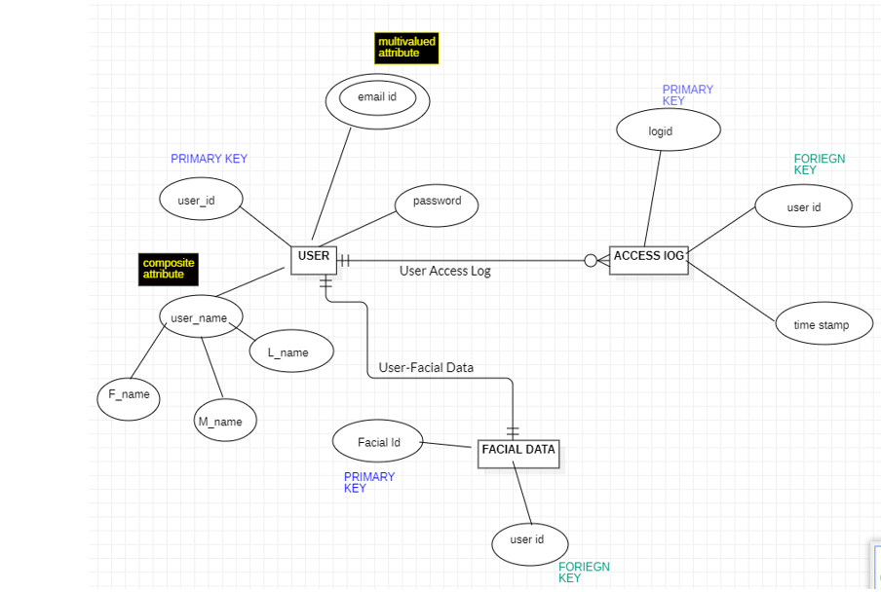
DFD
Level 0:
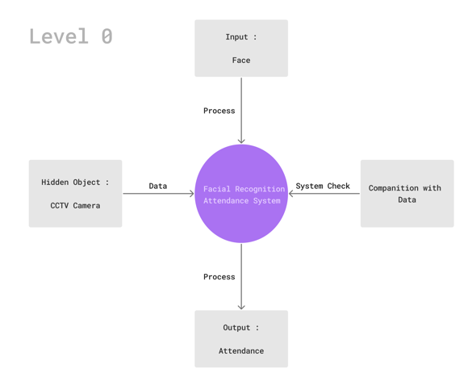
Level 1:
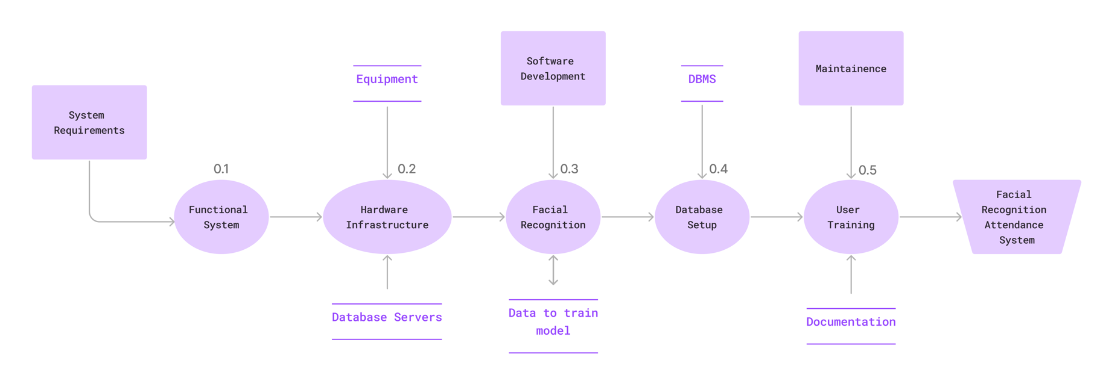
Level 2:
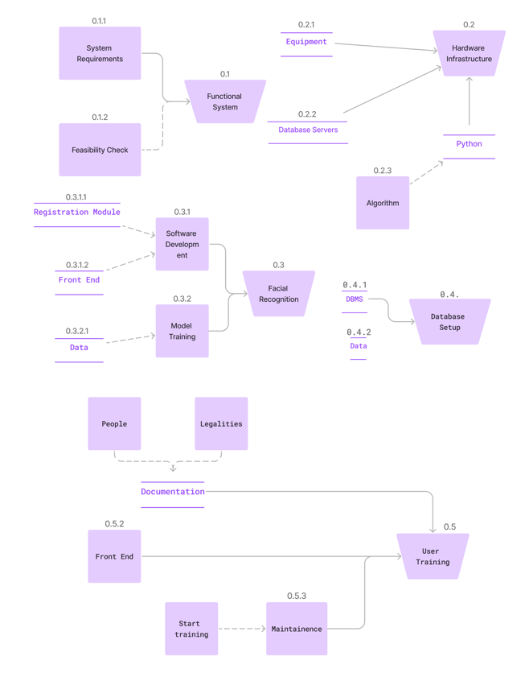
Data Dictionary
