Software Requirements Specification
for
Cattle Health Monitoring System using IoT
Version 1.0 approved

Prepared by:
Ananya Manjunath 1JT16IS002
Meghasri 1JT16IS027
Namratha V 1JT16IS028
Yashaswini U 1JT16IS062
JYOTHY INSTITUTE OF TECHNOLOGY
11/10/2019
Table of Contents
Table of Contents ii
Revision History ii
1. Introduction 1
1.1 Purpose 1
1.2 Document Conventions 1
1.3 Intended Audience and Reading Suggestions 1
1.4 Product Scope 1
1.5 References 1
1.6 Product Perspective………………………………………………………………………………...2
1.7 Product Functions……………………………………………………………………………….…4
1.8 Operating Environment………………………………………………………………….…………4
1.9 Design and Implementation Constraints……………………………………………………............4
2. External Interface Requirements 4
2.1 Functional Requirements 4
2.2 Non-Functional Requirements 5
3. System Features 6
3.1 System Feature 1 6
Appendix A: Summary 5
Conclusion 6

Revision History
Name | Date | Reason For Changes | Version

Introduction

Purpose
This project is to develop and identify the cattle health which can help the farmers to monitor the health condition of the cattle on a regular basis and can master the environment of unavailability of the veterinary. So, through the cattle monitoring system we can monitor the health of the cattle based on the parameters such as foot step, temperature, blood pressure, heart beat, respiration and body humidity.

Document Conventions
CHM-Cattle Health Monitoring System,

Intended Audience and Reading Suggestions
- As per the recent decades an important aspect of farm automation that is being researched is area of automated animal health monitoring system.
- In this we focus on monitoring the health of cattle’s by using non-invasive, low-cost sensors technology that detect sudden change in body parameters.

Product Scope
The cattle health monitoring system is a system which helps us to monitor the health of a cattle. It will give us information about the heartbeat, Steps, Chews, Body temperature and location of the cattle. All the data which will be fetched by the cattle health monitoring system will be feed to an application developed by using cloud.

References
- 1. Istepanian, R. S. H., Jovanov, E. and Zhang, Y. T. (2004). “Introduction to the Special Section on M-Health:Beyond Seamless Mobility and Global Wireless Health-Care Connectivity,” IEEEm Transactions on Information Technology in Biomedicine. 8(4), 405- 414.
- Broom D. M., (2006). Behaviour and welfare in relation to pathology, Department of Veterinary Medicine, University of Cambridge, Madingley Road, Cambridge CB3 0ES, UK, Applied Animal Behaviour Science 97, 73–83.
- C. Palombi, M. Paolucci, G. Stradaioli, M. Corubolo, P. B. Pascolo, and M. Monaci, “Evaluation of remote monitoring of parturition in dairy cattle as a new tool for calving management,” BMC Vet. Res., vol. 9, no. 1, p. 191, 2013.
- Mr. Rashid Hussain1, Purvi Mishra and Babita Sharma, “Use of Wireless Sensor Network for Humanand Animal Health Care during Flood”,International Journal of Application or Innovation in Engineering & Management (IJAIEM), Volume 2 Issue 3, March 2013.
- S. Monicka, C. Suganya, S. Nithya Bharathi and A.P.Sindhu, “A Ubiquitous Based System for Health Care Monitoring ” , International Journal of Scientific Research Engineering and technology (IJSRET), ISSN 2278-0882, Volume 3, Issue 5, July 2014.
- Leena Narayan, Dr. T. Muthumanickam and Dr. A. Nagappan, “Animal Health Monitoring System using Raspberry Pi and Wireless Sensor”, International Journal of Scientific Research and Education (IJSRE), Volume 3 Issue 5, May 2015.
- S. Jegadeesan1, Dr. G. K. D. Prasanna Venkatesan2, Smart Cow Health Monitoring, Farm Environmental Monitoring and Control System using Wireless Sensor Networks, E-ISSN 0976-3945, 2016.
- C. J. Rutten, C. Kamphuis, H. Hogeveen, K. Huijps, M. Nielen, and W. Steeneveld, “Sensor data on cow activity, rumination, and ear temperature improve prediction of the start of calving in dairy cows,” Comput. Electron. Agric., vol. 132, pp. 108–118, Jan. 2017.

Product Perspective

Existing System

Previous forecasting systems monitor the environment of livestock barns and the
activities of cattle using a pedometer or thermal imaging, making it difficult to produce clear predictive information describing the occurrences of live-
stock diseases.

Disadvantages
1. It is wired system.
2. The System is complicated.
3. It monitor’s core body temperature and heart rate only.

Proposed System
Sensors base technology use for biomedical application,size is the one of the important constraint.
The sensor device must be moderate in size and weight.However the sensors use in such device must be able to detect the body temperature and heart beats which plays important role in medical treatment and diagnosis.
Basically, our project is divide into 3 domains
- Sensor Technology
- Communication
- Software

- Sensor Technology: The sensors are used for automatic measurement of various health factors. The sensors are mounted on the cattle’s body, which continuously observe the body issues of the cattle like heartbeat rate, body temperature etc and delivers output in the type of electrical signs. The sensors such as temperature sensors, humidity sensor are used in the advanced CHM. These sensors are connected to the Arduino UNO(controller).

- Communication: We can send the cattle health graph to the doctor’s mobile using ESP8266 WIFI Module. This module sends the signal through the IOT technology. So by observing this graph doctor can predict the cattle’s health.Arduino UNO has enough memory to transform the signs arriving from the data gaining unit through sensors into the ESP8266 WIFI Module for communication and the signals are given to the software for examining and displaying the data.

- Software:A web page is created wherein the cattle’s data is being stored using cloud computation.The webpage can be accessed anywhere.In the cloud computation the data is scalable and there is no need of backups.

Product Functions
The main function of this unit is when the animal suffer from disease, people use to take that animal to the doctor for dignosis but sometimes doctors will not be available in hospitals so using this advance monitoring system we can sense the various activities of animals like body temperature, respiration , humidity etc. and we can send the animal health graph to the doctor mobile using ESP8266 WIFI module. So by observing this graphs doctor can tell about the animal health.

Operating Environment
  - THINKSPEAK
  - ARDUINO IDE(Version 1.8.10)

Design and Implementation Constraints
We implemented both the bio-sensors module and the WSN module as an integrated device on a single board for an easy installation on the trunk of the cattle. Our integrated device includes a MCU for signal processing and a WSN module.
In our CHM, the biometric data of each entity are collected using a bio-sensor module and are stored in an integrated management system.
The virtual information is provided to use on a PC or a smart phone through the created app.
The application provides the options for selecting entities and reports vital information on the selected entities for every cattle. We can easily manage each device because the state of each sensor and batteries is provided graphically.

EXTERNAL INTERFACE REQUIREMENTS

2.1. HARDWARE REQUIREMENTS
Node MCU (ESP 8266) -The ESP8266 WIFI Module approaches a complete and self-controlled Wi-Fi interacting solution.The ESP8266 Wi-Fi module are low cost,small and maintain Wi-Fi connection and encryption in client mode and access point mode. Wi-Fi module communication is done through simple serial RX and TX lines using “AT” i.e. attention type commands and data.

DHT11 sensors - The DHT11 is a basic, ultra low-cost digital temperature and humidity sensor.
This sensor is used to sense the body temperature of the cattle.The usual cattle temperature is 38.5-39.5⁰C.When the body temperature is more than 41⁰C on that time diseases occurs.
Humidity sensor is used to determine stress level of the animal. When the humidity is between 1-72%(No stress),72-79%(Mild stress),80-90%(Moderate stress),91-99%(severe stress).

GPS Sensor - The working/operation of Global positioning system is based on the 'trilateration' mathematical principle. The position is determined from the distance measurements to satellites. The GPS receiver takes the information from the satellite and uses the method of triangulation to determine a cattle’s position.

Proximity Sensor - A proximity sensor is an electronic sensor that can detect the presence of objects within its vicinity without any actual physical contact. In order to sense objects, the proximity sensor radiates or emits a beam of electromagnetic radiation, usually in the form of infrared light, and senses the reflection in order to determine the object's proximity or distance from the sensor.

HEALTH MONITORING APP- The I chart app is used to monitor the parameters which describes the graph of cattle health on mobile such as body temperature sensor, respiration sensor, humidity sensor, heart beat and rumination sensor etc. so by monitoring this graph doctor can tell about the cattle health.

2.2: SOFTWARE REQUIREMENTS

Thinkspeak – It is an open source IoT application and API to store and retrieve data from things using HTTP and MQTT protocol over the internet or via local area network.
In CHM the the data is read from the cattle it stores the value for each cattle and it plots the graph according the data and can predict the average temperature of the particular cattle.

Arduino IDE(1.8.10) - It is an open source electronics platform based on easy-to-use hardware and software components.
In CHM it is used to read the data from the cattle and sends to the thinkspeak.
In this we develop a code to read the data from the cattle such as temperature, humidity,etc using the particular sensors used.

3.System Features
A system to detect the health of the cattle by using various sensors to maintain a good health of the cattle.

3.1 System Feature 1

- To detect the temperature and humidity.
- Stores and data into the cloud.
- Can predict the average temperature, heartrate of the cattle.
- Retrieve the data and displays in the web page of the user.

4. Working of the device

4.1 BLOCK DIAGRAM

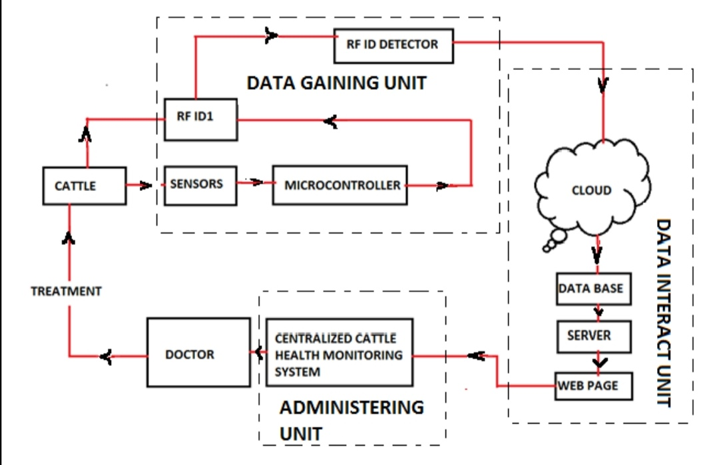

Data gaining unit consist of different types of biomedical sensors like body temperature sensor, blood pressure sensor, humidity sensor, heart beat rate detection sensor which is interfacing with microcontroller. The data gaining units obtain data and makes it accessible for the data administering and data interact unit (cloud, server and web page).

The sensors are used for simple and general automatic measurement of numerous health factors. Such type of health sensors will be mounted on the cattle body which continuously observe the body issues of the cattle like temperature , heart beat rate etc and deliver output in the type of electrical signal. These signal are then compared to a standard limit of normal values set as the starting point in data administering unit.

If administering unit are observed major changes or abnormal changes in particular cattle then they can contact to nearer animal care doctor or if some causes doctor will not available in nearer hospital then using IOT administering unit controlling person can send the health graph to the doctor. So by observing this graphs doctor can tell about the animal health information and proper treatment which to be apply on cattle in absence of doctor during emergency.
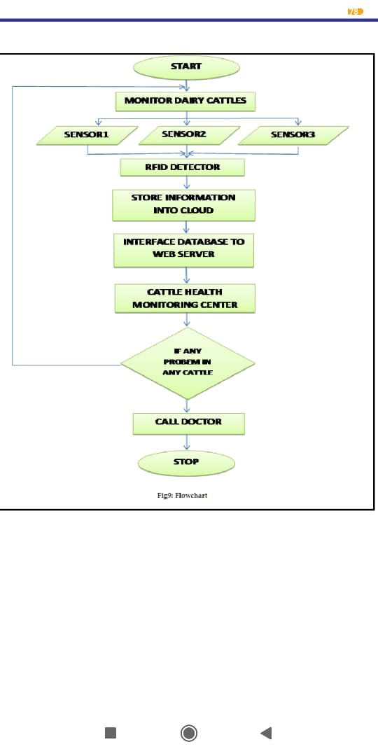

CONCLUSION
This research has been undertaken in order to establish specific sensor technologies as a significant means to monitor animal health and to ensure animal well-being in the fast changing conditions of automated farms. Due to the high demand and supply of dairy products, dairy cattle are in a constant demand for high yield, leading to the need of continuously monitoring of their health to ensure their fitness as it directly affects the health of the consumers. Moreover, the overall economy in the dairy farming industry depends on the herds’ health. Several cattle diseases have been studied in depth and analysis of the symptoms associated with these conditions. These symptoms were then mapped to the type of sensors that would be able to measure the said behavior.

