**GUI Automation**

Machine Name: IONDELWS496

Platform Details: 10.101.130.96: DelhiQA/Quality30000%

Jenkins: http://localhost:8081/job/TPRM_MMI_DASHBOARD_TESTS/

Helpful Documents:

* <https://confluence.iontrading.com/display/QA/ION.NET+Test+Automation+Framework>
* <https://confluence.iontrading.com/pages/viewpage.action?title=ION.NET+Test+Automation+Setup+and+Execution&spaceKey=QA>

**Steps to run tests manually:**

On cmd run

* DPlayer must be running: D:\Shubham_MMI_checkkout\tprm-mmi-dashboard-automation\RFDplayer\mkvdplayer301p2_x64.exe
* In folder: C:\Program Files (x86) \Microsoft Visual Studio\2019\Professional>

1. scum prepare

* In folder: D:\Shubham_MMI_checkkout\tprm-mmi-dashboard-shubhamautomation\tprm_ui_automation
* D:\Shubham_MMI_checkkout\tprm-mmi-dashboard-automation\tprm_ui_automation>

1.scum co mmi.net --tag 136p62d51 (mmi.net folder needs to be deleted)

2. scum rebuild release!x64 mmi.net --2019

3. scum co ion.automation.addon --tag 136p52d39 ( Folder needs to be deleted first)

4. scum rebuild release!x64 ion.automation.addon --2019 -N

5.scum co etrading.addon -v 100p3d1 ( Folder needs to be deleted first)

6.scum rebuild release!x64 etrading.addon --2013 -N

1.Run a manual Test with current setup- **Done**

2.Run manual tests with p63-**Done**

3.Run Multiprocess With p63 Tests- **Done**

3.Run manual tests from scratch-Done

4.Go through the documentation

5.See folder structure -What is inside the documents

6.See what all tests can be removed from manual-

7.See what can be added in automation with existing keywords

7.1 See what new keywords must be added.

8.Run Jenkins job

9. Setup the platform on aws machine

ISSUES LOGGED

1.[[IONNETGUI-3590] Not able to create some components by using "WindowManager CreateComponent" keyword. - ION Trading JIRA (iongroup.com)](https://jira.iongroup.com/browse/IONNETGUI-3590) -Assigned to tprm

2. [[IONNETGUI-3589] Grid keywords are not working for TPRM components. - ION Trading JIRA (iongroup.com)](https://jira.iongroup.com/browse/IONNETGUI-3589)-Assigned to tprm -Vlink

3. [[IONNETGUI-3588] Keyword required to select tab options in Market Monitor option dialog. - ION Trading JIRA (iongroup.com)](https://jira.iongroup.com/browse/IONNETGUI-3588)-Assigned to Rakshit Joshi (open,sorting grouping)

4. [[IONNETGUI-3740] PreferenceManager keywords are not working for RiskP/L preference page. - ION Trading JIRA (iongroup.com)](https://jira.iongroup.com/browse/IONNETGUI-3740)- Assigned to Fabio Nardelli (Open)

Platform Details: Sysadmin

Username-mkv

Password-mkvpwd

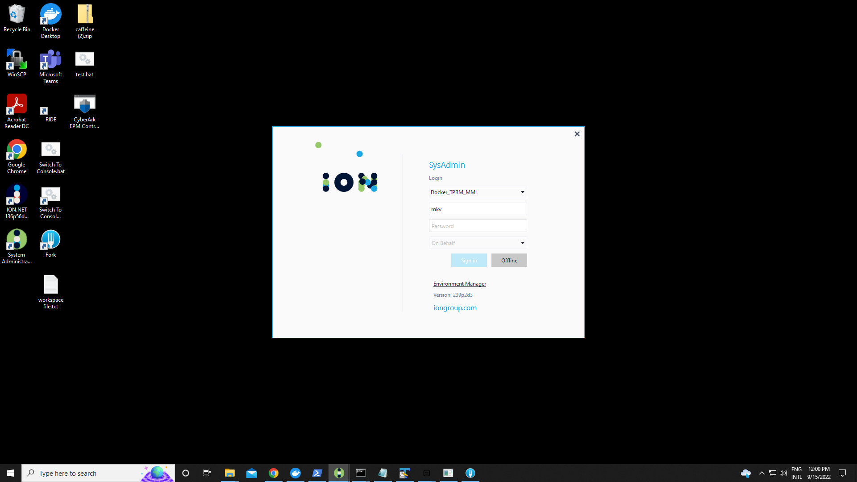

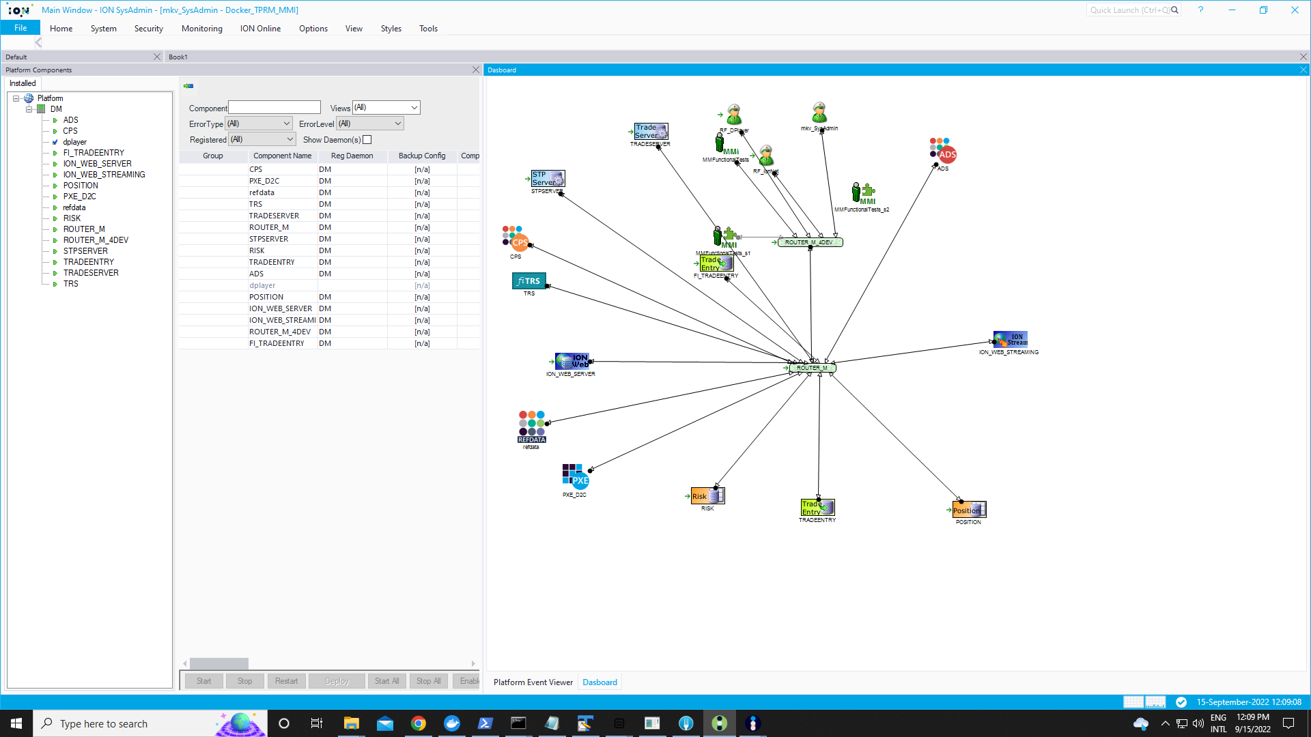

Env needs to be in this condition to be able to run tests

**To start platform**

* Start Windows PowerShell in ADMIN mode and navigate to D:\TPRM_FRC_Docker_Platform\frc-test-platforms-master-dev_sandbox_D2C\dev_sandbox_D2C
* Then run: launch_frc_platfrom.ps1

**Key for this platform expires almost every month**

* Go to yammer
* Find the latest version of devkit
* In D:\TPRM_FRC_Docker_Platform\frc-test-platforms-master-dev_sandbox_D2C\dev_sandbox_D2C\docker-compose.yml
* Find the selected text and Change Highlighted version to latest version and then run launch_frc_platfrom.ps1: image: registry.iongroup.com:5000/devkit/controller_host:1.1.41