|  |  |
| --- | --- |
| VISVESVARAYA TECHNOLOGICAL UNIVERSITY    BELAGAVI – 590018, Karnataka  INTERNSHIP REPORT  ON  “Web template for personal development”  Submitted in partial fulfilment for the award of degree(21INT49)    BACHELOR OF ENGINEERING IN ELECTRONICS AND COMMUNICATON ENGINEERING  Submitted by:  Ananya D  4MH21EC004    Conducted at  Varcons technologies pvt ltd      Maharaja Institute of Technology Mysore  Department of Information Science and Engineering  Accredited by NBA, New Delhi    BELWADI, SRIRANGAPATNA TALUK, MANDYA  571477    Internship report 2022-2022 | 1 |

Maharaja Institute of Technology Mysore

Department of Information Science and Engineering

Accredited by NBA, New Delhi

# BELWADI, SRIRANGAPATNA TALUK, MANDYA

571477



CERTIFICATE

This is to certify that the Internship titled “web template for personal development” carried out by Ms. Ananya D, a bonafide student of Maharaja Institute of Technology Mysore, in partial fulfillment for the award of Bachelor of Engineering, in ECE under

Visvesvaraya Technological University, Belagavi, during the year 2022-2023. It is certified that all corrections/suggestions indicated have been incorporated in the report.

The project report has been approved as it satisfies the academic requirements in respect of Internship prescribed for the course Internship / Professional Practice (21INT49)

Signature of Guide Signature of HOD Signature of Principal

External Viva:

Name of the Examiner Signature with Date

1)

2)

D E C L A R A T I O N

I, Ananya, Second year student of ECE, Maharaja Institute of Technology Mysore, declare that the Internship has been successfully completed, in Varcons Technologies Pvt Ltd. This report is submitted in partial fulfillment of the requirements for award of Bachelor Degree in ECE, during the academic year 2022-2023.

Date: :

Place:

USN: 4MH21EC004

NAME: Ananya D

## OFFER LETTER PROVIDED BY THE COMPANY



# A C K N O W L E D G E M E N T

This Internship is a result of accumulated guidance, direction, and support of several important persons. We take this opportunity to express our gratitude to all who have helped us to complete the Internship.

We express our sincere thanks to our Principal, for providing us adequate facilities to undertake this Internship.

We would like to thank our Head of Dept – branch code, for providing us an opportunity to carry out Internship and for his valuable guidance and support.

We would like to thank our (Lab assistant name) Software Services for guiding us during the period of internship.

We express our deep and profound gratitude to our guide, Guide name, Assistant/Associate Prof, for her keen interest and encouragement at every step in completing the Internship.

We would like to thank all the faculty members of our department for the support extended during the course of Internship.

We would like to thank the non-teaching members of our dept, for helping us during the Internship.

Last but not the least, we would like to thank our parents and friends without whose constant help, the completion of Internship would have not been possible.

NAME: Bhoomika

USN: 4MH21EC010

# ABSTRACT

Based on the analysis of 190 studies (18,573 participants), we estimate that the average silent reading rate for adults in English is 238 words per minute (wpm) for non-fiction and 260 wpm for fiction. The difference can be predicted by taking into account the length of the words, with longer words in non-fiction than in fiction. The estimates are lower than the numbers often cited in scientific and popular writings. The reasons for the overestimates are reviewed. The average oral reading rate (based on 77 studies and 5,965 participants) is 183 wpm. Reading rates are lower for children, old adults, and readers with English as second language. The reading rates are in line with maximum listening speed and do not require the assumption of reading-specific language processing. Within each group/task there are reliable individual differences, which are not yet fully understood. For silent reading of English non-fiction most adults fall in the range of 175 to 300 wpm; for fiction the range is 200 to 320 wpm. Reading rates in other languages can be predicted reasonably well by considering the number of words these languages require to convey the same message as in English.

Table of Contents

|  |  |
| --- | --- |
| Sl no | Description |
| 1 | Company Profile |
| 2 | About the Company |
| 3 | Introduction |
| 4 | System Analysis |
| 5 | Requirement Analysis |
| 6 | Implementation |
| 7 | Snapshots |
| 8 | References |

|  |  |  |
| --- | --- | --- |
|  | CHAPTER-1  COMPANY PROFILE |  |
| Internship report | 2022-2022 | 8 |

# COMPANY PROFILE

## A Brief History of Varcons Technologies

Varcons Technologies, was incorporated with a goal ”To provide high quality and optimal Technological Solutions to business requirements of our clients”. Every business is a different and has a unique business model and so are the technological requirements. They understand this and hence the solutions provided to these requirements are different as well. They focus on clients requirements and provide them with tailor made technological solutions. They also understand that Reach of their Product to its targeted market or the automation of the existing process into e-client and simple process are the key features that our clients desire from Technological Solution they are looking for and these are the features that we focus on while designing the solutions for their clients.

Sarvamoola Software Services. is a Technology Organization providing solutions for all web design and development, MYSQL, PYTHON Programming, HTML, CSS, ASP.NET and LINQ. Meeting the ever-increasing automation requirements, Sarvamoola Software Services. specialize in ERP, Connectivity, SEO Services, Conference Management, effective web promotion and tailor-made software products, designing solutions best suiting client’s requirements.

Varcons Technologies, strive to be the front runner in creativity and innovation in software development through their well-researched expertise and establish it as an out of the box software development company in Bangalore, India. As a software development company, they translate this software development expertise into value for their customers through their professional solutions.

They understand that the best desired output can be achieved only by understanding the clients demand better. VarconsTechnologies work with their clients and help them to defiine their exact solution requirement. Sometimes even they wonder that they have completely redefined their solution or new application requirement during the brainstorming session, and here they position themselves as an IT solutions consulting group comprising of high caliber consultants.

They believe that Technology when used properly can help any business to scale and achieve new heights of success. It helps Improve its efficiency, profitability, reliability; to put it in one sentence” Technology helps you to Delight your Customers” and that is what we want to achieve.

|  |  |  |
| --- | --- | --- |
|  | CHAPTER-2 ABOUT THE COMPANY |  |
| Internship report | 2022-2022 | 10 |

# ABOUT THE COMPANY



Varcons Technologies is a Technology Organization providing solutions for all web design and development, MYSQL, PYTHON Programming, HTML, CSS, ASP.NET and LINQ. Meeting the ever-increasing automation requirements, Varcons Technologies specialize in ERP, Connectivity, SEO Services, Conference Management, effective web promotion and tailormade software products, designing solutions best suiting clients requirements. The organization where they have a right mix of professionals as a stakeholder to help us serve our clients with best of our capability and with at par industry standards. They have young, enthusiastic, passionate, and creative Professionals to develop technological innovations in the field of Mobile technologies, Web applications as well as Business and Enterprise solution. Motto of our organization is to “Collaborate with our clients to provide them with best Technological solution hence creating Good Present and Better Future for our client which will bring a cascading a positive effect in their business shape as well”. Providing a Complete suite of technical solutions is not just our tag line, it is Our Vision for Our Clients and for Us, we strive hard to achieve it.

Products of Varcons Technologies.

Android Apps

It is the process by which new applications are created for devices running the Android operating system. Applications are usually developed in Java (and/or Kotlin; or other such option) programming language using the Android software development kit (SDK), but other development environments are also available, some such as Kotlin support the exact same Android APIs (and bytecode), while others such as Go have restricted API access.

The Android software development kit includes a comprehensive set of development tools. These include a debugger, libraries, a handset emulator based on QEMU, documentation, sample code, and tutorials. Currently supported development platforms include computers running Linux (any modern desktop Linux distribution), Mac OS X 10.5.8 or later, and Windows 7 or later. As of March 2015, the SDK is not available on Android itself, but software development is possible by using specialized Android applications.

Web Application

It is a client–server computer program in which the client (including the user interface and client- side logic) runs in a web browser. Common web applications include web mail, online

retail sales, online auctions, wikis, instant messaging services and many other functions. web applications use web documents written in a standard format such as HTML and JavaScript, which are supported by a variety of web browsers. Web applications can be considered as a specific variant of client–server software where the client software is downloaded to the client machine when visiting the relevant web page, using standard procedures such as HTTP. The Client web software updates may happen each time the web page is visited. During the session, the web browser interprets and displays the pages, and acts as the universal client for any web application. The use of web application frameworks can often reduce the number of errors in a program, both by making the code simpler, and by allowing one team to concentrate on the framework while another focuses on a specified use case. In applications which are exposed to constant hacking attempts on the Internet, security- related problems can be caused by errors in the program.

Frameworks can also promote the use of best practices such as GET after POST. There are some who view a web application as a two-tier architecture. This can be a “smart” client that performs all the work and queries a “dumb” server, or a “dumb” client that relies on a “smart” server. The client would handle the presentation tier, the server would have the database (storage tier), and the business logic (application tier) would be on one of them or on both. While this increases the scalability of the applications and separates the display and the database, it still doesn’t allow for true specialization of layers, so most applications will outgrow this model. An emerging strategy for application software companies is to provide web access to software previously distributed as local applications. Depending on the type of application, it may require the development of an entirely different browser-based interface, or merely adapting an existing application to use different presentation technology. These programs allow the user to pay a monthly or yearly fee for use of a software application without having to install it on a local hard drive. A company which follows this strategy is known as an application service provider (ASP), and ASPs are currently receiving much attention in the software industry.

Security breaches on these kinds of applications are a major concern because it can involve both enterprise information and private customer data. Protecting these assets is an important part of any web application and there are some key operational areas that must be included in the development process. This includes processes for authentication, authorization, asset handling, input, and logging and auditing. Building security into the applications from the beginning can be more effective and less disruptive in the long run.

Web design

It is encompasses many different skills and disciplines in the production and maintenance of websites. The different areas of web design include web graphic design; interface design; authoring, including standardized code and proprietary software; user experience design; and search engine optimization. The term web design is normally used to describe the design process relating to the front-end (client side) design of a website including writing mark up. Web design partially overlaps web engineering in the broader scope of web development. Web designers are expected to have an awareness of usability and if their role involves creating markup then they are also expected to be up to date with web accessibility guidelines. Web design partially overlaps web engineering in the broader scope of web development.

## Departments and services offered

Varcons Technologies plays an essential role as an institute, the level of education, development of student’s skills is based on their trainers. If you do not have a good mentor then you may lag in many things from others and that is why we at Varcons Technologies gives you the facility of skilled employees so that you do not feel unsecured about the academics. Personality development and academic status are some of those things which lie on mentor’s hands. If you are trained well then you can do well in your future and knowing its importance of Varcons Technologies always tries to give you the best.

They have a great team of skilled mentors who are always ready to direct their trainees in the best possible way they can and to ensure the skills of mentors we held many skill development programs as well so that each and every mentor can develop their own skills with the demands of the companies so that they can prepare a complete packaged trainee.

**Services provided by Varcons Technologies**.

* Core Java and Advanced Java

* Web services and development

* Dot Net Framework

* Python

* Selenium Testing

* Conference / Event Management Service

* Academic Project Guidance

* On The Job Training

* Software Training

|  |  |  |
| --- | --- | --- |
|  | CHAPTER 3 INTRODUCTION |  |
| Internship report | 2022-2022 | 14 |

# INTRODUCTION

## Introduction to Web Apps

Web applications are like the traditional applications you would install on your Information, such as Microsoft Office. They can perform the same kinds of tasks, they look the same and they feel the same but there is one key difference - the application itself is not installed on your phone or Information, but lives in the cloud. Web apps are not new, but it used to be that they were often unable to compete with more traditional applications for business-critical functions or where rich user interaction was required. This is no longer the case. With the power of modern web technologies, we can design and build performing, secure, and feature rich applications that live in the cloud and bring with them a huge number of benefits.

1. They can be accessed from anywhere.

● Because web applications are built with web technologies and they run in a web browser Internet Explorer, Google Chrome, Mozilla Firefox – this allows them to be accessed from every web enabled tool. If you have an internet connection you can use them.

● It allows for remote working, it allows for rapid publishing of content, it allows for real time collaboration between teams. If you have web access, you have the ability to access your business tools.

1. They are cost effective.

● Web applications are cheaper to produce and maintain than traditional applications. No matter how many platforms your business uses (Mac, Linux, Windows) web application build can be used across them all.

1. They benefit from more rapid update cycles.

● A huge benefit of web applications is that when an update is released, all your users are immediately using that version. This does not happen with installed applications, especially in large organizations with IT policies that restrict administrator access.

1. They are secure.

● Web developers have had to become experts in security – the web is a platform designed to share everything with everyone! As such, the types and levels of security included in web applications are often far greater than those seen in traditional applications.

|  |
| --- |
| ● They also benefit from the ability to launch updates in real-time – the application on the servers is the application people are using. The applications on people’s laptops however are the version last installed. And when those laptops get left on a train it is not a concern, as nothing is stored locally.  5. They enable more computing with fewer Information.     Web applications push all the hard work to the servers, and act as intermediaries between the user interface and the calculations happening behind the scenes. This means you can accomplish terrifyingly complex work on a tablet, or your phone.   We have built web applications that allow people to understand the complex relationships between 250,000 pieces of art on their phones, and applications that run the business systems of one of the largest solar energy providers in the world. Often these products are not financially viable to build using traditional application processes.    Problem Statement  Develop an application which facilitates creation of web pages having a need to install any HTML editor-based software and also which can be used by any novice user (no HTML knowledge needed) that is developing web pages on the online. This module is designed to reduce the process involved in managing the activity of customers and business where the business can sell their services and the customers can buy those.    Introduction to B2C Ecommerce Website Development with Admin Panel    B2C E-commerce website content providers to focus on creating effective assessment questions and focusing on providing a platform for easy access between Buyer and Consumer.  Here we present techniques that are pertinent to the elements of assessment process: answers submission, Informationized grading, and feedback after submission. As the modern organizations are automated and Informations are working as per the instructions, it becomes essential for the coordination of human beings, commodity and Informations in a modern  organization.              Internship report 2022-2022 16 |

|  |  |  |
| --- | --- | --- |
|  | CHAPTER 4 SYSTEM ANALYSIS |  |
| Internship report | 2022-2022 | 17 |

# SYSTEM ANALYSIS

1. Existing System:

* Normally we go through pre-programme life. i,e go to school, go to college, acquire a degree etc but not planned.
* It means following a course of continual growth and striving to reach your full potential.
* Personal development is a very broad topic that can encompass anything that involves your growth as a person.
* We can computarize our personal development in proposed system using this applications.
* More man power.
* Meet manual calculations.
* Time consuming.

1. Proposed System: The aim of proposed system is to develop a system of improved facilities. The proposed system can overcome all the limitations of the existing system. The system provides proper security and reduces the manual work.
   * Security of data
   * Data accuracy
   * Minimize manual data entry
   * Great efficiency
   * Better service
   * Minimum time

1. Objective of the System: this is a process of gathering and interpreting facts, diagnosing problems and the information to recommend improvements on the system. It is a problem solving activity that requires intensive communication between the system users and system developers.

Internship report

2022-2022

18

|  |  |  |
| --- | --- | --- |
|  | CHAPTER 5 REQUIREMENT ANALYSIS |  |
| Internship report | 2022-2022 | 19 |

20

2022-2022

Internship report

5

.

REQUIREMENT ANALYSIS

Hardware Requirement Specification

•

MySQL

•

NODE JS

•

Notepad++ Editor

•

Processor: Intel core i5 processer

•

Memory: 15.6 GB

•

Hard Disk: 40 GB

Software Requirement Specification

A]

Functional Requirements

•

We have used HTML for server-side scripting so the current version of HTML must be

available on the server

•

MySQL database has been used for storing the data of the website

•

HTML has been used for creating the layout of the web application

•

CSS has been used for creating the designing of the webpages

•

PHPS scripting language has been implemented on the system for performing all

of the Client Side Server Validation

B]

Non-Functional Requirements

●

Availability

The online registration system shall permit backing up of the registration database while other

registration actives are going on.

●

Accessibility

The system shall be accessible by people with specific vision needs to the extent that a user

shall be able to display whole user interface or other values

●

Security

The access permissions for system data may only be change by the systems data administrator

passwords shall never be viewable at the point of entry or any other time.

|  |  |  |
| --- | --- | --- |
|  | CHAPTER 6 IMPLEMENTATION |  |
|  |  |  |
|  | 6. IMPLEMENTATION  Implementation is the stage where the theoretical design is turned into a working system. The most crucial stage in achieving a new successful system and in giving confidence on the new system for the users that it will work efficiently and effectively.  The system can be implemented only after thorough testing is done and if it is found to work according to the specification. It involves careful planning, investigation of the current system and it constraints on implementation, design of methods to achieve the change over and an evaluation of change over methods a part from planning.  Two major tasks of preparing the implementation are education and training of the users and testing of the system. The more complex the system being implemented, the more involved will be the system analysis and design effort required just for implementation.  The implementation phase comprises of several activities. The required hardware and software acquisition is carried out. For this, programs are written and tested. The user then changes over to his new fully tested system and the old system is discontinued. |  |
|  |  |  |

7.SNAPSHOTS

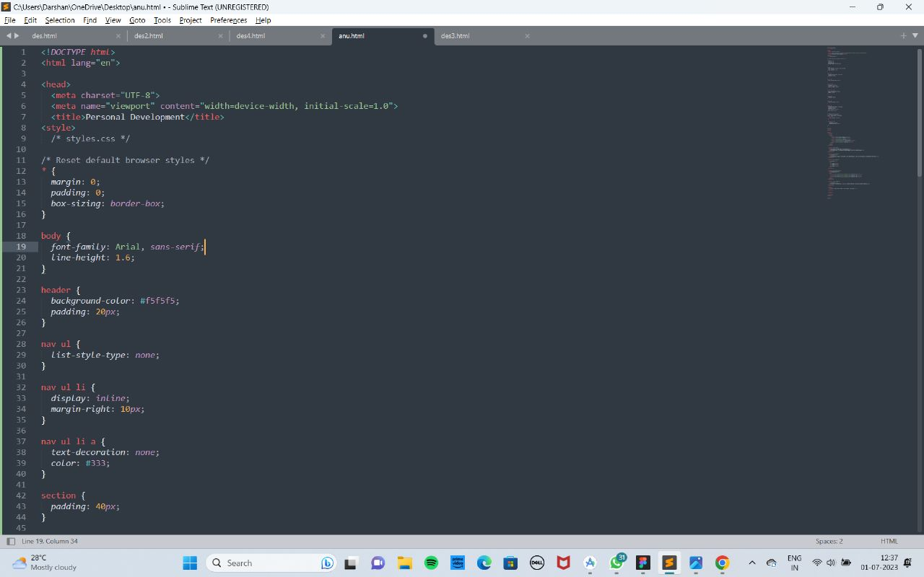

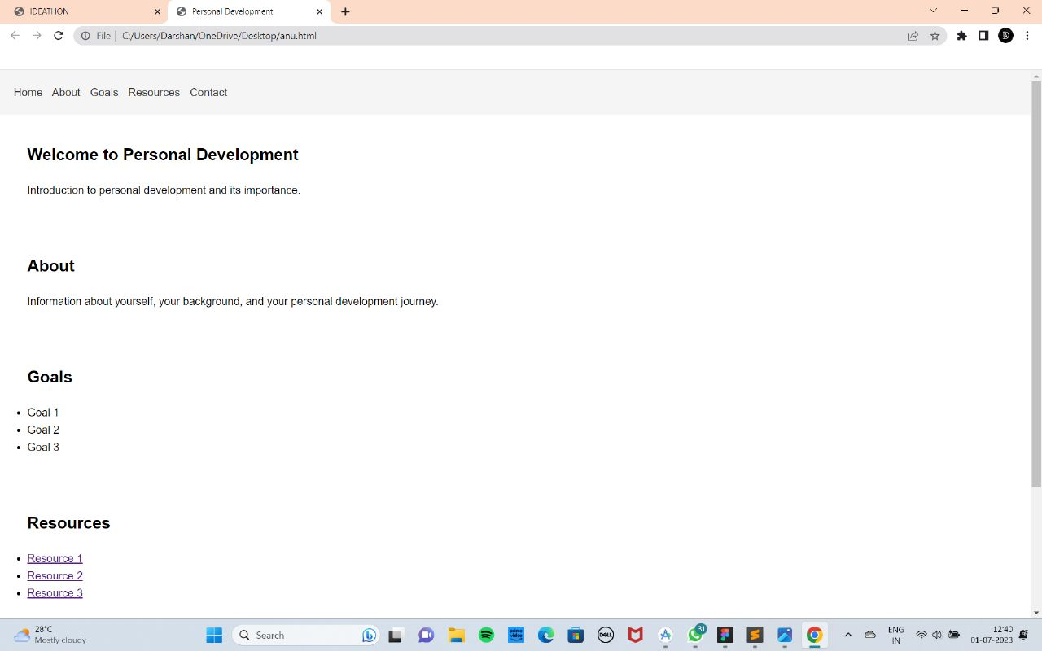

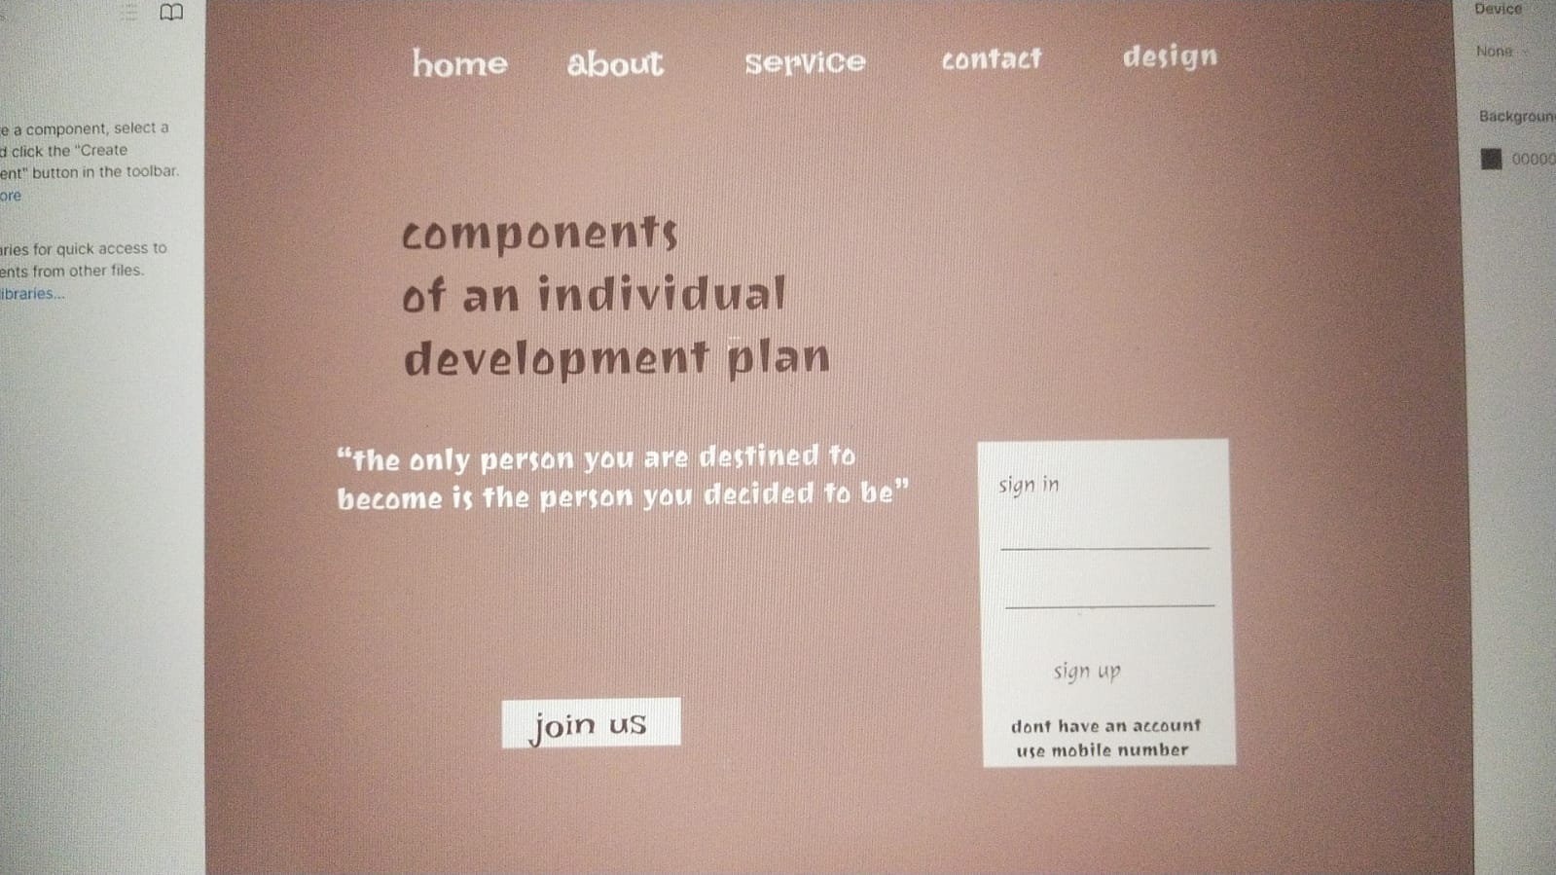

8.REFERENCE

1.https://www.google.com/url?sa=t&source=web&rct=j&url=htts://codepen.io/Praroz/pen/mdmZvwv

2.https://www.google.com/url?sa=t&source=web&rct=j&url=https://www.cloudways.com/

blog/custom-php-mysql-contact-form/&ved=2ahUKEwjvrMmYrr9AhUgSmwGHZg2CXQQFnoECDoQAQ&

usg=AOvVaw0l5fiP3314bEEPcovyRPH6

3. https://www.google.com/url?sa=t&source=web&rct=j&url=https://www.w3schools.com/

php/php_examples.asp&ved=2ahUKEwjvrMmYrr9AhUgSmwGHZg2CXQQFnoECDEQAQ&

usg=AOvVaw2rHlsuE2fvP2eg