SHRI B. V. V.SANGHA’S

BASAVESHWAR ENGINEERING COLLEGE (AUTONOMOUS) BAGALKOTE-587102



2024-2025

### DEPARTMENT OF INFORMATION SCIENCE AND ENGINEERING

**MINI PROJECT (22UIS616P)**

Report On

# “Eco Compost”

#### Mini Project Guide HOD

Prof Deepa I K Dr S P Bangarshetti

Submitted By

#### Team Members Name USN

1. Ananya K 2BA22IS011
2. Neha S 2BA22IS051
3. Pallavi S B 2BA22IS054

SHRI B. V. V. SANGHA'S

BASAVESHWAR ENGINEERING COLLEGE (AUTONOMOUS) BAGALKOTE-587102



2024-2025

### DEPARTMENT OF INFORMATION SCIENCE AND ENGINEERING CERTIFICATE

This is to certify that the mini project work entitled "Compost Production" is a bonafide work carried out by Pallavi S B ,Neha S ,Ananya K , Engineering College (Autonomous) Bagalkote affiliated to VTU Belgaum during the academic year 2023- 2024 ,the mini project report has been approved as it satisfies the academic requirements in respect of mini project work.

|  |  |  |
| --- | --- | --- |
| **Mini Project Guide** |  | **HOD** |
| Prof Deepa I K |  | Dr S P Bangarashetti |
| **Team Members Name** | **Project Associates** | **USN** |
| 1. Ananya P K |  | 2BA22IS011 |
| 1. Neha S |  | 2BA22IS050 |
| 1. Pallavi S B |  | 2BA22IS054 |
| **Name of Examiner** |  | **Signature with Date** |
| 1. …………………. |  | 1. …………………. |
| 2. …………………. |  | 2. …………………. |

# ACKNOWLEDGEMENT

The satisfaction that accompanies the successful completion of this project would be incomplete without the mention of the people who made it possible, without whose constant endurance and encouragement would have made efforts go in vain. We consider privileged to mess gratitude and respect towards all those who guided us through the completion of this project.

We convey thanks to our guide Prof. DEEPA I. K Asst Professor, Department of Information Science and Engineering, Co-Ordinator Prof G.B.SHETTER Asst Professor, department of Information Science and Engineering Basaveshwar Engineering College for providing encouragement, constant support and guidance which was of a great help to complete this project successfully

We are grateful to Dr. S. P. BANGARASHETTI, Professor and Head of Department of Information Science and Engineering. Basaveshwar Engineering College for giving us the support and encouragement that was necessary for completion of this project. We would also like to express our gratitude to Dr. B.R. HIREMATH Principal Basaveshwar Engineering College for providing us with a congenial environment to work in.

We are grateful to faculty and staff of department of Information Science and Engineering for providing the facilities which have helped in making in this project a success.

Finally, we would like to thank, our parents, friends and who helped to complete this project directly and indirectly, for their constant encouragement with moral and material support.

# ABSTRACT

# Eco-Compost is an innovative web-based system designed to address the growing need for sustainable waste management and promote eco-friendly practices. The platform provides an integrated solution for managing organic waste by connecting three key stakeholders: Households, Factories, and Farmers. The system aims to reduce environmental pollution, minimize landfill waste, and provide farmers with nutrient-rich compost to enhance agricultural productivity .Households serve as the primary contributors to the system by reporting the quantity of organic waste they generate through a user-friendly interface. The reported data is stored in a centralized database that is accessible to Factory personnel. Factory staff use this information to plan waste collection routes and schedules efficiently. Upon collection, the waste is processed in the factory to produce high-quality compost. The factory logs and updates the availability of compost in the system, ensuring real-time data access for farmers. Farmers are the end-users who benefit from the compost generated. They can log in to the platform to view the available compost, request its collection, and use it to improve soil fertility and crop yields. The system not only ensures seamless interaction between these stakeholders but also provides detailed records of waste quantities and compost distribution, enhancing transparency and traceability . Eco-Compost is developed using HTML, CSS, and PHP, offering a simple yet robust interface for all users. The application emphasizes scalability, accessibility, and efficiency. By creating a closed-loop system that turns waste into valuable compost, EcoCompost addresses critical environmental issues, promotes sustainable agriculture, and fosters a circular economy. This project is a step forward in creating a greener, cleaner, and more sustainable future.

**CONTENTS -**

## CHAPTER 1: INTRODUCTION

* 1. Motivation
  2. Objectives
  3. Scope of project
  4. Literature Survey

## CHAPTER 2: PROBLEM FORMULATION

* 1. Introduction
  2. Present System
  3. Proposed System
  4. Problem Statement

## CHAPTER 3: REQUIREMENTS

* 1. Functional Requirements
  2. Non functional Requirements
  3. Hardware & Software Requirements

## CHAPTER 4: DESIGN

* 1. ER Diagram
  2. Use case diagram
  3. Sequence diagram

## CHAPTER 5: IMPLEMENTATION

* 1. Flowcharts
  2. Implementation of the project
  3. Methodology

## CHAPTER 6: TESTING

* 1. Different steps of Testing
  2. Test Cases

## CHAPTER 7: RESULTS

* 1. Snapshots

## CHAPTER 8: CONCLUSION

* 1. Conclusion

## REFERENCES

**CHAPTER 1: INTRODUCTION**

* 1. **Motivation**

The motivation behind the Eco Compost project stems from the pressing need to address the challenges of organic waste management and its impact on the environment. With increasing urbanization and population growth, households generate significant amounts of organic waste, much of which ends up in landfills, contributing to greenhouse gas emissions and environmental degradation. At the same time, farmers face challenges in accessing affordable and sustainable alternatives to chemical fertilizers, which harm soil health and biodiversity. Recognizing the potential of organic waste as a resource, EcoCompost seeks to bridge this gap by creating a system that transforms waste into valuable compost. This project is driven by the vision of promoting a circular economy, reducing environmental pollution, and supporting sustainable agricultural practices. By leveraging technology to connect households, factories, and farmers, EcoCompost aims to foster community participation and create a greener, more sustainable future.

* 1. **Literature Survey**

|  |  |  |  |  |
| --- | --- | --- | --- | --- |
| **Sl. No** | **Authors** | **Title** | **Description** | **Website** |
| 1. | Manish kumar,  Akhilesh c | Research paper on vermiculture  (2010) | The machine is fully automatic, there is lot of operation occur inside with the help of component and convert our waste in useful product | https://www.ijrpr.com/uploads/V2ISSUE8/IJRPR1155.pdf |
| 2. | Rahmatullah  Hakeem | Compost machine  (2015) | Vermicomposting is an eco friendly fertilizer. In which paper waste is converted to vermicasts by the earth worms  (Eisenia fetida) | https://www.researchgate.net/publication/358511300_Research.pdf |
| 3. | Santosh S More | Rapid composting technique  (2019) | Technology is required to improve the quality of manuere in the shortest possible time where farmers can prepare the compost easily and improve its nutritional quality by the addition of cheap amendments such as rock phosphates and pyrites,micas etc. | https://www.researchgate.net/publication/316915492_A_Literature_Review_on_Rapid_Composting_Techniques |
| 4. | Mohan bangar | Design and Compost Machine  (2020) | System ploys high temperature to decompose food waste and organic matter. The prototype was able to decompose organic waste in a time frame of 38 to 50 hours | https://www.ijraset.com/research-paper/design-and-fabrication-of-compost-machine |
| 5. | Sushil Yadav | Composting as a Organic Solid Waste of Munciple Organic  (2021) | Vegitable Waste with high moisture content and readily biodegradable nature is causing major environmental problem due to improve waste | https://www.mdpi.com/2071-1050/16/15/6329 |
| 6. | Elena Elisabeta | Composting as a Sustainable Solution for Organic Solid Waste Management  (2023) | The production of Munciple Solid Waste (MSW) is growing rapidly. This study addresses the research gap in optimizing composting | https://www.ijraset.com/research-paper/design-and-fabrication-of-compost-machine |

## CHAPTER 2: PROBLEM FORMULATION

* 1. **Introduction**

In recent years, the challenges posed by waste management have become a pressing global concern. The increase in waste generation has led to environmental and public health issues. One promising solution is it reduces waste & also creates valuable resources for agriculture. Our project aims to create a comprehensive waste management system that connects waste contributors, compost-producing factories, and farmers.The process by collecting waste from contributors, processing it into compost at a factory and allowing farmers to request the compost for agricultural use. By creating a network that efficiently manages waste and transforms it into useful compost, this project contributes to sustainable farming and a cleaner environment.

* 1. **Present System**

An eco-composting software system is designed to help manage track and optimise composting processes enabling larger composting facilities to turn organic waste into compost efficiently and sustainablyAutomated Process Control-Adjusts factors like moisture and oxygen levels through an automated interface connected to equipment. Tracks the rate of decomposition to estimate time to maturity and efficiency. Allows users to monitor and control the composting process remotely, view analytics, and receive alerts on mobile devices. For agricultural user can integrate with farm management systems to improve large soil facilities to collaborate with local businesses for organic waste.

* 1. **Proposed System**

Home Composting: It targets individual users, providing guidance on managing waste in household. Information on compostable materials ratios and troubleshooting.

Community Composting Management Software: These platforms support neighborhood or community

composting initiatives. Keep track of compost volumes materials collected.

Smart Waste Management Solutions: These systems combine composting with broader of waste management .

* 1. **Post System**

Soil Health Improvement: Through the process farmers can get rich essential nutrients like nitrogen, phosphorus and potassium which are crucial for plant growth. When applied to soil compost gradually releases these nutrients enhancing soil fertility and crop productivity.

Cost Efficient: As the process is handheld it doesn’t require investment on raw materials it becomes cost efficient for farmers. Compost provides a steady nutrient release over time which supports healthier plants and leads to higher yields.

Eco-Conscious Branding: Sustainable practices resonate with consumers. Farmers using eco-composting can market their products as environmentally friendly, appealing to the growing demand for eco-conscious products

**2.5 Problem Statement**

Improper disposal of organic waste leads to environmental pollution, increased landfill usage, and missed opportunities to create valuable compost for agriculture. Households lack an efficient way to report waste, factories face challenges in collecting and processing it, and farmers struggle to access affordable compost. The absence of a streamlined system connecting these stakeholders hinders sustainable waste management and agricultural practices. EcoCompost addresses this issue by providing a web-based platform for efficient waste reporting, collection, compost production, and distribution.

## CHAPTER 3: REQUIREMENTS

#### Functional Requirements

1.Household Users: Ability to report household waste details (type, quantity, address). Option to schedule pickup for waste. Receive confirmation of waste collection from the factory.

2.Factory Personnel: View and manage waste collection requests from households Record waste pickup details Process the waste into compost and track the production progress. Notify farmers about compost availability.

3.Farmers: View compost availability details (quantity, quality, pricing) Place a request for compost from the factory. Schedule a pickup or delivery of the compost.

4.System Features: User authentication for all three user roles. Notifications to users about request statuses (e.g., waste collection, compost availability) Database to store user data, waste details, and compost stock

5.Reports and Analytics: Generate reports on waste collection, compost production, and usage trends for analysis and planning.

#### Non Functional Requirements

**1.⁠ ⁠Performance:**

The system shall handle simultaneous requests from multiple users without lag.

Waste pickup and compost request processing will be completed in seconds.

2.⁠ ⁠**Usability:**

The interfaces should be intuitive and easy to navigate for all user types.

3.⁠ **⁠Reliability:**

Ensure the system is available all the time to all users. Data should not be lost in case of a crash implement backups

#### Hardware & Software Requirements

##### 

##### Hardware Requirements

##### Client-Side:

##### 1.⁠ ⁠Device Requirements: Mobile Devices: Smartphones (Android/iOS) with at least 2 GB RAM and 16 GB storage. Desktop/Laptop: Minimum specs: Dual-core processor, 4 GB RAM, and 10 GB free disk space.

##### 2.⁠ ⁠Internet Requirements: Internet connection with a minimum speed of 2 Mbps for seamless app usage.

##### 3.⁠ ⁠Peripheral Devices (Optional): GPS-enabled devices for accurate location sharing. Barcode scanner (optional for factory personnel to track waste batches).

##### Server-Side:

##### 1.⁠ ⁠Server Specifications: Processor: Quad-core or higher (e.g., Intel Xeon or AMD EPYC). RAM: Minimum 8 GB, recommended 16 GB for scalability.

##### 2.⁠ ⁠Networking: High-speed internet connection with at least 10 Mbps upload/download speed. Secure server with firewall capabilities for data security.

##### 3.⁠ ⁠Backup System: External or cloud-based backup storage for periodic data backup.

##### Software Requirements:

##### Client-Side:

##### 1.⁠ ⁠Operating Systems: Android 9.0 or higher for mobile devices. iOS 12.0 or higher for Apple devices. Windows 10/MacOS 10.12 or higher desktop/laptops

##### 2.⁠ ⁠Browsers: Google Chrome, Mozilla Firefox, Safari.

##### Software Requirement Server-Side:

##### 3.⁠ ⁠Mobile App: Custom-built mobile application compatible with Android and iOS. Server-Side:

1.⁠ ⁠Backend Development: Programming Languages: html, javascript , php Database: MySQL.

2. ⁠Web Server: Apache HTTP Server for hosting web applications.

## CHAPTER 4: DESIGN

## 4.1 Architecture

## 

**4.2 Data flow**

Data flow diagrams are also used to model information systems. They provide greater detail than a context diagram as they display each process involved within the information system as an individual circle, meaning the end result will contain multiple circles/processes. A DFD also has a shape for data stores to represent where data is sent and retrieved from, such as a specific database. Data stores are represented as a three sides rectangle shape.

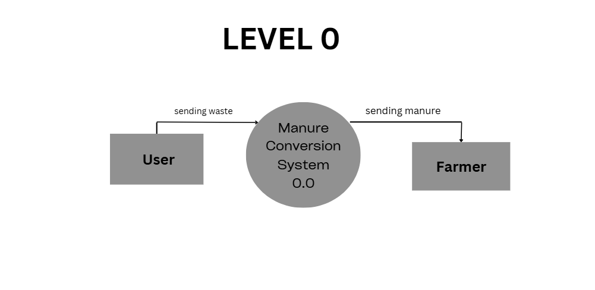

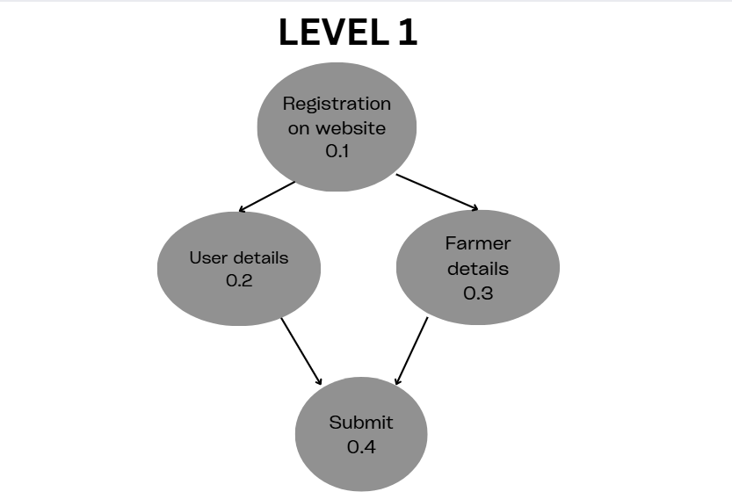

## 4.3 Sequence diagram

## 

## 4.3 Use Case Diagram

## 

## 5: IMPLEMENTATION

* 1. **Module Implementation**

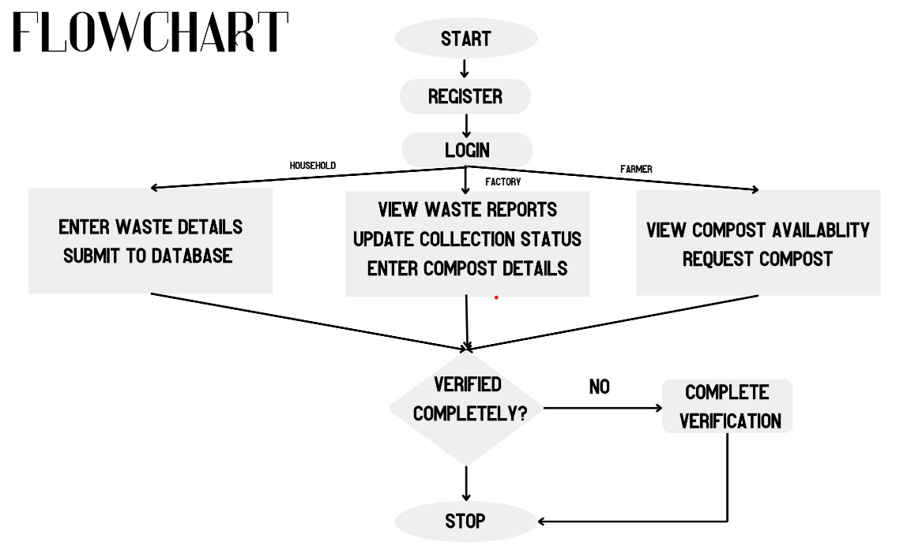

**CHAPTER 6**

**6.1 Snapshots**

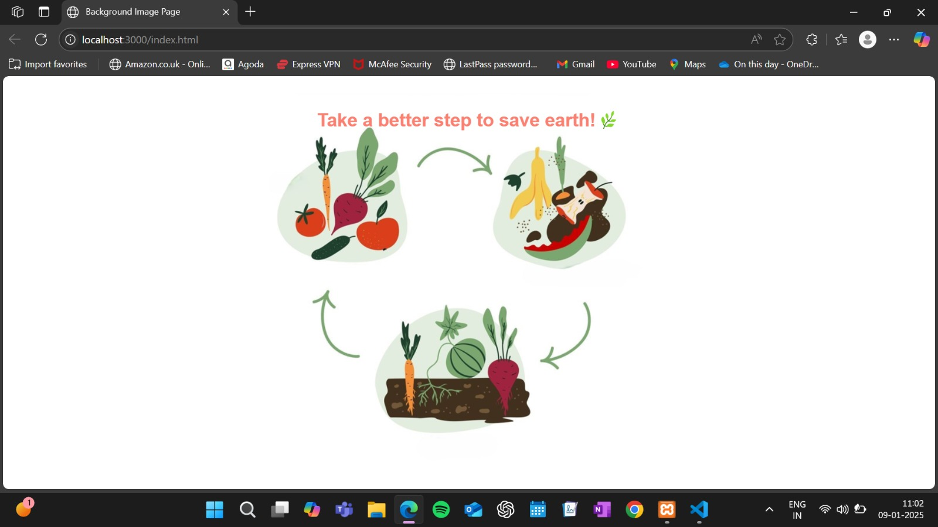

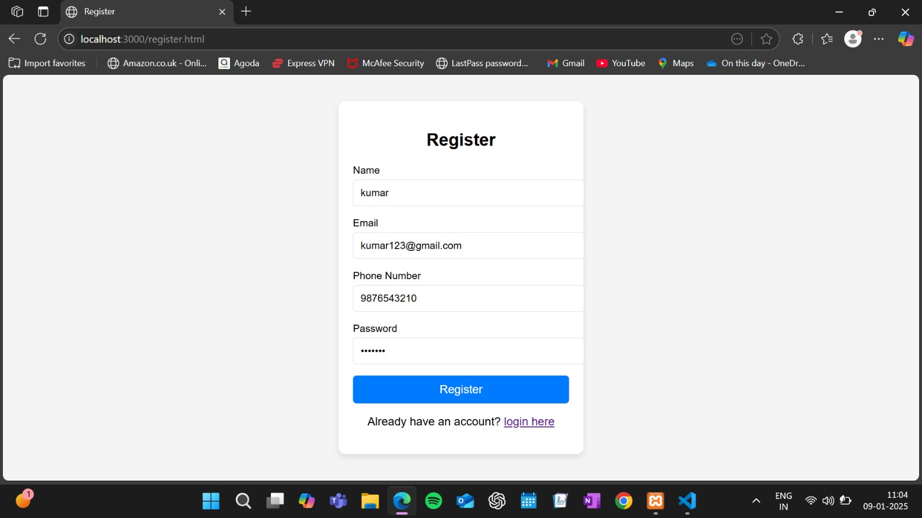

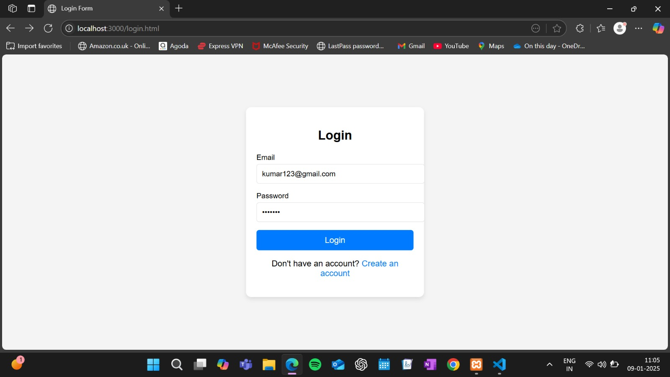

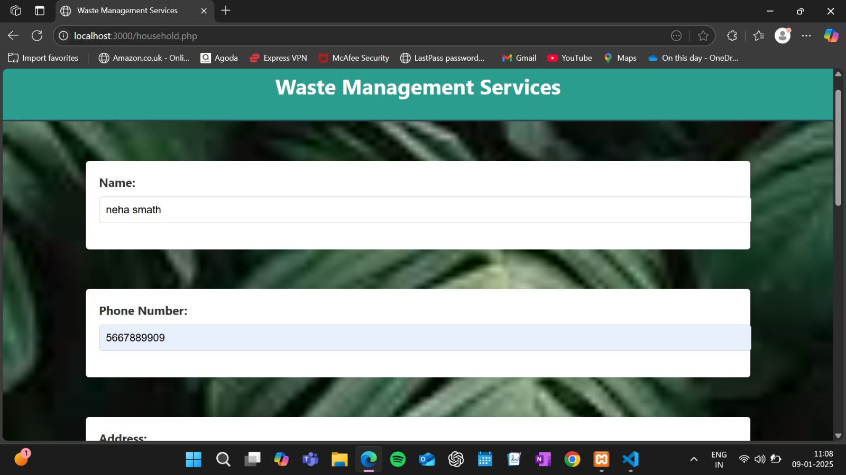

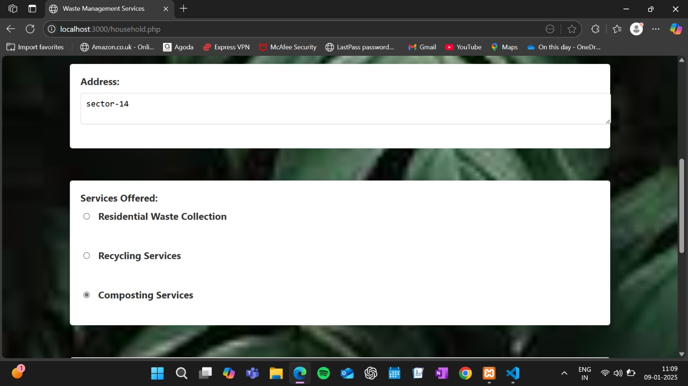

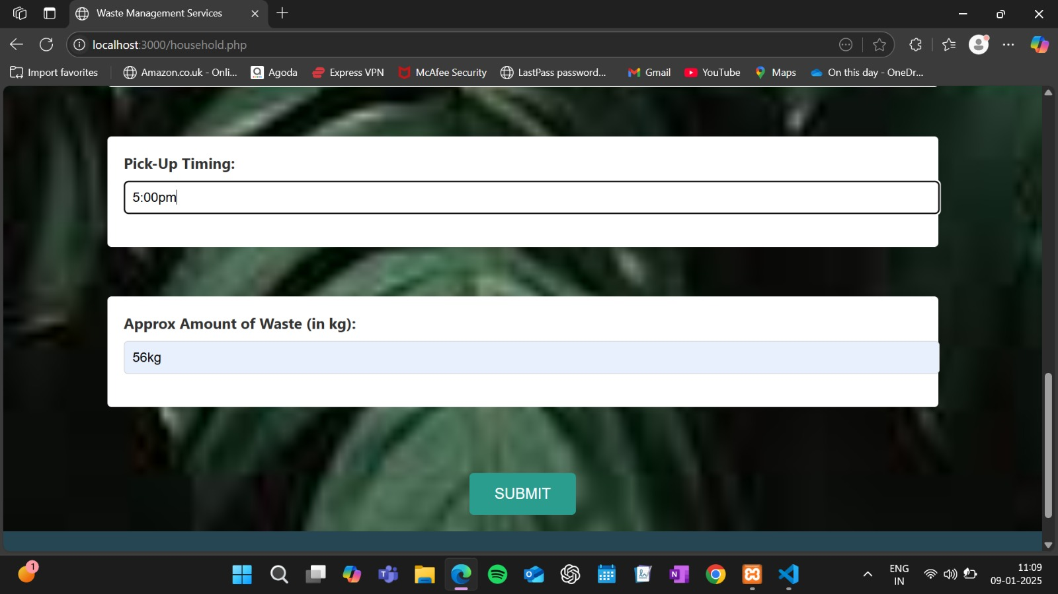

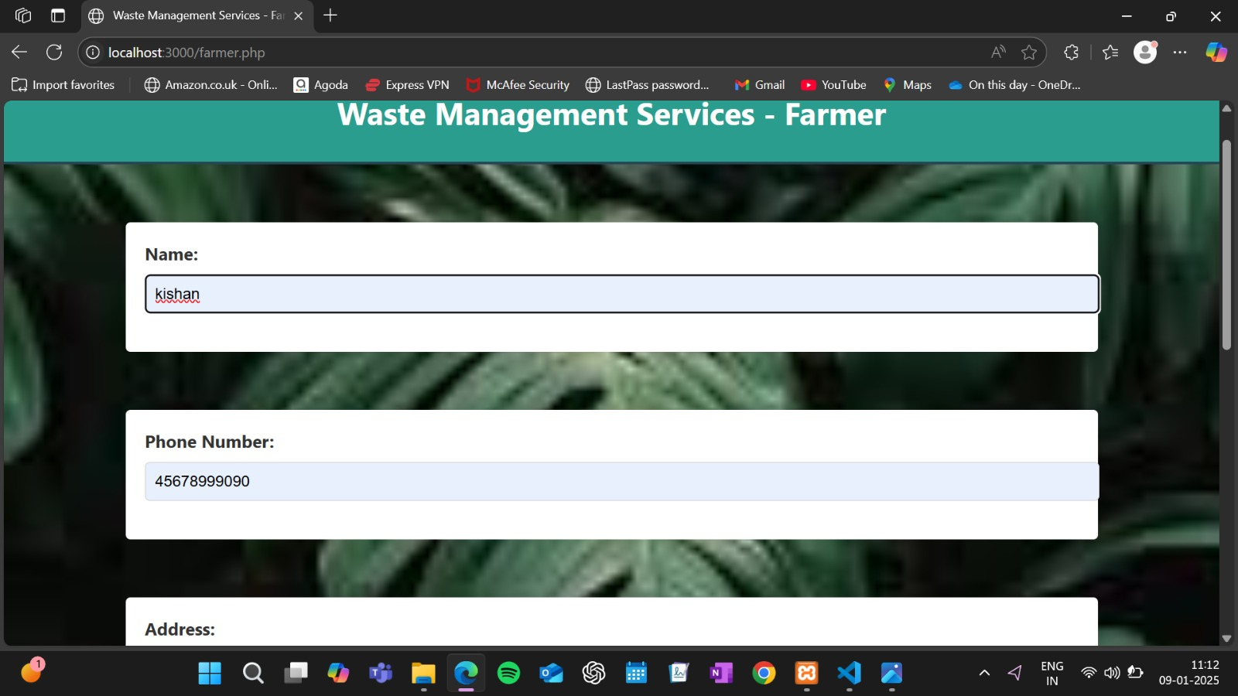

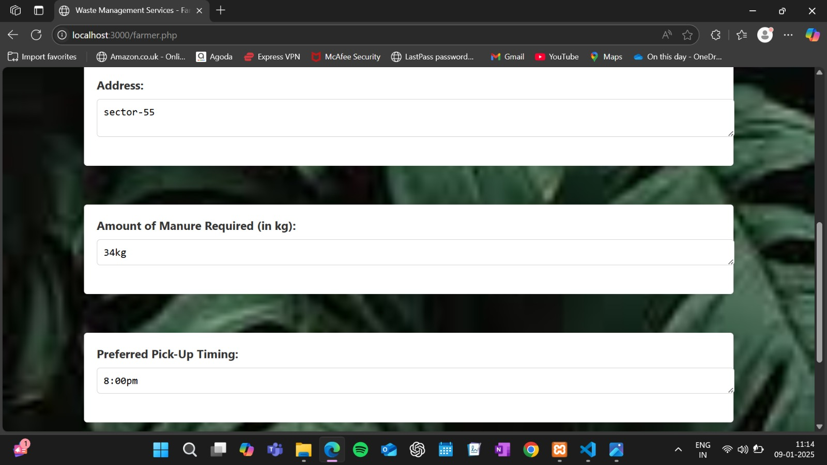

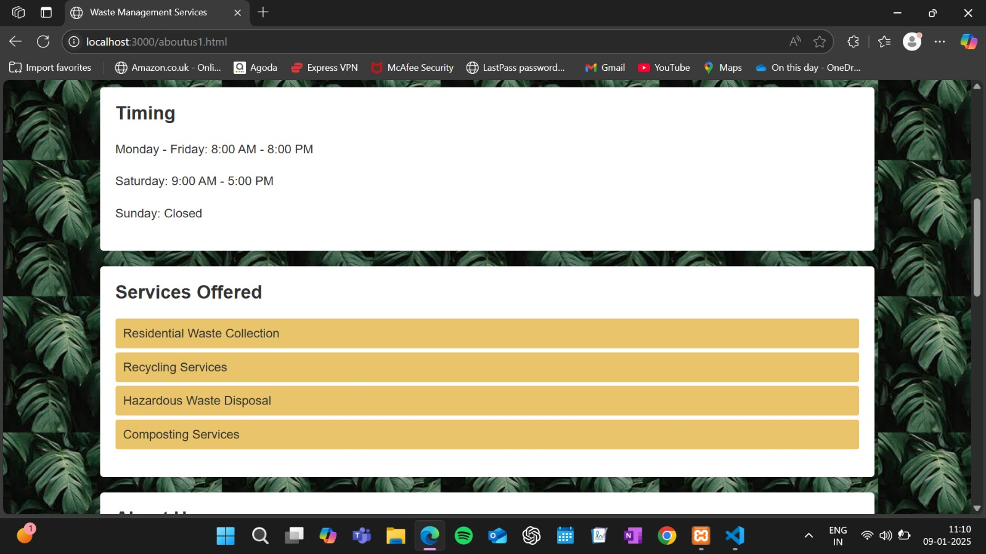

**CHAPTER 8: CONCLUSION**

* 1. **Conclusion**

In conclusion, the Eco Compost project bridges the gap between waste generation and sustainable agriculture by creating a seamless system that benefits households, factories, and farmers alike. By transforming waste into valuable compost, it not only promotes environmental sustainability but also fosters a circular economy where every stakeholder contributes to and benefits from the process. This innovative solution has the potential to reduce landfill waste, enrich agricultural productivity, and inspire communities to adopt greener practices. Eco Compost isn’t just a project; it’s a step toward a cleaner, greener future for all.

## REFERENCES

**1.Share Waste**

An online platform that connects individuals with neighbors who are composting, worm-farming, or keeping chickens. Households can donate their kitchen scraps to nearby composters, promoting community-driven waste recycling.

**2.CompostNow**

A service that provides food scrap collection for homes and businesses. Members receive a bin to fill with compostable materials, which is then collected and turned into compost. Participants can receive compost for their gardens or donate it to community gardens.

**3.Compost Crew**

Operating in the Washington, D.C., Maryland, and Virginia areas, Compost Crew offers food scrap collection services for homes and businesses. They transform organic waste into valuable compost, contributing to environmental sustainability.

**4.Mill**

An innovative kitchen device that turns food scraps into nutrient-rich grounds overnight. Users can use these grounds in their gardens or have them collected to support small farms, effectively closing the loop in food waste management.

**5.Dung Beetle DAO**

A decentralized waste management platform that equips households and farms with bins and training for waste sorting. It schedules collections and utilizes tokens to incentivize participation, aiming to streamline waste management processes.