DevCheckpoint
Product Requirements Document (PRD)
Developer memory for task switching, debugging continuity and team handoffs.
Product promise
Git saves your code. DevCheckpoint saves the working context around your code.

Hackathon Track
Developer Tooling - Workflow & Context Management
Version 1.0 | MVP PRD | September 2026

1. Executive Summary
What we are building and why it matters.
DevCheckpoint is a local-first developer productivity tool that creates save-points for software work. It captures the context around a coding task - the task goal, changed files, Git state, errors, commands, notes, attempted fixes and the next likely action - and turns that information into a concise AI-generated checkpoint.
When a developer is interrupted or switches projects, they can later open the saved checkpoint and quickly resume without reconstructing the entire mental state from Git history, terminal output and open files.
Core user outcome
A developer should be able to leave a task, return hours or days later, and understand the current state in under one minute.

MVP scope
- Add/select a local Git project.
- Create a task with a short task description.
- Capture Git branch, changed files, diff, recent commits and optional developer notes.
- Accept pasted terminal errors / recent commands in MVP; automatic terminal capture is a later enhancement.
- Generate an AI checkpoint containing current task, current problem, already-tried actions, important files and next step.
- Save checkpoints locally and reopen them later.
- Generate a shareable handoff summary for another developer.
Out of scope for MVP
- Full IDE replacement or code editor.
- Autonomous code changes or automatic commits.
- Continuous screen recording or keylogging.
- Enterprise analytics, SSO and organization-wide administration.
- Complex multi-repository dependency graphs.

2. Problem, Users & Goals
Problem statement
Git is excellent at recording code history, but it does not reliably capture the developer's temporary working context: why a change was being made, what failed during debugging, what approaches were rejected, what commands were run, and what should happen next. That information often disappears when the developer switches tasks or ends the day.
Primary users
User | Need | Example
Solo developer | Resume work quickly after interruptions | Return to a half-finished bug fix the next day
Software engineer in a team | Switch between tickets without losing mental context | Pause feature work to handle a production issue
Developer handing off work | Explain current state without a long call or message | Transfer an incomplete task to a teammate
New contributor | Understand what the previous developer was doing | Continue an existing task from a saved checkpoint

Product goals
- Reduce the time required to resume an interrupted coding task.
- Capture useful context that is usually missing from Git commits.
- Make task handoffs clearer and faster.
- Keep the MVP simple enough to work with existing Git projects and developer tools.
- Use AI to summarize context, not to replace the developer or IDE.
Success criteria for hackathon MVP
Metric | Target
Checkpoint creation | Under 10 seconds after context is submitted
Resume comprehension | User understands task state in under 60 seconds
Required user input | Only project + task description; notes/errors optional
Core demo flow | Start task -> save checkpoint -> switch -> resume -> handoff
Data handling | Project metadata/checkpoints stored locally by default

3. User Experience & Core Flow
Primary flow
1. Add Project - User selects a local Git repository.
2. Start Task - User enters a short description such as “Fix Stripe webhook verification.”
3. Work Normally - DevCheckpoint reads available project/Git context; developer can add errors, commands or notes.
4. Save Checkpoint - User saves the task state before stopping or switching.
5. AI Summary - AI converts raw context into a structured checkpoint.
6. Resume - User reopens the checkpoint and sees what was happening and what to do next.
7. Handoff - Optional: generate a concise summary for another developer.
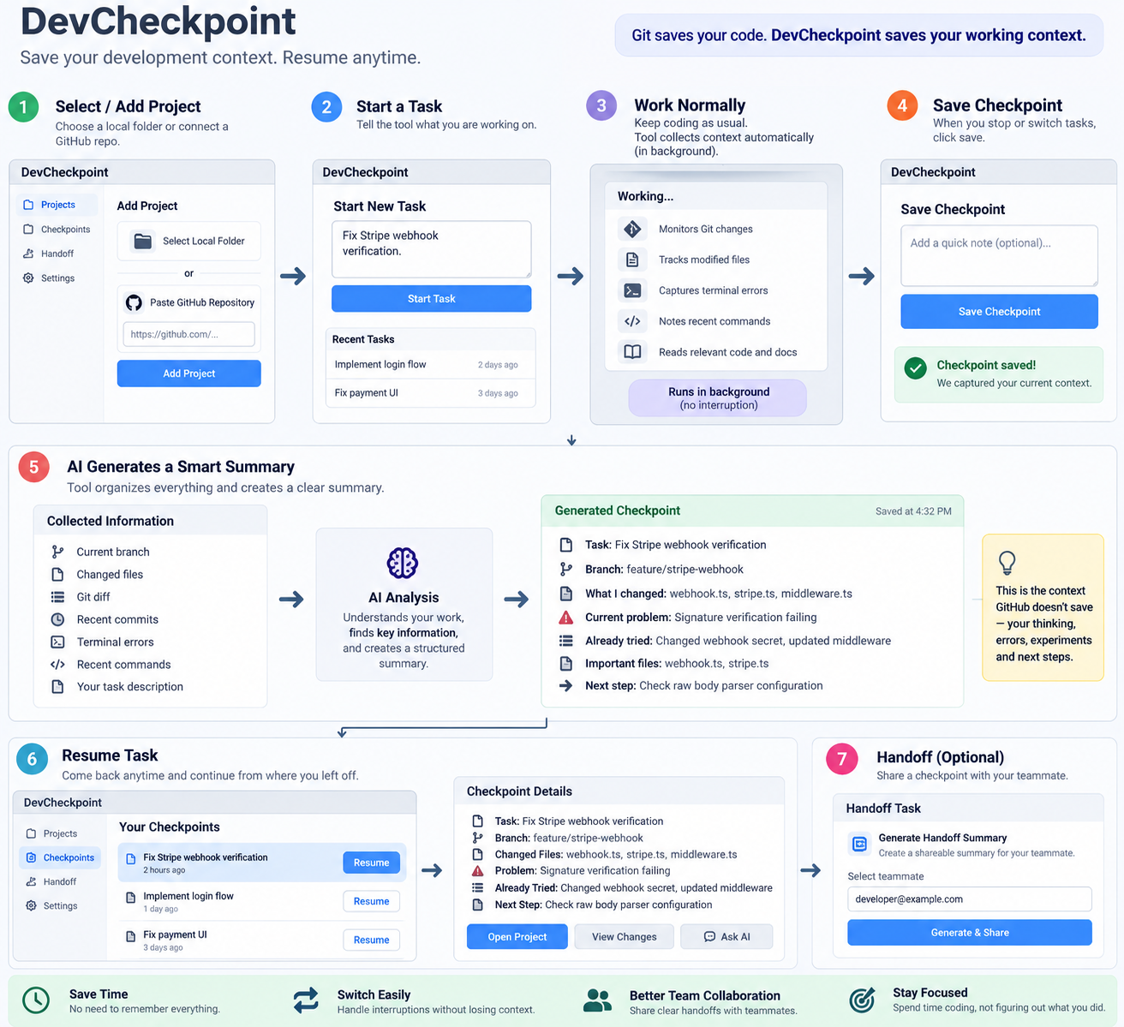
Concept flow: project -> task -> context capture -> checkpoint -> resume / handoff

4. Functional Requirements
Requirements are prioritized for the hackathon MVP.
ID | Capability | Priority | Requirement
FR-01 | Project selection | Must | User can select a local Git project and DevCheckpoint stores its path/reference.
FR-02 | Project validation | Must | System detects whether the selected directory is a Git repository and shows a clear error if it is not.
FR-03 | Task creation | Must | User can create a task with title/description and start time.
FR-04 | Git context | Must | Read current branch, git status, changed files, git diff and recent commits.
FR-05 | Developer notes | Must | User can enter free-text notes, blocker, attempted fixes, recent commands or error output.
FR-06 | Checkpoint generation | Must | AI converts captured context into a structured summary.
FR-07 | Checkpoint storage | Must | Checkpoint is stored locally with timestamp, project and task association.
FR-08 | Checkpoint list | Must | User can view previous checkpoints for a project/task.
FR-09 | Resume view | Must | User can open a checkpoint and immediately see current objective, problem, key files, attempted fixes and next step.
FR-10 | Handoff summary | Should | Generate a clean text handoff that can be copied/shared.
FR-11 | Ask AI about checkpoint | Should | User can ask a question using saved checkpoint context.
FR-12 | Automatic terminal capture | Later | Capture terminal commands/errors through IDE/terminal integration.
FR-13 | Background activity capture | Later | Track file activity during an active task with explicit user control.

Checkpoint output structure
Field | Description
Task | What the developer is trying to accomplish.
Branch | Current Git branch.
What changed | Short summary of relevant modified files / diff.
Current problem | The blocker, failing behavior or unresolved question.
Already tried | Experiments/fixes already attempted.
Important files | Files most relevant to continuing the task.
Next step | One or more concrete actions to try next.

5. Screens & Interaction Requirements
Screen | Purpose | Required elements
Projects | Entry point to all workspaces | Project cards, add project, last checkpoint, Resume button
Task | Start/monitor a task | Task title, description, project, branch, current status
Save Checkpoint | Capture context before switching | Detected Git info, notes/errors fields, Save button
Checkpoint Detail | Resume work | Task, changed files, blocker, tried, key files, next step, Ask AI
History | View previous save-points | Timeline/list of checkpoints with timestamps
Handoff | Transfer work | Generated summary, copy/export action

UX principles
- Checkpoint creation should feel lighter than writing a detailed status update.
- AI output must be concise and action-oriented, not a long chat response.
- The developer should always see what information is being collected.
- No automatic code edits in the MVP.
- The product should work alongside VS Code/Cursor/other IDEs rather than compete with them.
Key interaction
The strongest demo moment is “Resume Task”: one click should show the complete task state and a practical next step.

6. AI & Context Requirements
AI responsibilities
- Summarize Git changes in plain language.
- Combine user notes/errors with repository context.
- Identify likely important files from changed files and task description.
- Extract what has already been attempted.
- Suggest a next step without claiming certainty when evidence is incomplete.
- Generate a handoff summary in a compact format.
AI guardrails
- Do not invent commands, errors or experiments that are not present in captured context.
- Clearly label suggestions as recommendations when they are inferred.
- Never expose secrets from .env, credentials, private keys or ignored sensitive files.
- Do not automatically run destructive commands.
- Limit context sent to external AI providers; local-model mode should be supported later.
Suggested model input
Context package
Task description + branch + Git status + changed files + selected diff + recent commits + developer notes + pasted terminal errors/commands.

Suggested model output
Structured checkpoint
Task / Current state / What changed / Current blocker / Already tried / Important files / Recommended next step.

7. Technical Design
Recommended MVP stack
Layer | Technology | Reason
Frontend | Next.js + TypeScript | Fast UI development and easy API integration
UI | Tailwind CSS + shadcn/ui | Reusable, clean dashboard components
Backend | Next.js API routes or lightweight Node service | Keeps hackathon architecture simple
Database | SQLite | Local, simple and sufficient for projects/tasks/checkpoints
Git | simple-git / Git CLI | Reliable access to branch, diff, status and log
File access | Node.js fs APIs | Read selected project metadata/files as needed
AI | OpenAI/Gemini API or Qwen via Ollama | Structured summarization with option for local AI
Desktop later | Tauri | Safer local filesystem/background integration with small footprint

High-level architecture
Local Project -> Context Collector -> Context Filter -> AI Summary Engine -> SQLite -> Dashboard / Resume / Handoff
Core data model
Entity | Key fields
Project | id, name, local_path, repo_name, created_at
Task | id, project_id, title, description, status, started_at, closed_at
Checkpoint | id, task_id, timestamp, branch, git_status, diff_summary, blocker, tried, next_step, ai_summary
CheckpointFile | checkpoint_id, file_path, change_type, relevance_score (optional)
ContextNote | task_id, type (note/error/command), content, created_at

Privacy / security requirements
- Store project paths and checkpoints locally by default.
- Respect .gitignore and an additional DevCheckpoint ignore list.
- Exclude .env, credential files, SSH keys, private keys and obvious secret patterns.
- Show whether the selected AI provider is local or cloud-based.
- Require user action before generating/sending a checkpoint to an external model.
MVP implementation order
Phase | Deliverable
1 | Project picker + Git repo validation
2 | Task creation + local SQLite storage
3 | Git context collector (branch/status/diff/commits)
4 | Save Checkpoint form + developer notes/errors
5 | AI structured summary generation
6 | Checkpoint history + Resume Task view
7 | Handoff summary + copy/export
8 | Polish, demo project and edge-case handling

8. Acceptance Criteria & Roadmap
MVP acceptance criteria
- A user can add a valid Git repository without manual configuration.
- A user can create a task and save at least one checkpoint.
- The checkpoint contains branch, changed files and an AI summary.
- The summary includes the task, current problem, already-tried actions, important files and next step when that information is available.
- A user can close/reopen the app and still see saved checkpoints.
- A user can resume a task from the checkpoint detail screen.
- A user can generate and copy a handoff summary.
- Sensitive/common secret files are excluded from AI context.
Post-MVP roadmap
Stage | Enhancements
V1.1 | Automatic terminal command/error capture; file watcher; richer checkpoint timeline
V1.2 | VS Code/Cursor extension; one-click Start/Pause/Resume inside IDE
V1.3 | Semantic code search, smarter relevant-file detection and Ask Workspace
V1.4 | Multi-repo tasks, Jira/GitHub Issues integration and team handoff links
V2 | Team workspace, encrypted sync, organization controls, project knowledge memory

Demo scenario
1) Start “Fix Stripe webhook verification”. 2) Show changed files and a failing error. 3) Save a checkpoint. 4) Switch to another task. 5) Return and press Resume. 6) Show the AI checkpoint and recommended next action. 7) Generate a handoff summary for a teammate.
Final positioning
DevCheckpoint is not another code generator. It is the memory layer that helps developers stop, switch and continue without losing the context around their work.

Document status: MVP requirements ready for implementation. Requirements may be refined after prototype testing.

