**Build-A-Meal Calculator**

**Project Summary**

*It should be a 1-2 paragraph description of what your project is.*

Our project focuses on helping our users to develop healthy eating habits by tracking their calories, protein, carbohydrates, and fibre’s intake based on their Body Mass Index (BMI) and Body Metabolic Rate (BMR) with a guided 3-step process. The database that we are going to use for this project is “<https://www.ars.usda.gov/northeast-area/beltsville-md-bhnrc/beltsville-human-nutrition-research-center/food-surveys-research-group/docs/fndds-download-databases/>.”

This database includes Food Name, Carbohydrates, Protein, and Fiber, which are all the information needed to provide our users a suggested amount of calories and nutrients intake (Step 1).

The user then will be able to search on the ingredients they want and will be provided the calories and nutrients content for each ingredient. We will also include filters such as calories range, protein, carbohydrates, fiber content on ingredients to ease the process of searching. We will provide them with an interactive calculator, so that the user can mix and match their ingredients while seeing how it adds up to their total goal of calories (Step 2). Lastly, the user will be able to see the summary of the total calories and nutrients of the ingredients they have chosen (Step 3).

**Description of an application of your choice.**

*State as clearly as possible what you want to do. What problem do you want to solve, etc.?*

With the growing rate of obesity in the nation, we want to create a website that highlights the habit of healthy and mindful eating. This can be achieved by paying attention to the amount of calories consumed in regards to the calories needed for each individual. Our website will have a 3-step process to help beginners to follow along.

Step 1 : The user will be able to input their body weight, height, age, amount of daily exercise  where it will then suggest the calories and protein needed based on their BMI and BMR. In addition to that, the user can also modify the weight based on their personal goals.

Step 2 : We would use a clean UI design to display the calories and protein content in an ingredient taken from a database. We will heavily incorporate filters, so that the user can filter out foods based on its calorie range, protein content, sugar contents, and fibre content. We will provide them with an interactive calculator, so that the user can mix and match their ingredients while seeing how it adds up to their total goal of calories.

Step 3: After choosing the ingredients, we will provide them with a summary and indicate whether they are right on, exceed, or below their target calories, plus their total protein, sugar, and fibre intake of the day.

**Usefulness**

*Explain as clearly as possible why your chosen application is useful. Make sure to answer the following questions: Are there any similar websites/applications out there? If so, what are they, and how is yours different?*

Our application is useful as it helps users be more healthy and track the amount of calories they want to take and reach their ideal calorie goal. There are similar websites out there but they just provide the foods with their calories. Ours first calculates the BMR and then proceeds to give the user information on the type of calorie they want to take. Other than that, we also have an interactive calculator and a clean UI that is free of ads, and is very beginner-friendly. The 3 step process that we have stated will guide the user step-by-step. For example, most users are not informed about what their ideal calories intake are, which we will tackle in our first step. So, our website does not require the user to have prior knowledge to use.

**Realness**

*Describe what your data is and where you will get it.*

* Our data will be obtained from the official website of the US Department of Agriculture.
* Website: <https://www.ars.usda.gov/northeast-area/beltsville-md-bhnrc/beltsville-human-nutrition-research-center/food-surveys-research-group/docs/fndds-download-databases/>
* It contains the information about the amounts of calories, proteins, carbohydrates, fibers for a list of food items.

**Description of the functionality that your website offers.**

*This is where you talk about what the website delivers. Talk about how a user would interact with the application (i.e. things that one could create, delete, update, or search for). Read the requirements for stages 4 and 5 to see what other functionalities you want to provide to the users. You should include:*

1. Describe what data is stored in the database. (Where is the data from, what attributes and information would be stored?)

Our data will be obtained from the official website of the [US Department of Agriculture](https://www.ars.usda.gov/northeast-area/beltsville-md-bhnrc/beltsville-human-nutrition-research-center/food-surveys-research-group/docs/fndds-download-databases/). It contains the information about the amounts of calories, proteins, carbohydrates, fibers for a list of food items.

1. What are the basic functions of your web application? (What can users of this website do? Which simple and complex features are there?)
2. A form where users can fill in their body height, weight, sex, age, exercise intake. (simple)
3. BMI, BMR, calories, protein, fibres, carbohydrates calculators (simple)
4. Filters (calorie range, protein, fibres, carbohydrates content) (complex)
5. Ingredients Search Bar (complex)
6. Summary (Whether the target calories have been achieved)

3. What would be a good creative component (function) that can improve the functionality of your application? (What is something cool that you want to include? How are you planning to achieve it?) (Ananya)

The aspect which is different from other websites is that we are calculating the BMI and then sorting the foods according to their calorie content instead of just providing information on foods. Adding on, we have an interactive calculator that lets the user input their information and return their ideal BMR. The guided steps (stages) also help them navigate the website easily and get the information they needed from it. We are still thinking about how to achieve that by applying the basics of Database and SQL using a data structure.

**A low fidelity UI mockup**

*What do you imagine your final application’s interface might look like? A PowerPoint slide or a pencil sketch on a piece of paper works!*

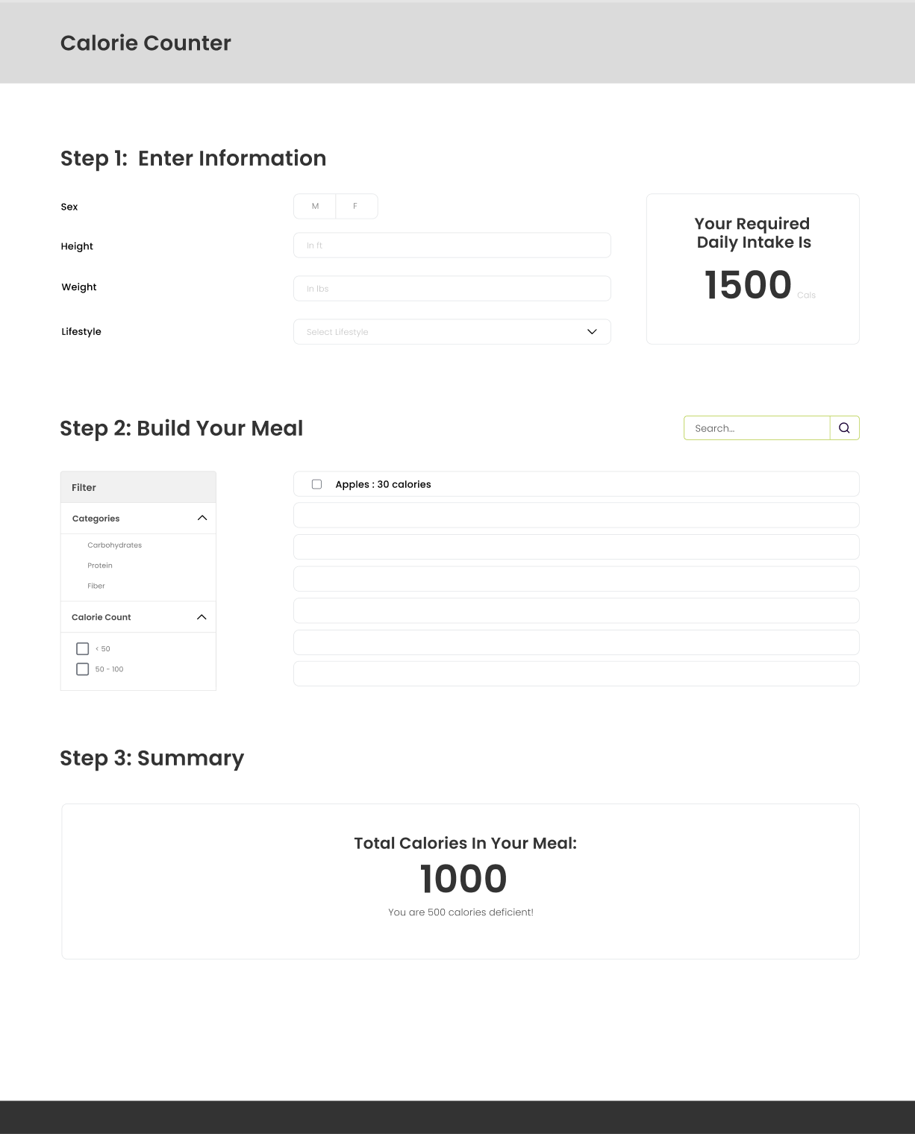

**Project work distribution**

*Who would be responsible for each of the tasks or subtasks?List of the person responsible for which exact functionalities in section f. Explain how backend systems will be distributed across members. Be as specific as possible as this could be part of the final peer evaluation metrics.*

Front-End (Gisella & Brenda):

Tech Stack:

* ReactJS
* HTML&Tailwind CSS

Job Description:

* Prototype
* Convert it to website with ReactJS, HTML&Tailwind CSS
* Form and posting the data to the BackEnd
* BMI, BMR, calories, protein, fibres, carbohydrates calculators
* Ingredients Search Bar (complex)
* Summary

Back-End (Heet & Ananya):

Tech Stack:

* SQL (Ananya)
* Python (Heet)

Job Description:

* Entity-Relationship Diagram *or* UML Diagram
* Filters (calorie range, protein, fibres, carbohydrates content) (complex)
* Ingredients Search Bar (complex)

**Resources**

1. **BMR CALC:** <https://www.checkyourhealth.org/eat-healthy/cal_calculator.php>
2. **DATA:** <https://www.ars.usda.gov/northeast-area/beltsville-md-bhnrc/beltsville-human-nutrition-research-center/food-surveys-research-group/docs/fndds-download-databases/>