**Blockchain Based Blood Donation System**

**ABSTRACT**

*HemoChain – Blood Donation Management System using blockchain.*

Donating blood is a voluntary medical procedure where the blood of a healthy individual is used for someone who had a major blood loss due to emergencies, injuries, surgeries etc. Blood donation is crucial at the time of such medical emergencies, and the unavailability of blood during this time can lead to the death of the patient. Thus, blood must be easily available and its information must be visible. This paper addresses the visibility challenges of hematological information and the timely delivery of blood by the integration of blockchain technology into the donation process. With the help of transparent and tamper-proof decentralized ledger technology, the blood donation process can become more efficient, enabling timely delivery of blood to the patient.

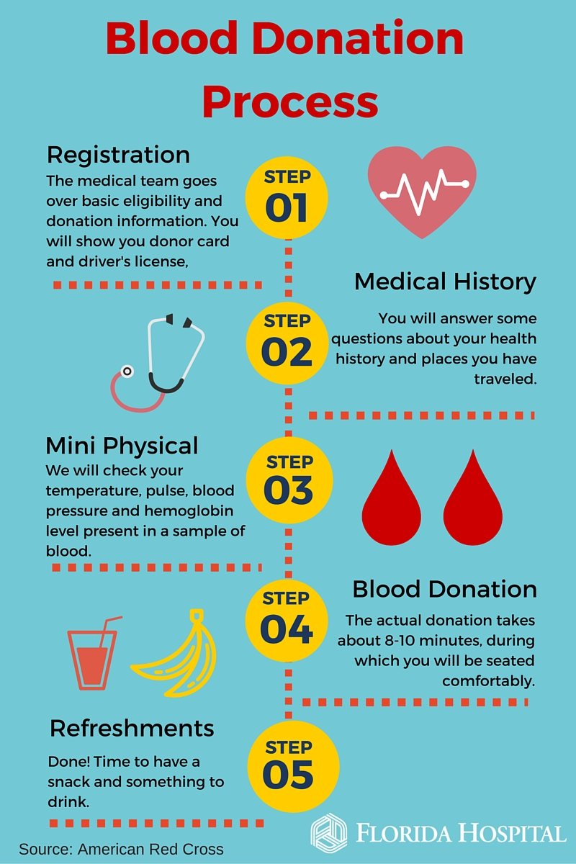**INTRODUCTION**

The supply chain of blood begins with the patient and terminates with the donor. There are several factors which affect this supply chain such as availability of healthy donor, quantity of blood required etc.

**Current issues in blood supply chain are:**

1. Centralized system
2. Unnecessary manual work
3. Probability of loss of records
4. Lack of visibility of hematological info
5. Inefficient mapping of donor and patient
6. **Centralized System**: In a centralized all decisions and processes are handled centrally. This causes inefficiencies and delays as information and resources need to be transferred from the centre to the peripheral units. It also causes lack of flexibility and adaptability to local conditions and needs.
7. **Unnecessary Manual Work**: Record-keeping and inventory management are time-consuming and prone to human error, causing increased costs.
8. **Probability of Loss of Records**: Paper-based records can be easily lost, damaged or misfiled. Searching for specific records can be time-consuming. Loss of records can have serious implications, including the inability to trace blood units.
9. **Low Visibility of Haematological Information**: Lack of access to real-time and accurate haematological information can hinder decision-making processes in blood supply management. This causes poor allocation of blood units and increased risk of transfusion reactions.
10. **Inefficient Mapping of Donor and Patient**: Inefficient systems for matching donors and patients can lead to delays in finding suitable blood units for patients. This can have serious implications for patient health, particularly in emergency situations.

**LITERATURE REVIEW**

[How blockchain is helping make every blood donation more effective | EY - Global](https://www.ey.com/en_gl/blockchain/how-blockchain-could-ensure-every-drop-of-blood-is-tracked-and-every-outcome-is-measured)

[Network | Free Full-Text | BloodChain: A Blood Donation Network Managed by Blockchain Technologies (mdpi.com)](https://www.mdpi.com/2673-8732/2/1/2)

[(PDF) BloodChain: A Blood Donation Network Managed by Blockchain Technologies (researchgate.net)](https://www.researchgate.net/publication/357795236_BloodChain_A_Blood_Donation_Network_Managed_by_Blockchain_Technologies)

[BloodChain and the Future of Healthcare in the Developing World | Info-Tech Research Group (infotech.com)](https://www.infotech.com/research/bloodchain-and-the-future-of-healthcare-in-the-developing-world)

[Blockchain-Based Organ Donation and Transplant Matching System | SpringerLink](https://link.springer.com/chapter/10.1007/978-3-031-35751-0_11)

<https://www.jetir.org/papers/JETIR2308091.pdf>  
  
<https://thesai.org/Downloads/Volume14No10/Paper_101-A_Comprehensive_System_for_Managing_Blood_Resources.pdf>  
  
<https://ijettjournal.org/Volume-70/Issue-8/IJETT-V70I8P210.pdf>  
  
[CENTRE OF EXCELLENCE IN BLOCKCHAIN TECHNOLOGY](https://blockchain.gov.in/Home/CaseStudy?CaseStudy=BloodBank)

https://www.semanticscholar.org/paper/Smart-Platform-for-Data-Blood-Bank-Management%3A-in-Elmir-Hemmak/3c1c317e4f041a34914cef16d6b1b22d438e3bd6

<https://www.researchgate.net/publication/370602395_Blood_Bank_Management_System>

**SOLUTION**

Blockchain technology, specifically Distributed Ledger Technology **(DLT)** and **smart contracts**, can address the challenges in blood supply management.

HemoChain, our proposed system, leverages **Ethereum’s private blockchain** to facilitate efficient transactions in blood donation networks. It tokenizes blood units, enabling real-time tracking from donor to medical clinics, thereby addressing complexities in the blood supply chain.

The system aims to:

1. **Enhance Information Visibility**: Blockchain’s transparency ensures visibility of haematological data and the entire blood donation process.
2. **Reduce Supply Time**: Efficient B2B transactions and real-time tracking reduce the time taken for blood supply.
3. **Improve Healthcare Transparency**: The immutable nature of blockchain prevents tampering of information, ensuring secure and transparent healthcare.

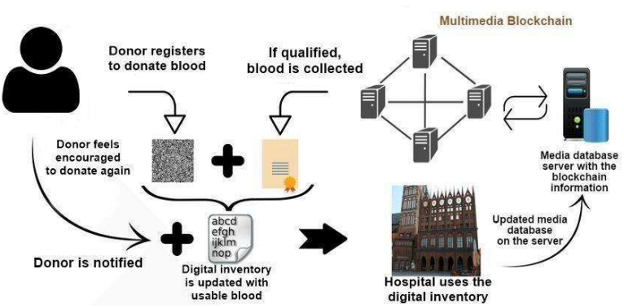

By optimizing blood supply chain management and efficiently matching donors with recipients, HemoChain aims to improve patient outcomes. The system’s inherent security and standardization features prevent counterfeiting and tampering, providing a robust platform for blood supply management.

**OUTCOMES**

The anticipated outcomes of implementing the HemoChain system include improved patient outcomes through efficient blood supply management, enhanced transparency in the healthcare sector, and a reduction in blood supply time.

By leveraging blockchain technology, the system aims to streamline the blood donation process, ensuring timely and secure access to blood units while maintaining the integrity of information throughout the supply chain, increase awareness and adoption of blockchain technology more broadly.

**METHODOLOGY**

