

AMITY INSTITUTE OF INFORMATION TECHNOLOGY

Course Code : CSE3048

“NOSQL DATABASES”

LABORATORY RECORD

Fall Semester - 2025

SUBMITTED TO:
Ms. Renuka A Babladkar
SUBMITTED BY:
Name:ANANYA B
SEN:A86904824021
BCA

INDEX
Sl. No. | Date | Program
1 | 12/11/2025 | MongoDB CRUD Operations & Query Operators
2 | 17/11/2025 | MongoDB CRUD Operations on Employees Collection
3 | 25/11/2025 | MongoDB UPDATE Operators on Students Collection
4 | 09/12/2025 | MongoDB Aggregation Pipeline (Match, Group, Project, Sort, Lookup, Out)
5 | 23/12/2025 | MongoDB Aggregation Pipeline Operations  (Using $match, $group, $project, $sort, $limit, $addFields, $count, $lookup, and $out)
6 | 30/12/2025 | MongoDB Indexing (Single Field, Compound & Text Indexes)

EX.NO: 1
DATE: 12/11/2025
MongoDB CRUD Operations & Query Operators.
CODE:
db.employees.insertMany([
{ empid: 100, dept: "Accounting", salary: 8000 },
{ empid: 101, dept: "Marketing", salary: 9000 },
{ empid: 102, dept: "Sales", salary: 7000 },
{ empid: 103, dept: "IT", salary: 10000 }
]);
db.employees.find();
db.employees.find({ empid: 100 });
db.employees.find({ salary: { $gt: 9000 } });
db.employees.find({ dept: "IT" });
db.employees.find().sort({ salary: 1 });
db.employees.replaceOne(
{ empid: 100 },
{ empid: 100, dept: "HR", salary: 6000 }
);
db.employees.deleteOne({ empid: 101 });
db.employees.deleteMany({ salary: { $lt: 7000 } });
db.employees.find().limit(4);
INPUT
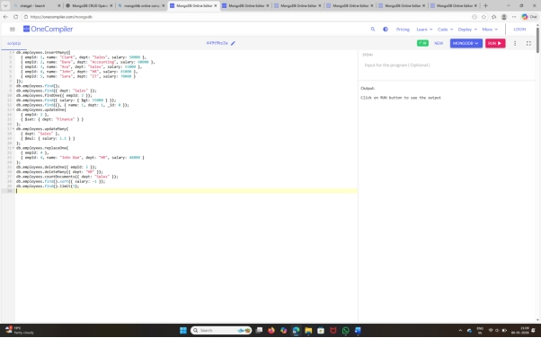
OUTPUT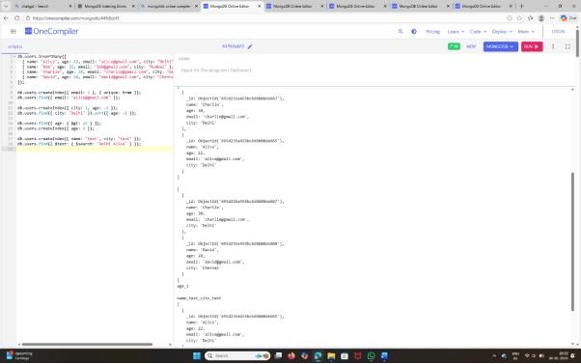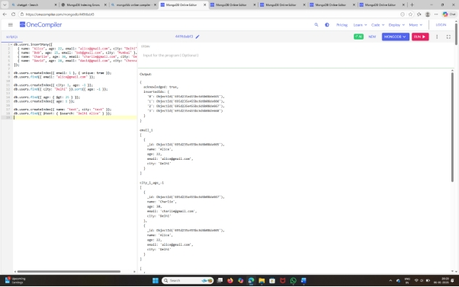
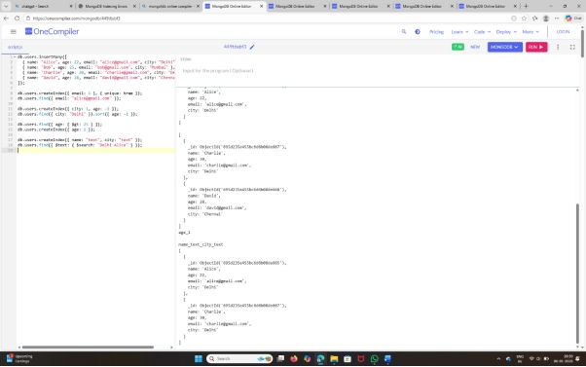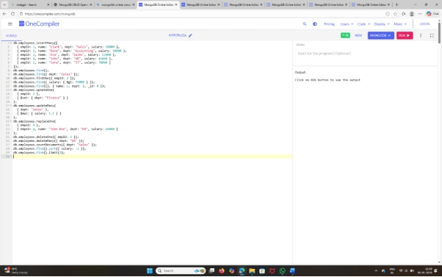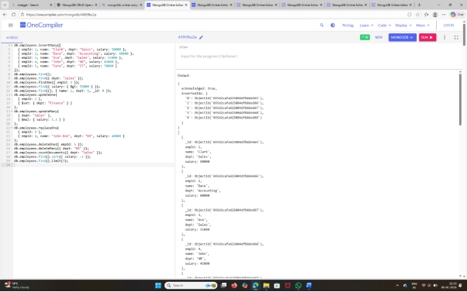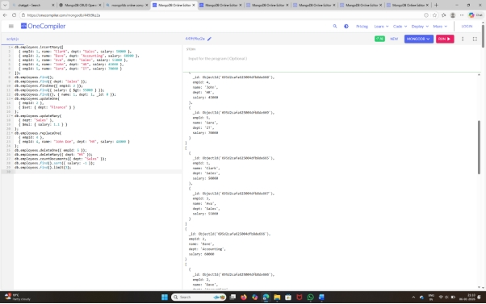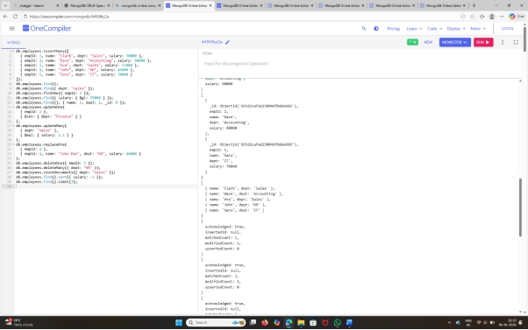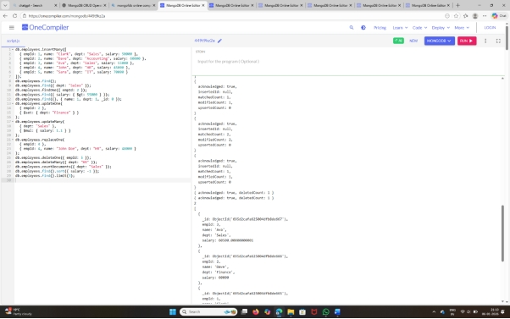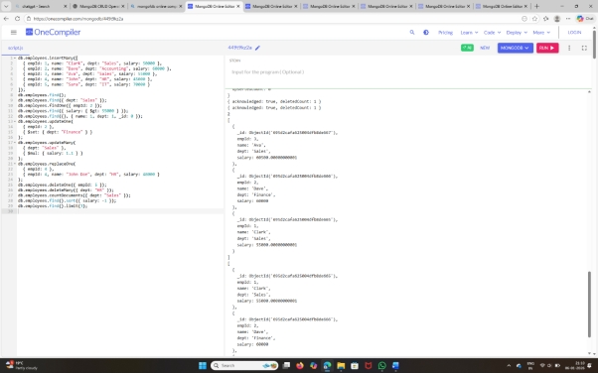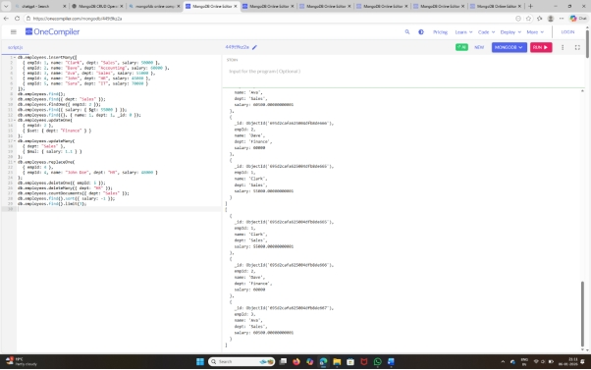

EX.NO: 2
DATE: 17/11/2025
MongoDB CRUD Operations on Employees Collection.
CODE:
db.students.insertMany([
{ name: "Alice", age: 22, marks: 85, subjects: ["Math", "Physics"], city: "Delhi" },
{ name: "Bob", age: 25, marks: 72, subjects: ["Math", "Chemistry"], city: "Mumbai" },
{ name: "Charlie", age: 23, marks: 90, subjects: ["Biology", "Chemistry"], city: "Delhi" },
{ name: "David", age: 21, marks: 60, subjects: ["Math"], city: "Chennai" },
{ name: "Eve", age: 24, marks: 78, subjects: ["Physics", "Math"], city: "Kolkata" }
]);

db.students.find({ city: { $eq: "Delhi" } });

db.students.find({ marks: { $gt: 80 } });

db.students.find({ age: { $gte: 23 } });

db.students.find({ age: { $lte: 23 } });

db.students.find({ city: { $in: ["Delhi", "Mumbai"] } });

db.students.find({ subjects: { $all: ["Math"] } });

db.students.find({ city: "Delhi", marks: { $gte: 80 } });

db.students.find().sort({ marks: -1 });

db.students.find({ city: "Delhi" }).sort({ marks: 1 });

db.students.find({ city: "Mumbai" }).sort({ age: -1 });

db.students.find({ age: { $type: "number" } });

db.students.find({ subjects: { $size: 2 } });

db.students.find({ subjects: { $in: ["Physics"] } });

db.students.find({ subjects: { $nin: ["Math"] } });

db.students.find({ name: { $regex: "^A" } });

db.students.find({ name: { $regex: "e$" } });

db.students.find({}, { name: 1, city: 1, _id: 0 });

db.students.find({ name: "Bob" });

db.students.find().count();

db.students.find().limit(3);

db.students.find().skip(2);

db.students.updateOne(
{ name: "Alice" },
{ $set: { city: "Bangalore" } }
);

db.students.updateOne(
{ name: "Bob" },
{ $inc: { marks: 5 } }
);

db.students.updateOne(
{ name: "David" },
{ $push: { subjects: "Physics" } }
);

db.students.updateOne(
{ name: "Alice" },
{ $pull: { subjects: "Math" } }
);

db.students.deleteOne({ name: "Charlie" });

db.students.deleteMany({ city: "Delhi" });

DATE:17/11/2025
INPUT
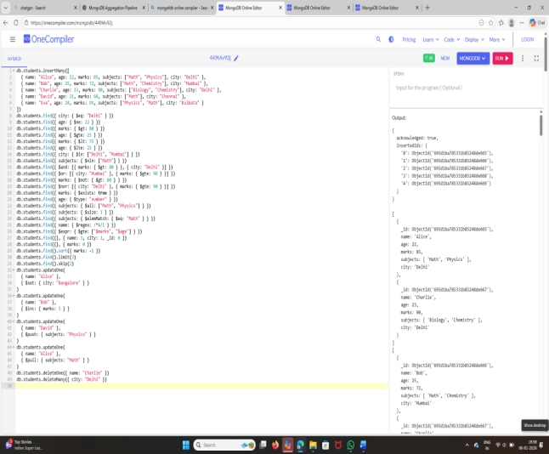
OUTPUT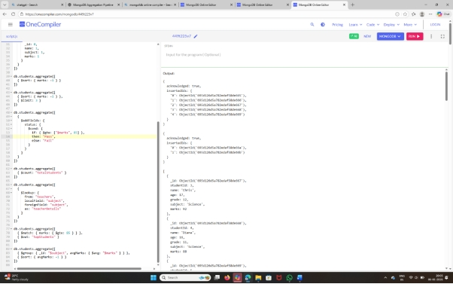
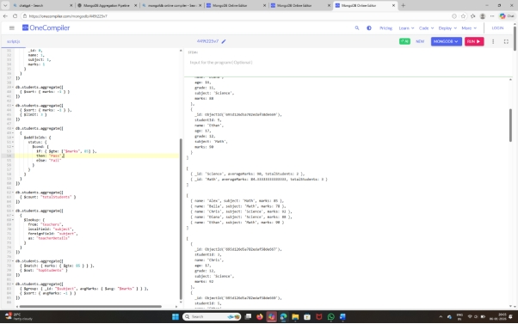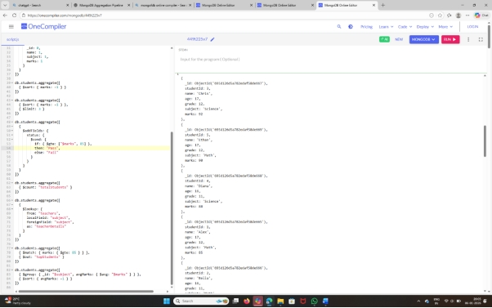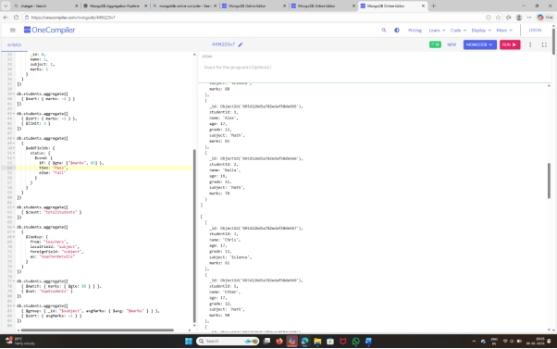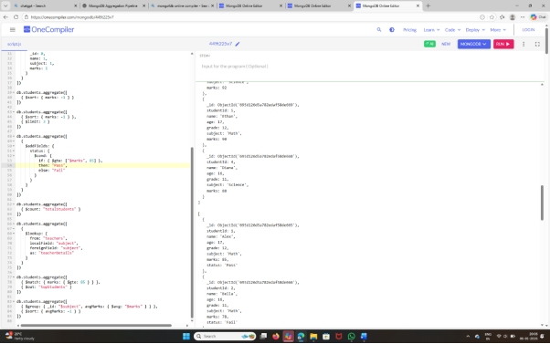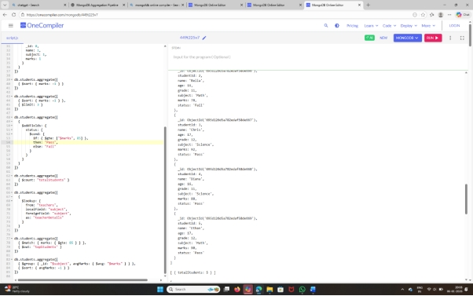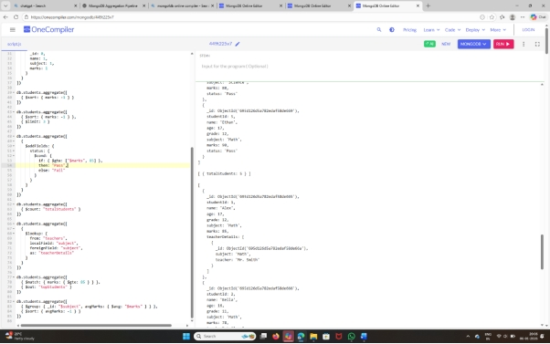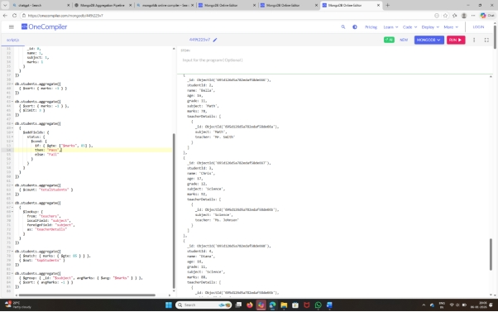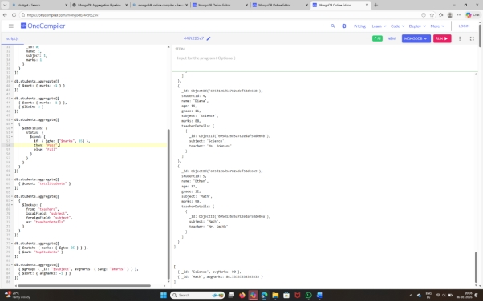

EX.NO: 3
DATE: 25/11/2025
MongoDB UPDATE Operators on Students Collection.
CODE:
db.students.insertMany([
{ name: "Alice", age: 22, grades: [85, 90], address: { city: "Delhi", zip: 110001 }, enrolled: true },
{ name: "Bob", age: 25, grades: [70, 75], address: { city: "Mumbai", zip: 400001 }, enrolled: false },
{ name: "Charlie", age: 23, grades: [88, 92], address: { city: "Delhi", zip: 110002 }, enrolled: true }
]);
db.students.updateOne(
{ name: "Alice" },
{ $set: { age: 23 } }
);
db.students.updateOne(
{ name: "Bob" },
{ $inc: { age: 1 } }
);
db.students.updateMany(
{ address.city: "Delhi" },
{ $set: { enrolled: false } }
);
db.students.updateOne(
{ name: "Charlie" },
{ $push: { grades: 95 } }
);
db.students.updateOne(
{ name: "Alice" },
{ $pull: { grades: 85 } }
);
db.students.updateOne(
{ name: "Bob" },
{ $unset: { address: "" } }
);
db.students.updateOne(
{ name: "David" },
{
$set: {
age: 20,
grades: [60, 65],
enrolled: true
}
},
{ upsert: true }
);
INPUT
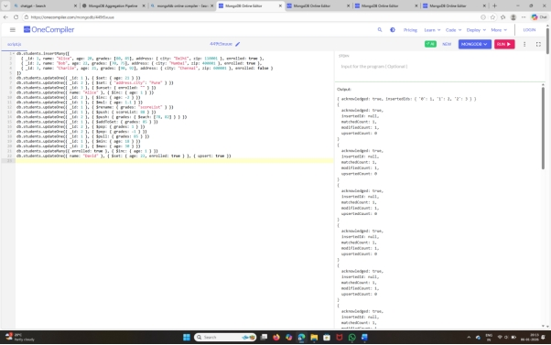
OUTPUT
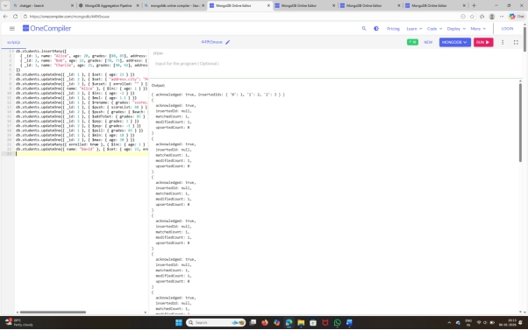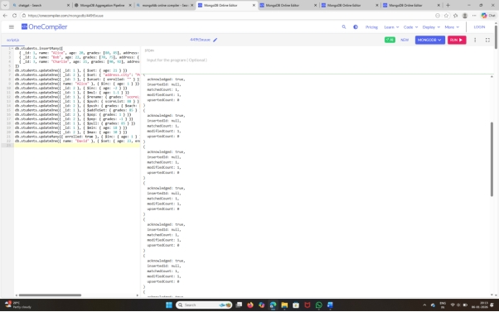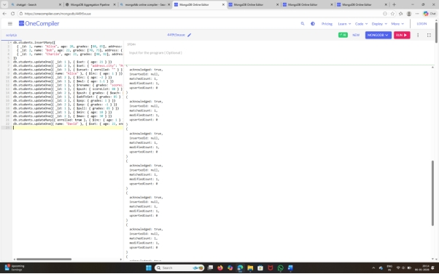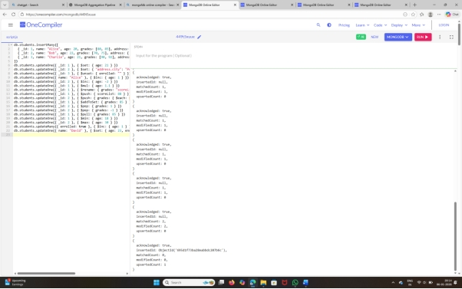

EX.NO: 4
DATE: 09/12/2025
MongoDB Aggregation Pipeline (Match, Group, Project, Sort, Lookup, Out)
CODE:
db.students.insertMany([
{ studentId: 1, name: "Alex", age: 17, grade: 12, subject: "Math", marks: 85 },
{ studentId: 2, name: "Bella", age: 16, grade: 11, subject: "Math", marks: 78 },
{ studentId: 3, name: "Chris", age: 17, grade: 12, subject: "Science", marks: 92 },
{ studentId: 4, name: "Diana", age: 16, grade: 11, subject: "Science", marks: 88 },
{ studentId: 5, name: "Ethan", age: 17, grade: 12, subject: "Math", marks: 90 }
])

db.teachers.insertMany([
{ subject: "Math", teacher: "Mr. Smith" },
{ subject: "Science", teacher: "Ms. Johnson" }
])

db.students.aggregate([
{ $match: { marks: { $gt: 85 } } }
])

db.students.aggregate([
{
$group: {
_id: "$subject",
averageMarks: { $avg: "$marks" },
totalStudents: { $sum: 1 }
}
}
])

db.students.aggregate([
{
$project: {
_id: 0,
name: 1,
subject: 1,
marks: 1
}
}
])

db.students.aggregate([
{ $sort: { marks: -1 } }
])

db.students.aggregate([
{ $sort: { marks: -1 } },
{ $limit: 3 }
])

db.students.aggregate([
{
$addFields: {
status: {
$cond: {
if: { $gte: ["$marks", 85] },
then: "Pass",
else: "Fail"
}
}
}
}
])

db.students.aggregate([
{ $count: "totalStudents" }
])

db.students.aggregate([
{
$lookup: {
from: "teachers",
localField: "subject",
foreignField: "subject",
as: "teacherDetails"
}
}
])

db.students.aggregate([
{ $match: { marks: { $gte: 85 } } },
{ $out: "topStudents" }
])

db.students.aggregate([
{ $group: { _id: "$subject", avgMarks: { $avg: "$marks" } } },
{ $sort: { avgMarks: -1 } }
])
INPUT
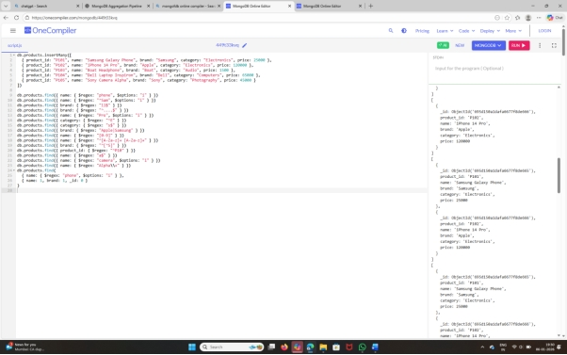
OUTPUT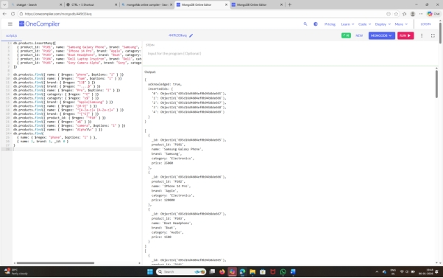
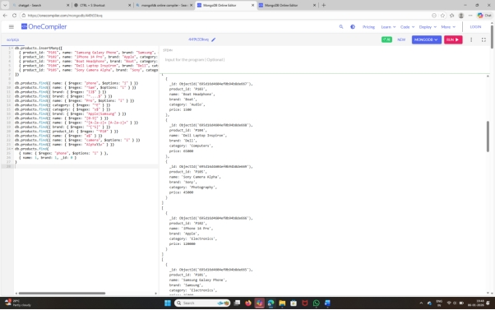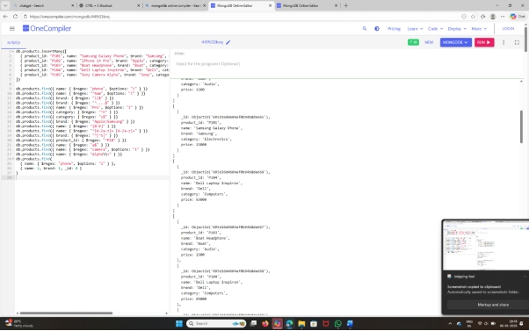
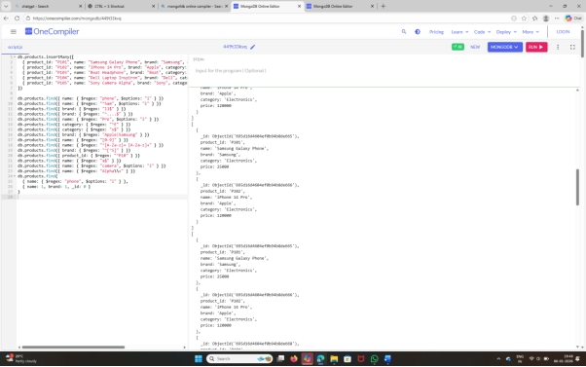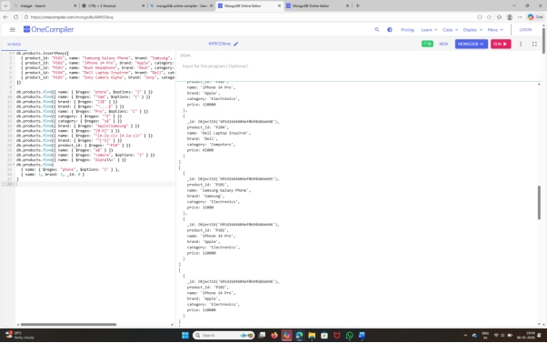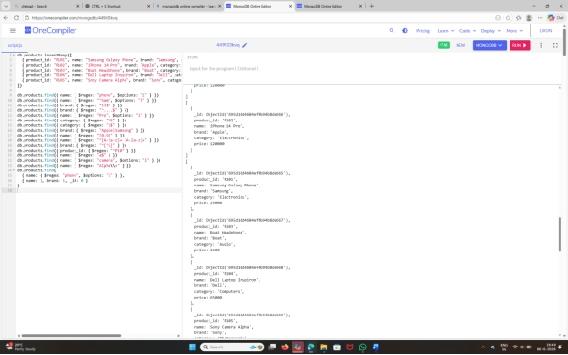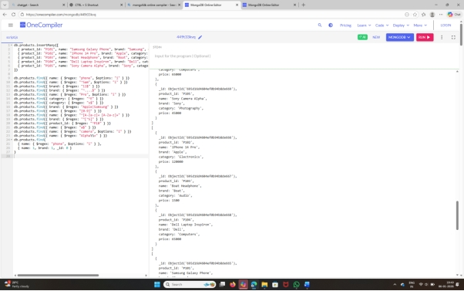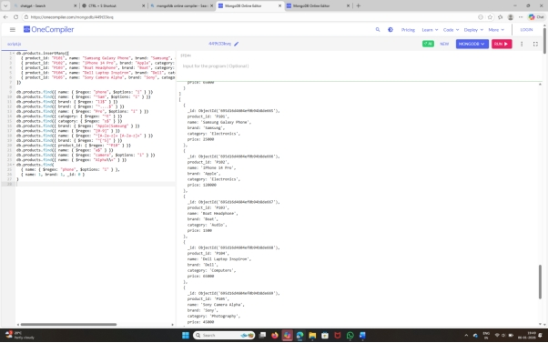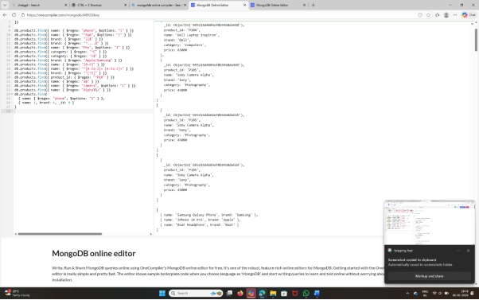

EX.NO: 5
DATE: 23/12/2025
MongoDB Aggregation Pipeline Operations
(Using $match, $group, $project, $sort, $limit, $addFields, $count, $lookup, and $out)
CODE:
db.students.insertMany([
{ studentId: 1, name: "Alex", age: 17, grade: 12, subject: "Math", marks: 85 },
{ studentId: 2, name: "Bella", age: 16, grade: 11, subject: "Math", marks: 78 },
{ studentId: 3, name: "Chris", age: 17, grade: 12, subject: "Science", marks: 92 },
{ studentId: 4, name: "Diana", age: 16, grade: 11, subject: "Science", marks: 88 },
{ studentId: 5, name: "Ethan", age: 17, grade: 12, subject: "Math", marks: 90 }
])

db.teachers.insertMany([
{ subject: "Math", teacher: "Mr. Smith" },
{ subject: "Science", teacher: "Ms. Johnson" }
])

db.students.aggregate([
{ $match: { marks: { $gt: 85 } } }
])

db.students.aggregate([
{
$group: {
_id: "$subject",
averageMarks: { $avg: "$marks" },
totalStudents: { $sum: 1 }
}
}
])

db.students.aggregate([
{
$project: {
_id: 0,
name: 1,
subject: 1,
marks: 1
}
}
])

db.students.aggregate([
{ $sort: { marks: -1 } }
])

db.students.aggregate([
{ $sort: { marks: -1 } },
{ $limit: 3 }
])

db.students.aggregate([
{
$addFields: {
status: {
$cond: {
if: { $gte: ["$marks", 85] },
then: "Pass",
else: "Fail"
}
}
}
}
])

db.students.aggregate([
{ $count: "totalStudents" }
])

db.students.aggregate([
{
$lookup: {
from: "teachers",
localField: "subject",
foreignField: "subject",
as: "teacherDetails"
}
}
])

db.students.aggregate([
{ $match: { marks: { $gte: 85 } } },
{ $out: "topStudents" }
])

db.students.aggregate([
{ $group: { _id: "$subject", avgMarks: { $avg: "$marks" } } },
{ $sort: { avgMarks: -1 } }
])
INPUT
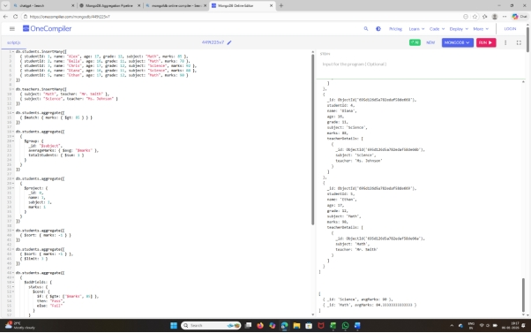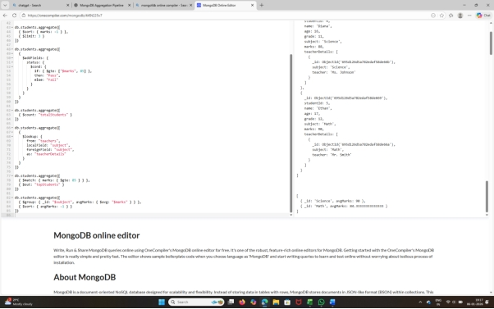

OUTPUT
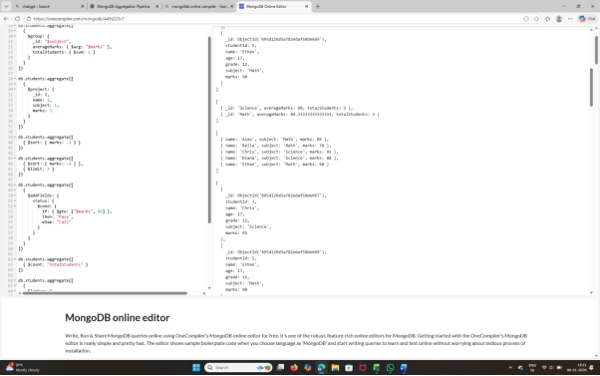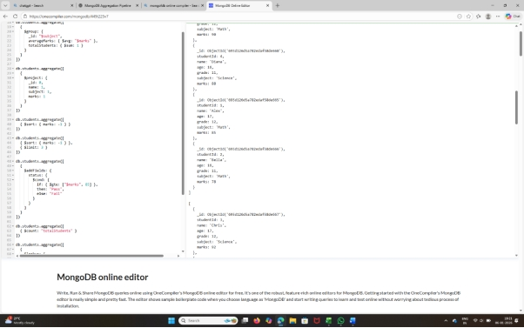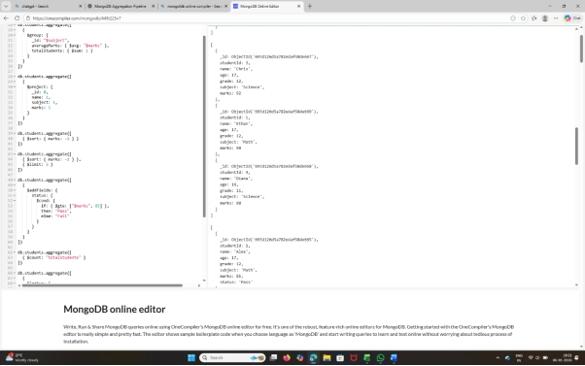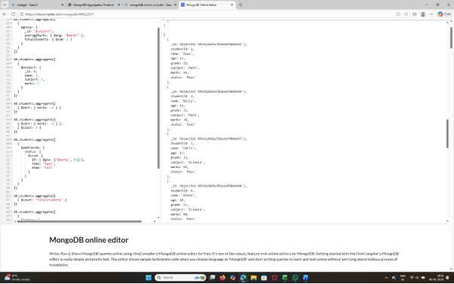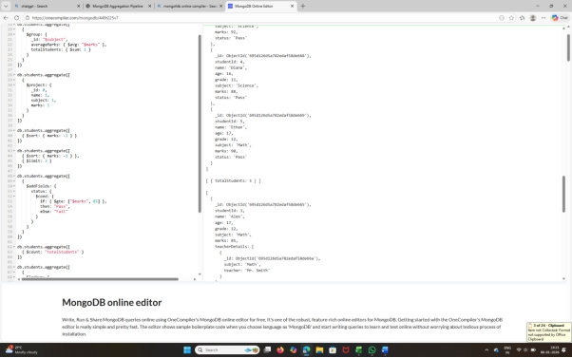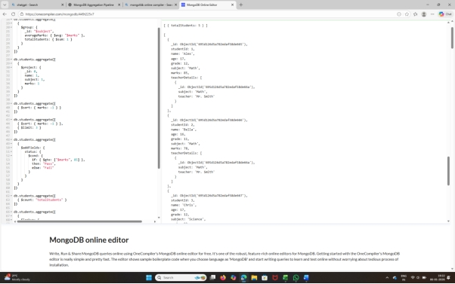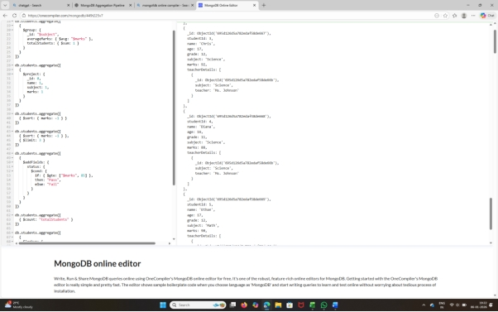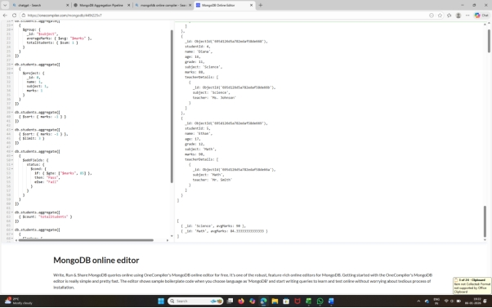

EX.NO: 6
DATE: 30/12/2025
MongoDB Indexing (Single Field, Compound & Text Indexes)
CODE:
db.users.insertMany([
{ name: "Alice", age: 22, email: "alice@gmail.com", city: "Delhi" },
{ name: "Bob", age: 25, email: "bob@gmail.com", city: "Mumbai" },
{ name: "Charlie", age: 30, email: "charlie@gmail.com", city: "Delhi" },
{ name: "David", age: 28, email: "david@gmail.com", city: "Chennai" }
]);
db.users.createIndex({ email: 1 }, { unique: true });
db.users.find({ email: "alice@gmail.com" });
db.users.createIndex({ city: 1, age: -1 });
db.users.find({ city: "Delhi" }).sort({ age: -1 });
db.users.find({ age: { $gt: 25 } });
db.users.createIndex({ age: 1 });
db.users.createIndex({ name: "text", city: "text" });
db.users.find({ $text: { $search: "Delhi Alice" } });

INPUT
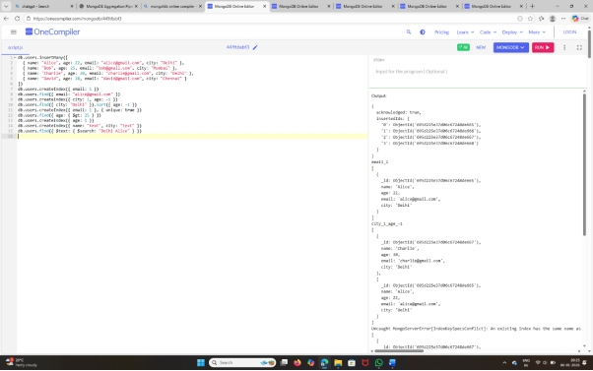

OUTPUT


*************************************

