Name: Ananya Billava

USN: 1NT19IS022

C1 BATCH

**import 'package:flutter/material.dart'**;

**void** main() { runApp(MaterialApp(

home: Text(

**'Without SafeArea'**, *// Text to display* textAlign: TextAlign.**center**, *//align the text to center* style: TextStyle(

fontSize: 40, *// fontSize in px* fontWeight: FontWeight.*w800*, *// font weight* color: Colors.*deepOrangeAccent*, *// Setting up the color font*

),

),

));

}

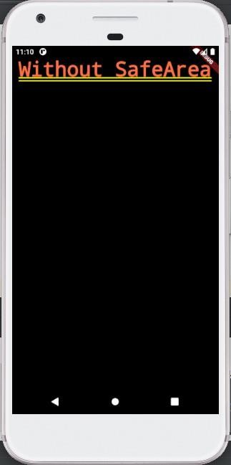

**import 'package:flutter/material.dart'**;

**void** main() {

runApp(MaterialApp( home: SafeArea( child: Text( **'With SafeArea'**, textAlign: TextAlign.**center**, style: TextStyle( fontSize: 40,

fontWeight: FontWeight.*w800*, color: Colors.*deepOrangeAccent*,

),

),

),

));

}

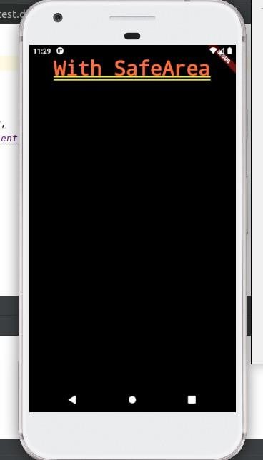

**import 'package:flutter/material.dart'**; **void** main() { runApp(

MaterialApp( home:Scaffold(

appBar: AppBar(

title: Text(**"First Flutter App"**),

), body: Center(

child: Text( **'This is a first App'**, style: TextStyle(

fontSize: 40.0, fontStyle: FontStyle.**italic**, fontWeight: FontWeight.*bold*,

),

),

),

),

),

);

}

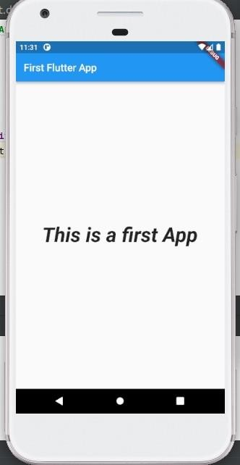

**import 'package:flutter/material.dart'**; **void** main() {

runApp(MaterialApp( home: Scaffold( *// Scaffold houses appBar and body property*

appBar:AppBar( title: Text(

**'Scaffold-SafeArea'**

), ), body:Container(

child: SafeArea( *// Defining SafeArea as Child of Container*

child: Center(

child: Text(

**'This is a Sample Text'**

),

),

),

),

),

));

}

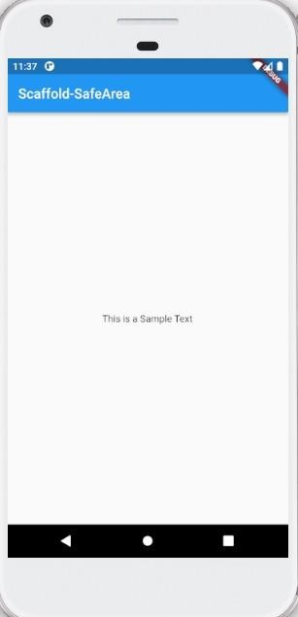

**LAYOUT WIDGETS**

**SINGLE AND MULTI CHILD WIDGETS**

**Single Child:**

Main.dart

import 'package:flutter/material.dart'; void main() {

runApp(MaterialApp(

home: RowApp(),

));

}

class RowApp extends StatelessWidget{

const RowApp({Key? key}): super(key: key);

@override

Widget build(BuildContext context) { return Row(

mainAxisAlignment: MainAxisAlignment.spaceEvenly, crossAxisAlignment: CrossAxisAlignment.start, children:[

Container( height: 100, width: 300, color: Colors.*purple*.shade50, child: Center( child: Text( 'Sunayana', style: TextStyle(

fontSize: 20.0,

),

),

),

),

],

);

}

}

**Multi Child (Column Alignment)**

Main.dart

import 'package:flutter/material.dart'; void main() {

runApp(MaterialApp(

home: RowApp(),

));

}

class RowApp extends StatelessWidget{

const RowApp({Key? key}): super(key: key);

@override

Widget build(BuildContext context) { return Column(

mainAxisAlignment: MainAxisAlignment.spaceEvenly, crossAxisAlignment: CrossAxisAlignment.start, children:[

Container( height: 100, width: 100, color: Colors.*deepOrange.shade50*, child: Center( child: Text( 'First child!', style: TextStyle(

fontSize: 20.0,

),

),

),

),

Container( height: 100, width: 100, color: Colors.*green.shade50*, child: Center( child: Text( 'Second Child', style: TextStyle(

fontSize: 20.0,

),

),

),

),

Container( height: 100, width: 100, color: Colors.*yellow.shade50*, child: Center( child: Text( 'Third child!', style: TextStyle(

fontSize: 20.0,

),

),

),

),

],

);

}

}

Output:

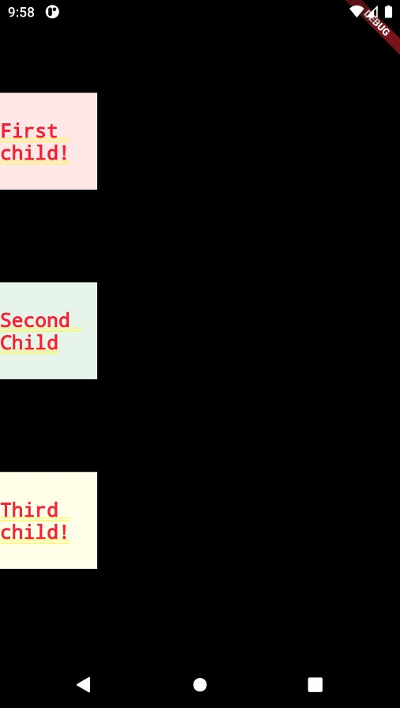

**Multi Child (Column Alignment)**

Main.dart

import 'package:flutter/material.dart'; void main() {

runApp(MaterialApp(

home: RowApp(),

));

}

class RowApp extends StatelessWidget{

const RowApp({Key? key}): super(key: key);

@override

Widget build(BuildContext context) { return Row(

mainAxisAlignment: MainAxisAlignment.spaceEvenly, crossAxisAlignment: CrossAxisAlignment.start, children:[

Container( height: 100, width: 100, color: Colors.*deepOrange.shade50*, child: Center( child: Text( 'First child!', style: TextStyle(

fontSize: 20.0,

),

),

),

),

Container( height: 100, width: 100, color: Colors.*green.shade50*, child: Center( child: Text( 'Second Child', style: TextStyle(

fontSize: 20.0,

),

),

),

),

Container( height: 100, width: 100, color: Colors.*yellow.shade50*, child: Center( child: Text( 'Third child!', style: TextStyle(

fontSize: 20.0,

),

),

),

),

],

);

}

}

Output:

