Following information is required for drafting of patent application.

- Full name, nationality and address of applicant(s):

Full Name | Nationality | Address
Vishwakarma Institute of Technology | Indian | 666, Upper Indiranagar, Bibwewadi, Pune, Maharashtra, India – 411 037

- Full name (including middle name), nationality, address (VIT/VIIT address), mail id, and phone number of inventor(s):

Full Name (Including middle name) (Min. Two faculty) | Nationality | VIT/VIIT Address (Start with full dept. name followed by full institute name) (For ex.) | Mail ID | Phone No. | Gender
Mrs. Shipla Manoj Katikar | IN | Department of Computer Engineering, Vishwakarma Institute of Technology, Pune | shilpa.katikar@vit.edu | 9923337012 | Female
Dr. Priyanka Amol Kadam | IN | Department of Computer Engineering, Vishwakarma Institute of Technology, Pune | priyanka.kadam@vit.edu | 8600838320 | Female
Ananya Choudhari | IN | Department of Computer Engineering, Vishwakarma Institute of Technology, Pune | viraj.ananya241@vit.edu | 9307971404 | Female
Arya Bharat Patil | IN | Department of Computer Engineering, Vishwakarma Institute of Technology, Pune | arya.patil24@vit.edu | 8605482342 | Female
Ankush Kumar | IN | Department of Computer Engineering, Vishwakarma Institute of Technology, Pune | ankush.kumar24@vit.edu | 9906088475 | Male
Aryan Bhat | IN | Department of Computer Engineering, Vishwakarma Institute of Technology, Pune | aryan.bhat24@vit.edu | 9596837415 | Male

Copy and paste clear soft copy of signatures of all inventors in the following table: (Insert or delete the cells as per number of inventers)

 |  |  | 
Mrs. Shipla Manoj Katikar | Dr. Priyanka Amol Kadam | Ananya Choudhari | Arya Bharat Patil
 | 
Ankush Kumatr | Aryan Bhat

- Title of the invention:

NeuroAid Pro: Hybrid EOG-Controlled Assistive Communication and Scanning Interface for Motor-Impaired Users

- Technical field of the invention:

Biomedical Signal Acquisition (EOG / Biosignals)
Assistive Communication Systems and Rehabilitative Engineering
Human–Computer Interaction (HCI)
Embedded Systems & Real-Time Signal Processing
Brain–Computer Interface (BCI) Inspired Technologies

- Prior art:

Existing assistive communication technologies predominantly rely on physical switches or high-cost neurological interfaces. The current state-of-the-art includes:
- Single-Input Scanning Systems (Switch-based AAC):
- These rely on mechanical buttons or sip-and-puff switches to trigger a scanning cursor.
- Disadvantages: They require voluntary muscle control (e.g., hand or head movement), making them unsuitable for patients with severe paralysis (e.g., Locked-In Syndrome). They suffer from slow typing speeds due to linear scanning and lack adaptability to user fatigue.
- EEG-Based Spellers (P300 / SSVEP):
- These systems use brainwave patterns detected via an electrode cap to select characters.
- Disadvantages: They require expensive, multi-channel amplifiers and gel-based caps that are difficult to set up. The signal-to-noise ratio is often poor, requiring long calibration times and a shielded environment, rendering them impractical for low-resource or home settings.
- Basic EOG Blink Detectors:
- Simple systems that threshold eye blink signals for binary on/off control.
- Disadvantages: Most provide only a binary trigger (Blink = Click) without a navigational interface. They lack the ability to control complex multi-level menus or typing interfaces efficiently and are often prone to false triggers from natural saccades.
How the Proposed Invention Overcomes These Disadvantages:
The​‍​‌‍​‍‌​‍​‌‍​‍‌ new device "NeuroAid Pro" is a hybrid hardware-software architecture that connects the cheapest BCI and the simplest mechanical switches.
- Dual-Mode Navigation: The technology which can only detect blinks in a row is upgraded by the neuromodulation device. The system is able to navigate both rows and columns with a single biosignal source (vertical EOG) thus full keyboard control is achieved.
- Cost Efficiency: A drastic reduction in cost is achieved by using standard operational amplifiers (AD620, LM358) instead of medical-grade EEG amplifiers while signal integrity is still maintained.
- Robust Signal Processing: The system features an online adaptive baseline tracking algorithm. It makes the system capable of finding command blinks even in very noisy environments and it is also able to separate them from involuntary eye movements, a position that is rarely considered in low-end open-source solutions.
- Minimal Hardware Footprint:The elimination of complex electrode caps is achieved by the neuromodulation device. Only three disposable electrodes are required thus the device is very portable and can be easily taken to or used in rural or low-resource healthcare centers.

- Object:

Challenged​‍​‌‍​‍‌​‍​‌‍​‍‌ with the human condition of a disabled and afflicted with motor skill problems, it is a matter of concern. The invention came of age intending to develop a low-cost, self-contained assistive communication system. It is understood that a paralyzed or motor-impaired user is capable of making the system perform such actions. These include typing text or triggering some commands with only the help of the user's eye blinks. Just one eye blink, if one is the user, is ​‍​‌‍​‍‌​‍​‌‍​‍‌enough
Specific objectives include:
- To design a high-gain, low-noise analog front-end for acquiring Electrooculography (EOG) signals.
- To implement an embedded algorithm for real-time blink detection that adapts to signal drift.
- To create a row-column scanning interface that maximizes typing efficiency for single-input users.
Advantages of the Invention Over Existing Technology:
- Affordability: Built using generic analog components (AD620, LM358) and an Arduino, reducing costs by orders of magnitude compared to commercial eye-trackers.
- Non-Invasive & Accessible: Works with standard disposable gel electrodes without the need for scalp abrasion or complex EEG caps.
- High Reliability: The adaptive thresholding algorithm accounts for DC drift and skin impedance changes, preventing false positives common in DC-coupled systems.
- User-Centric Design: The row-column scanning method significantly increases communication speed compared to linear scanning methods.
Portability: The entire system is lightweight and USB-powered, suitable for wheelchair mounting or bedside use.

- Synopsis:

NeuroAid​‍​‌‍​‍‌​‍​‌‍​‍‌ Pro is an assistive technological product that converts bio-electrical eye movements into digital commands. It uses a three-electrode EOG configuration to record the corneal-retinal potential changes associated with the vertical eye movements. A custom analog front-end consisting of an instrumentation amplifier (AD620) and an operational amplifier (LM358) for filtering and gain is used to amplify this microvolt-level signal. An Arduino microcontroller, which also runs a specialized algorithm for detecting "intentional blinks" while noise is being rejected, is used to digitize the processed signal. These blink occurrences serve as the input trigger for software-based row-column scanning keyboard on a connected computer. The user thus can select a row by one blink and a character by a second blink, thereby enabling full alphanumeric communication without the use of ​‍​‌‍​‍‌​‍​‌‍​‍‌limbs.
Type of Invention:
A Hybrid Hardware-Software Medical Assistive Device.
It functions as:
- A Bio-Signal Acquisition Unit
- An Alternative and Augmentative Communication (AAC) Device
- A Human-Computer Interface (HCI) for the disabled
Hardware Components Needed for the Device:
- Instrumentation Amplifier: AD620 (for high CMRR and initial gain).
- Operational Amplifier: LM358 (for secondary gain, active filtering, and DC offset correction).
- Microcontroller: Arduino Uno or Nano (for ADC sampling and serial transmission).
- Electrodes: Disposable Ag/AgCl wet gel electrodes (3 units).
- Passive Components: Precision resistors (for gain setting), ceramic/electrolytic capacitors (for filtering), and a breadboard/PCB.
- Power Supply: 5V DC via USB (or 9V battery for standalone isolation).
- Computing Unit: Laptop or Tablet running the interface software.

How the Components are Assembled:
- Electrode Placement:
Signal High (+IN): Placed approximately 1 cm above the eyebrow.
Signal Low (-IN): Placed approximately 1 cm below the eye (orbital bone).
Reference (GND): Placed on the mastoid (behind the ear) or forehead center.
- Analog Front-End:
- The​‍​‌‍​‍‌​‍​‌‍​‍‌ electrodes are linked to the AD620 inputs. A gain resistor (Rg) of about 1kΩ is employed to set the initial gain to around 50x.
  - The output of the AD620 is AC-coupled through a capacitor to the LM358 stage to get rid of DC drift due to electrode polarization.
  - The LM358 is set up as a non-inverting amplifier with active low-pass filtering to both smooth the signal and increase it to the 0–5V range that the Arduino can ​‍​‌‍​‍‌​‍​‌‍​‍‌read.
- Digital Interface:
- The analog output from the LM358 connects to the Arduino Analog Pin A0.
- The Arduino converts the signal at a sampling rate of ~100Hz and sends the data stream to the PC via USB Serial.

- Brief description of drawings (if any):

Table 1: Component Specifications - Details the value of the resistors, capacitors, and amplifiers used in the signal conditioning ​‍​‌‍​‍‌​‍​‌‍​‍‌circuit.
Component | Specification / Value | Purpose in Circuit
AD620 Instrumentation Amplifier | Gain set using 1 kΩ resistor (Gain ≈ 50) | First-stage amplification of weak EOG signals
LM358 Operational Amplifier | Single-supply, dual op-amp | Filtering + second-stage gain
Gain Resistor (RG) | 1 kΩ (for AD620 Gain ≈ 50) | Sets initial amplification of EOG signal
Voltage Divider Resistors | 100 kΩ + 100 kΩ | Creates 2.5 V mid-reference for AD620 REF pin
Coupling Capacitor | 1 µF electrolytic | AC coupling between AD620 and LM358 (high-pass behavior)
High-Pass Filter Resistor | 100 kΩ | Forms HPF (cutoff ~0.016 Hz) to remove DC drift
Feedback Resistor (LM358) | 100 kΩ | Sets secondary gain in LM358
Input/Reference Resistor (LM358) | 10 kΩ | With 100 kΩ sets gain ≈ 11
Low-Pass Filter Capacitor | 0.1 µF | Reduces high-frequency noise at LM358 output
Electrodes | 3 × Disposable gel electrodes | Upper eye, lower eye, reference

Figure 1: System Block Diagram -Shows the data flow starting from the user's eye (EOG) through the Amplifier stages (AD620/LM358) to the Arduino and eventually to the PC Software.
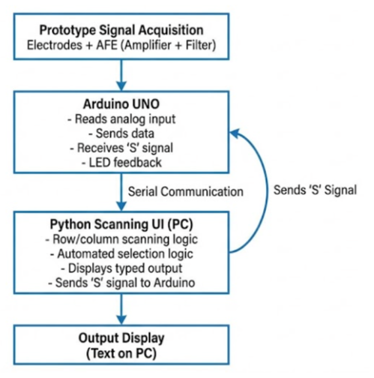
Figure 2: Circuit Schematic - Depicts the detailed wiring of the AD620 instrumentation amplifier and LM358 filter stages.
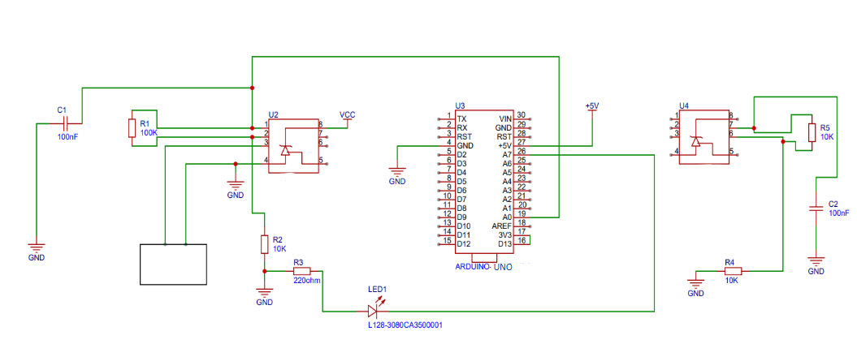
Figure 3: Blink Detection Waveform - A plot representing the raw EOG signal and the processed signal along with the dynamic threshold line indicating a "Blink ​‍​‌‍​‍‌​‍​‌‍​‍‌Event."
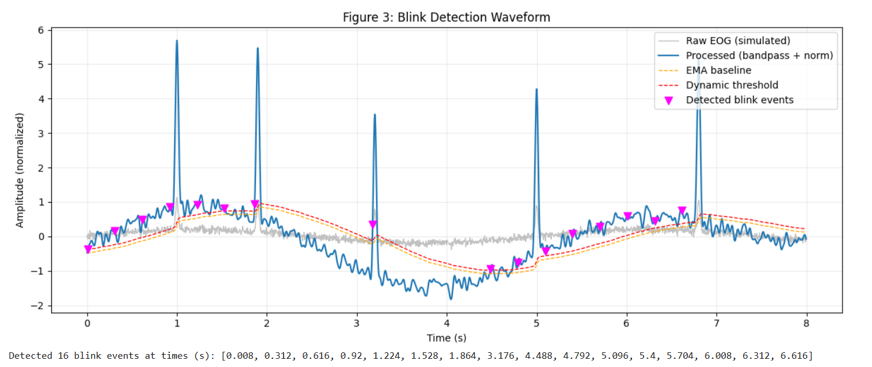
Figure 4: Scanning Interface GUI - Screenshot of the virtual keyboard showing the row/column highlighting method.
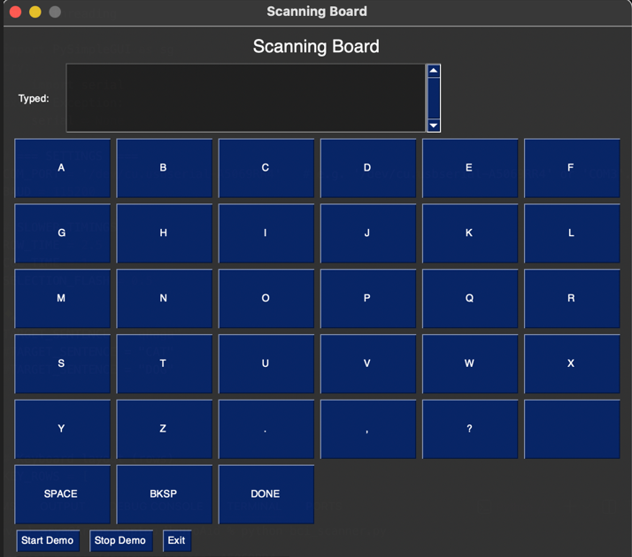

- Detail description of the invention:

The inventor is a complete Human-Computer Interface (HCI) system aimed at helping people with extreme motor disabilities regain their ability to communicate.

1. Bio-Potential Acquisition (The Sensor Layer):
The eye itself is a dipole with the cornea being the positive and the retina the negative part. Any vertical movement or blinking results in a change in voltage that can be easily detected (Electrooculogram). For the invention, the differential measurement technique is used through the AD620 instrumentation amplifier. The reason for selecting the AD620 is its high input impedance and Common Mode Rejection Ratio (CMRR), which is very important for rejecting the 50/60Hz power line noise that accompanies the human body.

2. Signal Conditioning (The Analog Layer):
The EOG signals obtained are often accompanied with a significant DC drift due to skin-electrode impedance changes. The invention comprises an LM358 operational amplifier, which is multi-stage configured:
- Stage 1 (High-Pass Filter): Using a passive RC network the DC component is removed and only AC "blink" spikes are allowed to pass.
- Stage 2 (Amplification): The signal is energized so as to make full use of the dynamic range of the Arduino's ADC (0V to 5V).
- Stage 3 (Low-Pass Filter): The high-frequency noise (EMG caused by muscle twitching) is reduced to get a noise-free signal.

3. Intelligent Processing (The Firmware Layer):
The microcontroller is in charge of Analog-to-Digital Conversion (ADC) and runs a very light processing algorithm. In contrast to a standard threshold trigger which ceases to function if the baseline changes, the invention introduces an Adaptive Baseline Tracker. This device finds the signal's floating baseline by calculating the Exponential Moving Average (EMA) of the signal. A blink is detected only if the signal amplitude surpasses the floating baseline by a certain delta (sensitivity) as a result of which the quality of electrodes can go on deteriorating but the system will still work with the same ​‍​‌‍​‍‌​‍​‌‍​‍‌consistency.

4. The Assistive Interface (The Application Layer):
The PC-side software listens for "Blink Events." It presents a Virtual Keyboard organized in a grid.
- State 1 (Row Scan): The software highlights rows of letters sequentially (e.g., Row 1, Row 2...). A blink selects the current row.
- State 2 (Column Scan): The software then scans the letters within that selected row. A second blink selects the specific letter.
- Output: The selected letter is typed into a text field, converted to speech (TTS), or sent as a command (e.g., "Call Nurse").

- Best method of performance of the invention:

To achieve optimal performance:
- Clean the skin at the electrode sites with alcohol to reduce impedance.
- Configure the AD620 gain resistor to approximately 1kΩ to ensure the signal is strong but not saturated.
- Set the software scanning speed to 1.5 seconds per row; this strikes the balance between speed and reaction time for new users.
- Use the "Refractory Period" setting in the code (e.g., 300ms) to prevent double-typing caused by involuntary micro-tremors following a strong blink.

- CLAIMS:
- A hybrid assistive communication system comprising an EOG-based bio-signal acquisition unit, a signal conditioning circuit utilizing an instrumentation amplifier and operational amplifier, and a computing unit running a row-column scanning interface controlled via eye blinks.
- The​‍​‌‍​‍‌​‍​‌‍​‍‌ system according to claim 1, where the signal conditioning unit employs an AD620 instrumentation amplifier for differential signal acquisition and an LM358 operational amplifier for active filtering and DC offset removal.
- Method for blink detection in a noise environment, using an adaptive baseline tracking algorithm that dynamically changes the trigger threshold according to the signal drift in real-time, thereby providing reliable operation in electrically noisy environments.
- The system according to Claim 1, where the user interface uses a two-step scanning mechanism (Row Selection followed by Column Selection) activated by a single binary biosignal input, thus allowing a full alphanumeric keyboard to be accessed.
- A local, inexpensive version of the system as recited in Claim 1, which is USB-powered via a normal 5V port, uses disposable electrodes, and is compatible with standard consumer laptops without the need for medical hardware.
- The system as claimed in Claim 1, additionally equipped with features such as predictive text or smart-home integration modules activated by specific blink patterns (e.g., double blink or long ​‍​‌‍​‍‌​‍​‌‍​‍‌blink).

- Inventive step of your invention:

The inventive step is in the democratization of BCI technology by a hybrid analog-digital architecture.
Key Innovative Features:
- Adaptive Biosignal Interpretation: The past technologies have been using static thresholds (which need frequent recalibration) but the firmware of the proposed system keeps on "learning" the noise floor of the environment and thus it can operate in non-shielded, real-world conditions (e.g., a home or general ward) constantly and that without human intervention.
- Single-Channel Efficiency: The invention is able to carry out complex navigation (typing, menu selection) with only one single channel of EOG data. It is able to achieve this by converting binary inputs (blinks) into a temporal scanning matrix, thus it is not necessary to use multi-channel eye-tracking cameras or EEG headsets.
Simplified Analog Chain: The particular combination of the AD620 and LM358 enables signal extraction of medical-grade at a consumer-electronics price, thus it solves the problem of the high-cost barrier in current rehabilitation ​‍​‌‍​‍‌​‍​‌‍​‍‌engineering.

- Industrial application:

- Rehabilitation Centers: As a communication tool for patients recovering from stroke, spinal cord injuries, or Guillain-Barré syndrome.
- Palliative Care: Providing a voice to end-stage ALS (Amyotrophic Lateral Sclerosis) patients who retain eye muscle control but have lost speech.
- Assistive Tech Manufacturing: The circuit design can be miniaturized into a wearable "smart glass" frame for commercial production.
Rural Healthcare: A deployable diagnostic and communication aid in low-resource settings where expensive eye-trackers are unavailable.

- Abstract:

The​‍​‌‍​‍‌​‍​‌‍​‍‌ invention reveals "NeuroAid Pro" a price-efficient, hybrid assistive communication interface aimed at patients with a condition of motor function severely impaired. The system employs Electrooculography (EOG) to capture voluntary eye blinks, which are then converted to digital commands. It includes a simple high-gain analog front-end (AD620/LM358) for the acquisition of vertical eye potentials, an Arduino-based digitizer, and a customized scanning keyboard application.The device is equipped with an innovative adaptive baseline algorithm that guarantees the blink detection is forceful even if the signal drifts and there is some electrical noise. By utilizing a row-column scanning technique, the apparatus allows the users to write the text and issue the commands by means of a single biosignal input.This invention presents a compact, non-invasive, and relatively inexpensive solution as compared to the intricate EEG-based Brain-Computer ​‍​‌‍​‍‌​‍​‌‍​‍‌Interface.
- Drawing

Circuit Schematic - Depicts the detailed wiring of the AD620 instrumentation amplifier and LM358 filter stages.

