# Classification of Osteoporosis Bone Disease using an advanced Deep-Learning.



A Minor Project Report

in partial fulfillment of the degree

**Bachelor of Technology**

in

**Computer Science & Artificial Intelligence**

**By**

**Ugge Reethu Varma (2103A52037)**

**Chanda Preethi (2103A52047)**

**Kasam Srinidhi (2103A52051)**

**Mamindla Ananya Darshini (2103A52095)**

**Nadipally Anuhya (2103A52186)**

**Under the Guidance of**

**Mr. (Md. sallauddin)**

**Asst. Professor, Department of CSE.**

**Submitted to**



**SCHOOL OF COMPUTER SCIENCE & ARTIFICIAL INTELLIGENCE**

# SR UNIVERSITY, ANANTHASAGAR, WARANGAL

**April, 2024.**



**SCHOOL OF COMPUTER SCIENCE & ARTIFICIAL INTELLIGENCE**

**CERTIFICATE**

This is to certify that this project entitled **“Classification of Osteoporosis Bone Disease using an advanced Deep-Learning”** " is the bonafied work carried out by **U. REETHU VARMA, CH.PREETHI, K.SRINIDHI, M.ANANYA DARSHINI, N.ANUHYA** as a Minor Project for the partial fulfillment to award the degree **BACHELOR OF TECHNOLOGY** in **COMPUTER SCIENCE & ARTIFICIAL INTELLIGENCE** during the academic year 2022-2023 under our guidance and Supervision.

### Md. Sallauddin Dr. M. Sheshikala

Asst. Professor Prof. & HOD

S R University S R University,

Ananthasagar, Warangal. Ananthasagar, Warangal.

**External Examiner**

**ACKNOWLEDGEMENT**

We owe an enormous debt of gratitude to our project guide Dr. Guide Name, Assistant Professor as well as Head of the CSE Department Dr. M.Sheshikala, Associate Professor for guiding us from the beginning through the end of the Minor Project with their intellectual advices and insightful suggestions. We truly value their consistent feedback on our progress, which was always constructive and encouraging and ultimately drove us to the right direction.

We express our thanks to the project co-ordinators Dr. P Praveen, Assoc. Prof for their encouragement and support.

We wish to take this opportunity to express our sincere gratitude and deep sense of respect to our beloved Dean, Dr.Indrajeet Gupta,Professor for his continuous support and guidance to complete this project in the institute.

Finally, we express our thanks to all the teaching and non-teaching staff of the department for their suggestions and timely support.

Ugge Reethu Varma

Chanda Preethi

Kasam Srinidhi

Ananya Darshini

Nadipally Anuhya

# Table of Contents

## Chapter No. Title Page No.

1. Overview
   1. Abstract 1
   2. Introduction 2
2. Literature survey

2.1. the survey done by you 3-6

1. Methodology
   1. Proposed Methodology 7
   2. Algorithms Used 8-10
   3. Performance Parameters 10-11

4. Dataset 12

5. Requirement Analysis 13

1. Implementation 14

7. Results 17-23

8. Conclusion and future scope 24

9. References 25-26

**ABSTRACT**

Top of Form

Osteoporosis, a prevalent skeletal disorder characterized by reduced bone mineral density and increased fracture risk, poses a significant public health concern. Accurate and timely classification of osteoporosis is crucial for early intervention and effective management. This project's main objective is to develop a deep learning model that creates a scalable and reliable method for correctly detecting osteoporosis, which will eventually improve patient outcomes and care. To predict osteoporosis, we used a variety of deep learning and classification models, including Random Forest, ADABoost, Decision Tree, Logistic Regression, SVM, KNN, Neural Network Classifier, Navie Bayes, VGG16, CNN, and VGG19. Using measures like precision, recall, f1 score, ROC AUC score, and accuracy score, we assessed the effectiveness of various deep learning and classification models. Methods for addressing data augmentation, duplicate data, missing data, and scaling or normalizing data are also included in the project. The dataset used for this project includes the x-rays and CT scans of the knees of the various patients. The proposed model utilizes state-of-the-art deep learning techniques to extract meaningful features from bone imaging modalities. Training on diverse datasets, the model demonstrates promising results in accurately categorizing bone health status. The results of this research help us identify the best model, which is a scalable and reliable method for the detection of osteoporosis. In conclusion, it helps organizations improve patient outcomes. It enables more efficient and accessible healthcare solutions for individuals at risk of osteoporosis, enhances healthcare efficiency, leads to better-informed clinical decisions, and advances our understanding and management of osteoporosis.

**INTRODUCTION**

Osteoporosis, a common skeletal disorder characterized by reduced bone mineral density and increased bone fragility, poses a significant global health concern. Early detection and accurate classification of osteoporosis are crucial for effective intervention and prevention of associated fractures. Traditional diagnostic methods, such as dual-energy X-ray absorptiometry (DXA), have limitations in terms of precision and accessibility. In recent years, advanced deep-learning techniques have emerged as promising tools for the automated and accurate classification of medical conditions, including osteoporosis.

The paper embarks on a comprehensive exploration, commencing with Wihandika work [1], which employs multiscale COSFIRE filters for the detection of branching in trabecular bone. Moving forward, Prakash [2] present a 4x-expert system using multi-model algorithms for early prediction of osteoporosis, emphasizing the importance of early intervention. Varalakshmi [3] focus on the utilization of DEXA scan images and deep learning models for osteoporosis detection, showcasing the potential of advanced imaging technologies.

Furthermore, contributions such as Osteo-Net [4] and Multi-View Computed Tomography Network [5] demonstrate the efficacy of deep learning models in analyzing X-ray and CT images, respectively. The integration of ultrashort echo time MRI and deep learning for automated quantification of cortical bone porosity is explored by Jones et al. [6], offering a calibration-free approach for postmenopausal osteoporosis assessment.

In the realm of radiography, Üsame [7] present a fully automated detection system for osteoporosis stages using YOLOv5 deep learning models, accompanied by the design of a graphical user interface for user-friendly application. Umamaheswari [8] propose an advanced deep learning approach for primary osteoporosis prediction, incorporating radiographs with clinical covariates to enhance prediction accuracy.

The convergence of machine learning and artificial intelligence is evident in studies such as Khanna [9], which introduces a decision support system for osteoporosis risk prediction using explainable artificial intelligence. Additionally, unconventional methods like osteoporosis detection through microwave signals [10] and the prediction of osteoporosis using MRI and CT scans [11] showcase the versatility of deep learning in diverse modalities.

This review also delves into recent innovations, including deep neural network-assisted optical image processing [12], machine learning classification techniques utilizing Transformer-based Attention Guided CNN [13], and a novel method based on CNN-LSTM for characterizing knee osteoarthritis [14]. The integration of domain-invariant features and comprehensive attention mechanisms for quantitative computer tomography diagnosis of osteoporosis is explored by Zhang [15].

**LITERATURE SURVEY**

Sunita K Sandhu et al. (2011) [1] – The paper explores the causes, symptoms, examination, and treatment of osteoporosis. In order to comprehend and treat osteoporosis, they go over models like bone mineral density assessment (DXA), the FRAX tool, mechanical loads, hormonal abnormalities, and genetic mutations. Their research focuses on all-encompassing care that integrates pharmaceutical and non-pharmacological methods, with the initial preference being for bisphosphonates because of their affordability and efficacy in treating fractures.

Tumay Sozen et al. (2017) [2] – The paper shows Various models, including risk assessment, performance prediction, resilience, and lifecycle management, are covered in Tumay Sozen and Lale Ozisik's 2017 overview of osteoporosis. In managing osteoporosis, they place a strong emphasis on biological, clinical, and demographic variables, such as age, BMD, hormonal state, and genetics. Cost savings, a lower death rate, and an enhanced quality of life are all benefits of good management. Issues like underdiagnosis, restricted access to care, and side effects from medications are mentioned.

Randy CahyaWihandika et al. (2018) [3] – The paper presents a comprehensive survey of deep learning techniques for anomaly detection. The authors focus on various deep learning models, including autoencoders, generative adversarial networks (GANs), and convolutional neural networks (CNNs). Experiment of the branching detection conducted yields an accuracy of 90.25% whereas the experiments of the classification step gives the best results in terms of accuracy, sensitivity, and specificity of 0.90122, 0.26316, and 0.55102, respectively. The paper also discusses the evaluation metrics and challenges in anomaly detection.

Prakash U M, et al. (2021) [4] - The proposed 4*x*-expert system is used to create a prediction system for osteoporosis suspected patients. It is designed using multi model [machine learning algorithms](https://www.sciencedirect.com/topics/engineering/machine-learning-algorithm). The experiment results shows, that the 4*x*-expert system covers the extensive prediction and accuracy of any suspected bone disorder patients, ranging from 75% to 91%. It concludes that the Decision tree and XGBoost models achieves the best results for accuracy (91.3%), precision (90%), recall (75%), and from visualizations of the confusion matrix and ROC_AUC curve.

[T. Ramesh](https://link.springer.com/article/10.1007/s13198-022-01760-9#auth-T_-Ramesh-Aff1), et al. (2022) [5] -The paper presents a multi-level classification technique for osteoporosis and osteopenia diagnosis. To evaluate sequential data for improved classification accuracy, they employ models like Convolutional Neural Network (CNN), Long Short-Term Memory (LSTM), Recurrent Neural Network (RNN), and Multilayer Perceptron (MLP). Accuracy, precision, specificity, and sensitivity are among the parameters assessed; these demonstrate better results and fewer false positives in the diagnosis of disease. Future directions seek to improve generalizability, model robustness, data quality, and integration of the approach into clinical settings for real-world applications.

[P Varalakshmi](https://ieeexplore.ieee.org/author/37298062600) et al. (2022) [6] - In this paper, the best model for predicting the risk of osteoporosis using DEXA scan images is identified. To improve the accuracy and specificity of the diagnosis, the scan images are pre-processed using denoising, image enhancement, and thresholding. Different CNN and hybrid models are trained, tested and the performance of the models is charted to infer the best model that gives promising results. Experimental results show that the proposed approach of pre-processing the images, data augmentation, sampling with Synthetic Minority Over Sampling Technique (SMOTE) and Inception v3 CNN model achieves the highest accuracy of 91.05%, specificity of 90.37%, the sensitivity of 90.87%, Precision of 89.97%, and F1 score of 90.88%.

[Arnav Kumar](https://ieeexplore.ieee.org/author/37089192415), et al. (2022) [7] - In this study, the authors propose a deep learning-based architecture, Osteo-Net, for diagnosing osteoporosis from bone X-ray images. The proposed architecture consists of multiple blocks and skip connections, which enhance the robustness of the model. The authors trained the Osteo-Net model on a large dataset of labeled X-ray images. The model achieved a validation accuracy of 84.06% and a testing accuracy of 82.61% on unseen test images. The proposed method is low-cost and computationally efficient, making it suitable for use in primary health care centers with limited resources.

DONG HWAN HWANG et al. (2023) [8] - The authors proposed a multi-view computed tomography (MVCT) network for osteoporosis classification. The proposed network consists of three main components: a multi-view representation learning module, a feature fusion module, and a classification module. The network can provide accurate and reliable osteoporosis classification based on CT images, which can assist clinicians i­­­­n diagnosing and managing osteoporosis. The proposed MVCT network achieved state-of-the-art performance on a dataset of 126 CT scans, with an accuracy of 88.24%, sensitivity of 86.15%, and specificity of 84.12%. The network can provide accurate and reliable osteoporosis classification based on CT images, which can assist clinicians in diagnosing and managing osteoporosis.

Brandon C. Jones, et al. (2023) [9] - This study demonstrated feasibility of a simple, automated, and ionizing-radiation-free protocol for quantifying cortical bone porosity and geometry in vivo from UTE MRI and deep learning. The deep learning model provided accurate labeling (Dice score 0.87, intersection-over-union 0.88) .Finally, automated porosity markers showed strong, inverse Pearson's correlations with BMD measured by pQCT (|R| ≥ 0.88) and DXA (|R| ≥ 0.76) in [postmenopausal women](https://www.sciencedirect.com/topics/medicine-and-dentistry/postmenopause), confirming that lower mineral density corresponds to greater porosity.

[Muhammet Üsame ÖZİÇ](https://link.springer.com/article/10.1007/s40846-023-00831-x#auth-Muhammet__same-_Z__-Aff1) et al. (2023) [10]- This study proposes a deep learning-based approach that automatically performs osteoporosis localization and stage estimation on panoramic radiographs with different contrasts. The data were trained and validated using the YOLOv5 deep learning algorithm in the Linux-based COLAB Pro cloud environment. The performance criteria of the test data were obtained as follows: an average precision of 0.894, a recall of 0.893, an F1-score of 0.893, and an inference time of 14.3 ms (0.0143 s).

[R. Umamaheswari](https://ieeexplore.ieee.org/author/37086157797), et al. (2023) [11] - This study examines the use of deep learning for osteoporosis categorization using panoramic dental radiographs. The study also investigates how the addition of clinical covariate data to radiographic image affects the accuracy of identification. The study also emphasizes the opportunity for accuracy enhancement using an ensemble deep learning Inception-v3 model that incorporates patient variables, which achieved 94.5% accuracy rate.

Varada Vivek Khanna et al. (2023) [12] - The study uses machine learning algorithms, including Random Forest, and Nature-inspired meta-heuristic algorithms like Grey Wolf Optimization (GWO). The study employs the Forward Feature Selection algorithm and multi-level ensemble learning-based stack as parameters. The results indicate that the classifiers trained on Forward Feature Selection engineered data achieved the best performance, with an accuracy of 88%.

[Yu Bo](https://link.springer.com/article/10.1007/s12596-023-01517-y#auth-Yu-Bo-Aff1) et.al (2023) [13] – The paper concentrates on using SVM in conjunction with image processing techniques to identify osteoporosis. They examine features like histograms using SVM in conjunction with image processing techniques, and they obtain an impressive accuracy of 83.6%. Their approach, which combines tissue and histogram information, represents a major breakthrough in the diagnosis of osteoporosis. This method provides more automated and speedier analysis with early detection potential.

[Ritu Chauhan](https://link.springer.com/chapter/10.1007/978-981-99-5792-7_8#auth-Ritu-Chauhan) (2023) [14] - The use of artificial intelligence (AI) to predict bone mineral density (BMD) in order to detect osteoporosis is examined in Ritu Chauhan's study from 2023. To predict BMD levels, a variety of models are used, including K-Means, Linear Bayesian Regression, Naïve Bayes Regression, Multi-Linear Regression, Random Forest Classifier, and Decision Tree Regression. Area Under the Curve (AUC), recall, accuracy, and precision are evaluation metrics. The study emphasizes quicker screening procedures, more accuracy, and early detection capabilities. Nonetheless, difficulties including biased data and restricted generalizability are recognized.

Debalina Ghosh & Prasant Kumar Sahu (2024) [15]-The study conducted sheds light on the critical role of understanding the electromagnetic behavior of bone tissues for effective osteoporosis detection. The utilization of machine learning algorithms, including Support Vector Machine (SVM), Random Forest, and k-Nearest Neighbors (KNN), in combination with parameters such as precision and accuracy, has provided valuable insights into optimizing microwave signal detection methods and enhancing diagnostic capabilities in healthcare settings. This algorithm proves efficient in osteoporosis classification based on microwave signal responses.

[Yasemin Küçükçiloğlu](https://pubmed.ncbi.nlm.nih.gov/?term=K%C3%BC%C3%A7%C3%BCk%C3%A7ilo%C4%9Flu%20Y%5BAuthor%5D) et al. (2024) [16] -This study demonstrated that osteoporosis was accurately predicted by the proposed models using both MR and CT images, and a multimodal approach improved the prediction of osteoporosis. The proposed unimodal CNN model outperformed the other con sidered models in predicting osteoporosis using MRI and CT images separately and obtained 86.54% and 88.84% balanced ac curacy, respectively. Superior results were obtained using the proposed multimodal CNN model, and 89.90% balanced accuracy was achieved.

[Mahmud Uz Zaman](https://link.springer.com/article/10.1007/s11082-023-06031-w#auth-Mahmud_Uz-Zaman-Aff1) et al. (2024) [17] – The study aims to diagnose osteoporosis using a deep neural network (DNN) assisted optical image processing method. The authors used a combination of image processing techniques and a support vector machine (SVM) model to achieve this. The results of the study showed that the proposed method achieved an accuracy of 83.6%. This indicates that the model was able to accurately diagnose osteoporosis in the majority of cases. However, the study also highlighted the need for further research and development to improve the generalizability and reliability of the model.

[Saleh Alyahyan](https://link.springer.com/article/10.1007/s11042-024-18358-x#auth-Saleh-Alyahyan-Aff1) (2024) [18] - The experimental results presented in the study by author demonstrate the superior performance of the TAGCNN model compared to other established models, such as ResNet50, AlexNet, and DenseNet169. The TAGCNN model achieved a training accuracy of 87.6% and a testing accuracy of 89%, outperforming the other models in terms of both training and testing accuracy. The proposed model offers a promising approach for disease diagnosis from medical imaging data using transformer-based attention mechanisms.

S. Y. Malathi and Geeta R. Bharamagoudar (2024) [19] -  The study utilizes a combination of convolutional neural networks (CNN) and long short-term memory (LSTM) networks to accurately characterize knee osteoarthritis from radiography. The CNN-LSTM model in this study is characterized by several parameters, including the activation function, pooling, and dropout. The method achieves a mean accuracy of 90% on the evaluation dataset, indicating its superiority over earlier deep learning approaches. However, concerns about overfitting and model interpretability remain.

Kun Zhang et al. (2024) [20] - The proposed framework utilizes a feedforward feature extraction network and achieves high accuracy in diagnosing osteoporosis from quantitative computed tomography (QCT) images across different domains. The experimental evaluations results, the average accuracies of 91% and 90.5% for dose and device domain images resp. The method also achieves a high fit (0.90) to the gold standard for estimating bone density values, indicating the reliability of the proposed approach. However, several limitations and challenges remain.’

**PROPOSED METHODOLOGY**

In this project, the goal is to is to develop a deep learning model that creates a scalable and reliable method for correctly detecting osteoporosis, which will eventually improve patient outcomes and care.

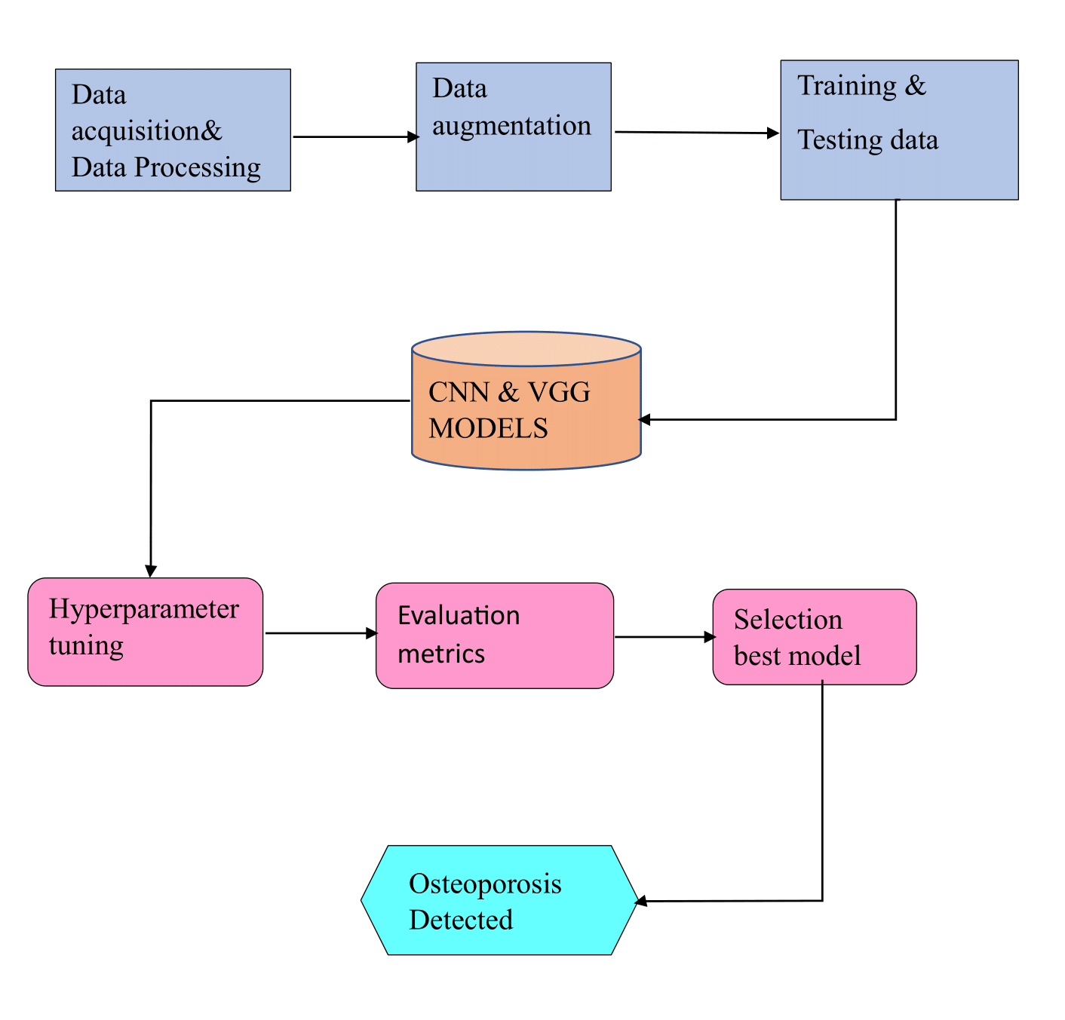

**FIG 1 –PROPOSED ARCHITECTURE**

**1.Data Collection/Acquisition:**

The method starts with gathering a significant set of knee CT scans. Images from patients with osteoporosis and normal bone density are presented in this collection.

**2.Data Preprocessing:**

This entails normalizing the pixel values, eliminating any extraneous information from the images, improving contrast, eliminating noise, and standardizing image sizes.

To evaluate the performance of the model, data is divided into training, validation, and testing sets.

**3.Model Selection:**

Several machine learning and deep learning techniques, including SVM, NNC, AdBoast, KNN, and convolutional neural networks (CNNs) (effectiveness in image analysis), are used to classify the images. Evaluating pre-trained models such as ResNet and VGG16, etc.

**4. Training the model:**

On training dataset, run the chosen model or models.

Implementing techniques to reduce overfitting and enhance dataset variety, such as data augmentation, Using methods like grid search and Bayesian optimization, adjust hyperparameters.

**5. Testing the model:**

The model's performance may be evaluated by testing it on a new set of images once it has been trained and verified.

**6.Evaluation Metrics:**

Using suitable evaluation standards, such as the area under the ROC curve, F1-score, recall, accuracy, and precision.

Confusion matrix computation is used to evaluate model performance in various classes.

**ALGORITHMS**

1. **Random Forest Regression**:

An approach to collective learning is Random Forest Regression. During training, several decision trees are constructed. The average (for regression) or mode (for classification) of each tree's contribution to the final prediction is used. It is renowned for its capacity in handling different types of data and reliability against overfitting.

1. **Support Vector Regression (SVR)**:

SVR is a regression method that extends Support Vector Machines to issues related to regression. It locates a hyperplane that minimizes the error margin and most accurately matches the data. SVR works well at identifying complex patterns in data and is especially helpful when working with high-dimensional data.

**3.** **Logistic regression :**

Logistic regression is a classification algorithm, used when the value of the target variable is categorical in nature. Logistic regression is most commonly used when the data in question has binary output, so when it belongs to one class or another, or is either a 0 or 1. Mathematically, a logistic regression model predicts P(Y=1) as a function of X.

1. **KNN:**

K-NN algorithm assumes the similarity between the new case/data and available cases and put the new case into the category that is most similar to the available categories.K-NN algorithm stores all the available data and classifies a new data point based on the similarity. This means when new data appears then it can be easily classified into a well suite category by using K- NN algorithm.

1. **Decision Trees:**

Decision Trees (DTs) are a non-parametric supervised learning method used for classification and regression.The deeper the tree, the more complex the decision rules and the fitter the model.Decision tree uses the tree representation to solve the problem.In which each leaf node corresponds to a class label and attributes are represented on the internal node of the tree. The primary challenge in the Decision Tree implementation is to identify the attributes(Root).

1. **VGG-19:**

VGG-19, also known as VGGNet-19, is a convolutional neural network (CNN) architecture specifically designed for image recognition tasks. Unlike some CNNs that use complex building blocks, VGG-19 relies on a relatively simple architecture.Each convolutional layer is followed by a rectified linear unit (ReLU) activation function, and some layers are followed by pooling layers for dimensionality reduction.This simplicity makes VGG-19 easier to train and interpret compared to more complex architectures. VGG-19 is a significant milestone in the development of CNNs for image recognition.

1. **VGG-16:**

VGG-16, also known as VGGNet-16, is a convolutional neural network (CNN) architecture designed for image classification tasks.VGG-16 played a pivotal role in demonstrating the effectiveness of deep learning for image recognition. While newer architectures may offer improvements in performance or efficiency, VGG-16 remains a valuable tool for researchers and practitioners in the field of computer vision.

1. **CNN:**

CNNs are a specific type of deep learning architecture designed to excel at image recognition and analysis tasks.CNNs automatically learn the most important features directly from the image data. CNNs leverage a special technique called convolution, which allows them to efficiently analyze the spatial relationships between pixels in an image. This is crucial for tasks like object detection and recognition where the arrangement of pixels holds significant meaning.

1. **Support Vector Machine:**

“Support Vector Machine” (SVM) is a supervised machine learning algorithm,which can be used for both classification or regression challenges. However, it is mostly used in classification problems. In the SVM algorithm, we plot each data item as a point in n-dimensional space (where n is number of features you have). we perform classification by finding the hyper-plane that differentiates the two classes very well.

1. **Naive Bayes:**

Naive Bayes works under the assumption that the features used for classification are conditionally independent of each other given the class label.Naive Bayes uses Bayes' theorem to calculate the posterior probability, which is the probability of a particular class given a set of features.Naive Bayes offers a robust and efficient classification approach, particularly for large datasets and when interpretability is important.

1. **Neural network classifier:**

A neural network classifier is a type of artificial intelligence model inspired by the structure and function of the human brain. It's designed to classify input data into different categories or classes based on patterns and features it learns from training data.The basic architecture typically includes an input layer, one or more hidden layers, and an output layer. Each neuron in the network receives input signals, processes them using an activation function, and passes the result to neurons in the subsequent layer.neural network classifiers offer a powerful and flexible approach to classification problems, with the potential to achieve high accuracy and robust performance across diverse datasets.

1. **AdaBoost:**

AdaBoost, short for Adaptive Boosting, is an ensemble learning algorithm used for classification tasks. It combines the predictions from multiple weak classifiers to build a strong classifier. The idea behind AdaBoost is to sequentially train a series of weak learners, where each subsequent learner focuses more on the misclassified examples from the previous ones.AdaBoost is particularly effective in situations where there is a large amount of noisy data or when the relationship between features and labels is complex. It adapts to difficult examples by focusing more on them during training, ultimately producing a strong classifier with improved generalization performance.

1. **Random Forest:**

Random Forest is a versatile and powerful ensemble learning method used for both classification and regression tasks. It operates by constructing multiple decision trees during training and outputs the mode (for classification) of the individual trees. It constructs multiple decision trees during training and combines their predictions to make more accurate and robust predictions.Random Forest provides estimates of feature importance, helping to identify which features are most informative for the task. It can handle large datasets with high dimensionality.Random Forest is widely used in various domains due to its simplicity, flexibility, and excellent performance.

**PERFORMANCE PARAMETERS**

**CLASSIFICATION METRICS:**

**PRECISION:**

It measures the percentage of correctly classified samples or events among the positive data.

Precision = True positives/ (True positives + False positives) = TP/(TP + FP)

**RECALL(Sensitivity):**

It is the percentage of all appropriate models that were successfully extracted.

Recall = True positives/ (True positives + False negatives) = TP/ (TP + FN)

**F1 SCORE:**

F1 score is calculated as the harmonic mean of precision and recall.

F1= TP/[TP+1/2(FP+FN)]

**ROC AUC SCORE:**

The ROC curve is the graphical representation of the effectiveness of binary classification model. It plots the true positive rate (TPR) vs the false positive rate (FPR) at different classification thresholds.

TPR=TP/(TP+FN)​

FPR=FP/(FP+TN)​

ROC AUC=∫01TPR(f(FPR−1(t)))dt

**ACCURACY SCORE:**

It measures the percentage of correctly predicted instances out of total instances in the dataset.

Accuracy = (TP + TN)/ (TP + TN + FP + FN)

**SUPPORT:**

The number of occurrences of each class in a dataset or in the output of a classification model.

Support(*Ci*​)=Number of samples belonging to class *Ci*​

**DATASET**

Our data was used to develop a system for early prediction of osteoporosis. It suggests information about patients who diagnosed with osteoporosis and potentially healthy controls. This dataset contains images of X-rays. Our Original dataset consists of 372 normal images and 372 Osteo images. Images in our dataset are in the form of JPG, PNG and JPEG format. We performed image augmentation, this technique is used in object detection tasks which increases the size and diversity of our dataset which aims to improve the robustness and generalizability of an object detection model. To augment the data we used augment image function which takes single image as input. This function performs augmentation techniques like Horizontal Flip-Which creates mirror image of original image along horizontal axis, Vertical Flip-Which creates mirror image of original image along vertical axis and Rotation by 90 degrees clockwise, counter-clockwise, 180 degrees-Which creates rotation version of original image. After data augmentation all the image extensions are converted to JPG format. For each image file it takes one image as input and generates augmented versions of each image and iterates through each image in the dataset. After performing all these techniques the augmented data consists of 1860 Normal images and 1860 Osteo images. In order to classify osteoporosis using deep learning, data processing is an essential step. We used different preprocessing techniques to improve quality and consistency of our data: Resizing-To make sure that the input requirements of your Deep Learning model are compatible, we must resize all images to uniform size. Normalization-The goal of normalization is to place all pixel values inside a shared range. Data Cleaning-This is the important step in data pre-processing which includes identifying and eliminating any irrelevant, duplicate, or missing data. Ensuring that the data is accurate, consistent, and error-free is the aim of data cleaning.

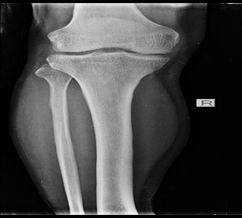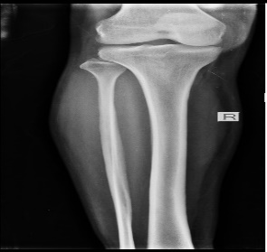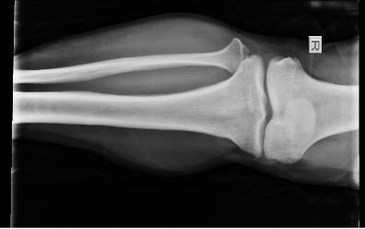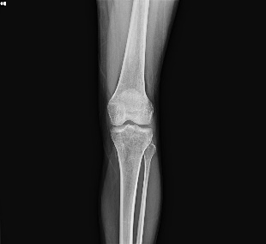 **FIG 2-Original Images FIG 3- Augmented Images**

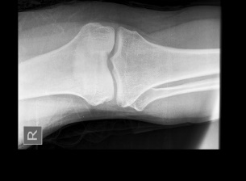 **Normal Normal**

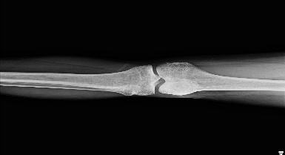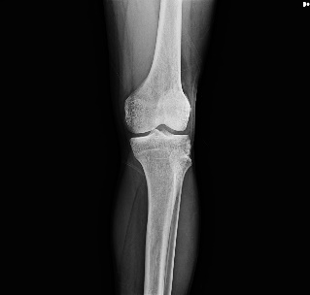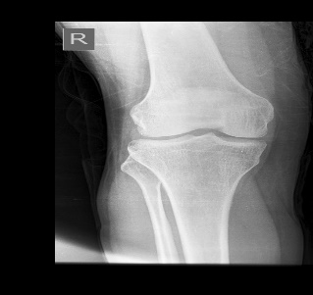

**Osteoporosis Osteoporosis**

**REQUIREMENT ANALYSIS**

**1.Python:** Most deep learning frameworks and libraries are built for Python.

**2.Deep Learning Frameworks:**

**TensorFlow:** Google created the open-source deep learning framework TensorFlow. TensorFlow gives excellent support for building and training deep learning models, including convolutional neural networks (CNNs) which are often used for image classification tasks.

**PyTorch:** PyTorch is known for its dynamic computation graph and user-friendly interface, making it a favorite among researchers and practitioners.Popular deep learning framework developed by Facebook.

**3.Libraries for Data Manipulation and Preprocessing**:

**NumPy:** Numpy is used for numerical computations and handling multi-dimensional arrays.

**Pandas:** For data manipulation and analysis, especially useful for handling structured data.

**OpenCV:** is an open-source computer vision and machine learning software library. It can process images and videos to identify objects, faces, or even the handwriting of a human.

**4.Deep Learning Model Architectures:**

**CNN Architectures:** Considered using pre-built architectures such as VGG for feature extraction and classification tasks in medical imaging.

**5.Visualization Tools:**

**Matplotlib**: used for creating visualizations such as plots, histograms, and image displays.

**6.Deep Learning Model Evaluation:**

**Scikit-learn:** It Provides tools for model evaluation, metrics calculation, and data preprocessing.

TensorFlow/Keras/PyTorch Metrics: Each framework provides built-in functions for evaluating model performance metrics such as accuracy, precision, recall, and F1-score.

**7.Development Environment:**

**Google colab:** Google Colab supports Python. It is an executable document that lets you write, run, and share code or you can think as an improved version.

**8.GPU Support:**

**CUDA Toolkit:** Install NVIDIA CUDA Toolkit for GPU acceleration.

**GPU Drivers:** Ensure compatible GPU drivers are installed for your NVIDIA GPU.

**IMPLEMENTATION**

We first implemented basic machine learning models. Our dataset is in the form of images(X-ray). The picture data is preprocessed for a classification job by setting labels ('N' for osteoporosis and 'O' for normal), scaling the photos to 200x200 pixels, and saving the images with their labels. For image processing, it makes use of OpenCV, and for numerical computations, numpy. Data is converted into list containing images with their labels(0 or 1).X is defined by 1-Dimensional array of images and Y is defines as labels of images . Data is splited into training images and testing images by using a specific size. Inages are reshaped into a 2D array with 744 rows and 120000 columns. The data is normalized in variables ‘d’ and ‘e’. Data augmentation on a set of images stored in a directory (original_dir) and saves the augmented images to another directory (aug_dir). Various augmentations are applied to the input image, including horizontal flip, vertical flip, and rotation by 90, 180, and 270 degrees clockwise. Augmented images are stored in a list. First we implemented logistic regression where precision is 0.8181 , Recall is 0.8804 , F1-score is 0.8481,roc is 0,8444 and accuracy is 84.41% . Confusion matrix has been plotted for logistic regression . KNN is another machine learning model where precision is 0.7168 , Recall is 0.8804, F1-score is 0.7902 , Roc is 0.77 and accuracy is 76.88% . Support Vector Machine(SVM) precision is 0.7962 , Recall is 0.9347 , F1-score is 0.8599 , roc is 0.8503 and accuracy is 84.95% . Accuracy of naïve bayes model is 75.27% , random forest accuracy is 88.17% , Neural Network accuracy is 86.56% , AdaBooost classifier accuracy is 80.05% , Decision tree accuracy is 80.05% . Confusion matrix is drawn for all the above machine learning algorithms.

After completing all machine learning models we used some of the deep learning methods like CNN and VGG-16. Efficiently gathers file paths and labels for knee image data, organizing them into a structured DataFrame. DataFrame is split into train_images and test_images, with 70% of the data assigned to training and 30% to testing. The second call further divides the training set into train_set and val_set, allocating 80% of the original data to training and 20% to validation. For the training, testing, and validation datasets obtained from dataframes train_set, test_images, and val_set, respectively, flow_from_dataframe method is used to create the data generators. Each generator is specified with parameters such as target size of images as (244,244), color mode as rgb, class mode (set to "categorical" for Sequential Model), batch size=4, and whether to shuffle the data. The shuffle parameter is set to False for all generators to maintain the order of data since shuffling is handled earlier during the splitting of datasets. Two classes are defined as Healthy and Osteoporosis. Convolutional Neural Network (CNN) using the Keras library in Python. The model starts with a convolutional layer with 128 filters, each of size 8x8 with a stride of (3,3) and ReLU activation function. This layer is followed by batch normalization. The output of this layer is then fed into a series of convolutional layers with varying filter sizes, activations, and normalization layers. The model also includes max pooling layers to reduce the spatial dimensions of the input volume. After several convolutional and pooling layers, the model flattens the output and connects it to a dense layer with 1024 neurons and ReLU activation. Dropout is used to prevent overfitting by randomly dropping out neurons during training. This is followed by another dense layer with 1024 neurons and ReLU activation, and another dropout layer. Finally, the model has a dense output layer with 2 neurons and a softmax activation function, which is suitable for multi-class classification problems. The model is compiled with categorical cross-entropy loss, stochastic gradient descent (SGD) optimizer with a learning rate of 0.001, and accuracy as a metric. In summary, this model is a deep CNN with multiple convolutional and pooling layers, followed by fully connected layers and dropout for regularization. It is suitable for image classification tasks with multiple classes.

Using pre-trained weights from ImageNet, the create_Base_model_from_VGG16 function initializes a VGG16 model that is setup without the top classification layers and to accept input images of size (224, 224, 3). In order to preserve their previously trained weights and stop additional training, it then freezes every layer. The next call to summary() produces an architecture summary of the model, including details on the layer structure and parameters, facilitating debugging and understanding of the model without requiring additional coding work.A VGG16 base model is extended using the add_custom_layers function, which adds custom dense layers for classification. It adds a flattening layer, a dense layer with ReLU activation, and a final dense layer with softmax activation for the required number of classes after generating the base model using the `create_Base_model_from_VGG16} function. The final model, referred to as {final_model}, extends from the VGG16 input to the newly created classification layers. After that, accuracy metrics, the Adam optimizer, and categorical cross-entropy loss are used to build it. The architecture of the returned model can be seen by calling {.summary()}, which shows the additional layers and their arguments.Using training and validation data for 10 epochs, the code trains a custom model ({model_from_vgg16}) based on the VGG16 architecture. Using ReduceLROnPlateau, it dynamically modifies the learning rate depending on validation loss during training.

Two functions are included in the code to build a convolutional neural network (CNN) based on VGG19. Using pre-trained weights from ImageNet, the first function initializes a VGG19 model and freezes each layer to maintain its initial weights. The second function builds the final model for training with categorical cross-entropy loss and the Adam optimizer by adding custom layers, such as flattening and dense layers, on top of the frozen VGG19 model.

Lastly, it presents assessment metrics succinctly and assesses the trained model's performance on the test dataset. Using the test dataset as a source, the algorithm creates predictions using model_from_vgg16, model_from_vgg19, model_from_CNN and transforms indices into labels for comparison. After that, it computes and outputs the accuracy score and classification report to assess how well the model performed on unobserved data. The ROC curve and AUC score for the predictions made by the models on the test data, as well as converting string labels to numeric values. Subsequently, the ROC curve is displayed and the ROC AUC score is generated, offering valuable insights into the binary classification performance of the model. At last the model predicts whether the randomly given image is healthy or has osteoporosis.

**RESULTS**

|  |  |  |  |  |  |
| --- | --- | --- | --- | --- | --- |
| MODELS | PRECISION | RECALL | F1 SCORE | ROC | ACCURACY_SCR |
| LR | 0.8652 | 0.8370 | 0.8508 | 0.8546 | 0.8548 |
| KNN | 0.7193 | 0.8913 | 0.7961 | 0.7754 | 0.7742 |
| SVM | 0.8119 | 0.8913 | 0.8497 | 0.8446 | 0.8441 |
| NB | 0.6627 | 0.5978 | 0.6286 | 0.6500 | 0.6505 |
| RF | 0.8539 | 0.8261 | 0.8398 | 0.8439 | 0.8441 |
| NNC | 0.8795 | 0.7935 | 0.8343 | 0.8435 | 0.8441 |
| DT | 0.8276 | 0.7826 | 0.8045 | 0.8115 | 0.8118 |
| ADA | 0.8193 | 0.7391 | 0.7771 | 0.7898 | 0.7903 |
| CNN | 0.93 | 0.93 | 0.93 | 0.9330 | 0.9327 |
| VGG16 | 0.92 | 0.92 | 0.92 | 0.9187 | 0.9204 |
| VGG19 | 0.86 | 0.85 | 0.85 | 0.8561 | 0.9062 |

**FIG 4– Evaluation Metrics**

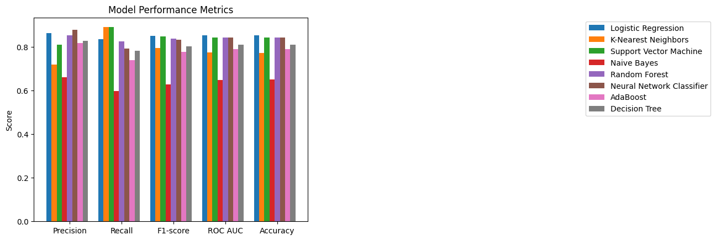

**FIG 5 – Evaluation Metrics Graph for ML Models**

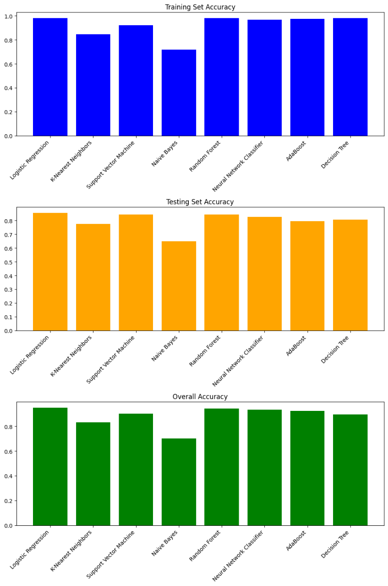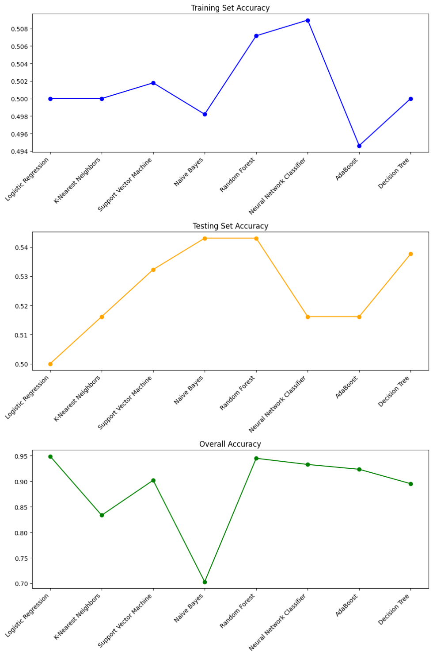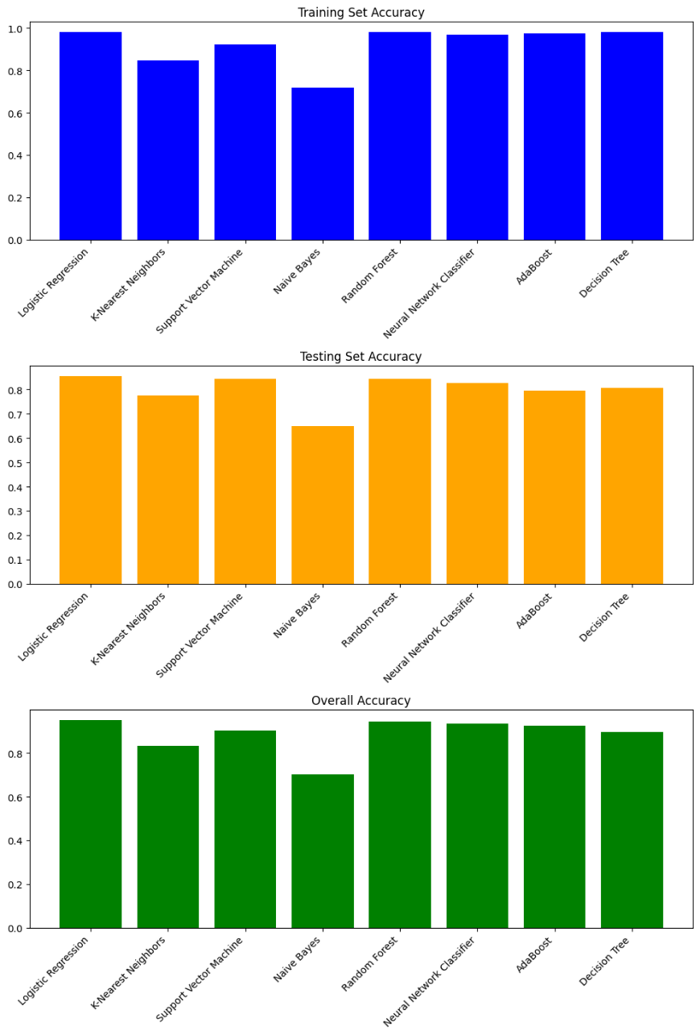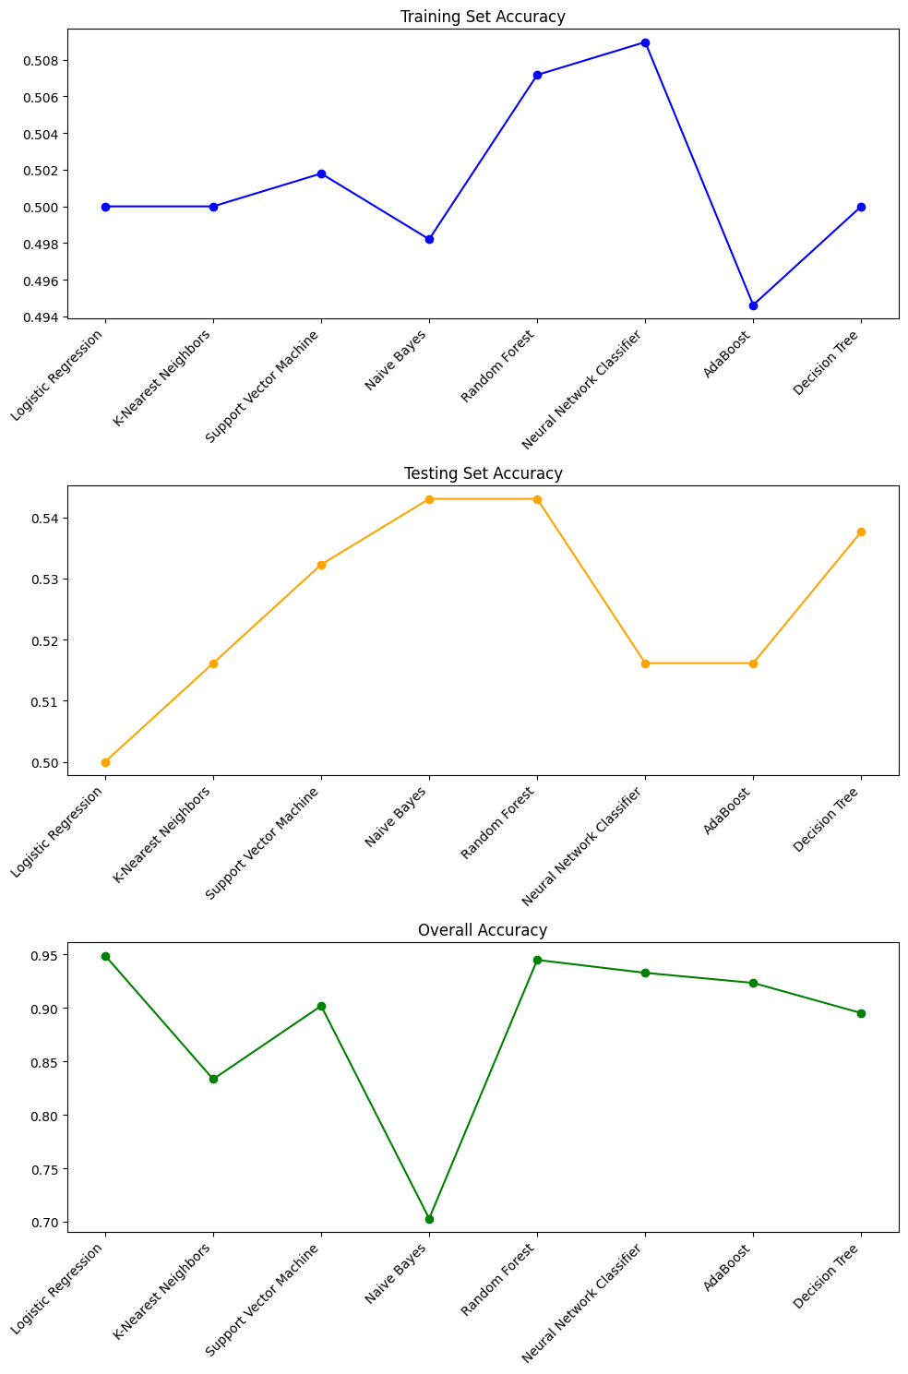 **FIG 6-Training Accuracy**

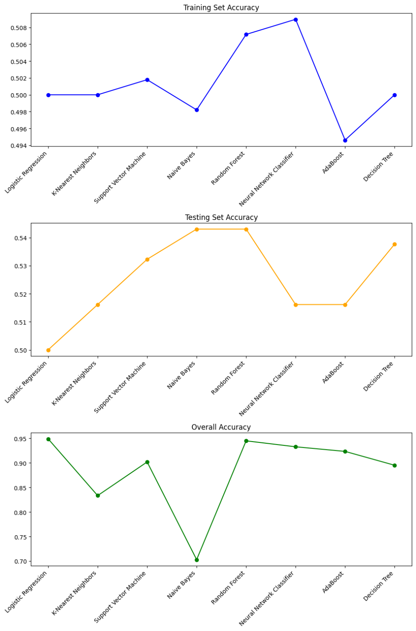 **FIG 7-Testing Accuracy**

**FIG 8-Overall Accuracy**

|  |  |  |  |
| --- | --- | --- | --- |
| Models | Training Accuracy | Testing Accuracy | Overall Accuracy |
| **LR** | 0.9802 | 0.8548 | 0.9489 |
| **KNN** | 0.8476 | 0.7741 | 0.8333 |
| **SVM** | 0.9211 | 0.8440 | 0.9018 |
| **NB** | 0.7168 | 0.6505 | 0.7029 |
| **RF** | 0.9802 | 0.8440 | 0.9448 |
| **NNC** | 0.9677 | 0.8279 | 0.9327 |
| **DT** | 0.9802 | 0.8064 | 0.8951 |
| **ADA** | 0.9749 | 0.7956 | 0.9233 |

**FIG 9 – Accuracies for Ml Models**

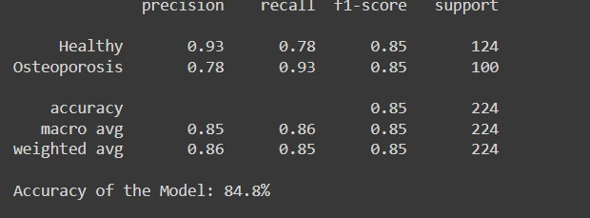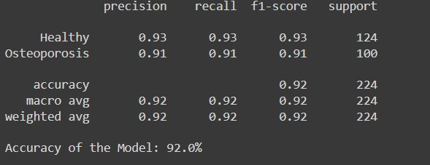

**FIG 10– VGG19 Metircs**

**FIG 11– VGG16 Metircs**

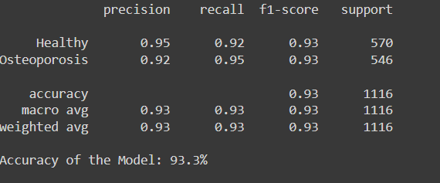

**FIG 12– CNN Metircs**

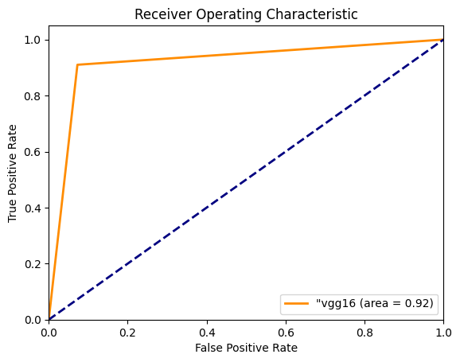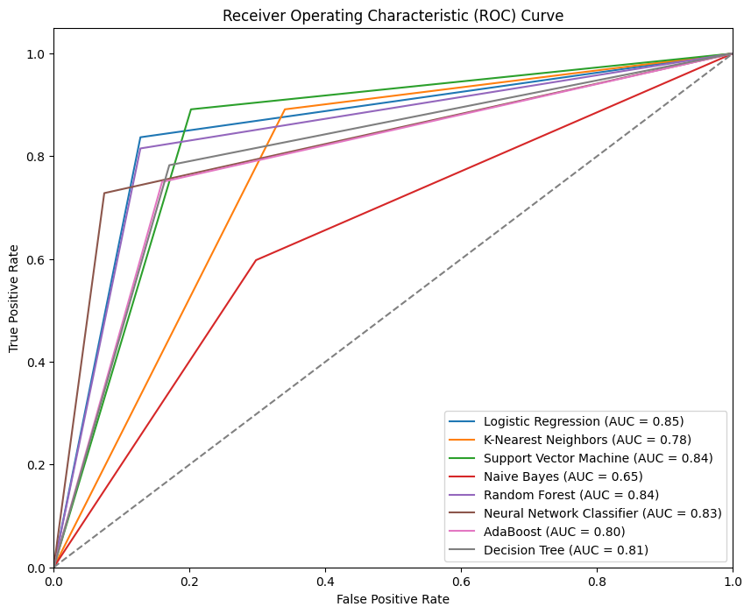**FIG 13 – ROC Curves for Ml Models FIG 14– ROC Curve VGG16**

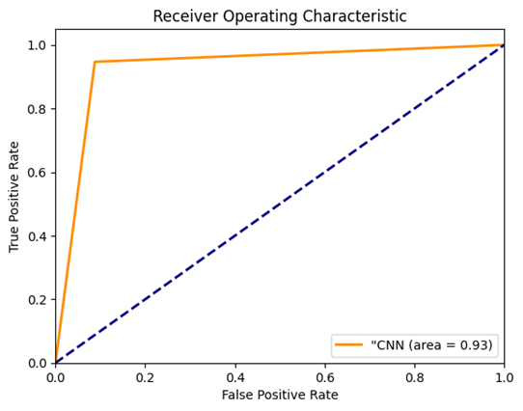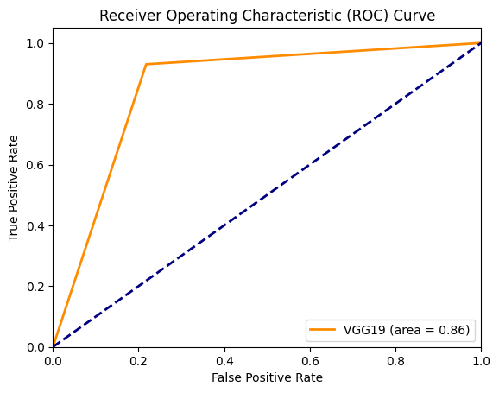

**FIG 16– ROC Curve CNN**

**FIG 15– ROC Curve VGG19**

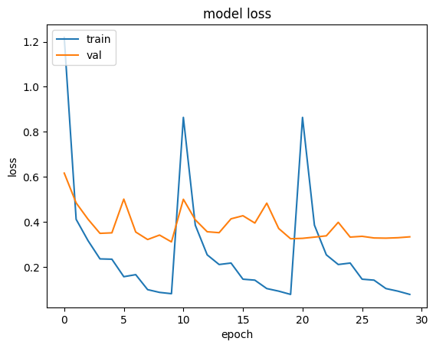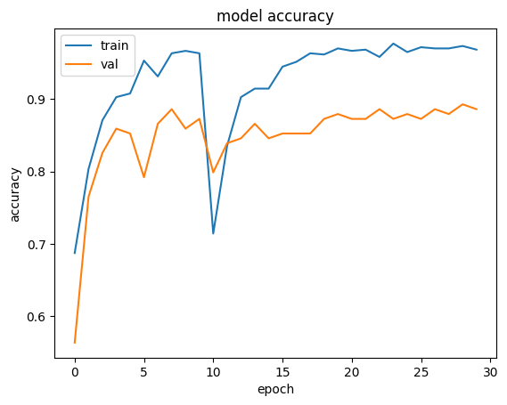

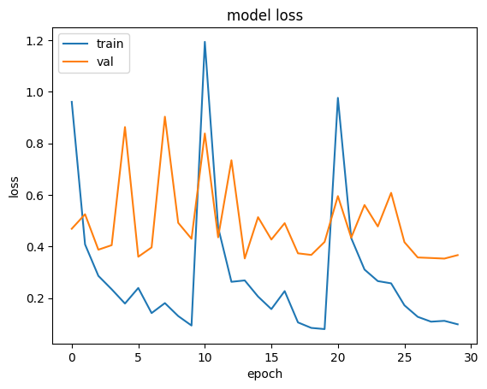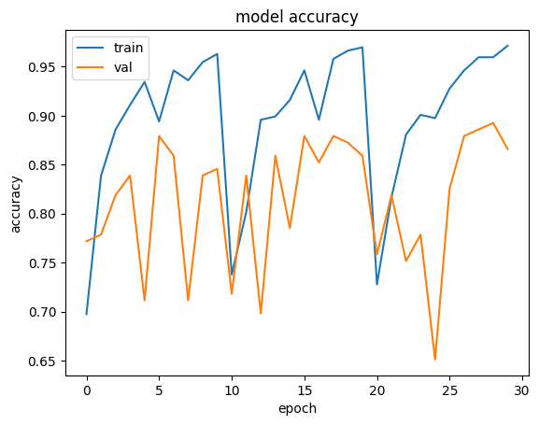

**FIG 17- Model Accuracy & Loss for VGG19**

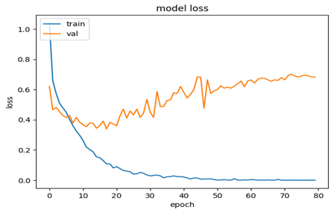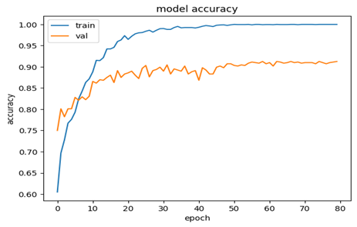

**FIG 18- Model Accuracy & Loss for VGG16**

**FIG 19- Model Accuracy & Loss for CNN**

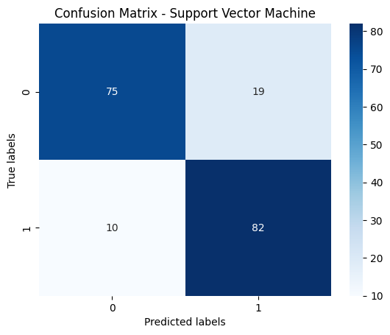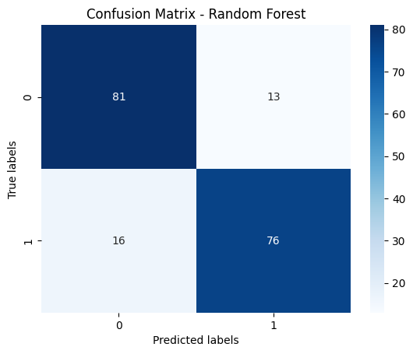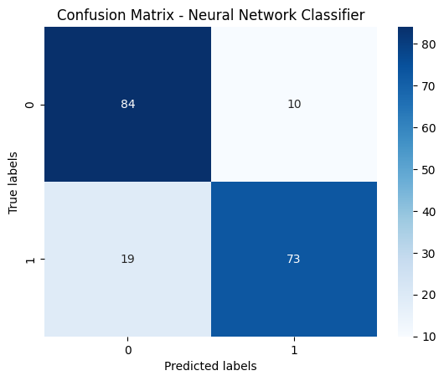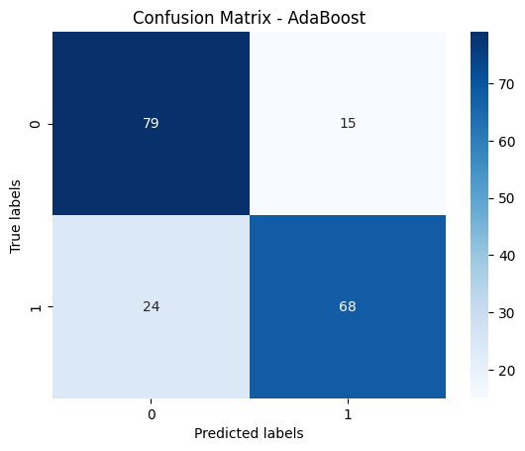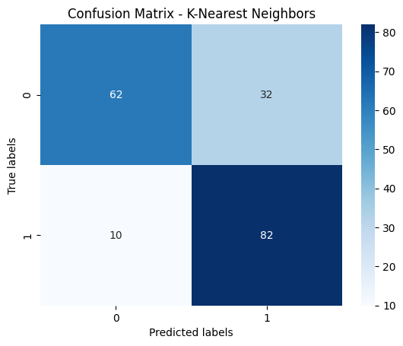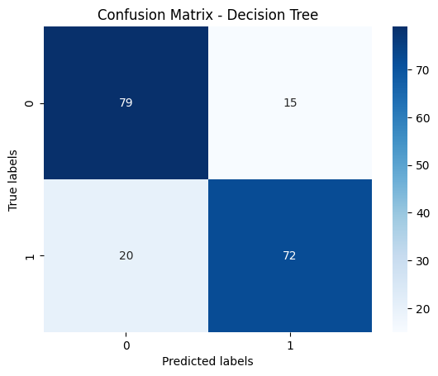

**FIG 20 - Confusion Matrix**

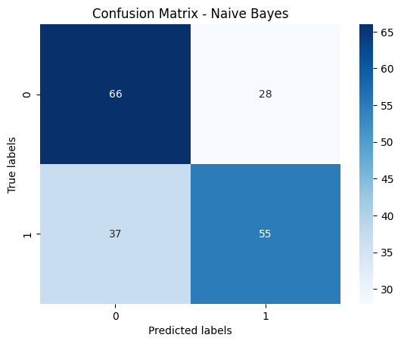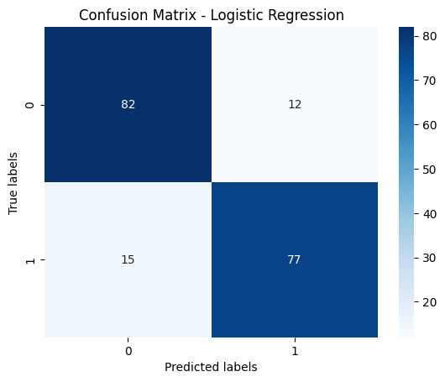

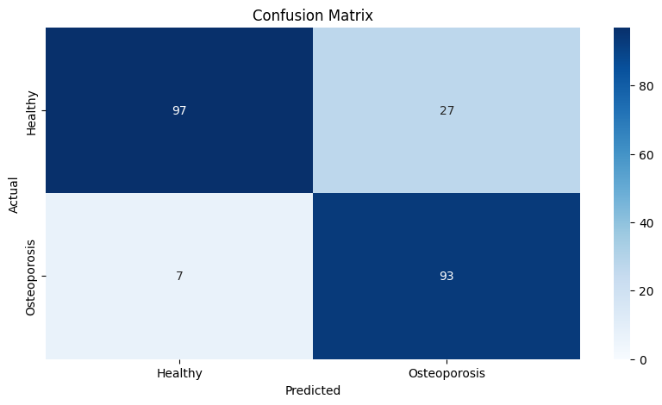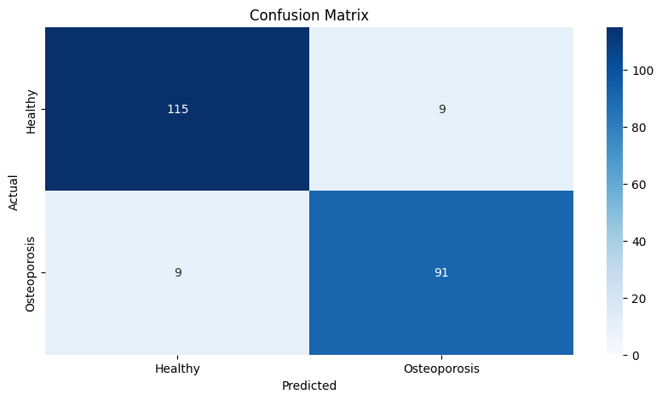

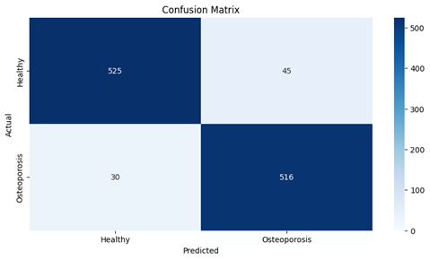

**VGG1**

**VGG1**

**CNN**

“CNN" holds the top position in maintaining a high level of performance. Because it has the least loss and highest accuracy. As a result, CNN fits the model very well, with an Accuracy of 93.3%.

**CONCLUSION**

In this analysis, we analyzed that sophisticated deep learning methods can effectively classify osteoporosis bone condition. Through the use of advanced algorithms and large-scale datasets, we have made significant progress in predictive diagnosis and classification. Our results highlight deep learning's potential as a useful tool for improving osteoporosis detection and management, which will eventually lead to better patient outcomes.

**FUTURE SCOPE:**

Improving model performance can involve fine-tuning deep learning architectures, fine-tuning hyperparameters, and including other data modalities such as genetic markers or medical pictures. While personalized medicine techniques might enhance treatment plans based on specific patient profiles, the development of real-time diagnostic technologies could transform the diagnosis and planning of osteoporosis. While long-term monitoring might offer insights into how a therapy is responding to a patient's illness and development over time, integration with healthcare systems would guarantee widespread acceptance.  Investigating multimodal data fusion might improve diagnosis accuracy by capturing the intricate interactions between variables that underlie osteoporosis.

**REFERENCES**

[1] Sandhu, S. K., & Hampson, G. (2011). The pathogenesis, diagnosis, investigation and management of osteoporosis. *Journal of clinical pathology*, *64*(12), 1042-1050.

[2] Sözen, T., Özışık, L., & Başaran, N. Ç. (2017). An overview and management of osteoporosis. *European journal of rheumatology*, *4*(1), 46.

[3] Wihandika, R. C., Arifin, A. Z., & Yuniarti, A. (2018, June). Detection of Branching in Trabecular Bone Using Multiscale COSFIRE Filter for Osteoporosis Identification. In *Proceedings of the 4th International Conference on Frontiers of Educational Technologies* (pp. 147-151).

[4] Prakash, U. M., Kottursamy, K., Cengiz, K., Kose, U., & Hung, B. T. (2021). 4x-expert systems for early prediction of osteopor Wihandika, R. C., Arifin, A. Z., & Yuniarti, A. (2018, June). Detection of Branching in Trabecular Bone Using Multiscale COSFIRE Filter for Osteoporosis Identification. In *Proceedings of the 4th International Conference on Frontiers of Educational Technologies* (pp. 147-151).osis using multi-model algorithms. *Measurement*, *180*, 109543.

[5] Ramesh, T., & Santhi, V. Multi-level classification technique for diagnosing osteoporosis and osteopenia using sequential deep learning algorithm. *International Journal of System Assurance Engineering and Management*, *15*(1), 412-428.

[6] Varalakshmi, P., Sathyamoorthy, S., Darshan, V., Ramanujan, V., & Rajasekar, S. J. S. (2022, January). Detection of Osteoporosis with DEXA Scan Images using Deep Learning Models. In *2022 International Conference on Advances in Computing, Communication and Applied Informatics (ACCAI)* (pp. 1-6). IEEE.

[7] Kumar, A., Joshi, R. C., Dutta, M. K., Burget, R., & Myska, V. (2022, July). Osteo-Net: A Robust Deep Learning-Based Diagnosis of Osteoporosis Using X-ray images. In *2022 45th International Conference on Telecommunications and Signal Processing (TSP)* (pp. 91-95). IEEE.

[8] Hwang, D. H., Bak, S. H., Ha, T. J., Kim, Y., Kim, W. J., & Choi, H. S. (2023). Multi-View Computed Tomography Network for Osteoporosis Classification. *IEEE Access*, *11*, 22297-22306.

[9] Jones, B. C., Wehrli, F. W., Kamona, N., Deshpande, R. S., Vu, B. T. D., Song, H. K., ... & Rajapakse, C. S. (2023). Automated, calibration-free quantification of cortical bone porosity and geometry in postmenopausal osteoporosis from ultrashort echo time MRI and deep learning. *Bone*, *171*, 116743.

[10] ÖZİÇ, M. Ü., Tassoker, M., & Yuce, F. (2023). Fully Automated Detection of Osteoporosis Stage on Panoramic Radiographs Using YOLOv5 Deep Learning Model and Designing a Graphical User Interface. *Journal of Medical and Biological Engineering*, *43*(6), 715-731.

[11] Umamaheswari, R., Lakshmi, D., Pandi, V. S., Geetha, B., Sumithra, S., & Ragini, P. Y. (2023, November). An Advanced Deep Learning Approach for Primary Osteoporosis Prediction Using Radiographs with Clinical Covariates. In *2023 7th International Conference on Electronics, Communication and Aerospace Technology (ICECA)* (pp. 788-793). IEEE.

[12] Khanna, V. V., Chadaga, K., Sampathila, N., Chadaga, R., Prabhu, S., Swathi, K. S., ... & Bhat, D. (2023). A decision support system for osteoporosis risk prediction using machine learning and explainable artificial intelligence. *Heliyon*, *9*(12).

[13] Bo, Y., Chen, G., Li, L., Tao, X., & Zhao, R. (2023). Detection of osteoporosis using image processing methods. *Journal of Optics*, 1-11.

[14] Chauhan, R., Varshney, Y., & Kaur, H. (2023, April). Prediction of Bone Mineral Density Using AI to Detect Osteoporosis. In *The International Conference on Recent Trends in Communication & Intelligent Systems* (pp. 105-116). Singapore: Springer Nature Singapore.

[15] Ghosh, D., & Sahu, P. K. (2024). Osteoporosis detection with microwave signals: An investigation into natural resonance frequencies. *Sensors and Actuators A: Physical*, *365*, 114867.

[16] Küçükçiloğlu, Y., Şekeroğlu, B., Adalı, T., & Şentürk, N. (2024). Prediction of osteoporosis using MRI and CT scans with unimodal and multimodal deep-learning models. *Diagnostic and Interventional Radiology*, *30*(1), 9.

[17] Zaman, M. U., Alam, M. K., Alqhtani, N. R., Robaian, A., Alqahtani, A. S., Alqahtani, M., ... & Alqahtani, F. (2024). Diagnosing osteoporosis using deep neural networkassisted optical image processing method. *Optical and Quantum Electronics*, *56*(3), 441.

[18] Alyahyan, S. (2024). Applying machine learning classification techniques for disease diagnosis from medical imaging data using Transformer based Attention Guided CNN (TAGCNN). *Multimedia Tools and Applications*, 1-27.

[19] Malathi, S. Y., & Bharamagoudar, G. R. (2024). A Novel Method Based on CNN-LSTM to Characterize Knee Osteoarthritis from Radiography. *Proceedings of the National Academy of Sciences, India Section B: Biological Sciences*, 1-16.

[20] Zhang, K., Lin, P. C., Pan, J., Shao, R., Xu, P. X., Cao, R., ... & Wang, L. (2024). DeepmdQCT: A multitask network with domain invariant features and comprehensive attention mechanism for quantitative computer tomography diagnosis of osteoporosis. *Computers in Biology and Medicine*, *170*, 107916.