Premium Pricing Predictive Analysis
A White Paper
FFA
Data Analytics

Contents

1. Introduction 2
2. Preprocessing Operations 3
3. Data Exploration 8
4. Model Building 13
5. Training & Testing 15
6. Results 18
7. Conclusion 25

Appendices 26
Appendix A – Glossary 26

Introduction
This paper aims to predict premium pricing for motor private car comprehensive policies based on relevant features of both policy and claims data from PIB (Malaysia) for the years 2020-2024.
The datasets used in this analysis include:
Policy data: Consists of 2,072,235 records and 117 features. Key features include policy details such as policy number, inception and expiry dates, vehicle information (e.g., make, model, engine number), coverage details (e.g., sum insured, policy type), customer details, and premium-related variables.
Claim data: Contains 491,804 records and 123 features, including columns similar to the policy data but with additional claim-specific fields such as 'nop_claimed', 'noc_total', 'noc_paid', and 'noc_os', along with their split variants.
The focus of this paper is on preprocessing the data, performing exploratory analysis, building predictive models, and evaluating their performance. The results and conclusions will be discussed after training and testing the models.

Preprocessing Operations
Part I
- The 'cc' feature, which originally ranged from 0 to 9180, was binned into six categories: '0-1000', '1000-1500', '1500-2000', '2000-3000', '3000-4000', and '4000+'. This transformation helped simplify the feature and make it more interpretable while reducing unnecessary variability.

- Next, we refined the dataset by selecting only the most relevant features. Instead of keeping all available fields, we retained a total of 37 features that were common between policy and claim datasets. Additionally, we kept 'GWP' from policy data and 'gic' and 'noc_total' from claim data, as these were essential for our analysis. This step helped eliminate redundant attributes such as customer details, vehicle specifics, and prior policy information, ensuring a cleaner dataset for modeling.

- To further structure the data, we applied a group-by operation based on policy number, inception date, expiry date, and split. For policy records, we aggregated 'GWP', 'xc_GWP_prv', and 'gr_comm_amount', while for claim records, we summed 'gic', 'xc_GWP_prv', and 'noc_total'. This resulted in a dataset with 1,601,765 records for policy data and 60,541 records for claim data.

- After preprocessing, we combined both datasets into a single consolidated file, maintaining the common features while handling policy and claim-specific fields. Policy records had 'gic' and 'noc_total' set to 0, while claim records had 'GWP' set to 0. This allowed us to track premium payments and claims together in one data set.

- Finally, we applied another group-by operation on the consolidated dataset to further sum up 'gic', 'GWP', and 'noc_total' at the policy level. This ensured that each policy's complete history—including total premiums paid and claims filed—was captured in a single record, making the dataset more structured and easier to analyze.

To ensure data accuracy, we first compared the total year-wise premium, total claims, and the number of claims against the official dashboard, confirming that the figures aligned correctly. Additionally, we verified that the aggregated values in the merged dataset matched those in the original datasets before merging, ensuring consistency throughout the process.

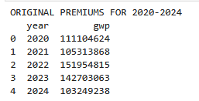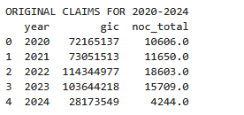

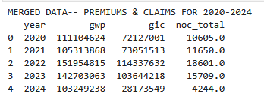
- Here, we have total number of records = 1,601,845 with number of features = 40 (37 + ‘GWP’, ‘gic’, ‘noc_total’)

Part II
- We checked for missing data in the merged dataset and handled each feature accordingly. Based on the percentage of missing values, we found that cust_post_code, make, and model had minimal missing data, while cust_gender and cust_age had a moderate amount. Additionally, nearly half of the records lacked data in the prv columns, indicating a significant portion of missing values in those fields.

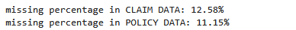
Missing data percentage in the merged dataframe:
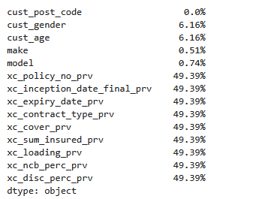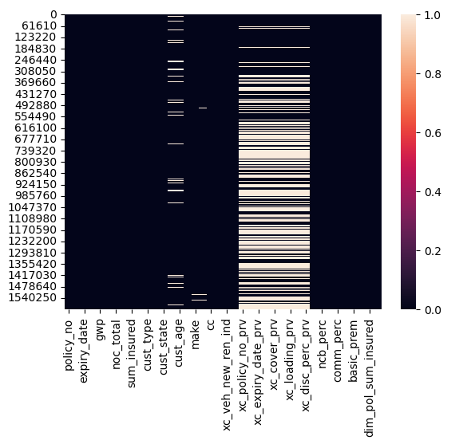

- We decided to drop columns where nearly half the records were missing, as synthetic augmentation wouldn't provide reliable data for the model to learn from. There were 7 columns as such and which were ‘xc_policy_no_prv','xc_inception_date_final_prv','xc_expiry_date_prv','xc_contract_type_prv','xc_cover_prv','xc_sum_insured_prv','xc_loading_prv','xc_ncb_perc_prv','xc_disc_perc_prv'. Keeping these columns could lead to misrepresentation and negatively impact model performance.
- For customer age, we found that there were outliers present going beyond minimum of 20 and maximum of 80, which may be absurd if we consider average age of the person who gets insurance for cars, hence we cap and floor the extreme ends of customer age to be minimum = 20 and maximum = 80.
- Later, we filled the missing values of cust_age by randomly sampling from the existing non-null values, ensuring that the dataset remains complete without introducing bias from more complex imputation methods.
- Next, we fill out the missing values in cust_gender by randomly imputing genders ('M' or 'F') based on their proportions in the dataset, ensuring the probabilities sum to 1. This approach is used to handle missing gender data while maintaining the overall gender distribution in the dataset.
- To handle missing values of model, we first calculated the distribution of the 'model' column, identifying the top 10 most frequent models. Then, we calculated the proportions of these top models and used them to randomly sample values for the missing entries in the 'model' column, ensuring the distribution of models remained consistent. Finally, we filled the missing values with the sampled models and verified that there were no remaining null values in the column.
- Since the missing values for 'cc', 'cust_post_code', and 'make' of the vehicles were minimal, we opted to remove the corresponding records from the dataframe to maintain data integrity.
- After removing all records and columns with missing values, we proceeded to add a new feature, loss_ratio, which is calculated by dividing each record's gross incurred claim amount by its gross weighted premium. We then classified these loss_ratio values into four categories, each with its corresponding meaning:
  - Zero: The customer has not made any claims.
  - Non-Zero: The customer has made a claim.
  - Not Defined: No premium is available, as the policy date falls outside the scope of the dataset considered here.
  - Doesn’t Exist: Both the claim amount and premium amount are missing, likely due to incomplete or missing data for certain records.
- We removed those records having loss_ratio class as ‘Not Defined’ and ‘Doesn’t Exist’.
- On further discussions, there were 10 more columns which were considered not so important. Hence we dropped - 'xc_veh_new_ren_ind','xc_veh_lost_ren_ind', 'policy_type', 'disc_perc', 'comm_perc', 'loading', 'basic_prem', ’dim_pol_sum_insured', 'dim_pol_veh_sum_insured', 'xc_GWP_prv'.
- Now, we have the total number of records = 1,561,624 with features = 23

Part III
- The step of extracting the year, month and day from inception_date_final was done to create separate features for the year, month, and day of policy inception, which can be useful for time-based analysis or modeling, allowing us to explore seasonal patterns or trends over time.
- The dataset was divided into distinct subsets: the training set (for 2020-2022) was prepared for model development, while the test sets for 2023 and 2024 were created to evaluate the model's performance on unseen data, ensuring an unbiased assessment of the model.
- These columns – policy_no, expiry_date, noc_total were removed because they were deemed unnecessary for the pricing prediction modeling process. This step reduces dimensionality and focuses on the most relevant features that are critical for building predictive models.
- Certain columns, such as 'inception_year', 'inception_month', 'inception_day', and 'cc', had their data types converted to the appropriate formats (e.g., integers for year, month, and day) to ensure they are compatible with modeling algorithms and avoid potential errors during computation.
- The columns were classified as either numerical or categorical to organize the dataset correctly. This classification is crucial for modeling algorithms, like CatBoost, which treat numerical and categorical data differently during model training.
- Lastly, the 'branch' codes were mapped to the corresponding 'reporting_branch' values to standardize them and ensure consistency. Additionally, records with irrelevant 'branch' codes (e.g., 'H5') were removed, improving the quality of the data and ensuring that only meaningful records remain for analysis.
- The final shape of the data that we’d feed the model with is of 1,561,624 records having 21 features.

Data Exploration
- Using df.info(), we have various datatypes in our data which need to be processed respectively to fit well into the predictive model. Namely, floats (17 continuous numeric values), integer (4 discrete numerical values), objects (17 categorical/text based features) and category (1 probably with a categorical variable with predefined levels).
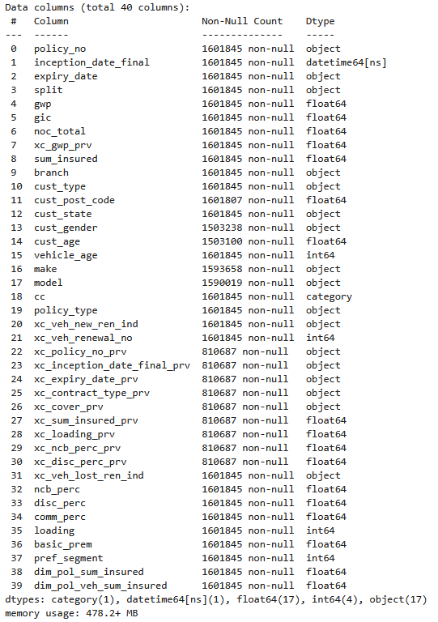

- On using df.describe() for data analysis, we also find that
  - GWP and xc_GWP_prv (previous premium) have negative values, which is likely incorrect.
  - Sum_insured, basic_prep and dim_pol_sum_insured have zero values, which may indicate missing values or policies that were cancelled.
  - Gic has a max value of 2.61million, which is significantly higher than the mean (244.3) and may indicate an outlier.
  - sum_insured varies from 0 to 18.75 million, suggesting a wide range in policy sizes.
  - Mean customer age is 45.48 years, with a minimum of 0 (potential error) and maximum of 121 (extreme but possible). Median customer age is 45 years, indicating a fairly normal distribution.
  - Mean of vehicle age is 12.12 years, suggesting policies are mostly for older vehicles. Range of vehicle age value is 0 to 57 years, with the 75th percentile at 17 years, meaning a significant portion of vehicles are old.
  - Mean of Renewals from xc_veh_renewal_no is 1.51, suggesting most policies have been renewed once or twice. Max is 11, indicating some long-term policyholders.
  - Median ncb_perc is 55%, suggesting many customers receive maximum No Claim Bonus.
  - disc_perc is mostly zero, indicating that explicit discounts are not common.
  - comm_perc is generally low (mean = 0.659%), which might indicate a standard commission structure.
  - loading (extra charges) ranges from 0 to 800, with an average of 9.35, suggesting that most policies don’t have excessive loadings.
  - Mean basic_premium is 109.08, with a max of 249,635, showing large variability. The standard deviation is 917.38, indicating significant differences between policies.
- Distribution of cust_age & vehicle_age
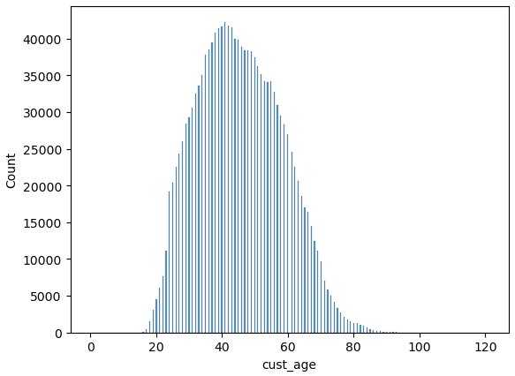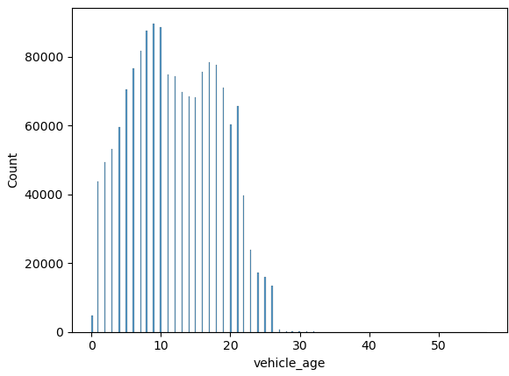
- Distribution of cust_type, cust_gender, cc, policy_type, pref_segment, loss_ratio_class
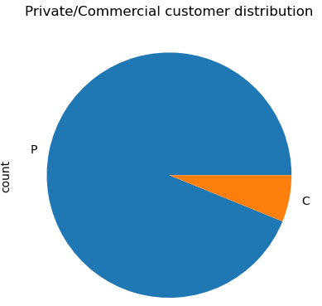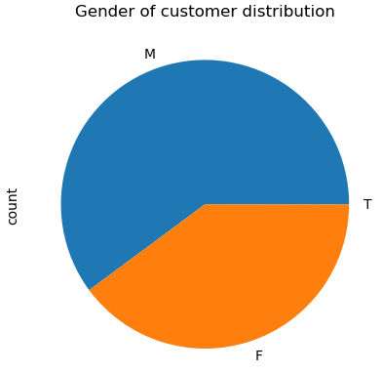
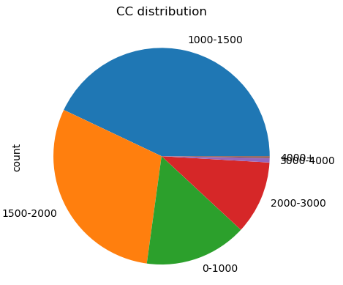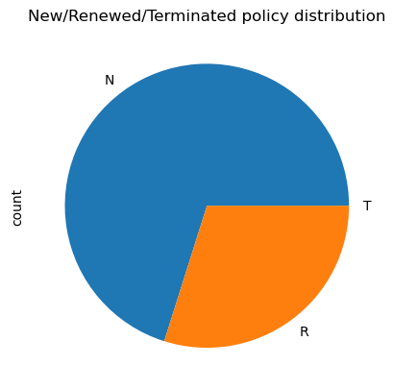
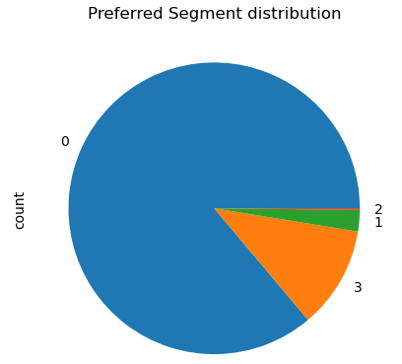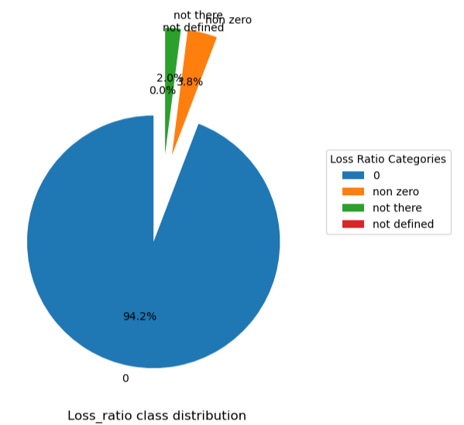

- Ouliers were detected in cust_age, which we handled by capping and flooring the extreme ages to 20 for minimum and 80 for max.
Before:
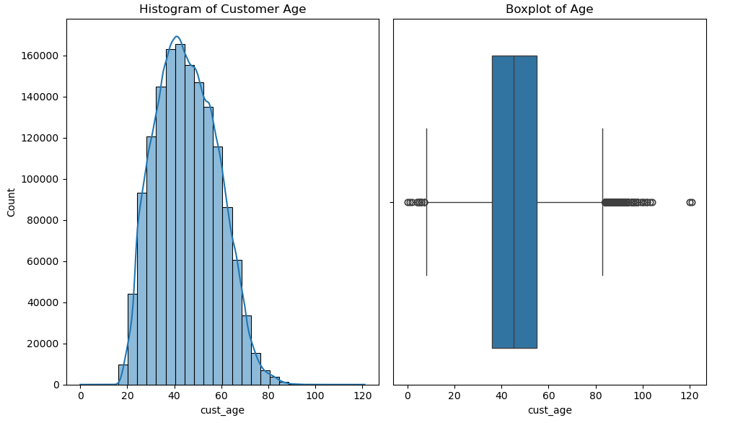
After:
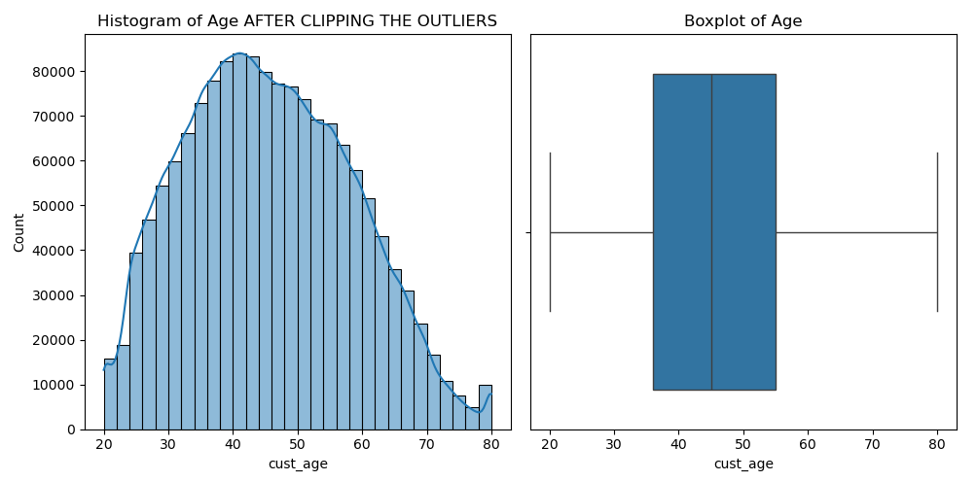
- Correlation analysis plot over multiple important columns for 5 years
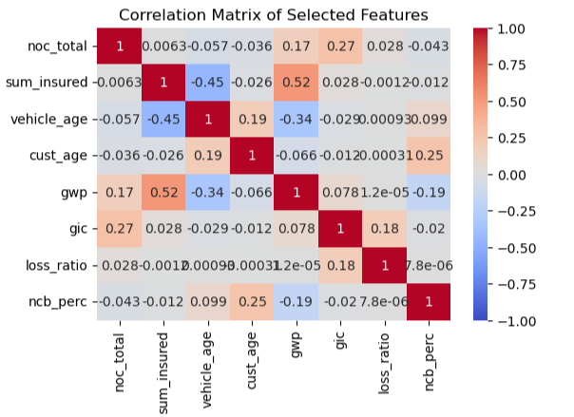
- We converted the 'inception_date_final' and 'expiry_date' columns to datetime format and calculated policy profitability by subtracting 'gic' from 'GWP'. Then, computed the policy duration and grouped the data by year to plot the average profitability trend over time.
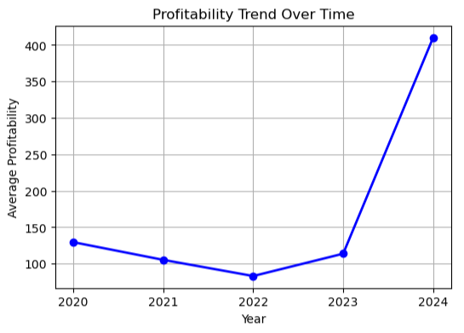

Model Building
The CatBoostRegressor was used because it’s particularly effective with categorical data and utilizes gradient boosting techniques. It incorporates methods like ordered boosting to efficiently handle such data, and early stopping ensures that the model does not overfit. The model's performance was thoroughly assessed using multiple evaluation metrics to understand its prediction accuracy, with all operations focused on optimizing the model's ability to generalize well on unseen data.
- The target variable y was set to ‘GWP’, and the feature set X was created using both numerical and categorical columns. This step defines what the model will predict and the input features used for training.
- TimeSeriesSplit was implemented to split the data into 5 folds, ensuring the model was evaluated on different temporal subsets. This approach is critical for time-series data as it avoids data leakage by maintaining the time-order integrity in the training and testing sets.
- The CatBoostRegressor model was initialized with specific hyperparameters like 900 iterations, a depth of 8, learning rate of 0.01, L2 regularization (leaf-wise) of 70, and early stopping after 50 rounds with no improvement. These settings were chosen to strike a balance between model complexity, overfitting prevention, and the speed of learning.
- Categorical columns were explicitly set by their indices, ensuring that CatBoost correctly processes them. This is important because CatBoost is optimized to handle categorical features natively, leveraging special algorithms like ordered boosting to improve performance.
- The model underwent cross-validation with TimeSeriesSplit, iterating through multiple training and test splits, ensuring that the model was evaluated on different parts of the data over time. This method provides a more robust evaluation, as the model is trained and tested on different subsets.
- Weights were applied to the training data to adjust the importance of different samples. This is useful when some records are more significant than others, such as those with higher loss ratios, ensuring that the model accounts for those differences in its training process.
- The columns were reordered so that the 'loss_ratio' feature came first. This prioritization was done with the assumption that the 'loss_ratio' is a crucial predictor and putting it at the beginning helps the model better learn its impact on the target variable.
- The CatBoost model was trained with early stopping, which helps prevent overfitting by halting training if the model's performance on the validation set does not improve after 100 rounds. This ensures that the model generalizes well and doesn’t continue to fit noise in the data.
- After training, the model made predictions on the test set, and various evaluation metrics such as R^2, MAE, MSE, and RMSE were calculated to assess the model’s performance. These metrics provide a comprehensive understanding of the model's accuracy and error rates. Here’s a short description of each metrics mentioned:
  - R^2 (R-squared): A statistical measure that indicates how well the independent variables explain the variability of the dependent variable. An R2 value closer to 1 means a better fit, while a value closer to 0 indicates that the model doesn't explain much of the variance in the data.
  - MAE (Mean Absolute Error): The average of the absolute differences between predicted and actual values. It measures the magnitude of error in predictions, with lower values indicating better accuracy.
  - MSE (Mean Squared Error): The average of the squared differences between predicted and actual values. It gives more weight to larger errors due to the squaring process, making it sensitive to outliers.
  - RMSE (Root Mean Squared Error): The square root of MSE. It provides an error metric in the same unit as the target variable and gives more weight to larger errors. Lower RMSE values indicate a better model fit.

- The fold-wise performance metrics were averaged to get an overall view of the model’s effectiveness. This approach provides a stable evaluation of model performance across different subsets of the data, helping mitigate any variance in the results from individual folds.

Training & Testing
The data used for training and testing the model spans from 2020 to 2024. Specifically:
- Training Data: The model is trained on data from 2020 to 2022, comprising 1,064,857 records with 24 features. This training dataset provides the model with historical information to learn patterns and relationships between various features and the target variable.
- Test Data: The model is evaluated on data from 2023 and 2024:
  - 2023 Test Data: The dataset for 2023 contains 330,401 records, each with the same 24 features as the training set.
  - 2024 Test Data: The dataset for 2024 contains 166,366 records, also with 24 features.
- The model is trained using 24 features, which are as follows:
Split, GWP, gic, sum_insured, branch, cust_type, cust_postcode, cust_state, cust_gender, cust_age, vehicle_age, make, model, cc, xc_veh_renewal_no, ncb_perc, pref_segment, loss_ratio, inception_year, inception_month, inception_day
- Weights are assigned to records based on the loss_ratio feature, which is the target variable. Specifically, the weight is assigned as follows:
  - Weight = 100 if the loss_ratio > 0.75, indicating that the record has a higher importance due to a higher loss ratio (potentially representing more risk or outliers).
  - Weight = 1 if the loss_ratio <= 0.75, indicating a regular, less-risky case.
  - This weighting scheme helps the model focus more on instances with higher loss ratios, which might be critical for the business (such as identifying riskier policies or customers).
- The model was trained with the following hyperparameters:
  - Number of Iterations (900): The model trains over 900 iterations or rounds, meaning it will perform up to 900 boosting steps to optimize the model’s predictions.
  - Depth (8): The maximum depth of the decision trees used in the boosting process is set to 8. This indicates how deep each tree can grow, balancing between underfitting and overfitting. A depth of 8 strikes a good balance for complex patterns in the data.
  - Learning Rate (0.01): The learning rate controls how much the model adjusts its weights in response to the error in each iteration. A smaller learning rate like 0.01 helps prevent overfitting but requires more iterations to converge to an optimal solution.
  - L2 Regularization (70): L2 regularization adds a penalty for large coefficients to avoid overfitting, particularly useful when the model has many features. A value of 70 indicates a relatively strong regularization, helping prevent the model from fitting noise in the data.
  - Early Stopping Rounds (50): If the model’s performance does not improve for 50 consecutive iterations, the training will stop early to avoid unnecessary computation and overfitting.
- The model shows strong performance, with an average R² of 0.8492 on the training data, indicating that about 84.92% of the variance is explained. The average MAE is 70.71, meaning the model’s predictions typically deviate by around 70.71 units.
- For the test data from 2023, the test R² is 0.8418, slightly lower than the training set, suggesting that the model generalizes well but with a slight increase in error. The test MAE increases to 97.27, and both the test MSE and RMSE are higher than those on the training data, indicating that the model performs less accurately on new data but still provides reasonable predictions. The adjusted test R² is very close to the regular test R², confirming the model's robustness.
- For the test data from 2024, the test R² is 0.8139, which is slightly lower than the previous year's result, suggesting a reasonable level of model performance on the new data. The test MAE increases to 156.38, and both the test MSE and RMSE are higher compared to the 2023 test data, indicating a slight decline in model accuracy. Despite these increases, the model still provides reasonable predictions. The adjusted test R² is very close to the regular test R², further confirming the model’s robustness and consistent performance across both test datasets.

- This plot below visualizes the differences between the predicted values and the actual values (residuals). A well-behaved residual plot typically shows a random distribution of points around zero, suggesting that the model has captured most of the signal and does not exhibit significant bias.
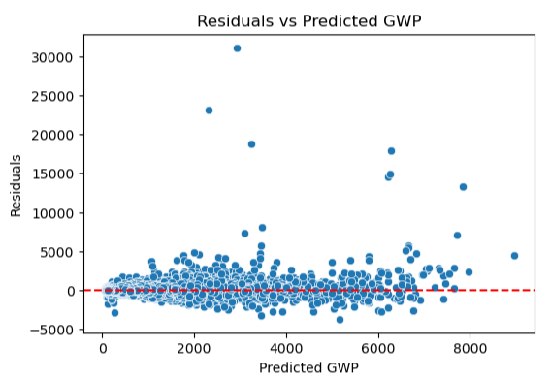

- The model assigns importance scores to each feature based on its contribution to predicting the loss ratio. Highest importance for prediction is given to split, sum_insured, ncb_perc, make, vehicle_age, cc, to name a top few.
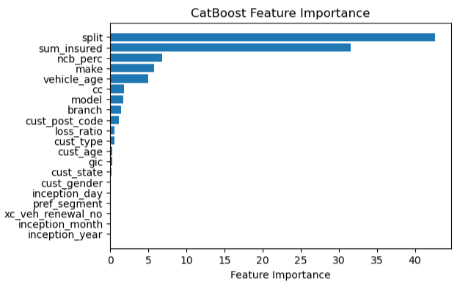

Results
ON 2023 YEAR TEST DATA
We are analyzing 14k records that were predicted to be high-risk policies, and checking how many of them indeed have a higher predicted GWP compared to the actual GWP. Out of the 14,123 records, 5,609 (39.7%) have a higher predicted GWP.

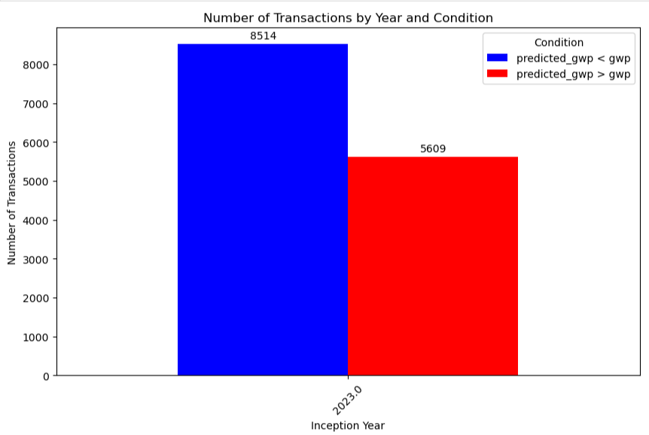

The plot below shows the percentage increase or decrease in predicted GWP for the 14,123 high-risk predicted records.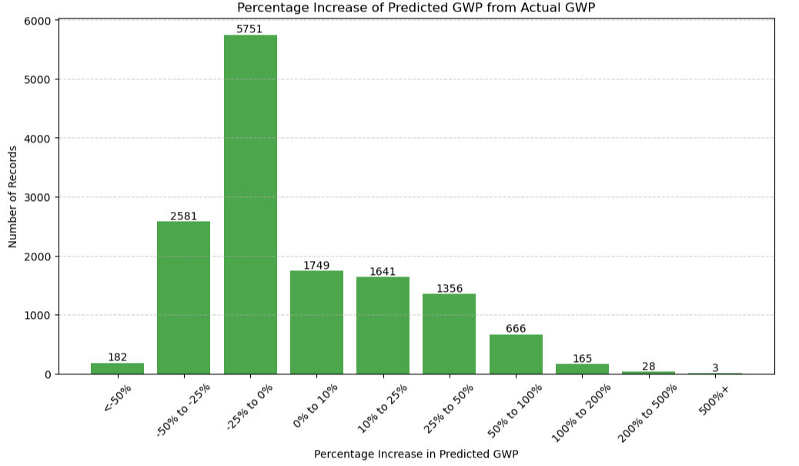

Similarly, we can analyze the low-risk predicted records. Out of 314k records, 185,380 (58.9%) have a lower predicted GWP compared to the actual GWP. The plot below shows the percentage increase or decrease in predicted GWP for these low-risk records.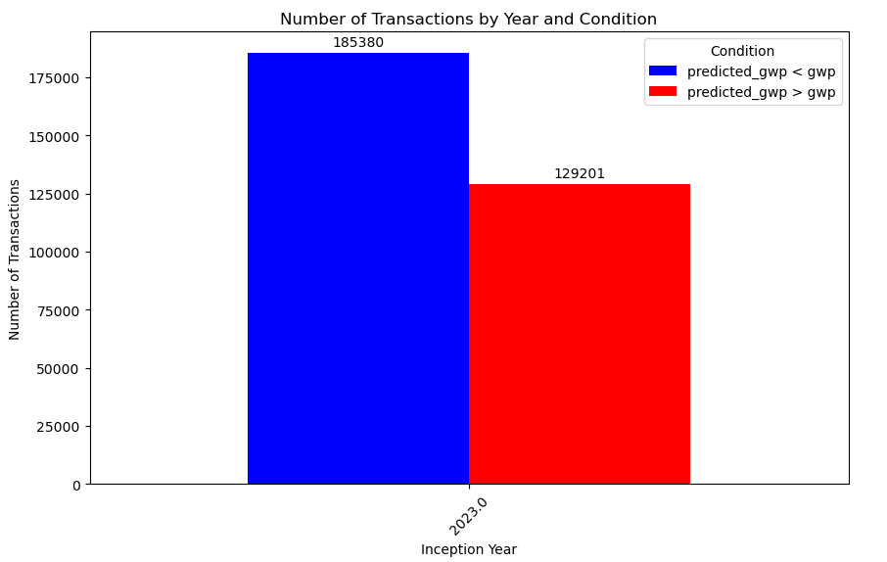
This plot below, shows how many policies have percentage increase or decrease in predicted GWP for low risk data records.
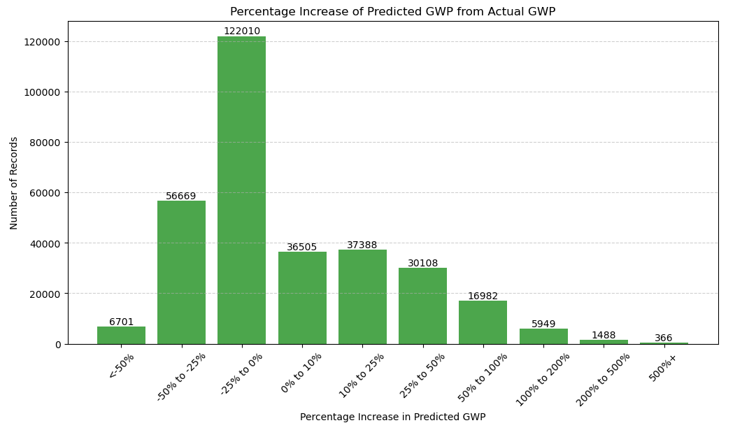

For 2023, for the bracket of 25-50% increase in predicted GWP from GWP:
- It appears that the makes with the highest average predicted GWP (Gross Written Premium) are Land Rover, Lexus, Porsche, Volvo, and JMC, with Land Rover having the highest predicted GWP. This suggests that vehicles of these makes are associated with higher predicted premiums in the dataset.
- The models with the highest average predicted GWP (Gross Written Premium) are ROVER, RX300, XC90, MACAN, and RX 300, with ROVER having the highest predicted GWP.
- The data shows that newer vehicles (ages 0-4 years) generally have higher average GWP compared to older vehicles (age 5+), indicating that newer vehicles tend to have higher insurance premiums due to factors like higher value and better condition.
- The average predicted GWP varies across branches, with "PAMB - HEAD OFFICE" showing the highest average predicted GWP at 1482.16, followed by other branches like "Broking" and "KL Agencies," while branches such as "Kota Kinabalu" have a relatively lower average predicted GWP.
- The average predicted GWP varies across sum insured brackets, with the "300k-350k" bracket showing the highest average predicted GWP at 5909.22, followed by "350k-400k" and "250k-300k" brackets, while the "150k-200k" bracket has the lowest average predicted GWP at 2124.66.
- The average predicted GWP is highest for the "pref_segment" 2.0, with a value of 2098.53, followed by segment 1.0 at 1365.06, while segments 3.0 and 0.0 have progressively lower average predicted GWPs at 832.97 and 727.84, respectively.

ON 2024 TEST DATA
We are also analyzing 3,900 records predicted as high-risk, out of which 1,904 have a predicted GWP greater than the actual GWP, which accounts for 48.74% of the data.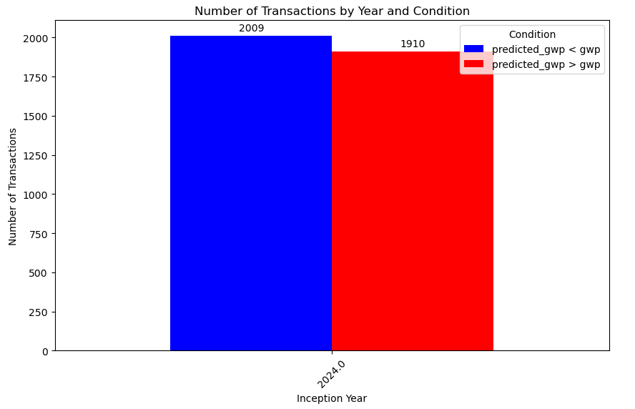
The plot below shows the breakdown of transactions based on the percentage increase or decrease in predicted GWP compared to the actual GWP.
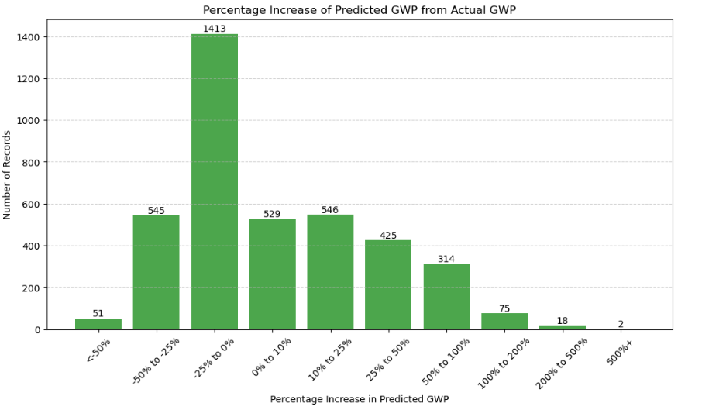

Similarly, for the low-risk predicted records in 2024, we have 111,220 out of 162,000 (68.63%) records with a predicted GWP lower than the actual GWP.
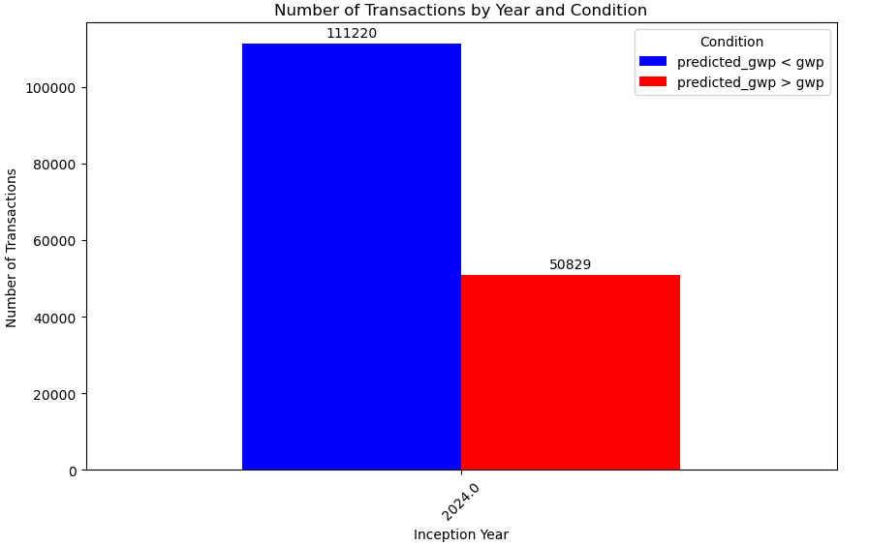

The plot below shows the total number of transactions, categorized by the percentage increase or decrease in predicted GWP compared to the actual GWP.
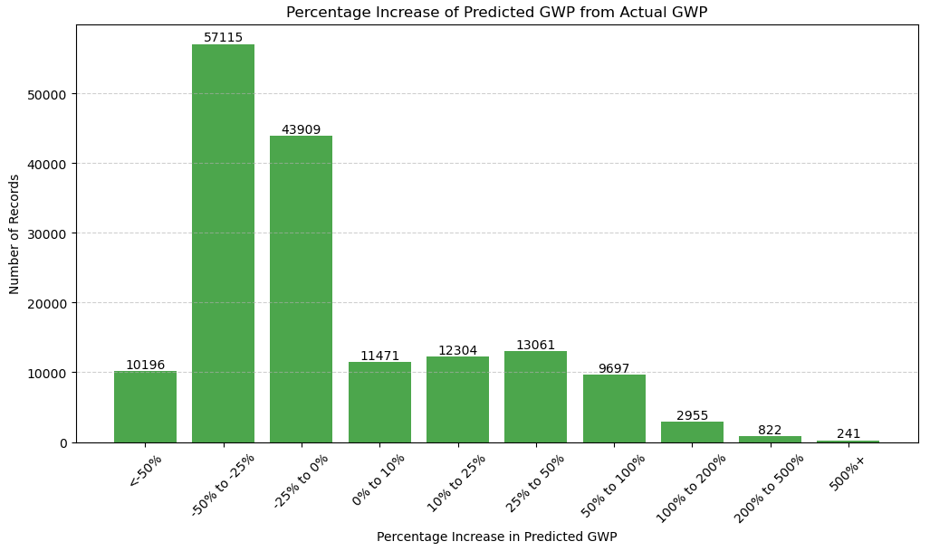

Conclusion
The model demonstrates strong performance, with R² values of 0.8492 on training data and 0.8418 (2023) and 0.8139 (2024) on test data, indicating good generalization. While the Mean Absolute Error (MAE) increased on test data (97.27 in 2023, 156.38 in 2024), the predictions remain reasonable.
High-risk records were correctly identified, with 39.7% (2023) and 48.74% (2024) of predicted high-risk policies having higher GWP than actual values. Key features like vehicle make, age, and sum insured showed significant impact on GWP, with newer vehicles and higher value makes associated with higher premiums.
Low-risk records were relatively better identified with 58.9% (2023) and 68.63% (2024) of predicted low-risk policies having lower GWP than actual values.
Although there was a slight decline in accuracy in 2024, the model remains effective for identifying and predicting risk.

Appendices

Appendix A – Glossary
basic_prem
comm_perc
cust_age
cust_gender
cust_post_code
dim_pol_sum_insured
dim_pol_veh_sum_insured
disc_perc
expiry_date
Gic
Gwp
gr_comm_amount
loss ratio
loss_ratio_class
make
model
noc_paid
nop_claimed
Noc total
Predicted_gwp
policy_no
policy_type
pref_segment
reporting_branch
sum_insured
xc_veh_lost_ren_ind
xc_veh_new_ren_ind
xc_cover_prv
xc_contract_type_prv
xc_disc_perc_prv
xc_expiry_date_prv
xc_inception_date_final_prv
xc_loading_prv
xc_model
xc_ncb_perc_prv
xc_policy_no_prv
xc_sum_insured_prv
xc_veh_ren_no
xc_veh_lost_ren_ind
xc_veh_new_ren_ind

