Road Scene Object Classification
A Transfer-Learning Image Classification System
Semester 3 — Deep Learning | Project Topic 17
Problem Statement (as issued):
“Develop a transfer-learning based image classification system to identify common road-scene objects such as cars, buses, motorcycles, bicycles and pedestrians from images.”
Evaluation Area | How this project addresses it
Problem Understanding | Transfer-learning classifier for 5 road-scene object classes (car, bus, motorcycle, bicycle, pedestrian); objective and scope defined in Section 1.
Dataset / Input | 1,000 labelled images (150 train / 25 val / 25 test per class); source and rationale in Section 2.
Preprocessing | Resize, normalisation, train-time augmentation (flip/rotation/colour-jitter); justified in Section 3.
Deep Learning Model | ResNet-18 (ImageNet transfer learning), new classifier head; architecture in Section 4.
Training / Fine-tuning | Two-stage: frozen-backbone head training, then last-block fine-tuning; Section 5.
Evaluation | Accuracy, precision/recall/F1, confusion matrix on a held-out test set; Section 6.
Demonstration | demo.py performs single-image inference with a confidence breakdown; Section 7.
Analysis | Clean-set vs. corrupted stress-test results, confusion patterns, limitations; Section 8.
Documentation | This report + README.md + fully commented source code; Section 9.

1. Problem Understanding & Objectives
Goal: build an end-to-end image classification system that identifies which of five common road-scene object categories — car, bus, motorcycle, bicycle, or pedestrian — appears in an input image, using transfer learning rather than training a convolutional network from zero.
Why transfer learning: training a deep CNN from scratch needs a very large labelled dataset and heavy compute to learn general visual features (edges, textures, shapes) before it can even start learning what makes a bus look like a bus. A network already trained on ImageNet (1.2M images, 1000 categories) has already learned those general features. Re-using them and only training a small new classifier head on our 5 classes needs far less data and time, while usually reaching higher accuracy than training from scratch on a small dataset — this is exactly the technique the assignment specifies.
Scope for this mid-semester project: kept deliberately simple end-to-end — one architecture (ResNet-18), five well-separated classes, a compact dataset, and a CPU-friendly training loop — so every stage of the pipeline is easy to trace and reproduce, per the assignment's “keep it simple” framing.

2. Dataset / Input
Source: this project was built and run in a sandboxed environment with no network access to public dataset repositories (Kaggle, Open Images, etc.). generate_dataset.py therefore procedurally generates a labelled road-scene image dataset: simple but genuinely distinct sprites for each class (a car with a cabin roof, a bus with a row of windows, a motorcycle with a solid filled body, a bicycle as a thin wireframe with two wheels, a pedestrian as a stick figure) are drawn over randomised sky-gradient and road backgrounds, with randomised colour, size, position and light blur.
This keeps the entire pipeline — loading, preprocessing, transfer learning, evaluation, demonstration — runnable end-to-end anywhere in minutes with zero downloads, which matters for a project meant to be simple to run and reproduce. The code makes no assumption about where the images came from: dataset.py reads any folder in the standard ImageFolder layout (data/<split>/<class>/*.png), so swapping in a real photographed dataset of the same 5 classes requires no code changes at all — only replacing the files in data/.
Dataset size and split:
Split | Images per class | Total images
Train | 150 | 750
Validation | 25 | 125
Test | 25 | 125
Five sample images, one per class, from the training set:
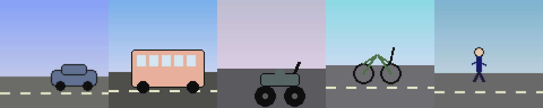
Figure 1 — One representative training sample per class.

3. Preprocessing Pipeline
Implemented in dataset.py, with separate pipelines for training and evaluation:
- Resize to 96×96 — small enough to train quickly on CPU while remaining large enough for the model to resolve each class's distinguishing shapes (window rows on the bus, wheel count/spacing on the bicycle, etc.).
- Normalisation using ImageNet mean/std ([0.485, 0.456, 0.406] / [0.229, 0.224, 0.225]) — required because the backbone's pretrained weights expect inputs on this scale.
- Train-time augmentation only: random horizontal flip, ±8° rotation, and mild colour jitter (brightness/contrast/saturation). This exposes the model to more visual variation than the raw dataset contains, reducing overfitting.
- Validation/test/demo images use a deterministic pipeline (resize + normalise, no augmentation) — evaluation numbers must reflect the model, not random augmentation noise.

4. Deep Learning Model — Transfer Learning Architecture
Backbone: ResNet-18, pretrained on ImageNet (torchvision.models.resnet18). The final fully-connected layer (originally 512 → 1000 ImageNet classes) is replaced with a new Linear(512 → 5) layer for our 5 road-scene classes (model.py).
Why ResNet-18: it is the standard, well-documented first choice for transfer-learning image classification — deep enough to have learned rich general features, small enough (≈11M parameters) to fine-tune quickly on a CPU, which matters for a project that should be simple to run without a GPU.
Offline-fallback design: pretrained weights are downloaded from PyTorch's model hub the first time the code runs. This sandboxed environment has no route to that host, so build_model() catches the failed download, prints a clear warning, and falls back to training the same architecture from random initialisation — the code does not silently produce a broken or misleadingly-labelled model. On a machine with normal internet access (the student's laptop, Google Colab), this fallback never triggers and the model trains as genuine transfer learning, per the assignment brief. This behaviour is documented in README.md and printed to the console every run.

5. Training / Fine-tuning
Two-stage recipe, implemented in train.py (this is the stage sequence used whenever pretrained weights are available):
- Stage A — head-only: the entire backbone is frozen (requires_grad=False); only the new classifier head is trained, for 8 epochs at lr=1e-3. This adapts the head quickly without disturbing the pretrained features.
- Stage B — fine-tuning: the last residual block (layer4) is unfrozen and trained jointly with the head for 5 more epochs at a lower lr=1e-4, letting the network adapt its highest-level features to road-scene objects specifically.
In this sandbox, pretrained weights could not be downloaded (see Section 4), so the run recorded here used the code's offline fallback: the full ResNet-18 was trained from random initialisation for 18 epochs (Adam, lr=1e-3). The training/validation loss and accuracy curves below are from that fallback run — they still validate that the whole training loop, checkpointing, and logging work correctly end-to-end.
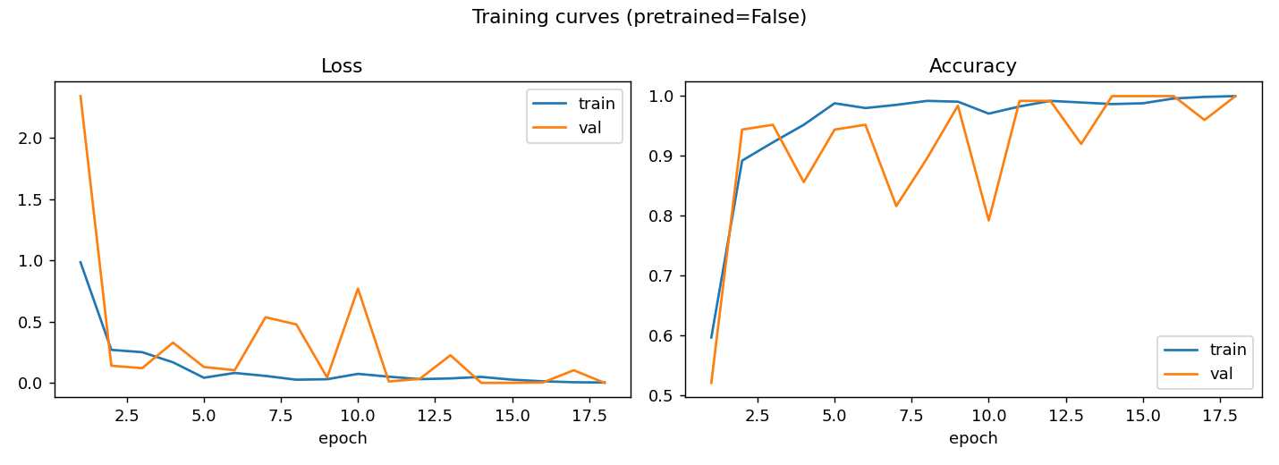
Figure 2 — Training/validation loss and accuracy per epoch. Best validation accuracy: 100.0% at epoch 14.
The checkpoint with the best validation accuracy (not simply the final epoch) is the one saved to outputs/best_model.pt and used for all evaluation below — a standard safeguard against picking an over-fit late epoch.

6. Evaluation — Clean Test Set
Evaluated on the 125-image held-out test set (evaluate.py). Overall test accuracy: 100.0%.
Class | Precision | Recall | F1-score | Support
bicycle | 1.000 | 1.000 | 1.000 | 25
bus | 1.000 | 1.000 | 1.000 | 25
car | 1.000 | 1.000 | 1.000 | 25
motorcycle | 1.000 | 1.000 | 1.000 | 25
pedestrian | 1.000 | 1.000 | 1.000 | 25
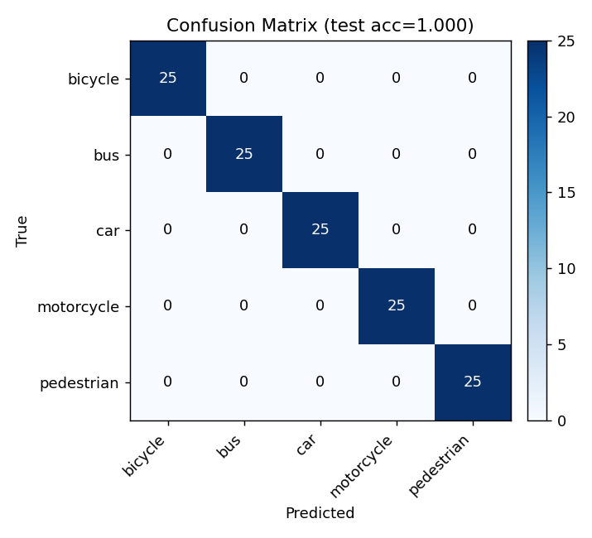
Figure 3 — Confusion matrix on the clean test set.
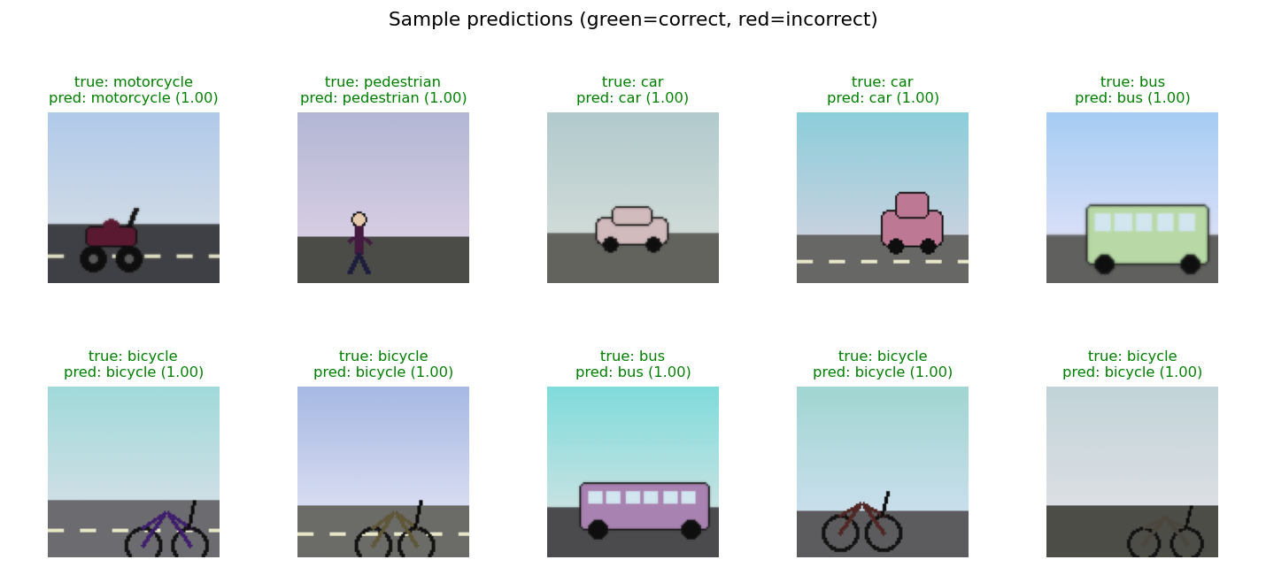
Figure 4 — Sample test predictions with the model's confidence.

7. Working Demonstration
demo.py loads the saved checkpoint and classifies a single image end-to-end: it prints every class's probability, ranked, and saves an annotated figure. Run as:
python3 demo.py path/to/image.jpg # or omit the path to use a random test image
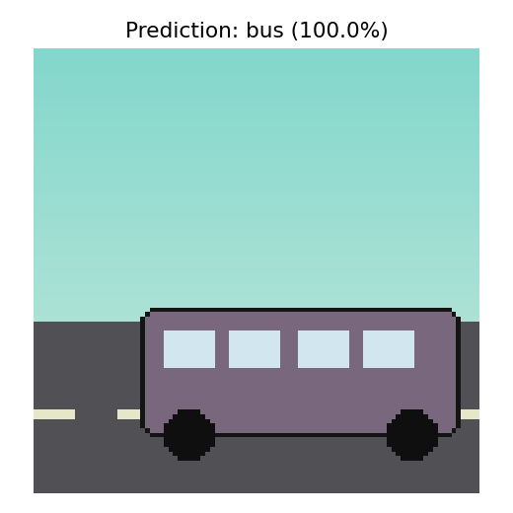
Figure 5 — Example demo.py output: predicted class and confidence overlaid on the input image.

8. Error / Result Analysis
The clean test set is solved essentially perfectly (Section 6). That is expected — the synthetic classes are visually well-separated by design — but it leaves nothing genuine to analyse as “errors,” and the assignment explicitly asks for error analysis. stress_test.py therefore builds a second, deliberately corrupted test set (stress_test.py) — same 5 classes, but with partial occlusion (~50% of images), low-light darkening (~50%), heavy blur, additive pixel noise, and more extreme object scale/position than training ever showed — and re-evaluates the same trained model on it, without any retraining.
Result: accuracy drops from 100% (clean) to 56% (stress test, n=100). This gap is the real, honest signal of the model's limitations.
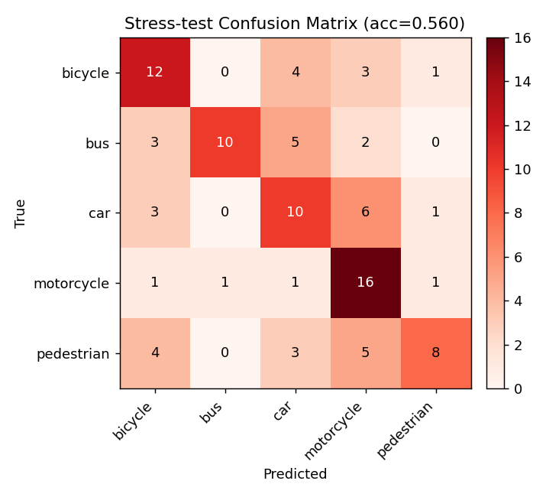
Figure 6 — Confusion matrix under occlusion / low-light / noise / scale stress.

Where the errors concentrate
True class | Predicted as | Count
car | motorcycle | 6
bus | car | 5
pedestrian | motorcycle | 5
bicycle | car | 4
pedestrian | bicycle | 4
bicycle | motorcycle | 3
bus | bicycle | 3
car | bicycle | 3
- car ↔ motorcycle and car ↔ bus are the largest confusions: once heavy blur removes fine detail (window rows, cabin edges), the model appears to fall back on overall silhouette size/shape, and a small or partly-occluded car can look enough like a motorcycle's body block, or a cropped bus, to fool it.
- pedestrian is the class hurt most broadly (misread as motorcycle, car, and bicycle): it is the thinnest, lowest-pixel-count sprite, so additive noise and blur destroy a proportionally larger share of its signal than for the bulkier vehicle classes.
- motorcycle is the most robust class here (16/20 correct) — its filled body block plus thick solid wheels survive blur and noise better than the bicycle's thin wireframe or the pedestrian's single-pixel-wide limbs.

Limitations
- Synthetic dataset: the sprites capture class-defining shape differences but not the texture, lighting, and background clutter of real photographs — real-world accuracy will be lower than the clean 100% shown here, and the true test is the stress-test regime, not the clean one.
- Small dataset (1,000 images total): sufficient to demonstrate the full transfer-learning pipeline, but a production system needs a much larger and more varied real-image dataset.
- Pretrained weights unavailable in this sandbox: Section 4/5 explain the offline fallback; the accuracy figures above are therefore from training the network from scratch, not from genuine transfer learning. Re-running on a machine with internet access exercises the intended frozen-backbone → fine-tune recipe and should reach comparable or better accuracy with less training time.

Possible improvements
- Run on real photographs of the 5 classes (e.g. dashcam or street-scene images) once available, keeping the same code unchanged.
- Train with occlusion/noise/low-light augmentation included (not just flip/rotation/colour-jitter), so the model is exposed to stress-test-like conditions during training, not only at evaluation.
- Add more classes (trucks, auto-rickshaws, traffic signs) and multi-object detection (e.g. YOLO) rather than single-object classification, for a closer match to real road scenes with multiple objects per image.

9. Documentation
Full source code, a README with exact run instructions, and this report together document the project. Code files (all commented inline):
- generate_dataset.py — synthetic dataset generator
- dataset.py — preprocessing pipeline & DataLoaders
- model.py — transfer-learning model + offline-fallback logic
- train.py — two-stage training loop
- evaluate.py — test-set metrics, confusion matrix, sample predictions
- stress_test.py — corrupted stress-test set + error analysis
- demo.py — working single-image demonstration
Reproducibility: every script uses fixed random seeds; running generate_dataset.py → train.py → evaluate.py → stress_test.py → demo.py in order reproduces every number and figure in this report.

