**MINI PROJECT REPORT**

**NAME: ANANYA GUPTA**

**TITLE: IMAGE SECURITY USING REVERSIBLE WATERMARKING**

**What is reversible watermarking**

**A digital watermark is a kind of marker covertly embedded in a noise-tolerant signal such as audio, video or image data. It is typically used to identify ownership of the copyright of such signal. "Watermarking" is the process of hiding digital information in a carrier signal; the hidden information should, but does not need to, contain a relation to the carrier signal. Digital watermarks may be used to verify the authenticity or integrity of the carrier signal or to show the identity of its owners. It is prominently used for tracing copyright infringements and for banknote authentication. A digital watermark does not change the size of the carrier signal. For marking media files with copyright information, a digital watermark has to be rather robust against modifications that can be applied to the carrier signal.** **Since a digital copy of data is the same as the original, digital watermarking is a passive protection tool. It just marks data, but does not degrade it or control access to the data.**

**Example**

[](https://en.wikipedia.org/wiki/File:An_example_of_a_(digital)_watermark_on_an_image.png)

**Example of a watermark overlay on an image; the logo of Wikipedia can be seen on the center to represent the owner of it.**

**Applications**

**One application of digital watermarking is *source tracking*. A watermark is** embedded **into a digital signal at each point of distribution. If a copy of the work is found later, then the watermark may be retrieved from the copy and the source of the distribution is known. This technique reportedly has been used to detect the source of illegally copied movies.**

* **Copyright protection**
* **Source tracking (different recipients get differently watermarked content)**
* **Broadcast monitoring (television news often contains watermarked video from international agencies)**
* **Video authentication**
* **ID card security**
* **Fraud and Tamper detection.**
* **Content management on social networks.**

**BLOCK DIAGRAM**

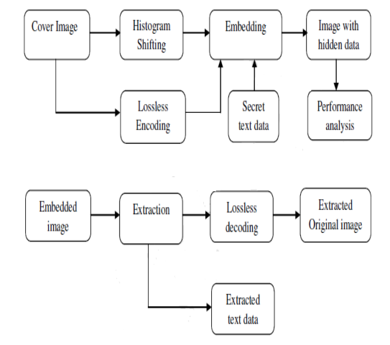

**Algorithm:**

**1. Loading Input Image**

**2. Finding Histogram**

**3. Bin Identification**

**4. Histogram Shifting**

**5. Loading Watermark**

**6. Watermark Embedding in Image**

**7. Parameter Calculation**

**8. Watermark Extraction**

**9. Parameter Calculation**

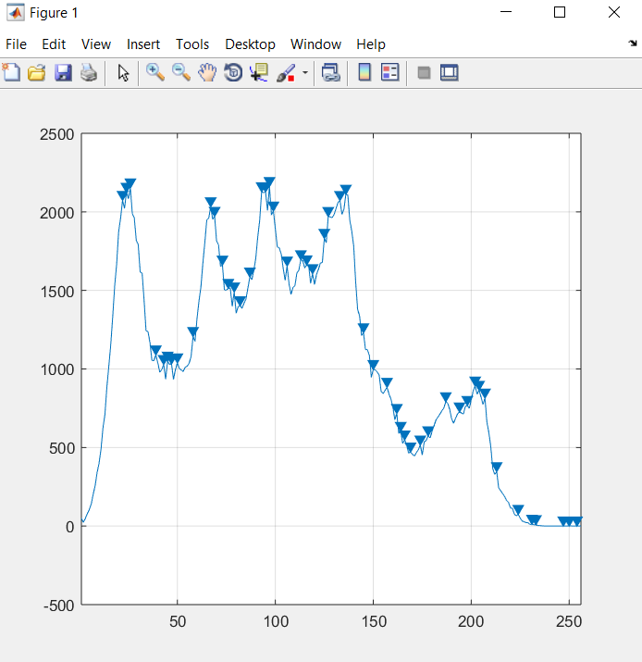

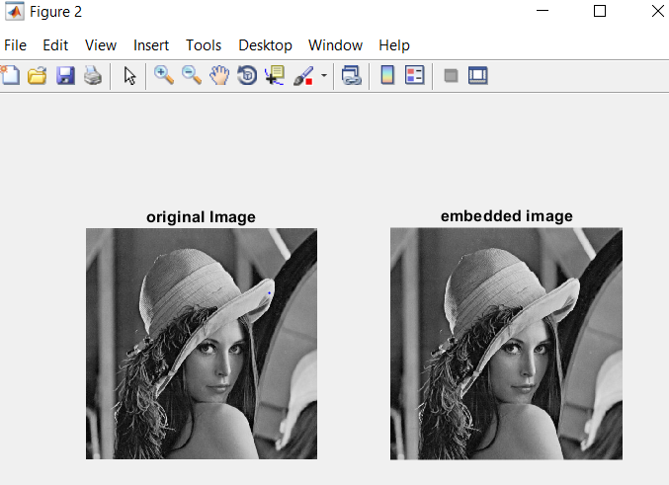

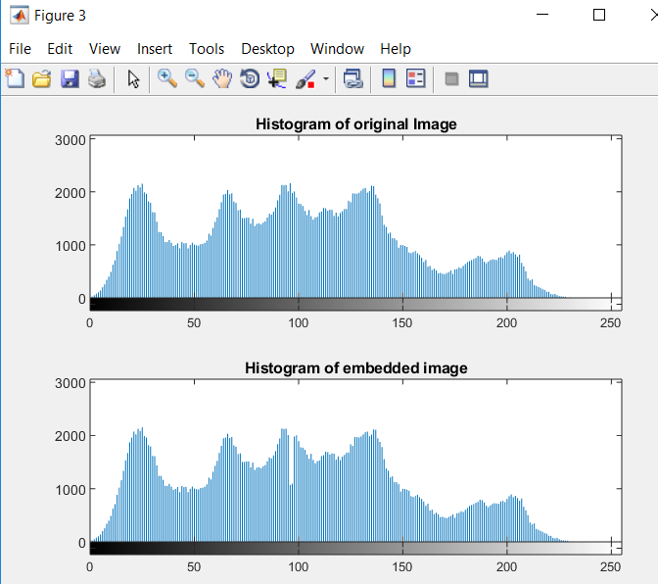

**DIFFERENCE IMAGE**

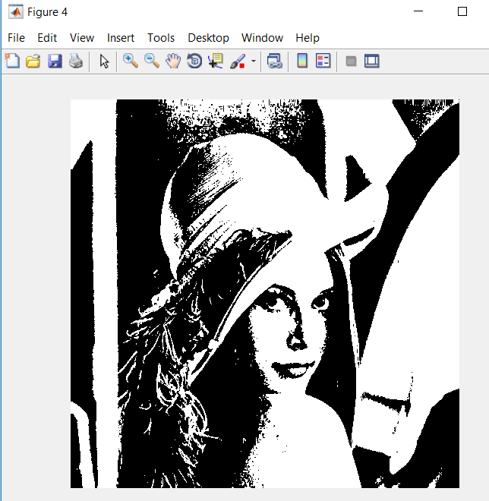

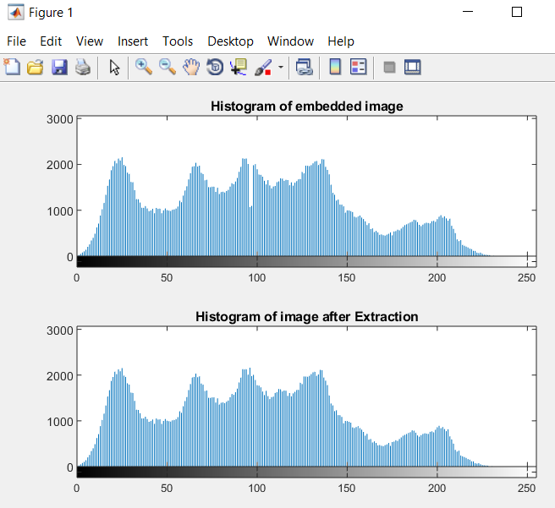

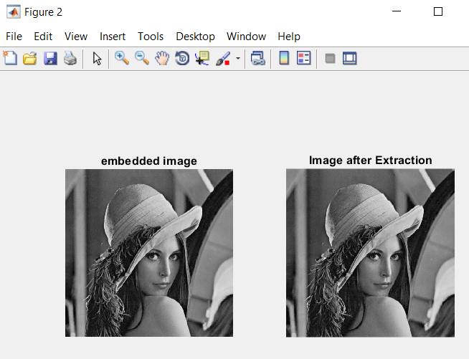

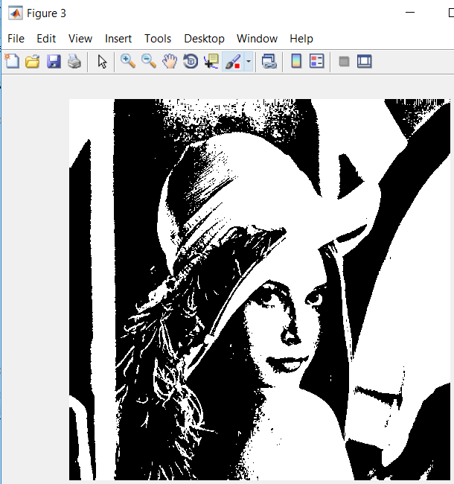

**BOTH THE DIFFERENCE IMAGE ARE EQUAL**

