***H.O.P.E***

***Harnessing Opportunities for Pursuing Education***

About RTE:

The Right to Education (RTE) Act passed in 2009 brought India in line with over 100 countries around the world that provide free and compulsory education to children. The idea of RTE is noble, that every child between the ages of 6-14 should receive free and compulsory education; however the provisions in the Act contain enough loopholes for exploitation.

Problem Statement:

Currently all the existing sites gives us the information regarding the history of RTE seats filled in the past. The problem here is, user will not be able to know the status of vacant seats for the current academic year in nearby schools. We are trying to address this problem in our project. Also, individuals do not know the procedure and provisions to admit kids to school under this act. Our site will give information on the number of seats in a school (for the current year) in which a child can be admitted through RTE. According to the RTE Act, even govt. affiliated private schools can have upto 25% of the seats for admission through RTE. Our site will also provide information and some useful links which will help the user to educate about RTE.

Wealthy parents are grabbing seats under RTE quota. Individuals do not know the procedure and provisions to admit kids to schools under this act. If they find the process and approach the school, management says that seats are completed and to try next year or in another school? So, instead if we have the data available online, then individual can pick up a particular school and approach for the admission.

Proposed Solution:

Through our website, we want bring the RTE, right to the doorsteps by one click solution for getting all the vacant seats in nearby registered schools. Our website helps in showing the RTE vacant seats information from class 1 to class 8 of a particular school, lists the registered schools. It is designed simple and user-friendly. There is a search option provided and any individual can search with Locality or school name. Once an area is searched, the site lists all the schools available in that area. User can choose a particular school, to get its details and RTE vacant seats. Design steps are given below.

**Design Architecture:**

Our Website consists of below pages:

Home Page: Home page gives the information about RTE Act, 2009.

Sign Up: Every school have to register in this site, to update its RTE information. When the school registers, school admin have to enter School details like Registration ID (given under Delhi School Act, 1973), school name, address, Email-ID, phone number. Once the school admin enters all details, a confirmation mail is sent to the mail ID. Admin needs to click on the link, in that mail and registration is successful.

If any of the mandatory fields are not filled, or incorrect phone number or mail ID is given, validation happens and throw error on the UI for the incorrect fields.

Sign-In: If a school is already registered, the person who registered would be the admin and would have the school registration ID as username and password (as set by admin). Once logged in, admin would be able to create new school, new classes table in the school. Admin can enter vacant RTE seats from class 1 to class 8, in general, OBC, SC, ST and others seats category. Admin will have edit, destroy and add options to various jobs on Class Info.

Admin have options for account settings, to change the password, sign out option to log out of the site.

All Schools: This page shows the list of all the schools with name and address. Users interested in particular school can click on the “show” option to check the school details and vacant RTE seats of all the classes.

Search Field: Facilitates user to search schools by Name, area name, Locality, PIN code, District and state.

About Us: About us page describes the Purpose of this site and success stories.

Contact Us: This page gives information regarding how to reach us.

**Design Flow Diagram:**

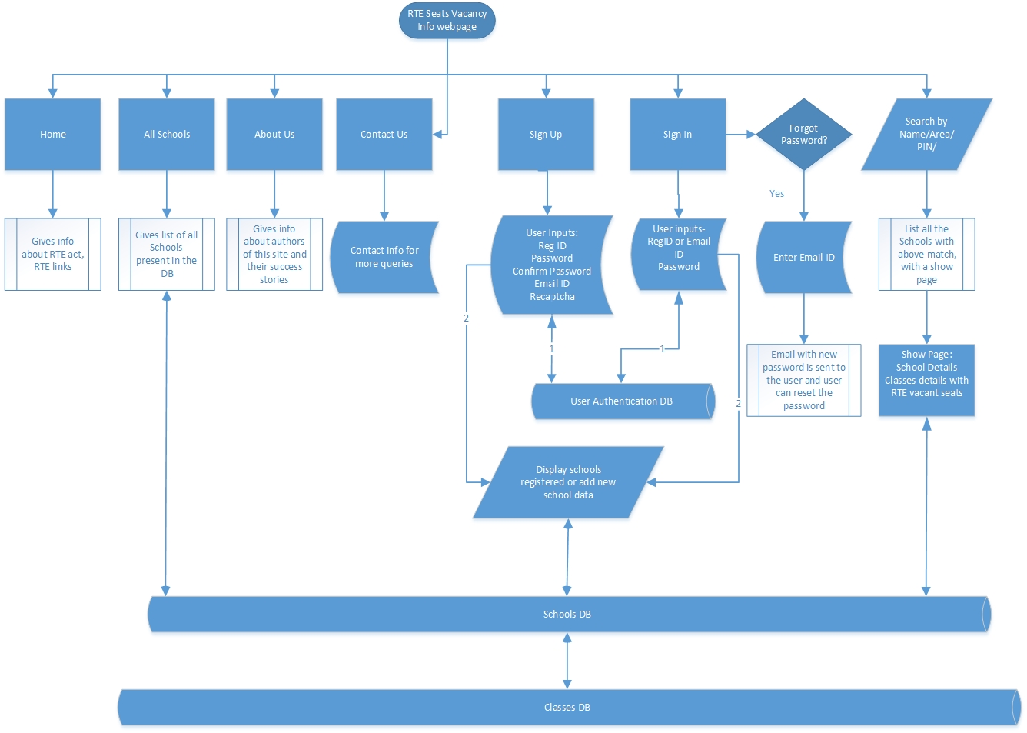

**Figure: Flow chart for our website.**

**Languages/Technologies Used:**

1. **Ruby on Rails:** Framework and language
2. **Html5:** for GUI
3. **MySQL:** Database built using mysql
4. **CSS:** Style sheet
5. **Json:** for facilitating interaction between database server and web client
6. **WEBrick:** Web server

**Future Scope:**

* Can be expanded to Mobile App.
* Location based school search using GPS.