TECHNICAL REPORT
Positive-Unlabeled and Mean Teacher Learning for Cross-Domain Deception Detection
A leakage-resistant quick-mode study on the seven-domain DiFrauD benchmark
Report field | Value
Primary evidence | Successfully executed notebook; 14/14 code cells, zero execution errors
Dataset revision | aaaf94b336c563a14806bb4f3f58727bed9ed8d4
Execution scope | CPU quick mode; 10,500 stratified records; one seed (42)
Evaluation | Official splits plus reduced LODO: job scams, product reviews, phishing
Date | August 2, 2026

Evidence boundary All numerical claims in this report come from the stored outputs of the successfully executed quick-mode notebook. Full three-seed, all-domain LODO, and transformer fine-tuning configurations were not executed and are not presented as results.

Executive summary
This study evaluated whether deception signals transfer across seven heterogeneous text domains when only a small share of deceptive training examples is labeled. It compared a valid non-negative positive-unlabeled estimator (nnPU), an invalid unlabeled-as-negative shortcut, a Mean Teacher consistency extension, supervised baselines, and cross-domain holdouts. The central empirical result is cautionary: in-domain text models learned useful signal, but domain provenance was highly predictable and cross-domain performance was weak or unstable.
The fully supervised TF-IDF logistic-regression upper bound achieved F1 0.712 and PR-AUC 0.775 on the official test splits. At 10% revealed positives, nnPU achieved F1 0.628 and PR-AUC 0.603, narrowly exceeding the naive comparator on those metrics. The combined PU-Mean Teacher model reached F1 0.617 and PR-AUC 0.577, so consistency learning did not improve nnPU at that operating point in this one-seed run. At 20%, nnPU reached F1 0.653 and the combined model reached F1 0.650.
A text-only domain classifier achieved 93.1% accuracy. Metadata-only and domain-prior baselines were also predictive, demonstrating that the benchmark contains strong source and composition cues. The near-duplicate audit found 296 pairs above cosine similarity 0.92 in the quick sample, including 212 cross-split pairs. These observations materially limit claims that the models detect deception itself rather than source-specific artifacts.

1. Research objective and questions
The project develops and evaluates a domain-independent textual deception detector under positive-label scarcity. The target setting assumes that a small subset of deceptive examples is labeled while the remaining training pool mixes hidden positives and genuine negatives. The study asks:
- How much performance remains when 1%, 5%, 10%, or 20% of deceptive training examples are revealed?
- Does correct nnPU learning outperform the common but invalid practice of treating all unlabeled examples as negative?
- Does confidence-filtered teacher-student consistency improve a PU detector?
- Do text models learn deception, or domain identity and constituent-dataset artifacts?
- How well does the detector generalize to a completely held-out domain?

2. Dataset and execution scope
DiFrauD contains English binary text-classification data from phishing, fake news, political statements, product reviews, job scams, SMS, and Twitter rumours. The official repository exposes 21 JSONL files: train, validation, and test for each domain. Direct JSONL loading avoided execution of the repository's remote loading script. The full snapshot contained 95,854 records with no missing text, empty text, missing labels, or invalid binary labels.
Domain | Train | Validation | Test | Train prevalence
Fake news | 16,364 | 2,046 | 2,046 | 43.2%
Job scams | 11,436 | 1,429 | 1,430 | 4.2%
Phishing | 12,217 | 1,527 | 1,528 | 39.8%
Political statements | 9,997 | 1,250 | 1,250 | 64.3%
Product reviews | 16,776 | 2,097 | 2,098 | 50.0%
SMS | 5,259 | 657 | 658 | 19.4%
Twitter rumours | 4,631 | 579 | 579 | 34.0%

Quick mode retained 500 stratified examples per domain and official split, producing 10,500 analyzed records. This preserves official split membership but is a representative computational reduction, not a full-dataset experiment. Frozen all-MiniLM-L6-v2 sentence embeddings and small PyTorch multilayer perceptrons enabled CPU execution.
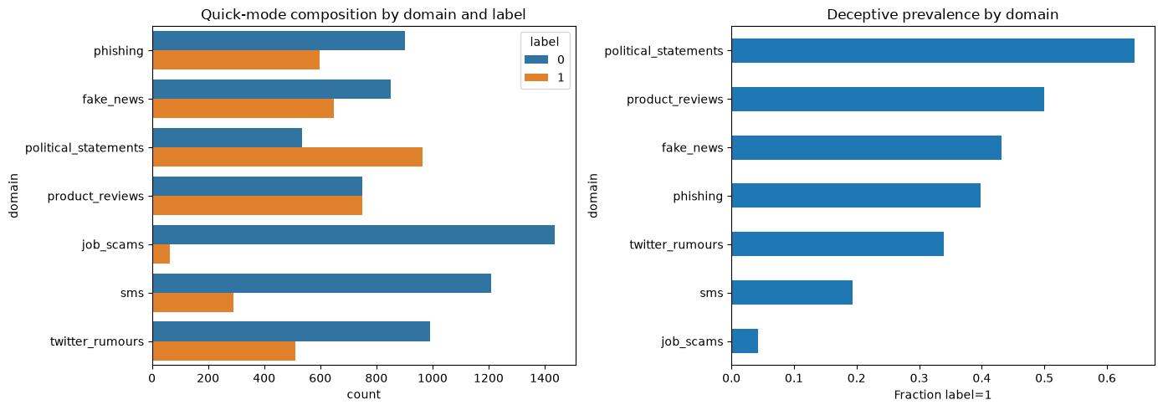
Figure 1. Quick-mode composition and deceptive prevalence by domain. Stored notebook output.

3. Dataset-quality audit

3.1 Composition, integrity, and imbalance
Class prevalence varied from approximately 4.2% for job scams to 64.3% for political statements. A model can therefore gain substantial apparent performance by learning domain identity. The audit measured character, word, sentence, URL, digit, punctuation, capitalization, non-ASCII, repeated-punctuation, HTML-residue, and replacement-character features. The full acquisition check found zero missing or empty texts, but integrity and provenance signals remained domain-dependent.

3.2 Duplicate and leakage risk
No exact normalized duplicate groups appeared in the 10,500-row quick sample. Character 3-5 gram TF-IDF nearest-neighbor screening identified 296 near-duplicate pairs at cosine similarity at least 0.92; 212 crossed official split boundaries. Representative pairs included structurally similar account-verification emails and related news or conversational text. Because near-duplicate auditing was performed on the quick sample, these counts are lower bounds for the full repository.
Leakage implication Cross-split near duplicates can inflate in-domain performance even when the official split labels are preserved. A publication-grade full run should de-duplicate or cluster before splitting and report sensitivity to cluster-level exclusion.

3.3 Shortcut learning and domain separability
Diagnostic model | Metric | Result
Metadata-only logistic regression | F1 | 0.576
Metadata-only logistic regression | ROC-AUC | 0.655
Domain-prior baseline | F1 | 0.613
Domain-prior baseline | ROC-AUC | 0.721
Text domain classifier | Accuracy | 0.931

The 93.1% domain-classifier accuracy is the clearest shortcut warning: domain provenance is much easier to recover than a domain-independent deception concept. Domain-prior and metadata-only baselines further show that composition and shallow formatting carry label information. Out-of-fold label-disagreement analysis surfaced ambiguous job-scam positives and Twitter-rumour or SMS negatives, but these are suspected label issues rather than confirmed annotation errors.
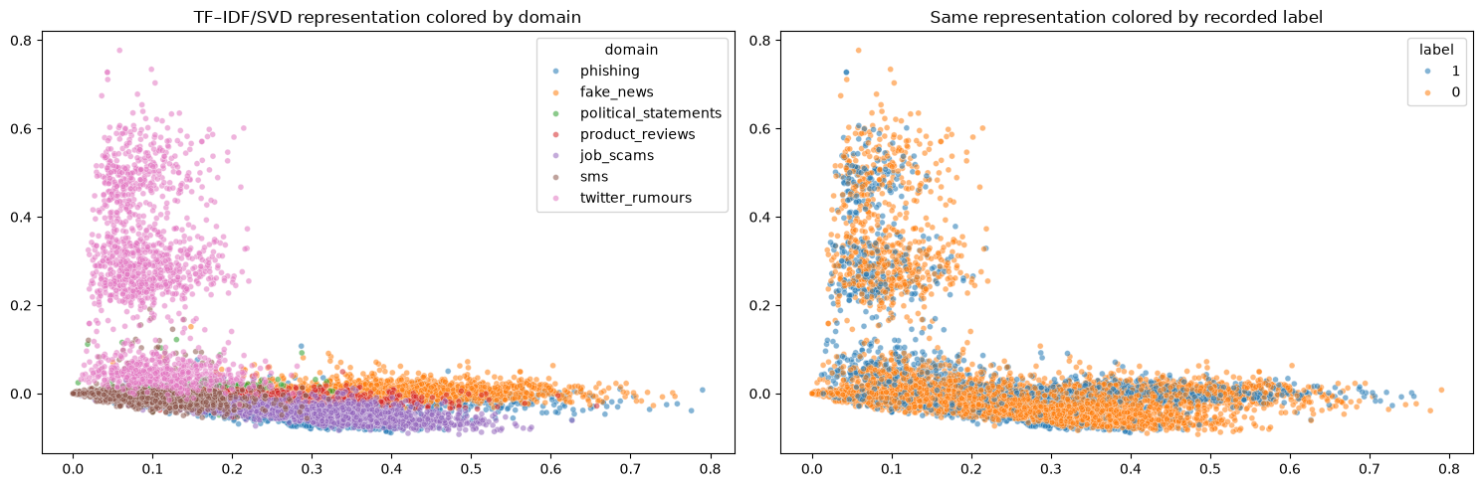
Figure 2. TF-IDF/SVD representation colored by domain and recorded label. Stored notebook output.

4. Experimental design

4.1 Leakage-resistant evaluation
In-domain experiments trained only on official training rows, selected thresholds and early-stopping states on validation rows, and used test labels only for final scoring. LODO experiments removed the held-out domain from training, prior estimation, early stopping, calibration, and threshold selection. Held-out labels entered only the final metric calculation.

4.2 Positive-unlabeled simulation
For each positive-label fraction, a seeded subset of deceptive training examples was revealed as P. All remaining positives and every negative became U. Ground-truth labels were removed from the training view; hidden labels were retained only by the experiment harness for evaluation. Consequently, the unlabeled pool remained a mixture rather than a pseudo-negative class.

4.3 nnPU objective
For score function f, logistic loss l, and positive class prior pi, the unbiased PU risk is pi E_P[l(f,+1)] + E_U[l(f,-1)] - pi E_P[l(f,-1)]. When the estimated negative-risk component becomes negative, the Kiryo non-negative correction reverses that component's gradient. The implementation returns positive, negative, corrected, and total risks and rejects invalid priors, shapes, empty batches, and non-finite logits.

4.4 PU-Mean Teacher detector
The combined model adds a sigmoid-ramped consistency loss to nnPU risk. A student receives stronger feature masking while an exponential-moving-average teacher receives a weaker view. Teacher probabilities contribute only when confidence exceeds 0.80. This differs from ordinary self-training: pseudo-label consistency supplements a valid PU objective and the unlabeled pool is never assigned a negative classification target.

4.5 Class-prior estimation
The notebook reported the true training prevalence only as a non-deployable oracle reference. A training-only Elkan-Noto-style estimate used out-of-fold probabilities for observed positive selection. Estimated priors increased from 0.063 at 1% revealed positives to 0.200 at 20%, while the oracle prevalence was 0.364. The gap demonstrates substantial prior-estimation bias in this quick-mode setup.

5. In-domain results
Method | P revealed | F1 | Macro F1 | PR-AUC | ROC-AUC | MCC
Majority | 100% | 0.000 | 0.389 | 0.364 | 0.500 | 0.000
Naive U-as-negative | 1% | 0.546 | 0.390 | 0.442 | 0.588 | 0.123
nnPU | 1% | 0.544 | 0.463 | 0.457 | 0.616 | 0.134
PU-Mean Teacher | 1% | 0.545 | 0.412 | 0.442 | 0.607 | 0.123
Naive U-as-negative | 5% | 0.580 | 0.552 | 0.565 | 0.690 | 0.243
nnPU | 5% | 0.602 | 0.636 | 0.550 | 0.715 | 0.314
PU-Mean Teacher | 5% | 0.588 | 0.580 | 0.518 | 0.682 | 0.267
Naive U-as-negative | 10% | 0.625 | 0.629 | 0.597 | 0.741 | 0.350
nnPU | 10% | 0.628 | 0.649 | 0.603 | 0.756 | 0.360
PU-Mean Teacher | 10% | 0.617 | 0.643 | 0.577 | 0.733 | 0.340
Naive U-as-negative | 20% | 0.627 | 0.668 | 0.647 | 0.769 | 0.367
nnPU | 20% | 0.653 | 0.658 | 0.632 | 0.774 | 0.408
PU-Mean Teacher | 20% | 0.650 | 0.658 | 0.617 | 0.768 | 0.401
Supervised TF-IDF upper bound | 100% | 0.712 | 0.759 | 0.775 | 0.861 | 0.528

At matched label fractions, nnPU improved over the naive comparator most clearly at 5%, 10%, and 20% in F1, balanced ranking, or MCC, but not on every metric. At 10%, nnPU improved F1 by 0.003 and PR-AUC by 0.006. At 20%, it improved F1 by 0.026 and MCC by 0.041, while naive training retained a slightly higher PR-AUC. The combined consistency model did not surpass nnPU at any tested fraction on F1 or PR-AUC in this run.
The 10% oracle-prior nnPU reference achieved F1 0.646 and PR-AUC 0.637, compared with F1 0.628 and PR-AUC 0.603 using the training-only estimate. Prior multipliers of 0.75 and 1.25 changed results materially. Positive-prior estimation is therefore not a peripheral detail; it is a central source of deployable-model uncertainty.
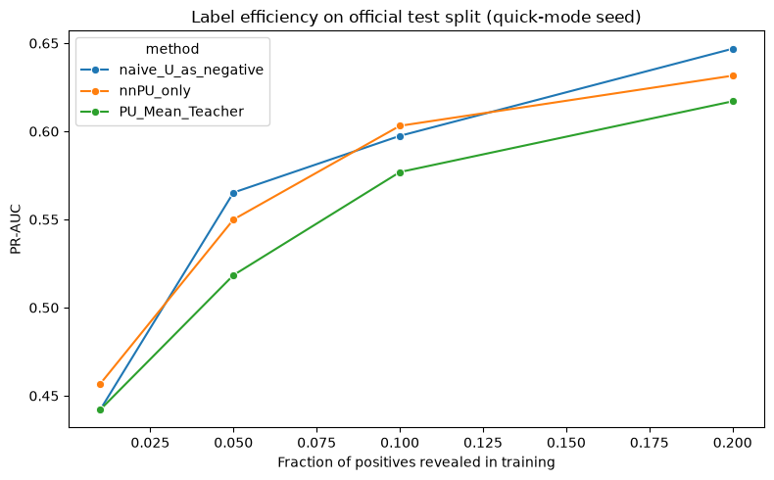
Figure 3. Label-efficiency curves for the naive, nnPU, and PU-Mean Teacher models. Stored notebook output.

6. Cross-domain evaluation
Held-out domain | Method | F1 | Macro F1 | PR-AUC | ROC-AUC | MCC
Job scams | Supervised TF-IDF | 0.089 | 0.173 | 0.061 | 0.620 | 0.057
Job scams | PU-Mean Teacher 10% | 0.085 | 0.173 | 0.096 | 0.639 | 0.031
Product reviews | Supervised TF-IDF | 0.210 | 0.416 | 0.490 | 0.478 | -0.034
Product reviews | PU-Mean Teacher 10% | 0.536 | 0.495 | 0.482 | 0.474 | -0.004
Phishing | Supervised TF-IDF | 0.453 | 0.495 | 0.382 | 0.505 | 0.004
Phishing | PU-Mean Teacher 10% | 0.586 | 0.458 | 0.532 | 0.646 | 0.158

LODO results were substantially weaker than in-domain results. Job-scam F1 remained near 0.09, reflecting severe imbalance and distribution shift. Product-review ranking was near chance for both models despite the combined model's thresholded F1 of 0.536; its MCC remained approximately zero. Phishing was the strongest combined-model holdout, with ROC-AUC 0.646 and MCC 0.158, but false-positive rates remained operationally high. These results do not establish domain independence.
Interpretation Thresholded F1 can look favorable even when ranking and correlation metrics remain weak. Cross-domain conclusions must consider PR-AUC, ROC-AUC, MCC, prevalence, and false-positive burden together.

7. Error analysis and interpretability
The executed notebook stratified false positives and false negatives by domain, text length, and URL presence, and displayed a small set of truncated high-confidence errors. Classical TF-IDF coefficients highlighted URL artifacts, political names, product-review and job-posting templates, source-specific vocabulary, and formatting cues. These coefficients are associations rather than causal explanations. Attention weights were not used as definitive explanations.
A bootstrap over test examples gave a 95% percentile interval of approximately 0.595 to 0.636 for the selected 10% PU-Mean Teacher F1. This interval reflects test-sample variation only; it does not capture seed, representation, hyperparameter, or domain uncertainty.
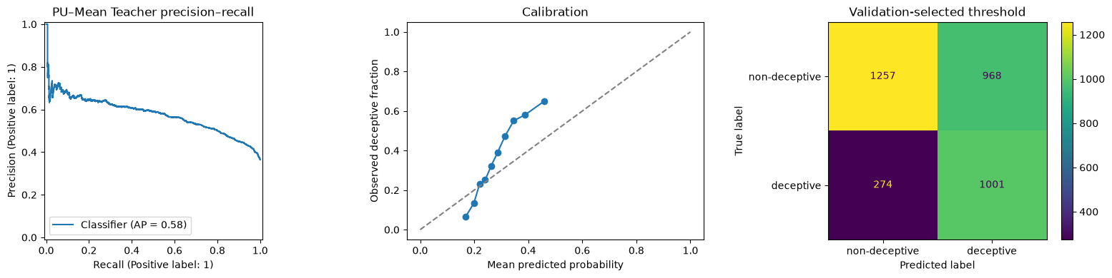
Figure 4. Precision-recall, calibration, and confusion-matrix diagnostics for the selected combined model. Stored notebook output.

8. Threats to validity and limitations
- Only one random seed was executed, so no training-variance estimate or valid paired significance test is available.
- Quick mode capped every domain/split at 500 stratified examples; its results must not be presented as full-dataset performance.
- PU labels were simulated by hiding known positives. Real labeling mechanisms may violate selected-completely-at-random assumptions.
- The Elkan-Noto-style prior estimate substantially underestimated the oracle prior, and the optimal prior may vary by domain.
- Near-duplicate and provenance artifacts can inflate in-domain performance and complicate attribution to deception semantics.
- Reduced LODO covered only job scams, product reviews, and phishing; all seven rotations remain necessary.
- Frozen sentence embeddings and small MLPs are computationally appropriate for quick mode but are not a substitute for a controlled GPU fine-tuning study.
- Deception detection is not factual verification and cannot establish speaker intent.

9. Ethical and operational considerations
False positives may harm job applicants, political speakers, reviewers, or ordinary message senders. The observed cross-domain false-positive burdens make autonomous enforcement especially inappropriate. Any downstream system should operate as a human-reviewed alerting aid with calibrated domain-specific thresholds, audit logs, appeal mechanisms, privacy safeguards, subgroup evaluation, and drift monitoring.
Dataset labels inherit the assumptions and provenance of constituent sources. A production claim requires source-by-source licensing and documentation review, external validation on post-collection data, and explicit analysis of whether protected or socially sensitive attributes are indirectly encoded by domain or source vocabulary.

10. Reproducibility and verification
Control | Evidence
Notebook execution | 14/14 code cells executed; zero stored error outputs
Unit tests | 8 passed: finite loss, gradients, shapes, correction, invalid inputs, NaN safeguards
Dataset pin | aaaf94b336c563a14806bb4f3f58727bed9ed8d4
Randomness | Seed 42; deterministic PyTorch settings where practical
Test-label isolation | No fitting, prior estimation, early stopping, calibration, or threshold selection used test labels
Artifact hygiene | Data, caches, checkpoints, embeddings, outputs, and virtual environments are Git-ignored

11. Conclusions and recommended next experiments
Valid nnPU learning was competitive with and sometimes better than treating the unlabeled pool as negative, especially as more positives were revealed. However, the gains were modest and metric-dependent. Mean Teacher consistency did not add value consistently in the executed configuration. Strong domain separability, near-duplicate leakage risk, prior-estimation bias, and weak LODO results indicate that benchmark provenance remains a larger obstacle than in-domain classifier capacity.
The next experiment should run three or more paired seeds across all four label fractions and all seven LODO rotations after cluster-level near-duplicate control. It should estimate domain-conditional priors, tune confidence and consistency schedules strictly within validation data, and compare frozen representations with compact-transformer fine-tuning on GPU. Paired permutation or Wilcoxon comparisons should be reported only after sufficient matched runs exist.
Bottom line The executed evidence supports PU learning as a principled alternative to pseudo-negative training, but it does not support a claim of domain-independent deception detection or a consistent benefit from Mean Teacher consistency.

References
DiFrauD dataset repository. Hugging Face: https://huggingface.co/datasets/difraud/difraud. Revision aaaf94b336c563a14806bb4f3f58727bed9ed8d4.
Kiryo, R., Niu, G., du Plessis, M. C., and Sugiyama, M. (2017). Positive-Unlabeled Learning with Non-Negative Risk Estimator. Advances in Neural Information Processing Systems.
Tarvainen, A., and Valpola, H. (2017). Mean Teachers Are Better Role Models: Weight-Averaged Consistency Targets Improve Semi-Supervised Deep Learning Results. Advances in Neural Information Processing Systems.
Elkan, C., and Noto, K. (2008). Learning Classifiers from Only Positive and Unlabeled Data. Proceedings of KDD.

