This the user’s view for the project. Where he can login ,register, fetch data and see his vaccines records from database, see his profile, and logout.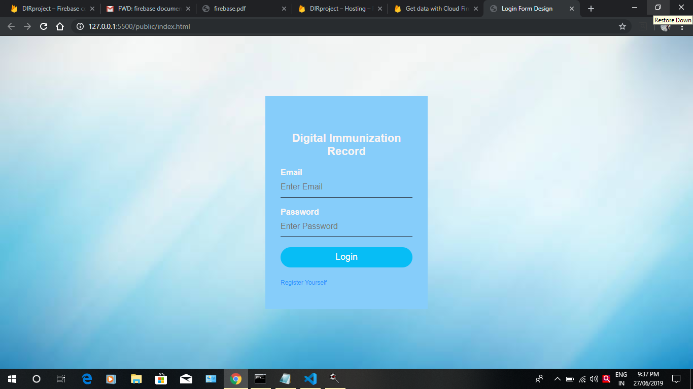

So this is the login page from where user gets into his records .

If the user is new he will click the link “Register Yourself ” and will automatically redirected to the registration page.

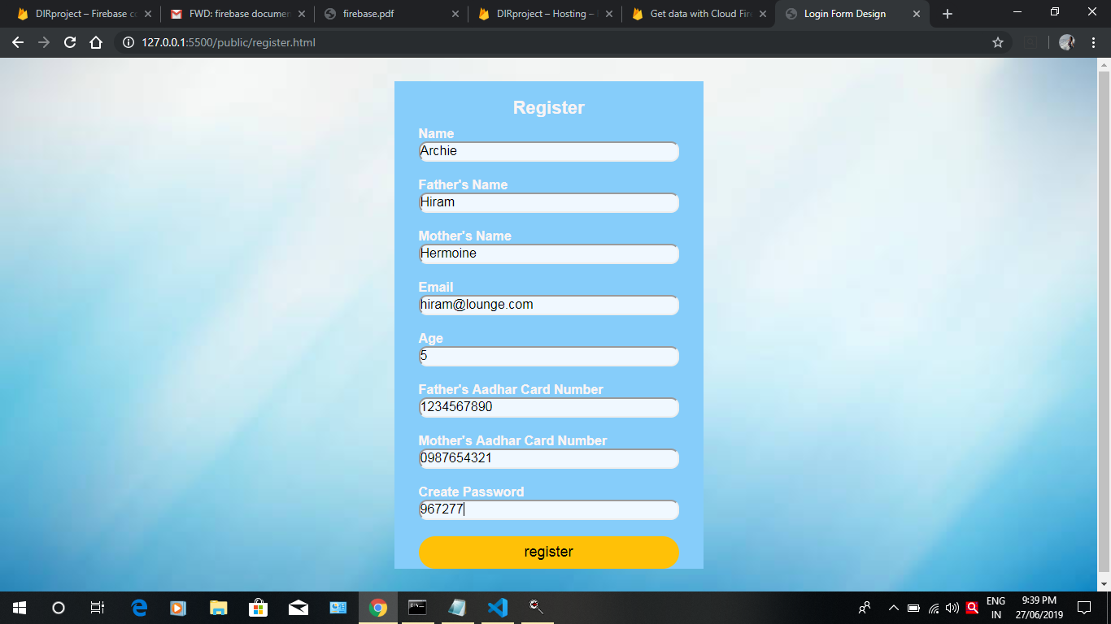

Once a new person is registered his details will be saved in the firestore

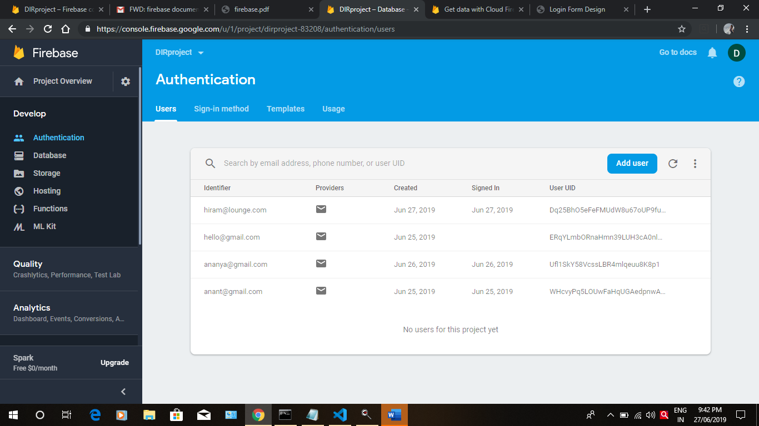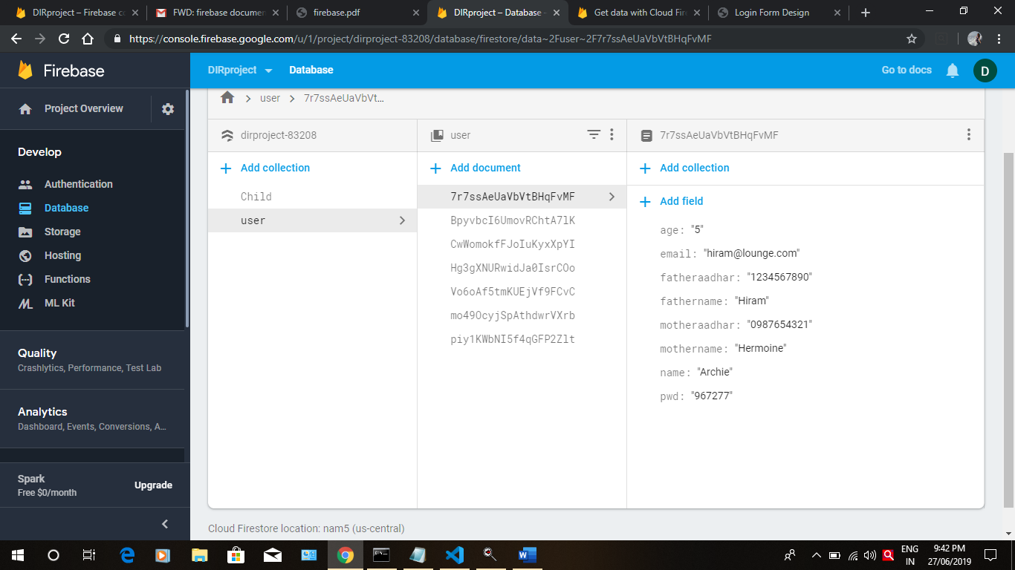

Now if a person have already a account and his doctor has maintained a record of vaccines for him it will be shown in his records when he logs in.

For example this is the record updated by the doctor in any user’s profile .

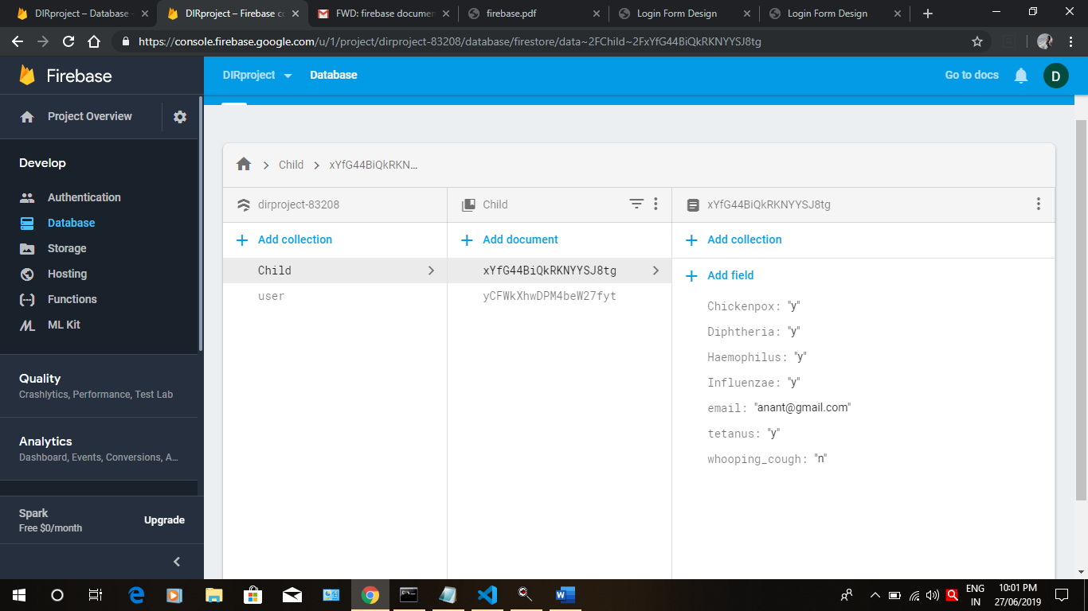

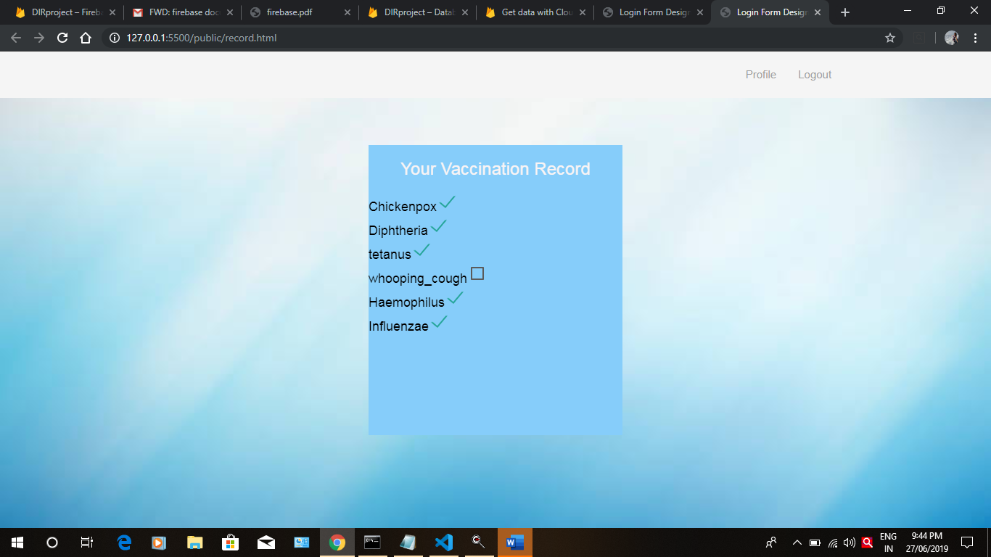

The checkboxes respective to every vaccine will get checked according to the record above.

User can also see his profile .

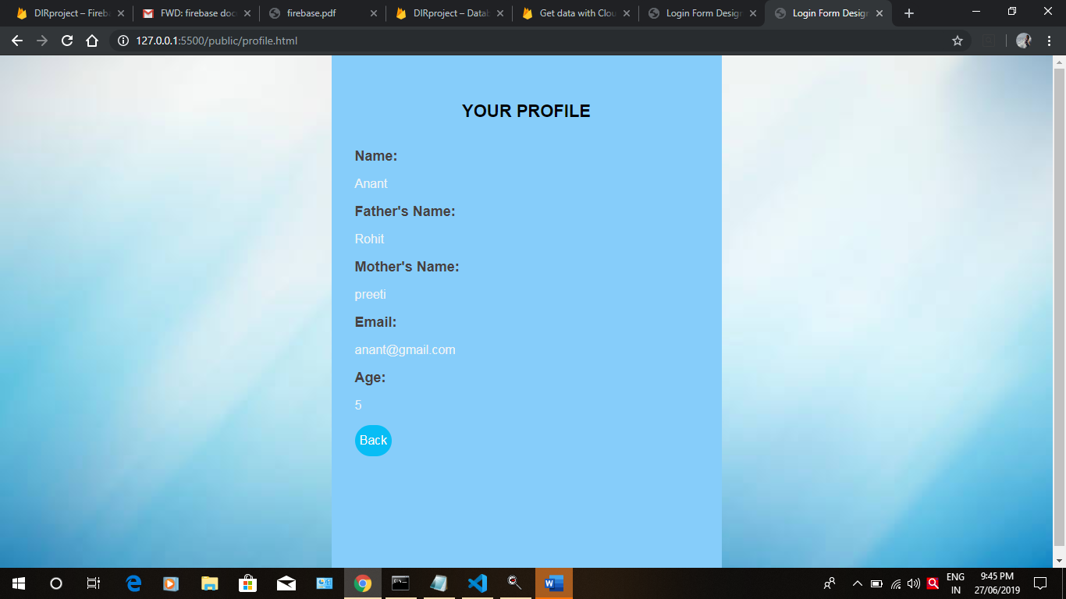

Aslo he can log out of his account when done.