End-to-End Data Analysis Case Study

● Clean and explore the dataset in Python.
● Analyze data using SQL or Pandas.
● Visualize results using Excel and a BI tool (Power BI/Tableau).
● Compile a final report including charts, findings, and recommendations.
Tools Used
- Google Colab (Python)
- Microsoft Excel
- Tableau Public
Dataset
https://docs.google.com/spreadsheets/d/14imPqAnjQyJfsLhOEnrE6kmVo2uQzzl9/edit?usp=drive_link
Internship – Data Analytics
2 July 2026 – 13 August 2026
Submitted by:
Ananya Kanchan

Table of Contents
- Introduction
- Project Objectives
- Dataset Description
- Methodology
- Data Cleaning and Analysis (Python)
- Excel Dashboard
- Tableau Dashboard
- Key Business Insights
- Recommendations
- Conclusion

Introduction
Data has become one of the most valuable assets for organizations, enabling businesses to understand customer behavior, monitor performance, identify trends, and make informed strategic decisions. Modern organizations rely heavily on data analytics to transform raw data into meaningful insights that improve efficiency, increase profitability, and enhance customer satisfaction. This project demonstrates an end-to-end data analysis workflow by combining Python, Microsoft Excel, and Tableau to analyze a financial sales dataset. The project begins with data preprocessing and cleaning in Google Colab using Python, followed by business analysis using Microsoft Excel Pivot Tables and interactive dashboard development in Tableau.
The primary objective of this project was to transform raw business data into actionable information that could assist management in understanding sales performance across different countries, customer segments, and products. By combining programming, spreadsheet analysis, and business intelligence tools, the project demonstrates the complete lifecycle of a data analysis project—from importing and cleaning data to generating interactive dashboards and presenting meaningful business recommendations.

Project Objectives
The objective of this project was to perform a complete business sales analysis using modern data analytics tools and techniques. The project aimed to clean and preprocess the dataset using Python, identify and handle missing values and duplicate records, analyze sales and profitability using exploratory data analysis, and prepare a structured dataset for visualization. Another objective was to create Pivot Tables and Pivot Charts in Microsoft Excel to summarize key business metrics and build an interactive Tableau dashboard that enables users to explore the data through filters and calculated fields. Finally, the project aimed to communicate the findings through a stakeholder-oriented report containing visualizations, insights, and recommendations.

Dataset Description
The dataset used in this project is the Financial Sample dataset, which represents business sales transactions across multiple countries, products, and customer segments. It includes important financial metrics such as Gross Sales, Discounts, Sales, Cost of Goods Sold (COGS), and Profit, along with supporting attributes including Country, Product, Segment, Discount Band, Units Sold, Manufacturing Price, Sale Price, Date, Month Number, Month Name, and Year.
The dataset provides sufficient information to evaluate sales performance across various dimensions and enables detailed analysis of regional performance, product profitability, seasonal sales trends, and customer segmentation. Since the data contains multiple financial indicators, it serves as an ideal dataset for demonstrating the complete data analytics process.

Methodology
The project followed a structured data analytics workflow consisting of data collection, preprocessing, exploratory data analysis, visualization, dashboard creation, and business interpretation. Initially, the dataset was imported into Google Colab where Python libraries including Pandas, NumPy, and Matplotlib were used to inspect and clean the data. The cleaning process involved checking for missing values, removing duplicate records, correcting data types, identifying outliers, and preparing the data for analysis.
Once the data was cleaned, it was exported as a new Excel workbook and used for creating Pivot Tables and Pivot Charts in Microsoft Excel. The Excel dashboard summarized business metrics using KPIs and interactive slicers. Finally, the cleaned dataset was imported into Tableau Public, where interactive dashboards and calculated fields were created to provide deeper business insights. The results obtained from all three tools were analyzed together to derive conclusions and recommendations.

Data Cleaning and Preprocessing using Google Colab
The first phase of the project focused on improving data quality through preprocessing. The dataset was imported into Google Colab using the Pandas library. Initial exploration included examining the dataset dimensions, reviewing column names, understanding data types, and generating descriptive statistics. This preliminary analysis helped identify potential issues that could affect the quality of subsequent analysis.
The dataset was checked for missing values in every column. Numerical columns containing missing values were filled using the median, which provides a reliable measure of central tendency while reducing the influence of extreme values. Categorical columns were filled using the mode so that the most frequently occurring category replaced missing entries. Duplicate records were identified and removed to ensure that each transaction was counted only once during analysis.
Date columns were converted into datetime format to facilitate time-based analysis such as monthly sales trends. Descriptive statistics including mean, median, standard deviation, minimum, and maximum values were generated to better understand the distribution of the data. Boxplots were created to detect outliers, and the Interquartile Range (IQR) method was applied to remove extreme values that could distort business insights. Once preprocessing was complete, the cleaned dataset was exported as Cleaned_Data.xlsx for further analysis in Excel and Tableau.
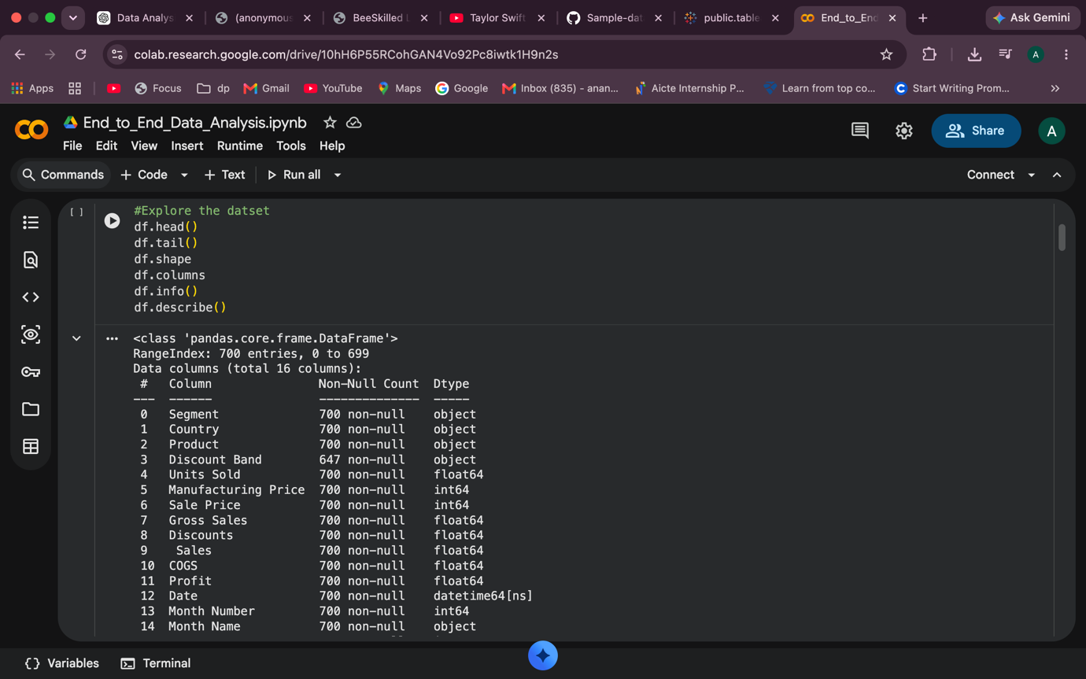
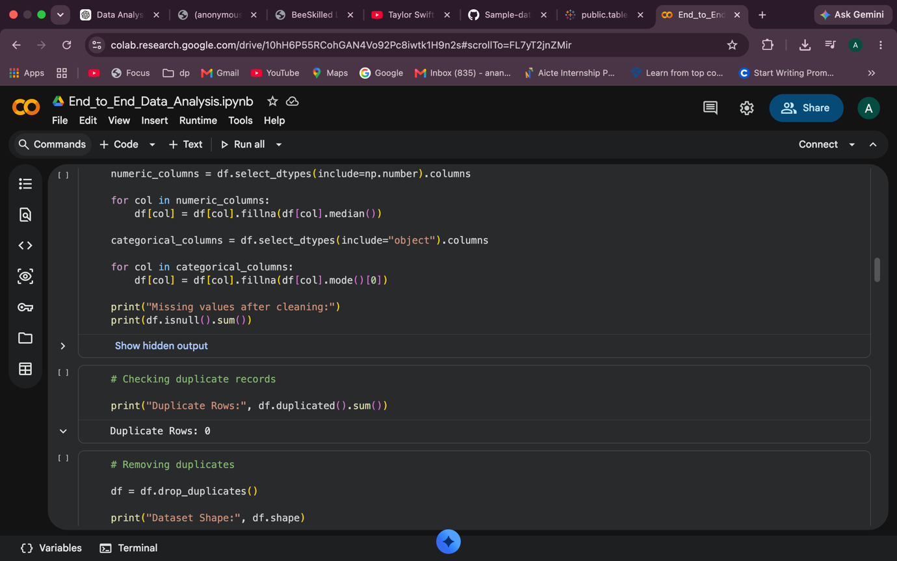
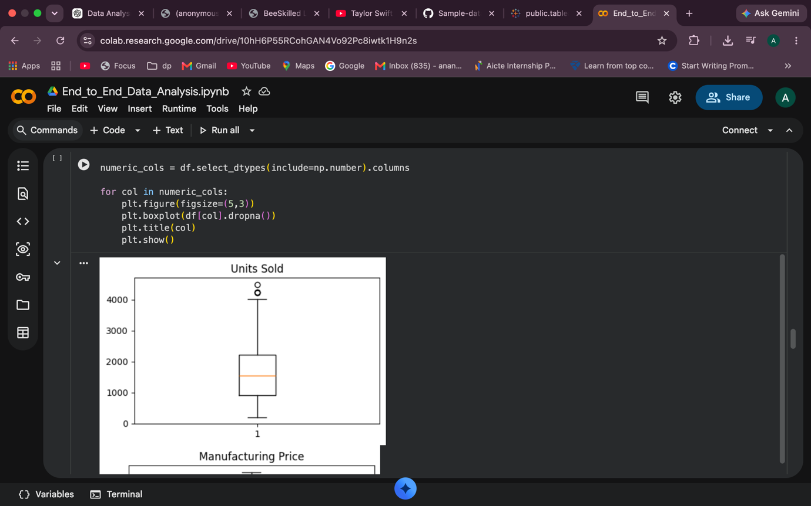

Exploratory Data Analysis
After cleaning the dataset, exploratory data analysis (EDA) was performed to better understand business performance. Statistical summaries were generated for numerical columns to observe the overall distribution of sales, profit, and units sold. Visualizations such as histograms, boxplots, bar charts, and line charts were created to identify trends, seasonal variations, and potential anomalies within the data.
The analysis focused on identifying countries with the highest sales, products contributing the greatest profit, monthly sales trends, and the distribution of revenue across different customer segments. These visualizations provided valuable insights into overall business performance and served as the foundation for creating interactive dashboards.

Microsoft Excel Dashboard
The cleaned dataset was imported into Microsoft Excel to develop an interactive dashboard using Pivot Tables and Pivot Charts. Excel provided an effective platform for summarizing business information and presenting key performance indicators in a clear and concise format.
Four major Pivot Tables were created to analyze Sales by Country, Profit by Product, Monthly Sales Trends, and Sales by Segment. Corresponding Pivot Charts including clustered bar charts, column charts, line charts, and pie charts were generated to improve visual interpretation of the results. KPI cards displaying Total Sales, Total Profit, Total Units Sold, and Total Gross Sales were added to provide an immediate overview of business performance.
Interactive slicers for Country, Product, Segment, and Discount Band enabled users to dynamically filter the dashboard and analyze data from multiple perspectives. The Excel dashboard successfully transformed complex transactional data into a simple and interactive business reporting tool.

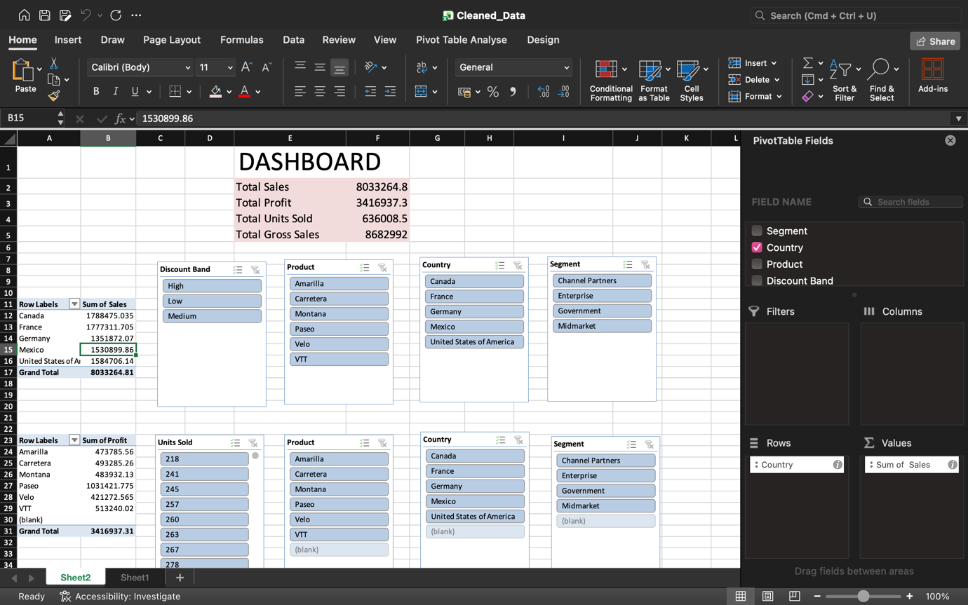

Tableau Dashboard
To further enhance data visualization and storytelling, an interactive dashboard was created in Tableau Public. Tableau provided advanced visualization capabilities that allowed users to explore the dataset dynamically through interactive filters and calculated fields.
The dashboard consisted of visualizations including Sales by Country, Profit by Product, Monthly Sales Trends, and Sales by Segment. Filters for Country, Product, Segment, Discount Band, and Year enabled users to focus on specific subsets of the data. A calculated field named Profit Margin was created to measure profitability relative to sales, providing an additional analytical metric beyond the original dataset.
The dashboard layout was designed to facilitate business storytelling by presenting related visualizations together and enabling quick comparisons across multiple dimensions. Interactive features allowed users to identify sales patterns, compare regional performance, evaluate product profitability, and understand customer segment contributions.
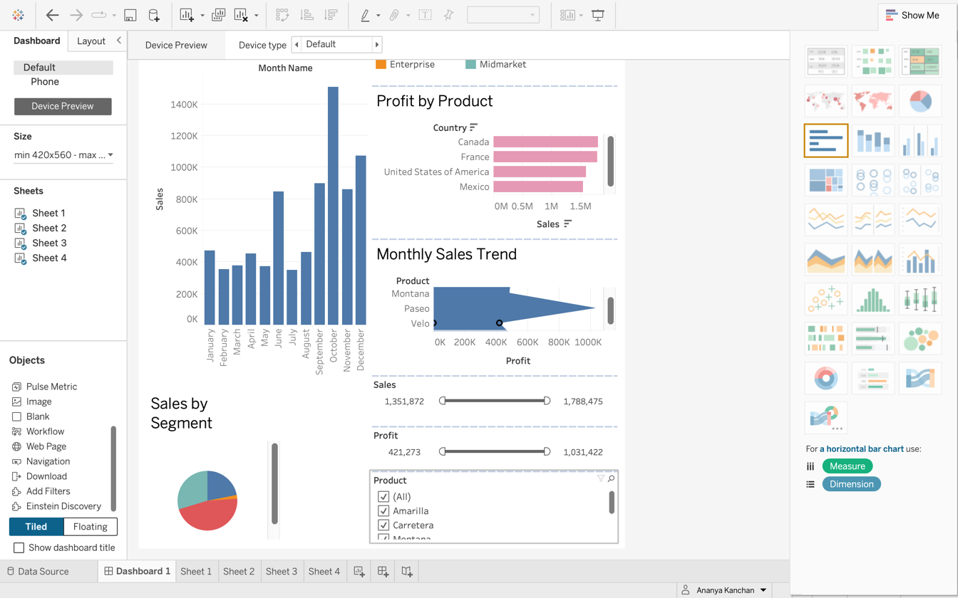

Business Insights
The analysis produced several important business insights. Sales performance varied significantly across different countries, indicating that certain regions generated substantially higher revenue than others. Products differed considerably in profitability, suggesting that product-specific strategies could improve overall business performance. Monthly sales analysis revealed seasonal patterns, with certain months consistently recording higher sales volumes. Customer segmentation showed that Government and Enterprise customers contributed a significant share of total revenue, making them important market segments for future business growth.
The analysis also demonstrated that while discount campaigns helped increase sales volume, excessive discounts reduced overall profitability. This highlights the importance of balancing promotional strategies with profit objectives.

Recommendations
Based on the findings, several recommendations can be made to improve business performance. The organization should prioritize marketing activities in high-performing countries while developing targeted campaigns to improve sales in lower-performing regions. High-profit products should receive greater promotional support and inventory allocation to maximize returns. Discount strategies should be carefully optimized to ensure that increased sales volumes do not significantly reduce profit margins.
Seasonal trends observed in the analysis suggest that businesses should plan inventory management and marketing campaigns ahead of peak demand periods. Customer segmentation analysis also indicates the opportunity to design personalized promotional campaigns that target specific customer groups, improving both customer satisfaction and revenue generation.

Conclusion
This project successfully demonstrated a complete end-to-end data analytics workflow using Google Colab, Microsoft Excel, and Tableau. Python was used to clean, preprocess, and analyze the dataset, ensuring high-quality data for visualization. Microsoft Excel provided an effective platform for summarizing business performance through Pivot Tables, KPI cards, and interactive charts, while Tableau enabled advanced dashboard development and business storytelling through interactive visualizations and calculated fields.
The project illustrates how combining programming, spreadsheet analysis, and business intelligence tools enables organizations to transform raw business data into meaningful insights. The analysis not only highlighted sales performance and profitability trends but also provided actionable recommendations that could support strategic decision-making. Overall, this case study demonstrates practical data analytics skills that are directly applicable to real-world business environments.

