Effectiveness of a Lock-down to combat COVID-19 using Regression Analysis: A Case Study in India

Jabeena A.¹, Ananya K. R.²
¹Associate Professor, Vellore Institute of Technology, Vellore, Tamil Nadu, India
²B.Tech Student, Vellore Institute of Technology, Vellore, Tamil Nadu, India

¹jabeena@vit.ac.in , ²anumanipal99@gmail.com

Abstract
Ever since its outbreak in the city of Wuhan in China, COVID-19 has spread around the world at a rapid rate and has now been identified in over 187 countries. To combat the spread of the virus and to isolate the affected, one of the most significant measures taken by various countries around the world is to enforce a complete lock-down across the nation. This paper aims to examine the effectiveness of the one such lock-down enforced in India by the Government on the 24th of March 2020 so as to curb the spread of COVID-19. In order to be able to estimate the effectiveness, an approach of Regression Analysis, which is a sub-branch of Predictive Analytics, has been applied using Python Programming. Upon following this approach, it is observed that the 41-day long lock-down has been highly effective in limiting the total number of COVID-19 positive cases in India.

Keywords: Regression, Log-Linear Model, Statistical Analysis in Python, Coronavirus

1. Introduction

The Coronavirus represents a large family of viruses that is held responsible for causing a gamut of illnesses which include the common cold, Middle East Respiratory Syndrome (MERS-CoV) and Severe Acute Respiratory Syndrome (SARS-CoV). A novel Coronavirus (nCoV) may be a new strain that has not been previously identified in humans. In general, the human population has no acquired immunity to the new Coronavirus and while most people who contract the virus will experience no or mild symptoms, some people will develop severe or even life-threatening symptoms. As of 2nd May 2020, more than 3.39 million cases of COVID-19 have been reported in 187 countries and territories, resulting in more than 241,000 deaths. More than 1.06 million people have recovered. Owing to this, the Coronavirus has been declared as a global pandemic by the World Health Organisation (WHO).

In India, the first positive case of COVID-19 was reported on 30th January 2020. Since then, the number of cases has been rising constantly. In order to curb the spread of the disease, the Government of India declared a nationwide lock-down on 24th March 2020, initially for a span of 21 days i.e., up-to 14th April 2020, but subsequently extended the period up-to 3rd May 2020 and later, with various relaxations, extended it to 17th May 2020.

The primary objective of this paper is to examine the effect of the enforced lock-down (from 24th March 2020 to 3rd May 2020), for a period of 41 days in curbing the number of COVID-19 positive cases in the India.

2. Methodology

In order to arrive at the effectiveness of the Lock-down enforced on 24th of March 2020, the approach of Predictive Analytics has been put to use using Python Software. Predictive Analytics is a statistical technique that involves studying and analysing the current data to make predictions about the future through the application of various means such as Data Collection, Data Modelling and Statistics, to name a few. It is an extremely useful technique that can be applied in various spheres to get an estimate of the behavioural trends and patterns of the data in the future.

This methodology of applying Predictive Analytics has been used to predict the total number of COVID-19 positive cases had the lock-down not been enforced. This number has then been compared to the total number of COVID-19 positive cases that were recorded while the lock-down of 41 days, as ordered by the Government of India, was in enforcement. This difference in the number of COVID-19 positive cases in both the above stated scenarios will be used to arrive at an estimate of the effectiveness of the nation-wide lock-down in India to combat the spread of the coronavirus.

The most crucial steps as followed in the paper to achieve the objective have been listed as follows:
- Data Collection
- Statistical Modelling
- Linear Regression Analysis
- Transforming the data into Log-Linear Model
- Construction of Best-Fit Line
- Future Prediction

In the following sections, the above mentioned steps have been elaborated in great detail with various mathematical calculations to supplement it. The analysis carried out in this paper has been programmed in Python using the Numpy, Pandas, and Matplotlib Software libraries.

2.1. Data Collection

Data Collection and Data Pre-Processing are the initial steps in any project or research that involves modelling the data. In short, Data Collection can be defined as the procedure that aims to gather and measure information on different interests in a systematic approach, which allows one to draw conclusions to research-oriented questions, to test various hypotheses, and to predict the outcomes. Accurate data collection is extremely essential to maintaining the integrity of research. [1]

The primary data that is required in order to achieve this paper's objective is the total number of COVID-19 positive cases that have been recorded each day since the outbreak of the Coronavirus in India. This data is primary to the research since all predictions and conclusions have been drawn by modelling and observing this data. There are various other factors that propel the spread of the virus such as the number of testing centres, number of successful tests carried out, number of affected migrants, the quality of healthcare facilities, presence of public awareness, adherence to issued guidelines in the country and so on. However, due to lack of adequate and accurate data pertaining to these factors at the moment, this paper does not take them into consideration.

To maintain the integrity of the research, all the data that has been used in this paper is sourced from the official COVID-19 website of the Government of India. Apart from spreading the awareness of the virus amongst its citizens, this website also gives open access to the daily count of the number of confirmed cases to one and all. This prevents anomalous and inaccurate data to affect the course of the research.

The thus obtained data is stored in the form of a CSV (Comma-separated values) file as shown in Table 1. It includes the total number of COVID-19 cases corresponding to each date since the first positive case of COVID-19 was recorded in India. This number is cumulative in nature. The data ranges from 30th of January 2020 since the outbreak to the 3rd of May 2020, which marked the end of the second extension of the lock-down. [2]

However, it has been observed that there is absolutely no change in the total number of COVID-19 positive cases in the month of February 2020. Due to this, it has been regarded as an outlier to the data and is not considered during the statistical modelling. This is done in order to avoid any discrepancies to the accuracy of the predictions of the model and is thus omitted from Table 1.

Table 1. Daily Count of COVID-19 positive cases in India
Date | Number of COVID-19 positive  cases per day (Cum.)
30-Jan-20 | 1
01-Feb-20 | 1
02-Feb-20 | 2
03-Feb-20 | 3
02-Mar-20 | 5
03-Mar-20 | 6
04-Mar-20 | 28
05-Mar-20 | 30
06-Mar-20 | 31
07-Mar-20 | 34
08-Mar-20 | 39
09-Mar-20 | 44
10-Mar-20 | 50
11-Mar-20 | 60
12-Mar-20 | 73
13-Mar-20 | 81
14-Mar-20 | 97
15-Mar-20 | 107
16-Mar-20 | 118
17-Mar-20 | 137
18-Mar-20 | 151
19-Mar-20 | 173
20-Mar-20 | 223
21-Mar-20 | 283
22-Mar-20 | 360
23-Mar-20 | 434
24-Mar-20 | 519
25-Mar-20 | 606
26-Mar-20 | 694
27-Mar-20 | 834
28-Mar-20 | 918
29-Mar-20 | 1024
30-Mar-20 | 1251
31-Mar-20 | 1397
01-Apr-20 | 1834
02-Apr-20 | 2069
03-Apr-20 | 2547
04-Apr-20 | 3072
05-Apr-20 | 3577
06-Apr-20 | 4281
07-Apr-20 | 4789
08-Apr-20 | 5274
09-Apr-20 | 5865
10-Apr-20 | 6761
11-Apr-20 | 7529
12-Apr-20 | 8447
13-Apr-20 | 9352
14-Apr-20 | 10815
15-Apr-20 | 11933
16-Apr-20 | 12759
17-Apr-20 | 13835
18-Apr-20 | 14792
19-Apr-20 | 16116
20-Apr-20 | 17656
21-Apr-20 | 18985
22-Apr-20 | 20471
23-Apr-20 | 21700
24-Apr-20 | 23452
25-Apr-20 | 24942
26-Apr-20 | 26917
27-Apr-20 | 28380
28-Apr-20 | 29974
29-Apr-20 | 31787
30-Apr-20 | 33610
01-May-20 | 35365
02-May-20 | 37776
03-May-20 | 40263

2.2. Statistical Modelling

A Scatter Plot is a graph of plotted points that shows the relationship between two sets of numeric data. The obtained data in Table 1 is represented in the form of a Scatter Plot wherein the total number of COVID-19 positive cases has been expressed as a function of the corresponding date of occurrence, as shown in Figure. 1.

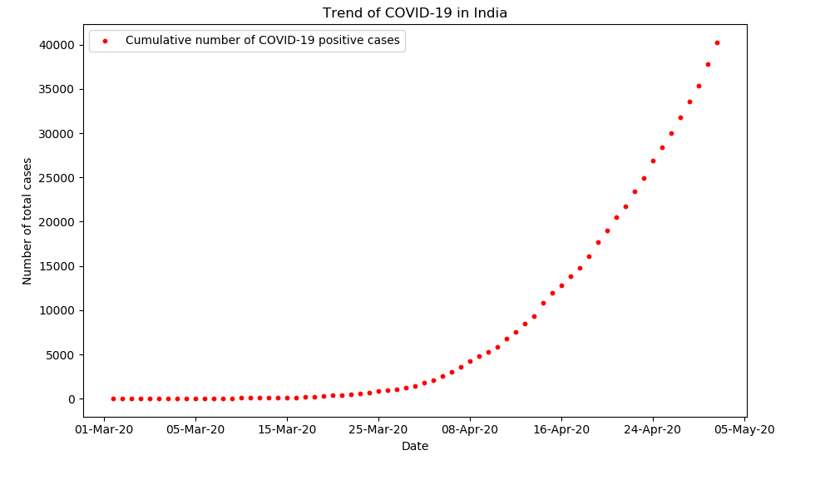Figure 1. Trend of COVID-19 in India

The Scatter Plot thus obtained closely resembles an exponential curve in nature. According to the mathematical definition, a quantity is said to be growing at an exponential rate if it increases with a rate proportional to its current size. Thus, by observing the obtained graph, it can be implied that greater the number of people initially affected by the virus in the early stages of its outbreak, greater the number of people who will get affected in the later stages. The consistent doubling of cases in a fixed period is the hallmark of exponential growth. [3][4]

The number of new infections that a single infectious individual will cause during their infectious period is known as the basic reproduction number of a disease. The initial exponential growth rate of a virus is an important measure of the severity of the spread, and is also closely related to the basic reproduction number. This number is key to determining how widespread a virus will become. For COVID-19, estimates of the basic reproduction number have it somewhere between 1.03 and 1.67. [5][6][7]

2.3. Linear Regression Analysis

Linear Regression is the most commonly used tool of Predictive Analytics. The approach of Linear Regression involves establishing relationships between two or more variables, necessarily one dependant variable and one or more independent variables. In this case, the dependant variable is the total number of COVID-19 positive cases, which is plotted on the y-axis, and the independent variable or the predictor variable is the date, that is plotted on the x-axis. [8]

The most common applications of Linear Regression Analysis are to determine the strength of predictor variables, and to forecast an effect or trend. In other words, the Regression Analysis is used to gauge the amount of change produced in the dependent variable when it is subjected to a change in one or more independent variables.

Thus, Linear Regression Analysis is applied to the data in order to gauge the pattern of growth of the dependant variable, that is, the total number of positive COVID-19 cases. However, this approach is not applied to the entire data, but just a portion of it. Since the lock-down was enforced on 24th of March 2020, it is important to apply Linear Regression only to the data pertaining to the dates prior to it. This is done in order to predict the total number of COVID-19 positive cases had the lock-down not been enforced. Thus, a Scatter Plot of the total number of COVID-19 positive cases as a function of the dates during which the lock-down had not been enforced is plotted as shown in Figure. 2.

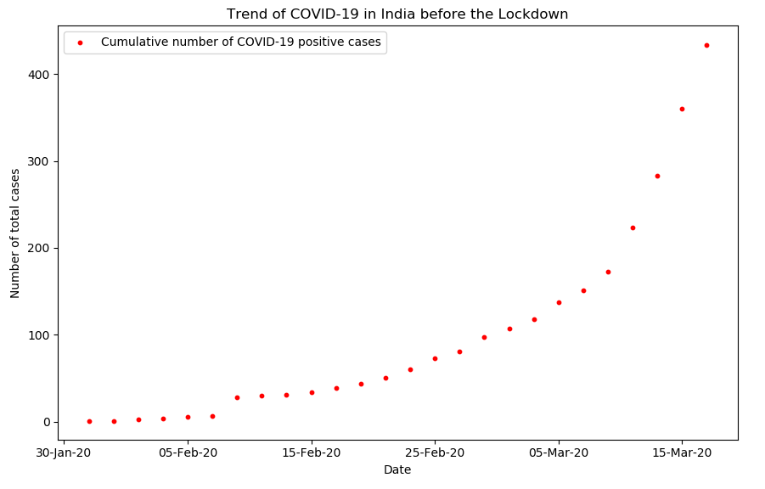

Figure 2. Trend of COVID-19 in India before the Lock-down

It is important to note that Linear Regression can only be applied if the curve is of the linear form, in the equation of which, 'm' denotes the slope of the curve and 'b' denotes the y-intercept of the curve. In other words, only if the variables share a linear relationship, the approach of Linear Regression can be applied. The equation of the a linear curve is stated as follows:
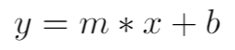
(1)

On the other hand, Coronavirus spreads in a communicable fashion, through which an infected person affects whosoever is in close vicinity. This leads to the curve that is depicted in Figure. 2., which is roughly similar to an exponential curve. Thus, the approach of Linear Regression cannot be applied to it. The equation of an exponential curve is of the following form, in which the base 'k' is a constant and 'x' is a variable:
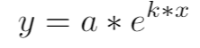
(2)

This discrepancy in the approach is resolved by transforming the data into the Log-Linear Model as described in the following section.
2.4. Transforming the Data into Log-Linear Model

In order to remove the discrepancy in the approach and to apply Linear Regression, it is necessary to transform the exponential curve obtained in Figure. 2., into a linear curve. To carry out the above mentioned process, a few mathematical simplifications are necessary. It is known that the exponential curve is of the form that is depicted in Equation. 2. It can be re-written as follows:
(3)

Taking logarithm on both sides of the above equation, the following equation is obtained:
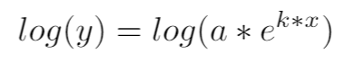
(4)

Upon further simplification of the above equation, one can arrive at the following equation:
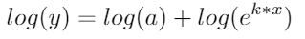
(5)

On application of the logarithm rules, the above equation can be simplified to:
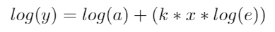
(6)

It is known that,
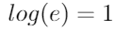
(7)

Thus, Equation. 6 can be re-written as:
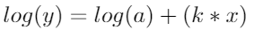
(8)

Assuming that,
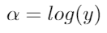
(9)

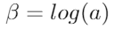
(10)

Now, Equation. 8 can be written as:
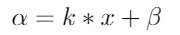
(11)

Upon comparing Equation. 11 to Equation. 1, it is observed that they are now in similar forms:
(12)
(13)

This process, in which an exponential curve is modified into a linear curve through the application of logarithms is known as Logarithmic Transformation. [9]

In the scatter plots plotted throughout the course of this paper, in general, the x-axis represents the date and y-axis represents the total number of COVID-19 positive cases recorded on the corresponding date. As seen in the above mathematical derivation, Logarithmic Transformation involves computing the logarithm of the y-axis values. The logarithmic y values are now plotted on the y-axis in place of the previous values.

Plotting the newly transformed y-axis values versus the x-axis values will result in a new plot with a nearly straight line. This plot is termed to be in the form of a 'Log-Linear' model. When one uses natural log values for the dependent variable (y) and keep the independent variables (x) in their original linear scale, the resulting graph is called a Log-Linear model.

The above explained process of Logarithmic Transformation is applied to the data recorded before the lock-down was enforced as well as to the overall data collected during the enforcement of the lock-down. The Scatter Plots, thus obtained, have been depicted in Figure. 3. and Figure. 4. respectively.

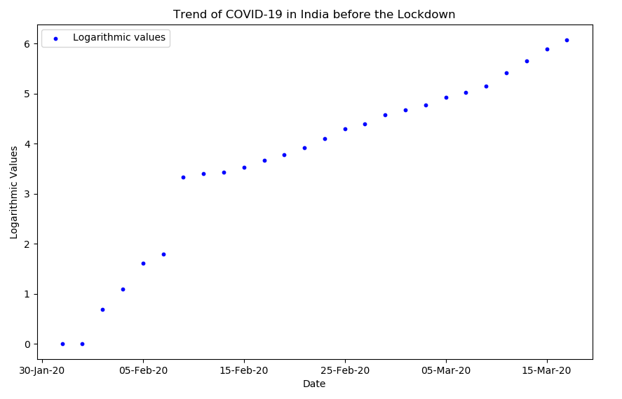

Figure 3. Trend of COVID-19 in India before the Lock-down (Log-Linear)

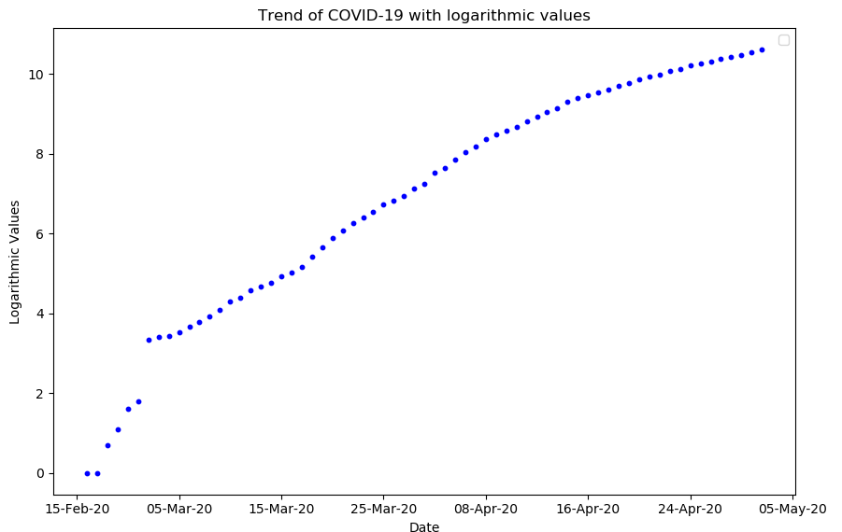

Figure 4. Trend of COVID-19 in India in Lock-down Period (Log-Linear)

As observed in Figure. 3. and Figure. 4., the Log-Linear Models obtained are in close similarity to the Linear Curves, and resemble a straight line. This enables one to perform Linear Regression Methods on these logarithmic-ally transformed curves.

2.5. Construction of Best Fit Line

The Line of Best Fit (or "trend" line) is a straight line that best represents the data on any plot. This line may pass through some of the points, none of the points, or all of the points. In other words, the line of best fit is the line for which the sum of the squares of the residual errors between the individual data values and the line is at its minimum. [10]

A Line of Best Fit can be roughly determined using an eyeball method by drawing a straight line on a scatter plot so that the number of points above the line and below the line is about equal (and the line passes through as many points as possible). However, a more accurate way of finding the line of best fit is the Least Square Method, as described below.

The straight line that constitutes the Best Fit to a set of data points in the x-y plane is typically calculated by minimizing the sum of the squares of the distances from the points to the line—a method that was introduced by Legendre and Gauss more than two hundred years ago.

The Line of Best Fit is drawn for the Logarithmic-ally transformed scatter plot for the data that was recorded before the Lock-down was enforced. To do so, the approach of Least Squares Method has been put to use as described in detail below. The line of best fit is of the standard form:
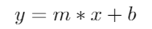
(14)

where 'm' represents the slope of the line and 'b' represents the y-intercept of the line.
To arrive at the equation of the Best-Fit line, the following values are first calculated by taking the sum of the x-axis values, logarithmic-ally transformed y-axis values, the square of x-axis values, and the product of the x-axis and logarithmic-ally transformed y-axis values in accordance to the data presented in Table I as shown below. The total number of observations 'n' is computed as well.

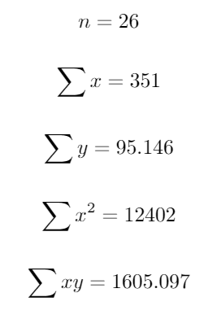
(15)

(16)

(17)

(18)

(19)

Substituting the above values, the slope 'm' and the y-intercept 'b' of the Best-Fit Line are computed using the following formulae:
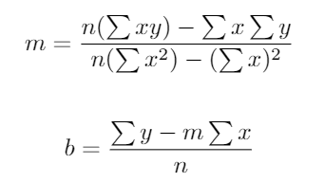

(20)

(21)

where 'x' and 'y' represent the respective axis values.

After the application of the above formulae on the data, the values of 'm' and 'b' are obtained to be:

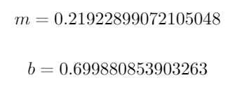
(22)

(23)

Upon arriving at the values of the slope and intercept using the above formulae, the Best-Fit line has been plotted over the graph in Figure. 2., to obtain the graph as depicted in Figure. 5.

This Line of Best Fit depicted in Figure. 5. is the line that is the representation of all the points in the Scatter Plot, since it is at an equal distance from all the points. In other words, this Line of Best Fit represents the the data of all the COVID-19 positive cases that were recorded before the lock-down had been enforced.

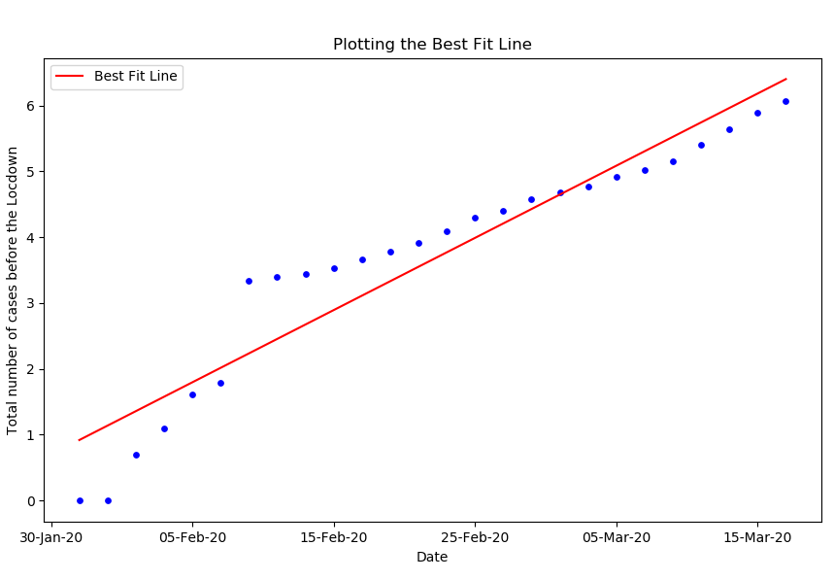
Figure 5. Construction of Best-Fit Line

2.6. Future Prediction

A best-fit line is meant to mimic the trend of the data. Thus, in order to examine the effectiveness of the lock-down enforced, it is necessary to extend the line of Best-Fit constructed for the data when the lock-down had not been enforced throughout the data. This is done since it is assumed that had the lock-down not been enforced, the number of COVID-19 positive cases would have risen in a similar fashion. The Logarithmic-ally Transformed linear graph for the data when the lock-down was in enforcement has been depicted in Figure. 4. The Best-Fit line that was plotted in Figure. 5. is extended and superimposed over the graph in Figure. 4. The plot thus obtained is depicted in Figure. 6.
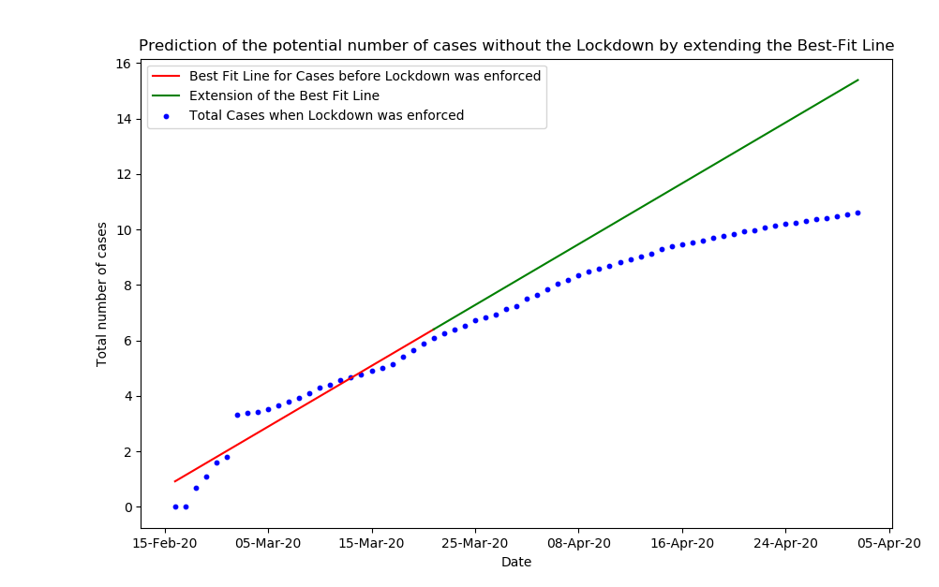
Figure 6. Extension of Best-Fit Line to entire Data
In Figure. 6., the red line represents the Best-Fit Line that was drawn for the data that was recorded before 24th of March 2020. In other words, it is the trend-line for the total number of COVID-19 positive cases before the lock-down was enforced in the country. The green line represents the extension of the Best-Fit line that is fitted on to the rest of the data which includes the total number of COVID-19 cases recorded in the country while the lock-down was in enforcement. The Observations of the Methodology followed in the above sections has been elucidated in the following section.

2.7. Observations

The most striking observation made with respect to Figure. 6. at the end of this process is the significant difference in the slopes of the extended Best-Fit Line and the Logarithmic-ally Transformed Linear line. It can be observed that the slope of the line depicting the total number of COVID-19 positive cases during the lock-down is much lesser when compared to the slope of the line that represents the total number of COVID-19 positive cases had the lock-down not been enforced. This gives a visual proof of the effectiveness of the 41-day long lock-down. To strengthen the presented argument, the mathematical proof of the observation has been presented below.

The two cases that need to be compared in order to arrive at a suitable conclusion are as follows:

- The total number of COVID-19 positive cases after 41 days had the lock-down not been enforced. (As represented by the Best-Fit Line in Figure. 6.)

- The total number of COVID-19 positive cases after 41 days of the lock-down enforcement. (As represented by the scatter plot that has been obtained via Logarithmic Transformation in Figure. 6.)

The mathematical observation can be made by arriving at the y-axis values corresponding to the x-axis date of 3rd of May 2020. The values obtained upon doing so are 'y1' and 'y2' respectively for the above mentioned cases:

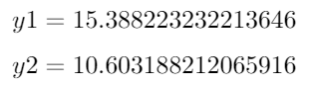
(24)

(25)

However, it is important to note that Figure. 6. represents a Log-Linear model. This implies that the x-axis values are linear in nature whereas the y-axis values are logarithmic in nature.
Thus, the values of 'y1' and 'y2' that have been obtained in Equation. 24 and Equation. 25 are logarithmic in nature.

In order to compute the number of COVID-19 cases, it is necessary to convert the logarithmic values back into the linear values. This can be accomplished by calculating the anti-logarithmic values of 'y1' and 'y2', as shown below:
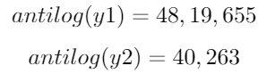
(26)

(27)

The obtained values from Equation. 26 and Equation. 27. are representative of the total number of COVID-19 positive cases without and with the enforcement of the lock-down respectively. It is thus concluded that the total number of cases in the country if the lock-down had not been enforced would be approximately 4.8 million cases. This is an exorbitant number. On the other hand, it is obtained that the number of cases with the lock-down in place is close to 40 Thousand cases till the end of the second lock-down extension of 3rd May 2020.

- Conclusion

In this paper, an approach of Regression Analysis has been applied to the data of per-day count of the number of COVID-19 positive cases in India that has been recorded ever since the outbreak of the Coronavirus since 30th of January 2020 till the end of the second extension of the enforced Lock-down, that is the 3rd of May 2020.

Upon following the methodology that involved the steps of Data Collection, Statistical Modelling, Linear Regression Analysis, Logarithmic Transformation in order to obtain a Log-Linear Model, Construction of the line of Best-Fit and obtaining the Future Predictions, various visual and mathematical observations have been made as elucidated in the previous section.

According to the results obtained through data visualisation and modelling, it can be concluded that had the lock-down not been enforced, there would be close to a 4.8 million COVID-19 positive cases in India by the 3rd of May 2020. On the other hand, since the lock-down has been enforced on 24th of March 2020, the total number of COVID-19 positive cases in the country by the 3rd of May 2020 is around 40 Thousand.

Thus, it is concluded the lock-down of 41 days enforced by the Government of India to tackle the Coronavirus pandemic has been highly effective in reducing the number of active COVID-19 cases in the country by reducing the potential 4.8 million positive cases to around 40 thousand positive cases in the through the duration of 41 days.

References

- Knatterud.,G.L., Rockhold, F.W., George, S.L., Barton, F.B., Davis, C.E., Fairweather, W.R., Honohan, T., Mowery, R, O’Neill, R. (1998). "Guidelines for quality assurance in multicenter trials: a position paper". Controlled Clinical Trials, 19:477-493.

- J. Mitlöhner, S. Neumaier, J. Umbrich and A. Polleres, "Characteristics of Open Data CSV Files," 2016 2nd International Conference on Open and Big Data (OBD), Vienna, 2016, pp. 72-79.

- J. Ma, J. Dushoff, B.M. Bolker, D.J.D. Earn "Estimating initial epidemic growth rates", Bulletin of Mathematical Biology, 76 (2013), pp. 245-260

- E. Pourabbas, A. d’Onofrio, M. Rafanelli "A method to estimate the incidence of communicable diseases under seasonal fluctuations with application to cholera", Applied Mathematics and Computation, 118 (2001), pp. 161-174

- J. Wallinga, M. Lipsitch "How generation intervals shape the relationship between growth rates and reproductive numbers", Proceedings of the Royal Society B: Biological Sciences, 274 (2006), pp. 599-604.

- F.J. Richards "A flexible growth function for empirical use", Journal of Experimental Botany, 10 (1959), pp. 290-300.

- L. Zhong, L. Mu, J. Li, J. Wang, Z. Yin and D. Liu, "Early Prediction of the 2019 Novel Coronavirus Outbreak in the Mainland China Based on Simple Mathematical Model," in IEEE Access, vol. 8, pp. 51761-51769, 2020.

- Astrid Schneider, Dipl. Math.,1 Gerhard Hommel, Prof. Dr. rer. nat.,1 and Maria Blettner, Prof. Dr. rer. nat.*,1. "Linear Regression Analysis" Dtsch Arztebl Intv.107(44); 2010 Nov; PMC2992018.

- M. T. Abuelma'atti and N. A. Tassaduq, "A new implementation for the logarithmic/exponential function generator," 2014 International Symposium on Intelligent Signal Processing and Communication Systems (ISPACS), Kuching, 2014, pp. 127-132.

- M. B. Jain, M. K. Nigam and P. C. Tiwari, "Curve fitting and regression line method based seasonal short term load forecasting," 2012 World Congress on Information and Communication Technologies, Trivandrum, 2012, pp. 332-337.

Authors

 | Jabeena A., is an Associate Professor in School of Electronics Engineering, VIT University, Vellore-632014, India. She has completed her B.E [Electronics and Communication Engineering] in Bhrathiar University, Coimbatore, an M.E. in Applied Electronics and has received her PhD. in Optical communication at Vellore Institute of Technology, Vellore. She has more than 25 years of teaching experience and her Research Interest includes application of Evolutionary algorithms to optimization problems in Wireless Optical Communication, Satellite communication, Optical Sensors and visible light communication. She is a member of Indian Society for Technical Education, IEEE, Institution of Engineers and Indian Science Congress Association. She has published more than 60 of her contributions in Scopus journals and IEEE conferences. She is also reviewer of several international conferences and Scopus indexed journals.
 | Ananya. K. R., is a pre-final year student pursuing a Bachelor of Technology degree in Electronics and Communication in Vellore Institute of Technology, Vellore-632014, India. She is also a core-committee member of the IEEE Student Chapter - VIT (affiliated to Madras Section, India of IEEE). With a great interest in Machine Learning Algorithms and its Applications, she plans to specialise in this field in the future. Her Research Interest includes applying Machine Learning Techniques and Statistical Modelling to solve real-world problems.

