INDIAN RAILWAYS CATERING AND TRANSPORT CORPORATION
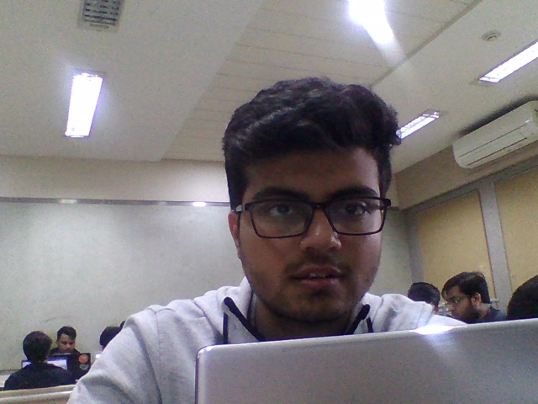
Student-Swapnil Kadakia
From: Charni Road To: Vile Parle
Class: First
Fare: 465

