**Quantum Computing**

Let’s dive into the deeper end straight, and begin by asking a simple question, “What is quantum?”. It is in high probability that as a millenial in this day and age of pop culture, quantum has been a term, that one has heard one too many times. Taking the literal meaning Quantum is derived from the latin word of amount, that is the smallest possible discrete unit of any physical property such as energy or matter. Through our higher school life, we have very carefully and thoroughly studied quantum in physics. After being first proposed by Max Planck in a german conference, in the 1900, quantum theory has evolved over the years with various acclaimed scientists, proposing various acclaimed theories. Just to make sure all of us are on the same page, Quantum is the minimum amount of any physical entity involved in an interaction.



We now realise that we have a decent idea on quantum, however, by the time we have understood this another concept called quantum computing pops up! Basically, quantum computing involves application of properties of quantum physics to process information. These computers involve operation with nanoscale components at temperatures colder than intergalactic space, with which they have the potential to solve the world’s toughest problems.

An initial assumption of quantum computers, often begin with the very popular belief that these computers are an alternative to classical computing, however many heavyweights in the industry strongly believe that quantum and classical computers are here to co-exist. Infact corporations such as Microsoft have very famously imagined quantum computers like a GPU, a specialized processor used for applicable scenarios. In a nutshell, while the classical computers shall run computations, the *tougher* problems with complexity that are said to be unsolved can be solved by our quantum computers.

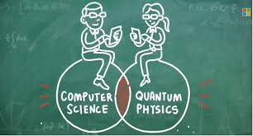

Now that we have understood what quantum computing is, let’s explore it’s functionality and it’s workability. We know that our *regular* computers work on binary bits, 1 and 0. Everything that we see, understand and compute is first converted into a binary string of 1’s and 0’s, it’s after that the system applies an algorithm to execute a favoured task.They follow the principles of Boolean Algebra.The regular computers have a macroscopic view, while quantum computing is a view in the microscopic world. It is based on the fact that, in the microscopic world, things don't have to be as clear-cut as we'd expect from our macroscopic experience. They can be in several places at once, for example, and in the case of photons simultaneously exhibit two kinds of polarisation. We never see this *superposition* of different states in ordinary life because it somehow disappears once a system is observed: when you measure the location of an electron or the polarisation of a photon, all but one of the possible alternatives are eliminated and you will see just one. Nobody knows how that happens, but it does. It bears an eerie similarity to Schrodinger's cat.

The Quantum computer, by contrast, can work with a two-mode logic gate: [XOR](https://whatis.techtarget.com/definition/logic-gate-AND-OR-XOR-NOT-NAND-NOR-and-XNOR) and a mode we'll call QO1 (the ability to change 0 into a superposition of 0 and 1, a logic gate which cannot exist in classical computing). In a quantum computer,the elemental particles like electrons and photons, with either their charge or polarization acting as a representation of 0 and/or 1. Each of these particles is known as a quantum bit, or qubit, the nature and behavior of these particles form the basis of quantum computing. The two most relevant aspects of quantum physics are the principles of *superposition* and *entanglement.*

Now, don’t worry, I do realise that if you are as new as me, in this world of quantum, an article as basic as this can go right over your head and jump off into another dimension, so we stop here. Today in a world where IBM, Google and Microsoft all are in a crazy race to attain Quantum supremacy, we need to understand that the next iteration in commercial computing may in fact depend upon the Quantum Computing.

Machine Learning an extremely popular domain amongst the rising techno stars, actually stands to benefit a lot from Quantum. Quantum computing could empower Machine Learning by enabling AI to search from gigantic datasets concerning medical research, financial markets, consumer experiences. Quantum Computing could be used in optimization, by handling innumerable permutation and combinations, in an extremely efficient way that might as well pave a breakaway in algorithm design and analysis. Through Quantum we will be able to simulate and create and model molecular structure, only advancing biomedical research. According to IBM, Quantum computing could be used to model financial data and isolate key global risk factors. 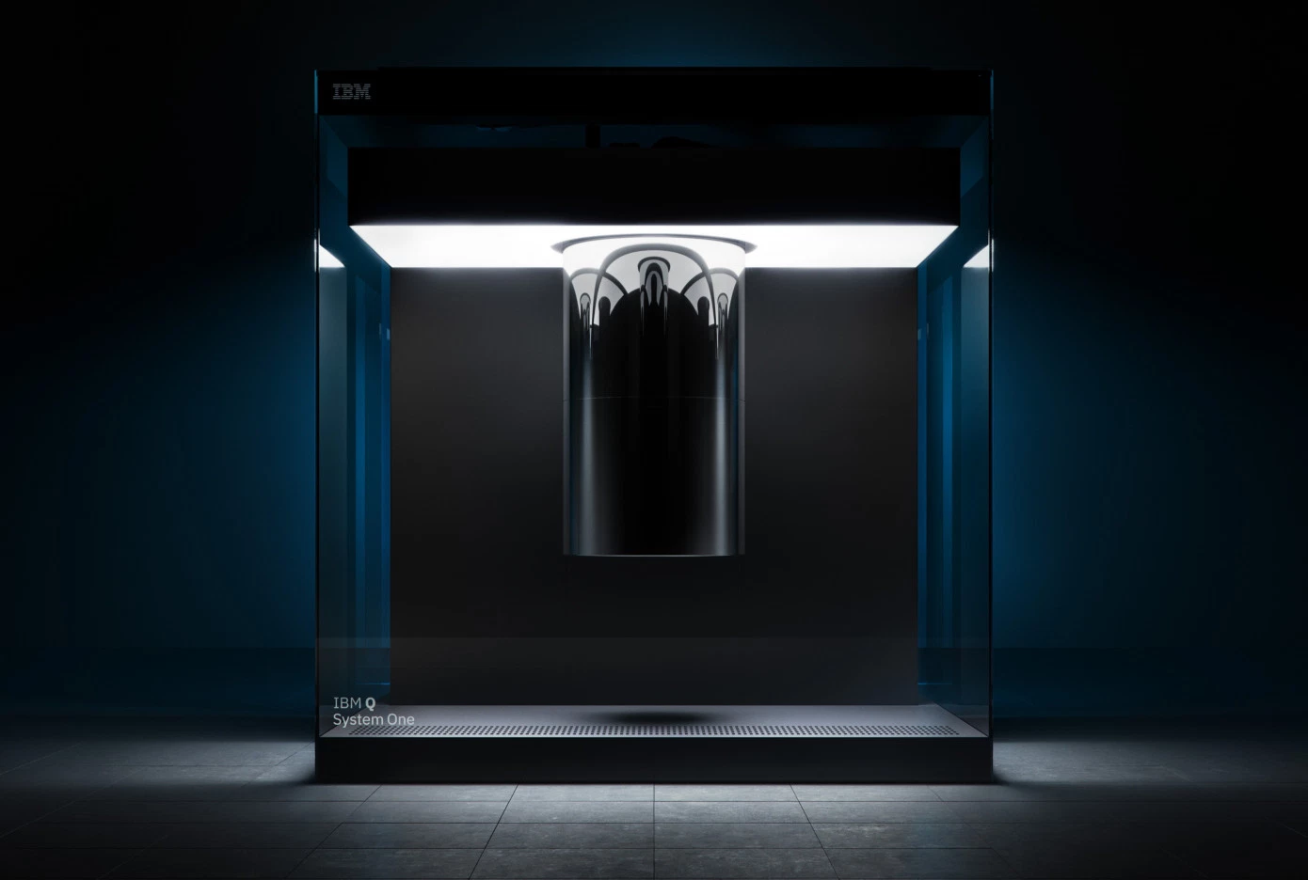

IBM, in January, 2019, unveiled its first commercial quantum computer. While it is nowhere as powerful in applications as people envisioned it to be. Yet it’s a huge leap for mankind. With quantum in trend, it’s theoretical applications have always been in abundance. What’s fascinating to us, as young engineering students, to see these applications come to life.