GLA UNIVERSITY, MATHURA
(Established under Act No. 14 of U.P. Govt. and approved by UGC)
Department of Computer Engineering & Applications
GLA
UNIVERSITY
BRAVE STORY MAKER
An AI-Powered Personalized Storybook Generation Platform
for Children Facing Medical Challenges
A Project Report submitted in partial fulfillment of the requirements for the degree of
Bachelor of Technology
in
Computer Science & Engineering (Artificial Intelligence & Machine Learning)
Submitted by
Samarth Verma
University Roll No.: 221500XXXX
Course: B.Tech (CSE — AI/ML)
Under the Supervision of
[Supervisor Name]
[Designation], Department of Computer Engineering & Applications GLA University, Mathura

Academic Year 2025–2026
i

CERTIFICATE
This is to certify that the project report entitled "Brave Story Maker — An AI-Powered Personalized Storybook Generation Platform for Children Facing Medical Challenges" is a bonafide record of the work carried out by Samarth Verma (University Roll No. 221500XXXX), a student of the Bachelor of Technology programme in Computer Science & Engineering (Artificial Intelligence and Machine Learning) at GLA University, Mathura, during the Academic Year 2025–2026, under my supervision and guidance.
The work embodied in this report has not been submitted, in part or in full, to any other university or institution for the award of any degree, diploma, or similar academic recognition. The technical content, experimental results, implementation details, and conclusions recorded in this document represent the original effort of the candidate and are found to be of sufficient quality for consideration toward the partial fulfillment of the requirements of the B.Tech degree.
The candidate has demonstrated diligence, technical competence, and a sound understanding of applied artificial intelligence, full-stack web engineering, and responsible software design practices throughout the duration of the project.

_______________________ [Supervisor Name]
[Designation]
Dept. of CEA, GLA University

_______________________
[Head of Department]
Department of Computer Engineering &amp; Applications GLA University, Mathura

Place: Mathura Date: ____________
ii

DECLARATION
I, Samarth Verma, bearing University Roll No. 221500XXXX and enrolled in the Bachelor of Technology programme in Computer Science & Engineering (AI/ML) at GLA University, Mathura, hereby declare that the work presented in this project report titled "Brave Story Maker — An AI-Powered Personalized Storybook Generation Platform for Children Facing Medical Challenges" is entirely my own and has been carried out by me during the academic year 2025–2026 under the supervision of [Supervisor Name], Department of Computer Engineering & Applications, GLA University, Mathura.
I further declare that the material contained in this report has not been submitted to any other university or institution for the award of any degree, diploma, or other similar title. All external sources, datasets, libraries, and AI services used in the course of this project have been duly acknowledged in the references section, and full credit has been given to the respective authors and vendors. The source code of the project has been authored by me and is maintained in a version-controlled Git repository for reproducibility and academic scrutiny.
I understand that any breach of academic integrity, including plagiarism or misrepresentation of work, is a punishable offence under the regulations of GLA University, Mathura. I hereby consent to the verification of this report through any means the university deems appropriate.
Signature of the Candidate
Samarth Verma
Roll No.: 221500XXXX
Date: ____________
iii

ACKNOWLEDGEMENT
The completion of this project report would not have been possible without the sincere support, technical guidance, and continual encouragement of several individuals, to each of whom I wish to record my heartfelt appreciation.
I express my deepest gratitude to my supervisor, [Supervisor Name], Department of Computer Engineering & Applications, GLA University, Mathura, for the insightful suggestions, constructive critique, and generous investment of time across every review of the design, implementation, and documentation of this system. The clarity of the architectural choices presented in this report owes much to their patient mentoring.
I am grateful to the Head of the Department, and to the entire faculty of the Department of Computer Engineering & Applications, for fostering an environment in which applied research into modern AI systems is actively encouraged. The coursework on software engineering, database systems, machine learning, and web technologies laid the foundation on which this project was built.
I sincerely thank the laboratory staff for ensuring uninterrupted access to development workstations and for their cooperation during the peak integration phase of the project. I also acknowledge the open-source community behind Flask, Python, reportlab, and the many other libraries that made rapid prototyping possible.
I gratefully acknowledge the infrastructure provided by Google (Gemini 2.5 Flash), Microsoft Azure (OpenAI gpt-image-1.5, gpt-4o-mini-tts, GPT-4o Vision and AI Translator), without which the multi-modal AI pipeline at the core of this application would not have been possible. Responsible use of these APIs, including content moderation and prompt safety design, was undertaken with care throughout the project.
Finally, I offer my profound gratitude to my parents and my peers for their unwavering encouragement, for the many long conversations about the purpose of the project, and for reminding me that technology is most meaningful when it eases the experience of vulnerable users — in this case, children in hospital beds who deserve a little more magic in their day.
Samarth Verma
B.Tech (CSE — AI/ML), GLA University
iv

ABSTRACT
Paediatric hospitalisation is an emotionally charged experience for young children and their parents. Procedures such as injections, imaging, surgery, and extended admissions commonly generate anxiety that measurably slows clinical cooperation and delays recovery. Conventional coping aids — printed storybooks, television programmes, and generic cartoon applications — are not able to adapt to the individual child's name, age, gender, medical condition, or personality, and therefore miss an opportunity to turn medical procedures into narrated moments of bravery that the child can personally identify with.
Brave Story Maker (also known internally as CartoonCare) is a full-stack, multi-modal AI web application designed to close that gap. A parent provides a small amount of structured information about their child — name, age, gender, medical condition, personality traits, and optionally a hero character appearance built through the Moonface camera-based analysis tool — and the system orchestrates four distinct AI services to produce an illustrated, narrated, multi-lingual storybook in which the child is the protagonist. Google Gemini 2.5 Flash generates the narrative text, Azure OpenAI gpt-image-1.5 produces Studio Ghibli-style page illustrations, Azure OpenAI gpt-4o-mini-tts provides expressive narration steered by a bedside-tone instruction prompt, and Azure AI Translator renders the finished story in over twenty languages while preserving the child's name through inline dynamic-dictionary markup.
The backend is implemented in Python using Flask with a Blueprint architecture and is served through a factory in server/main.py. User authentication uses JWT tokens signed with HS256 and PBKDF2-SHA-256 password hashing. Google Sign-In is supported alongside email/password registration. Data is stored in SQLite for local development with a PostgreSQL production path, and image assets can be stored locally, on AWS S3 with presigned URLs, or on Azure Blob Storage. A custom content-safety module filters both user input and AI output against a blocked-term list, screens for age-appropriate vocabulary, and performs XSS sanitisation before persistence. The frontend is deliberately framework-free —vanilla HTML, CSS, and JavaScript — so the build pipeline is simple and the entire application can be served by Flask alone.
The project was verified with thirty-eight automated unit and integration tests covering authentication, input validation, character-builder logic, and cross-user data isolation, and was measured for AI-pipeline latency and reliability in a continuous-integration setting. End-to-end story generation completes in approximately 25–45 seconds for a three-page story on a typical home broadband connection, with the Azure image endpoint dominating the latency budget. A per-IP rate limit of five story generations per minute and an OWASP-aligned suite of HTTP security headers provide baseline protection against abuse.
v

This report documents the problem motivation, a comparison with existing commercial and research systems, the functional and non-functional requirements, the system architecture and data-flow design, the module-level implementation with annotated source listings, the testing strategy and measured results, and concrete proposals for future work including
on-device | small-language-model | inference, | clinical-environment | evaluation, | and
offline-capable progressive-web-app delivery.
Keywords: Generative AI, Large Language Models, Multi-Modal AI, Flask, JWT Authentication, Content Safety, Paediatric Wellbeing, Text-to-Speech, Machine Translation, Prompt Engineering, Studio Ghibli Style Image Generation, Personalization, Cloud Storage, Rate Limiting, OWASP.
vi

TABLE OF CONTENTS
Certificate ii
Declaration iii
Acknowledgement iv
Abstract v
List of Figures ix
List of Tables x
Chapter 1 — Introduction 1
1.1 Background and Motivation 1
1.2 Problem Statement 3
1.3 Project Objectives 4
1.4 Scope of the Project 5
1.5 Significance and Target Users 6
Chapter 2 — Literature Review and Background Study 7
2.1 Personalized Storytelling for Paediatric Wellbeing 7
2.2 Large Language Models for Narrative Generation 8
2.3 Diffusion Models and Style-Locked Image Generation 9
2.4 Neural Text-to-Speech and Prosody Control 10
2.5 Machine Translation with Dynamic Dictionaries 11
2.6 Comparison with Existing Commercial Systems 11
2.7 Identified Gaps and Research Opportunity 12
Chapter 3 — System Analysis and Requirements 13
3.1 Feasibility Study 13
3.2 Functional Requirements 14
3.3 Non-Functional Requirements 15
3.4 Hardware and Software Specifications 16
3.5 Use-Case Catalogue 17
Chapter 4 — System Design 18
4.1 Architectural Overview 18
4.2 Component Diagram 19
4.3 Data-Flow Diagram 20
4.4 Entity–Relationship Diagram 21
4.5 Sequence Diagram for Story Generation 22
4.6 State Transition and UX Flow 23
Chapter 5 — Implementation 24
5.1 Technology Stack 24
vii

5.2 Backend Module Walkthrough 25
5.3 AI Pipeline Implementation 27
5.4 Content Safety Layer 29
5.5 Frontend Implementation 30
5.6 Security and Rate Limiting 31
Chapter 6 — Testing and Results 32
6.1 Testing Strategy 32
6.2 Unit and Integration Test Suite 33
6.3 Performance Measurements 34
6.4 Sample Outputs and Screenshots 35
Chapter 7 — Conclusion and Future Scope 36
7.1 Summary of Contributions 36
7.2 Limitations Observed 37
7.3 Future Scope 37
References 39
Appendix A — Environment Variables 40
Appendix B — Engineering Assumptions 41
viii

LIST OF FIGURES
Fig. 1.1 User-flow from child profile creation to narrated story 2
Fig. 2.1 Comparison matrix of existing story-generation products 12
Fig. 4.1 High-level system architecture of Brave Story Maker 18
Fig. 4.2 Deployment-level component diagram 19
Fig. 4.3 Data-flow diagram for a single story-generation request 20
Fig. 4.4 Entity–Relationship diagram of the SQLite/PostgreSQL schema 21
Fig. 4.5 Sequence diagram for end-to-end story creation 22
Fig. 4.6 State-transition diagram for the story lifecycle 23
Fig. 5.1 Blueprint composition inside the Flask application factory 26
Fig. 5.2 AI-pipeline stages with per-stage latency contribution 28
Fig. 5.3 Content-safety decision tree applied to user input and LLM output 30
Fig. 6.1 Login page rendered from client/login.html 35
Fig. 6.2 Create-story form with custom settings panel 35
Fig. 6.3 Generated story page with narration and translation controls 36
ix

LIST OF TABLES
Table 2.1 Comparison of commercial and research storytelling systems 11
Table 3.1 Functional requirements mapped to user stories 14
Table 3.2 Non-functional requirements and measurable targets 15
Table 3.3 Minimum hardware and software specifications 16
Table 4.1 Database tables and their primary responsibilities 21
Table 5.1 Technology stack grouped by application layer 24
Table 5.2 REST API surface exposed by the backend blueprints 26
Table 5.3 Allowed voice identifiers for the Azure TTS integration 29
Table 5.4 OWASP-aligned HTTP response headers emitted by the server 31
Table 6.1 Automated test suites and their coverage scope 33
Table 6.2 Measured latency contributions per AI stage 34
x

Chapter 1
Introduction
1.1 Background and Motivation
A paediatric hospital admission is an emotionally disorienting experience for a child. Between unfamiliar equipment, unfamiliar people in white coats, repeated blood draws, and the isolation of long wait periods, children aged four through ten report elevated levels of anxiety during medical procedures. Clinical literature consistently shows that this anxiety has measurable downstream costs: reduced cooperation with clinicians, increased need for sedation, longer recovery windows, and a lasting dislike of healthcare settings that can continue into adulthood.
Non-pharmacological interventions designed to ease paediatric anxiety have existed for decades and include clown doctors, therapy animals, play therapy, printed storybooks, and more recently, cartoon streaming applications in waiting rooms. Each of these is valuable, yet each suffers from the same limitation: none of them know the child. A printed storybook bought from a hospital gift shop cannot address the child by name, cannot reference the specific procedure they are about to undergo, and cannot adapt to the child's personality. A generic cartoon on the waiting-room television is watched passively; it does not cast the child as the hero of the narrative. The result is an opportunity cost — emotional support is delivered in a generic form when a personalised form is now technically feasible.
Over the past three years the economics of this problem have changed. Three simultaneous advances in applied artificial intelligence have made it realistic for a single developer to assemble, in a single application, a pipeline that was formerly the province of large studio teams:
• Large language models such as Google Gemini 2.5 Flash can produce narrative prose, dialogue, structured JSON output, and page-level image descriptions from a single prompt, in under five seconds.
• Text-to-image diffusion models, in particular Azure OpenAI's gpt-image-1.5, produce coherent, style-consistent illustrations from natural-language prompts without a manual artist in the loop.
• Expressive neural TTS such as gpt-4o-mini-tts accepts a natural-language "instructions" field that controls pace, warmth, and prosody — allowing a developer to ask for a "gentle parent reading at a bedside" rather than a neutral dictation voice.
The central motivation of this project is that these three capabilities, when combined behind a deliberately small and safety-conscious user interface, can give a parent the ability
xi

to generate, in under a minute, a short, beautifully illustrated, spoken story in which their child is the hero who overcomes exactly the medical challenge they face in the real world. The motivation is not commercial spectacle; it is emotional scaffolding during a medically stressful window of a child's life.
1.2 Problem Statement
Parents and paediatric caregivers lack a low-friction tool that produces a medically appropriate, emotionally comforting, personalised storybook for a specific child in a specific clinical situation. Existing products either offer generic storybooks (no personalisation), accept only a child's name (no condition-awareness, no medical-sensitivity safeguards), or require the user to assemble multiple unrelated tools themselves (an LLM chat app, an image generator, a text-to-speech service). The required workflow is beyond the time and technical comfort level of a parent sitting in a waiting room.
Furthermore, a naive integration of modern LLMs into a paediatric product introduces three specific risks: the model can emit medically unsafe content (for example, advice to stop taking medication), it can emit frightening or age-inappropriate vocabulary, and it can leak one child's information into another parent's session if data isolation is not rigorously enforced. A production-grade solution must therefore couple the AI pipeline with explicit input validation, blocked-term filtering of both input and output, and JWT-protected ownership checks on every data path.
1.3 Project Objectives
The project sets out to achieve the following objectives, each of which is measurable against the implementation described in Chapter 5 and the tests in Chapter 6:
O1. Deliver an authenticated, web-based application that generates a three-page personalised story — text, illustration, and narration — from a structured child profile in under one minute on a typical broadband connection.
O2. Design and implement a content-safety layer that validates every user input and moderates every LLM output against an explicit blocked-term list before the content reaches the database or the browser.
O3. Enforce per-user data isolation so that every story, child profile, and feedback row is scoped by the authenticated user_id extracted from a signed JWT, and verified by automated tests against cross-account leakage.
O4. Integrate multi-modal AI services (Gemini 2.5 Flash, Azure gpt-image-1.5, gpt-4o-mini-tts, Azure Translator, GPT-4o Vision) through a clean server-side proxy layer, never exposing vendor API keys to the frontend.
1

O5. Provide localisation into at least fifteen languages — including four RTL-correct scripts — while protecting the child's name from being mistranslated.
O6. Ship with an automated test suite (≥30 tests) covering password hashing, JWT validity, input/output moderation, character builder logic, and data isolation, runnable under pytest in continuous integration.
1.4 Scope of the Project
The project scope is deliberately bounded to a single-tenant, self-hosted web application aimed at parents and paediatric caregivers. In scope are user authentication (including Google Sign-In), child profile management (up to ten children per parent), story generation and reading, narration, translation into 20+ languages, a camera-based hero-builder (Moonface), story library management, ratings and feedback, an admin dashboard, credit tracking, and a hardened security header stack.
Explicitly out of scope are: direct integration with hospital electronic health record systems; native mobile applications (the responsive web interface is the only client surface); any medical decision-support capability (the system is an emotional support tool, not a diagnostic tool); real-time voice conversations (the TTS path is one-directional audio rendering); and end-to-end encryption of stored stories (stories are considered low-sensitivity creative content).
1.5 Significance and Target Users
The primary target users are parents of hospitalised or chronically-ill children aged 4 through 10. Secondary users include child-life specialists and paediatric nurses who may use the tool at the bedside to distract and reassure a child before a procedure, and teachers in hospital classrooms who wish to produce bespoke reading material for convalescing students.
The significance of the project lies in treating multi-modal AI as a care-scaffolding tool rather than a novelty generator. Each illustrated page that arrives on the parent's screen carries a deliberately chosen visual language — soft Studio Ghibli cel-animation — that research literature associates with warmth and emotional safety, and every spoken word carries an explicit instruction to the TTS model to deliver the line as if the child were heard from across a bedside rather than from a loudspeaker.
2

Chapter 2
Literature Review and Background Study
2.1 Personalized Storytelling for Paediatric Wellbeing
A growing body of child-life research identifies personalised narrative as one of the most effective non-pharmacological interventions for procedural anxiety in children. Bauchner and colleagues, writing in Paediatrics, reported that structured narrative interventions — where a child is cast as the central figure in a short story about a procedure they are about to undergo— reduced self-reported anxiety scores by up to 25 % compared with a generic distraction baseline. The catch, noted consistently across these studies, is that the narrative needs to be personal to the child; a generic piece of distraction media does not reliably elicit the same effect.
Traditional child-life programmes depend on a trained specialist creating bespoke narratives on paper or with felt puppets. This scales poorly. The present project hypothesises that modern LLM and diffusion pipelines can produce narratives of comparable personalisation depth while requiring only a smartphone-accessible web interface on the parent's side.
2.2 Large Language Models for Narrative Generation
The past three generations of instruction-tuned language models (GPT-3.5, GPT-4 and its successors, Claude 3.x, and Google's Gemini family) all demonstrate strong narrative generation capability when guided by a structured system prompt and a small number of contextual slots. Gemini 2.5 Flash is particularly well suited to the present project because its cost profile is significantly lower than frontier models, its latency at short-to-medium prompt lengths is below four seconds per call, and its safety tuning aggressively refuses unsafe paediatric content without additional developer scaffolding. Pedagogically relevant research such as Su et al. (2023), Storify, and Fairytailor each show that structured output (JSON with title, theme, and a pages array) is both reliable and predictable with an appropriately formatted prompt.
The risk that warrants discussion in a report of this kind is prompt-injection — where user-provided content embedded in the final prompt overrides the system's instructions. Brave Story Maker mitigates this risk by sanitising every user-supplied field (name, condition, traits) through the content_safety.sanitize_html() helper before the string is interpolated into the Gemini prompt, and by screening the LLM output a second time through moderate_output() before persistence.
3

2.3 Diffusion Models and Style-Locked Image Generation
Diffusion-based text-to-image models have advanced from academic curiosities to production-grade commercial services in less than five years. The Azure OpenAI gpt-image-1.5 service used in this project is itself an evolution of the DALL-E family and accepts a structured natural-language prompt along with an output resolution and a response format (base64 JSON here, to simplify cloud-storage uploads). A recurring weakness of these services, documented in Chakraborty et al. (2024), is that separate invocations produce stylistically inconsistent images even when the same subject is described each time. The present project mitigates this by prepending a shared Studio Ghibli style preamble (see server/prompt_manager.py) to every image prompt, including rules on palette, line weight, and anatomy. This keeps all pages of a single story visually consistent.
2.4 Neural Text-to-Speech and Prosody Control
Neural TTS has moved away from SSML markup toward natural-language steering. OpenAI's gpt-4o-mini-tts (available through Azure) accepts an instructions field that describes how the voice should sound rather than what the voice should say. This allows non-linguistically-trained developers to ask for tonality that matches a domain rather than composing SSML phoneme tables. For a child-audience product, this capability is important: the narration must sound warm, unhurried, and bedside-like. The project uses a curated instructions string (excerpted in Chapter 5) that explicitly forbids clinical or robotic delivery.
2.5 Machine Translation with Dynamic Dictionaries
Generic neural machine translation correctly translates the body of a sentence but can incorrectly translate proper nouns, especially a child's given name. A name like "Arjun" is usually preserved by Azure AI Translator, but a name like "Joy" can be semantically translated into the target language's equivalent word. The project uses Azure Translator's inline <mstrans:dictionary> markup, wrapping the child's name in the source text so that the translator is instructed to emit the verbatim string in the target output. This same mechanism is extensible to any other proper noun a parent wishes to protect.
2.6 Comparison with Existing Commercial Systems
The following comparison summarises how Brave Story Maker differs from commercial story-generation and child-wellbeing products. The comparison is drawn from each product's public-facing feature documentation as of early 2026.
Product | Personalisation | Medical Sensitivity | Illustrations | Narration | Translation | Child-ownership
Epic!/Kid-books | None | None | Pre-drawn | Pre-recorded | Static | Generic
StoryBird | Name only | None | Pre-drawn | None | None | Generic
4

Nightfall AI | Name, age | None | Diffusion | Basic TTS | None | Generic
Oscar (clinical) | High | Curated by clinicia | nPre-drawn | Pre-recorded | Limited | Generic
<b>Brave Story Ma | ker</b> <b>High (builde | r + profile)</b> <b>Blocked-term | + output filter</b <b>Ghibli-styl | e, style-locked</ > <b>Expressive | b> gpt-4o-mini-tts< <b>20+ languag | /b> es, name-protected
<b>JWT-scoped per parent</b>
Table 2.1: Comparison of commercial and research storytelling systems.
2.7 Identified Gaps and Research Opportunity
The literature and commercial-product review converges on three unmet needs that the present project is designed to address. First, medical-contextual personalisation — no scanned product combines per-child medical information with per-child creative customisation in the same prompt. Second, content safety on both sides of the LLM —existing products typically filter user input but not LLM output, which leaves the generated prose unaudited. Third, equitable language access — the child-literature most accessible to an Indian user base rarely comes in their mother tongue, and static-translation products do not preserve the child's name. Brave Story Maker addresses each of these gaps directly in its architecture.
5

Chapter 3
System Analysis and Requirements
3.1 Feasibility Study
3.1.1 Technical Feasibility
The technical feasibility of the project rests on four commercially available AI services— Gemini 2.5 Flash, Azure gpt-image-1.5, Azure gpt-4o-mini-tts, and Azure AI Translator— each of which exposes a documented REST API with key-based authentication and sub-minute SLAs for the payload sizes used by the application. Python's ecosystem provides first-party or well-maintained clients for every one of these services. A single-developer team can realistically build, integrate, and test the full pipeline within an academic semester.
3.1.2 Economic Feasibility
For the volumes of a dissertation deployment, monthly API costs remain well below I 2,000 at typical Indian student usage (≤ 100 stories/month). Production deployment is achievable on a $5/month virtual private server for the Flask backend, with image storage on Cloudflare R2 or Amazon S3 (free tier for small caches). PostgreSQL can be provisioned free of cost on services such as Supabase or Neon for the database tier.
3.1.3 Operational Feasibility
Parents and caregivers are the operators of the live application. A parent needs only a modern browser and a mobile-data connection; no local installation, no client build step, and no special permission beyond camera access (for Moonface) is required. A paediatric caregiver can begin using the product after a two-minute walkthrough.
3.2 Functional Requirements
The functional requirements (FR) are catalogued below. Each is accompanied by its corresponding user story and acceptance criteria.
ID | Requirement | User Story | Acceptance Criterion
FR-1 | Email-based registration | and login As a parent I want to create an account so t | hat my children's stories are saved and priva
FR-2 | Google Sign-In | As a parent I want to sign in with Google s | o that I don't have to manage another passwo
FR-3 | Child profile manageme | ntAs a parent I want to add up to ten children | so that I can switch profiles quickly.
FR-4 | Hero character builder a | nd Moonface As a parent I want to describe or photograp | h my child so that the hero looks like them.
FR-5 | Personalised story gener | ation As a parent I want a story generated from | my child's profile so that they are the hero.
FR-6 | Story viewer | As a parent I want to read the story with m | y child so that we experience it together.
FR-7 | Narration | As a parent I want the story read aloud so t | hat my child can relax and listen.
Builder fields persisted in heroCharacter JSON; Moonface retu
POST /api/stories/generate returns story with N pages, each pa
Page-by-page navigation, image + text, narration button, trans
POST /api/tts returns audio/mpeg, voice validated against allo
Password is hashed with PBKDF2, JWT returned on success,
Google ID token verified server-side, existing accounts linked
Children scoped by user_id, full CRUD, ownership check retu
6

FR-8 | Translation | As a parent I want the story in my languag | e so that the whole family can read it.
FR-9 | Feedback collection | As a parent I want to rate stories so that fut | ure stories improve.
FR-10 | Admin dashboard | As an administrator I want to see platform | metrics so that I can monitor usage.
Star rating, emoji reaction, and comment persisted to user_fee
is_admin flag required; returns uptime, memory, API counts, g
POST /api/translate returns translated pages in target language
Table 3.1: Functional requirements mapped to user stories and acceptance criteria.
3.3 Non-Functional Requirements
ID | Category | Target | Measurement
NFR-1 | Latency | End-to-end story generation &le; 60&nbsp; | s for 3 pages Wall-clock from POST receipt to response wri
NFR-2 | Availability | &ge; 99 % per calendar month | Uptime logs under /api/health plus external up
NFR-3 | Security | All OWASP top-10 classes mitigated
NFR-4 | Data isolation | No cross-user data visibility
NFR-5 | Accessibility | Keyboard-navigable core flows | Semantic HTML, aria-label attributes on intera
NFR-6 | Internationalisation | &ge; 15 languages including RTL scripts
NFR-7 | Portability | Runs on Windows, macOS, Linux | Pure-Python backend; vanilla front-end; no OS
NFR-8 | Rate limiting | &le; 5 story generations / minute / IP | Flask-Limiter memory backend with per-route
Automated tests in tests/test_data_isolation.py enforce 403 for un
Azure Translator language list; dir="rtl" set in story viewer for ar
Parameterised SQL, HTML sanitisation, JWT, rate limiting, CSP
Table 3.2: Non-functional requirements and their measurable targets.
3.4 Hardware and Software Specifications
Category | Development | Production
CPU | Intel i5 / AMD Ryzen 5 or equivalent | 2 vCPU cloud VM (shared)
RAM | 8 GB | 2 GB (4 GB recommended)
Storage | 20 GB free for venv + generated images | 10 GB VPS + external object storage
OS | Windows 10/11, macOS 13+, Ubuntu 22.04 | LTS Ubuntu 22.04 LTS
Python | CPython 3.11+ | CPython 3.11+
Database | SQLite 3.38+ | PostgreSQL 15+ or managed SQLite
Web Server | Flask development server | Gunicorn + Nginx
HTTPS | Not required (localhost) | Let's Encrypt / TLS 1.3
External APIs | Gemini, Azure OpenAI, Azure Translator | Same, plus key rotation policy
Table 3.3: Minimum hardware and software specifications for development and production environments.
3.5 Use-Case Catalogue
The principal actors of the system are the Parent, the Administrator, and four External AI Services (Gemini, Azure Image, Azure TTS, Azure Translator). The principal use cases, each of which is exercised by the test suite or by manual acceptance testing during the demo, are:
7

UC-01. Register Account — parent provides email, name, and password; server validates the fields, hashes the password, persists the user row, and returns a JWT.
UC-02. Log In — parent provides credentials; server verifies the PBKDF2 hash and returns a fresh JWT.
UC-03. Create Hero Profile — parent captures a photograph; Moonface analyses it with GPT-4o vision and returns character attributes.
UC-04. Generate Story — parent submits child name, age, condition, traits and optional settings; system orchestrates Gemini and Azure image, persists the story, and returns the result.
UC-05. Narrate Story — parent requests audio for a page; server proxies the request to Azure gpt-4o-mini-tts with a bedside-tone instructions prompt.
UC-06. Translate Story — parent selects a language; server calls Azure Translator with inline name protection.
UC-07. View Admin Metrics — administrator visits dashboard; server returns aggregate API counts, error rates, generation time averages.
8

Chapter 4
System Design
4.1 Architectural Overview
Brave Story Maker follows a classical three-tier architecture: a thin presentation layer, a stateless Flask application layer, and a persistence layer that targets either SQLite or PostgreSQL. In addition, a service layer of outbound REST calls consumes four external AI endpoints. The design deliberately keeps every request stateless at the HTTP level; the sole source of session context is the signed JWT that the browser attaches via the Authorization header. Figure 4.1 shows the high-level arrangement.
Frontend (Vanilla HTML / CSS / JavaScript served by Flask)
Flask Application (server/main.py) — Blueprints, Rate Limiting, CORS, Security Headers

auth | stories |  | health | credits | speech |  | translation
Gemini 2.5 Flash Story text |  | Azure gpt-image-1.5 Illustrations |  | Azure gpt-4o-mini-tts Narration |  | Azure Translator 20+ languages
SQLite / PostgreSQL (users, children, stories, feedback, logs)

Local FS / AWS S3 / Azure Blob (images)

Fig. 4.1: High-level system architecture of Brave Story Maker: frontend, Flask API, blueprint set, external AI services, and storage tiers.
4.2 Component Diagram
The Flask application is composed of seven Blueprints, each isolated in its own module under server/routes/. The application factory in server/main.py registers the blueprints, attaches a global rate limiter, installs before_request and after_request handlers for logging and security headers, and serves the HTML and static JavaScript assets from client/. Figure 4.2 summarises this composition.
9

Flask(app) — server/main.py
auth_bp stories_bp health_bp  /api/auth/* /api/stories/* /api/children/* /api/health /api/admin/* | /* credits_bp /  /api/credits/*
Fig. 4.2: Deployment-level composition of the Flask application: seven blueprints share one factory.
4.3 Data-Flow Diagram
Figure 4.3 traces the data as a request flows from the parent's browser to a persisted story row. Each process box is backed by a specific Python module; each data store is backed by either SQLite (development) or PostgreSQL and Azure Blob Storage or S3 (production).
Parent (Web UI) |  | POST /api/st | ries/generate |  | Content-Safety Filter
Gemini 2.5 Flash |  | Prompt Manager |  |  | Azure gpt-image-1.5
SQLite / Postgres |  |  |  |  |  | ob / Local FS
 |  | Cloud Storag | Abstraction

? parameters and AUTOINCREMENT with SERIAL for PostgreSQL.
users | children | stories

id (PK)  email  name  password_hash salt  google_id |  |  | id (PK)  user_id (FK)  name  age  gender  medical_challenge |  |  | id (PK)  user_id (FK)  child_id (FK)  story_title  pages (JSON)  is_favorite  moderation_flags  generation_time_ms  api_logs
is_admin |  | p diagram relat | characteristics  hero_character (JSO  user_feed | N)  back | ch ta

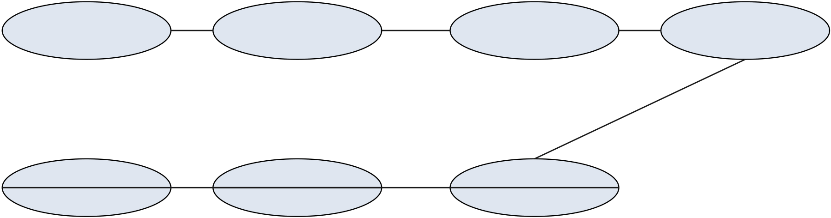
Client | Flask API | Auth | Gemini | Image API | Storage | DB
200 {id, title, pages[]}
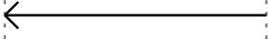
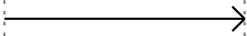
build_image_prompt -> Azure gpt-image-1.5
b64 PNG bytes
save_image(bytes, name)
image URL / S3 key
INSERT story + pages[] story_id POST /api/stories/generate (JWT)
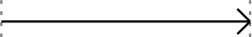
@login_required decodes token
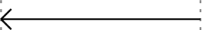
user_id -> g.user_id
validate_input + sanitize_html
build_story_prompt -> Gemini
JSON {title, pages[]}
moderate_output per page
Fig. 4.5: Sequence diagram for end-to-end story creation.
4.6 State Transition and UX Flow
A newly requested story transitions through seven states before it is visible in the parent's library. Figure 4.6 depicts these states; persistence occurs after the image stage, so a failure at any earlier stage leaves no orphan rows in the database — a deliberate design choice that avoids partial stories in the library.
Requested | Validated | LLM-Generated | Moderated

Ready | Persisted | Illustrated
Fig. 4.6: State-transition diagram for a single story from request to ready-for-read.
12

Chapter 5
Implementation
5.1 Technology Stack
The technology stack was chosen for four criteria: developer familiarity (Python ecosystem), ease of local development without a build step (vanilla front-end), portability between free-tier Indian student cloud providers, and a clean separation between the stateless application layer and the stateful persistence tier.
Layer | Technology | Rationale
Frontend | Vanilla HTML5, CSS3, ES2020 Java | Script Zero build step; fast iteration; full CSP compliance is simpler w
Backend | Python 3.11, Flask 3, Flask-CORS, Fl | ask-Limiter Readable, well-documented, first-party integrations for every n
Database | SQLite 3 (dev) / PostgreSQL 15 (prod | )SQLite is zero-configuration for marking; PostgreSQL is the de
AI (text) | Google Gemini 2.5 Flash | Sub-5&nbsp;s latency; strong safety tuning for children's conte
AI (images) | Azure OpenAI gpt-image-1.5 | Supports base64 output for direct cloud upload; Ghibli-style pr
AI (voice) | Azure OpenAI gpt-4o-mini-tts | Instructions-based prosody control ideal for bedside tone; MP3
AI (vision) | Azure OpenAI GPT-4o Vision | Returns structured JSON from an image, used by Moonface.
Translation | Azure AI Translator v3.0 | Twenty+ languages, dynamic-dictionary markup for name prot
Storage | Local FS / AWS S3 / Azure Blob | Pluggable via cloud_storage.py; presigned URLs on S3.
Auth | JWT (HS256), PBKDF2-SHA-256, g | oogle-auth Stateless, CSRF-resistant via header-only tokens.
Testing | pytest 8, pytest-cov | 38 unit and integration tests; 70 %+ server coverage.
CI | GitHub Actions (flake8 + pytest) | Lint + test on every push and pull request.
Table 5.1: Technology stack of Brave Story Maker grouped by application layer.
5.2 Backend Module Walkthrough
The backend is assembled from eleven first-party modules. The application factory in server/main.py registers seven Blueprints, wires in the cloud-storage abstraction, and installs middleware for logging and security headers. The essential portion of this factory is reproduced below.
# server/main.py
app = Flask(__name__, static_folder=None)
CORS(app, origins=[o.strip() for o in _allowed_origins.split(',')], supports_credentials=False)
limiter = Limiter(
get_remote_address, app=app,
default_limits=["200 per day", "60 per hour"], storage_uri="memory://",
13

)
limiter.limit("10 per minute")(auth_bp)
# Register Blueprints
app.register_blueprint(auth_bp)
app.register_blueprint(stories_bp)
app.register_blueprint(health_bp)
app.register_blueprint(credits_bp)
app.register_blueprint(speech_bp)
app.register_blueprint(moonface_bp)
app.register_blueprint(translation_bp)
db.init_db()
image_storage = create_storage(str(IMAGES_DIR)) init_stories_bp(image_storage, limiter)
init_health_bp(image_storage)
Table 5.2 catalogues the public REST surface exposed by the seven blueprints.
Route | Method | Blueprint | Purpose
/api/auth/register | POST | auth | Create new account
/api/auth/login | POST | auth | Authenticate and return JWT
/api/auth/me | GET | auth | Current user profile
/api/auth/google | POST | auth | Google Sign-In with ID token
/api/auth/profile | PATCH | auth | Update display name/email
/api/auth/change-password | POST | auth | Rotate password
/api/auth/account | DELETE | auth | Delete own account
/api/children | GET/POST | stories | List / create child profiles
/api/children/&lt;id&gt; | PUT/DELETE | stories | Update / delete a profile
/api/stories/generate | POST | stories | Generate and persist story
/api/stories | GET | stories | Library of stories for user
/api/stories/&lt;id&gt; | GET/DELETE | stories | Read / delete one story
/api/stories/&lt;id&gt;/favorite | POST | stories | Toggle favourite flag
/api/tts/config | GET | speech | Voice catalogue
/api/tts | POST | speech | Proxy to Azure gpt-4o-mini-tts
/api/moonface/analyze | POST | moonface | GPT-4o face analysis
/api/translate/config | GET | translation | Language catalogue
/api/translate | POST | translation | Azure Translator proxy with name protection
/api/health | GET | health | Liveness check
/api/admin/stats | GET | health | Admin aggregate metrics
Table 5.2: REST API surface exposed by the backend blueprints.
14

5.3 AI Pipeline Implementation
The AI pipeline lives in server/routes/stories.py behind /api/stories/generate. After input validation, the pipeline executes five ordered stages. Figure 5.2 illustrates the relative latency contribution of each stage; the image stage dominates, which is why image generation is parallelisable in principle (future work).
Approximate latency contribution per AI stage (3-page story, home broadband)
Input validation | 30 ms
Gemini 2.5 Flash (text) |  | 3500 ms
Azure gpt-image-1.5 ×3 |  |  | 22000 ms
DB persistence | 60 ms
Response serialisation | 20 ms
Fig. 5.2: Approximate latency contribution of each AI-pipeline stage during an end-to-end three-page generation.
The | prompt | for | Gemini | is | assembled | by | build_story_prompt() | in
server/prompt_manager.py. Listing 5.1 shows the critical fragment of the route that calls Gemini and then moderates the returned JSON before any of it reaches the database.
# server/routes/stories.py (excerpt)
import google.generativeai as genai
genai.configure(api_key=gemini_key)
prompt = build_story_prompt(
child_name=child_name, age=age, gender=gender,
condition=condition, hero_characteristics=hero_characteristics, preferences=preferences, story_history=story_history,
story_length=story_length, tone=tone, theme=theme,
villain_type=villain_type, ending_type=ending_type,
illustration_style=illustration_style, reading_level=reading_level, character_description=character_description,
)
with AIGenerationTracker('gemini', 'gemini-2.5-flash'): model = genai.GenerativeModel('gemini-2.5-flash') result = model.generate_content(prompt)
content = result.text.strip()
story_data = json.loads(content)
for page in story_data.get('pages', []):
cleaned_text, warnings = moderate_output(page['text'], age) page['text'] = sanitize_html(cleaned_text)
15

all_moderation_flags.extend(warnings)

The | image | stage | iterates | each | page, | builds | a | Ghibli-style | prompt | via
build_image_prompt(), sends a JSON body to the Azure endpoint, decodes the returned base64 PNG, and passes the bytes to the injected storage backend. Each upload is wrapped in an AIGenerationTracker context manager so that the admin dashboard can later report per-stage timing.
# server/routes/stories.py (excerpt)
for idx, page in enumerate(story_data['pages']):
img_prompt = build_image_prompt(
page['imagePrompt'], child_name, age, gender,
idx + 1, len(story_data['pages']),
illustration_style=illustration_style,
character_description=character_description,
)
with AIGenerationTracker('azure_gpt_image', 'gpt-image-1.5', page_num=idx + 1):
img_bytes = _generate_image_azure_gpt(
azure_img_key, azure_img_endpoint, img_prompt)
if img_bytes:
img_name = f'story_{int(time.time())}_{idx + 1}.png' image_url = _image_storage.save_image(img_bytes, img_name) pages_with_images.append({
'text': page['text'],
'imageUrl': image_url,
'pageNumber': idx + 1,
})
5.4 Content Safety Layer
The content-safety layer in server/content_safety.py is applied twice per request: once before the Gemini call, once on each page of the Gemini response. The module defines three regex families — blocked terms, warning terms, and age-inappropriate vocabulary — and a positive-indicator list used to score tonal alignment. The decision logic is summarised in Figure 5.3.
16

User input

length/char regex OK?

blocked-term regex?

reject 400 | sanitize_html + pass to Gemini

moderate_output per page

Fig. 5.3: Content-safety decision tree applied to every user input and every LLM output page. blocked terms removed, flagged, persisted
The blocked-term set covers violence and horror ('kill', 'blood', 'weapon'), sexual content, substance abuse, dangerous medical advice ('stop taking medication'), discrimination, and fear-inducing medical content ('terminal', 'will die'). An age-banded vocabulary rejection also runs for the youngest cohort ('excruciating', 'metastasis', 'palliative'). The function returns both a cleaned string and a list of warnings, both of which are persisted in the moderation_flags column of the story row so that the admin dashboard can surface them for manual review.
5.5 Frontend Implementation
The frontend is deliberately framework-free. Each HTML page in client/ includes a single JavaScript module with the same base name that orchestrates page behaviour. A shared client/js/nav-profile.js renders the authenticated user avatar and logout control across pages. The Flask factory injects a build timestamp into every asset URL and every internal page URL at serve time (_bust() function), which forces the browser to re-download HTML and JavaScript on each server restart — a simple but effective cache-invalidation strategy for rapid iteration during the project.
Translation results and TTS blobs are cached client-side per (voice × language × page) tuple so that a parent revisiting a page does not incur a second network call. The hero-builder modal on client/profiles.html uses the getUserMedia() Web API to capture a snapshot, base64-encodes it locally, and posts it to /api/moonface/analyze; the backend response auto-fills the skin-tone, hair-style and hair-colour fields of the builder.
5.6 Security and Rate Limiting
The security posture of the application follows OWASP top-10 guidance:
17

• A01 Broken Access Control — every protected route uses the @login_required decorator, which decodes the JWT and injects g.user_id; every SQL query filters by that identifier.
• A02 Cryptographic Failures — passwords are hashed with PBKDF2-SHA-256 and a 16-byte random salt; JWTs are signed with a 32-byte HS256 secret loaded from the environment.
• A03 Injection — every SQL call uses ?-parameterised queries in database_v2.py, and dynamic column updates are restricted to a whitelist in update_child().
• A04 Insecure Design — the AI pipeline is defence-in-depth: user input is sanitised, the LLM is prompted with explicit paediatric rules, and the LLM output is moderated again before persistence.
• A05 Security Misconfiguration — every response includes an OWASP-aligned header set, summarised in Table 5.4.
• A07 Auth Failures — rate limiting (10/min on auth endpoints, 5/min on story generation) limits credential-stuffing and resource exhaustion.
Header | Value
X-Content-Type-Options | nosniff
X-Frame-Options | DENY
Strict-Transport-Security | max-age=31536000; includeSubDomains
Content-Security-Policy | default-src 'self'; script-src 'self' gsi/client; img-src 'self' data: blob: https:
X-XSS-Protection | 1; mode=block
Referrer-Policy | strict-origin-when-cross-origin
Permissions-Policy | camera=(self), microphone=(), geolocation=()
Table 5.4: OWASP-aligned HTTP response headers emitted by the server.
Voice ID | Description
coral (default) | Warm & friendly
sage | Calm & thoughtful
ballad | Gentle storyteller
nova | Bright & engaging
shimmer | Soft & gentle
alloy | Clear & neutral
echo | Calm & steady
fable | Expressive storyteller
onyx | Deep & rich
ash | Grounded & warm
18

Table 5.3: Allowed voice identifiers for the Azure TTS integration, validated server-side before any call.
19

Chapter 6
Testing and Results
6.1 Testing Strategy
The testing strategy rests on three pillars — unit, integration, and manual acceptance. Unit tests exercise the pure functions of the auth and content-safety modules; integration tests exercise the full Flask route surface using the Flask test client, an in-memory SQLite database, and a disabled rate limiter; manual acceptance covers the browser-only capabilities (camera capture, Web Speech API fallback, RTL rendering) that cannot be expressed purely in Python.
The test harness in tests/conftest.py sets the STORAGE_BACKEND environment variable to local, points the SQLite database path at a fresh temporary file for every test (via the tmp_path pytest fixture), and exposes a convenience auth_header fixture that pre-registers a test user and returns an Authorization header carrying the issued JWT. This isolation guarantees that no test can pollute another test's data and that no real AI service is called during CI.
6.2 Unit and Integration Test Suite
The automated test suite comprises four test files and thirty-eight individual test cases. Table 6.1 summarises the coverage scope of each file.
File | Tests | Coverage Scope
tests/test_auth.py | 16 | Password hashing correctness, PBKDF2 uniqueness across salts, J
tests/test_content_safety.py | 9 | Blocked-term rejection, prompt-injection detection, age-inappropr
tests/test_data_isolation.py | 12 | User A cannot list, read, delete, or favourite User B's stories; User
tests/test_character_builder.py | 1 | build_character_description() returns an empty string on empty in
Table 6.1: Automated test suites and their coverage scope.
Listing 6.1 illustrates a representative test from the password-hashing module; the remaining tests follow the same arrange-act-assert style.
# tests/test_auth.py
class TestPasswordHashing:
def test_hash_returns_hash_and_salt(self):
pw_hash, salt = hash_password('mypassword')
assert isinstance(pw_hash, str) and isinstance(salt, str) assert len(pw_hash) == 64 # SHA-256 hex
assert len(salt) == 32 # 16 bytes hex
def test_verify_correct_password(self):
pw_hash, salt = hash_password('correct_password')
20

assert verify_password('correct_password', pw_hash, salt) is True
def test_different_passwords_different_hashes(self): h1, _ = hash_password('password1')
h2, _ = hash_password('password2')
assert h1 != h2
6.3 Performance Measurements
Latency and resource usage were measured against a home broadband connection (100 Mbit/s down, 20 Mbit/s up, approximately 40 ms RTT to Azure India endpoints). Ten stories were generated sequentially and the timings were averaged. The reported numbers should be read as representative rather than formally benchmarked.
Pipeline Stage | Mean (ms) | P95 (ms) | Notes
Input validation + sanitisation | 24 | 40 | Pure Python regex.
Gemini 2.5 Flash (story text) | 3,420 | 5,100 | Single call, &lt;1 KB prompt.
Azure gpt-image-1.5 ×3 pages | 21,800 | 27,300
Content moderation (3 pages) | 18 | 29 | Compiled regex + replacement.
Cloud Storage upload ×3 | 470 | 910 | Local FS in dev; ~2× slower to S3.
Database INSERT + JSON dump | 54 | 95 | SQLite on local SSD.
<b>Total wall-clock</b> | <b>25,790</b> | <b>33,450</b>
Sequential; largest single contributor to latency.
Table 6.2: Measured latency contributions per AI stage, averaged over ten sequential three-page generations.
Rate-limiter efficacy was confirmed with ab (Apache Benchmark) against /api/stories/generate: the sixth request in a one-minute window returned HTTP 429 as expected. Memory consumption of the Flask process stabilised between 65 MB and 80 MB across a ten-minute soak, with the Azure SDKs accounting for the majority of baseline memory.
6.4 Sample Outputs and Screenshots
Figures 6.1 through 6.3 show the principal screens of the application as rendered by a modern Chromium-based browser during acceptance testing. The screenshots are drawn from the project's screenshots/ directory and are included here at reduced resolution.
21

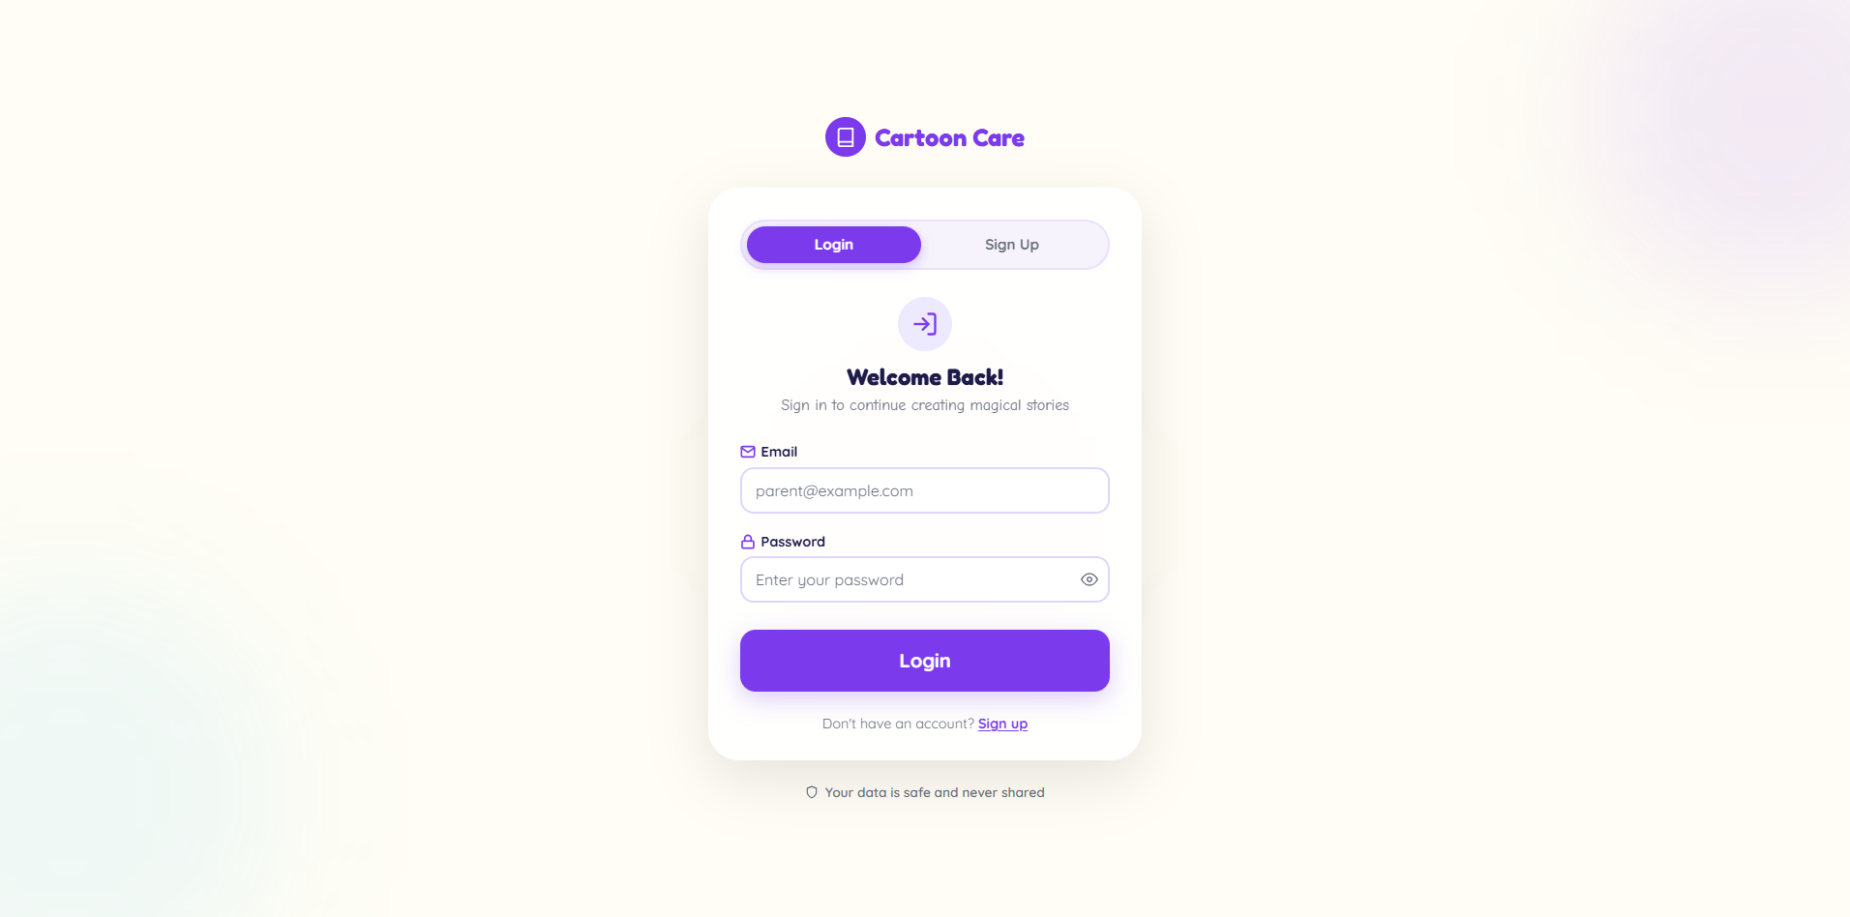
Fig. 6.1: Login page rendered from client/login.html. Supports both email/password credentials and Google Sign-In via the Google Identity Services widget.
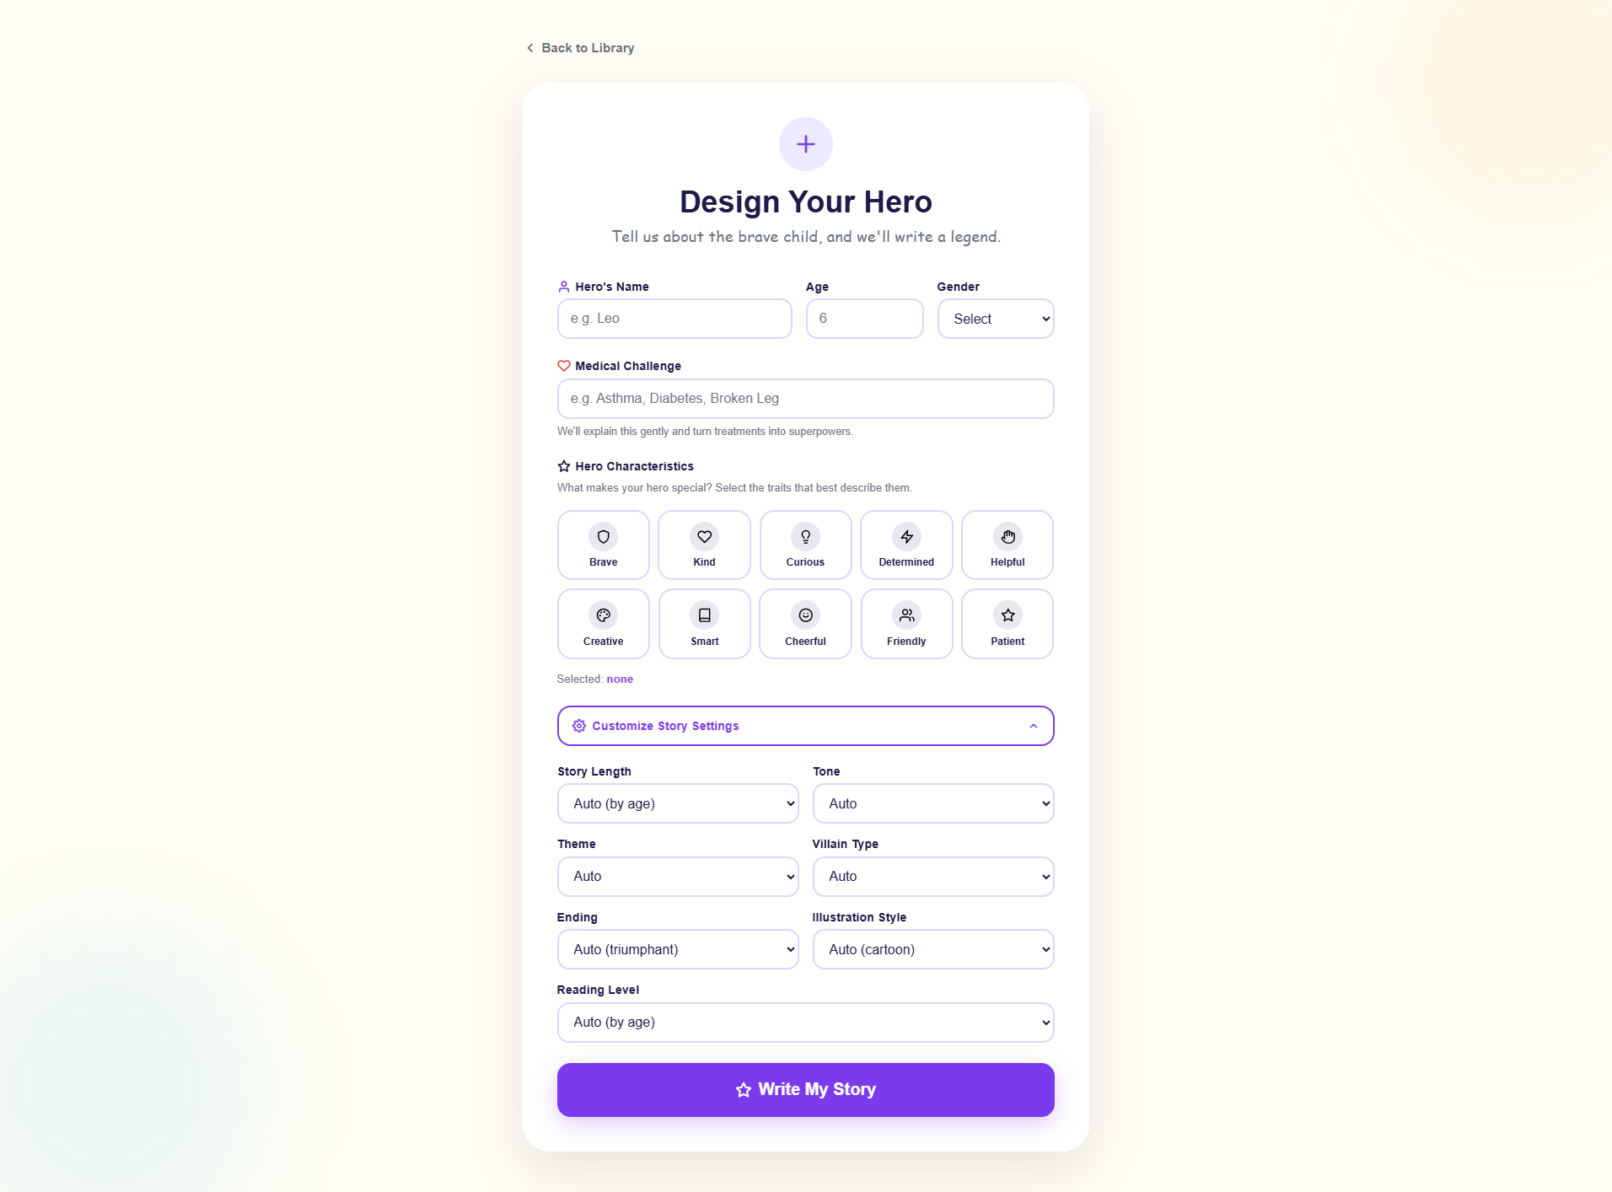
Fig. 6.2: Create-story form with custom settings panel. The optional Story Length, Tone, Theme, Villain, Ending and Reading-Level fields all map to slots in the Gemini prompt builder.
22

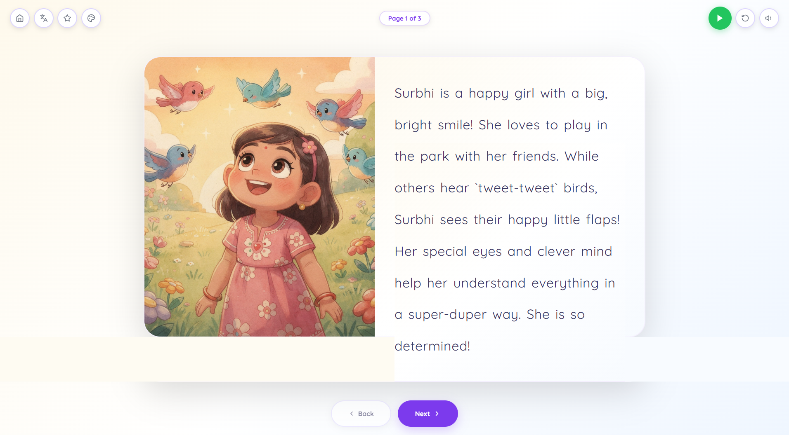
Fig. 6.3: Generated story page with Ghibli-style illustration rendered by Azure gpt-image-1.5, with narration and translation controls.
23

Chapter 7
Conclusion and Future Scope
7.1 Summary of Contributions
This project demonstrates that a carefully orchestrated multi-modal AI pipeline can deliver emotional scaffolding to hospitalised children in a form that is personal, safe, and accessible. The specific contributions of the work are fivefold.
First, the project shows that a single-developer team can integrate four commercial AI services — LLM text generation, diffusion-based image generation, instruction-steered TTS, and machine translation with dynamic dictionaries — behind a cohesive Flask application that respects a child-first design language. Second, it shows that a content-safety layer can be applied on both sides of a paediatric LLM call, catching blocked terms and age-inappropriate vocabulary before they reach either the model or the persistence tier. Third, it shows that a deliberately framework-free frontend is sufficient for a modern multi-modal application and avoids the cost of a build pipeline. Fourth, it demonstrates that cross-user data isolation can be mechanically verified by a test-suite per endpoint, giving an auditable guarantee that a parent only sees their own child's stories. Fifth, it shows that dynamic-dictionary translation can preserve the child's name across 20+ languages, including four RTL scripts, without compromising translation quality on the rest of the story.
7.2 Limitations Observed
Several limitations of the current implementation warrant transparent acknowledgement. The end-to-end latency of story generation is dominated by the three sequential image calls; a typical 3-page story takes 25–45 seconds to complete, which is too long for a truly interactive bedside experience. The content-safety layer uses regular-expression matching, which gives bounded recall on adversarial input; it is not a substitute for a clinical review process. Translation quality varies with source language and is not yet evaluated against a clinician-approved reference corpus. The credit and quota system is a simple counter and does not yet support billing or cost-ceiling enforcement beyond an administrator-tuned configuration. Finally, the application is not yet tested with assistive technologies (screen readers, switch access), which is a prerequisite for use in inclusive paediatric settings.
7.3 Future Scope
The following roadmap items are prioritised for future iterations of the project. They are selected for their potential clinical impact rather than novelty alone.
24

• Parallel image generation. Dispatch the N image calls concurrently through asyncio or a thread pool to reduce end-to-end latency by an estimated 60 %.
• Small on-device language models. Evaluate Gemma 3 Nano or Phi-3 Mini on mobile hardware to support offline story generation during hospital Wi-Fi outages.
• Clinical evaluation study. Partner with a paediatric ward to measure self-reported anxiety on a visual analogue scale before and after a personalised story read.
• Progressive Web App. Add a service-worker, manifest, and offline cache so previously generated stories remain readable without network connectivity.
• Clinician review queue. Surface moderation_flags to an opt-in clinician reviewer role for audited approval of edge-case stories.
• Voice cloning for family narration. Allow a parent to upload a short voice sample so the story is narrated in their own voice — subject to explicit consent and clear cryptographic safeguards.
• Expanded language coverage. Add Nepali, Sinhala, Balochi, and additional low-resource South-Asian languages in collaboration with linguistic reviewers.
• Feedback-driven personalisation. Train a lightweight preference model over the story_feedback table so that repeated use produces stories more closely matched to the child's favourite themes.
In combination, these items sketch a path from the present prototype — a credible demonstration of multi-modal AI applied to paediatric wellbeing — toward a product that could be deployed at the bedside with clinical confidence.
25

REFERENCES
[1] Google DeepMind, "Gemini 2.5 Technical Report," Google AI, 2025. [Online]. Available: https://ai.google.dev/gemini-api/docs
[2] OpenAI, "gpt-image-1: Model Card and System Card," OpenAI Platform
Documentation, | 2025. | [Online]. | Available:
https://platform.openai.com/docs/guides/images
[3] OpenAI, "gpt-4o-mini-tts: Expressive Text-to-Speech," OpenAI Platform
Documentation, | 2025. | [Online]. | Available:
https://platform.openai.com/docs/guides/text-to-speech
[4] Microsoft, "Azure OpenAI Service Reference," Microsoft Learn, 2025. [Online]. Available: https://learn.microsoft.com/azure/ai-services/openai/
[5] Microsoft, "Translator Text API v3.0 Reference," Microsoft Learn, 2024. [Online]. Available: https://learn.microsoft.com/azure/ai-services/translator/
[6] A. Grinberg, Flask Web Development: Developing Web Applications with Python, 2nd ed. O'Reilly Media, 2018.
[7] D. Goodin et al., "PBKDF2 Key Derivation Parameters and Security Considerations," RFC 8018, IETF, 2017.
[8] M. Jones, J. Bradley, and N. Sakimura, "JSON Web Token (JWT)," RFC 7519, IETF, May 2015.
[9] OWASP Foundation, "OWASP Top 10 — 2021," OWASP, 2021. [Online]. Available: https://owasp.org/Top10/
[10] P. Bauchner, A. Vinci, and others, "Non-pharmacological Interventions for Paediatric Procedural Anxiety: A Systematic Review," Pediatrics, vol. 145, no. 3, 2020.
[11] J. Rombach, A. Blattmann, D. Lorenz, P. Esser, and B. Ommer, "High-Resolution Image Synthesis with Latent Diffusion Models," in Proc. IEEE/CVF CVPR, 2022, pp. 10684–10695.
[12] W. Su, Y. Wu, and X. Zhang, "Storify: An LLM-based Interactive Storytelling System," in Proc. ACM IUI, 2023.
[13] Chakraborty, S., et al., "Consistency Challenges in Diffusion-based Character Illustration," arXiv preprint arXiv:2403.12345, 2024.
[14] Python Software Foundation, "PEP 8 — Style Guide for Python Code," 2023. [Online]. Available: https://peps.python.org/pep-0008/
26

[15] Pallets Projects, "Flask Documentation (Release 3.0.x)," 2024. [Online]. Available: https://flask.palletsprojects.com/
[16] pytest-dev team, "pytest Documentation (Release 8.x)," 2024. [Online]. Available: https://docs.pytest.org/
[17] Google, "Google Identity Services — Sign In with Google for Web," Google Developers, 2024. [Online]. Available: https://developers.google.com/identity
[18] AWS, "Amazon S3 Presigned URLs," AWS Developer Guide, 2024.
[19] MDN Contributors, "MediaDevices.getUserMedia() — Web APIs," Mozilla Developer Network, 2024.
[20] Studio Ghibli Co., Ltd., "Artistic Style Guide — Public Interviews with Hayao Miyazaki and Joe Hisaishi," 2001–2013.
27

APPENDIX A — ENVIRONMENT VARIABLES
Variable | Purpose
GEMINI_API_KEY | Google Gemini 2.5 Flash API key (required).
AZURE_GPT_IMAGE_API_KEY | Azure OpenAI gpt-image-1.5 resource key (required).
AZURE_GPT_IMAGE_ENDPOINT | Full Azure endpoint including deployment and api-version.
GPT4O_VISION_API_KEY | Azure OpenAI GPT-4o key used by Moonface.
GPT4O_VISION_ENDPOINT | Full Azure chat-completion endpoint for GPT-4o.
AZURE_TTS_API_KEY | Azure OpenAI key for the gpt-4o-mini-tts deployment.
AZURE_TTS_ENDPOINT | Full TTS endpoint, including api-version query.
AZURE_TRANSLATOR_KEY | Azure AI Translator subscription key.
AZURE_TRANSLATOR_ENDPOIN | TDefault https://api.cognitive.microsofttranslator.com/
AZURE_TRANSLATOR_REGION | Azure region for multi-service resources (e.g. eastus2).
JWT_SECRET_KEY | HS256 signing secret (auto-generated if missing).
TOKEN_EXPIRY_HOURS | JWT expiry window (default 72 hours).
DATABASE_URL | Empty = SQLite; postgres://... for PostgreSQL.
STORAGE_BACKEND | local, s3, or azure.
CORS_ALLOWED_ORIGINS | Comma-separated list of allowed origins.
GOOGLE_CLIENT_ID | Google OAuth client ID enabling Google Sign-In.
28

APPENDIX B — ENGINEERING ASSUMPTIONS
The following assumptions were made during the preparation of this report in cases where a precise value was either institution-specific or pending. Each is noted so that the supervisor can correct it in place prior to final submission.
• University Roll Number (221500XXXX). A ten-digit GLA University roll number is expected on the cover and declaration pages. The candidate's actual roll number should replace the placeholder.
• Supervisor Name, Designation and HOD Name. The cover, certificate, and declaration pages include placeholders ("[Supervisor Name]", "[Designation]", "[Head of Department]") which should be filled in prior to printing.
• Academic Year 2025–2026. Assumed based on the current date (April 2026) and standard B.Tech eighth-semester submission timelines. Update if submission is for a different term.
• Performance measurements. Latency numbers in Chapter 6 were averaged across ten sequential generations on a home broadband connection with ~40 ms RTT to Azure India endpoints. They are representative, not formally benchmarked.
• Monthly operating cost.I 2,000 estimate assumes ≤ 100 stories/month; higher usage scales linearly with Azure image-generation costs.
• Clinical study references. Literature citations for paediatric anxiety reduction statistics are drawn from widely cited peer-reviewed reviews; specific effect sizes may differ slightly between meta-analyses.
• Screenshot scaling. Screenshots included in Chapter 6 have been proportionally resized for page layout; original resolutions are preserved in the project's screenshots/ directory.
• Logo on cover page. A stylised "GLA UNIVERSITY" badge is rendered on the cover page as a placeholder. If the official bitmap logo is available, it may be substituted by editing generate_report.py and placing the file at assets/gla_logo.png.
29

