

NMAM INSTITUTE OF TECHNOLOGY NITTE
Nitte Karkala-574110

Assignment ON

COMPLAINT AND FEEDBACK TRACKING SYSTEM

Submitted to

Dr. JASON ELROY MARTIS
Professor

In the partial fulfilment of requirements for the award of degree

BACHELOR OF ENGINEERING IN
INFORMATION SCIENCE AND ENGINEERING

by

ANANYA NINJOOR NNM24IS025

2. Abstract
In many organizations complaints and feedback are not handled in a structured way. Most complaints are received through emails phone calls or written registers. Because of this it becomes difficult to track the complaint status and ensure that it is resolved on time. Users often do not receive updates and management may not have proper records for analysis.
To solve this issue a Complaint and Feedback Tracking System can be developed. This system allows users to submit complaints online and track them using a unique complaint ID. Administrators can manage complaints through a centralized dashboard and update their status.
In this report I have analyzed how this system can be developed using three SDLC models: Waterfall Incremental and Spiral. I compared them based on flexibility risk handling cost and change management. I also discussed requirements engineering validation strategy risk analysis testing maintenance and GitHub repository structure.
After comparing all three models I believe the Incremental model is more suitable because it allows step-by-step development and supports future changes. Through this assignment I understood how important proper planning and model selection are in software engineering.

3. Introduction
Software engineering is not just about writing code. It involves planning designing testing and maintaining systems properly. Many real-world problems can be solved with structured software systems. One common problem in many organizations is improper complaint management.
In colleges students complain about facilities. In companies customers complain about services. But in many cases, these complaints are handled manually. Some are written in notebooks. Some are sent by email. Some are told verbally. There is no proper tracking system.
Because of this:
- Complaints may get delayed.
- There is no transparency.
- Users do not know the status.
- Management cannot easily monitor performance.
This creates dissatisfaction and reduces trust.
So a Complaint and Feedback Tracking System is needed. It provides a digital platform where complaints are stored in a database assigned to departments, and tracked properly.
The aim of this case study is to analyze how this system can be developed using different SDLC models and to choose the most suitable one.

4. Background and Need for the System
Every organization receives complaints. Complaints are not always negative. They actually help organizations improve. But if complaints are not handled properly they can damage reputation.
Manual complaint handling has many problems:
- No centralized database
- No clear responsibility
- Delays in response
- Poor documentation
- No performance tracking
For example, if a complaint is written in a register what happens if the register is misplaced? Or if an email is ignored? There is no accountability.
A digital system can solve these issues. It can:
- Store complaints securely
- Track time taken to resolve issues
- Provide reports
- Improve communication
- Increase transparency
That is why building a Complaint and Feedback Tracking System is important.

5. Problem Statement
The current manual complaint handling system is inefficient and unorganized. There is no structured method to track complaints from submission to resolution.
The system should:
- Allow online complaint submission
- Generate unique complaint ID
- Store data securely
- Allow status tracking
- Allow admin updates
- Provide reporting features
The objective of this case study is to compare SDLC models and identify the most suitable one for this system.

6. Stakeholder Analysis
Stakeholders are people who are involved in or affected by the system.
For this system stakeholders include:
- Users (students/customers)
- Administrators
- IT team
- Management
Users want quick resolution and updates.
Administrators want easy management tools.
IT team wants system stability.
Management wants reports and performance data.

Understanding stakeholders helps in defining correct requirements.

7. System Overview
The system has two main modules.

User Module
Users can:
- Register and login
- Submit complaints
- Submit feedback
- Track complaint status
Each complaint gets a unique ID.

Admin Module
Administrators can:
- View all complaints
- Categorize complaints
- Assign to departments
- Update status
- Add remarks
- Generate reports
This makes complaint handling transparent and organized.

8. Detailed Comparison of SDLC Models
Now I will explain the three models in detail.

8.1 Waterfall Model

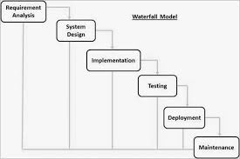

Waterfall model follows a fixed sequence:

- Requirement Analysis
- Design
- Implementation
- Testing
- Deployment
- Maintenance
Each phase must finish before the next begins.
Advantages
- Simple and easy to understand
- Clear documentation
- Easy to manage
- Well defined stage
Disadvantages
- Not flexible
- Hard to make changes
- Risk identified late
- not suitable for complex and evolving system
For this system if new features are needed later it becomes difficult.
Waterfall is suitable only when requirements are stable and clear.

8.2 Incremental Model

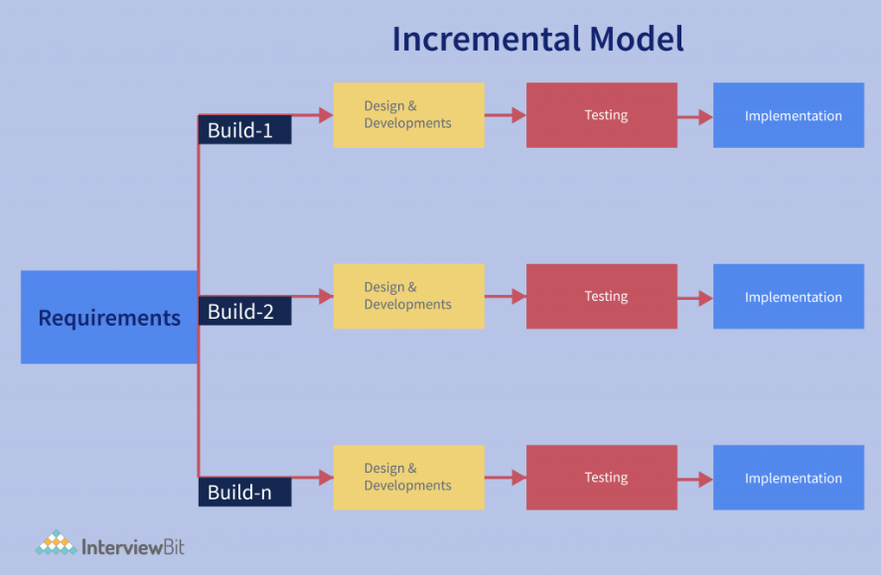

Incremental model develops the system in parts.
Example:
1:Registration
2:Complaint submission
3:Admin dashboard
4: Reports

Each increment delivers a working version.
Advantages
- Flexible
- Easier to test
- Supports changes
- Early working system
Disadvantages
- Requires careful integration
- Needs good planning
I feel this model is best for this system because complaint systems may need updates.

8.3 Spiral Model

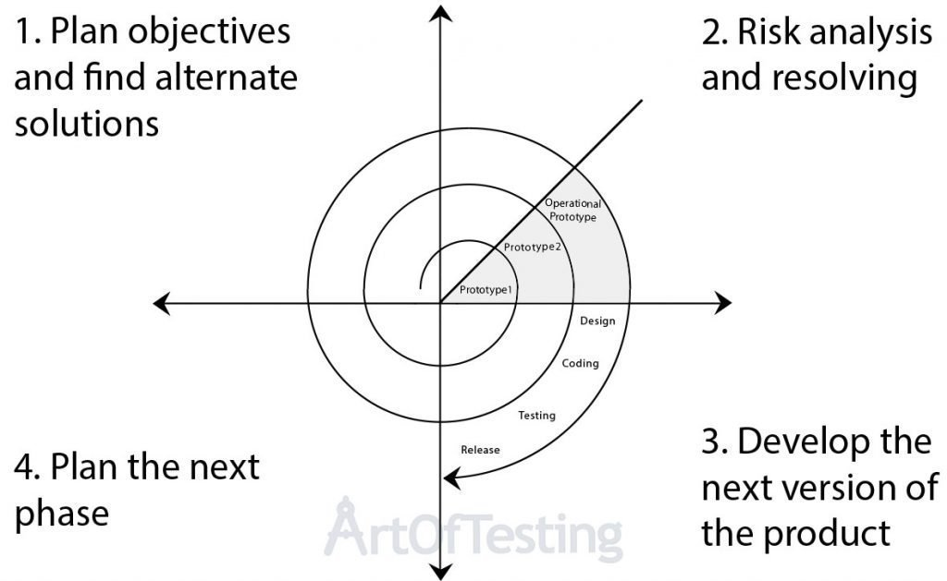

Spiral model focuses on risk analysis and works in cycles.
Each cycle includes:
- Planning
- Risk analysis
- Development
- Evaluation
Advantages
- Strong risk control
- Flexible
- Continuous improvement
Disadvantages
- Expensive
- Complex
- Time-consuming
Spiral is useful for large systems with high risk.

9. Requirements Engineering
Requirements engineering means deciding what the system should do.

Functional Requirements
It may state what the system should not do and how the system should react to particular inputs.
- User registration
- Complaint submission
- Unique complaint ID
- Status tracking
- Admin updates
- Report generation

Non-Functional Requirements
It apply to the system as a whole rather in particular features.
- Security
- Fast response
- Multiple user support
- Data privacy
- User-friendly interface
- It can be realiable

10. Requirements Validation
Validation ensures requirements are correct.
Methods:
- Discussions
- Reviews
- Prototype
- Testing
Challenges include changing requirements and misunderstanding.

11. Risk Analysis
Possible risks:
- Data security breach
- Server downtime
- Performance issues
- Requirement changes
Impact of a Problem:
- Secure authentication
- Regular backups
- Load testing
- Modular design

12. Testing Strategy
Testing ensures system works properly.
Types of testing:
- Unit testing
- Integration testing
- System testing
- User acceptance testing
Testing helps identify errors before deployment.

13. Maintenance Planning
After deployment, maintenance is required.
Types of maintenance:
- Corrective maintenance
- Adaptive maintenance
- Perfective maintenance
Regular updates keep system stable.

14. Time and Cost Considerations
Waterfall has lower initial cost but higher change cost.
Incremental spreads cost across phases.
Spiral has higher cost due to risk analysis.

For medium organizations, Incremental is cost-effective.

15. GitHub Repository Structure
complaint-feedback-system/
│
├── README.md
├── requirements/
| ├── initial.md
│ ├── revised.md
├── diagrams/
│ ├── waterfall.png
│ ├── incremental.png
│ ├── spiral.png
└── report/
|── final-report.pdf

Branching:
- main
- dev
- feature branches

16. Limitations
- Internet dependency
- Requires maintenance
- Initial setup cost

17. Future Improvements
- Mobile application
- SMS notifications
- Chat support
- AI-based categorization

18. Reflection
While doing this assignment I understood that choosing the right SDLC model is very important. Earlier I thought Waterfall is simple but after studying flexibility very high risk also it is not a good model for complex and long projects and it change management I realized Incremental model is more practical and it is very easy to get customer feedback. This case study helped me understand real-world problems and application of software engineering concepts.

19. Conclusion
The Complaint and Feedback Tracking System improves transparency and efficiency. Compared to manual methods it provides structured complaint handling.
After comparing Waterfall, Incremental and Spiral models I believe Incremental model is most suitable due to flexibility and ease of updates. It is also easier to get costumers feedback on the work that has been done. Rapid delivery and implementation of useful software is easily possible.
This assignment helped me understand planning, requirements engineering, and risk management in software development.

20. GitHub Link

URL: https://github.com/ananyaninjoor/IS1103-1-COMPLAINT-AND-FEEDBACK-TRACKING-SYSTEM

