**Introduction to Problem Solving and Programming**

**CSE1021**

**Submitted to: Dr. Kanchan Lata Kashyap Submitted by: Ananya Prasad**

**SCSE Reg. No:20BCE10093**

**Slot-D11-D12-D13**

**Assignment-1**

**Write Python programs for following problems**

1.In a town, the percentage of men is 52. The percentage of total literacy is 48. If total percentage of literate men is 35 of the total population, write an algorithm to find the total number of illiterate men and women if the population of the town is 80,000.

**ANSWER:**

t_pop=80000

m=0.52

lm=0.35

l=0.48

w=1-m

lw=l-lm

ilm=m*t_pop-lm*t_pop

ilw=(w-lw)*t_pop

print("Total number of illiterate men:",ilm)

print("Total number of illiterate women:",ilw)

**OUTPUT:**



2.If the total selling price of 15 items and the total profit earned on them is input through the keyboard, write a program to find the cost price of one item.

**ANSWER:**

s=float(input("Enter the selling price of 15 items:"))

p=float(input("Enter the total profit of 15 items:"))

c=(s-p)/15

print("Cost price of one item",c)

**OUTPUT:**



3.If the lengths of the sides of a triangle are denoted by a, b, and c, then area of triangle is given by heron’s formula.

**ANSWER:**

import math

a=float(input("Enter the first side of the triangle:"))

b=float(input("Enter the second side of the triangle:"))

c=float(input("Enter the third side of the triangle:"))

s=(a+b+c)/2

print("s=",s)

area=math.sqrt(s*(s-a)*(s-b)*(s-c))

print("The area of the given triangle is:",area)

**OUTPUT:**

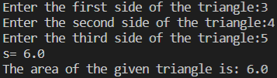

4.Write an algorithm to compute the distance between two points.

**ANSWER:**

import math

x1=float(input("Enter the x coordinate of first point:"))

y1=float(input("Enter the y coordinate of first point:"))

x2=float(input("Enter the x coordinate of second point:"))

y2=float(input("Enter the y coordinate of second point:"))

dist = math.sqrt((x2 - x1)**2 + (y2 - y1)**2)

print("The Distance between the two points :",dist)

**OUTPUT:**

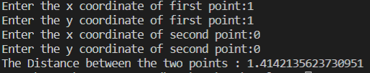

5.Enter distance into kilometre and convert it into meter and centimetre.

**ANSWER:**

print("Metric Conversion")

a=float(input("Enter the distance in kilometers:"))

m=a*1000

c=a*100000

print("Meters:",m,"m")

print("Centimeters:",c,"cm")

**OUTPUT:**

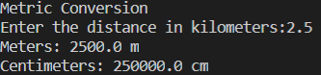

6. Enter time into hour and convert it into minutes and second.

**ANSWER:**

h=float(input("Enter the time in hours:"))

m=h*60

s=h*60*60

print("Time in hours:",h,"Hours")

print("TIme in minutes:",m,"Minutes")

print("Time in seconds:",s,"Seconds")

**OUTPUT:**

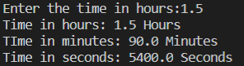

7.Enter marks of 5 subjects and find the total marks and percentage.

**ANSWER:**

p=float(input("Enter the marks in Physics out of 100:"))

c=float(input("Enter the marks in Chemistry out of 100:"))

m=float(input("Enter the marks in Maths out of 100:"))

e=float(input("Enter the marks in English out of 100:"))

cs=float(input("Enter the marks in Computer Science out of 100:"))

t_marks=p+c+m+e+cs

print("Total marks out of 500:",t_marks)

p_age=(t_marks/500)*100

print("Percentage:",p_age)

**OUTPUT:**

